## Comparison between Bayes Factor and ONS projections

Finally, we will estimate the Bayes Factors implied by each of the average improvement rates implied by each of the recent ONS mortality projections, discussing how optimistic or pessimistic each of these scenarios seems to be, and how the Bayes Factor strategy can be applied to more openly update our beliefs about the persistence and extent of a life expectancy slowdown in the UK as and when the 2019 period life expectancy estimate becomes available.

Let’s now compare the values that maximise the Bayes factor against the ONS population projections:

| **Year** | **BF- female** | **BF- male** | **ONS- female** | **ONS- male** |
| --- | --- | --- | --- | --- |
| 2011-2012 | 0.161 | 0.276 | 0.137 | 0.148 |
| 2011-2014 | 0.163 | 0.218 | 0.129 | 0.147 |
| 2011-2016 | 0.088 | 0.138 | 0.115 | 0.134 |
| 2011-2018 | 0.075 | 0.108 | 0.094 | 0.114 |

So, up to 2014, the ONS was projecting a slower improvement rates than 2011-12 alone would suggest. For the 2016 and 2018 projections, the rates were slightly higher than the Bayes Factor alone would suggest, especially for females. Now, the remaining analysis (possibly the only remaining analysis) is to express the UK’s recent improvement rates and ONS projections as a % of the mean improvement from 1980 to 2010.

Code

|  |
| --- |
|  |

| **sex**  <chr> | **mean_ch_e0**  <dbl> | **var_ch_e0**  <dbl> |
| --- | --- | --- |
| female | 0.1974194 | 0.03615978 |
| male | 0.2654839 | 0.02369226 |

So, by 2012 the ONS was projecting future improvmeent rates that were around 30% lower (1 - 0.137 / 0.197) than long-term average improvement rates for females, and around 44% lower than long-term trends (1 - 0.148 / 0.265) for males. By contrast the Bayes Factor approach alone would predict slowdowns of around 18% for females, and gains of around 4% for males.

By 2014 the ONS was projecting slowdowns of around 35% for females, and 44% for males. This contrasts with Bayes Factor estimates of around a

| **Year** | **BF_female** | **BF_male** | **ONS_female** | **ONS_male** |
| --- | --- | --- | --- | --- |
| 2011-12 | 0.816 | 1.040 | 0.694 | 0.557 |
| 2011-14 | 0.826 | 0.821 | 0.653 | 0.554 |
| 2011-16 | 0.446 | 0.520 | 0.583 | 0.505 |
| 2011-18 | 0.380 | 0.407 | 0.476 | 0.429 |

And as a graph

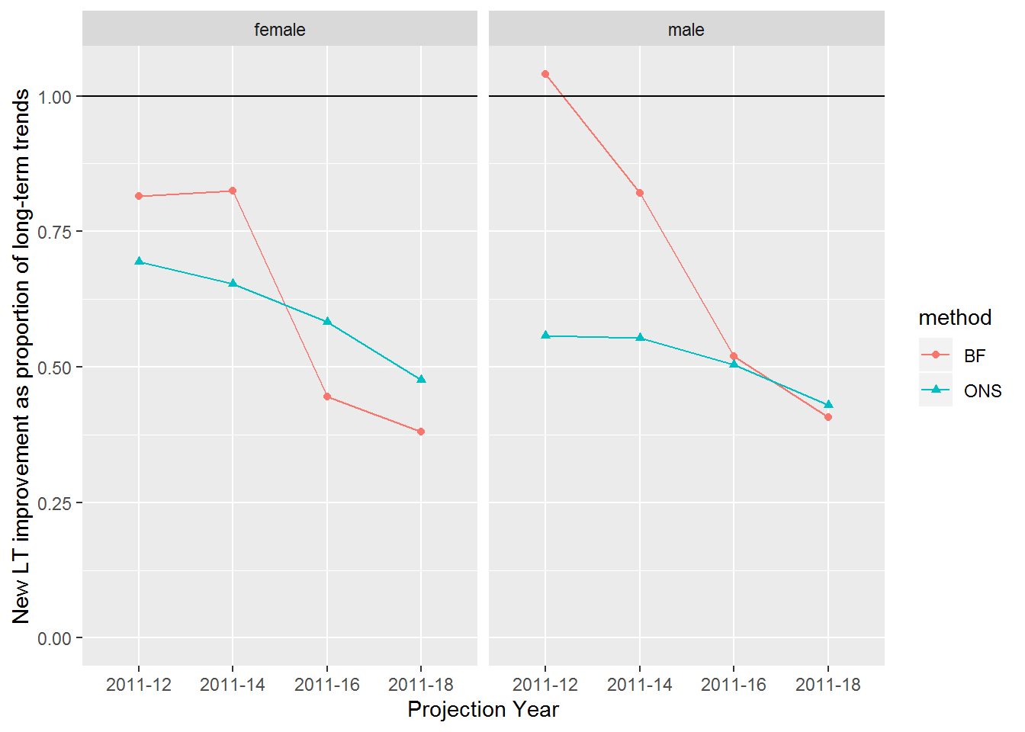

So, it appears the ONS, and the experts who advised them, believed that the long-term improvement trends were unsustainable from 2011 onwards, and projected trends that were slower than the average improvement rates seen between 1980 and 2011. However, each successive biennial update has projected a slower rate of improvement than the previous projection. The Bayes Factor approach, with the accumulated data from 2011 to 2018, suggests the ONS projections are largely in line with recent data for males, but may still be underestimating the extent of the stalling in life expectancy gains for females.

An advantage of the Bayes Factor approach is that it is trivial to update it every year, taking only a minute or so to rerun with an additional year’s worth of data. This means that as soon as new data becomes available, it can be used to update our beliefs about long-term trends, and the extent of the deterioration from long-term trends if the accumulated recent data is considered representive of how long-term trends are likely to progress.