| **sex** | **decade** | **HMD** | **ONS** |
| --- | --- | --- | --- |
| f | 80s | 0.168 | 0.168 |
| f | 90s | 0.168 | 0.170 |
| f | 00s | 0.244 | 0.241 |
| f | 10s | 0.091 | 0.080 |
| m | 80s | 0.229 | 0.230 |
| m | 90s | 0.229 | 0.232 |
| m | 00s | 0.319 | 0.313 |
| m | 10s | 0.164 | 0.131 |

Let’s now present this as a barplot

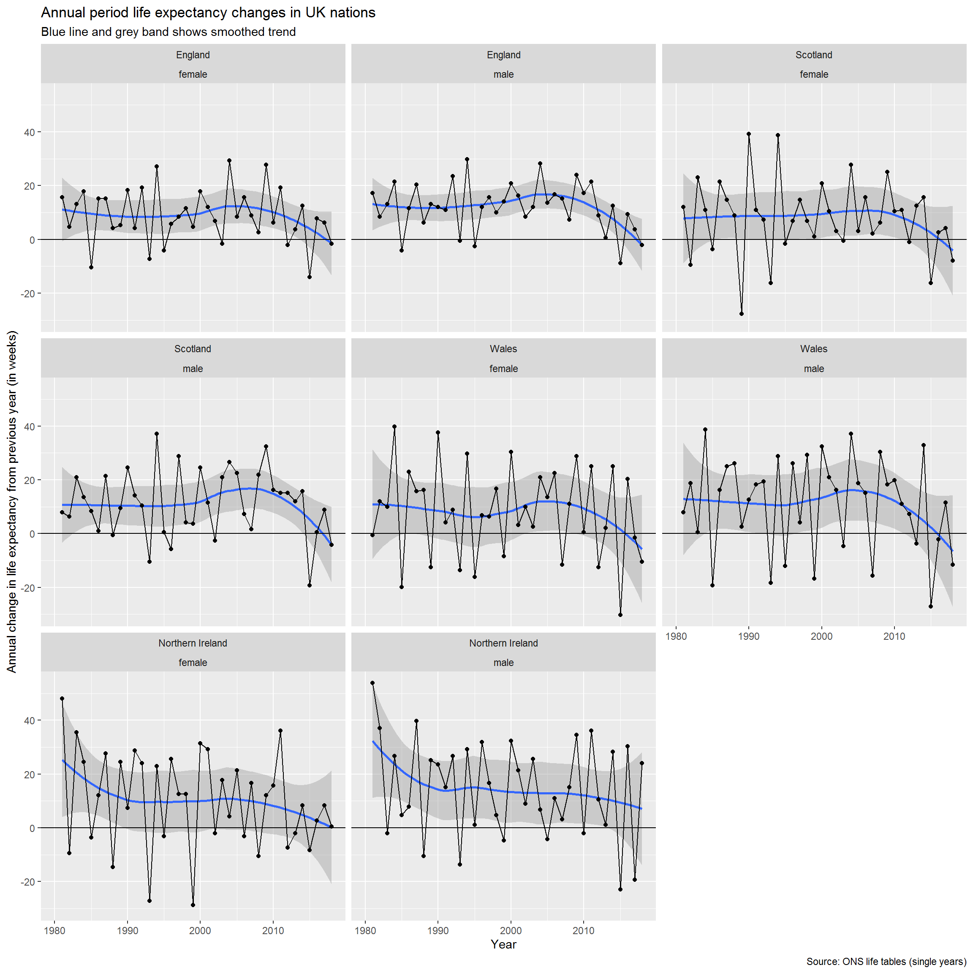

There are clear similarities between the trends in each of the UK nations, again with the exception of Northern Ireland. The trends even seem to correspond in terms of which years are ‘good years’ and which years are ‘bad years’ (i.e. they oscillate in phase with each other). To check this let’s look at the correlation between the trends.

|  |
| --- |
|  |

| **rowname**  <chr> | **England_female**  <dbl> | **England_male**  <dbl> | **Northern Ireland_female**  <dbl> |  |
| --- | --- | --- | --- | --- |
| England_female | *NA* | 0.8948164 | 0.5202739 |  |
| England_male | 0.8948164 | *NA* | 0.5633628 |  |
| Northern Ireland_female | 0.5202739 | 0.5633628 | *NA* |  |
| Northern Ireland_male | 0.4978847 | 0.5355912 | 0.5540548 |  |
| Scotland_female | 0.7748321 | 0.6215946 | 0.3588286 |  |
| Scotland_male | 0.6337257 | 0.6817908 | 0.4110520 |  |
| Wales_female | 0.8082490 | 0.6682959 | 0.3316528 |  |
| Wales_male | 0.6785138 | 0.6435823 | 0.3780715 |  |

8 rows | 1-4 of 9 columns

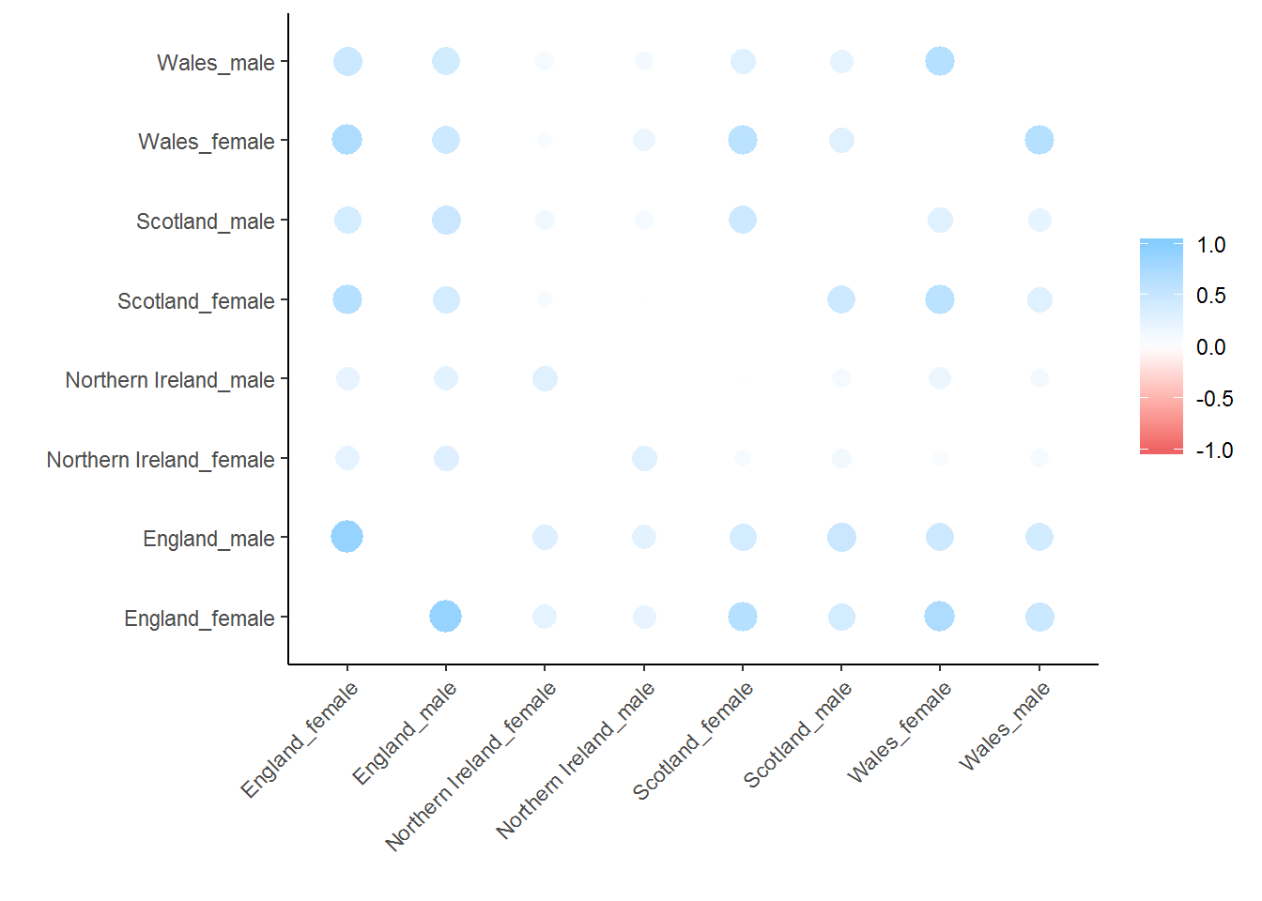

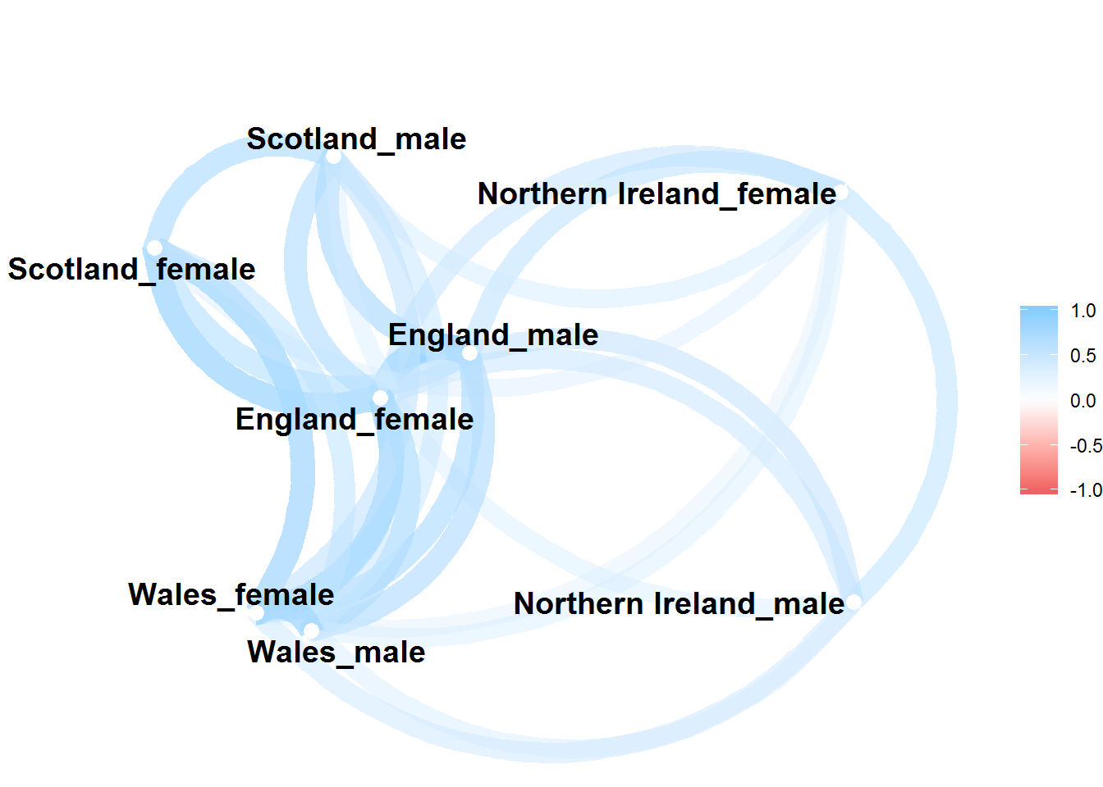

Trends in males and females in England are highly correlated (r = 0.89). The correlation between male and female trends in Wales are also strong (r = 0.77), which is slightly below the correlation between females in England and Wales (r = 0.81). Correlations between males and females in Scotland are slightly weaker (r = 0.67), and the associations between sexes are weakest in Northern Ireland (r = 0.55).

The network plot places series that are more correlated with each other closer together, and less correlated series further from each other. This confirms that males’ and females’ trends are closely correlated to each other in England and Wales, somewhat less so in Scotland, and least in Northern Ireland, where trends between sexes are less correlated with each other than are the correlations between countries elsewhere in the UK.

This suggests that any general trends which apply throughout the UK will apply less strongly in Northern Ireland than elsewhere. This should be considered when looking at the results in the next section, which aims to identify if and when there have been breakpoints in the trends in UK nations.