## Change in life expectancy, UK and UK constituent nations

Secondly, we will calculate changes in life expectancy for each UK nation or group of nations, to see whether the slowdown is similar in magnitude and contemporaneous throughout UK populations; this will be supported by performing change-point analysis of annual life expectancy changes for each of these UK populations.

# **2 Annual change rates in life expectancy in the UK as a whole and UK nations or groups of nations + change point analyses**

The previous section used data from the HMD, comparing the UK as a whole against other countries in the HMD. The last year available for the UK in the HMD was 2016. More recent e0e0 estimates are available from the ONS, which also provides estimates disaggregated by country and group of countries within the UK. We will use this data to explore how (dis)similar the trends in life expectancy change have been within different UK nations/groups of nations.

|  |
| --- |
|  |

| **population**  <chr> | **year**  <dbl> | **sex**  <chr> | **e0**  <dbl> |
| --- | --- | --- | --- |
| England | 1980 | female | 76.81 |
| England | 1980 | male | 70.80 |
| England | 1981 | female | 77.11 |
| England | 1981 | male | 71.13 |
| England | 1982 | female | 77.20 |
| England | 1982 | male | 71.29 |
| England | 1983 | female | 77.45 |
| England | 1983 | male | 71.54 |
| England | 1984 | female | 77.79 |
| England | 1984 | male | 71.95 |

**2.2 Analysis**

**2.2.1 Change in life expectancy in UK nations and groups of nations**

**2.2.1.1 Figure of change in life expectancy in UK nations and groups of nations**

Visualise the life expectancy and change in life expectancy for each year

From the above it seems most populations have seen a slowdown in improvement in recent years, and on average relatively stable improvements previously, with the exception of Northern Ireland, which saw a slowdown in improvement in the 1980s. The smaller populations tend to exhibit greater variability in annual rates of change than the larger populations. The extent of oscillation (negative autocorrelation from one year to the next) also appears greater in smaller populations. It is not immediately clear that the breakpoint for the slowdown is the same for all UK populations.

As expected, the ONS and HMD estimates of mean improvement per decade are closely aligned, usually within two decimal places, though are somewhat lower in the 2010s for ONS than for HMD:

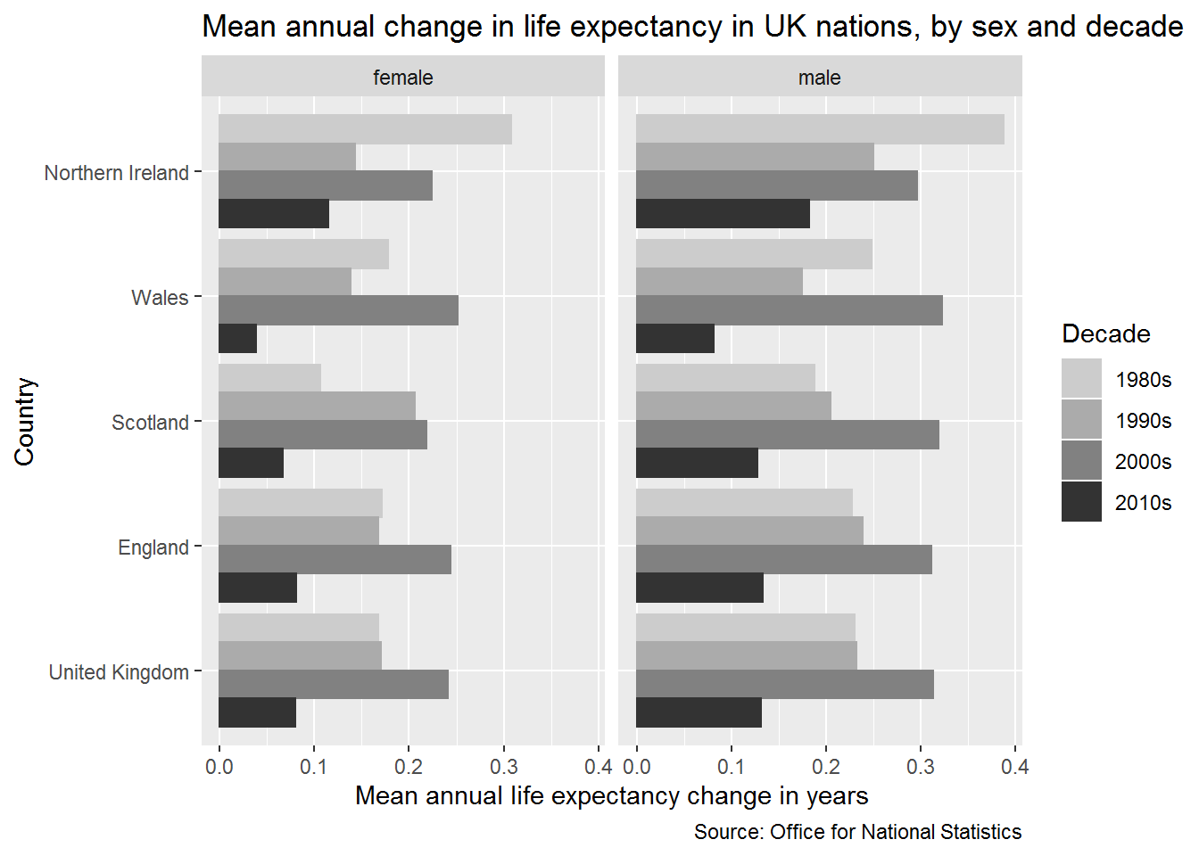

For each UK nation, the 2000s had exceptionally high rates of improvement. By contrast the 2010s are exceptionally low. Within Northern Ireland, there was an exceptionally high rate of improvement in the 1980s. Rates of improvement in the 2000s have been higher in the 2000s in males than females.