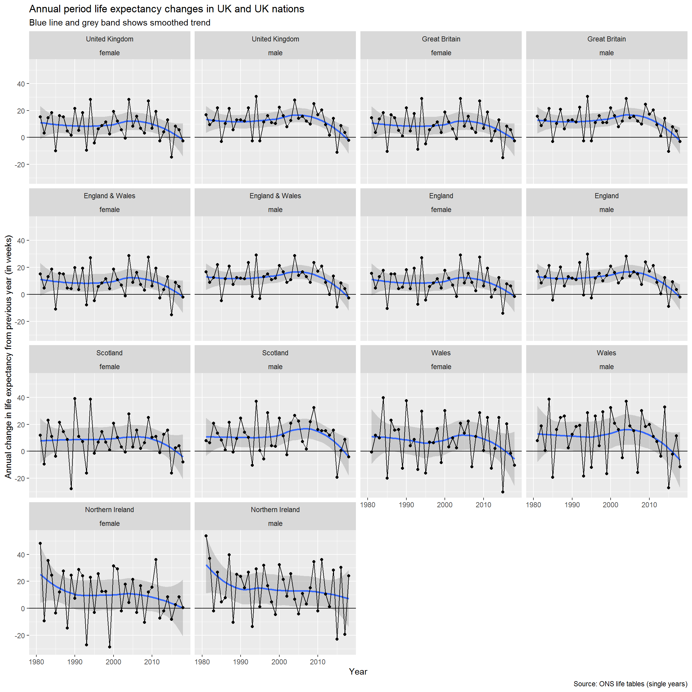

**2.2.2 Average change by decade**

As before, let’s look at the average improvement per decade. This will allow us to compare the UK rates from the ONS against those in the HMD.

|  |
| --- |
|  |

| **population**  <fctr> | **sex**  <chr> | **decade**  <chr> | **mean_ch_e0**  <dbl> |
| --- | --- | --- | --- |
| United Kingdom | female | 1980s | 0.16777778 |
| United Kingdom | female | 1990s | 0.17000000 |
| United Kingdom | female | 2000s | 0.24100000 |
| United Kingdom | female | 2010s | 0.08000000 |
| United Kingdom | male | 1980s | 0.23000000 |
| United Kingdom | male | 1990s | 0.23200000 |
| United Kingdom | male | 2000s | 0.31300000 |
| United Kingdom | male | 2010s | 0.13111111 |
| Great Britain | female | 1980s | 0.16444444 |
| Great Britain | female | 1990s | 0.17100000 |

#### **2.2.3.2 Change in life expectancy in mutually exclusive UK nations – overlaid**

