#### **2.2.4.3 Breakpoint figure - mutually exclusive UK nations**

The following shows the breakpoints and standard errors.

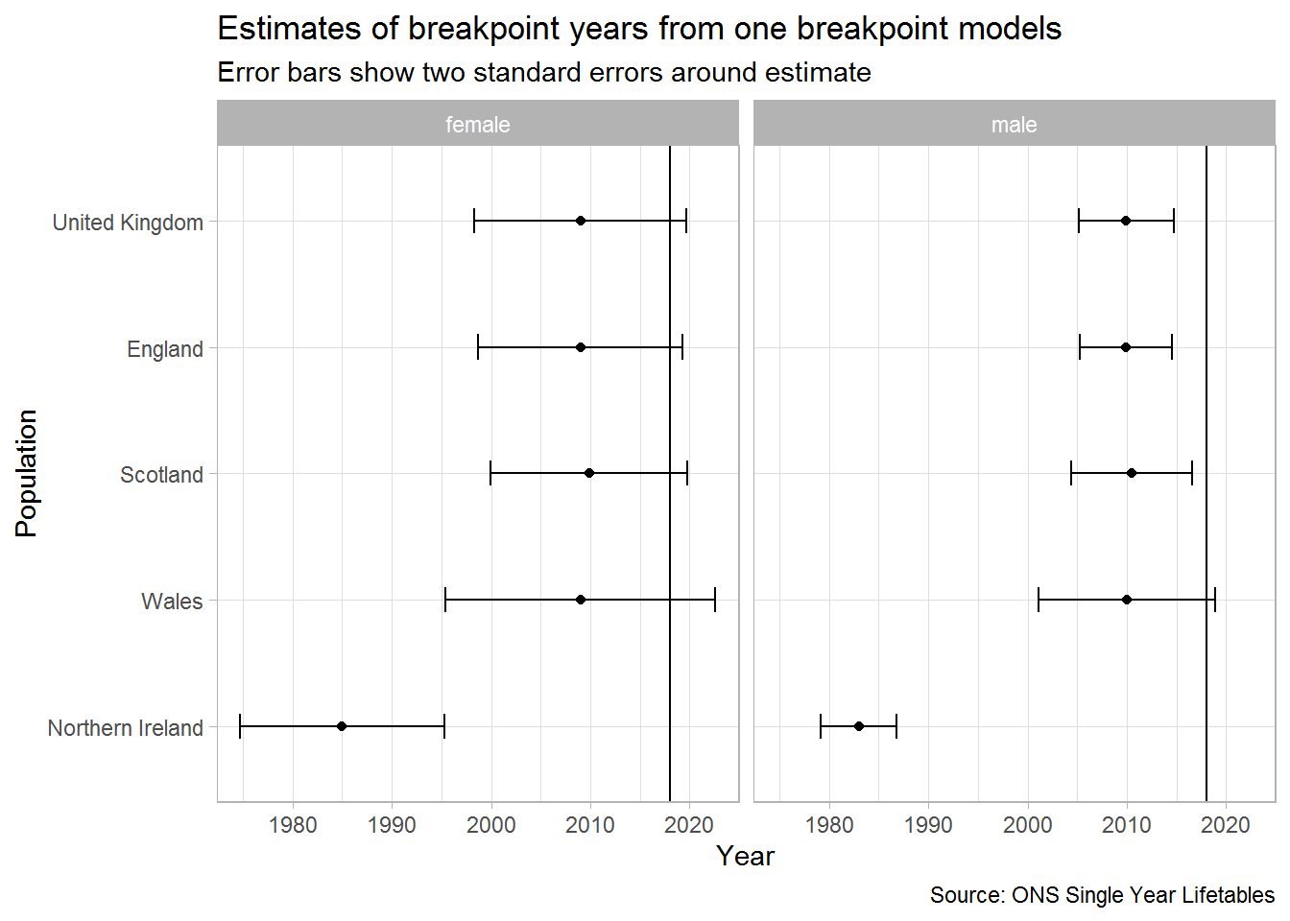

**2.2.4.2 Breakpoint table**

This shows a lot of consistency in estimates of when the breakdown occurred. With the exception of Northern Ireland, we can use 2010 afterwards as ‘post-slowdown’, and the years from 1980 onwards as ‘pre-slowdown’.

**2.2.4.2 Effect of different random number seeds on breakpoint**

Let’s do the same for the five one breakpoint models using different seeds

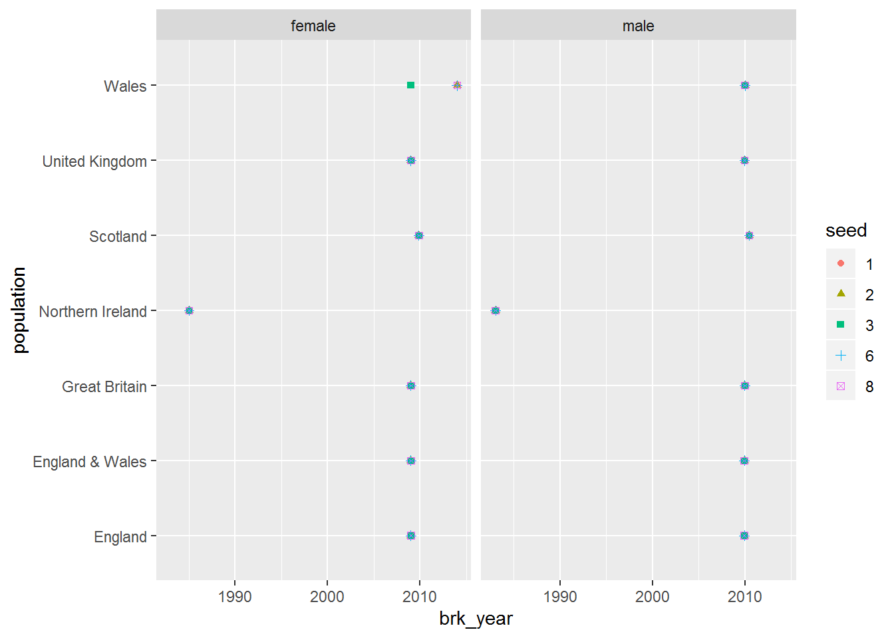

 Break point years, where they can be calculated, are largely identical. They confirm 2010 as a reasonable breakpoint year except for Northern Ireland.

1. ONS life expectancy projections from 2012 onwards, to show how these have been successively downrated with each biennial projection
2. **2.2.4.1 Breakpoint figure**
3. The following shows the breakpoints and standard errors.
4. 