# Appendices

## International Comparisons

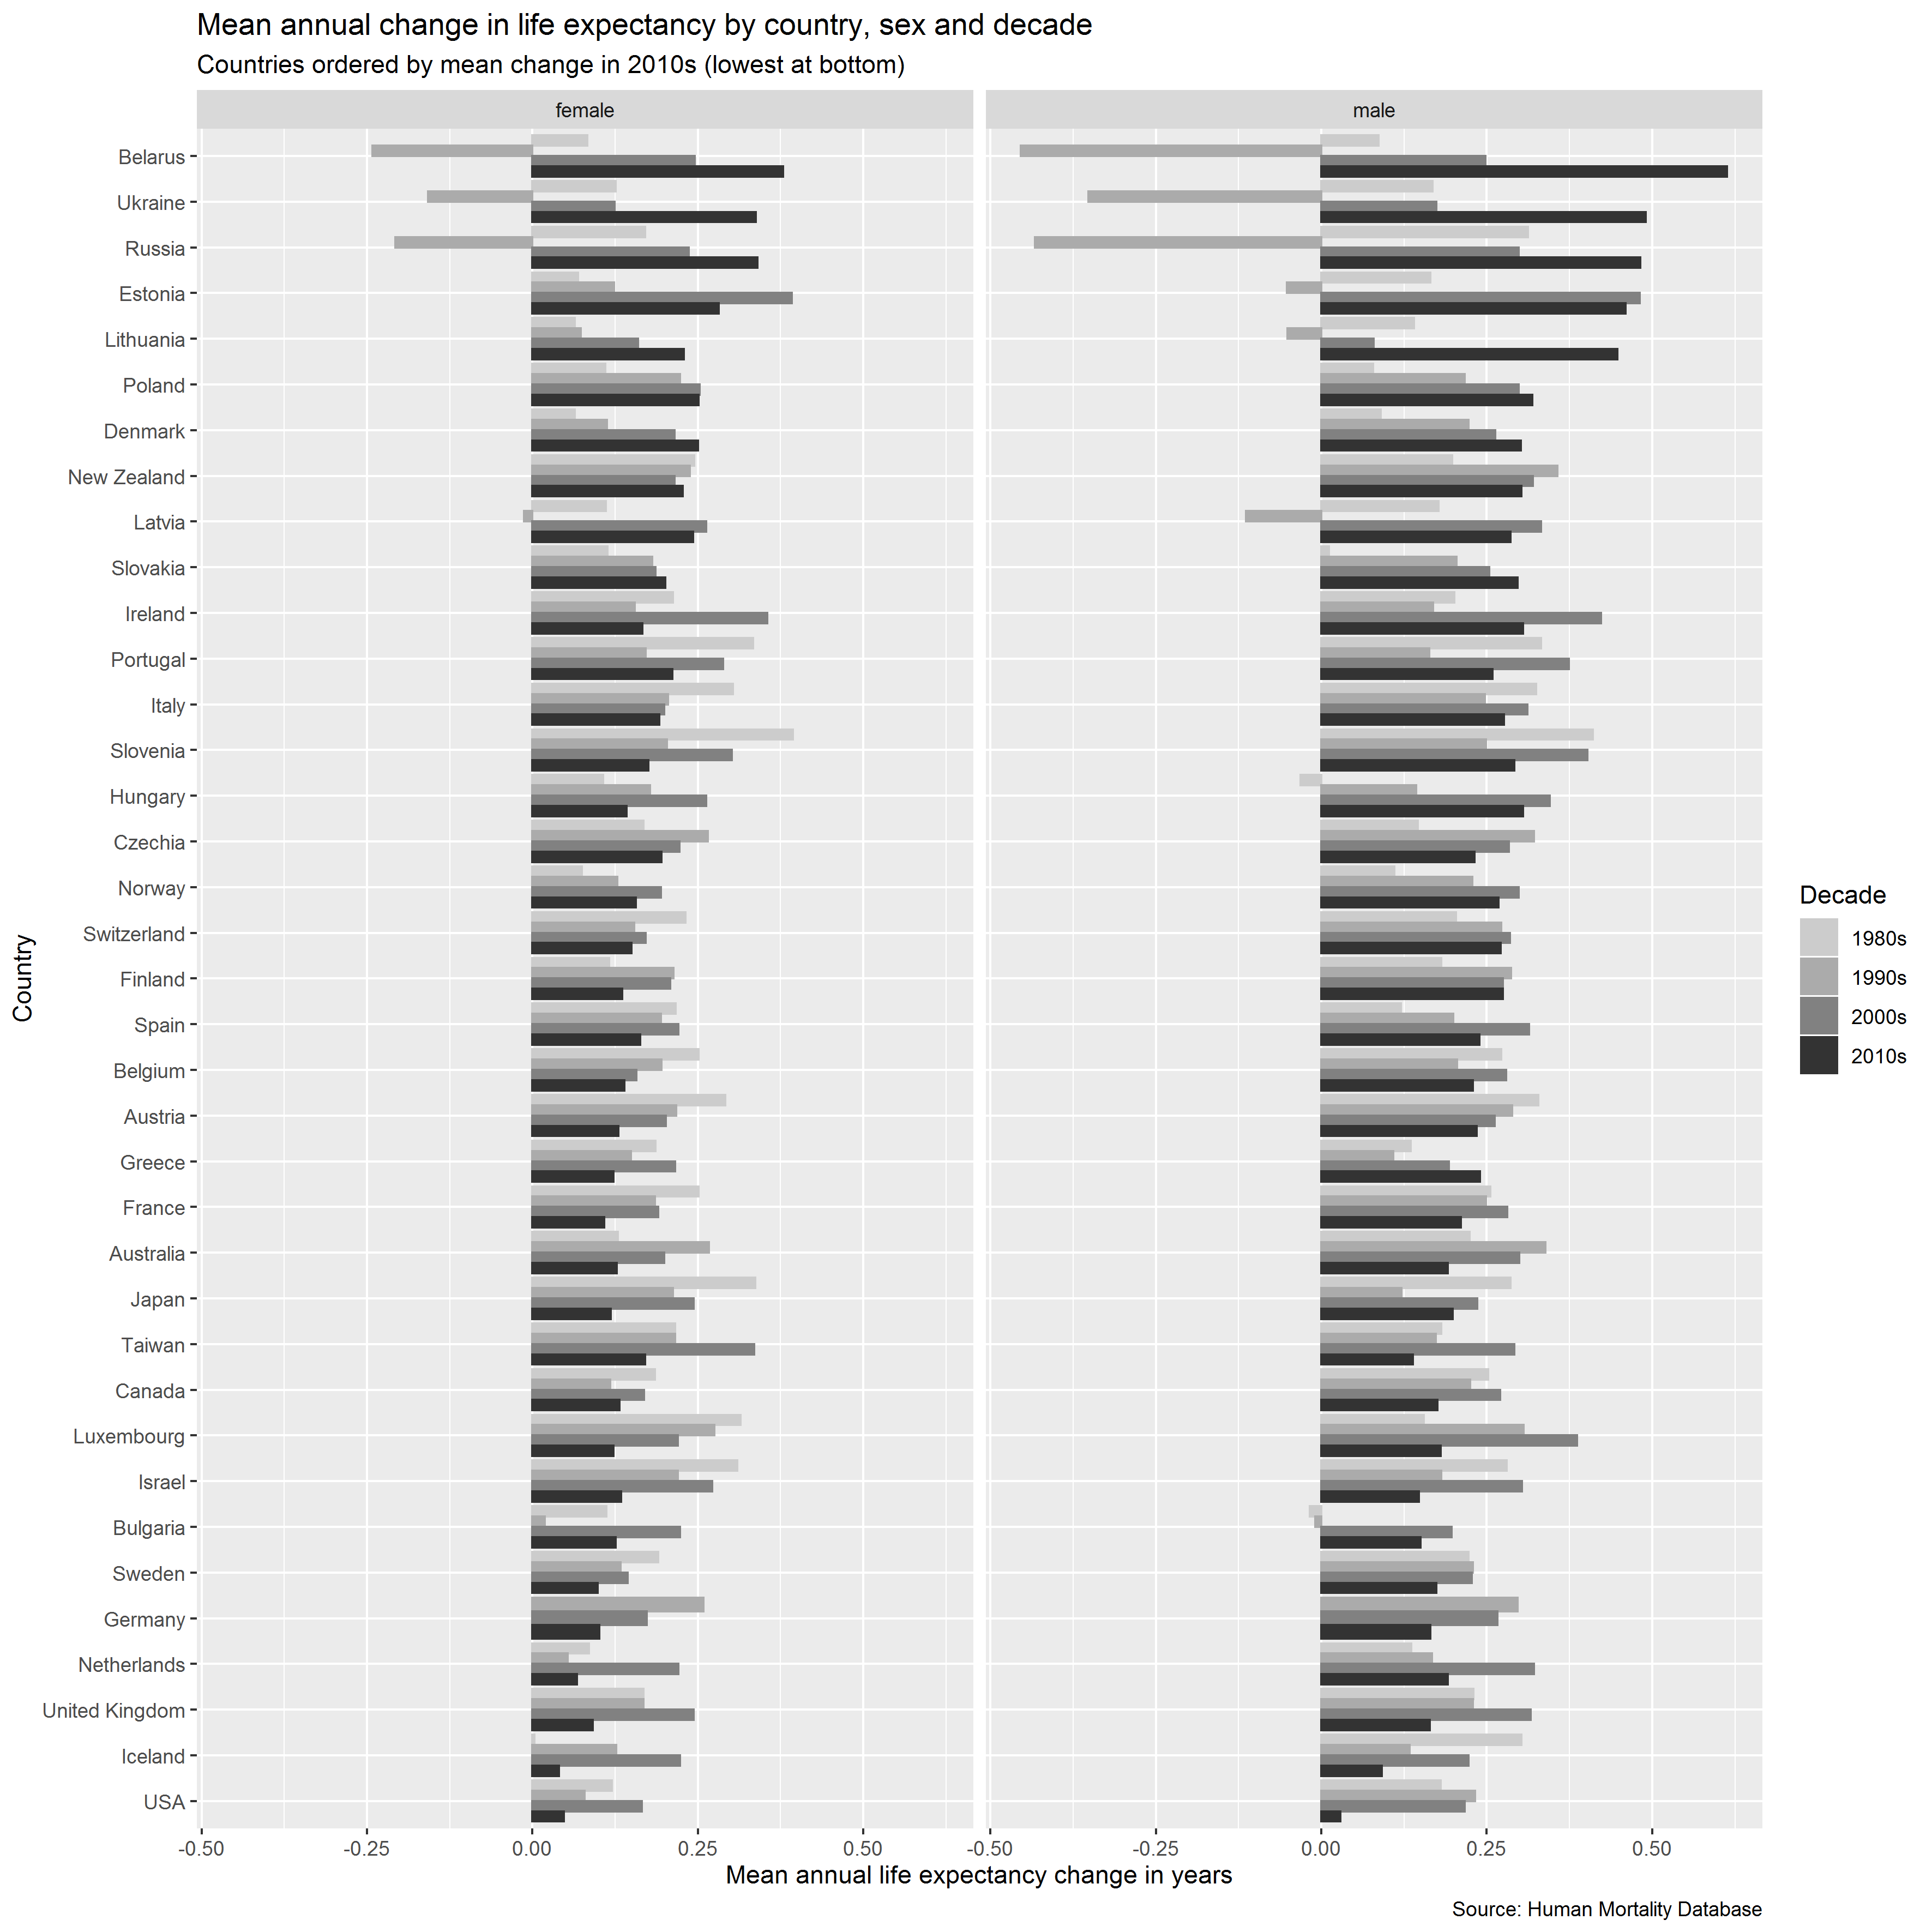

Figure Mean annual change in life expectancy by country, sex, and decade

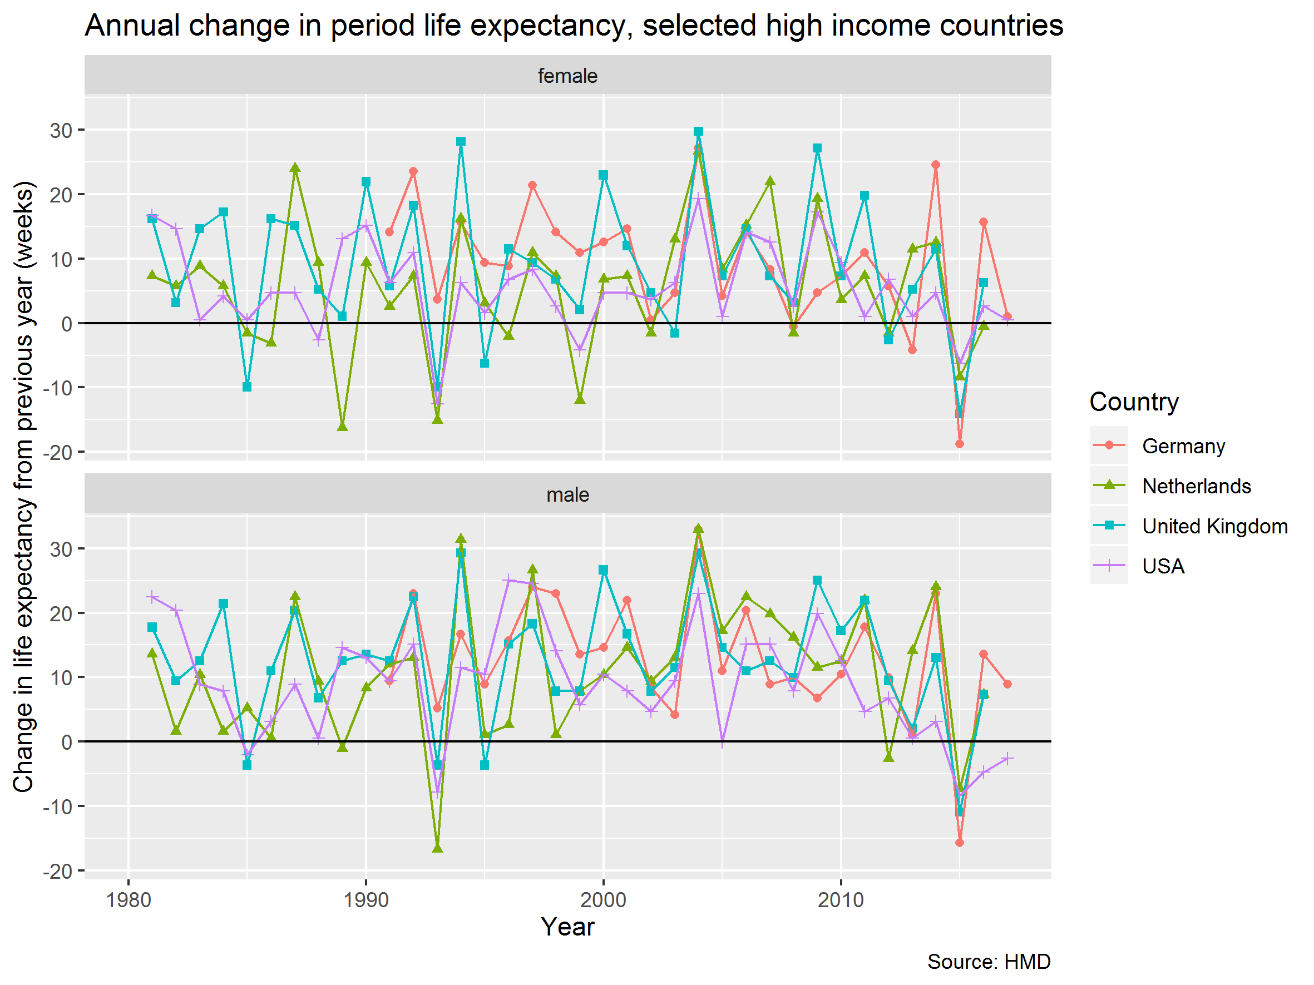

Figure Annual change in life expectancy for Germany, the Netherlands, the UK, and the USA

## Life expectancy changes for UK and UK nations

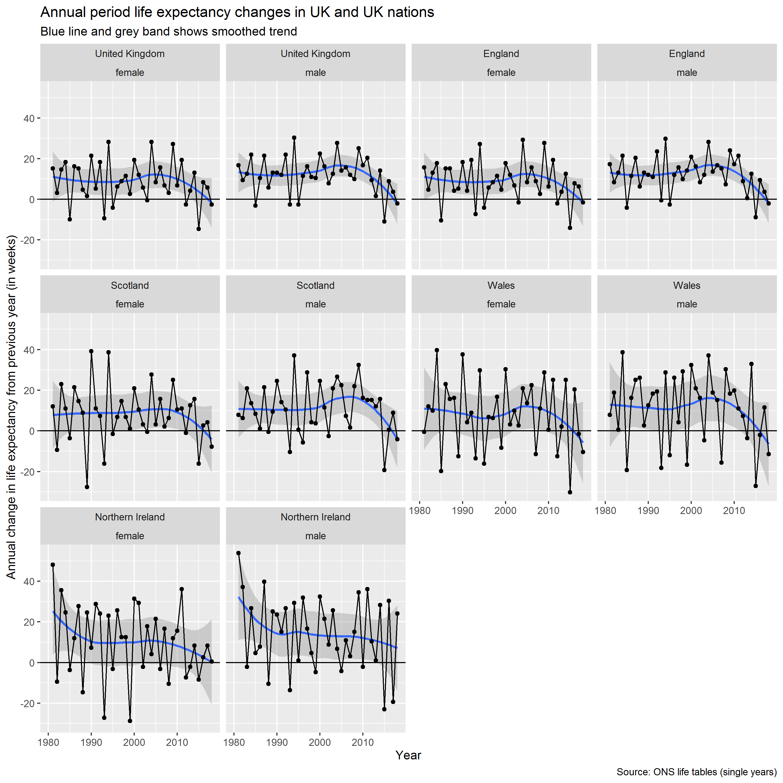

Figure Annual period life expectancy changes in the UK and UK nations

|  |  |  |  |
| --- | --- | --- | --- |
| **Sex** | **Decade** | **Average annual gain** | |
|  |  | **HMD** | **ONS** |
| female | 1980s | 0.168 | 0.189 |
| female | 1990s | 0.170 | 0.168 |
| female | 2000s | 0.241 | 0.244 |
| female | 2010s | 0.080 | 0.091 |
| male | 1980s | 0.230 | 0.252 |
| male | 1990s | 0.232 | 0.229 |
| male | 2000s | 0.313 | 0.316 |
| male | 2010s | 0.131 | 0.164 |

Table Comparison between ONS and HMD estimates of mean annual increase in life expectancy by decade, UK

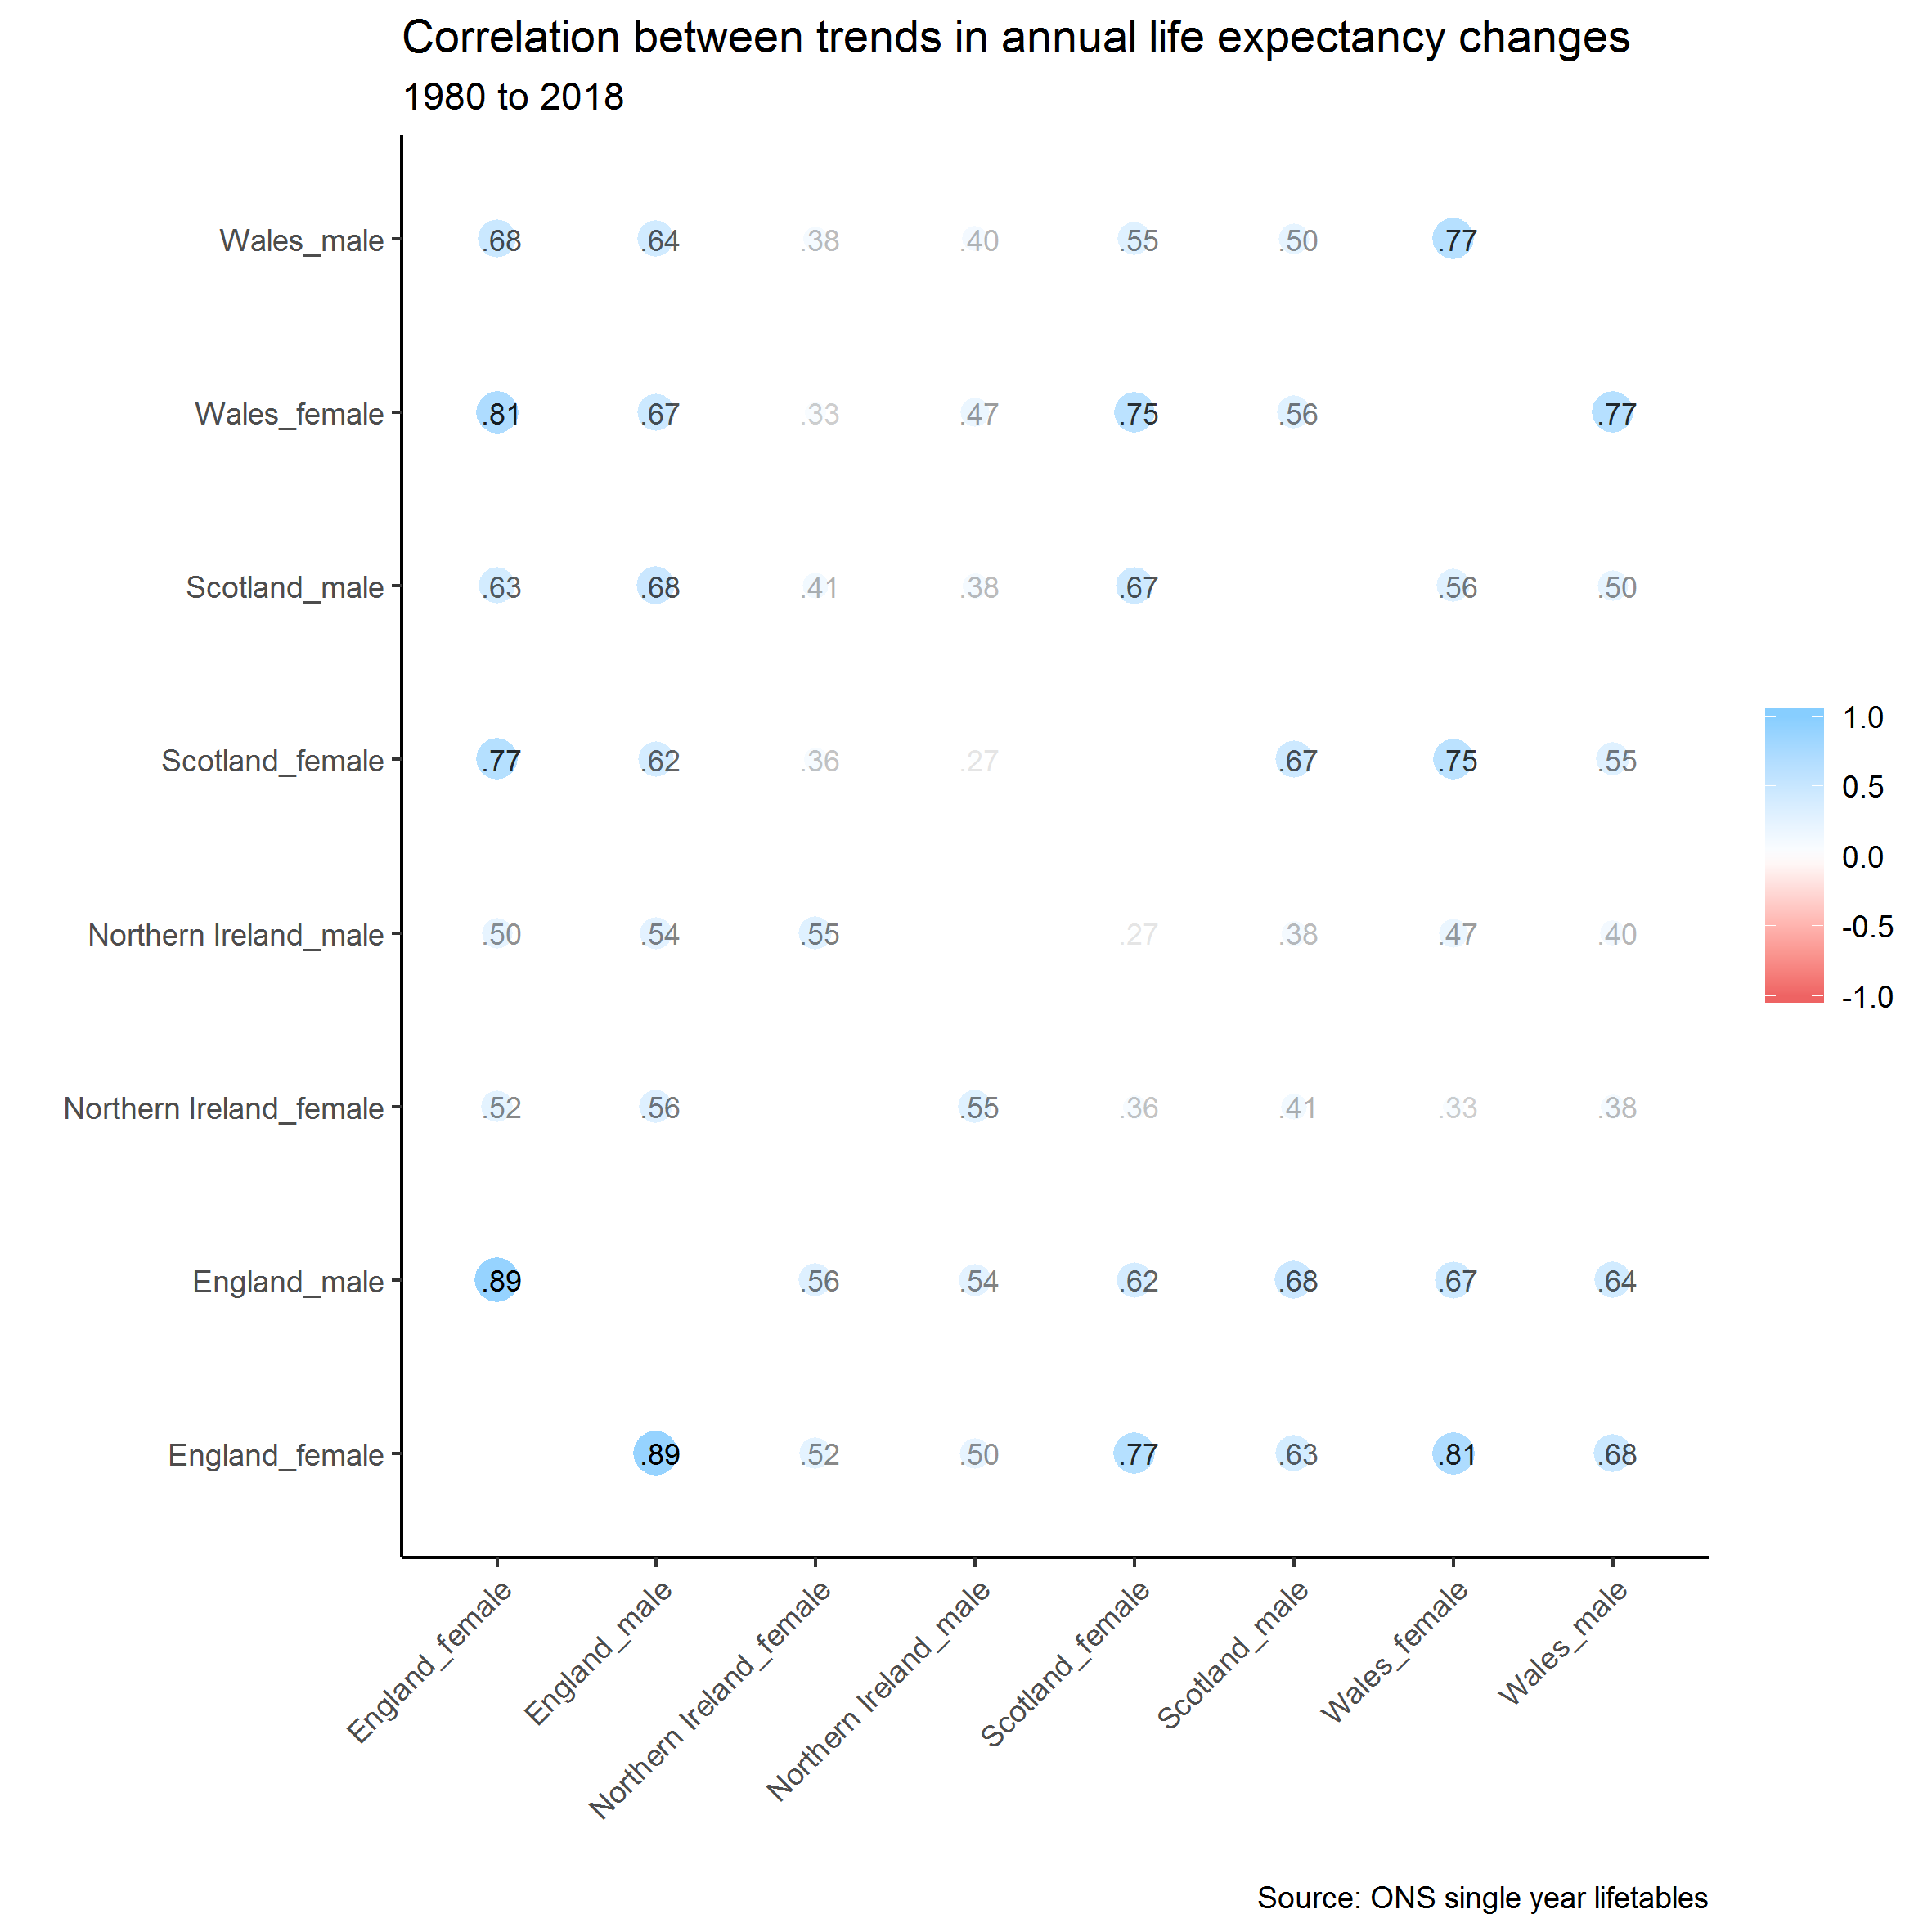

Figure Correlation between trends in annual life expectancy changes, by sex and UK nation

|  |  |  |  |  |  |  |  |  |
| --- | --- | --- | --- | --- | --- | --- | --- | --- |
|  | **England_female** | **England_male** | **Northern Ireland_female** | **Northern Ireland_male** | **Scotland_female** | **Scotland_male** | **Wales_female** | **Wales_male** |
| **England_female** |  | 0.895 | 0.520 | 0.498 | 0.775 | 0.634 | 0.808 | 0.679 |
| **England_male** | 0.895 |  | 0.563 | 0.536 | 0.622 | 0.682 | 0.668 | 0.644 |
| **Northern Ireland_female** | 0.520 | 0.563 |  | 0.554 | 0.359 | 0.411 | 0.332 | 0.378 |
| **Northern Ireland_male** | 0.498 | 0.536 | 0.554 |  | 0.268 | 0.381 | 0.467 | 0.396 |
| **Scotland_female** | 0.775 | 0.622 | 0.359 | 0.268 |  | 0.667 | 0.751 | 0.554 |
| **Scotland_male** | 0.634 | 0.682 | 0.411 | 0.381 | 0.667 |  | 0.560 | 0.503 |
| **Wales_female** | 0.808 | 0.668 | 0.332 | 0.467 | 0.751 | 0.560 |  | 0.772 |
| **Wales_male** | 0.679 | 0.644 | 0.378 | 0.396 | 0.554 | 0.503 | 0.772 |  |

Table Correlation between life expectancy trends in UK nations and sexes

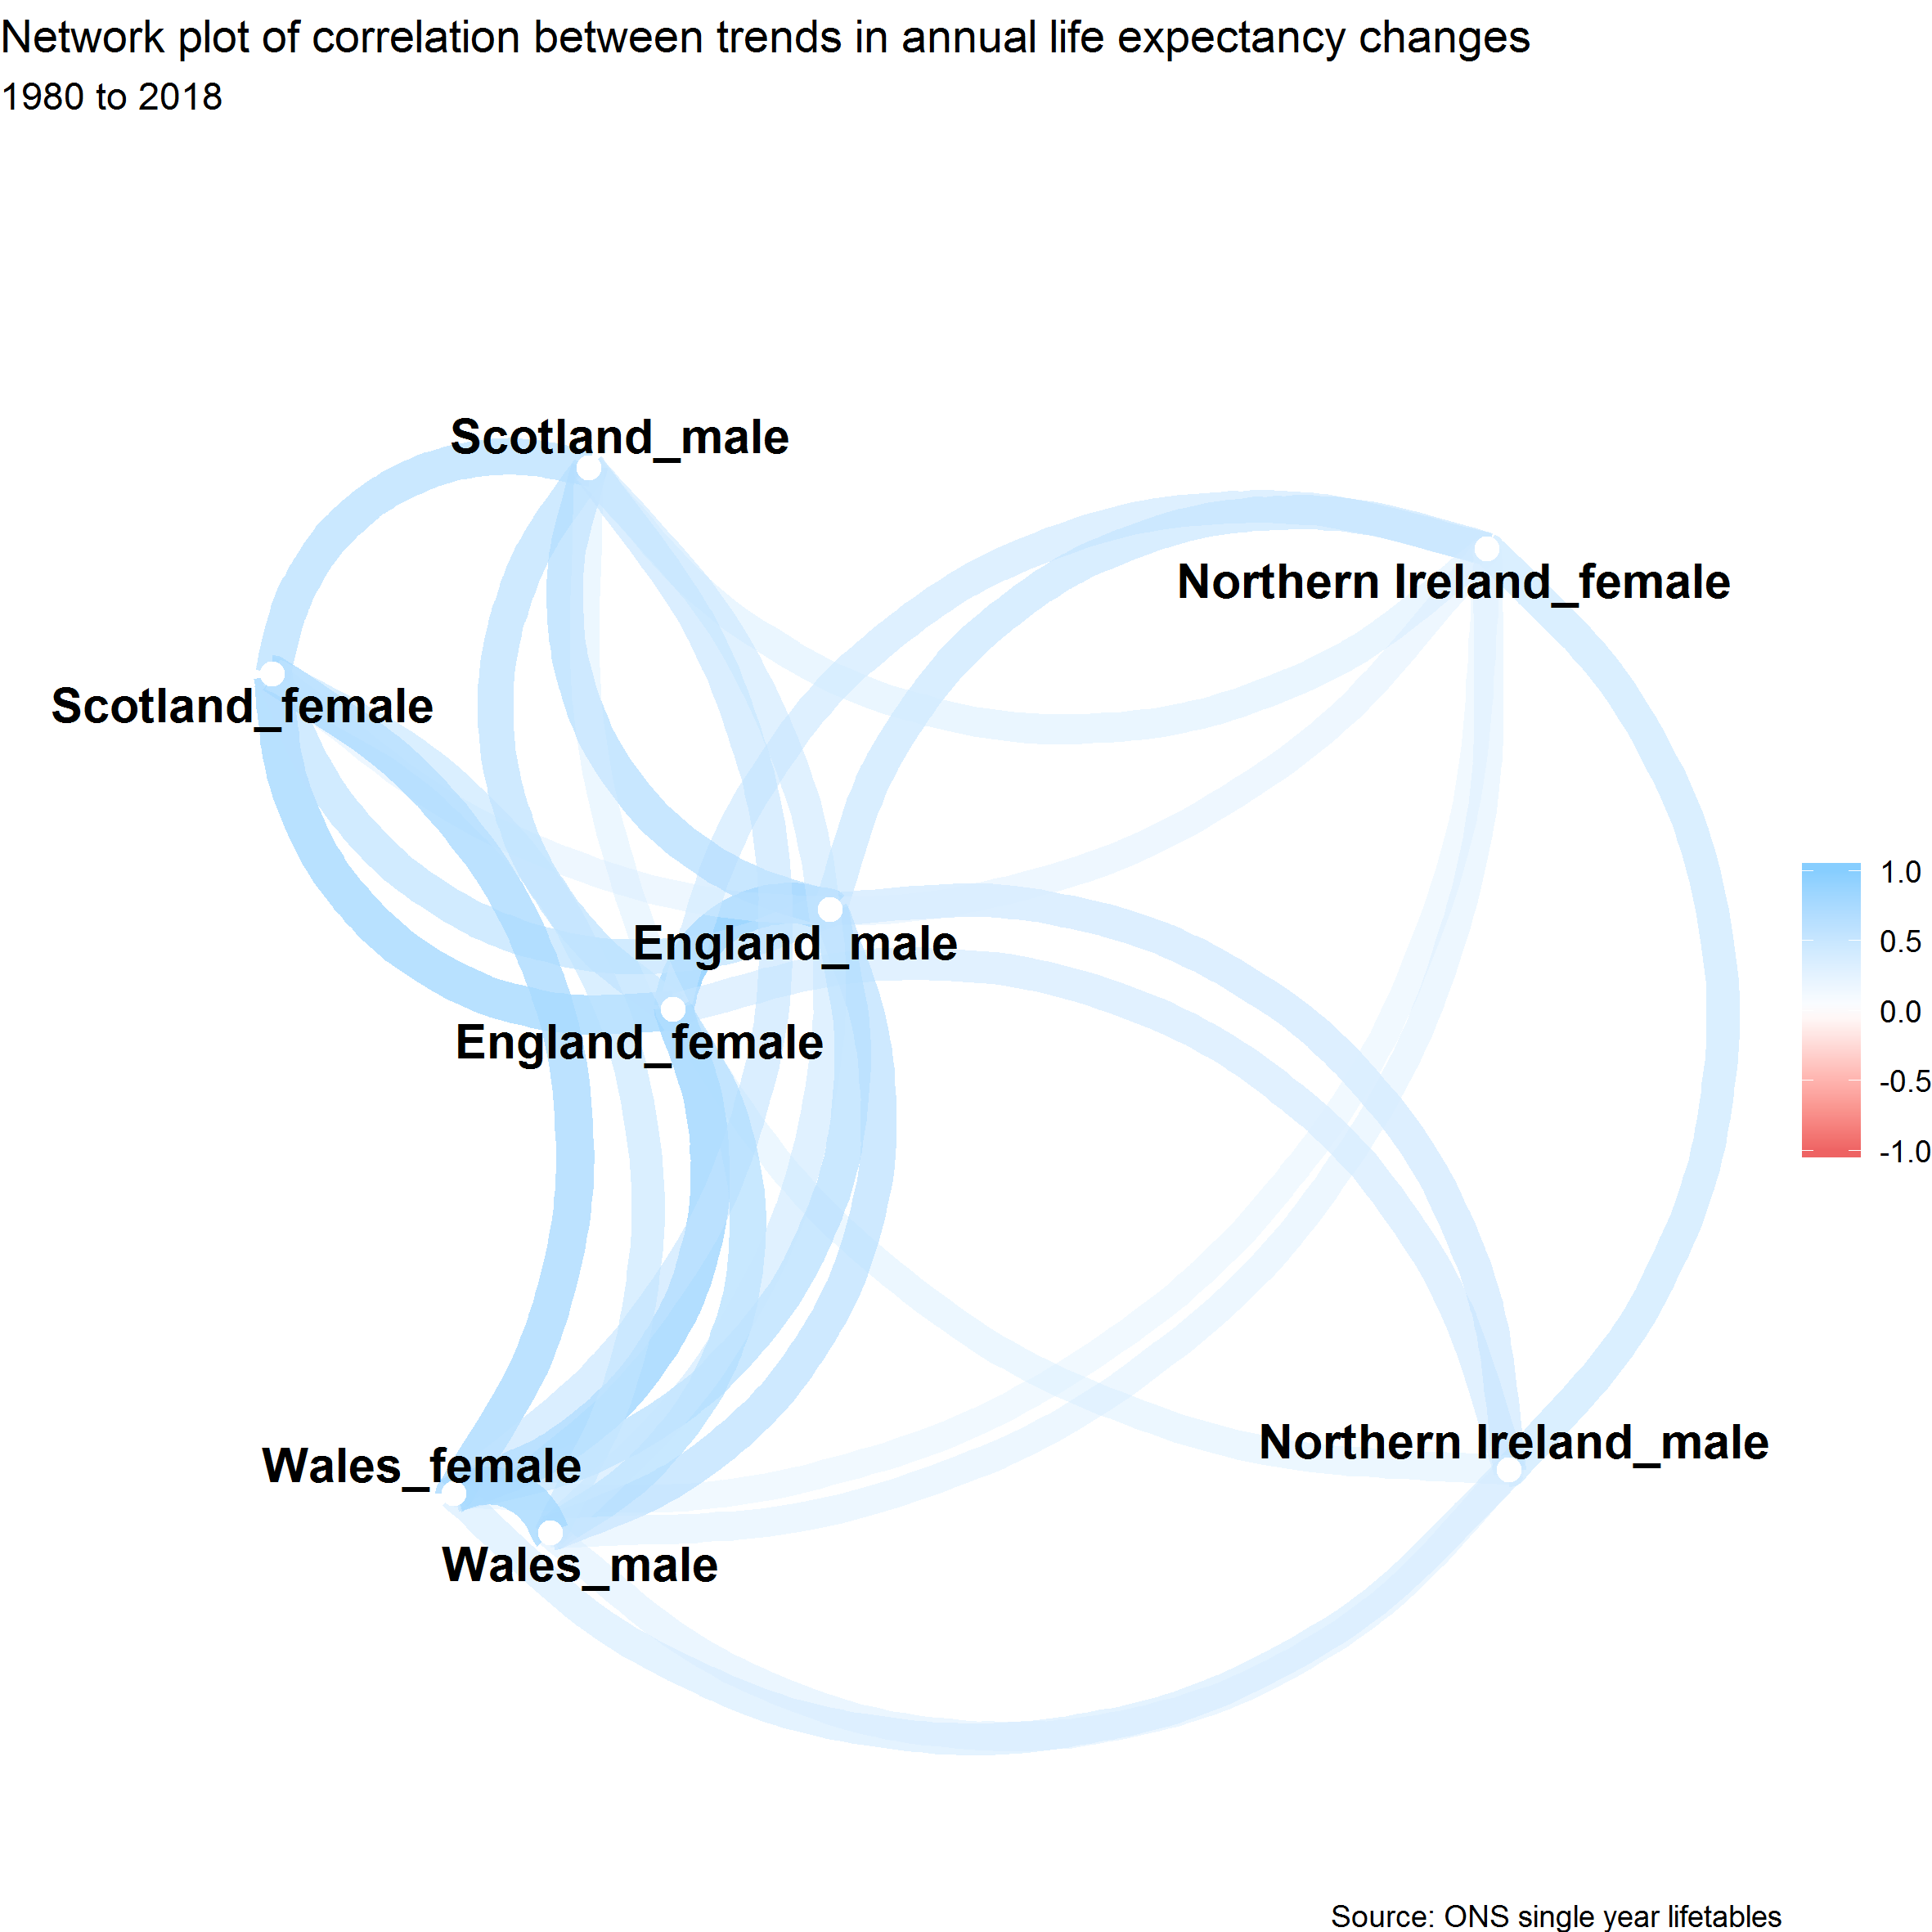

Figure Network map of correlations between trends in annual life expectancy by sex and UK nations

## Recent ONS life expectancy projections

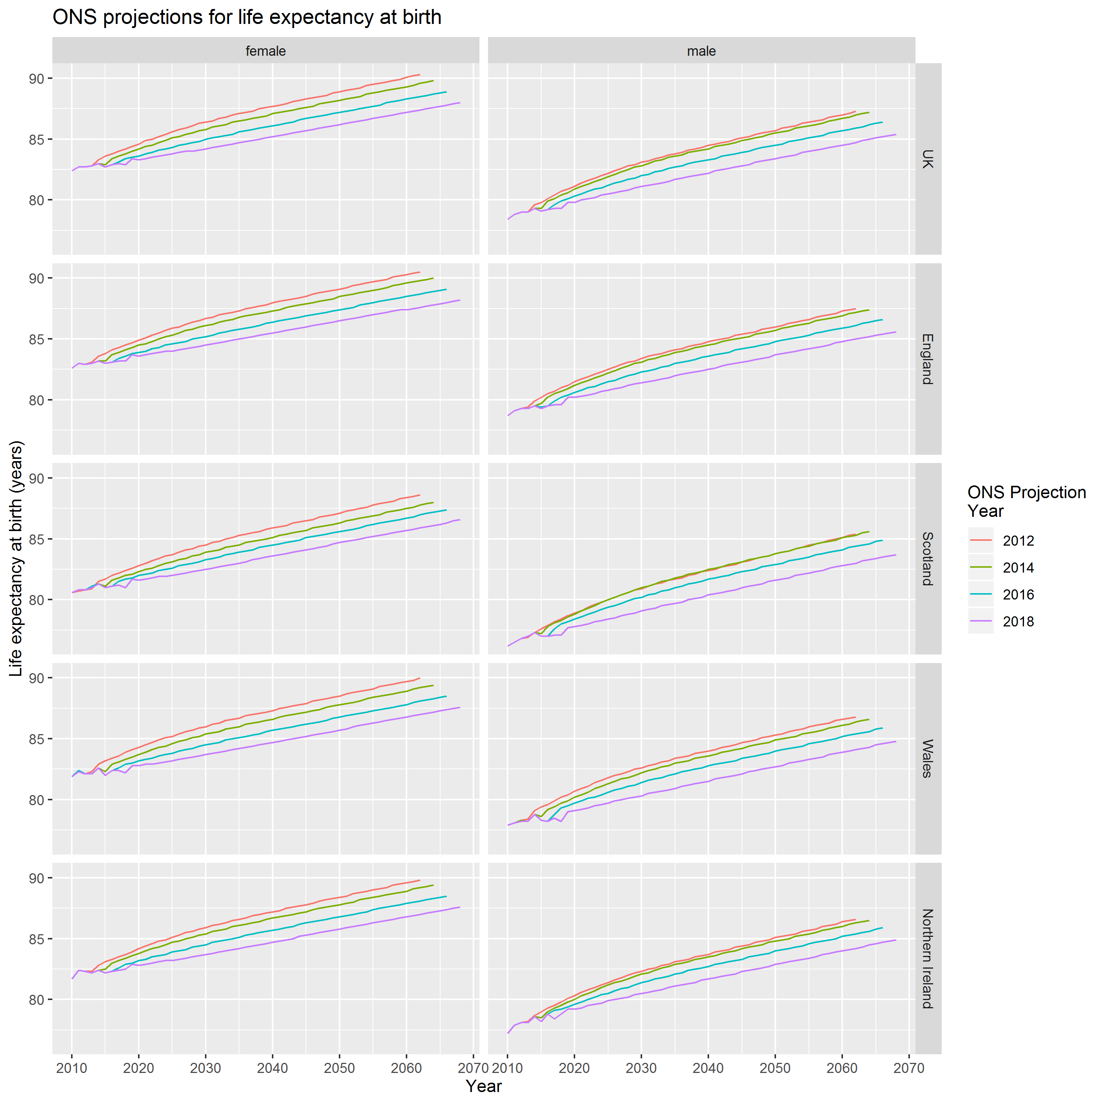

Figure ONS life expectancy projections, 2012-2018

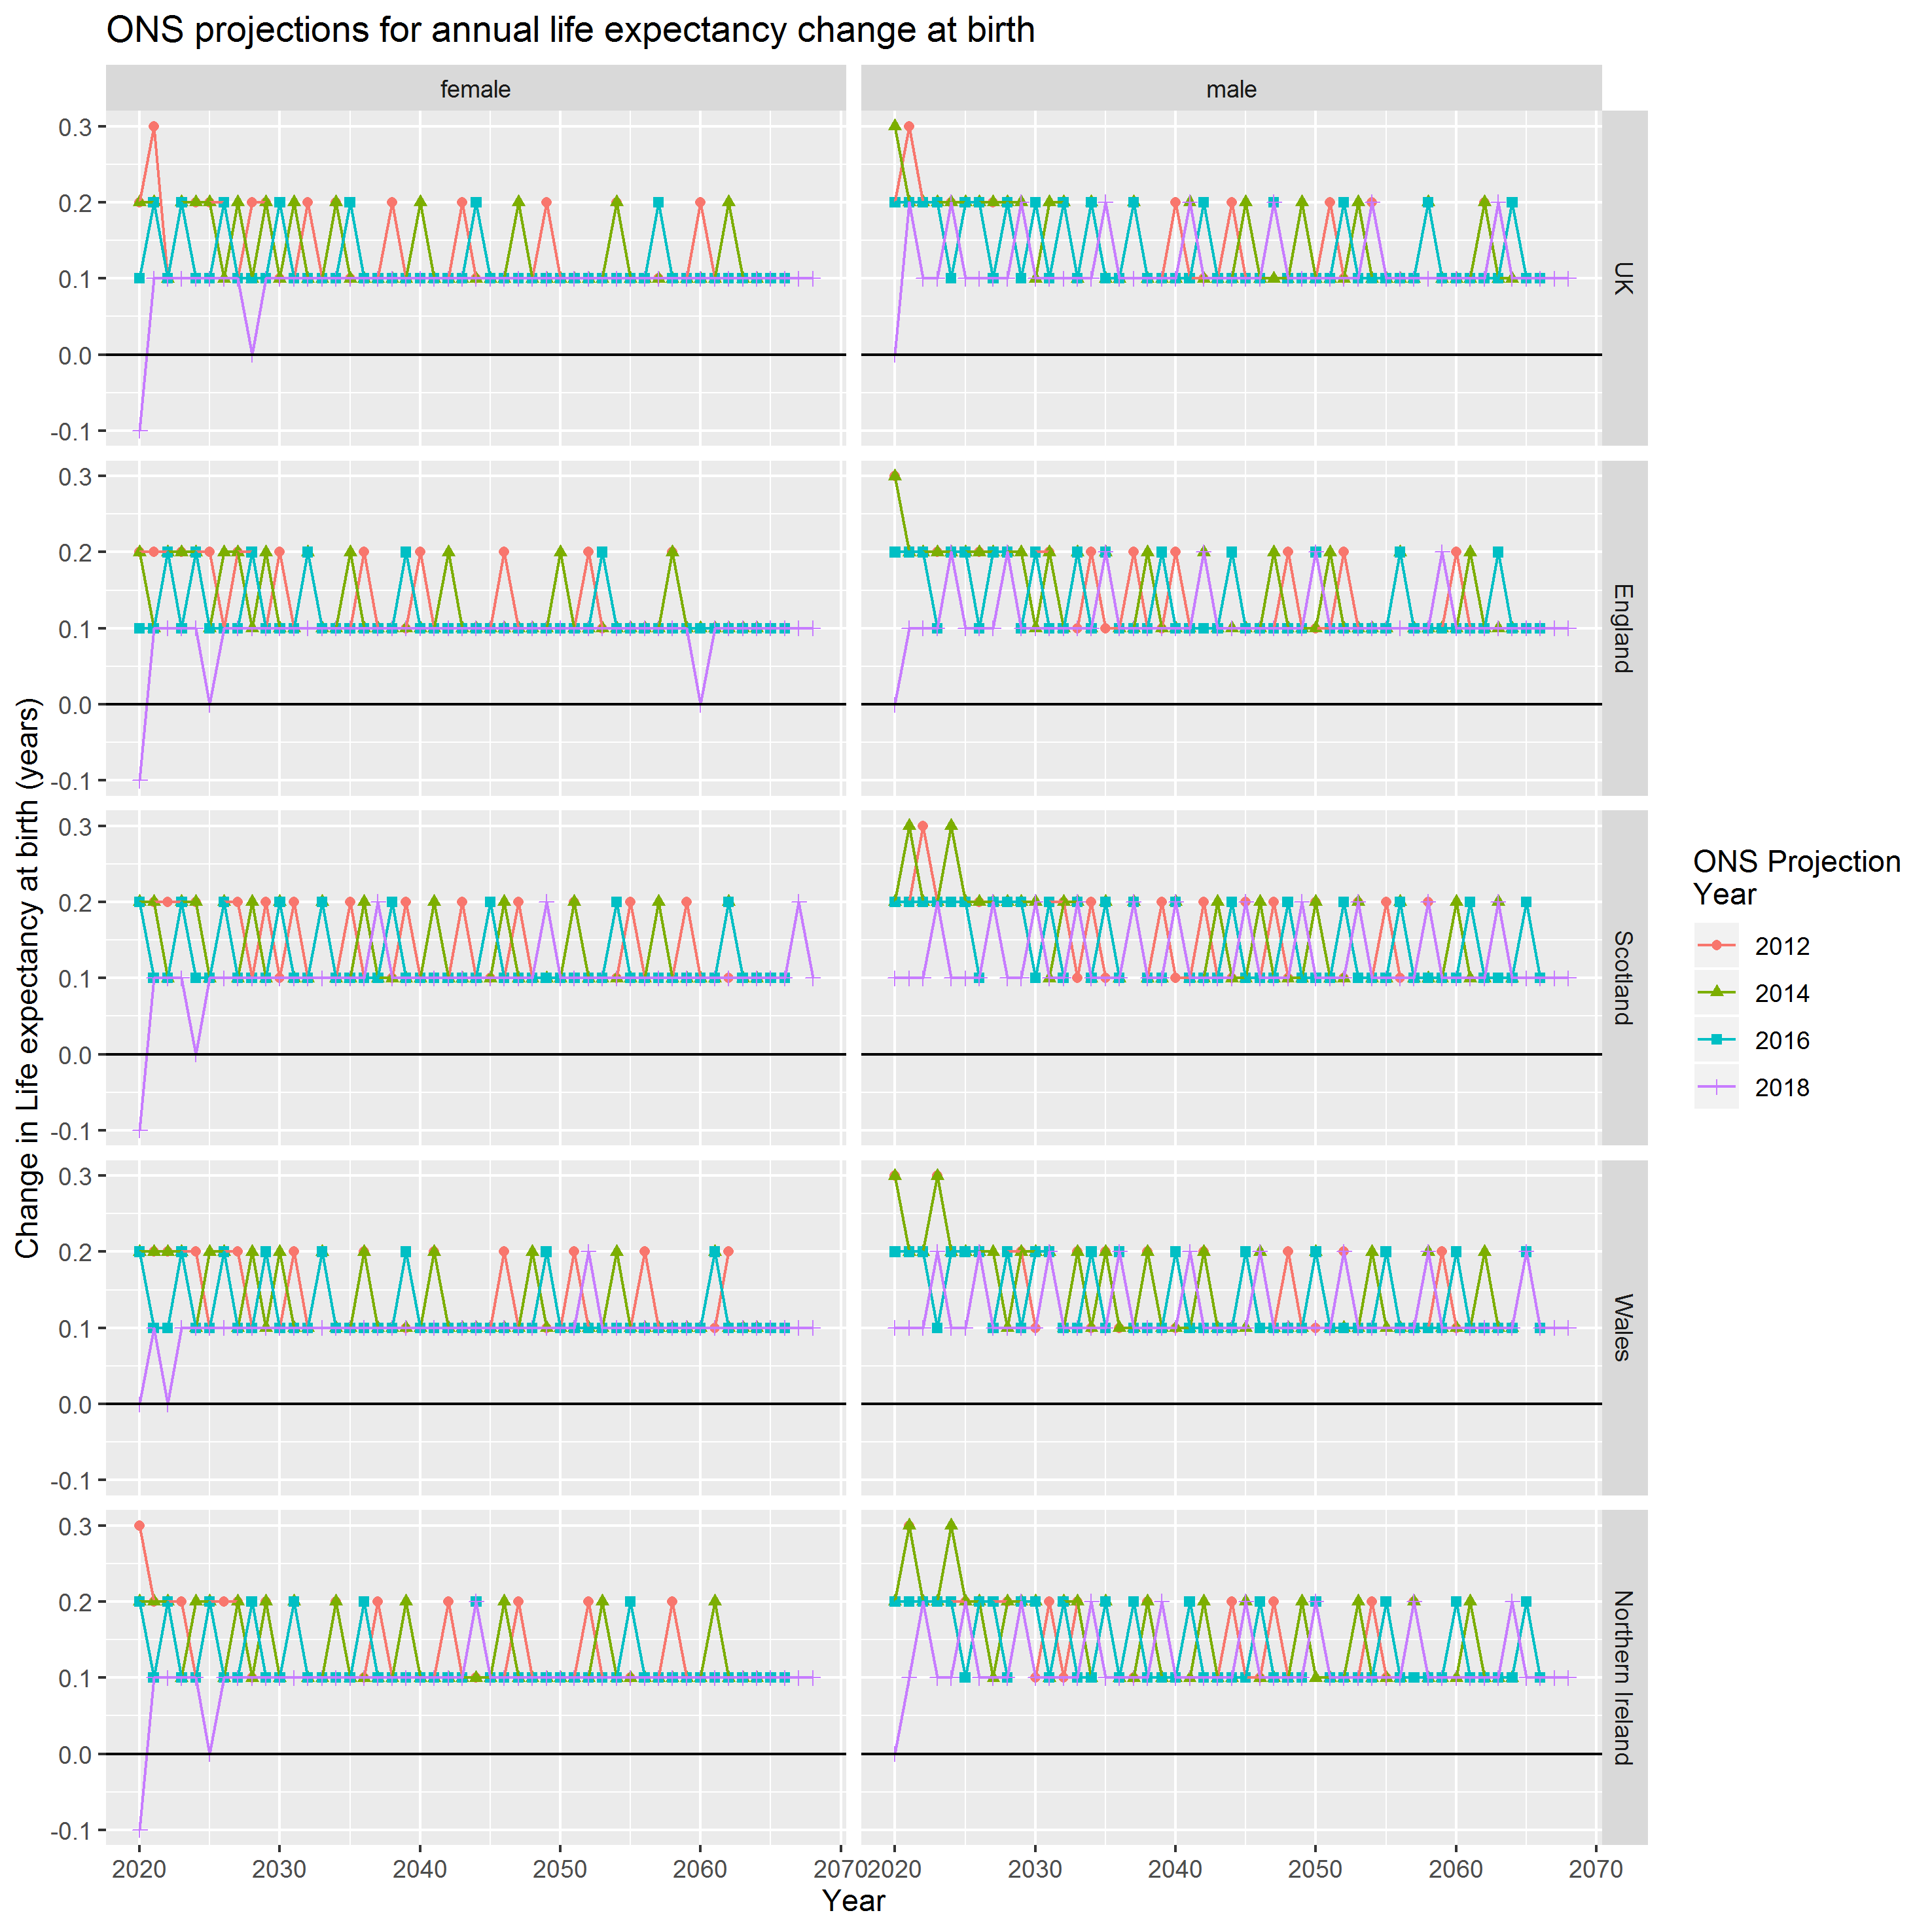

Figure ONS projections, implied change in life expectancy from previous year, by projection

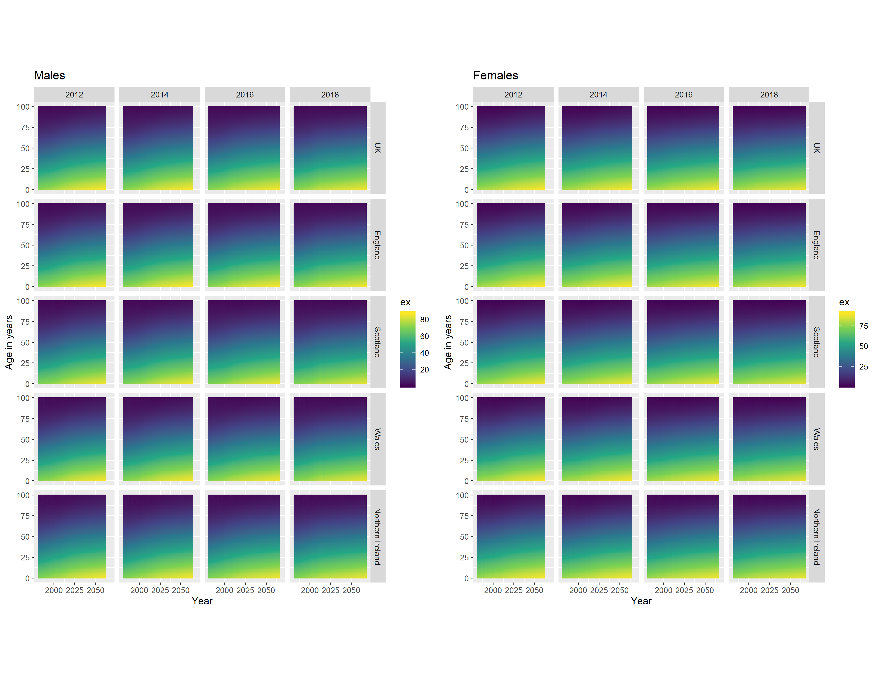

Figure Conditional life expectancies by gender, UK nation, and ONS projection

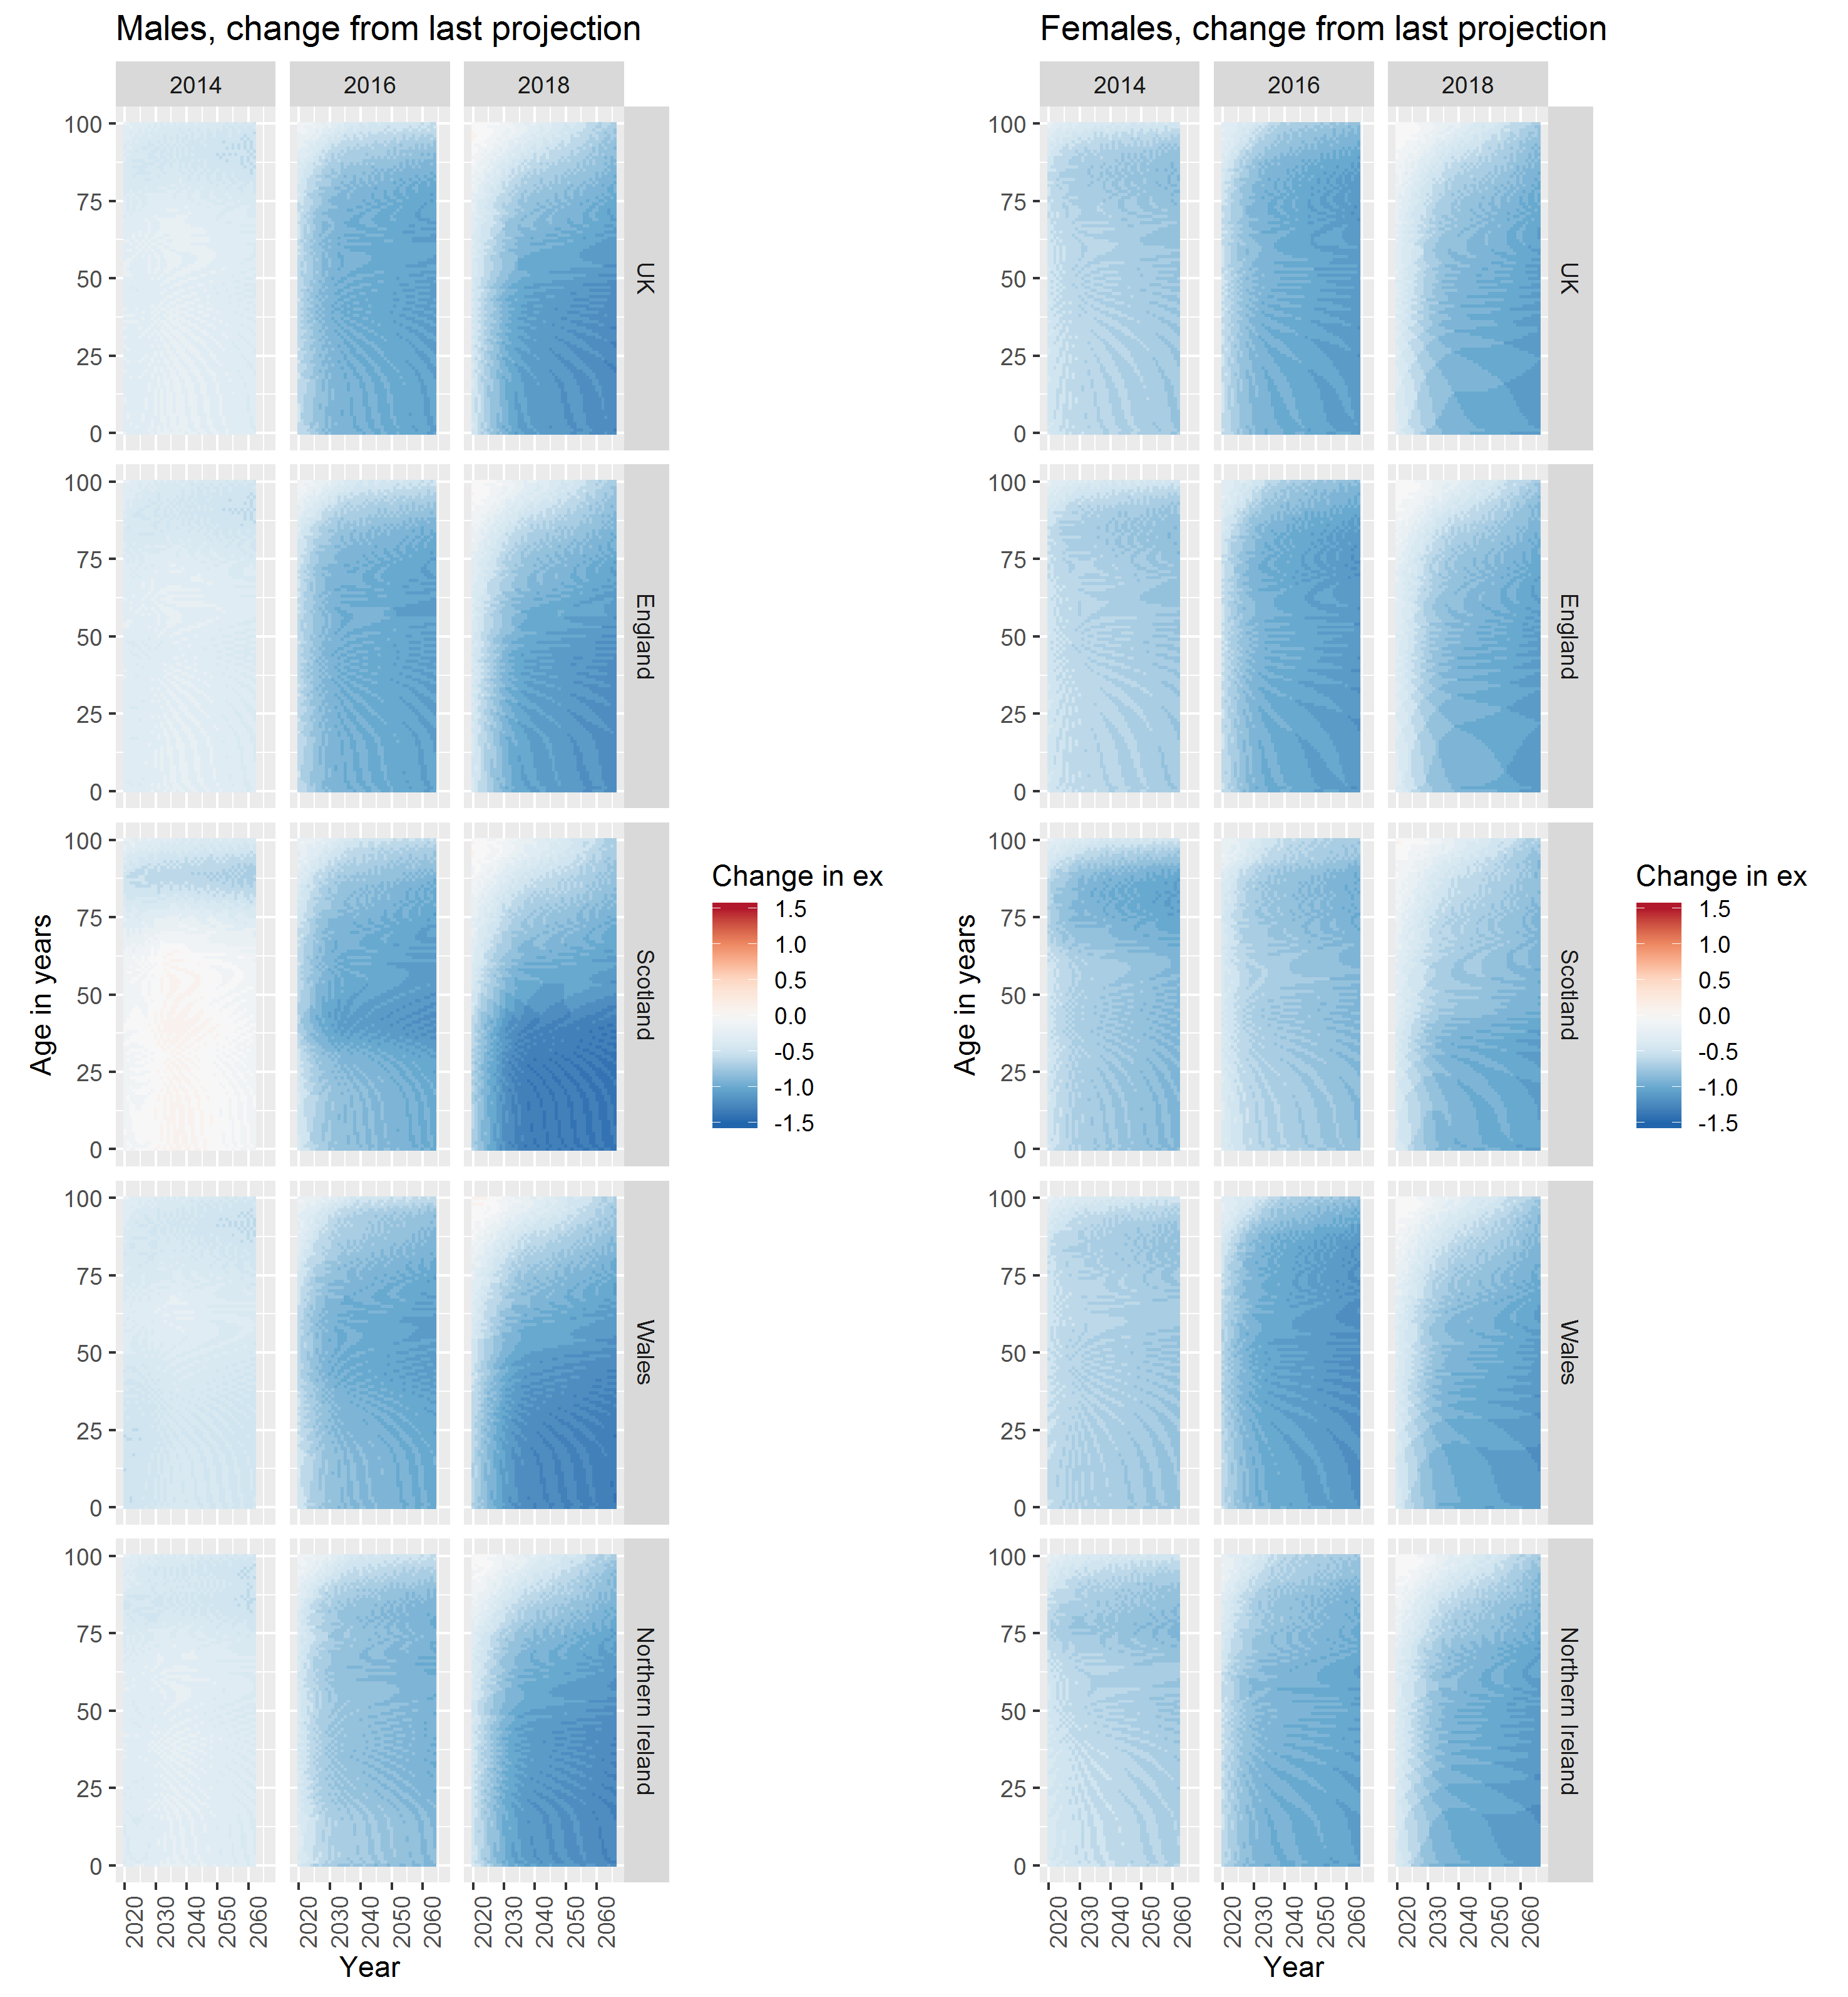

Figure Change in conditional life expectancies between biennial ONS projections

## Breakpoint analyses

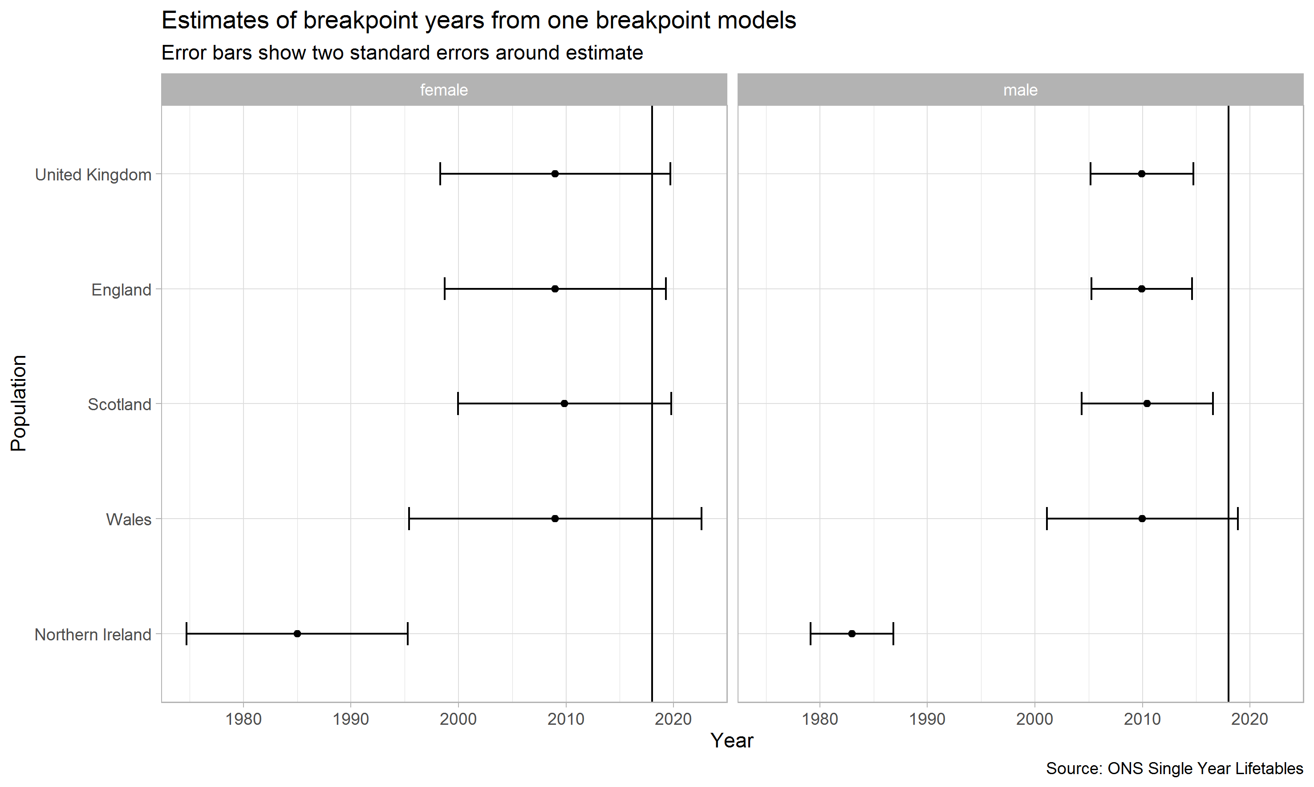

Figure Breakpoint estimates for change in life expectancy trends, UK and UK nations

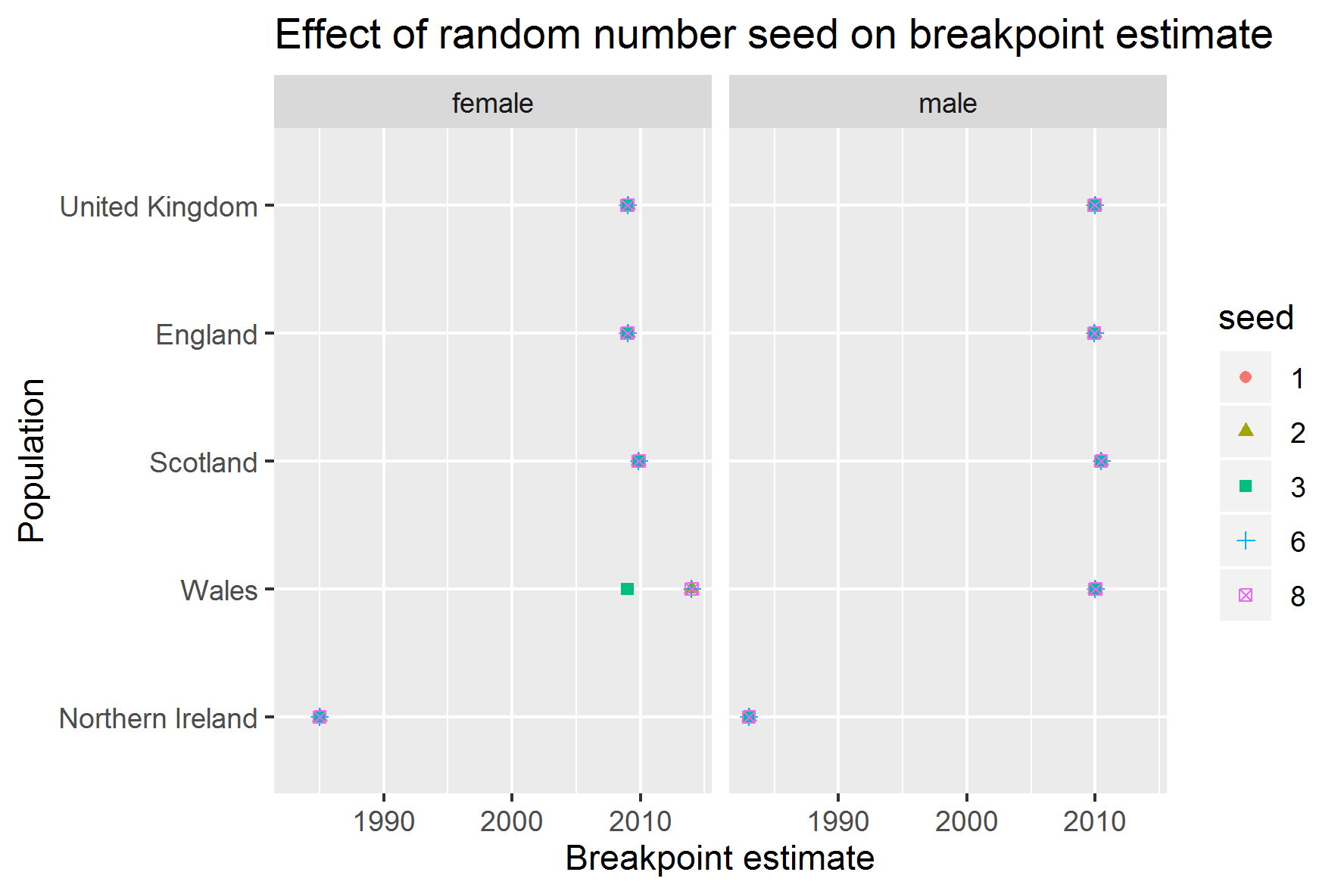

Figure Sensitivity of random number seed to breakpoint estimates

|  |  |  |  |  |  |
| --- | --- | --- | --- | --- | --- |
| **Population** | **Sex** | **Breakpoint** | **Standard Error** | **Lower CI** | **Upper CI** |
| England | female | 2009.00 | 5.15 | 1998.70 | 2019.30 |
| England | male | 2009.93 | 2.34 | 2005.26 | 2014.60 |
| Northern Ireland | female | 1985.00 | 5.13 | 1974.73 | 1995.27 |
| Northern Ireland | male | 1983.00 | 1.92 | 1979.16 | 1986.84 |
| Scotland | female | 2009.87 | 4.95 | 1999.97 | 2019.77 |
| Scotland | male | 2010.45 | 3.05 | 2004.36 | 2016.54 |
| Wales | female | 2009.00 | 6.80 | 1995.40 | 2022.60 |
| Wales | male | 2010.00 | 4.43 | 2001.14 | 2018.86 |
| United Kingdom | female | 2009.00 | 5.35 | 1998.30 | 2019.70 |
| United Kingdom | male | 2009.95 | 2.39 | 2005.18 | 2014.72 |

Table Breakpoint analyses and standard errors

## Bayes Factor Analyses

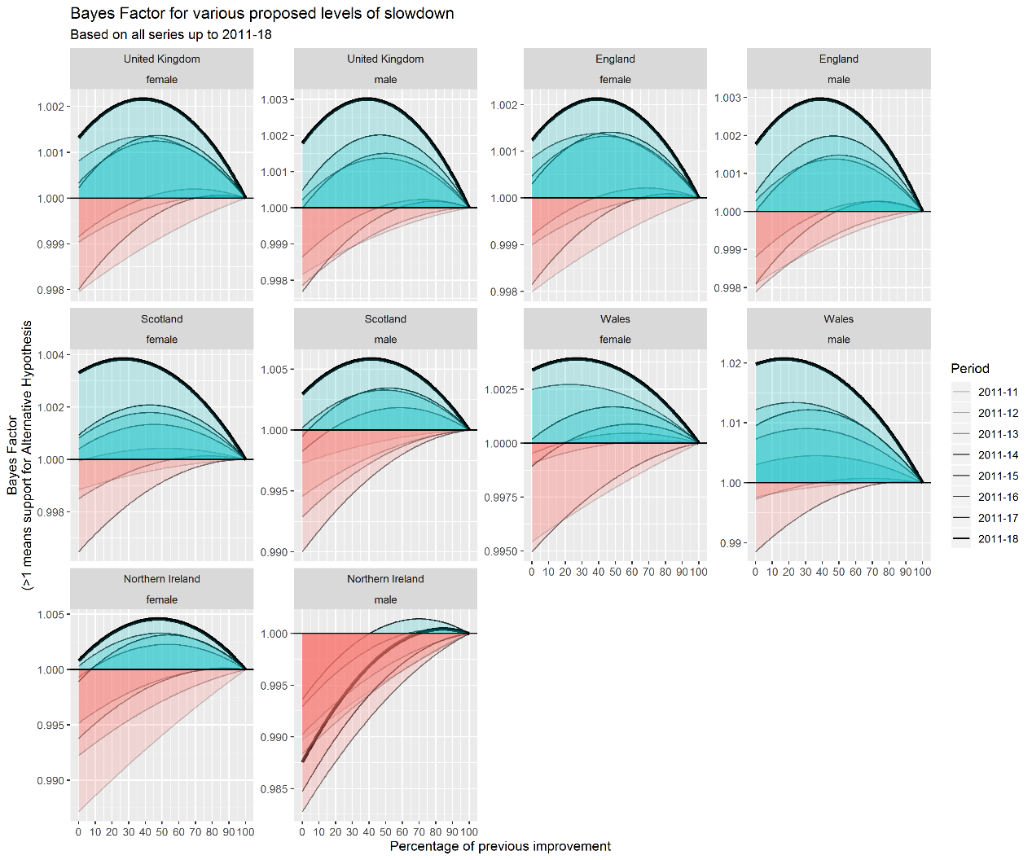

Figure Effect additional post 2011 single year life expectancy estimates on Bayes Factor schedules, UK and constituent nations

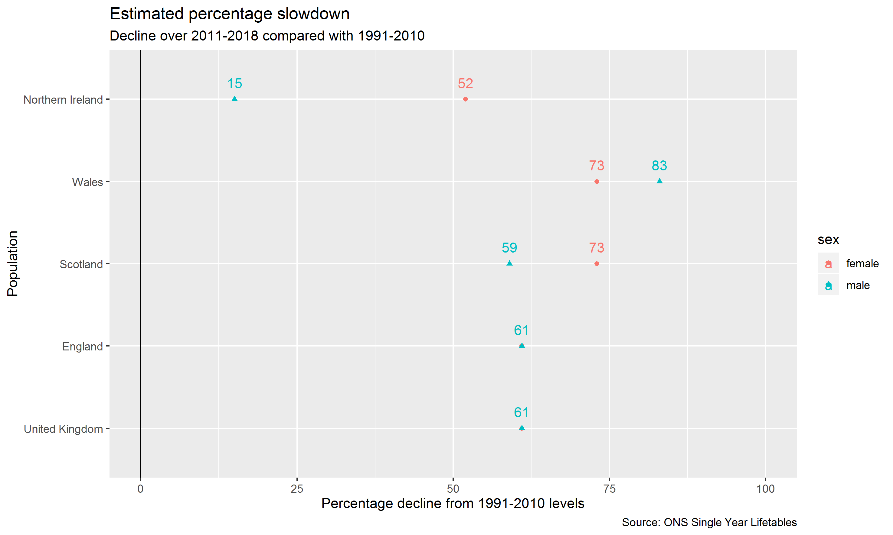

Figure Estimated percentage slowdown by 2018 in annual average life expectancy gains, 2011-2018 compared with 1991-2010

|  |  |  |  |
| --- | --- | --- | --- |
| **Country** | **Sex** | **Mean gain** | **SD** |
| United Kingdom | female | 0.192 | 0.197 |
| United Kingdom | male | 0.276 | 0.163 |
| England | female | 0.195 | 0.195 |
| England | male | 0.280 | 0.159 |
| Scotland | female | 0.185 | 0.230 |
| Scotland | male | 0.254 | 0.256 |
| Wales | female | 0.159 | 0.268 |
| Wales | male | 0.256 | 0.337 |
| Northern Ireland | female | 0.192 | 0.337 |
| Northern Ireland | male | 0.249 | 0.271 |

Table Average annual change in life expectancy, 1991-2010, UK and UK nations

### Technical definition: Likelihood and Log Likelihood of the Normal Distribution

For computational reasons it is more common to calculate the log likelihood of a function rather than the likelihood itself. Defining X={x1,x2,...,xn}X={x1,x2,...,xn} as a series of nn observations, the Log Likelihood of the Normal Distribution is as follows:

logL(μ,σ2|X={x1,x2,...,xn})=−n2log(2π)−nlog(σ)−12σ2∑i=1n(xi−μ)2logL(μ,σ2|X={x1,x2,...,xn})=−n2log(2π)−nlog(σ)−12σ2∑i=1n(xi−μ)2

This is implemented as a function in R as follows:

get_ll <- **function**(x, mu, sig_sq){

sig <- sqrt(sig_sq)

n <- length(x)

- n * log(sig) - (n/2) * log(2 * pi) - (1 / 2 * sig_sq) * sum((x - mu)^2)

}

The Bayes Factor is defined as ratio of Likelihoods of two models. In the general case, if g(θ)g(θ) refers to a model with parameters θθ, and θnullθnull and θaltθalt to two different candidate parameters, then the Bayes Factor is

L(g(θalt)|X)L(g(θnull)|X)L(g(θalt)|X)L(g(θnull)|X)

Note that the alternative and null model specifications both contain a number of parameters in the Log likelihood that are identical. This includes n2log(2π)n2log(2π) and nlog(σ)nlog(σ) (because we are not concerned about testing proposed difference in the variance before and after). This means Bayes Factor could be calculated without including these parameters. However, they have been included for completeness.