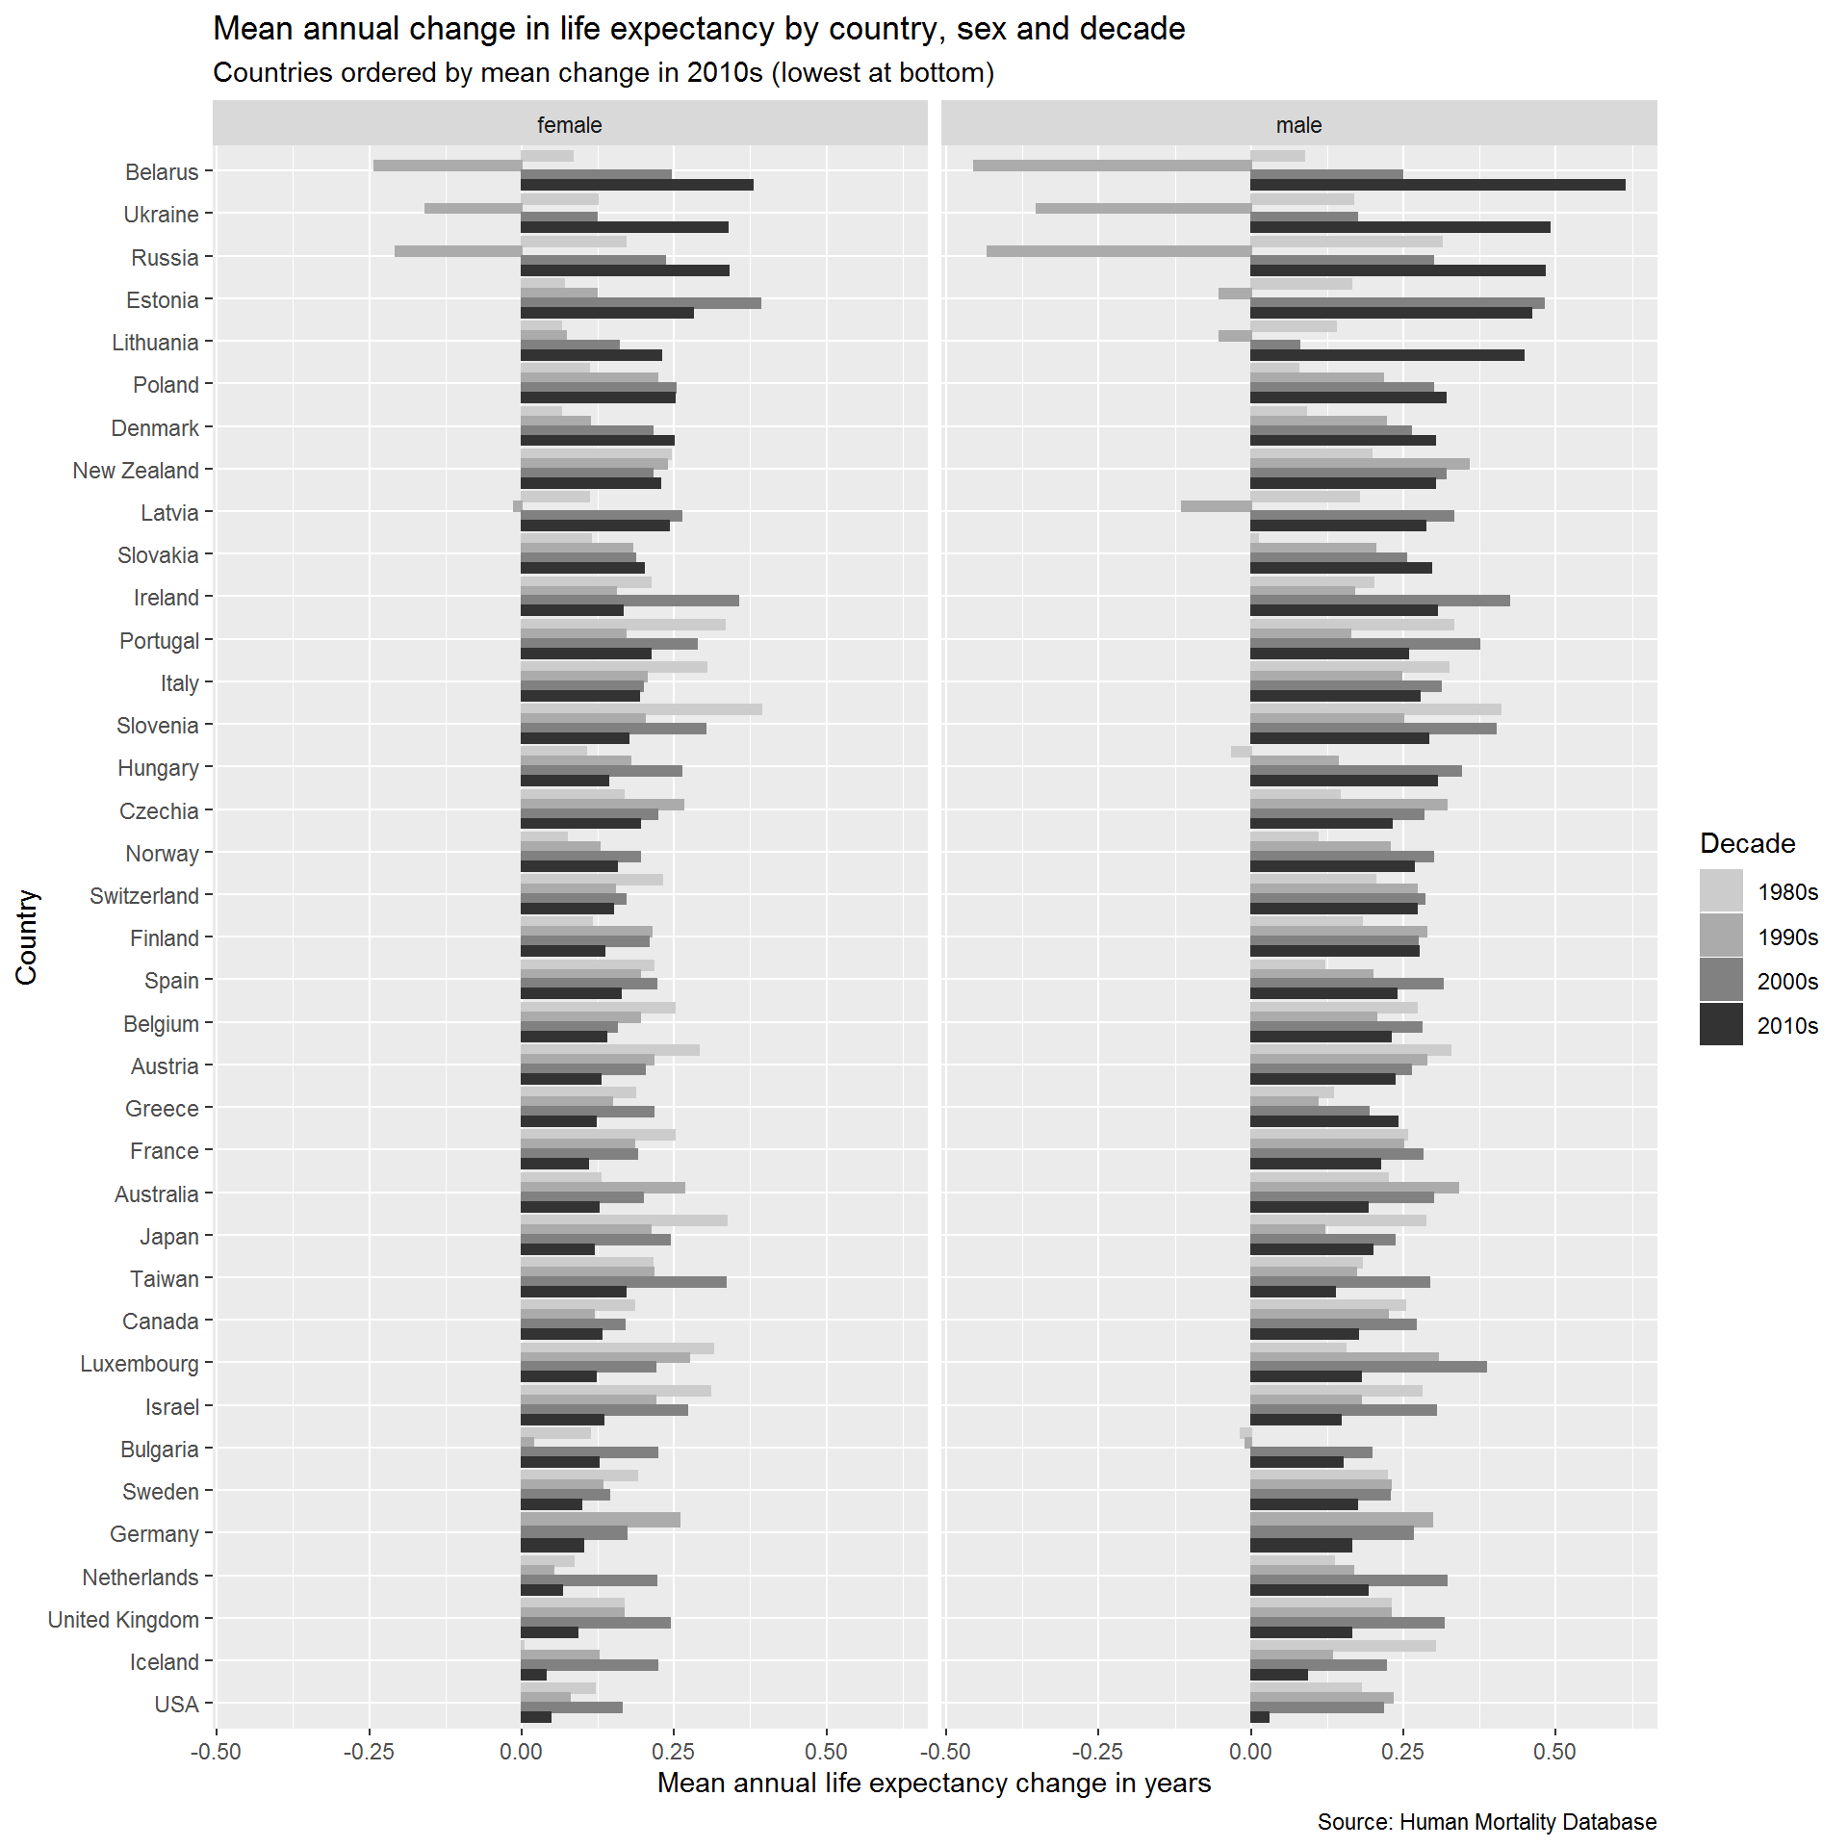

**1.2.1.3 Annual change in slow gainers since 1980**

There are some important differences, however, in how annual change rates have varied in the the slowest-improving countries. Figure X shows this for the five slowest-improving countries excluding Iceland, which due to its small population size shows much greater levels of annual variability than the other countries. From this figure it is apparent that the USA not only tended to show lower rates of improvement before 2010, but has also been exhibiting continuing and more persistent declines than the other countries, with three consecutive years of declining mortality for males in the last three available years, and only modest improvements for females.

