Older projections that had to be uprated [to do]

**3.2 Visualise projections**

**3.2.1 Change in projections**

How do the projections (e0 at birth) change over time between countries?

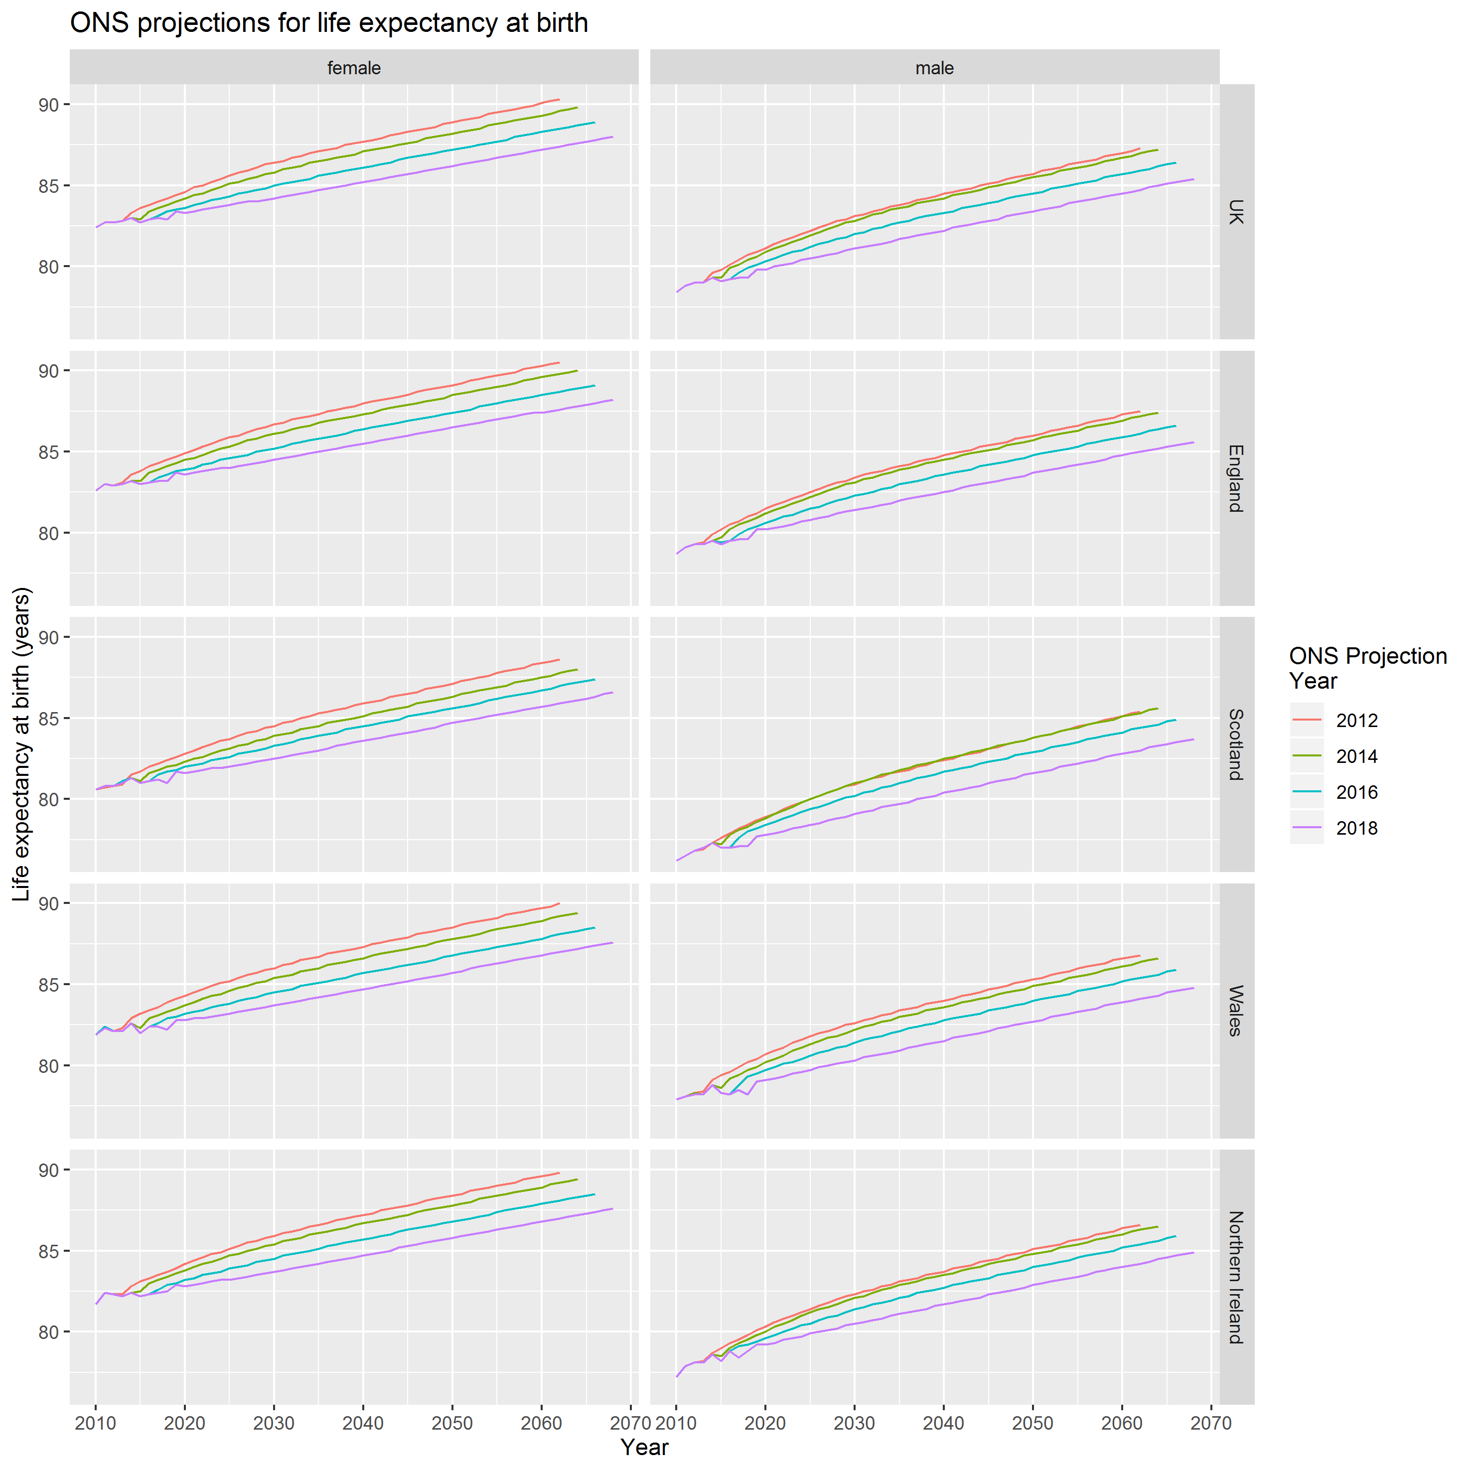

Figure 1 ONS life expectancy projections at birth, 2012 to 2018 revisions

So, the projections involve adding varying numbers of increments of 0.1 life expectancy gain per year. Values within these intervals are created by changing the numbers of years of 0.2, 0.1 and 0.0 gain.

**3.2.2 Change in projections - annual increases**

For each of these projections, what’s the implied expected improvement level?

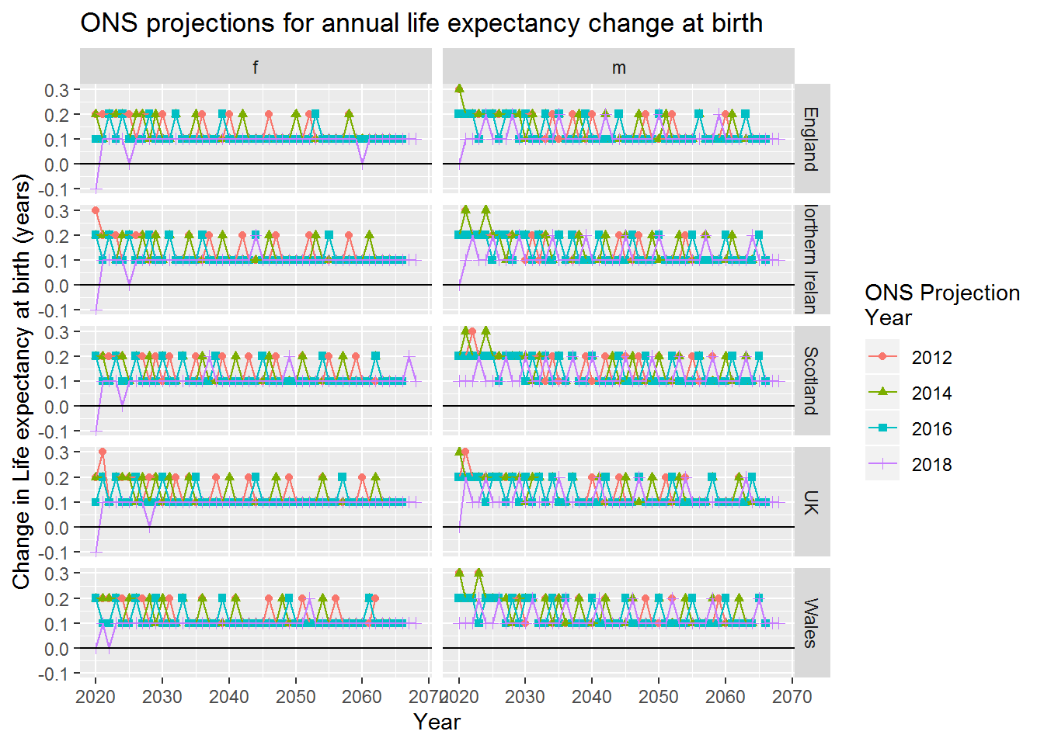

At this point let’s compare the ONS projections against the historic values observed since 1990

| **sex** | **decade** | **HMD** | **ONS** |
| --- | --- | --- | --- |
| f | 80s | 0.168 | 0.168 |
| f | 90s | 0.168 | 0.170 |
| f | 00s | 0.244 | 0.241 |
| f | 10s | 0.091 | 0.080 |
| m | 80s | 0.229 | 0.230 |
| m | 90s | 0.229 | 0.232 |
| m | 00s | 0.319 | 0.313 |
| m | 10s | 0.164 | 0.131 |
|  |  |  |  |

The before period used in the Bayes Factor calculations before is 1991 onwards. Let’s identify what the average improvement was over this period.

| **sex** | **mean_ch_e0** | **var_ch_e0** |
| --- | --- | --- |
| female | 0.191 | 0.039 |
| male | 0.276 | 0.026 |

This checks out with what I’ve calculated before. (Phew!)

**3.2.3 Projections at all ages**

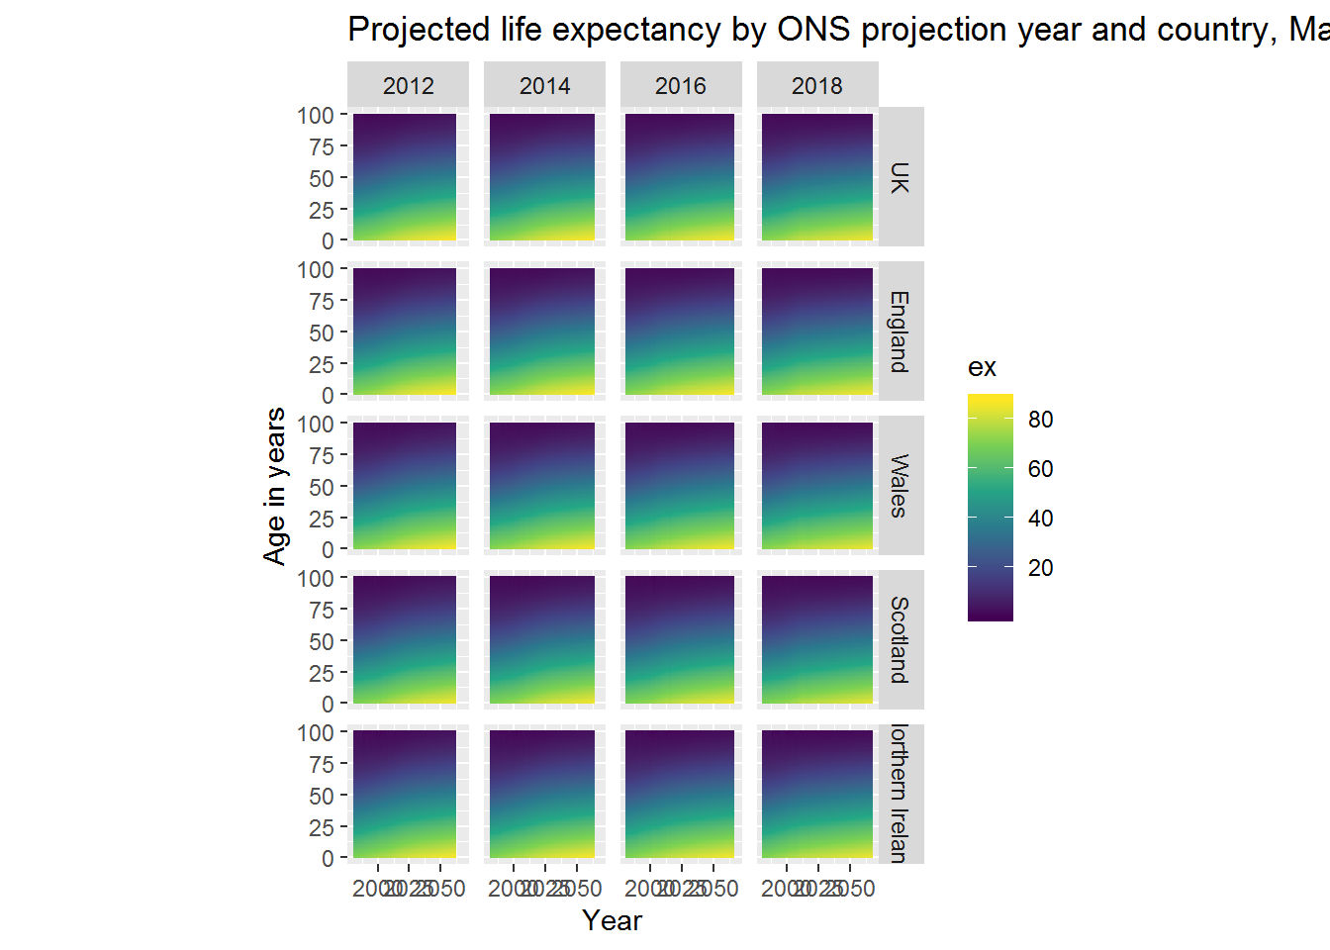

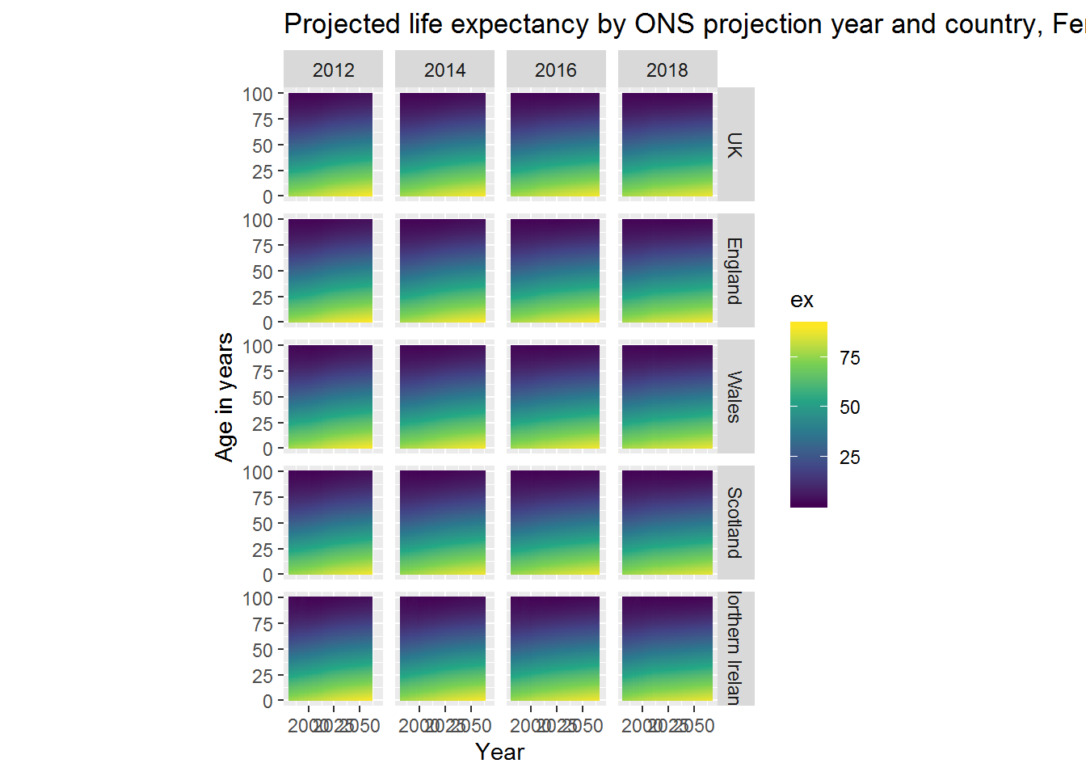

**3.2.4 Change in projections at all ages**

