# ONS life expectancy projections

Figure R4.1 shows ONS life expectancy projections from 1971 to 2018, compared with observed life expectancy at birth in a black line. ONS life expectancies have, since 1971, tended to consistently under-predict the life expectancies that were achieved up until around 2010. After 2012, there are increasing indications that life expectancy projections may now be over-predicting life expectancy gains instead, with the most recent projections returning to around those levels assumed in projections from the early 2000s.

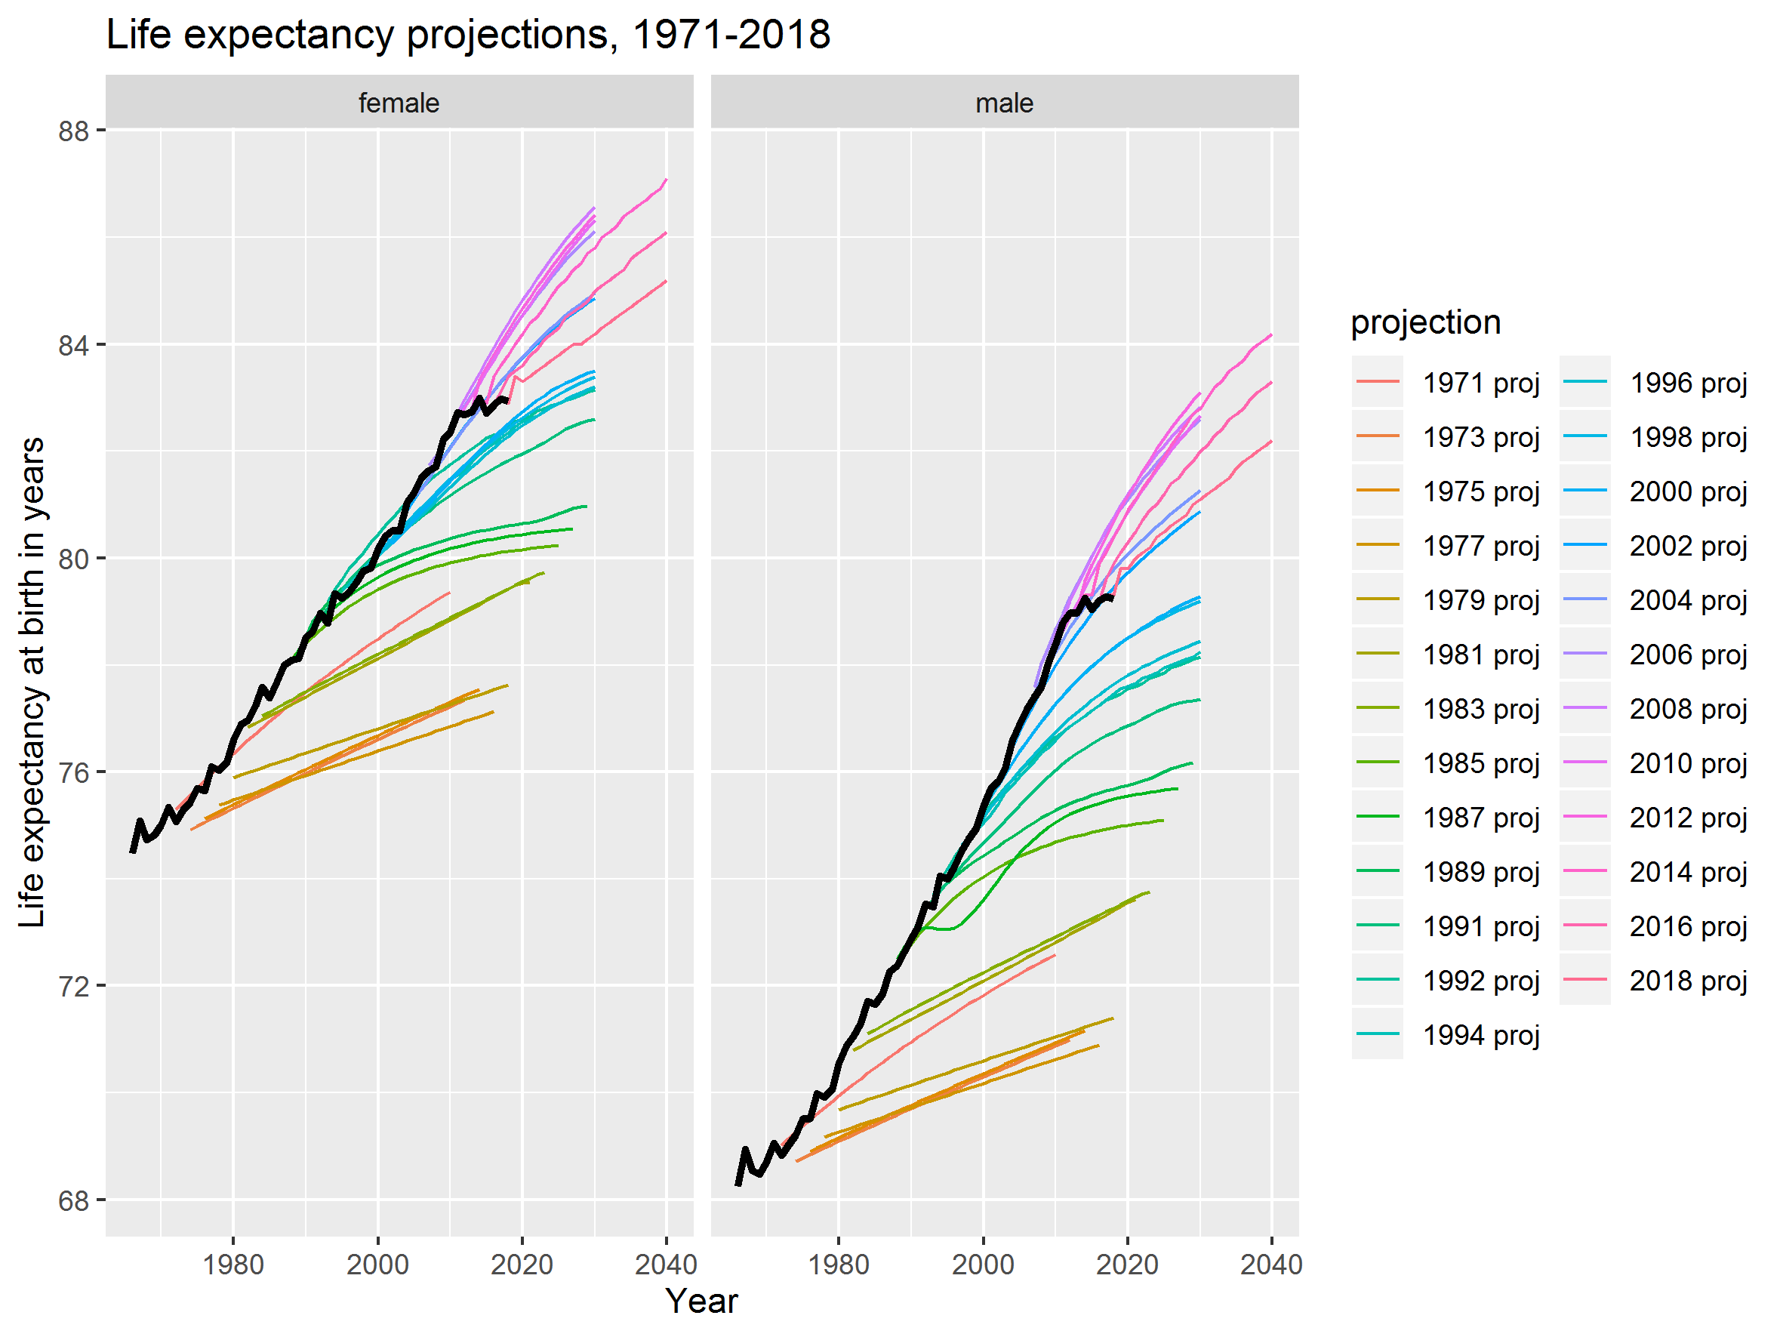

Figure R4.1 ONS UK life expectancy projections compared with observed life expectancy (black line)

It is apparent from the differences in projection shapes that a range of different methods have been used to produce ONS projections, with some of the earliest projections shown resulting in straight lines, but later projections being curved. These earlier straight line projections are likely to have been based on simple linear life expectancy trends, whereas later projections have tended to involve making a range of different assumptions about rates of change in age-specific mortality risks over a range of time periods. Historically, mortality rates based on age-specific mortality risks have tended to underestimate achieved life expectancy gains in high income countries. (1) Assumptions about different rates of age-specific mortality risk affect conditional life expectancy estimates too, as shown in the Lexis surfaces of conditional life expectancy for 2012-2018 projections shown in Figure R4.2A in the web appendix, along with changes between conditional life expectancy between successive revisions, as shown in Figure R4.3A in the web appendix. Figure R4.3A shows, for instance, that there was little downgrading of conditional life expectancies for males up to around age 60, between the 2012 to 2014 projection, whereas there was moderate downgrading between these two revisions for females. After 2014 successive revisions have continued to downgrade projections at all ages, in particular for males aged under 50 years between the 2016 and 2018 revisions.

Table R4.1 shows the average annual long-term change in life expectancy at birth assumed by each ONS projection from 2012 onwards, along with the standard deviation in the implied annual projections. For the UK as a whole, life expectancy was expected to improve by 0.137 years/year for females, and 0.149 years/year for males. By the 2018 the projected long-term improvement rates had been cut to 0.094 years/year for females (a 31% fall) and to 0.114 years/year for males (a 23% fall). It is important to note that even the 2012 projections were lower than the observed rates in the UK in the 1980s (female 0.168 years/year, male 0.230 years/year), 1990s (0.170 and 0.232 years/year respectively) and 2000s (0.241 and 0.313), and so may have been considered pessimistic/conservative estimates at the time.

|  |  |  |  |  |  |  |  |  |
| --- | --- | --- | --- | --- | --- | --- | --- | --- |
|  | **Female** | | | | **Male** | | | |
| Country | 2012 | 2014 | 2016 | 2018 | 2012 | 2014 | 2016 | 2018 |
| United Kingdom | 0.137 (0.054) | 0.129 (0.046) | 0.115 (0.036) | 0.094 (0.032) | 0.149 (0.055) | 0.147 (0.055) | 0.134 (0.048) | 0.114 (0.041) |
| England | 0.135 (0.048) | 0.127 (0.045) | 0.113 (0.034) | 0.092 (0.034) | 0.147 (0.055) | 0.144 (0.055) | 0.132 (0.047) | 0.110 (0.037) |
| Scotland | 0.140 (0.049) | 0.131 (0.047) | 0.119 (0.040) | 0.100 (0.041) | 0.156 (0.055) | 0.156 (0.059) | 0.143 (0.050) | 0.122 (0.042) |
| Wales | 0.137 (0.049) | 0.131 (0.047) | 0.117 (0.038) | 0.098 (0.025) | 0.149 (0.059) | 0.149 (0.059) | 0.136 (0.049) | 0.118 (0.039) |
| Northern Ireland | 0.137 (0.054) | 0.129 (0.046) | 0.117 (0.038) | 0.096 (0.035) | 0.151 (0.055) | 0.149 (0.059) | 0.138 (0.049) | 0.116 (0.043) |

Table R4.1 Mean long-term annual change in life expectancy (Standard deviation) by UK and constituent nation, sex, and ONS projection revision