**Towards understanding the pre-covid-19 slowdown in life expectancy gains in the UK: International comparisons; Comparisons with ONS life expectancy projections; and a proposed method for interim revision of projections between ONS revisions**

# Abstract

## Background

Since around 2010 rates of improvement in life expectancy in the UK have been much lower than might have been expected from trends in previous decades. The UK Office for National Statistics (ONS) usually updates their life expectancy forecasts every two years. During much of the 2000s, before the slowdown in life expectancy gains, these forecasts tended to underestimate life expectancy improvement, and were successively uprated, but since 2010 they have tended to underestimate life expectancy improvement, and have been successively downrated. The most recent 2018 forecast was released in 2019. This paper presents a large number of international and within-UK comparisons of trends in life expectancy, compares observed trends against those projected previously by the ONS, and proposes and implements a method for exploring how consistent observed life expectancy data for the most recent years are against longer-term observed trends and ONS projections.

## Methods

Period life expectancy at birth (e­­0) was extracted from the Human Mortality Database (HMD) to allow comparison between the UK and other high income nations, and obtained from the ONS to allow comparison within UK nations and groups. Annual change in life expectancies across European and Anglophone nations which were available from the HMD were calculated to assess the extent to which a slowdown in e0 improvement rates is seen internationally, and within UK nations to assess how similar trends in slowdown are within the UK. For UK nations changepoint analysis is performed to assess whether the slowdown is contemporaneous/simultaneous, suggesting common exposure. ONS forecasts from 2012 onwards for the UK as a whole are shown to identify broad tendencies of these projections to either systematically under- or over-estimate the gains observed.

As well as To better determine the amount of annual gain in e0 that should be assumed if current e0 improvement rates were to continue, 101 different e0 gain scenarios, ranging from 0% slowdown, assuming no slowdown since the breakpoint year, to 100% slowdown, assuming no gain since the breakpoint year, and the Bayes Factors (ratio of likelihoods) for each of these scenarios were calculated as compared with the 0% slowdown scenario. The scenario that maximises the Bayes Factor is identified. Each ONS biennial projection is reexpressed in terms of implied average annual improvement rates, aconverted into an improvement rate scenario, and the Bayes Factor for each of these scenarios calculated as well.

## Results/Key findings

Slowdowns in e0 gain have been observed in a number of high income nations in recent years, but have been more severe in the UK than in all other nations except USA. In all UK nations except Northern Ireland, a breakpoint in improvement rates between 2010 to 2011 was identified. Between 2010 and 2012 ONS life expectancy forecasts were reduced first for females, then for both sexes. If average rates of e0 gain since 2010 were to continue then the assumption that life expectancy improvement rates have slowed down by 61% is most likely (Bayes Factor: 1.002 for females compared with no slowdown; males 1.003). However, the most recent ONS projection assumes an X% slowing in improvement rates. ONS projections may still be too optimistic.

**Introduction**

## Slowing/Stalling longevity gains in the UK

Since around 2014, slowing trends in life expectancy improvement have been an increasing area of focus and concern in the UK amongst public health researchers and academics. (1–6) Much of the analysis and commentary surrounding the slowing improvement rates in life expectancy has focused on the role of UK-government austerity policies, and corresponding changes in funding and provision of out-of-work benefits, social and healthcare funding (7–9), continuing concerns raised previously about the adverse health effects of austerity in an international context. (10–12) Analyses conducted and commissioned by Public Health England, The Kings Fund, the Health Foundation, and the OECD have instead focused more on extensive description of trends broken down into disease categories, emphasised the multifactorial nature of the slowdown, and the possible role of influenza (in 2013-14) and slowing cardiovascular disease improvements in particular. (13–17)

## Demographic Projections and Forecasts

The UK’s Office for National Statistics (ONS) usually produces new population projections every two years, including new assumptions about mortality, longevity, fertility, and population structure. Such projections, whether carried out by national statistical bodies or by private insurers, are vital inputs to a wide range of important decisions for the effective provision of state services and assets, including schools, social and healthcare services at UK, national and local levels. Trends in life expectancy are also an important indicator of the general rate of improvement in the health of the population.

(18)

In parallel with the ONS’ attempts to accurately project and predict life expectancy trends, academic demographers and commercial actuaries working for the life insurance and financial industries have also been making predictions. .

A number of different approaches to forecasting life expectancy have been tried. The most technically sophisticated approaches have involved forecasting the individual components of life expectancy, mortality rates at individual ages, and calculating life expectancies based on estimated lifetables; (19) making use of Bayesian methods for ‘smoothing’ observations from neighbouring years and age groups; (20,21), and/or incorporating cohort effects in improvement rates which allow for faster or slower gains in some cohorts than others. (22) An important example of this, which when identified by commercial actuaries led to substantial increases in projected life expectancies, was the identification of a so-called ‘Golden Cohort’ in the UK, persons born between around 1925 and 1945, whose rates of mortality improvement appeared systematically higher than would have been expected given earlier and later cohorts. (23) Though cohort effects had been identified many decades previously, (24) they had often been negative (worse than might be expected from earlier/later cohorts) rather than positive (better than might be expected by earlier/later cohorts) (25,26), and the UK’s cohort effect was of particular interest to the actuarial profession as they constituted a source of substantial ‘longevity risk’ affecting the viability of both private and state pensions. (27)

Perhaps surprisingly, more complex approaches to demographic forecasting have not been found to outperform simpler approaches, (28), and a very simple approach to forecasting life expectancy, which does not involve forecasting mortality at individual ages, has also been found to be effective. (29) This approach simply involves assuming that life expectancy improvements will tend to continue to improve linearly on average over the long term. This assumption seems to hold more for the average of many similar populations, or for the best performing of a collection of high income nations, (30–32) than for any single population, but has the dual advantages of simplicity, and of allowing uncertainty intervals in projections to be generated using the observed variation in annual changes in life expectancy and well-established time series modelling strategies. (33) This will be the main approach taken in this paper.

(1–6)(7–9)(10–12)(13–17)This paper aims to bring some of these divergent strands of research together by focusing on the way ONS mortality projections have changed over this period of stalling UK life expectancy, and on how new data about UK life expectancies can be better used to inform our assumptions about future life expectancy trajectories in the UK. We introduce a complementary approach to both evaluating and updating beliefs about how substantial and persistent the recent stalling in life expectancy improvements have been, which uses Bayes Factors to estimate the relative likelihood of having observed the life expectancy improvement that have been observed since 2010 if the long-term trends in life expectancy improvement rates previously observed were still continuing. The approach allows quick updating of beliefs about how far short post-2010 improvement rates have fallen from earlier trends, which can rapidly incorporate each new annual release of UK life expectancy data. This means we can produce interim life expectancy projections in the years between the biennial releases.

The rest of this paper proceeds as follows: Firstly, we will present annual change rates in life expectancy in the UK as compared with a number of other high income countries, to determine the extent to which the recent slowdown in life expectancy in the UK is an international phenomenon. Secondly, we will calculate changes in life expectancy for each UK nation or group of nations, to see whether the slowdown is similar in magnitude and contemporaneous/simultaneous throughout UK populations; this will be supported by performing change-point analysis of annual life expectancy changes for each of these UK populations. Thirdly, we will present the ONS life expectancy projections for the UK from 2012 onwards, to show how these projections have been successively downrated with each biennial projection. Fourthly, we will formally quantify the extent of the slowing in life expectancy improvement rates since 2010 by proposing a series of 100 modelled scenarios, each corresponding to a different percentage slowdown from earlier trends, and identifying the slowdown rate that maximises the Bayes Factor (ratio of model likelihoods, as compared with no slowdown) given observed life expectancy. Finally, we will estimate the Bayes Factors implied by each of the average improvement rates implied by each of the recent ONS mortality projections, discussing how optimistic or pessimistic each of these scenarios seems to be, and how the Bayes Factor strategy can be applied to more openly update our beliefs about the persistence and extent of a life expectancy slowdown in the UK as and when the 2019 period life expectancy estimate becomes available.

# Methods

The Human Mortality Database (HMD) is a joint initiative by the Max Planck Institute for Demographic Research (MPIDR), the University of California, and Institut National D’Etudes Demographiques (INED) in Paris, which aims to provide detailed mortality and population data for research, including life expectancy estimates produced using a standard set of methods for many different populations. It currently covers 41 countries or areas.

Period life expectancy at birth (e­­0) was extracted from the HMD to allow comparison between the UK and other high income nations. The HMD does not provide life expectancy for England and Wales separately, and so life expectancies were also extracted from the ONS to allow comparison within each UK nation. Annual change in life expectancy across European and Anglophone nations was calculated to assess the extent to which a slowdown in e0 improvement rates is seen internationally, and within UK nations to assess how similar trends in slowdown are within the UK. For UK nations changepoint analysis is performed to assess whether the slowdown is contemporaneous, suggesting common exposure. ONS forecasts from 2012 onwards for the UK as a whole are shown to demonstrate the extent of the slowdown assumed by each biennial projection.

To better determine the amount of annual gain in e0 that should be assumed if current e0 improvement rates were to continue, 101 different e0 gain scenarios were generated, ranging from 0% slowdown, assuming no slowdown since the breakpoint year, to 100% slowdown, assuming no gain since the breakpoint year, and the Bayes Factor (ratio of likelihoods) for each of these scenarios calculated as compared with the 0% slowdown scenario. The scenario that maximises the Bayes Factor is identified. Each ONS biennial projection is converted into an improvement rate scenario, and the Bayes Factor for each of these scenarios calculated as well.

Some further details on the Bayes Factor approach is as follows: The approach involves comparing the likelihood of a model which assumes life expectancies will continue to improve at the long-term pre-2010 rate, with a series of models which assume anywhere between a 0% and 100% long-term decline from this earlier rate, at 1% increments. The most likely of this family of alternative models (given the data) can then be identified, and with each new annual lifetable for the UK and constituent nations the preferred model and changing strength of evidence in support of this model can be updated. This strength of evidence is expressed as a Bayes Factor, which shows the ratio of the likelihood of two models given the data. In the results presented, a Bayes Factor above 1 indicates more support for a model positing a slowdown from pre-2010 trends, and a ratio below 1 indicates more support for ‘no slowdown’ than ‘slowdown’.

## Change in life expectancy, UK compared with other high income nations

shows the average annual change in life expectancy by decade for 37 HMD nations including the UK. Figure 1A of the appendix shows the same results graphically, with countries arranged by average annual improvement in the 2010s.

The countries with the fastest average improvement in life expectancies in the 2010s include Belarus (0.38 years/year for females, 0.61 years/year for males), Ukraine (0.34 females, 0.49 males), Russia (0.34 females, 0.48 males), Lithuania (0.23 females, 0.45 males), and Poland (0.25 females, 0.32 males). By contrast, the countries with the slowest improvements in the 2010s include the USA (0.05 females, 0.03 males), Iceland (0.04 females, 0.09 males), the United Kingdom (0.09 females, 0.16 males), Netherlands (0.07 females, 0.19 males), and Germany (0.10 females, 0.17 males).

In general, there appears a tendency for those countries with the worst changes in the 1980s and 1990s to have the fastest rates of improvement in the 2010s, and vice-versa, with the fastest recent gains seen in Russia and Eastern European nations, and the slowest gains in the USA, the UK, and other rich Western European nations. For many countries - including the USA, Iceland, the UK, Canada, Taiwan, Spain, Ireland and Estonia – there were faster rates of improvement in the 2000s than in earlier decades, especially for males. However not all of these countries with fast rates of improvements in the 2000s then saw exceptionally low rates of improvement in the 2010s.

The similarity between average rates of improvement in the 2010s in Germany and the UK is noteworthy, with average sex specific improvement rates within 0.01 years per year of each other (0.09 compared with 0.10 for females in the UK and Germany respectively; 0.16 compared with 0.17 for males). The German data covers 2010-2017 inclusive, whereas for the UK the data extends to 2016. Further analysis of annual improvement rates in the USA, the UK, the Netherlands and Germany is presented in Figure 2 of the appendix.

|  |  |  |  |  |  |  |  |  |
| --- | --- | --- | --- | --- | --- | --- | --- | --- |
| Table 1 Average annual life expectancy changes (in years) by decade, arranged by average gain for both sexes combined in the 2010s. (Lowest at top.) Source: Human Mortality Database | **Female** | | | | **Male** | | | |
| Country | 1980s | 1990s | 2000s | 2010s | 1980s | 1990s | 2000s | 2010s |
| USA | 0.120 | 0.079 | 0.165 | 0.047 | 0.180 | 0.232 | 0.217 | 0.029 |
| Iceland | 0.003 | 0.127 | 0.223 | 0.040 | 0.302 | 0.133 | 0.222 | 0.091 |
| United Kingdom | 0.168 | 0.168 | 0.244 | 0.091 | 0.230 | 0.229 | 0.316 | 0.164 |
| Netherlands | 0.086 | 0.053 | 0.221 | 0.067 | 0.136 | 0.167 | 0.321 | 0.191 |
| Germany |  | 0.259 | 0.173 | 0.101 |  | 0.297 | 0.266 | 0.165 |
| Sweden | 0.190 | 0.133 | 0.144 | 0.099 | 0.222 | 0.229 | 0.227 | 0.174 |
| Bulgaria | 0.112 | 0.019 | 0.223 | 0.126 | -0.018 | -0.009 | 0.197 | 0.150 |
| Israel | 0.310 | 0.220 | 0.272 | 0.134 | 0.280 | 0.181 | 0.303 | 0.147 |
| Luxembourg | 0.314 | 0.275 | 0.220 | 0.123 | 0.154 | 0.306 | 0.386 | 0.180 |
| Canada | 0.186 | 0.118 | 0.169 | 0.131 | 0.252 | 0.225 | 0.270 | 0.176 |
| Taiwan | 0.216 | 0.216 | 0.335 | 0.170 | 0.181 | 0.173 | 0.292 | 0.138 |
| Japan | 0.337 | 0.212 | 0.244 | 0.119 | 0.286 | 0.121 | 0.236 | 0.199 |
| Australia | 0.129 | 0.267 | 0.199 | 0.127 | 0.224 | 0.339 | 0.299 | 0.191 |
| France | 0.251 | 0.185 | 0.190 | 0.109 | 0.256 | 0.249 | 0.281 | 0.211 |
| Greece | 0.186 | 0.149 | 0.216 | 0.122 | 0.135 | 0.109 | 0.193 | 0.240 |
| Austria | 0.291 | 0.217 | 0.202 | 0.130 | 0.328 | 0.288 | 0.262 | 0.235 |
| Belgium | 0.251 | 0.195 | 0.157 | 0.139 | 0.272 | 0.205 | 0.279 | 0.229 |
| Spain | 0.217 | 0.194 | 0.221 | 0.163 | 0.120 | 0.199 | 0.314 | 0.239 |
| Finland | 0.116 | 0.213 | 0.208 | 0.136 | 0.181 | 0.287 | 0.274 | 0.274 |
| Switzerland | 0.231 | 0.154 | 0.171 | 0.150 | 0.203 | 0.272 | 0.285 | 0.271 |
| Norway | 0.074 | 0.128 | 0.194 | 0.157 | 0.110 | 0.228 | 0.298 | 0.268 |
| Czechia | 0.168 | 0.265 | 0.222 | 0.195 | 0.146 | 0.321 | 0.283 | 0.231 |
| Hungary | 0.107 | 0.178 | 0.263 | 0.143 | -0.031 | 0.143 | 0.345 | 0.305 |
| Slovenia | 0.393 | 0.203 | 0.301 | 0.175 | 0.410 | 0.249 | 0.402 | 0.291 |
| Italy | 0.303 | 0.205 | 0.199 | 0.192 | 0.324 | 0.247 | 0.311 | 0.276 |
| Portugal | 0.333 | 0.171 | 0.288 | 0.212 | 0.332 | 0.163 | 0.374 | 0.258 |
| Ireland | 0.212 | 0.155 | 0.355 | 0.166 | 0.201 | 0.169 | 0.423 | 0.305 |
| Slovakia | 0.113 | 0.181 | 0.186 | 0.201 | 0.011 | 0.204 | 0.254 | 0.296 |
| Latvia | 0.111 | -0.013 | 0.263 | 0.242 | 0.177 | -0.114 | 0.332 | 0.286 |
| New Zealand | 0.244 | 0.238 | 0.215 | 0.228 | 0.198 | 0.357 | 0.320 | 0.302 |
| Denmark | 0.064 | 0.113 | 0.215 | 0.250 | 0.090 | 0.222 | 0.263 | 0.301 |
| Poland | 0.110 | 0.223 | 0.253 | 0.251 | 0.078 | 0.217 | 0.298 | 0.319 |
| Lithuania | 0.064 | 0.073 | 0.160 | 0.229 | 0.140 | -0.051 | 0.079 | 0.447 |
| Estonia | 0.069 | 0.123 | 0.392 | 0.281 | 0.164 | -0.052 | 0.481 | 0.460 |
| Russia | 0.170 | -0.207 | 0.236 | 0.340 | 0.312 | -0.433 | 0.298 | 0.482 |
| Ukraine | 0.126 | -0.158 | 0.124 | 0.338 | 0.168 | -0.352 | 0.174 | 0.490 |
| Belarus | 0.083 | -0.242 | 0.245 | 0.379 | 0.087 | -0.454 | 0.248 | 0.613 |

## Change in life expectancy, UK and UK constituent nations

Table 2 and Figure 1 show the average annual change in life expectancy in the UK and constituent nations by sex and decade. For the UK as a whole, and all constituent nations except Northern Ireland, the 2000s saw faster rates of improvement in life expectancy than the 1980s and 1990s. Rates of improvement in the UK as a whole have been higher each decade for males than for females, including in the 2010s, with annual gains of 0.31 years/year for males in the 2000s, compared with 0.24 years/year for females. For the UK and all constituent nations, rates of annual improvement were lower in the 2010s than any of the three previous decades, and lower still for females than males.

|  |  |  |  |  |  |  |  |  |
| --- | --- | --- | --- | --- | --- | --- | --- | --- |
| 2 | **Female** | | | | **Male** | | | |
| Population | 1980s | 1990s | 2000s | 2010s | 1980s | 1990s | 2000s | 2010s |
| United Kingdom | 0.168 | 0.170 | 0.241 | 0.080 | 0.230 | 0.232 | 0.313 | 0.131 |
| England | 0.171 | 0.168 | 0.244 | 0.081 | 0.228 | 0.239 | 0.311 | 0.133 |
| Scotland | 0.107 | 0.206 | 0.218 | 0.067 | 0.188 | 0.205 | 0.319 | 0.128 |
| Wales | 0.178 | 0.138 | 0.251 | 0.039 | 0.248 | 0.175 | 0.323 | 0.081 |
| Northern Ireland | 0.308 | 0.143 | 0.224 | 0.114 | 0.388 | 0.250 | 0.296 | 0.182 |

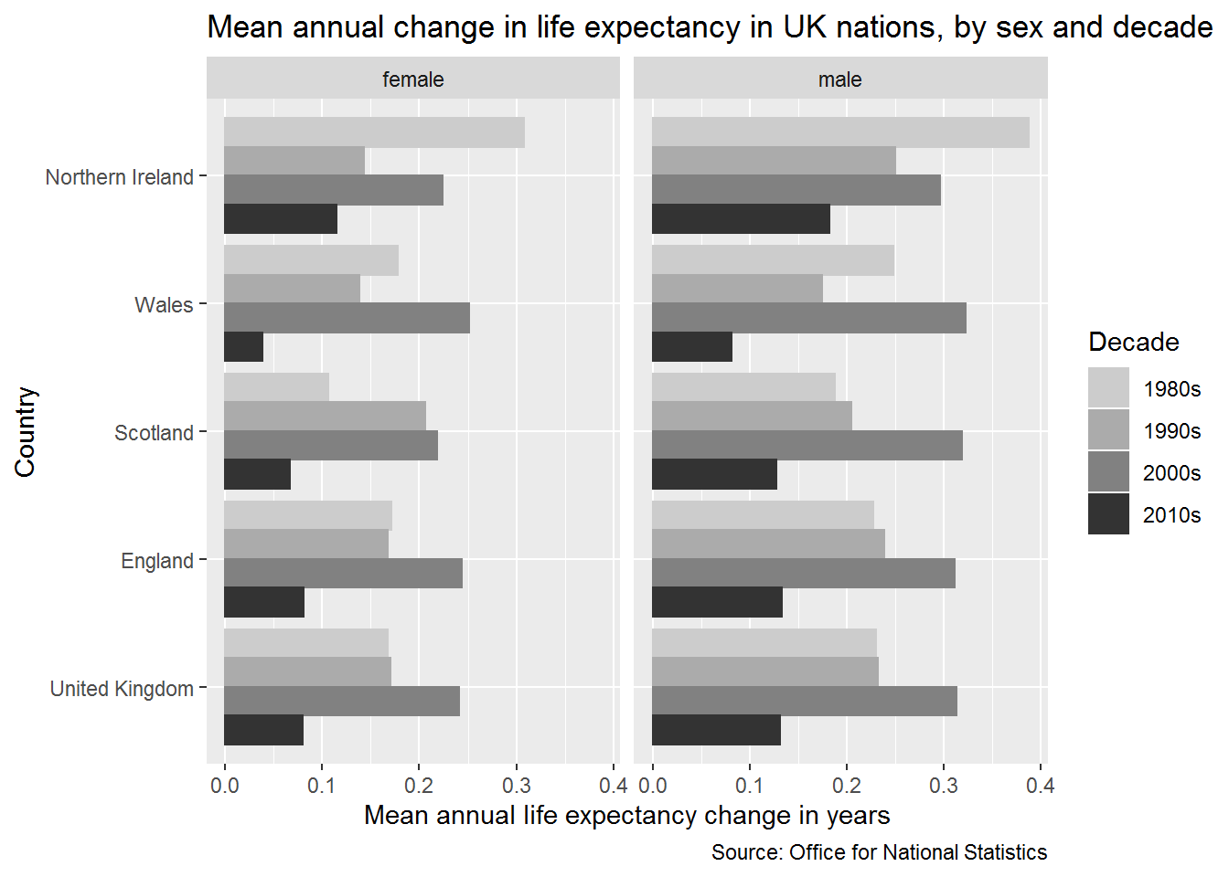

Figure 1Average annual change in life expectancy in the UK and constituent nations, by sex and decade. (Source: ONS)

The appendix provides further analyses of trends in annual life expectancy gains in the UK and constituent nations. Figure 3A presents annual series in life expectancy trends in the UK and constituent nations, and Figure 4A and 5A looks at how correlated the annual life expectancy series are between males and females and each UK nation (i.e. it compares the correlation since 1980s in eight series of annual life expectancy changes, males and females in each of the UK’s four nations).

The results presented in Figure 3A shows that, again with the exception of Northern Ireland, the low rate of average annual improvement seen in the 2010s is not driven by any single ‘bad year’, but is part of a continuing trend towards slowdown; if this downwards trend continues it suggests the overall average annual life expectancy gain observed by the end of the 2010s will be lower rather than higher than the already-exceptionally-low rates shown here. The presentation of annual series also shows that single years in which life expectancy fell rather than rose compared with the previous year are not in themselves exceptional; rather, it is a combination of both faster falls in life expectancy in ‘bad years’ combined with lower rates of gain in ‘good years’ that seem to be driving the recent trend towards slowdown.

The results presented in Figure 5A indicate that male and female trends within nations tend to be more strongly correlated with the same sex in other nations. This coupling of trends in strongest in Wales and England, weaker in Scotland, and weakest in Northern Ireland, where the between-sex correlations are weaker than between countries. However for all countries the correlations over time are above r = 0.5.

Table 1A compares estimates of average annual change in life expectancy by decade derived from the HMD and ONS data, and finds estimates to be very similar.

## Breakpoint analysis

To determine whether the 2010s represent a distinct break from previous trends in life expectancy improvement in the UK, breakpoint analysis was performed using the segmented package in R. (34) These analyses are presented in the appendix. Figure 6A and Table 3A confirm that in the UK as a whole, and all constituent nations except Northern Ireland, a breakpoint in the series was identified within one year of 2010. (For Northern Ireland a breakpoint was instead identified in the mid-1980s.) Figure 7A shows the sensitivity of this finding to model parameterisation (the choice of random number seed used in the breakpoint algorithm), and finds the same breakpoints to be identified in all instances except for females in Wales.

## ONS life expectancy projections

Figure 2 shows ONS life expectancy projections from 1971 to 2018, compared with observed life expectancy at birth in a black line. ONS life expectancies have, since 1971, tended to consistently under-predict the life expectancies that were achieved up until around 2010. After 2012, it appears life expectancy projections are over-predicting life expectancy gains instead, with the most recent projections returning to around those levels assumed in projections from the early 2000s.

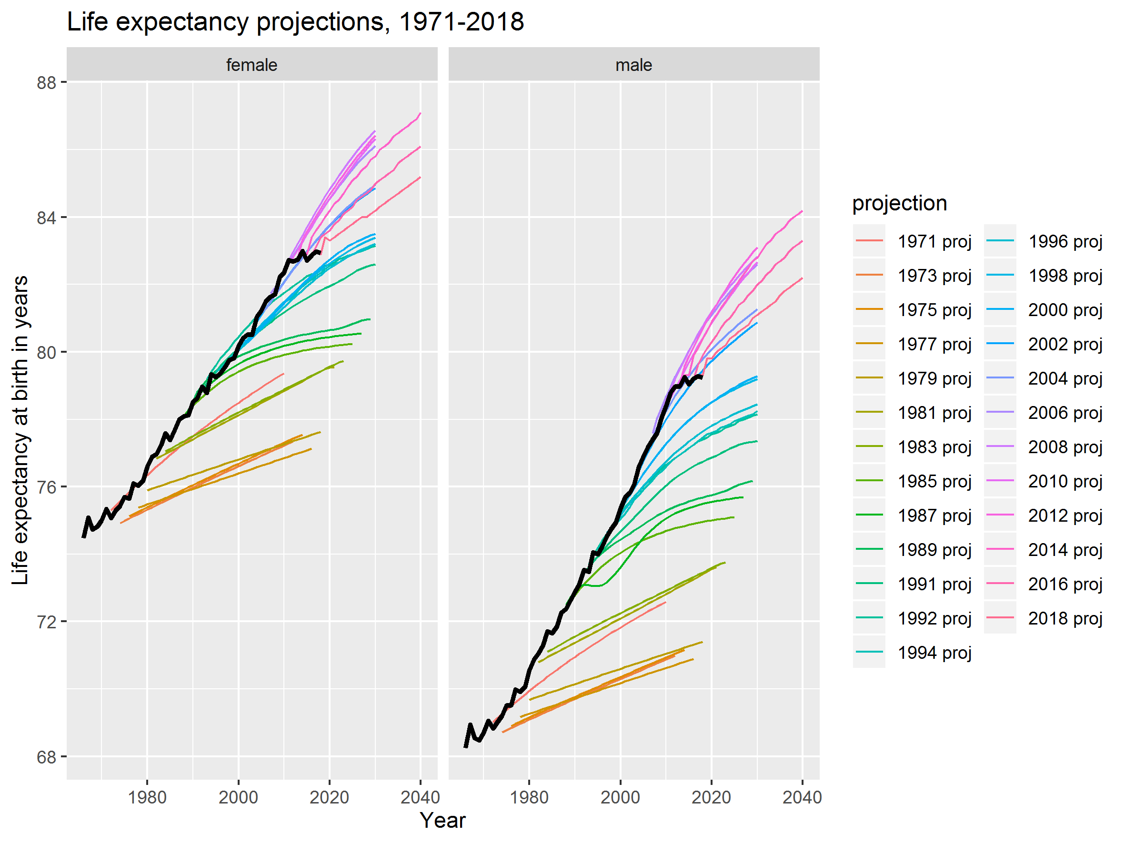

Figure 2 ONS UK life expectancy projections compared with observed life expectancy (black line)

Assumptions about different rates of age-specific mortality risk affect conditional life expectancy estimates too, as shown in the Lexis surfaces of conditional life expectancy for 2012-2018 projections shown in Figure 8A (for life expectancy at birth) and Figure 9A (for conditional life expectancy at ages in individual years) of the appendix. Appendix Figure 10A shows how the conditional life expectancies were modified between successive ONS projections; it shows, for instance, that there was little downgrading of conditional life expectancies for males up to around age 60, between the 2012 to 2014 projection, whereas there was moderate downgrading between these two revisions for females. After 2014 successive revisions have continued to downgrade projections at all ages, in particular for males aged under 50 years between the 2016 and 2018 revisions.

Table 3 shows the average annual long-term change in life expectancy at birth assumed by each ONS projection from 2012 onwards, along with the standard deviation in the implied annual projections. For the UK as a whole, life expectancy was expected to improve by 0.137 years/year for females, and 0.149 years/year for males. By the 2018 the projected long-term improvement rates had been cut to 0.094 years/year for females (a 31% fall) and to 0.114 years/year for males (a 23% fall). It is important to note that even the 2012 projections were lower than the observed rates in the UK in the 1980s (female 0.168 years/year, male 0.230 years/year), 1990s (0.170 and 0.232 years/year respectively) and 2000s (0.241 and 0.313), and so may have been considered pessimistic/conservative estimates at the time.

|  |  |  |  |  |  |  |  |  |
| --- | --- | --- | --- | --- | --- | --- | --- | --- |
|  | **Female by year** | | | | **Male by year** | | | |
| Country | 2012 | 2014 | 2016 | 2018 | 2012 | 2014 | 2016 | 2018 |
| United Kingdom | 0.137 (0.054) | 0.129 (0.046) | 0.115 (0.036) | 0.094 (0.032) | 0.149 (0.055) | 0.147 (0.055) | 0.134 (0.048) | 0.114 (0.041) |
| England | 0.135 (0.048) | 0.127 (0.045) | 0.113 (0.034) | 0.092 (0.034) | 0.147 (0.055) | 0.144 (0.055) | 0.132 (0.047) | 0.110 (0.037) |
| Scotland | 0.140 (0.049) | 0.131 (0.047) | 0.119 (0.040) | 0.100 (0.041) | 0.156 (0.055) | 0.156 (0.059) | 0.143 (0.050) | 0.122 (0.042) |
| Wales | 0.137 (0.049) | 0.131 (0.047) | 0.117 (0.038) | 0.098 (0.025) | 0.149 (0.059) | 0.149 (0.059) | 0.136 (0.049) | 0.118 (0.039) |
| Northern Ireland | 0.137 (0.054) | 0.129 (0.046) | 0.117 (0.038) | 0.096 (0.035) | 0.151 (0.055) | 0.149 (0.059) | 0.138 (0.049) | 0.116 (0.043) |

Table 3 Mean long-term annual change in life expectancy (Standard deviation) by UK and constituent nation, sex, and ONS projection revision

## Bayes Factor estimation of the extent of the slowdown

The previous section showed that since 2012 life expectancy projections have tended to overestimate the improvements in life expectancy so far observed, and that forecasts have since tended to be successively downgraded with each new biennial projection. This section presents the results of a relatively simple approach for quantifying the extent to which recent life expectancy improvement rates within the UK have fallen short of pre-2010 trends (those starting in 1991), as well as the additional information produced by each successive annual life expectancy estimate produced by the ONS in informing researchers and policy makers as to the extent and persistence of the post-2010 slowdown. The results are expressed as a Bayes Factor (BF), which is the ratio of the likelihood of a model which assumes no change in long-term life expectancy trends, with a series of models which assume anywhere from a 1% to 100% slowdown in these earlier trends; BF values > 1 show more support for some proposed level of slowdown than no slowdown. By design, no criterion for declaring a difference as ‘statistically significant’ is used, though a common rule of thumb is that Bayes Factors below 3 are commonly considered as offering only ‘anecdotal’ or ‘weak’ support for the alternative hypothesis. (36) All Bayes Factors estimated here are substantially below this threshold.

Figure 12A in the appendix shows the Bayes Factor schedules for each proposed percentage slowdown as compared with the 1991-2010 trends. Fainter lines indicate estimates based on fewer years (such as 2011-2012 only), whereas darker lines indicate estimates also using more recent years, with the darkest line the schedule based on all years from 2011-2018 inclusive. The height of the schedules indicates the changing strength of the evidence; the addition of the 2018 life expectancy data substantially increased support for the belief that life expectancy improvements are below those observed from 1991-2010, as well as the magnitude of the slowdown.

These findings are summarised in Table 4 Percent decline from 1991-2010 average annual life expectancy improvements and Bayes Factor, by collection of annual life expectancy series from 2011 onwards

, which shows the proposed percentage slowdown which maximises the Bayes Factor, along with these maximised Bayes Factors. For the UK as a whole, when using only 2011-2012 observations, the Bayes Factor was maximised when a 16% slowdown (84% of previous rate) was assumed for females, with no slowdown identified for males. Using the currently complete series, including all observations from 2011-2018 inclusive, the Bayes Factor was maximised when a 61% slowdown was assumed for both sexes, and the magnitude of the Bayes Factor (support for belief in a slowdown) had also increased. The same 61% slowdown maximised the Bayes Factor based on 2011-2018 data for both males and females in England. A similar proposed slowdown (59%) maximised the Bayes Factor for males in Scotland, and a larger proposed slowdown, of 73%, for females in Scotland. In Wales somewhat larger proposed slowdown percentages (73% for females and 83% for males) maximised the Bayes Factor. Only for males in Northern Ireland was evidence supporting belief in a substantial (50% or more) slowdown from earlier trends not identified.

|  |  |  |  |  |  |  |  |  |
| --- | --- | --- | --- | --- | --- | --- | --- | --- |
| **Population** | **Sex** | **2011-12** | **2011-13** | **2011-14** | **2011-15** | **2011-16** | **2011-17** | **2011-18** |
| United Kingdom | female | 16% (BF: 1.00004) | 30% (BF: 1.00020) | 15% (BF: 1.00007) | 61% (BF: 1.00135) | 54% (BF: 1.00125) | 52% (BF: 1.00137) | 61% (BF: 1.00216) |
| United Kingdom | male | 0% (BF: 1.00000) | 28% (BF: 1.00023) | 21% (BF: 1.00018) | 52% (BF: 1.00137) | 50% (BF: 1.00150) | 53% (BF: 1.00201) | 61% (BF: 1.00301) |
| England | female | 15% (BF: 1.00003) | 31% (BF: 1.00021) | 18% (BF: 1.00009) | 62% (BF: 1.00138) | 55% (BF: 1.00132) | 53% (BF: 1.00141) | 61% (BF: 1.00212) |
| England | male | 0% (BF: 1.00000) | 30% (BF: 1.00026) | 26% (BF: 1.00026) | 53% (BF: 1.00138) | 50% (BF: 1.00148) | 54% (BF: 1.00198) | 61% (BF: 1.00296) |
| Scotland | female | 49% (BF: 1.00042) | 22% (BF: 1.00013) | 1% (BF: 1.00000) | 54% (BF: 1.00134) | 58% (BF: 1.00179) | 57% (BF: 1.00208) | 73% (BF: 1.00383) |
| Scotland | male | 0% (BF: 1.00000) | 0% (BF: 1.00000) | 0% (BF: 1.00000) | 42% (BF: 1.00185) | 51% (BF: 1.00328) | 48% (BF: 1.00346) | 59% (BF: 1.00584) |
| Wales | female | 25% (BF: 1.00011) | 41% (BF: 1.00046) | 0% (BF: 1.00000) | 77% (BF: 1.00272) | 40% (BF: 1.00088) | 51% (BF: 1.00168) | 73% (BF: 1.00390) |
| Wales | male | 32% (BF: 1.00075) | 64% (BF: 1.00452) | 11% (BF: 1.00018) | 70% (BF: 1.00904) | 77% (BF: 1.01341) | 68% (BF: 1.01219) | 83% (BF: 1.02068) |
| Northern Ireland | female | 0% (BF: 1.00000) | 11% (BF: 1.00008) | 13% (BF: 1.00013) | 47% (BF: 1.00228) | 51% (BF: 1.00329) | 46% (BF: 1.00313) | 52% (BF: 1.00458) |
| Northern Ireland | male | 0% (BF: 1.00000) | 0% (BF: 1.00000) | 0% (BF: 1.00000) | 19% (BF: 1.00040) | 0% (BF: 1.00000) | 30% (BF: 1.00142) | 15% (BF: 1.00044) |

Table 4 Percent decline from 1991-2010 average annual life expectancy improvements and Bayes Factor, by collection of annual life expectancy series from 2011 onwards

## Comparison between Bayes Factor-maximising slowdowns and implied slowdowns from post-2012 ONS biennial projections

shows how the average annual gain in life expectancy based on the Bayes Factor approach, which can be updated with every new annual life expectancy release, compares with the rates implied by each ONS biennial projection, (See Figure 12A in the appendix for the implied annual life expectancy series from each projection, and the associated repository for the code used to calculate these) for the UK as a whole and each constituent nation. Figure 3 shows this graphically for the UK only.

Table 5 Average annual long term improvement (years per year) in life expectancy based on Bayes Factor and ONS Biennial projections by sex and population

|  |  |  |  |  |  |
| --- | --- | --- | --- | --- | --- |
| **Population** | **Year** | **Female** | | **Male** | |
|  |  | **Bayes** | **ONS** | **Bayes** | **ONS** |
| United Kingdom | 2011 | 0.192 |  | 0.276 |  |
| United Kingdom | 2012 | 0.161 | 0.152 | 0.276 | 0.166 |
| United Kingdom | 2013 | 0.134 |  | 0.199 |  |
| United Kingdom | 2014 | 0.163 | 0.136 | 0.218 | 0.158 |
| United Kingdom | 2015 | 0.075 |  | 0.132 |  |
| United Kingdom | 2016 | 0.088 | 0.120 | 0.138 | 0.144 |
| United Kingdom | 2017 | 0.092 |  | 0.130 |  |
| United Kingdom | 2018 | 0.075 | 0.102 | 0.108 | 0.122 |
| England | 2011 | 0.195 |  | 0.280 |  |
| England | 2012 | 0.165 | 0.152 | 0.280 | 0.164 |
| England | 2013 | 0.134 |  | 0.196 |  |
| England | 2014 | 0.159 | 0.136 | 0.207 | 0.158 |
| England | 2015 | 0.074 |  | 0.132 |  |
| England | 2016 | 0.088 | 0.120 | 0.140 | 0.142 |
| England | 2017 | 0.091 |  | 0.129 |  |
| England | 2018 | 0.076 | 0.100 | 0.109 | 0.120 |
| Scotland | 2011 | 0.185 |  | 0.254 |  |
| Scotland | 2012 | 0.094 | 0.156 | 0.254 | 0.172 |
| Scotland | 2013 | 0.144 |  | 0.254 |  |
| Scotland | 2014 | 0.183 | 0.134 | 0.254 | 0.166 |
| Scotland | 2015 | 0.085 |  | 0.147 |  |
| Scotland | 2016 | 0.077 | 0.126 | 0.124 | 0.158 |
| Scotland | 2017 | 0.079 |  | 0.132 |  |
| Scotland | 2018 | 0.050 | 0.112 | 0.104 | 0.132 |
| Wales | 2011 | 0.159 |  | 0.210 |  |
| Wales | 2012 | 0.119 | 0.158 | 0.174 | 0.170 |
| Wales | 2013 | 0.094 |  | 0.092 |  |
| Wales | 2014 | 0.159 | 0.136 | 0.228 | 0.156 |
| Wales | 2015 | 0.037 |  | 0.077 |  |
| Wales | 2016 | 0.095 | 0.122 | 0.059 | 0.154 |
| Wales | 2017 | 0.078 |  | 0.082 |  |
| Wales | 2018 | 0.043 | 0.108 | 0.044 | 0.132 |
| Northern Ireland | 2011 | 0.192 |  | 0.249 |  |
| Northern Ireland | 2012 | 0.192 | 0.150 | 0.249 | 0.170 |
| Northern Ireland | 2013 | 0.170 |  | 0.249 |  |
| Northern Ireland | 2014 | 0.167 | 0.140 | 0.249 | 0.158 |
| Northern Ireland | 2015 | 0.101 |  | 0.201 |  |
| Northern Ireland | 2016 | 0.094 | 0.124 | 0.249 | 0.142 |
| Northern Ireland | 2017 | 0.103 |  | 0.174 |  |
| Northern Ireland | 2018 | 0.092 | 0.102 | 0.211 | 0.122 |

For the UK as a whole, the Bayes Factor approach identified a similar average improvement as the 2012 biennial projection (0.161 years/year compared with 0.152 years/year) for females, but a much higher rate of improvement for males (0.276 years/year compared with 0.166 years/year). By 2018 the Bayes Factor approach produced more pessimistic estimates for both sexes than are implied by the 2018 ONS projection (0.075 years/year compared with 0.102 years/year for females; 0.108 years/year compared with 0.122 years/year for males), with an apparent turning point in the Bayes Factor estimates being 2014. This is shown even more clearly in Figure 1Figure 3, which presents the projected gains in weeks/year rather than years per year.

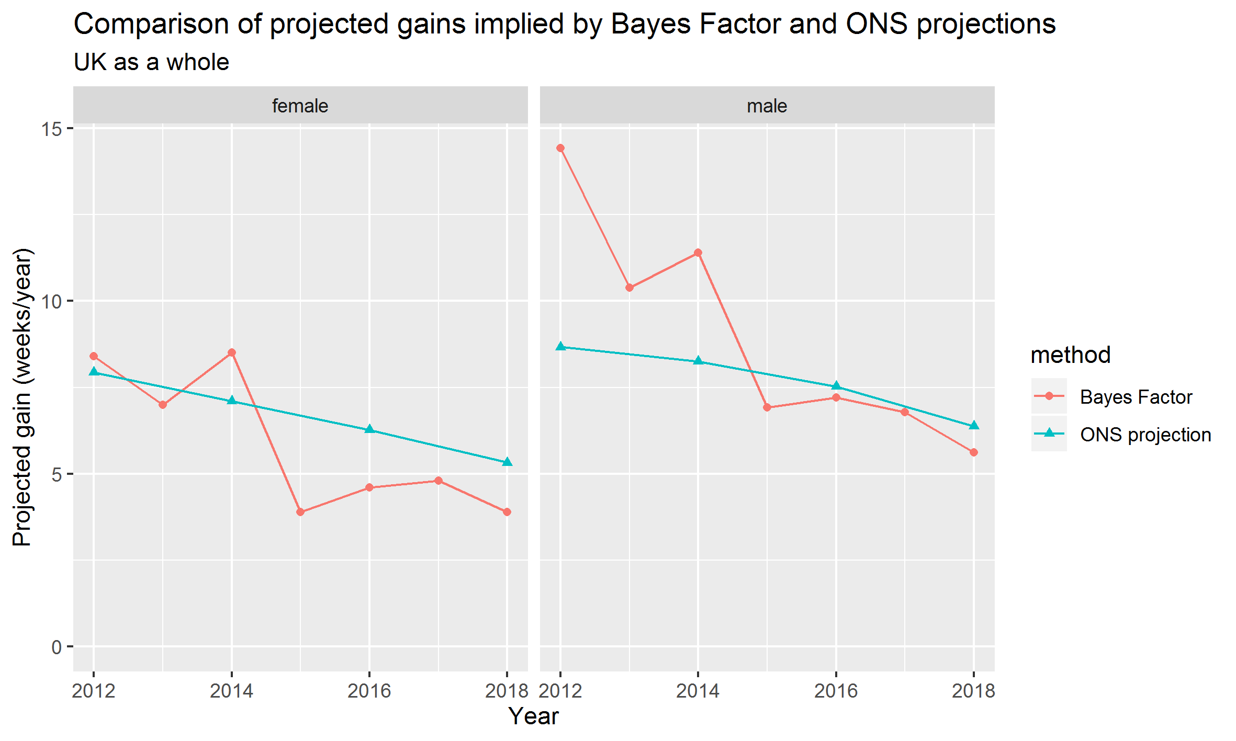

Figure 3 Comparison between implied annual gains (in weeks/year) for the UK based on Bayes Factor maximisation approach and ONS biennial projections

# Discussion

This paper has presented average improvements in life expectancy in the UK and constituent nations by decade and in comparison with many other nations. This showed, over the four decades of international and within-UK comparison, the 1990s and 2000s were a period of particularly rapid improvement in the UK, as they were in many other already high-income nations, and that a slowdown from the previous two decades was seen in the UK, alongside comparator nations, over the 2010s. However, the UK slowdown since 2010 was more severe than in many of these comparators. A breakpoint analysis for UK life expectancy trends was also performed confirming a change in life expectancy improvement rates around 2010, broadly consistent with previous published research. (6)

(18)

Though the paper does not aim to resolve disagreement between researchers as to the causes of the recent slowdown, it does aim to make the process of reasoning about the extent and persistence of the post 2010 slowdown more explicit, along with the process of updating our beliefs about the extent of this slowdown as and when new annual life expectancy estimates become available. To the extent the approach can be used to formally quantify and assess divergence between the UK’s life expectancy gains and those in other high income countries, and to demonstrate that slowdown has continued to persist longer than would be expected if it were due to transient factors like ‘bad winters’, the paper does aim to advance causal thinking about the slowdown indirectly, through establishing commonly acceptable strategies for analysis and interpretation of UK life expectancy data, and ‘ground truths’ around which researchers with divergent beliefs and perspectives can agree.

The ONS projections over the longer term, since 1971, show that for many decades projections were pessimistic, under-projecting life expectancy gains throughout the 1970s, 1980s, 1990s and 2000s. However, this changed after 2012, with more recent ONS biennial projections tending to over-project observed gains instead. A breakpoint in improvement rates in the UK, after 2010, has already been identified (Fenton) and was also identified in analysis for this paper.

The Bayes Factor approach allowed a more formal comparison between the rate of improvement so far observed after 2010, with those that were observed during the 1990s and 2000s. By 2018 this comparison suggests that rates of annual life expectancy improvement are over 60% lower than were achieved in the 1990s and 2000s.

The ONS biennial projections appear to have factored in a slowdown in the life expectancy gains from the 2012 projection onwards. However, since 2014 the results suggest these projections may still be somewhat optimistic, despite having being gradually downgraded with each successive biennial release.

The Bayes Factor exercise can be re-run whenever the ONS release new single-year lifetables for the UK and its nations, and should be rerun when the 2019 lifetable becomes available. This will help inform researchers and users of longevity data as to whether the 2020 ONS projection is likely to further downgrade its projections of UK longevity gains, and if so by what magnitude. Actuarial research, published January 2020 as part of the Continuous Monitoring Investigation suggests that 2019 was a relatively good year for mortality improvements for England & Wales, as compared with those observed from 2009 onwards, and so the 2019 single year life expectancy may be a slight improvement over 2018 values. (37) However it still seems likely that the overall rate of improvement in life expectancies observed over the 2010s will still be substantially lower in the UK than in the previous two decades.

A rule of thumb applied to Bayes Factors is that ratios below 10 should be considered 'anecdotal'. And although the magnitude of the Bayes Factor has increased, especially with the addition of the 2018 period life expectancy observations, they remain substantially below 10. However, they are still informative, and represent a novel method for observing the impact that a single additional data point has on the strength of evidence for various degrees of proposed longevity slowdown, and so a useful method of continually monitoring mortality trends in the UK between biennial releases by the ONS.

The UK's slowdown in the 2010s is not unusual among high income nations in its occurrence, but the magnitude of the slowdown is exceptional. The slowdown in the UK as a whole was also similar across between sexes, and in each UK nation, with the exception of Northern Ireland. In the case of Northern Ireland, the adverse political circumstances and sectarian conflict which prevailed throughout much of the 1980s and 1990s may have led to a decoupling of mortality improvement trends in this nation compared with the rest of the UK, and the fact the disparity between Northern Ireland and the rest of the UK is particularly pronounced for males rather than females appears to support this suggestion.

A prevailing hypothesis put forward to explain the slowdown in mortality improvement internationally is that the 1990s and 2000s were exceptional periods of improvement in cardiovascular disease (CVD) mortality, and that the various improvements in treatment and primary prevention may not be repeatable. The ONS' projections from 2012 onwards appear to have factored in the assumption that the earlier trends were not sustainable, perhaps for this reason. However, as CVD has historically contributed more to male than female mortality, an overall slowdown predominantly due to CVD slowdown alone is likely to lead to faster rates of slowdown for males than females. Instead in the UK the slowdown appear to have affected both sexes similarly and contemporaneously. Instead, the UK's exceptionally rapid slowdown is likely to be due to exposures common to the UK but not comparator nations. The UK's various policies of 'austerity', including sustained cuts to various social and public services which the most vulnerable populations in the UK rely on most, is likely to be an important factor in explaining the severity of the UK's slowdown. If such cuts were reversed, mortality improvement rates can still be expected to improve. Life expectancy in the UK is also below that of many comparator nations, especially for females, and so even the rapid gains seen in the 1990s and 2000s are still achievable and reasonable to expect if appropriate action is taken.

Bibliography

1. Hiam L, Dorling D. Rise in mortality in England and Wales in first seven weeks of 2018. BMJ. 2018 Mar 14;360:k1090.

2. Hiam L, Dorling D, McKee M. The cuts and poor health: when and how can we say that one thing causes another? J R Soc Med. 2018 Jun;111(6):199–202.

3. Hiam L, Harrison D, McKee M, Dorling D. Why is life expectancy in England and Wales “stalling”? J Epidemiol Community Health. 2018 Feb 20;72(5):404–408.

4. Hiam L, Dorling D, Harrison D, McKee M. What caused the spike in mortality in England and Wales in January 2015? J R Soc Med. 2017 Apr;110(4):131–137.

5. Hiam L, Dorling D, McKee M. Rise in mortality-when will the government take note? BMJ. 2018 Jun 25;361:k2747.

6. Fenton L, Minton J, Ramsay J, Kaye-Bardgett M, Fischbacher C, Wyper GMA, et al. Recent adverse mortality trends in Scotland: comparison with other high-income countries. BMJ Open. 2019 Oct 31;9(10):e029936.

7. Green MA, Dorling D, Minton J, Pickett KE. Could the rise in mortality rates since 2015 be explained by changes in the number of delayed discharges of NHS patients? J Epidemiol Community Health. 2017 Nov;71(11):1068–1071.

8. Green M, Dorling D, Minton J. The Geography of a rapid rise in elderly mortality in England and Wales, 2014-15. Health Place. 2017 Feb 12;44:77–85.

9. Lambie-Mumford H, Green MA. Austerity, welfare reform and the rising use of food banks by children in England and Wales. Area. 2017 Sep;49(3):273–279.

10. Stuckler D, Basu S. The Body Economic: Eight experiments in economic recovery, from Iceland to Greece. London: Penguin; 2013.

11. Karanikolos M, Mladovsky P, Cylus J, Thomson S, Basu S, Stuckler D, et al. Financial crisis, austerity, and health in Europe. Lancet. 2013 Apr 13;381(9874):1323–1331.

12. McKee M, Karanikolos M, Belcher P, Stuckler D. Austerity: a failed experiment on the people of Europe. Clin Med. 2012 Aug;12(4):346–350.

13. Raleigh V. Trends in life expectancy in EU and other OECD countries: Why are improvements slowing? 2019 Feb.

14. Public Health England. Recent trends in mortality in England: review and data packs - GOV.UK. 2018.

15. Murphy M, Luy M, Torrisi O. Stalling of mortality in the United Kingdom and Europe: an analytical review of the evidence [Internet]. LSE; 2019 Nov [cited 2019 Dec 10]. Report No.: 11-19. Available from: http://www.lse.ac.uk/social-policy/Assets/Documents/PDF/working-paper-series/11-19-Mike-Murphy.pdf

16. Marshall L, Finch D, Cairncross L, Bibby J. Mortality and life expectancy trends in the UK: stalling progress. Health Foundation; 2019 Nov.

17. Raleigh VS. Stalling life expectancy in the UK. BMJ. 2018 Sep 27;362:k4050.

18. ONS. National Population Projections Accuracy Report [Internet]. ONS; 2016 Feb [cited 2020 Jan 7]. Available from: https://www.ons.gov.uk/peoplepopulationandcommunity/populationandmigration/populationprojections/methodologies/nationalpopulationprojectionsaccuracyreport

19. Lee RD, Carter LR. Modeling and forecasting U.S. mortality. J Am Stat Assoc. 1992 Sep;87(419):659–671.

20. Bijak J, Bryant J. Bayesian demography 250 years after Bayes. Popul Stud (NY). 2016 Feb 23;70(1):1–19.

21. King G. Demographic Forecasting. 2008;

22. Renshaw AE, Haberman S. A cohort-based extension to the Lee–Carter model for mortality reduction factors. Insurance: Mathematics and Economics. 2006 Jun;38(3):556–570.

23. Willets R. THE COHORT EFFECT : INSIGHTS AND EXPLANATIONS. Willets Consulting Limited; 2003 p. 1–38.

24. Kermack WO, McKendrick AG, McKinlay PL. Death-rates in Great Britain and Sweden. Some general regularities and their significance. Int J Epidemiol. 2001 Aug;30(4):678–683.

25. Minton J, Vanderbloemen L, Dorling D. Visualizing Europe’s demographic scars with coplots and contour plots. Int J Epidemiol. 2013 Aug;42(4):1164–1176.

26. Almond D. Is the 1918 Influenxa Pandemic Over? Long-Term Effects of In Utero Influenza Exposure in the Post-1940 U.S. Population. Journal of Political Economy2. 2006;114(4):672–712.

27. Willets RC, Gallop AP, Leandro PA, Lu JLC, Macdonald AS, Miller KA, et al. Longevity in the 21st century. Br Actuar J. 2004 Oct 1;10(4):685–832.

28. Pascariu MD, Lenart A, Canudas-Romo V. The maximum entropy mortality model: forecasting mortality using statistical moments. Scand Actuar J. 2019 Mar 29;1–25.

29. White KM. Longevity Advances in High-Income Countries, 1955-96. Popul Dev Rev. 2002 Mar;28(1):59–76.

30. Christensen K, Doblhammer G, Rau R, Vaupel JW. Ageing populations: the challenges ahead. Lancet. 2009 Oct 3;374(9696):1196–1208.

31. Pascariu MD, Canudas-Romo V, Vaupel JW. The double-gap life expectancy forecasting model. Insurance: Mathematics and Economics. 2018 Jan;78:339–350.

32. Torri T, Vaupel JW. Forecasting life expectancy in an international context. Int J Forecast. 2012 Apr;28(2):519–531.

33. Box GEP, Jenkins GM, Reinsel GC, Ljung GM. Time Series Analysis: Forecasting And Control (wiley Series In Probability And Statistics). 5th ed. Hoboken, New Jersey: Wiley; 2015.

34. Muggeo VMR. Estimating regression models with unknown break-points. Stat Med. 2003 Oct 15;22(19):3055–3071.

35. Bergeron-Boucher MP, Kjærgaard S. The impact of the choice of life table statistics when forecasting mortality. Demographic …. 2019;

36. Jarosz AF, Wiley J. What are the odds? A practical guide to computing and reporting bayes factors. J Probl Solving. 2014 Nov 7;7(1).

37. Anon A. England & Wales mortality monitor - January 2020 [Internet]. Institute and Faculty of Actuaries; 2020 Jan [cited 2020 Jan 30]. Available from: https://www.actuaries.org.uk/system/files/field/document/Mortality%20monitor%20Q4%202020%20v01%202020-01-28.pdf

Scrapbook