# Title

Understanding recent trends in UK life expectancy: International comparisons; comparisons with ONS projections; and a new methodology for comparing observed against historic and projected data

# Abstract

## Background

The rate of annual increase in life expectancy in the UK in the 2010s is lower than that which occurred in previous decades. The cause of this slowdown/stalling in life expectancy has been attributed by some to austerity policies implemented by the UK government following the 2008 financial crisis. If so it might be expected that trends in life expectancy increase in the 2010s are notably dissimilar from other high income nations which did not pursue UK-style fiscal austerity. The UK’s Office for National Statistics (ONS) also produces population projections, including life expectancy projections, which can be compared against observed life expectancy both before and after the slowdown to see if earlier projections had already assumed a slowdown in trends.

## Objective

To provide a comprehensive international and within-UK comparison of trends in life expectancy between the UK (and constituent nations) and other high income populations, both before and after around 2010, using only publicly available data.

## Methods

Descriptive statistics include mean annual rate of change in life expectancy in high income countries by decade from the 1980s, comparison between trends in UK nations (England, Wales, Northern Ireland and Scotland), and analysis of how successive ONS population projections have compared against observed life expectancy. The changing support for the belief that there has been a slowdown in improvement in life expectancy in the UK, and the most likely magnitude of this slowdown, with the addition of new annual series, is explored using Bayes Factor analysis.

## Results

A number of other high income countries also saw slowdowns in life expectancy gains in the 2010s, but of large populations only the USA experienced a more severe slowdown/reversal. Eastern European populations and Russia have seen comparatively rapid improvements in life expectancy in the 2010s. The Bayes Factor approach showed increasing support for the belief that there has been a fundamental slowdown in the annual improvement in life expectancy, especially after 2014, which is seen in all UK populations except perhaps males in Northern Ireland.

## Conclusion

The UK is not unique in high income Western European nations in experiencing slower gains in the 2010s than the previous three decades, but the magnitude of the slowdown is more severe than other large European populations. Support for the belief that there has been a decline in the fundamentals of life expectancy gains grows has been increasing with each new annual lifetable release for UK populations.

## Contribution

This paper and associated appendix and online materials makes available a wide range of analyses, using publicly available data, with which the UK’s slowdown in life expectancy can be more fully described and contextualised. The Bayes Factor approach is a simple tool which can be applied to formally update beliefs about the extent of the slowdown whenever new relevant data becomes available, and can be used as a ‘stopgap’ method for adjusting beliefs about longevity trends in the UK between official ONS population projection estimates.

# Introduction

This paper looks at recent (but pre-Covid 19) life expectancy trends in the UK in comparison with those seen in other high income countries over the most recent four decades, at ONS life expectancy projections in comparison with observed life expectancy, and applies Bayes Factor analysis to quantify the most likely magnitude of the slowdown in life expectancy since around 2012 as compared with the average rate of improvement observed in the UK since the 1990s.

## Aims and Objectives

The aims of this paper include: to explore how similar the UK’s slowdown in life expectancy improvement after 2012 has been compared with other comparable nations; to explore how accurate historic ONS projections of life expectancy gains have been; and to better understand how compatible the most recent life expectancy data are with various life expectancy trend scenarios. To do this the paper combines descriptive statistics of both observed improvement and ONS projections with a simple analytic technique.

The primary objective of the paper is to present a narrative summary of a series of linked analyses for better understanding the magnitude of the UK’s recent stalling in life expectancy, and the extent to which this stalling is exceptional either in kind or magnitude as compared with other populations. The analyses presented in this paper are complemented with an extensive appendix containing additional analyses and use freely available data. The code used to produce the analyses, and update them as and when more data become available, are also made freely available on a public Github repository (https://github.com/JonMinton/bayes_factor_slowdown.git). The paper does not aim to make the case for or against any specific hypothesis for the slowdown and should be considered primarily descriptive rather than inferential in its purpose, with the intent being to provide a resource that will allow researchers to make more informed judgements about the extent and potential causes of the UK’s slowdown.

A secondary objective is to introduce and apply a simple methodology for continual formal updating of our beliefs about i) the magnitude and ii) the strength of evidence in support of various proposed levels of slowdown in life expectancy improvement in the UK, since 2012, as compared with i) the average rate of annual improvement in life expectancy observed since 1991, and ii) recent ONS projections about changing life expectancy. This method involves pairwise comparison of two models: i) a Null model, in which annual life expectancy gains since 2012 are assumed to be the same as during the period 1991-2011; and ii) an Alternative model, in which the variation in annual life expectancy is assumed to be the same as in the Null model, but the mean rate of annual improvement is assumed to be anywhere from 100% (no slowdown) to 0% (complete slowdown) of the values seen in the earlier (1991-2011) period. The pairwise comparison of the Null and Alternative model involves taking the ratio of the likelihood of the two models, a parameter known as the Bayes Factor (BF). BF values > 1 indicate more support for the Alternative model (some magnitude of slowdown) than the Null model (no slowdown), BF values < 1 indicate more support for the Null than the Alternative model, and BF values of 1 indicate equal support for both models. (Note that the 100% Alternative model is the same as the Null model, so the BF will be 1 by definition.) Whereas the ONS projection exercise is usually conducted every two years, the BF approach can be performed whenever a new annual life expectancy output is produced, and so can be used as a simple stopgap between official projections for informing us as to whether the most recent projection appears either ‘optimistic’ or ‘pessimistic’ as compared with observed data, and if so in which direction, and by what extent, future ONS projections are likely to be adjusted. The potential for applying this kind of approach to monitoring and updating beliefs about rapidly updated data, such as daily updates of confirmed cases, tests, and deaths associated with Covid-19, is discussed briefly in the discussion.

# Background

## Stalling/Slowing longevity gains in the UK

Since around 2014, slowing trends in life expectancy improvement have been an increasing area of focus and concern in the UK amongst public health researchers and academics. (1–6) Much of the analysis and commentary surrounding the slowing improvement rates in life expectancy has focused on the role of UK-government austerity policies, and corresponding changes in funding and provision of out-of-work benefits, social and healthcare funding (7–9), continuing concerns raised previously about the adverse health effects of austerity in an international context. (10–12) Analyses conducted and commissioned by Public Health England, The Kings Fund, the Health Foundation, and the OECD have instead focused more on extensive description of trends broken down into disease categories, emphasised the multifactorial nature of the slowdown, the possible role of influenza (in 2013-14) and slowing cardiovascular disease improvements in particular. (13–17)

## Austerity as a cause of the UK’s stalling life expectancy

Research into the consequences of austerity to population health was accelerated by differences in longer-term policy responses to the 2008 Global Financial Crisis (GFC). Findings and arguments from key papers produced in the wake of the GFC include: that Greece, Spain and Portugal imposed especially strict fiscal austerity, and saw increased rates of suicide and outbreaks of infectious diseases, whereas Iceland did not impose fiscal austerity and did not experience these population health consequences; (11) that austerity led to increased rates of hospital inpatient deaths in European countries due to increases in nurse-to-patient ratios; (18) and that the adverse effects of austerity on both suicide and infectious diseases were consistent internationally. (12) Within much of the research over this post-GFC period, in particular in work associated with David Stuckler, the argument was made that the USA, which implemented fiscal stimulus rather than austerity, and as a result did not see the same adverse health consequences. (10,12) However, more recently the USA has seen sustained reductions (rather than simply slowdowns in improvements) in life expectancy, driven largely by ‘deaths of despair’ including suicide and drug-related deaths, much of which driven by opiate use. (19–21)

Whereas much of the above ‘first wave’ of research into the causative roles of austerity in adversely affecting population health identified made claims about the effects of austerity on specific causes of death – including suicide, drug-related deaths, and infectious diseases – and had a largely international focus, since around 2016 a somewhat smaller ‘second wave’ of research has emerged focused more on austerity as implemented in the UK, and which has largely focused on overall mortality and longevity, using outcomes like infant mortality, life expectancy at birth, death counts, and standardised death rates, and focusing on the pathway of social and healthcare standing in particular. (22,23) An especially high profile paper from this second wave estimated that each £10 per capita decline in public healthcare expenditure was associated with around five more care home deaths per 100,000 population, and that overall slowdowns in mortality improvement from 2009-2014, as compared with those trends in 2001-2010, would result in around 150,000 additional deaths between 2015-2020. (24)

## Demographic projections and Forecasts

The UK’s Office for National Statistics (ONS) usually produces new population projections every two years, including new assumptions about mortality, longevity, fertility, and population structure. Such projections, whether carried out by national statistical bodies or by private insurers, are vital inputs to a wide range of important decisions for the effective provision of state services and assets, including schools, social and healthcare services at UK, national and local levels. Trends in life expectancy are also an important indicator of the general rate of improvement in the health of the population.

In parallel with the ONS’ attempts to accurately project and predict life expectancy trends, academic demographers and commercial actuaries working for the life insurance and financial industries have also been making predictions. A number of different approaches to forecasting life expectancy have been tried. The most technically sophisticated approaches have involved forecasting the individual components of life expectancy, mortality rates at individual ages, and calculating life expectancies based on estimated lifetables; (25) making use of Bayesian methods for ‘smoothing’ observations from neighbouring years and age groups; (26,27), and/or incorporating cohort effects in improvement rates which allow for faster or slower gains in some cohorts than others. (28) An important example of this, which when identified by commercial actuaries led to substantial increases in projected life expectancies, was the identification of a so-called ‘Golden Cohort’ in the UK, persons born between around 1925 and 1945, whose rates of mortality improvement appeared systematically higher than would have been expected given earlier and later cohorts. (29) Though cohort effects had been identified many decades previously, (30) they had often been negative (worse than might be expected from earlier/later cohorts) rather than positive (better than might be expected by earlier/later cohorts) (31,32), and the UK’s cohort effect was of particular interest to the actuarial profession as they constituted a source of substantial ‘longevity risk’ affecting the viability of both private and state pensions. (33)

Perhaps surprisingly, more complex approaches to demographic forecasting have not been found to outperform simpler approaches, (34), and a very simple approach to forecasting life expectancy, which does not involve forecasting mortality at individual ages, has also been found to be effective. (35) This approach simply involves assuming that life expectancy improvements will tend to continue to improve linearly on average over the long term. This assumption seems to hold more for the average of many similar populations, or for the best performing of a collection of high income nations, (36–38) than for any single population, but has the dual advantages of simplicity, and of allowing uncertainty intervals in projections to be generated using the observed variation in annual changes in life expectancy and well-established time series modelling strategies. (39) This will be the main approach taken in this paper.

## Structure of paper

The rest of this paper proceeds as follows: Firstly, we will present annual change rates in life expectancy in the UK as compared with a number of other high income countries, to determine the extent to which the recent slowdown in life expectancy in the UK is an international phenomenon. Secondly, we will calculate changes in life expectancy for each UK nation or group of nations, to see whether the slowdown is similar in magnitude and contemporaneous/simultaneous throughout UK populations; this will be supported by performing change-point analysis of annual life expectancy changes for each of these UK populations. Thirdly, we will present the ONS life expectancy projections for the UK from 2012 onwards, to show how these projections have been successively downrated with each biennial projection. Fourthly, we will formally quantify the extent of the slowing in life expectancy improvement rates since 2010 by proposing a series of 100 modelled scenarios, each corresponding to a different percentage slowdown from earlier trends, and identifying the slowdown rate that maximises the Bayes Factor (ratio of model likelihoods, as compared with no slowdown) given observed life expectancy. Finally, we will estimate the Bayes Factors implied by each of the average improvement rates implied by each of the recent ONS projections, discussing how optimistic or pessimistic each of these scenarios seems to be, and how the Bayes Factor strategy can be applied to more openly update our beliefs about the persistence and extent of a life expectancy slowdown in the UK as and when the 2019 period life expectancy estimate becomes available.

# Methods

## Data Sources

Period life expectancies at birth (e0) were extracted from the Human Mortality Database (HMD), a joint initiative by the Max Planck Institute for Demographic Research (MPIDR), the University of California, and Institut National D’Etudes Demographiques (INED) in Paris. It currently covers 41 countries or areas. Populations with life expectancy data from 1980 were included in the international comparison, with the exception of Germany, which was reunified in 1990, but which is also included as a major Western European comparator population.

Period life expectancies were also extracted for individual UK nations from Office for National Statistics (ONS) lifetables, along with biennial population projections. This is both because the HMD does not disaggregate life expectancy into England and Wales separately, and because ONS life expectancy provides more recent estimates.

## Descriptive Statistics

For international comparisons (treating the UK as a single population and using HMD data), the average annual gain in life expectancy by country, sex and decade was calculated. These are presented both graphically and in tabular form in the manuscript and appendix, and arrange by mean improvement for the total (male + female) population in the 2010s.

For within-UK comparisons, the same statistics are calculated for the UK as a whole (using ONS data) and for each UK constituent nation. Additional descriptive statistics, including breakpoint analysis and correlation in trends between sexes and populations, were also performed and presented in the appendix.

A visual comparison of ONS life expectancy projections, by sex, as compared with observed life expectancy, is also reported, in which the projections are represented by coloured lines and the observed life expectancy by a thicker black line. Where the coloured lines are below the black line then this shows the projections underestimated actual life expectancy improvements, and when they coloured lines are above the black line then the projections overestimated actual life expectancy improvements.

The Bayes Factor analysis is predicated on the assumption that the average rate of improvement in life expectancy in the 2010s was fundamentally lower than that of previous recent decades. To support and test this assumption, breakpoint analysis for the UK as a whole and UK nations was also performed, using the R ‘segmented’. (40) Similar analyses have already been performed (6) and so the results of this analysis are included only in the appendix, along with analysis of the correlation between life expectancy trends by UK country and sex.

## Bayes Factor analysis

The analytical part of the paper addresses the questions: what is the changing level of support for the proposal that life expectancy gains have slowed down in the UK and constituent nations after 2012? And what is the most likely magnitude of the slowdown if some form of slowdown is more likely than no slowdown? To address these questions the mean and standard deviation in annual changes in life expectancy observed in the UK and nations from a ‘pre slowdown’ period, 1990 to 2010 was calculated. This formed the ‘Null’ model scenario. The likelihood of the model given the data is proportional to the probability of the data given the model, and the ratio of likelihoods of any two models – Null and Alternative - given the same data is referred to as the Bayes Factor (BF). A large family of alternative models were produced, each assuming that the variability (standard deviation) in annual changes was the same after 2011 as compared with 1990-2010, but that the mean rate of increase was anywhere between 0% (complete stalling) and 100% (no change) of the 1990-2010 period, varying at 1% (of 1990-2010 trends) increments. The BFs were produced for each sex, length of post 2010 series (from a single year up to all years from 2011-2018 inclusive) and UK nation, and the percentage of previous improvement that maximised the BF was identified. A more formal definition of the models and approach is presented in the appendix. Each recent ONS biennial projection is converted into an improvement rate scenario, and the Bayes Factor for each of these scenarios calculated as well.

# Results

## Change in life expectancy, UK compared with other high income nations

Table 1 shows the average annual change in life expectancy by decade for 37 HMD nations including the UK. Figure 1A of the appendix shows the same results graphically, with countries arranged by average annual improvement in the 2010s.

The countries with the fastest average improvement in life expectancies in the 2010s include Belarus (0.38 years/year for females, 0.61 years/year for males), Ukraine (0.34 females, 0.49 males), Russia (0.34 females, 0.48 males), Lithuania (0.23 females, 0.45 males), and Poland (0.25 females, 0.32 males). By contrast, the countries with the slowest improvements in the 2010s include the USA (0.05 females, 0.03 males), Iceland (0.04 females, 0.09 males), the United Kingdom (0.09 females, 0.16 males), Netherlands (0.07 females, 0.19 males), and Germany (0.10 females, 0.17 males).

In general, there appears a tendency for those countries with the worst changes in the 1980s and 1990s to have the fastest rates of improvement in the 2010s, and vice-versa, with the fastest recent gains seen in Russia and Eastern European nations, and the slowest gains in the USA, the UK, and other rich Western European nations. For many countries - including the USA, Iceland, the UK, Canada, Taiwan, Spain, Ireland and Estonia – there were faster rates of improvement in the 2000s than in earlier decades, especially for males. However not all of these countries with fast rates of improvements in the 2000s then saw exceptionally low rates of improvement in the 2010s.

The similarity between average rates of improvement in the 2010s in Germany and the UK is noteworthy, with average sex specific improvement rates within 0.01 years per year of each other (0.09 compared with 0.10 for females in the UK and Germany respectively; 0.16 compared with 0.17 for males). The German data covers 2010-2017 inclusive, whereas for the UK the data extends to 2016. Further analysis of annual improvement rates in the USA, the UK, the Netherlands and Germany is presented in Figure 2A of the appendix.

Table 1 Average annual life expectancy changes (in years/year) by decade, arranged by average gain for both sexes combined in the 2010s. (Lowest at top.) Source: Human Mortality Database

|  |  |  |  |  |  |  |  |  |
| --- | --- | --- | --- | --- | --- | --- | --- | --- |
|  | **Female** | | | | **Male** | | | |
| Country | 1980s | 1990s | 2000s | 2010s | 1980s | 1990s | 2000s | 2010s |
| USA | 0.120 | 0.079 | 0.165 | 0.047 | 0.180 | 0.232 | 0.217 | 0.029 |
| Iceland | 0.003 | 0.127 | 0.223 | 0.040 | 0.302 | 0.133 | 0.222 | 0.091 |
| United Kingdom | 0.168 | 0.168 | 0.244 | 0.091 | 0.230 | 0.229 | 0.316 | 0.164 |
| Netherlands | 0.086 | 0.053 | 0.221 | 0.067 | 0.136 | 0.167 | 0.321 | 0.191 |
| Germany |  | 0.259 | 0.173 | 0.101 |  | 0.297 | 0.266 | 0.165 |
| Sweden | 0.190 | 0.133 | 0.144 | 0.099 | 0.222 | 0.229 | 0.227 | 0.174 |
| Bulgaria | 0.112 | 0.019 | 0.223 | 0.126 | -0.018 | -0.009 | 0.197 | 0.150 |
| Israel | 0.310 | 0.220 | 0.272 | 0.134 | 0.280 | 0.181 | 0.303 | 0.147 |
| Luxembourg | 0.314 | 0.275 | 0.220 | 0.123 | 0.154 | 0.306 | 0.386 | 0.180 |
| Canada | 0.186 | 0.118 | 0.169 | 0.131 | 0.252 | 0.225 | 0.270 | 0.176 |
| Taiwan | 0.216 | 0.216 | 0.335 | 0.170 | 0.181 | 0.173 | 0.292 | 0.138 |
| Japan | 0.337 | 0.212 | 0.244 | 0.119 | 0.286 | 0.121 | 0.236 | 0.199 |
| Australia | 0.129 | 0.267 | 0.199 | 0.127 | 0.224 | 0.339 | 0.299 | 0.191 |
| France | 0.251 | 0.185 | 0.190 | 0.109 | 0.256 | 0.249 | 0.281 | 0.211 |
| Greece | 0.186 | 0.149 | 0.216 | 0.122 | 0.135 | 0.109 | 0.193 | 0.240 |
| Austria | 0.291 | 0.217 | 0.202 | 0.130 | 0.328 | 0.288 | 0.262 | 0.235 |
| Belgium | 0.251 | 0.195 | 0.157 | 0.139 | 0.272 | 0.205 | 0.279 | 0.229 |
| Spain | 0.217 | 0.194 | 0.221 | 0.163 | 0.120 | 0.199 | 0.314 | 0.239 |
| Finland | 0.116 | 0.213 | 0.208 | 0.136 | 0.181 | 0.287 | 0.274 | 0.274 |
| Switzerland | 0.231 | 0.154 | 0.171 | 0.150 | 0.203 | 0.272 | 0.285 | 0.271 |
| Norway | 0.074 | 0.128 | 0.194 | 0.157 | 0.110 | 0.228 | 0.298 | 0.268 |
| Czechia | 0.168 | 0.265 | 0.222 | 0.195 | 0.146 | 0.321 | 0.283 | 0.231 |
| Hungary | 0.107 | 0.178 | 0.263 | 0.143 | -0.031 | 0.143 | 0.345 | 0.305 |
| Slovenia | 0.393 | 0.203 | 0.301 | 0.175 | 0.410 | 0.249 | 0.402 | 0.291 |
| Italy | 0.303 | 0.205 | 0.199 | 0.192 | 0.324 | 0.247 | 0.311 | 0.276 |
| Portugal | 0.333 | 0.171 | 0.288 | 0.212 | 0.332 | 0.163 | 0.374 | 0.258 |
| Ireland | 0.212 | 0.155 | 0.355 | 0.166 | 0.201 | 0.169 | 0.423 | 0.305 |
| Slovakia | 0.113 | 0.181 | 0.186 | 0.201 | 0.011 | 0.204 | 0.254 | 0.296 |
| Latvia | 0.111 | -0.013 | 0.263 | 0.242 | 0.177 | -0.114 | 0.332 | 0.286 |
| New Zealand | 0.244 | 0.238 | 0.215 | 0.228 | 0.198 | 0.357 | 0.320 | 0.302 |
| Denmark | 0.064 | 0.113 | 0.215 | 0.250 | 0.090 | 0.222 | 0.263 | 0.301 |
| Poland | 0.110 | 0.223 | 0.253 | 0.251 | 0.078 | 0.217 | 0.298 | 0.319 |
| Lithuania | 0.064 | 0.073 | 0.160 | 0.229 | 0.140 | -0.051 | 0.079 | 0.447 |
| Estonia | 0.069 | 0.123 | 0.392 | 0.281 | 0.164 | -0.052 | 0.481 | 0.460 |
| Russia | 0.170 | -0.207 | 0.236 | 0.340 | 0.312 | -0.433 | 0.298 | 0.482 |
| Ukraine | 0.126 | -0.158 | 0.124 | 0.338 | 0.168 | -0.352 | 0.174 | 0.490 |
| Belarus | 0.083 | -0.242 | 0.245 | 0.379 | 0.087 | -0.454 | 0.248 | 0.613 |

## Change in life expectancy, UK and UK constituent nations

Table 2 and Figure 1 show the average annual change in life expectancy in the UK and constituent nations by sex and decade. For the UK as a whole, and all constituent nations except Northern Ireland, the 2000s saw faster rates of improvement in life expectancy than the 1980s and 1990s. Rates of improvement in the UK as a whole have been higher each decade for males than for females, including in the 2010s, with annual gains of 0.31 years/year for males in the 2000s, compared with 0.24 years/year for females. For the UK and all constituent nations, rates of annual improvement were lower in the 2010s than any of the three previous decades, and lower still for females than males.

Table 2 Average annual change in life expectancy (years/year) by sex and decade, UK and constituent nations. (Source: ONS)

|  |  |  |  |  |  |  |  |  |
| --- | --- | --- | --- | --- | --- | --- | --- | --- |
|  | **Female** | | | | **Male** | | | |
| Population | 1980s | 1990s | 2000s | 2010s | 1980s | 1990s | 2000s | 2010s |
| United Kingdom | 0.168 | 0.170 | 0.241 | 0.080 | 0.230 | 0.232 | 0.313 | 0.131 |
| England | 0.171 | 0.168 | 0.244 | 0.081 | 0.228 | 0.239 | 0.311 | 0.133 |
| Scotland | 0.107 | 0.206 | 0.218 | 0.067 | 0.188 | 0.205 | 0.319 | 0.128 |
| Wales | 0.178 | 0.138 | 0.251 | 0.039 | 0.248 | 0.175 | 0.323 | 0.081 |
| Northern Ireland | 0.308 | 0.143 | 0.224 | 0.114 | 0.388 | 0.250 | 0.296 | 0.182 |

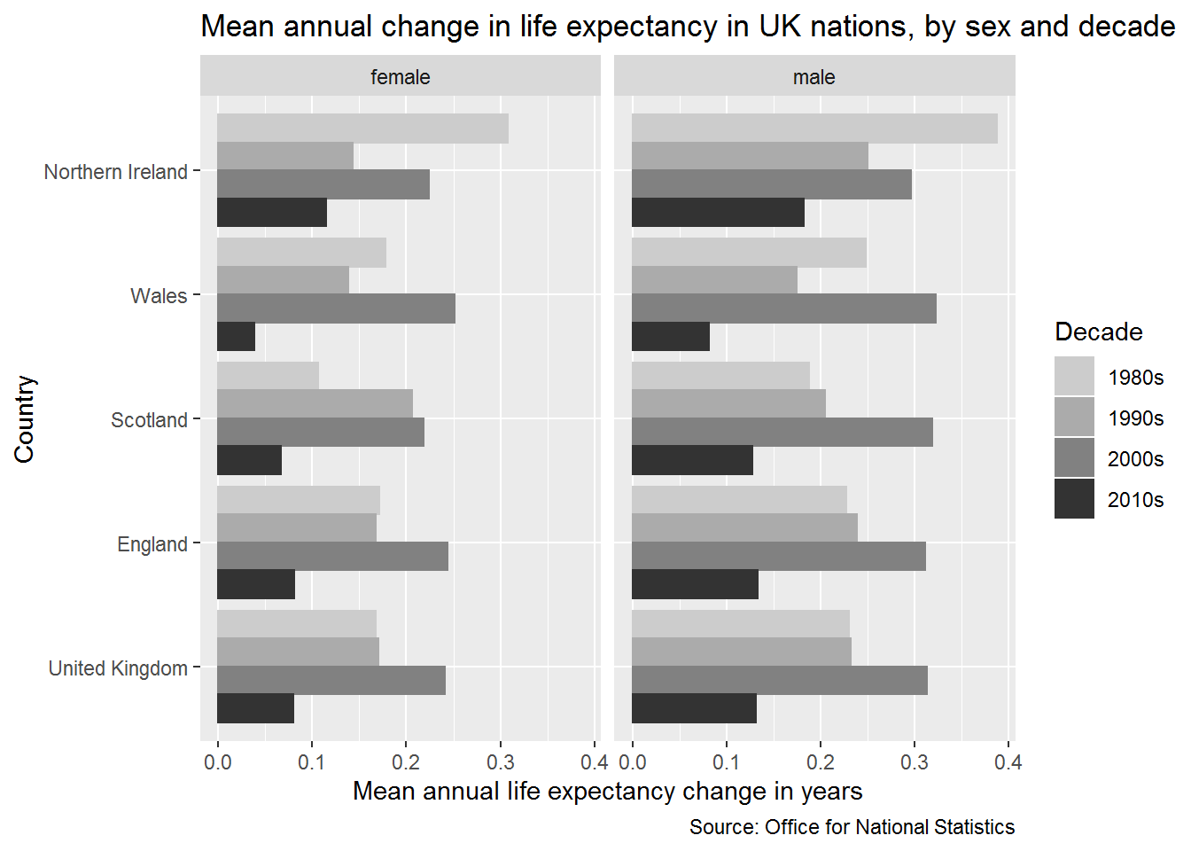

Figure 1 Average annual change in life expectancy in the UK and constituent nations, by sex and decade. (Source: ONS)

The appendix provides further analyses of trends in annual life expectancy gains in the UK and constituent nations. Figure 3A presents annual series in life expectancy trends in the UK and constituent nations, and Figure 4A and 5A looks at how correlated the annual life expectancy series are between males and females and each UK nation (i.e. it compares the correlation since 1980s in eight series of annual life expectancy changes, males and females in each of the UK’s four nations). The results presented in Figure 3A shows that, again with the exception of Northern Ireland, the low rate of average annual improvement seen in the 2010s is not driven by any single ‘bad year’, but is part of a continuing trend towards slowdown; if this downwards trend continues it suggests the overall average annual life expectancy gain observed by the end of the 2010s will be lower rather than higher than the already-exceptionally-low rates shown here. The presentation of annual series also shows that single years in which life expectancy fell rather than rose compared with the previous year are not in themselves exceptional; rather, it is a combination of both faster falls in life expectancy in ‘bad years’ combined with lower rates of gain in ‘good years’ that seem to be driving the recent trend towards slowdown.

The results presented in Figure 5A indicate that male and female trends within nations tend to be , but are not always, more strongly correlated with the same sex in other nations, than with the opposite sex in the same nation. This coupling of trends in strongest in Wales and England, weaker in Scotland, and weakest in Northern Ireland, where the between-sex correlations are weaker than between countries. However for all countries the correlations over time are above r = 0.5.

Table 1A compares estimates of average annual change in life expectancy by decade derived from the HMD and ONS data, and finds estimates to be very similar.

## Breakpoint analysis

These analyses are presented in the appendix, and indicate a breakpoint in improvement trends within one year of 2010 for all UK nation and sex combinations except males in Northern Ireland. These results are presented in Figure 6A and Table 3A. Figure 7A shows the sensitivity of this finding to model parameterisation (the choice of random number seed used in the breakpoint algorithm), and finds the same breakpoints to be identified in all instances except for females in Wales.

## ONS life expectancy projections

Figure 2 shows ONS life expectancy projections from 1971 to 2018, compared with observed life expectancy at birth in a black line. ONS life expectancies have, since 1971, tended to consistently under-predict the life expectancies that were achieved up until around 2010. After 2012, it appears life expectancy projections are over-predicting life expectancy gains instead, with the most recent projections returning to around those levels assumed in projections from the early 2000s.

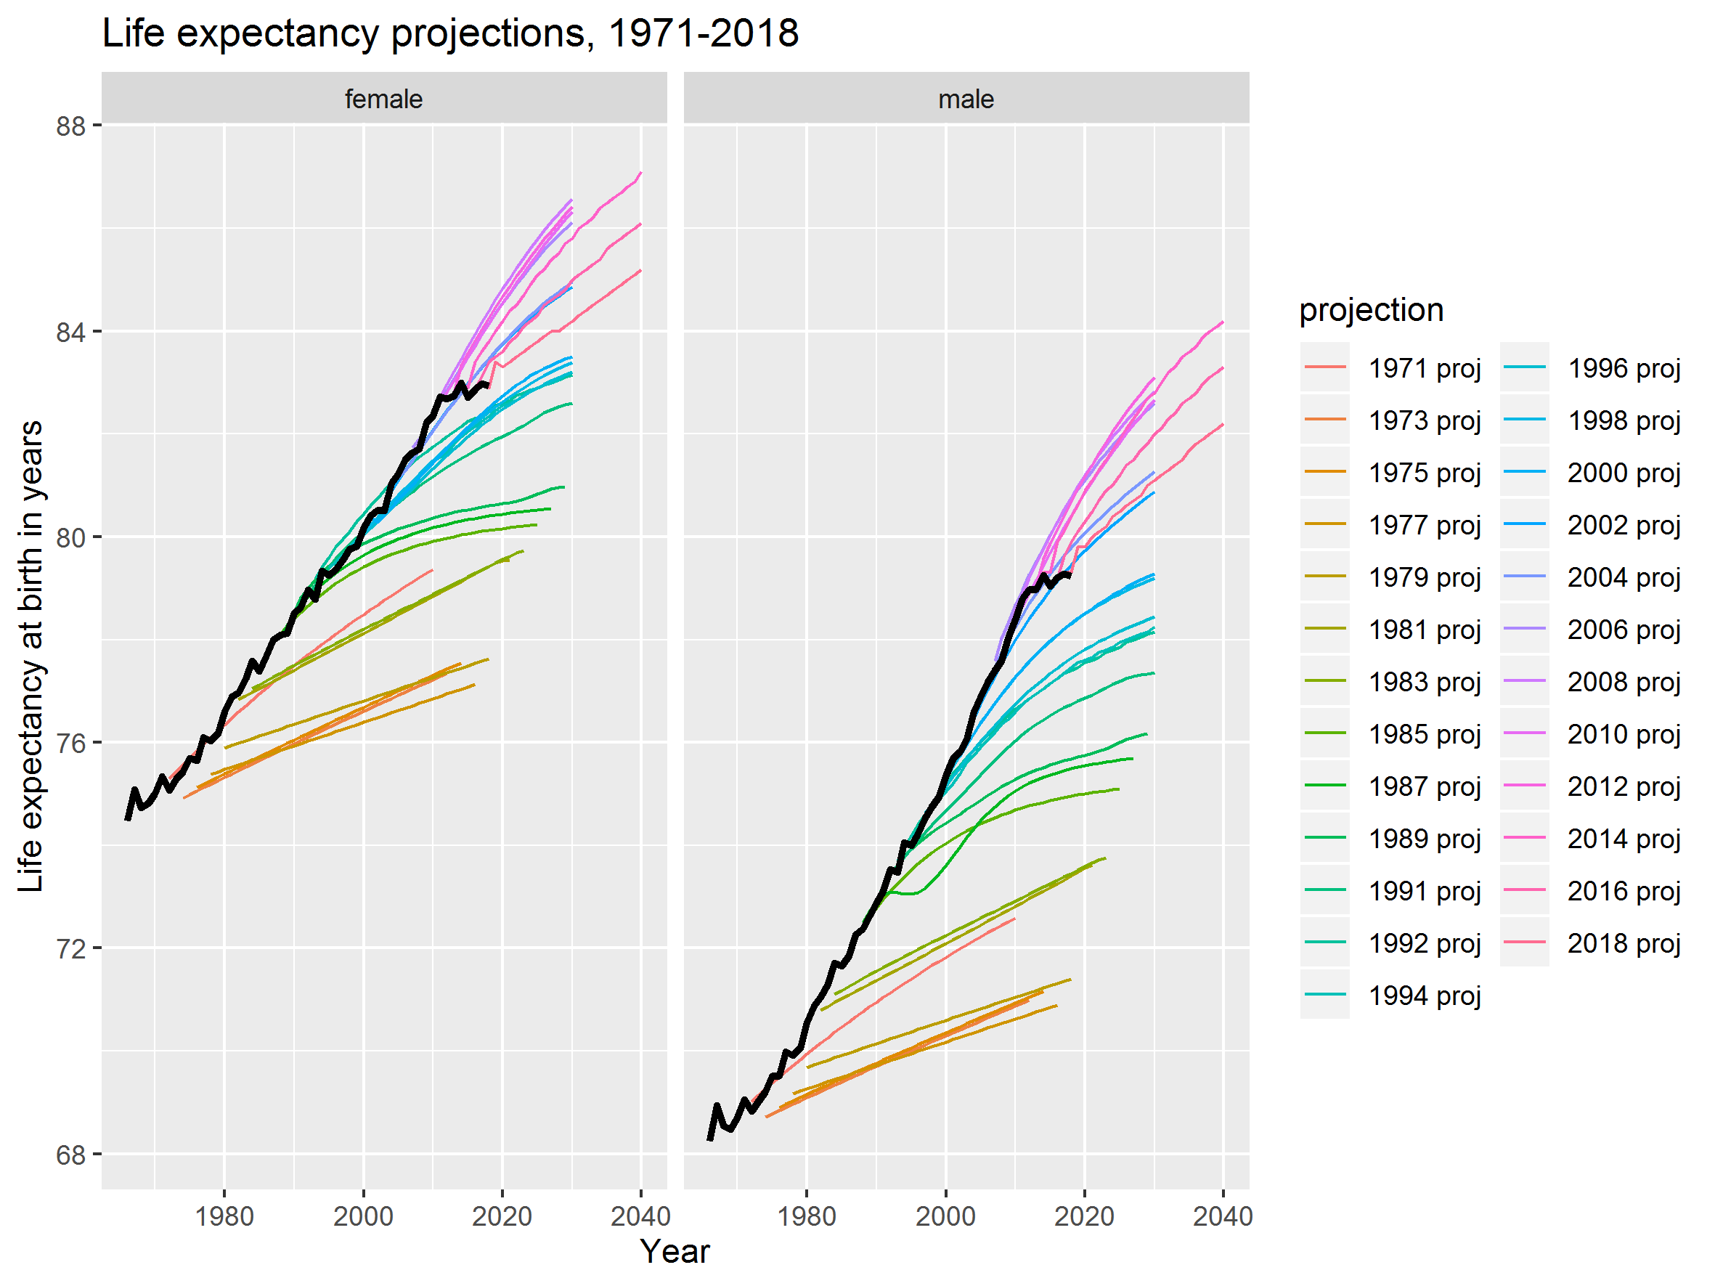

Figure 2 ONS UK life expectancy projections compared with observed life expectancy (black line)

Assumptions about different age-specific mortality rates affect conditional life expectancy (i.e. ex where x > 0) estimates too, as shown in the Lexis surfaces of conditional life expectancy for 2012-2018 projections shown in Figure 8A (for life expectancy at birth) and Figure 9A (for conditional life expectancy at ages in individual years) of the appendix. Appendix Figure 10A shows how the conditional life expectancies were modified between successive ONS projections; it shows, for instance, that there was little downgrading of conditional life expectancies for males up to around age 60, between the 2012 to 2014 projection, whereas there was moderate downgrading between these two revisions for females. After 2014 successive revisions have continued to downgrade projections at all ages, especially for males aged under 50 years between the 2016 and 2018 revisions.

Table 3 shows the average annual long-term change in life expectancy at birth assumed by each ONS projection from 2012 onwards, along with the standard deviation in the implied annual projections. For the UK as a whole, life expectancy was expected to improve by 0.137 years/year for females, and 0.149 years/year for males. By the 2018 the projected long-term improvement rates had been cut to 0.094 years/year for females (a 31% fall) and to 0.114 years/year for males (a 23% fall). It is important to note that even the 2012 projections were lower than the observed rates in the UK in the 1980s (female 0.168 years/year, male 0.230 years/year), 1990s (0.170 and 0.232 years/year respectively) and 2000s (0.241 and 0.313), and so may have been considered pessimistic/conservative estimates at the time.

Table 3 Implied mean long-term annual change (years/year) in life expectancy (Standard deviation) for different ONS projections, by UK and constituent nation, sex, and ONS projection revision

|  |  |  |  |  |  |  |  |  |
| --- | --- | --- | --- | --- | --- | --- | --- | --- |
|  | **Female by year** | | | | **Male by year** | | | |
| Country | 2012 | 2014 | 2016 | 2018 | 2012 | 2014 | 2016 | 2018 |
| United Kingdom | 0.137 (0.054) | 0.129 (0.046) | 0.115 (0.036) | 0.094 (0.032) | 0.149 (0.055) | 0.147 (0.055) | 0.134 (0.048) | 0.114 (0.041) |
| England | 0.135 (0.048) | 0.127 (0.045) | 0.113 (0.034) | 0.092 (0.034) | 0.147 (0.055) | 0.144 (0.055) | 0.132 (0.047) | 0.110 (0.037) |
| Scotland | 0.140 (0.049) | 0.131 (0.047) | 0.119 (0.040) | 0.100 (0.041) | 0.156 (0.055) | 0.156 (0.059) | 0.143 (0.050) | 0.122 (0.042) |
| Wales | 0.137 (0.049) | 0.131 (0.047) | 0.117 (0.038) | 0.098 (0.025) | 0.149 (0.059) | 0.149 (0.059) | 0.136 (0.049) | 0.118 (0.039) |
| Northern Ireland | 0.137 (0.054) | 0.129 (0.046) | 0.117 (0.038) | 0.096 (0.035) | 0.151 (0.055) | 0.149 (0.059) | 0.138 (0.049) | 0.116 (0.043) |

## Bayes Factor estimation of the extent of the slowdown

Figure 12A in the appendix shows the BF schedules for each proposed percentage slowdown as compared with the 1991-2010 trends. Fainter lines indicate estimates based on fewer years (such as 2011-2012 only), whereas darker lines indicate estimates also using more recent years, with the darkest line the schedule based on all years from 2011-2018 inclusive. The height of the schedules indicates the changing strength of the evidence; the addition of the 2018 life expectancy data substantially increased support for the belief that life expectancy improvements are below those observed from 1991-2010, as well as the magnitude of the slowdown.

These findings are summarised in Table 4, which shows the proposed percentage slowdown which maximises the BF, along with these maximised BFs for series of data which incorporate ever more years. For the UK as a whole, when using only 2011-2012 observations, the BF was maximised when a 16% slowdown (84% of previous rate) was assumed for females, with no slowdown identified for males. Using the currently complete series, including all observations from 2011-2018 inclusive, the BF was maximised when a 61% slowdown was assumed for both sexes, and the magnitude of the BF (support for belief in a slowdown) had also increased. The same 61% slowdown maximised the BF based on 2011-2018 data for both males and females in England. A similar proposed slowdown (59%) maximised the BF for males in Scotland, and a larger proposed slowdown, of 73%, for females in Scotland. In Wales somewhat larger proposed slowdown percentages (73% for females and 83% for males) maximised the BF. Only for males in Northern Ireland was evidence supporting belief in a substantial (50% or more) slowdown from earlier trends not identified.

|  |  |  |  |  |  |  |  |  |
| --- | --- | --- | --- | --- | --- | --- | --- | --- |
| **Population** | **Sex** | **2011-12** | **2011-13** | **2011-14** | **2011-15** | **2011-16** | **2011-17** | **2011-18** |
| United Kingdom | female | 16% (BF: 1.00004) | 30% (BF: 1.00020) | 15% (BF: 1.00007) | 61% (BF: 1.00135) | 54% (BF: 1.00125) | 52% (BF: 1.00137) | 61% (BF: 1.00216) |
| United Kingdom | male | 0% (BF: 1.00000) | 28% (BF: 1.00023) | 21% (BF: 1.00018) | 52% (BF: 1.00137) | 50% (BF: 1.00150) | 53% (BF: 1.00201) | 61% (BF: 1.00301) |
| England | female | 15% (BF: 1.00003) | 31% (BF: 1.00021) | 18% (BF: 1.00009) | 62% (BF: 1.00138) | 55% (BF: 1.00132) | 53% (BF: 1.00141) | 61% (BF: 1.00212) |
| England | male | 0% (BF: 1.00000) | 30% (BF: 1.00026) | 26% (BF: 1.00026) | 53% (BF: 1.00138) | 50% (BF: 1.00148) | 54% (BF: 1.00198) | 61% (BF: 1.00296) |
| Scotland | female | 49% (BF: 1.00042) | 22% (BF: 1.00013) | 1% (BF: 1.00000) | 54% (BF: 1.00134) | 58% (BF: 1.00179) | 57% (BF: 1.00208) | 73% (BF: 1.00383) |
| Scotland | male | 0% (BF: 1.00000) | 0% (BF: 1.00000) | 0% (BF: 1.00000) | 42% (BF: 1.00185) | 51% (BF: 1.00328) | 48% (BF: 1.00346) | 59% (BF: 1.00584) |
| Wales | female | 25% (BF: 1.00011) | 41% (BF: 1.00046) | 0% (BF: 1.00000) | 77% (BF: 1.00272) | 40% (BF: 1.00088) | 51% (BF: 1.00168) | 73% (BF: 1.00390) |
| Wales | male | 32% (BF: 1.00075) | 64% (BF: 1.00452) | 11% (BF: 1.00018) | 70% (BF: 1.00904) | 77% (BF: 1.01341) | 68% (BF: 1.01219) | 83% (BF: 1.02068) |
| Northern Ireland | female | 0% (BF: 1.00000) | 11% (BF: 1.00008) | 13% (BF: 1.00013) | 47% (BF: 1.00228) | 51% (BF: 1.00329) | 46% (BF: 1.00313) | 52% (BF: 1.00458) |
| Northern Ireland | male | 0% (BF: 1.00000) | 0% (BF: 1.00000) | 0% (BF: 1.00000) | 19% (BF: 1.00040) | 0% (BF: 1.00000) | 30% (BF: 1.00142) | 15% (BF: 1.00044) |

Table 4 Percent decline from 1991-2010 average annual life expectancy improvements and Bayes Factor, by collection of annual life expectancy series from 2011 onwards

## Comparison between Bayes Factor-maximising slowdowns and implied slowdowns from post-2012 ONS biennial projections

Table 5 shows how the average annual gain in life expectancy based on the Bayes Factor approach, which can be updated with every new annual life expectancy release, compares with the rates implied by each ONS biennial projection, (See Figure 12A in the appendix for the implied annual life expectancy series from each projection, and the associated repository for the code used to calculate these) for the UK as a whole and each constituent nation. Figure 3 shows this graphically for the UK only.

Table 5 Average annual long term improvement (years per year) in life expectancy based on Bayes Factor and ONS Biennial projections by sex and population

|  |  |  |  |  |  |
| --- | --- | --- | --- | --- | --- |
| **Population** | **Year** | **Female** | | **Male** | |
|  |  | **Bayes** | **ONS** | **Bayes** | **ONS** |
| United Kingdom | 2011 | 0.192 |  | 0.276 |  |
| United Kingdom | 2012 | 0.161 | 0.152 | 0.276 | 0.166 |
| United Kingdom | 2013 | 0.134 |  | 0.199 |  |
| United Kingdom | 2014 | 0.163 | 0.136 | 0.218 | 0.158 |
| United Kingdom | 2015 | 0.075 |  | 0.132 |  |
| United Kingdom | 2016 | 0.088 | 0.120 | 0.138 | 0.144 |
| United Kingdom | 2017 | 0.092 |  | 0.130 |  |
| United Kingdom | 2018 | 0.075 | 0.102 | 0.108 | 0.122 |
| England | 2011 | 0.195 |  | 0.280 |  |
| England | 2012 | 0.165 | 0.152 | 0.280 | 0.164 |
| England | 2013 | 0.134 |  | 0.196 |  |
| England | 2014 | 0.159 | 0.136 | 0.207 | 0.158 |
| England | 2015 | 0.074 |  | 0.132 |  |
| England | 2016 | 0.088 | 0.120 | 0.140 | 0.142 |
| England | 2017 | 0.091 |  | 0.129 |  |
| England | 2018 | 0.076 | 0.100 | 0.109 | 0.120 |
| Scotland | 2011 | 0.185 |  | 0.254 |  |
| Scotland | 2012 | 0.094 | 0.156 | 0.254 | 0.172 |
| Scotland | 2013 | 0.144 |  | 0.254 |  |
| Scotland | 2014 | 0.183 | 0.134 | 0.254 | 0.166 |
| Scotland | 2015 | 0.085 |  | 0.147 |  |
| Scotland | 2016 | 0.077 | 0.126 | 0.124 | 0.158 |
| Scotland | 2017 | 0.079 |  | 0.132 |  |
| Scotland | 2018 | 0.050 | 0.112 | 0.104 | 0.132 |
| Wales | 2011 | 0.159 |  | 0.210 |  |
| Wales | 2012 | 0.119 | 0.158 | 0.174 | 0.170 |
| Wales | 2013 | 0.094 |  | 0.092 |  |
| Wales | 2014 | 0.159 | 0.136 | 0.228 | 0.156 |
| Wales | 2015 | 0.037 |  | 0.077 |  |
| Wales | 2016 | 0.095 | 0.122 | 0.059 | 0.154 |
| Wales | 2017 | 0.078 |  | 0.082 |  |
| Wales | 2018 | 0.043 | 0.108 | 0.044 | 0.132 |
| Northern Ireland | 2011 | 0.192 |  | 0.249 |  |
| Northern Ireland | 2012 | 0.192 | 0.150 | 0.249 | 0.170 |
| Northern Ireland | 2013 | 0.170 |  | 0.249 |  |
| Northern Ireland | 2014 | 0.167 | 0.140 | 0.249 | 0.158 |
| Northern Ireland | 2015 | 0.101 |  | 0.201 |  |
| Northern Ireland | 2016 | 0.094 | 0.124 | 0.249 | 0.142 |
| Northern Ireland | 2017 | 0.103 |  | 0.174 |  |
| Northern Ireland | 2018 | 0.092 | 0.102 | 0.211 | 0.122 |

For the UK as a whole, the BF approach identified a similar average improvement as the 2012 biennial projection (0.161 years/year compared with 0.152 years/year) for females, but a much higher rate of improvement for males (0.276 years/year compared with 0.166 years/year). By 2018 the BF approach produced more pessimistic estimates for both sexes than are implied by the 2018 ONS projection (0.075 years/year compared with 0.102 years/year for females; 0.108 years/year compared with 0.122 years/year for males), with an apparent turning point in the Bayes Factor estimates being 2014. This is shown even more clearly in Figure 3, which presents the projected gains in weeks/year rather than years/year.

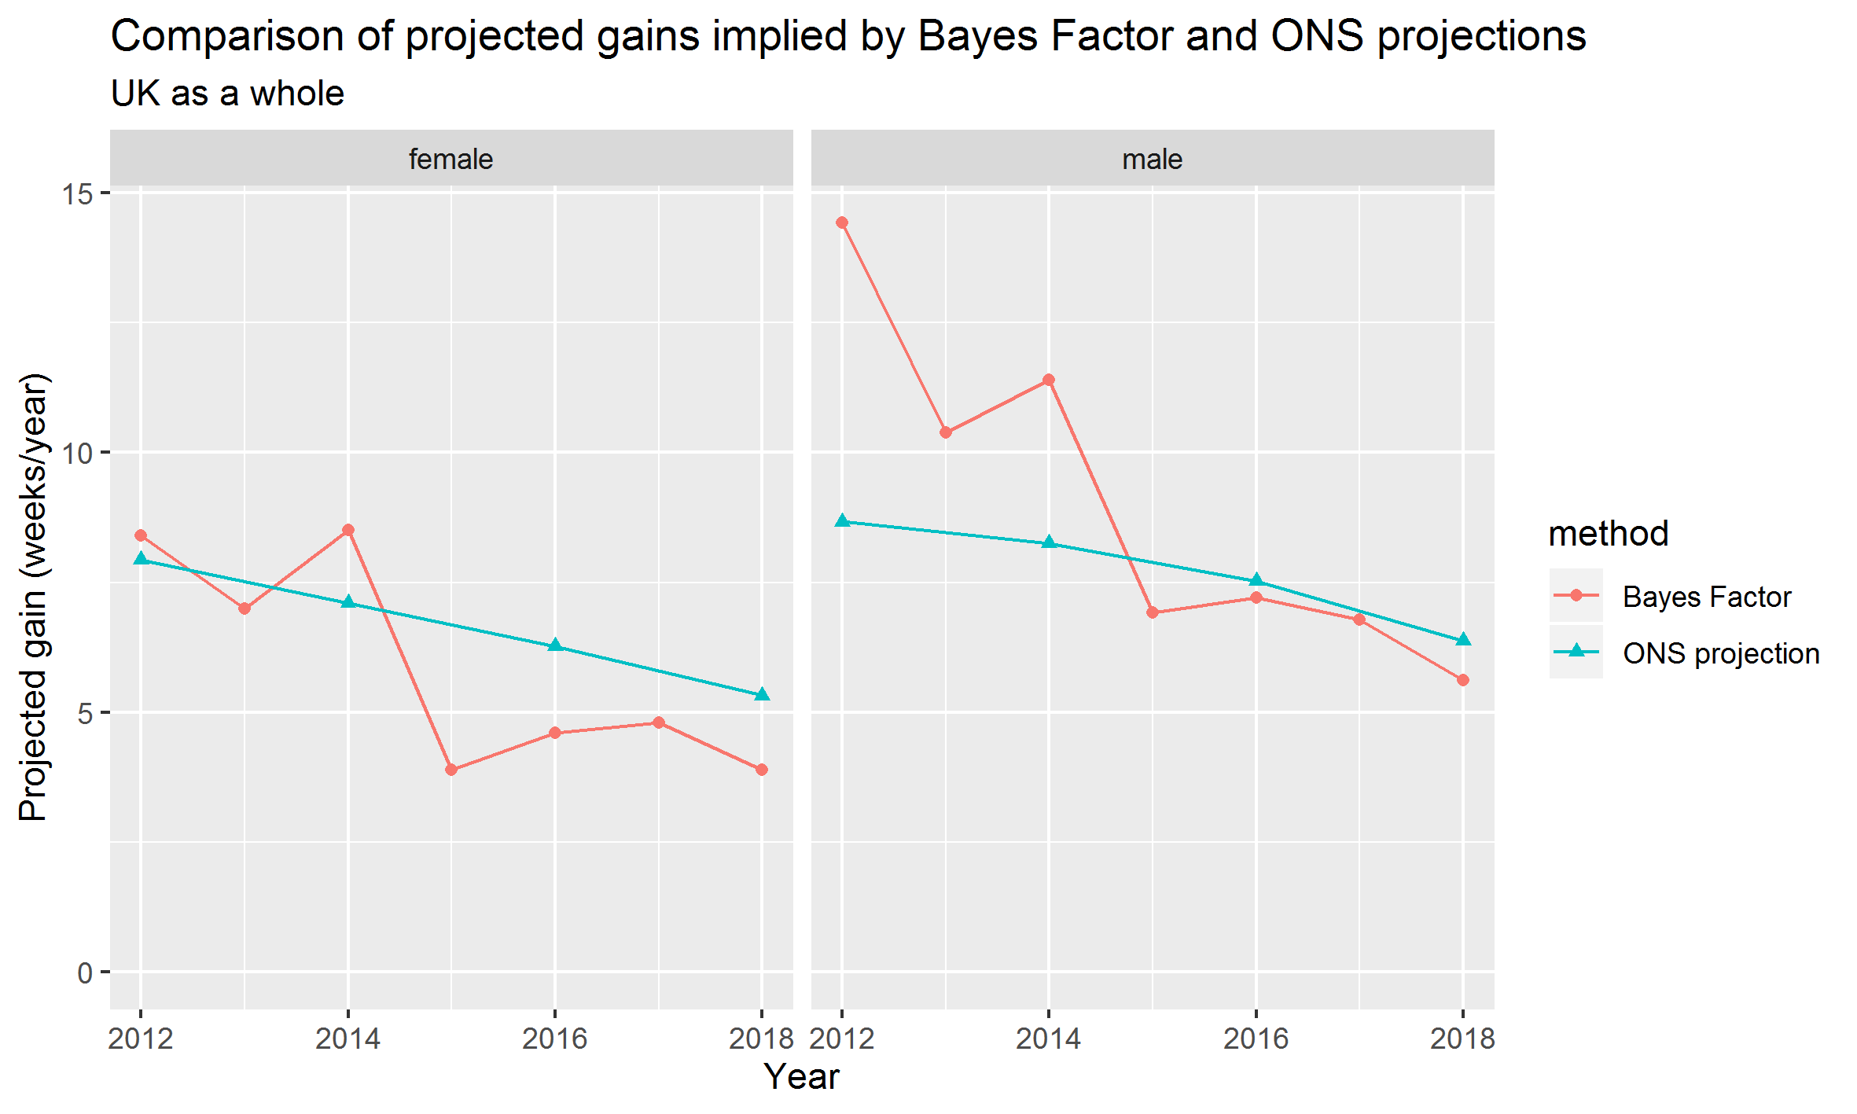

Figure 3 Comparison between implied annual gains (in weeks/year) for the UK based on Bayes Factor maximisation approach and ONS biennial projections

# Discussion

## Summary of Descriptive Comparisons

This paper has attempted to bring together a wide range of analyses together in order to better the UK’s recent slowdown in longevity improvement in a longer term and international context. These analyses all use publicly available data and the code required to run them is also freely available, and so can be run, modified, and updated as required.

Some broad interpretations of the international comparisons (using HMD) are as follows: there is a general tendency for life expectancies to increase in high income nations over time, but there is also some systemic variation around the average rate of increase in each decade. Populations which experienced comparatively large annual gains in life expectancy in the 2010s include formerly ‘second world’ nations such as Belarus, Ukraine, Russia, Lithuania and Poland, many of which had lower life expectancies in the 1980s and 1990s than Western ‘first world’ nations, and became active members and trading partners of the EU in the 2000s. This highlights that a slowdown in life expectancy increases is not a universal phenomenon, and is largely localised to populations which were in the ‘first world’ group of nations since the end of the Second World War, and which had already experienced faster average gains in life expectancy in previous decades. However, it is within this historic ‘first world’ group of nations that a notable divergence is evident, with particularly pronounced life expectancy reveresals and slowdowns in the 2010s in the USA and the UK respectively.

Within the UK, and using lifetable data from the ONS, the slowing in average annual gains in life expectancy is evident in most UK nations, with the possible exception of males in Northern Ireland. The breakpoint analysis identified for Northern Irish males a breakpoint in the mid 1980s rather than around 2010, as with other populations, which may be due to the legacy of sectarian conflict affecting this population from the 1970s. For the UK as a whole, the breakpoint identified was largely congruent with existing published research, (6) and compatible with the argument that austerity measures represent a new deleterious form of exposure for UK nations which made earlier rates of annual improvement harder to achieve.

Up until 2010, ONS forecasts of life expectancy gains consistently underestimated rates of improvement, and the assumptions were consistently uprated and made more optimistic in successive revisions.(41) However, since 2010 the life expectancy improvement assumptions made by the ONS have been too optimistic, and now been successively made more pessimistic for the fourth revision in a row.

## Bayes Factor Analysis

The Bayes Factor analysis showed that, for each additional year of data added to the series of observations from 2012 onwards, the strength of the evidence in support of the belief that rates of life expectancy improvement are substantially below those observed in the 1990s and 2000s increased. They also indicated that, though the ONS projections have been revised downwards over successive revisions since 2012, they may still require further downwards revision if the slow annual gains seen since around 2012 were to continue.

The Bayes Factor approach was presented both as an external means of comparing the ONS projections against observed trends, and as a potential ‘stopgap’ method for identifying whether future projections are more likely to be revised upwards or downwards in those years before new projection estimates are produced. Usually the ONS population projections are released every two years, but the next projection may be delayed by more than two years due both to the planned 2021 census, and uncertainty in the effects that Covid-19 may have on life expectancy in both 2020 and in the longer term.

A rule of thumb applied to Bayes Factors is that ratios below 10 should be considered 'anecdotal'. And although the magnitude of the Bayes Factor has increased, especially with the addition of the 2018 period life expectancy observations, they remain substantially below 10. However, they are still informative, and represent a novel method for observing the impact that a single additional data point has on the strength of evidence for various degrees of proposed longevity slowdown, and so a useful method of continually monitoring mortality trends in the UK between biennial releases by the ONS.

The Bayes Factor exercise can be re-run whenever the ONS release new single-year lifetables for the UK and its nations, and should be rerun when the 2019 lifetable becomes available. This will help inform researchers and users of longevity data as to whether the 2020 ONS projection is likely to further downgrade its projections of UK longevity gains, and if so by what magnitude. Actuarial research, published January 2020 as part of the Continuous Monitoring Investigation suggests that 2019 was a relatively good year for mortality improvements for England & Wales, as compared with those observed from 2009 onwards, and so the 2019 single year life expectancy may be a slight improvement over 2018 values. (42) However it still seems likely that the overall rate of improvement in life expectancies observed over the 2010s will still be substantially lower in the UK than in the previous two decades.

## Conclusion

This paper has presented a large range of linked analyses using publicly available data and code, in order to better understand the recent slowdown of life expectancy gains in the UK in a broader international and historical context. It has blended both extensive descriptive statistics with an approach for formally assessing and updating beliefs about competing hypotheses as and when new data becomes available. Though this Bayes Factor approach is applied here to assess and allow updating of strength of beliefs about mortality based on annual data, the same kind of exercise can be used with frequently updated data, such as the changing level of support for different hypotheses about the additional mortality burdens associated with Covid-19 as and when new data becomes updated quarterly, monthly, weekly or even daily.

# Bibliography

1. Hiam L, Dorling D. Rise in mortality in England and Wales in first seven weeks of 2018. BMJ. 2018 Mar 14;360:k1090.

2. Hiam L, Dorling D, McKee M. The cuts and poor health: when and how can we say that one thing causes another? J R Soc Med. 2018 Jun;111(6):199–202.

3. Hiam L, Harrison D, McKee M, Dorling D. Why is life expectancy in England and Wales “stalling”? J Epidemiol Community Health. 2018 Feb 20;72(5):404–408.

4. Hiam L, Dorling D, Harrison D, McKee M. What caused the spike in mortality in England and Wales in January 2015? J R Soc Med. 2017 Apr;110(4):131–137.

5. Hiam L, Dorling D, McKee M. Rise in mortality-when will the government take note? BMJ. 2018 Jun 25;361:k2747.

6. Fenton L, Minton J, Ramsay J, Kaye-Bardgett M, Fischbacher C, Wyper GMA, et al. Recent adverse mortality trends in Scotland: comparison with other high-income countries. BMJ Open. 2019 Oct 31;9(10):e029936.

7. Green MA, Dorling D, Minton J, Pickett KE. Could the rise in mortality rates since 2015 be explained by changes in the number of delayed discharges of NHS patients? J Epidemiol Community Health. 2017 Nov;71(11):1068–1071.

8. Green M, Dorling D, Minton J. The Geography of a rapid rise in elderly mortality in England and Wales, 2014-15. Health Place. 2017 Feb 12;44:77–85.

9. Lambie-Mumford H, Green MA. Austerity, welfare reform and the rising use of food banks by children in England and Wales. Area. 2017 Sep;49(3):273–279.

10. Stuckler D, Basu S. The Body Economic: Eight experiments in economic recovery, from Iceland to Greece. London: Penguin; 2013.

11. Karanikolos M, Mladovsky P, Cylus J, Thomson S, Basu S, Stuckler D, et al. Financial crisis, austerity, and health in Europe. Lancet. 2013 Apr 13;381(9874):1323–1331.

12. McKee M, Karanikolos M, Belcher P, Stuckler D. Austerity: a failed experiment on the people of Europe. Clin Med. 2012 Aug;12(4):346–350.

13. Raleigh V. Trends in life expectancy in EU and other OECD countries: Why are improvements slowing? 2019 Feb.

14. Public Health England. Recent trends in mortality in England: review and data packs - GOV.UK. 2018.

15. Murphy M, Luy M, Torrisi O. Stalling of mortality in the United Kingdom and Europe: an analytical review of the evidence [Internet]. LSE; 2019 Nov [cited 2019 Dec 10]. Report No.: 11-19. Available from: http://www.lse.ac.uk/social-policy/Assets/Documents/PDF/working-paper-series/11-19-Mike-Murphy.pdf

16. Marshall L, Finch D, Cairncross L, Bibby J. Mortality and life expectancy trends in the UK: stalling progress. Health Foundation; 2019 Nov.

17. Raleigh VS. Stalling life expectancy in the UK. BMJ. 2018 Sep 27;362:k4050.

18. Aiken LH, Sloane DM, Bruyneel L, Van den Heede K, Griffiths P, Busse R, et al. Nurse staffing and education and hospital mortality in nine European countries: a retrospective observational study. Lancet. 2014 May 24;383(9931):1824–1830.

19. Case A, Deaton A. Rising morbidity and mortality in midlife among white non-Hispanic Americans in the 21st century. Proc Natl Acad Sci USA. 2015 Dec 8;112(49):15078–15083.

20. Case A, Deaton A. Mortality and morbidity in the 21st century. BPEA Conference Drafts. 2017.

21. Minton J, Green M, McCartney G, Shaw R, Vanderbloemen L, Pickett K. Two cheers for a small giant? Why we need better ways of seeing data: A commentary on: “Rising morbidity and mortality in midlife among White non-Hispanic Americans in the 21st century”. Int J Epidemiol. 2017 Feb 1;46(1):356–361.

22. Hiam L, Dorling D, Harrison D, McKee M. Why has mortality in England and Wales been increasing? An iterative demographic analysis. J R Soc Med. 2017 Apr;110(4):153–162.

23. Dorling D, Rigby J. Recession, austerity and life expectancy. Ir Med J. 2019 Feb 14;112(2):876.

24. Watkins J, Wulaningsih W, Da Zhou C, Marshall DC, Sylianteng GDC, Dela Rosa PG, et al. Effects of health and social care spending constraints on mortality in England: a time trend analysis. BMJ Open. 2017 Nov 15;7(11):e017722.

25. Lee RD, Carter LR. Modeling and forecasting U.S. mortality. J Am Stat Assoc. 1992 Sep;87(419):659–671.

26. Bijak J, Bryant J. Bayesian demography 250 years after Bayes. Popul Stud (NY). 2016 Feb 23;70(1):1–19.

27. King G. Demographic Forecasting. 2008;

28. Renshaw AE, Haberman S. A cohort-based extension to the Lee–Carter model for mortality reduction factors. Insurance: Mathematics and Economics. 2006 Jun;38(3):556–570.

29. Willets R. THE COHORT EFFECT : INSIGHTS AND EXPLANATIONS. Willets Consulting Limited; 2003 p. 1–38.

30. Kermack WO, McKendrick AG, McKinlay PL. Death-rates in Great Britain and Sweden. Some general regularities and their significance. Int J Epidemiol. 2001 Aug;30(4):678–683.

31. Minton J, Vanderbloemen L, Dorling D. Visualizing Europe’s demographic scars with coplots and contour plots. Int J Epidemiol. 2013 Aug;42(4):1164–1176.

32. Almond D. Is the 1918 Influenxa Pandemic Over? Long-Term Effects of In Utero Influenza Exposure in the Post-1940 U.S. Population. Journal of Political Economy2. 2006;114(4):672–712.

33. Willets RC, Gallop AP, Leandro PA, Lu JLC, Macdonald AS, Miller KA, et al. Longevity in the 21st century. Br Actuar J. 2004 Oct 1;10(4):685–832.

34. Pascariu MD, Lenart A, Canudas-Romo V. The maximum entropy mortality model: forecasting mortality using statistical moments. Scand Actuar J. 2019 Mar 29;1–25.

35. White KM. Longevity Advances in High-Income Countries, 1955-96. Popul Dev Rev. 2002 Mar;28(1):59–76.

36. Christensen K, Doblhammer G, Rau R, Vaupel JW. Ageing populations: the challenges ahead. Lancet. 2009 Oct 3;374(9696):1196–1208.

37. Pascariu MD, Canudas-Romo V, Vaupel JW. The double-gap life expectancy forecasting model. Insurance: Mathematics and Economics. 2018 Jan;78:339–350.

38. Torri T, Vaupel JW. Forecasting life expectancy in an international context. Int J Forecast. 2012 Apr;28(2):519–531.

39. Box GEP, Jenkins GM, Reinsel GC, Ljung GM. Time Series Analysis: Forecasting And Control (wiley Series In Probability And Statistics). 5th ed. Hoboken, New Jersey: Wiley; 2015.

40. Muggeo VMR. Estimating regression models with unknown break-points. Stat Med. 2003 Oct 15;22(19):3055–3071.

41. ONS. National Population Projections Accuracy Report [Internet]. ONS; 2016 Feb [cited 2020 Jan 7]. Available from: https://www.ons.gov.uk/peoplepopulationandcommunity/populationandmigration/populationprojections/methodologies/nationalpopulationprojectionsaccuracyreport

42. Anon A. England & Wales mortality monitor - January 2020 [Internet]. Institute and Faculty of Actuaries; 2020 Jan [cited 2020 Jan 30]. Available from: https://www.actuaries.org.uk/system/files/field/document/Mortality%20monitor%20Q4%202020%20v01%202020-01-28.pdf