Devil’s Advocacy

Jon Minton

15 August 2019

# Introduction

The Bayes Factor approach has been used to test for both the likelihood and magnitude of various proposed levels of life expectancy slowdown. By assuming that 1990-2012 is the ‘before slowdown’ period and the years after the ‘after-slowdown’ period. After combining five successive observations, annual changes in life expectancy, a Bayes Factor of around 1.003 was produced for a proposed slowdown of around 77% of previous levels.

The exercise followed from trying to formalise an intuitive ‘reading’ of the life expectancy series for the UK, which is that the curve in life expectancy looks much ‘flatter’ after around 2012 than from 1990 up to that year. Five observations, annual changes since 2012, were used to investivate the relative likelihood of a slowdown compared with no slowdown.

However, looking at the time series of life expectancy over time, there appears to be another way of interpreting the series. This is that life expectancy gains briefly *increased* after the 2008 recession, before *returning to their previous trajectory* in the last few years. Graphically, the two proposed interpretations can be represented as follows

source("scripts/load_packages_and_functions.R")  
  
e0_uk <- read_csv("data/e0_uk.csv")

## Parsed with column specification:  
## cols(  
## year = col_double(),  
## sex = col_character(),  
## e0 = col_double()  
## )

The Slowdown interpretation, which the majority of research to date has focused on, proposes that, after a certain date (2012), the rate of annual improvement in life expectancy has slowed. Graphically, this is presented as two discontinuous lines of life expectancy over time, a higher improvement rate period, covering 1990-2012, and a lower improvement (or even zero improvement) rate period, for those years after 2012. This looks as follows:

e0_uk %>%   
 filter(year >= 1990) %>%   
 mutate(period = case_when(  
 year <= 2012 ~ "Before slowdown",  
 year > 2012 ~ "After slowdown"  
 )) %>%   
 ggplot(aes(x = year, y = e0, group = sex, colour = sex, linetype = sex)) +  
 geom_point() +   
 stat_smooth(aes(x = year, y = e0, group = paste0(sex, period), colour = sex, linetype = sex),   
 method = "lm", se = F) +   
 labs(x = "Year", y = "Period life expectancy at birth",  
 title = "Slowdown interpretation",  
 caption = "Sources: HMD; ONS for 2017") +   
 geom_vline(xintercept = 2012) +   
 annotate(geom = "text", x = 2012, y = 75, label = "2012", colour = "darkred", angle = 90) +   
 scale_x_continuous(breaks = seq(1990, 2015, by = 5))

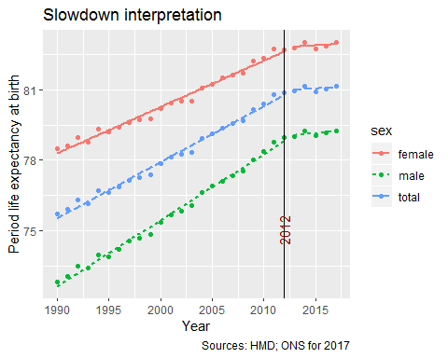

Another possible interpretation of the same data is that the last period is broadly typical of improvement rates over the whole period. Instead, the ‘atypical’ period was in the years immediately following the 2008 recession, during which life expectancy improvement rates briefly *increased*. Under this interpretation, the apparent flattening in the curve is due to a relatively typical period of life expectancy improvmeent following an atypically *good* period of improvement, rather than being a genuine slowdown from a typical to a slow improvement period. Graphically, this alternative reading of the data looks as follows:

e0_uk %>%   
 filter(year >= 1990) %>%   
 mutate(period = case_when(  
 between(year, 2009, 2014) ~ "GFC Bump",  
 TRUE ~ "Improvement as usual"  
 )) %>%   
 ggplot(aes(x = year, y = e0, group = sex, colour = sex, linetype = sex)) +  
 geom_point() +   
 stat_smooth(aes(x = year, y = e0, group = paste0(sex, period), colour = sex, linetype = sex),   
 method = "lm", se = F) +   
 labs(x = "Year", y = "Period life expectancy at birth",  
 title = "GFC Bump Interpretation",  
 caption = "Sources: HMD; ONS for 2017") +   
 geom_vline(xintercept = 2009) +   
 geom_vline(xintercept = 2014) +   
 scale_x_continuous(breaks = seq(1990, 2015, by = 5))

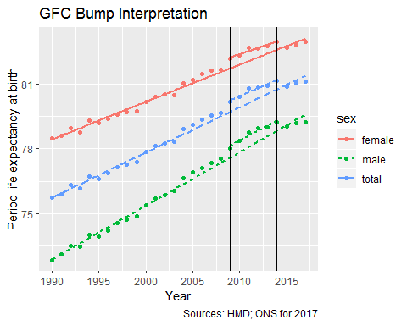

Both of these interpetations are based on the same number of continuous observations of values that appear discordant with the overall series. Both interpretations also appear theoretically justifiable: Whereas the proposed mechanism for the slowdown interpretation is that Austerity implemented in the post-GFC period has led to a substantial deterioration of health and social care services, with consequent adverse effects on population health, the proposed mechanism for the GFC bump would be that reductions in dependable disposible income would lead to, on the average, a higher proportion of personal spend being salugenic rather than pathogenic. The most obvious example of this would be if, as a result of having less disposible income, the UK population cannot afford to drive as much, and so faces a reduced exposure to vehicle-related mortality. Another example would include reduced alcohol consumption, and so a reduced hazard of alcohol-related mortality. In the conclusion of this document, some of the testable implications of the GFC ‘bump’ hypothesis will be considered further.

# Graphs of annual change

Both the Slowdown and the GFC Bump interpretations can be expressed through graphs of annual changes in life expectancy, rather than life expectancy alone. In both graphs of annual change, points are added to some line segments. These indicate the points that are considered ‘atypical’ from the perspective of the interpretation under consideration.

The graph showing annual changes under the GFC Bump interpretation is shown in the following:

e0_uk %>%   
 group_by(sex) %>%   
 arrange(year) %>%   
 mutate(ch_e0 = e0 - lag(e0)) %>%   
 filter(year >= 1990) %>%   
 ggplot(aes(x = year, y = ch_e0)) +  
 geom_line() +   
 geom_point(aes(x = year, y= ch_e0), inherit.aes = FALSE,   
 data = . %>% filter(between(year, 2009, 2013))  
 ) +  
 labs(x = "Year", y = "Change in life expectancy from previous year",  
 title = "Annual changes in life expectancy in the UK since 1990",  
 caption = "Sources: HMD; ONS for 2017") +   
 geom_vline(xintercept = 2008) + geom_vline(xintercept = 2014) +   
 scale_x_continuous(breaks = seq(1990, 2015, by = 5)) +   
 geom_hline(yintercept = 0) +  
 facet_grid(sex ~ .) +   
 theme_minimal()

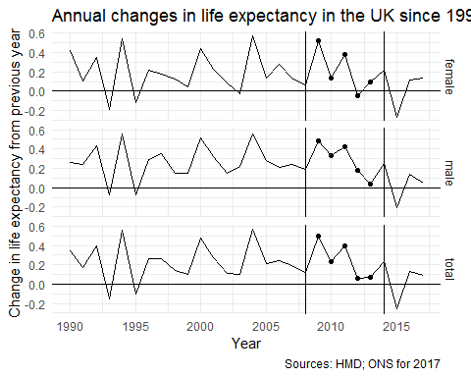

Of these five observations, the last two do not like particular ‘good’ years, with a small decline in life expectancy observed for one year for females. Also the improvement years are not higher than those observed since 1990 previously. However, the use of five observations makes meaningful comparison with the previous exercise more straightforward.

Let’s now calculate the average change and standard deviation around this for the series excluding these five points. This will form the new Null model specification.

devils_summaries <-   
 e0_uk %>%   
 group_by(sex) %>%   
 arrange(year) %>%   
 mutate(ch_e0 = e0 - lag(e0)) %>%   
 filter(year >= 1990) %>%  
 filter(!between(year, 2009, 2013)) %>%   
 group_by(sex) %>%   
 summarise(mu_ch = mean(ch_e0),   
 var_ch = var(ch_e0)  
 )  
  
devils_summaries

## # A tibble: 3 x 3  
## sex mu_ch var_ch  
## <chr> <dbl> <dbl>  
## 1 female 0.166 0.0445  
## 2 male 0.226 0.0364  
## 3 total 0.194 0.0404

The means are somewhat lower than previously calculated (under the Slowdown interpretation); the variances are similar

# Bayes factors

As when evaluating the Slowdown interpretion, the GFC Bump interpretation compares the relative likelihood of the assumption that life expectancy changes in the ‘atypical’ period were different from those in the ‘typical’ period, to the assumption that they were the same. Unlike with the Slowdown interpretation, the proposed differences are all higher rather than lower than the ‘typical’ period, with proposed improvement levels between 100% and 200% of their ‘typical period’ levels.

Using the first year of the atypical period under the GFC Bump interpretion alone, the Bayes Factor schedule looks as follows:

e0_uk_bf <-   
 e0_uk %>%   
 group_by(sex) %>%   
 arrange(year) %>%   
 mutate(ch_e0 = e0 - lag(e0)) %>%   
 filter(year >= 1990) %>%  
 nest() %>%   
 crossing(drop_end = 2008:2013) %>%   
 mutate(  
 bayes_df = map2(  
 drop_end, data, ~calc_devils_bayes_factors(drop_period = c(2008, .x), full_period = c(1990, 2016), outcome_var = ch_e0, dta = .y)  
 )  
 ) %>%  
 select(sex, drop_end, bayes_df) %>%   
 unnest() %>%   
 mutate(  
 period = paste0("2008-", str_sub(drop_end, 3,4))  
 )

## Joining, by = c("year", "e0", "ch_e0")  
## Joining, by = c("year", "e0", "ch_e0")  
## Joining, by = c("year", "e0", "ch_e0")  
## Joining, by = c("year", "e0", "ch_e0")  
## Joining, by = c("year", "e0", "ch_e0")  
## Joining, by = c("year", "e0", "ch_e0")  
## Joining, by = c("year", "e0", "ch_e0")  
## Joining, by = c("year", "e0", "ch_e0")  
## Joining, by = c("year", "e0", "ch_e0")  
## Joining, by = c("year", "e0", "ch_e0")  
## Joining, by = c("year", "e0", "ch_e0")  
## Joining, by = c("year", "e0", "ch_e0")  
## Joining, by = c("year", "e0", "ch_e0")  
## Joining, by = c("year", "e0", "ch_e0")  
## Joining, by = c("year", "e0", "ch_e0")  
## Joining, by = c("year", "e0", "ch_e0")  
## Joining, by = c("year", "e0", "ch_e0")  
## Joining, by = c("year", "e0", "ch_e0")

First year only

e0_uk_bf %>%   
 filter(period == "2008-09") %>%   
 mutate(perc = 100 * perc) %>%   
 ggplot(aes(x = perc, y = bayes_factor)) +  
 geom_line() +   
 geom_ribbon(aes(ymin = 1, x = perc, ymax = bayes_factor,fill = is_pos),   
 data = e0_uk_bf %>%   
 filter(period == "2008-09") %>%   
 mutate(perc = 100 * perc) %>%  
 mutate(is_pos = bayes_factor > 1),  
 inherit.aes = FALSE, alpha = 0.2) +   
 facet_wrap(~sex) +  
 scale_y_continuous(limits = c(0.999, 1.005),   
 breaks = seq(0.999, 1.0050, by = 0.001)  
   
 ) +  
 geom_hline(yintercept = 1) +   
 labs(  
 x = "Percentage of previous improvement",  
 y = "Bayes Factor\n(>1 means support for Alternative Hypothesis",  
 title = "Bayes Factor for various proposed levels of GFC Speedup"  
 ) +   
 guides(fill = FALSE)

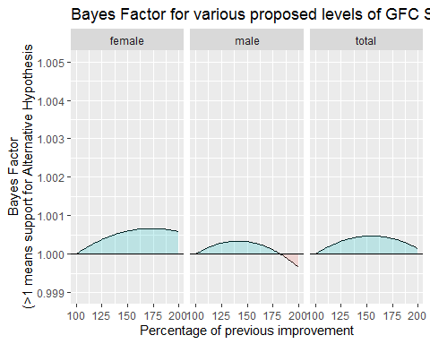

This first observation provides very slight support for the hypothesis that there was a post 2008 slowdown. However, it appears to provide slightly stronger support for a slowdown in females than males. This does not appear immediately consonant with the most plausible mechanisms for a recessionary ‘bump’ in life expectancy, which may be expected to lead to greater improvements in males than females, as most of the pathogenic behaviours that a fall in discretionary spend may be assumed to curtail generally tend to affect male mortality hazards (due to higher baseline risks) than female mortality hazards. (A converse case could also be made, however: the effect of a recession can be expected to reduce discretionary spend, leading to faster rates of improvement in males than females, as males had previously converted more of their discretionary spend into pathogenic health behaviours; but also the effect of a recession can be expected to lead to more unemployment and under-employment, adversely affecting wellbeing in both genders, which in males tends to get converted into despair-related mortality, in particular drug-related deaths and suicide, at a higher rate than in females. There are threfore mechanisms by which a recession could lead to an expansion or a contraction in gender differences in mortality, and the above differences in schedules, based on a single obervation, are not conclusive in any way.)

The following shows the effect of adding a second observation:

e0_uk_bf %>%   
 filter(period %in% c("2008-09", "2008-10")) %>%   
 mutate(perc = 100 * perc) %>%   
 ggplot(aes(x = perc, y = bayes_factor, alpha = period)) +  
 geom_line() +   
 geom_ribbon(aes(  
 ymin = ifelse(is_pos, 1, bayes_factor),   
 ymax = ifelse(is_pos, bayes_factor, 1),   
 x = perc, group = paste0(is_pos, period),  
 fill = is_pos  
 ),   
 data = e0_uk_bf %>%   
 filter(period %in% c("2008-09", "2008-10")) %>%   
 mutate(perc = 100 * perc) %>%  
 mutate(is_pos = bayes_factor > 1),  
 inherit.aes = FALSE, alpha = 0.2) +   
 facet_wrap(~sex) +  
 scale_y_continuous(limits = c(0.999, 1.005),   
 breaks = seq(0.999, 1.0050, by = 0.001)  
   
 ) +  
 scale_alpha_discrete("Period", range = c(0.5, 1), breaks = c("2008-09", "2008-10")) +  
 geom_hline(yintercept = 1) +   
 labs(  
 x = "Percentage of previous improvement",  
 y = "Bayes Factor\n(>1 means support for Alternative Hypothesis",  
 title = "Bayes Factor for various proposed levels of slowdown",  
 subtitle = "Based on periods 2008-09, and 2008-10"  
 ) +  
 guides(fill = FALSE)

## Warning: Using alpha for a discrete variable is not advised.

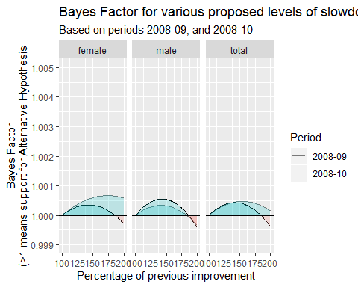

With two observations, the support for any kind of GFC Bump has decreased, and the most likely quantity of the ‘bump’ has decreased - for females and total - as well. This might be expected if the Bump were inherently transient in nature, but if it were then this undermines the broader argument of the GFC Bump interpretation. Namely, that the effect of the bump on life expectancy were long enough to give the impression that a return to typical rates of improvement looks like a Slowdown.

The following figure adds the third observation in the series:

e0_uk_bf %>%   
 filter(period %in% c("2008-09", "2008-10", "2008-11")) %>%   
 mutate(perc = 100 * perc) %>%   
 ggplot(aes(x = perc, y = bayes_factor, alpha = period)) +  
 geom_line() +   
 geom_ribbon(aes(  
 ymin = ifelse(is_pos, 1, bayes_factor),   
 ymax = ifelse(is_pos, bayes_factor, 1),   
 x = perc, group = paste0(is_pos, period),  
 fill = is_pos  
 ),   
 data = e0_uk_bf %>%   
 filter(period %in% c("2008-09", "2008-10", "2008-11")) %>%   
 mutate(perc = 100 * perc) %>%  
 mutate(is_pos = bayes_factor > 1),  
 inherit.aes = FALSE, alpha = 0.2) +   
 facet_wrap(~sex) +  
 scale_y_continuous(limits = c(0.999, 1.005),   
 breaks = seq(0.999, 1.0050, by = 0.001)  
   
 ) +  
 scale_alpha_discrete("Period", range = c(0.5, 1), breaks = c("2008-09", "2008-10", "2008-11")) +  
 geom_hline(yintercept = 1) +   
 labs(  
 x = "Percentage of previous improvement",  
 y = "Bayes Factor\n(>1 means support for Alternative Hypothesis",  
 title = "Bayes Factor for various proposed levels of slowdown",  
 subtitle = "Based on periods 2008-09 to 2008-11"  
 ) +  
 guides(fill = FALSE)

## Warning: Using alpha for a discrete variable is not advised.

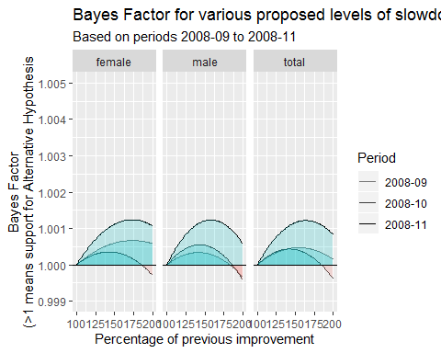

With the addition of this third observation, from 2010-2011, the support for a Bump has increased again, with no proposed level of improvement up to 200% of trend levels being ‘less likely’ than the hypothesis that there has been no improvement.

The following adds a forth observation, from 2011-2012.

e0_uk_bf %>%   
 filter(period %in% c("2008-09", "2008-10", "2008-11", "2008-12")) %>%   
 mutate(perc = 100 * perc) %>%   
 ggplot(aes(x = perc, y = bayes_factor, alpha = period)) +  
 geom_line() +   
 geom_ribbon(aes(  
 ymin = ifelse(is_pos, 1, bayes_factor),   
 ymax = ifelse(is_pos, bayes_factor, 1),   
 x = perc, group = paste0(is_pos, period),  
 fill = is_pos  
 ),   
 data = e0_uk_bf %>%   
 filter(period %in% c("2008-09", "2008-10", "2008-11", "2008-12")) %>%   
 mutate(perc = 100 * perc) %>%  
 mutate(is_pos = bayes_factor > 1),  
 inherit.aes = FALSE, alpha = 0.2) +   
 facet_wrap(~sex) +  
 scale_y_continuous(limits = c(0.998, 1.005),   
 breaks = seq(0.998, 1.0050, by = 0.001)  
   
 ) +  
 scale_alpha_discrete("Period", range = c(0.5, 1), breaks = c("2008-09", "2008-10", "2008-11", "2008-12")) +  
 geom_hline(yintercept = 1) +   
 labs(  
 x = "Percentage of previous improvement",  
 y = "Bayes Factor\n(>1 means support for Alternative Hypothesis",  
 title = "Bayes Factor for various proposed levels of slowdown",  
 subtitle = "Based on periods 2008-09 to 2008-12"  
 ) +  
 guides(fill = FALSE)

## Warning: Using alpha for a discrete variable is not advised.

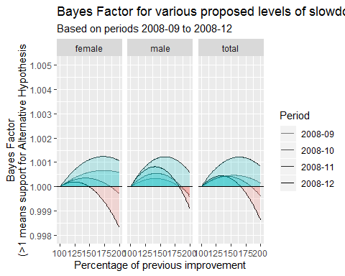

With this forth observation, the support for the Bump interpretation has decreased, especially for females. The most likely level of improvement has also fallen, and many higher rates of proposed improvement are now less likely than the No Improvement hypothesis. (Red region below 1.000. The scale has been adjusted to allow the full schedule to be shown)

Finally, the following shows the effect of incorporating the fifth observation, from 2012-2013.

e0_uk_bf %>%   
 filter(period %in% c("2008-09", "2008-10", "2008-11", "2008-12", "2008-13")) %>%   
 mutate(perc = 100 * perc) %>%   
 ggplot(aes(x = perc, y = bayes_factor, alpha = period)) +  
 geom_line() +   
 geom_ribbon(aes(  
 ymin = ifelse(is_pos, 1, bayes_factor),   
 ymax = ifelse(is_pos, bayes_factor, 1),   
 x = perc, group = paste0(is_pos, period),  
 fill = is_pos  
 ),   
 data = e0_uk_bf %>%   
 filter(period %in% c("2008-09", "2008-10", "2008-11", "2008-12", "2008-13")) %>%   
 mutate(perc = 100 * perc) %>%  
 mutate(is_pos = bayes_factor > 1),  
 inherit.aes = FALSE, alpha = 0.2) +   
 facet_wrap(~sex) +  
 scale_y_continuous(limits = c(0.996, 1.005),   
 breaks = seq(0.996, 1.0050, by = 0.001)  
   
 ) +  
 scale_alpha_discrete("Period", range = c(0.5, 1), breaks = c("2008-09", "2008-10", "2008-11", "2008-12", "2008-13")) +  
 geom_hline(yintercept = 1) +   
 labs(  
 x = "Percentage of previous improvement",  
 y = "Bayes Factor\n(>1 means support for Alternative Hypothesis",  
 title = "Bayes Factor for various proposed levels of slowdown",  
 subtitle = "Based on periods 2008-09 to 2008-13"  
 ) +  
 guides(fill = FALSE)

## Warning: Using alpha for a discrete variable is not advised.

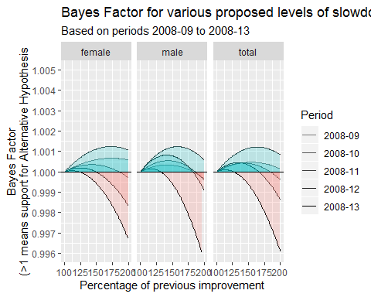 The lower part of the scale has been expanded further because the lower bounds of the estimated Bayes Factors is even lower. With five full observations, there now appears to be very little evidence of a sustained GFC Bump.

The final figure shows only the schedule based on all five observations.

e0_uk_bf %>%   
 filter(period == "2008-13") %>%   
 mutate(perc = 100 * perc) %>%   
 ggplot(aes(x = perc, y = bayes_factor)) +  
 geom_line() +   
 geom_ribbon(aes(  
 ymin = ifelse(is_pos, 1, bayes_factor),   
 ymax = ifelse(is_pos, bayes_factor, 1),   
 x = perc, group = paste0(is_pos, period),  
 fill = is_pos  
 ),   
 data = e0_uk_bf %>%   
 filter(period == "2008-13") %>%   
 mutate(perc = 100 * perc) %>%  
 mutate(is_pos = bayes_factor > 1),  
 inherit.aes = FALSE, alpha = 0.2) +   
 facet_wrap(~sex) +  
 scale_y_continuous(limits = c(0.996, 1.005),   
 breaks = seq(0.996, 1.0050, by = 0.001)  
   
 ) +  
 geom_hline(yintercept = 1) +   
 labs(  
 x = "Percentage of previous improvement",  
 y = "Bayes Factor\n(>1 means support for Alternative Hypothesis",  
 title = "Bayes Factor for various proposed levels of slowdown",  
 subtitle = "Based on periods 2008-09 to 2008-13"  
 ) +  
 guides(fill = FALSE)

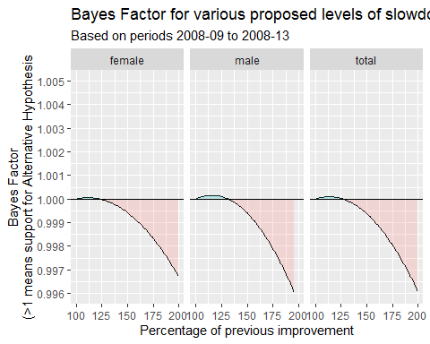

# Discussion

With five continuous observations, the evidence is against a GFC Bump interpetation of the UK life expectancy series since 1990. The Bayes Factor maximises at around a 15% improvement rate, with a maximum Bayes Factor of around 1.0001. This compares with a Bayes Factor for the Slowdown Hypothesis, also based on five observations, which maximises at around 1.003, when a slowdown to around 20% of pre-slowdown levels is assumed.

As the two interpretations are not being directly compared, and the Null hypotheses considered in both interpretations are different, it is probably theoretically inappropriate to conclude, on the basis of this, that the data provide around 30 times (1.003 / 1.0001) more support for the Slowdown interpretation than the GFC Bump interpetation. However, the results of this exercise in ‘Devil’s Advocacy’ do not appear to provide a strong case for preferring the GFC Bump interpretation over the Slowdown interpretation of recent UK life expectancy trends in a longer-term context. The evidence does not appear to be ‘moot’ with regards to how convincing these two interpretations are. Put another way, the data are not a Duck-Rabbit, which can be interpreted equally plausibly as either a ‘Duck’ (GFC Bump) or a ‘Rabbit’ (Slowdown).