Confidence Intervals for loess fits and linear/segmented regression models

2022-10-18

# Aim

This appendix shows the 95% confidence intervals for the loess and linear/segmented models presented in the main paper.

# Data preparation

# load packages  
  
library(tidyverse)

## ── Attaching packages ─────────────────────────────────────── tidyverse 1.3.1 ──

## ✔ ggplot2 3.3.6 ✔ purrr 0.3.4  
## ✔ tibble 3.1.7 ✔ dplyr 1.0.9  
## ✔ tidyr 1.2.0 ✔ stringr 1.4.0  
## ✔ readr 2.1.2 ✔ forcats 0.5.1

## ── Conflicts ────────────────────────────────────────── tidyverse_conflicts() ──  
## ✖ dplyr::filter() masks stats::filter()  
## ✖ dplyr::lag() masks stats::lag()

library(glue)  
  
# load data   
hmd_lt <- read_rds("https://github.com/JonMinton/change-in-ex/blob/main/data/lifetables.rds?raw=true")  
  
  
# Labels for codes   
country_code_lookup <-   
 tribble(  
 ~code, ~country,  
 "DEUTNP", "Germany",  
 "DEUTE", "East Germany",  
 "DEUTW", "West Germany",  
 "ESP", "Spain",  
 "FRATNP", "France",   
 "ITA", "Italy",  
 "GBRTENW", "England & Wales",  
 "GBR_SCO", "Scotland",  
 "DEUTSYNTH", "Synthetic Germany",  
 "NLD", "Netherlands"  
 )  
  
countries_of_interest <- c(  
 "GBRTENW",  
 "GBR_SCO",  
 "GBR_UK",  
 "FRATNP",  
 "ESP",  
 "ITA",  
 "DEUTNP",  
 "DEUTE",   
 "DEUTW",  
 "NLD"  
)  
  
source("https://raw.githubusercontent.com/JonMinton/change-in-ex/main/R/make_synthetic_germany_functions.R")  
  
source("https://raw.githubusercontent.com/JonMinton/change-in-ex/main/R/make_pop_selection.R")  
  
  
change_in_ex_selected_countries <-   
 hmd_ex_selected_countries_with_synth %>%   
 group_by(code, x, sex) %>%   
 arrange(year) %>%   
 mutate(delta_ex = ex - lag(ex)) %>%   
 ungroup()

# LOESS smoother, confidence intervals

The following shows the LOESS smoother line with confidence intervals for annual changes in life expectancy at birth:

p_0_loess <- change_in_ex_selected_countries %>%   
 filter(x == 0) %>%   
 left_join(country_code_lookup) %>%   
 mutate(country = factor(country, levels = c("England & Wales", "Scotland", "Synthetic Germany", "Spain", "France", "Italy", "Netherlands"))) %>%   
 filter(!is.na(country)) %>%   
 filter(between(year, 1980, 2020)) %>%   
 mutate(delta_ex = delta_ex * 52.25) %>% # Convert to weeks  
 ggplot(aes(x = year, y = delta_ex)) +   
 geom_point() +   
 stat_smooth(se = TRUE) + # Changed from se = FALSE  
 facet_grid(sex~country) +   
 geom_hline(yintercept = 0) +   
 scale_y_continuous(breaks = seq(-30, 50, by = 10)) +  
 theme(  
 axis.text.x = element_text(angle = 90, vjust = 0.5, hjust=1)  
 ) +   
 labs(  
 x = "Year",  
 y = "Change in life expectancy from previous year (in weeks)",  
 title = "Annual change in life expectancy at birth, selected countries",  
 subtitle = "Line: nonlinear smoother over the points",  
 caption = "Source: Human Mortality Database. Synthetic Germany based on 20% East/80% West German population weighting"  
 )

## Joining, by = "code"

p_0_loess

## `geom_smooth()` using method = 'loess' and formula 'y ~ x'

## Warning: Removed 2 rows containing non-finite values (stat_smooth).

## Warning: Removed 2 rows containing missing values (geom_point).

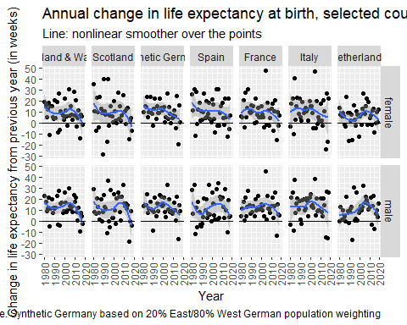

And the following shows the same for life expectancy from age 65 years

p_65_loess <- change_in_ex_selected_countries %>%   
 filter(x == 65) %>%   
 left_join(country_code_lookup) %>%   
 mutate(country = factor(country, levels = c("England & Wales", "Scotland", "Synthetic Germany", "Spain", "France", "Italy", "Netherlands"))) %>%   
 filter(!is.na(country)) %>%   
 filter(between(year, 1980, 2020)) %>%   
 mutate(delta_ex = delta_ex * 52.25) %>% # Convert to weeks  
 ggplot(aes(x = year, y = delta_ex)) +   
 geom_point() +   
 stat_smooth(se = TRUE) + # changed from se = FALSE   
 facet_grid(sex~country) +   
 geom_hline(yintercept = 0) +   
 scale_y_continuous(breaks = seq(-30, 50, by = 10)) +  
 theme(  
 axis.text.x = element_text(angle = 90, vjust = 0.5, hjust=1)  
 ) +   
 labs(  
 x = "Year",  
 y = "Change in life expectancy from previous year (in weeks)",  
 title = "Annual change in life expectancy at age 65, selected countries",  
 subtitle = "Line: nonlinear smoother over the points",  
 caption = "Source: Human Mortality Database. Synthetic Germany based on 20% East/80% West German population weighting"  
 )

## Joining, by = "code"

p_65_loess

## `geom_smooth()` using method = 'loess' and formula 'y ~ x'

## Warning: Removed 2 rows containing non-finite values (stat_smooth).

## Warning: Removed 2 rows containing missing values (geom_point).

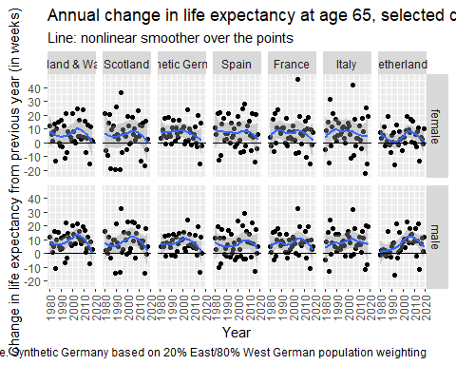

We can see that the 95% CI on the smoother includes values below zero for a number of populations.

Within the above, and in the main paper, the LOESS smoother is called in ggplot2’s stat_smooth function, which uses slightly different parameterisation than if the loess function in the stats packages were called directly. For consistency with the main paper we can extract the point estimate, lower and upper CIs, and standard error, directly from the above ggplot objects. The following function does this:

extract_loess_ci <- function(p){  
 b <- ggplot_build(p)  
 panel_lookup <- b$layout$layout  
   
 # get smoother values  
 p_loess <- b$data[[2]]  
   
 # Join and simplify   
   
 sm <- p_loess %>%   
 select(x, y, ymin, ymax, se, PANEL) %>%   
 left_join(panel_lookup)  
   
 # find last year for each country   
   
 max_years <- p$data %>%   
 group_by(country, sex) %>%   
 filter(year == max(year)) %>%   
 select(country, sex, max_year = year)  
   
 sm %>%   
 select(x, y, ymin, ymax, se, sex, country) %>%   
 left_join(max_years) %>%   
 filter(x == max_year)  
}

And the following code applies the function to the two previously created ggplot2 objects

loess_lastyear_x0 <-   
extract_loess_ci(p_0_loess) %>%   
 rename(year = x, y_point = y,  
 y_lower = ymin, y_upper = ymax, y_se = se) %>%   
 mutate(x = 0) %>% # x now starting age   
 select(year, x, sex, country, everything(), -max_year)

## `geom_smooth()` using method = 'loess' and formula 'y ~ x'

## Warning: Removed 2 rows containing non-finite values (stat_smooth).

## Joining, by = "PANEL"

## Joining, by = c("sex", "country")

loess_lastyear_x65 <-   
extract_loess_ci(p_65_loess) %>%   
 rename(year = x, y_point = y,  
 y_lower = ymin, y_upper = ymax, y_se = se) %>%   
 mutate(x = 65) %>% # x now starting age   
 select(year, x, sex, country, everything(), -max_year)

## `geom_smooth()` using method = 'loess' and formula 'y ~ x'

## Warning: Removed 2 rows containing non-finite values (stat_smooth).

## Joining, by = "PANEL"  
## Joining, by = c("sex", "country")

loess_lastyear_both <-   
 bind_rows(loess_lastyear_x0, loess_lastyear_x65)  
  
loess_lastyear_both

## year x sex country y_point y_lower y_upper y_se  
## 1 2018 0 female England & Wales -1.37085831 -13.530072 10.788356 5.983454  
## 2 2018 0 female Scotland -3.61707693 -20.509289 13.275135 8.312525  
## 3 2017 0 female Synthetic Germany 2.96747333 -8.062811 13.997757 5.414911  
## 4 2018 0 female Spain 2.94139772 -11.305593 17.188389 7.010833  
## 5 2018 0 female France 1.37863909 -12.054318 14.811596 6.610253  
## 6 2018 0 female Italy 5.10750796 -11.526141 21.741157 8.185288  
## 7 2019 0 female Netherlands 2.36725240 -8.638790 13.373295 5.422197  
## 8 2018 0 male England & Wales -1.77259987 -11.851773 8.306573 4.959882  
## 9 2018 0 male Scotland -3.64395051 -17.511375 10.223474 6.824051  
## 10 2017 0 male Synthetic Germany 5.96684307 -4.694271 16.627957 5.233681  
## 11 2018 0 male Spain 4.51381577 -9.686210 18.713842 6.987722  
## 12 2018 0 male France 5.32872389 -5.947412 16.604860 5.548898  
## 13 2018 0 male Italy 7.76595659 -6.604990 22.136904 7.071830  
## 14 2019 0 male Netherlands 5.69252174 -5.722116 17.107159 5.623494  
## 15 2018 65 female England & Wales -0.90447135 -12.535858 10.726915 5.723714  
## 16 2018 65 female Scotland -0.06883654 -16.054439 15.916766 7.866390  
## 17 2017 65 female Synthetic Germany 1.60189046 -8.061272 11.265053 4.743773  
## 18 2018 65 female Spain 2.19830409 -11.023504 15.420112 6.506348  
## 19 2018 65 female France 1.39777068 -11.805226 14.600767 6.497091  
## 20 2018 65 female Italy 4.47429730 -10.963447 19.912041 7.596793  
## 21 2019 65 female Netherlands 0.65630234 -8.168485 9.481090 4.347588  
## 22 2018 65 male England & Wales 0.03630923 -8.724677 8.797295 4.311213  
## 23 2018 65 male Scotland 1.54944773 -10.702427 13.801322 6.029051  
## 24 2017 65 male Synthetic Germany 1.51214525 -6.944740 9.969031 4.151596  
## 25 2018 65 male Spain 2.76986201 -9.287731 14.827455 5.933447  
## 26 2018 65 male France 2.23048158 -7.404687 11.865650 4.741391  
## 27 2018 65 male Italy 6.56582403 -4.980548 18.112196 5.681879  
## 28 2019 65 male Netherlands 4.38609383 -4.768505 13.540692 4.510071

The estimates are in weeks of increase per year. The following function produces summary statements for each population

summarise_loess <- function(df, cntry, dp = 2){  
 df <- df %>% filter(country == cntry)  
   
 last_year <- df$year[1]  
   
 y_x0_pt_m <- df %>% filter(x == 0, sex == "male") %>% pull("y_point") %>% round(dp)  
 y_x65_pt_m <- df %>% filter(x == 65, sex == "male") %>% pull("y_point") %>% round(dp)  
 y_x0_pt_f <- df %>% filter(x == 0, sex == "female") %>% pull("y_point") %>% round(dp)  
 y_x65_pt_f <- df %>% filter(x == 65, sex == "female") %>% pull("y_point") %>% round(dp)  
  
 y_x0_lwr_m <- df %>% filter(x == 0, sex == "male") %>% pull("y_lower") %>% round(dp)  
 y_x65_lwr_m <- df %>% filter(x == 65, sex == "male") %>% pull("y_lower") %>% round(dp)  
 y_x0_lwr_f <- df %>% filter(x == 0, sex == "female") %>% pull("y_lower") %>% round(dp)  
 y_x65_lwr_f <- df %>% filter(x == 65, sex == "female") %>% pull("y_lower") %>% round(dp)  
  
 y_x0_upr_m <- df %>% filter(x == 0, sex == "male") %>% pull("y_upper") %>% round(dp)  
 y_x65_upr_m <- df %>% filter(x == 65, sex == "male") %>% pull("y_upper") %>% round(dp)  
 y_x0_upr_f <- df %>% filter(x == 0, sex == "female") %>% pull("y_upper") %>% round(dp)  
 y_x65_upr_f <- df %>% filter(x == 65, sex == "female") %>% pull("y_upper") %>% round(dp)  
  
  
 y_x0_se_m <- df %>% filter(x == 0, sex == "male") %>% pull("y_se") %>% round(dp)  
 y_x65_se_m <- df %>% filter(x == 65, sex == "male") %>% pull("y_se") %>% round(dp)  
 y_x0_se_f <- df %>% filter(x == 0, sex == "female") %>% pull("y_se") %>% round(dp)  
 y_x65_se_f <- df %>% filter(x == 65, sex == "female") %>% pull("y_se") %>% round(dp)  
   
 pfall_x0_m <- pnorm(0, y_x0_pt_m, y_x0_se_m) %>% round(dp)  
 pfall_x65_m <- pnorm(0, y_x65_pt_m, y_x65_se_m) %>% round(dp)  
 pfall_x0_f <- pnorm(0, y_x0_pt_f, y_x0_se_f) %>% round(dp)  
 pfall_x65_f <- pnorm(0, y_x65_pt_f, y_x65_se_f) %>% round(dp)  
   
 glue::glue("{cntry} in {last_year}: \nFor males, LOESS estimated annual changes of {y_x0_pt_m} (95% CI {y_x0_lwr_m} to {y_x0_upr_m}) weeks/year for life expectancy at birth, and annual changes of {y_x65_pt_m} (95% CI {y_x65_lwr_m} to {y_x65_upr_m}) weeks/year for life expectancy at age 65; the probability that life expectancy fell in the last observed year was {pfall_x0_m} for life expectancy at birth, and {pfall_x65_m} for life expectancy from age 65. \nFor females, LOESS estimated annual changes of {y_x0_pt_f} (95% CI {y_x0_lwr_f} to {y_x0_upr_f}) weeks/year for life expectancy at birth, and annual changes of {y_x65_pt_f} (95% CI {y_x65_lwr_f} to {y_x65_upr_f}) weeks/year for life expectancy at age 65; the probability that life expectancy fell in the last observed year was {pfall_x0_f} for life expectancy at birth, and {pfall_x65_f} for life expectancy from age 65.")   
}

The following are descriptive summaries of life expectancy trends in the last observed year, as estimated through the LOESS method:

unique(loess_lastyear_both$country) %>% as.character() %>%   
 map(summarise_loess, df = loess_lastyear_both)

## [[1]]  
## England & Wales in 2018:   
## For males, LOESS estimated annual changes of -1.77 (95% CI -11.85 to 8.31) weeks/year for life expectancy at birth, and annual changes of 0.04 (95% CI -8.72 to 8.8) weeks/year for life expectancy at age 65; the probability that life expectancy fell in the last observed year was 0.64 for life expectancy at birth, and 0.5 for life expectancy from age 65.   
## For females, LOESS estimated annual changes of -1.37 (95% CI -13.53 to 10.79) weeks/year for life expectancy at birth, and annual changes of -0.9 (95% CI -12.54 to 10.73) weeks/year for life expectancy at age 65; the probability that life expectancy fell in the last observed year was 0.59 for life expectancy at birth, and 0.56 for life expectancy from age 65.  
##   
## [[2]]  
## Scotland in 2018:   
## For males, LOESS estimated annual changes of -3.64 (95% CI -17.51 to 10.22) weeks/year for life expectancy at birth, and annual changes of 1.55 (95% CI -10.7 to 13.8) weeks/year for life expectancy at age 65; the probability that life expectancy fell in the last observed year was 0.7 for life expectancy at birth, and 0.4 for life expectancy from age 65.   
## For females, LOESS estimated annual changes of -3.62 (95% CI -20.51 to 13.28) weeks/year for life expectancy at birth, and annual changes of -0.07 (95% CI -16.05 to 15.92) weeks/year for life expectancy at age 65; the probability that life expectancy fell in the last observed year was 0.67 for life expectancy at birth, and 0.5 for life expectancy from age 65.  
##   
## [[3]]  
## Synthetic Germany in 2017:   
## For males, LOESS estimated annual changes of 5.97 (95% CI -4.69 to 16.63) weeks/year for life expectancy at birth, and annual changes of 1.51 (95% CI -6.94 to 9.97) weeks/year for life expectancy at age 65; the probability that life expectancy fell in the last observed year was 0.13 for life expectancy at birth, and 0.36 for life expectancy from age 65.   
## For females, LOESS estimated annual changes of 2.97 (95% CI -8.06 to 14) weeks/year for life expectancy at birth, and annual changes of 1.6 (95% CI -8.06 to 11.27) weeks/year for life expectancy at age 65; the probability that life expectancy fell in the last observed year was 0.29 for life expectancy at birth, and 0.37 for life expectancy from age 65.  
##   
## [[4]]  
## Spain in 2018:   
## For males, LOESS estimated annual changes of 4.51 (95% CI -9.69 to 18.71) weeks/year for life expectancy at birth, and annual changes of 2.77 (95% CI -9.29 to 14.83) weeks/year for life expectancy at age 65; the probability that life expectancy fell in the last observed year was 0.26 for life expectancy at birth, and 0.32 for life expectancy from age 65.   
## For females, LOESS estimated annual changes of 2.94 (95% CI -11.31 to 17.19) weeks/year for life expectancy at birth, and annual changes of 2.2 (95% CI -11.02 to 15.42) weeks/year for life expectancy at age 65; the probability that life expectancy fell in the last observed year was 0.34 for life expectancy at birth, and 0.37 for life expectancy from age 65.  
##   
## [[5]]  
## France in 2018:   
## For males, LOESS estimated annual changes of 5.33 (95% CI -5.95 to 16.6) weeks/year for life expectancy at birth, and annual changes of 2.23 (95% CI -7.4 to 11.87) weeks/year for life expectancy at age 65; the probability that life expectancy fell in the last observed year was 0.17 for life expectancy at birth, and 0.32 for life expectancy from age 65.   
## For females, LOESS estimated annual changes of 1.38 (95% CI -12.05 to 14.81) weeks/year for life expectancy at birth, and annual changes of 1.4 (95% CI -11.81 to 14.6) weeks/year for life expectancy at age 65; the probability that life expectancy fell in the last observed year was 0.42 for life expectancy at birth, and 0.41 for life expectancy from age 65.  
##   
## [[6]]  
## Italy in 2018:   
## For males, LOESS estimated annual changes of 7.77 (95% CI -6.6 to 22.14) weeks/year for life expectancy at birth, and annual changes of 6.57 (95% CI -4.98 to 18.11) weeks/year for life expectancy at age 65; the probability that life expectancy fell in the last observed year was 0.14 for life expectancy at birth, and 0.12 for life expectancy from age 65.   
## For females, LOESS estimated annual changes of 5.11 (95% CI -11.53 to 21.74) weeks/year for life expectancy at birth, and annual changes of 4.47 (95% CI -10.96 to 19.91) weeks/year for life expectancy at age 65; the probability that life expectancy fell in the last observed year was 0.27 for life expectancy at birth, and 0.28 for life expectancy from age 65.  
##   
## [[7]]  
## Netherlands in 2019:   
## For males, LOESS estimated annual changes of 5.69 (95% CI -5.72 to 17.11) weeks/year for life expectancy at birth, and annual changes of 4.39 (95% CI -4.77 to 13.54) weeks/year for life expectancy at age 65; the probability that life expectancy fell in the last observed year was 0.16 for life expectancy at birth, and 0.17 for life expectancy from age 65.   
## For females, LOESS estimated annual changes of 2.37 (95% CI -8.64 to 13.37) weeks/year for life expectancy at birth, and annual changes of 0.66 (95% CI -8.17 to 9.48) weeks/year for life expectancy at age 65; the probability that life expectancy fell in the last observed year was 0.33 for life expectancy at birth, and 0.44 for life expectancy from age 65.

We can see from the above summaries that the confidence intervals for all populations tend to include negative values, and that the resulting estimated probabilities that the true value in the last observed year (conditional on the model) is below zero, i.e. falling, is substantial (at least 12%) for populations and starting ages considered. For England & Wales, and Scotland (except males from age 65), it is more probable than not that life expectancy fell in the last observed year.

## Linear regression and Breakpoint confidence intervals

estimate_breakpoints_and_pval <- function(df){  
 null_mdl <- lm(ex ~ year, data = df)   
 seg_mdl <- segmented::segmented(null_mdl, seg.Z= ~year, psi = 2010)  
 seg2_mdl <- segmented::segmented(null_mdl, seg.z= ~year, psi= c(1985, 2010)) # added to test  
  
 list(  
 null = null_mdl,   
 seg = seg_mdl,  
 seg2 = seg2_mdl  
 )  
}  
  
segmented_breakpoints_models <-   
 hmd_ex_selected_countries_with_synth %>%   
 filter(code != "DEUTNP") %>%   
 filter(year >= 1979) %>%   
 group_by(code, x, sex) %>%   
 nest() %>%   
 mutate(  
 mdl_outputs = map(data, estimate_breakpoints_and_pval)  
 ) %>%   
 unnest_longer(mdl_outputs)   
  
  
# Now let's get the BIC for each model   
  
make_predictions <- function(mdl, dta = tibble(year = 1980:2020)){  
 tibble(  
 year = dta$year,   
 ex_pred = predict(mdl, newdata = dta)  
 )  
}  
  
best_model_predictions_descriptions <-   
segmented_breakpoints_models %>%   
 mutate(bic = map_dbl(mdl_outputs, BIC)) %>%   
 group_by(code, x, sex) %>%   
 mutate(rank_bic = rank(bic)) %>%  
 filter(rank_bic == 1) %>%   
 mutate(  
 best_model = case_when(  
 mdl_outputs_id == 'seg2' ~ "Two breakpoints",  
 mdl_outputs_id == 'seg' ~ "One breakpoint",   
 mdl_outputs_id == 'null' ~ "No breakpoints"  
 )  
 ) %>%   
 mutate(  
 first_breakpoint = map2_dbl(  
 mdl_outputs_id, mdl_outputs,   
 function(x, y){  
 if (x == 'null' ) {NA_real_} else {  
 y[["psi"]][1,2]  
 }  
 }   
 ),  
 first_breakpoint_se = map2_dbl(  
 mdl_outputs_id, mdl_outputs,  
 function(x, y){  
 if (x == 'null' ) {NA_real_} else {  
 y[["psi"]][1,3]  
 }  
   
 }  
 ),  
 second_breakpoint = map2_dbl(  
 mdl_outputs_id, mdl_outputs,  
 function(x, y){  
 if (x == 'seg2') {  
 y[["psi"]][2,2]  
 } else {  
 NA_real_  
 }  
 }   
 ),  
 second_breakpoint_se = map2_dbl(  
 mdl_outputs_id, mdl_outputs,  
 function(x, y){  
 if (x == 'seg2') {  
 y[["psi"]][2,3]  
 } else {  
 NA_real_  
 }  
 }  
 )  
 ) %>% # let's add predictions too   
 mutate(  
 pred_data = map(mdl_outputs, make_predictions),  
 joined_data = map2(data, pred_data, left_join)  
 ) %>%   
 select(code, x, sex, joined_data, first_breakpoint:second_breakpoint_se) %>%   
 unnest(joined_data)

## Joining, by = "year"  
## Joining, by = "year"  
## Joining, by = "year"  
## Joining, by = "year"  
## Joining, by = "year"  
## Joining, by = "year"  
## Joining, by = "year"  
## Joining, by = "year"  
## Joining, by = "year"  
## Joining, by = "year"  
## Joining, by = "year"  
## Joining, by = "year"  
## Joining, by = "year"  
## Joining, by = "year"  
## Joining, by = "year"  
## Joining, by = "year"  
## Joining, by = "year"  
## Joining, by = "year"  
## Joining, by = "year"  
## Joining, by = "year"  
## Joining, by = "year"  
## Joining, by = "year"  
## Joining, by = "year"  
## Joining, by = "year"  
## Joining, by = "year"  
## Joining, by = "year"  
## Joining, by = "year"  
## Joining, by = "year"  
## Joining, by = "year"  
## Joining, by = "year"  
## Joining, by = "year"  
## Joining, by = "year"  
## Joining, by = "year"  
## Joining, by = "year"  
## Joining, by = "year"  
## Joining, by = "year"

best_breakpoint_model_predictions <-   
 segmented_breakpoints_models %>%   
 mutate(bic = map_dbl(mdl_outputs, BIC)) %>%   
 group_by(code, x, sex) %>%   
 filter(bic == min(bic)) %>%   
 mutate(predictions = map2(mdl_outputs, data, predict, interval = "confidence", level = 0.95)) %>%   
 mutate(data_augmented = map2(data, predictions, bind_cols)) %>%   
 select(code, x, sex, data_augmented) %>%   
 ungroup() %>%   
 unnest(data_augmented)

best_breakpoint_model_predictions %>%   
 left_join(country_code_lookup) %>%   
 mutate(country = factor(country, levels = c("England & Wales", "Scotland", "Synthetic Germany", "Spain", "France", "Italy", "Netherlands"))) %>%   
 filter(!is.na(country)) %>%   
 filter(x == 0) %>%   
 ggplot(aes(x = year)) +   
 facet_grid(sex ~ country) +   
 geom_point(aes(y = ex), alpha = 0.35) +   
 geom_line(aes(y = fit), colour = "red") +  
 geom_ribbon(aes(ymin = lwr, ymax = upr), fill = "red", colour = NA, alpha = 0.5) +  
 theme(  
 axis.text.x = element_text(angle = 90, vjust = 0.5, hjust=1)  
 ) +   
 labs(  
 x = "Year",  
 y = "Life expectancy (years)",  
 title = "Predicted and observed life expectancy at birth, selected countries",  
 subtitle = "Line: Best segmented regression model for the country",  
 caption = "Source: Human Mortality Database. Synthetic Germany based on 20% East/80% West German population weighting"  
 )

## Joining, by = "code"

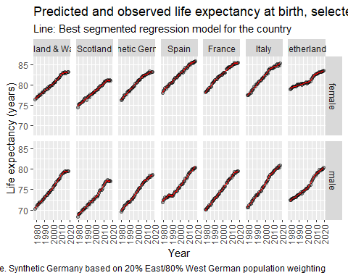 The confidence intervals are quite hard to see given the data points. In the figure below they are shown without the points

best_breakpoint_model_predictions %>%   
 left_join(country_code_lookup) %>%   
 mutate(country = factor(country, levels = c("England & Wales", "Scotland", "Synthetic Germany", "Spain", "France", "Italy", "Netherlands"))) %>%   
 filter(!is.na(country)) %>%   
 filter(x == 0) %>%   
 ggplot(aes(x = year)) +   
 facet_grid(sex ~ country) +   
# geom_point(aes(y = ex), alpha = 0.35) +   
 geom_line(aes(y = fit), colour = "red") +  
 geom_ribbon(aes(ymin = lwr, ymax = upr), fill = "red", colour = NA, alpha = 0.5) +  
 theme(  
 axis.text.x = element_text(angle = 90, vjust = 0.5, hjust=1)  
 ) +   
 labs(  
 x = "Year",  
 y = "Life expectancy (years)",  
 title = "Predicted and observed life expectancy at birth, selected countries",  
 subtitle = "Line: Best segmented regression model for the country",  
 caption = "Source: Human Mortality Database. Synthetic Germany based on 20% East/80% West German population weighting"  
 )

## Joining, by = "code"

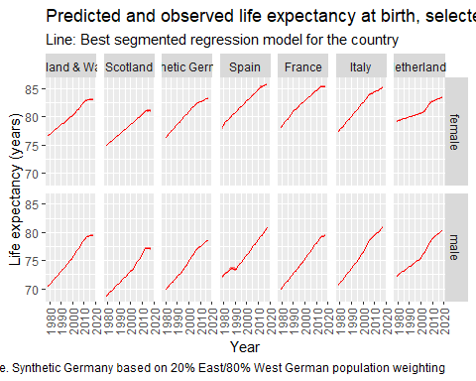 They are repeated, with and then without points, for life expectancy from age 65 below:

best_breakpoint_model_predictions %>%   
 left_join(country_code_lookup) %>%   
 mutate(country = factor(country, levels = c("England & Wales", "Scotland", "Synthetic Germany", "Spain", "France", "Italy", "Netherlands"))) %>%   
 filter(!is.na(country)) %>%   
 filter(x == 65) %>%   
 ggplot(aes(x = year)) +   
 facet_grid(sex ~ country) +   
 geom_point(aes(y = ex), alpha = 0.35) +   
 geom_line(aes(y = fit), colour = "red") +  
 geom_ribbon(aes(ymin = lwr, ymax = upr), fill = "red", colour = NA, alpha = 0.5) +  
 theme(  
 axis.text.x = element_text(angle = 90, vjust = 0.5, hjust=1)  
 ) +   
 labs(  
 x = "Year",  
 y = "Life expectancy (years)",  
 title = "Predicted and observed life expectancy at age 65, selected countries",  
 subtitle = "Line: Best segmented regression model for the country",  
 caption = "Source: Human Mortality Database. Synthetic Germany based on 20% East/80% West German population weighting"  
 )

## Joining, by = "code"

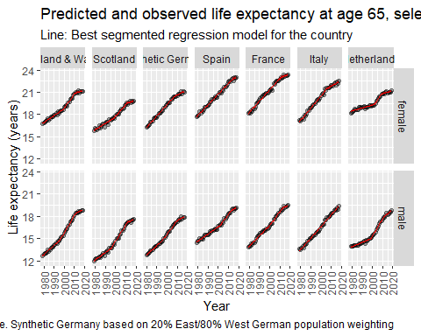

best_breakpoint_model_predictions %>%   
 left_join(country_code_lookup) %>%   
 mutate(country = factor(country, levels = c("England & Wales", "Scotland", "Synthetic Germany", "Spain", "France", "Italy", "Netherlands"))) %>%   
 filter(!is.na(country)) %>%   
 filter(x == 65) %>%   
 ggplot(aes(x = year)) +   
 facet_grid(sex ~ country) +   
# geom_point(aes(y = ex), alpha = 0.35) +   
 geom_line(aes(y = fit), colour = "red") +  
 geom_ribbon(aes(ymin = lwr, ymax = upr), fill = "red", colour = NA, alpha = 0.5) +  
 theme(  
 axis.text.x = element_text(angle = 90, vjust = 0.5, hjust=1)  
 ) +   
 labs(  
 x = "Year",  
 y = "Life expectancy (years)",  
 title = "Predicted and observed life expectancy at age 65, selected countries",  
 subtitle = "Line: Best segmented regression model for the country",  
 caption = "Source: Human Mortality Database. Synthetic Germany based on 20% East/80% West German population weighting"  
 )

## Joining, by = "code"

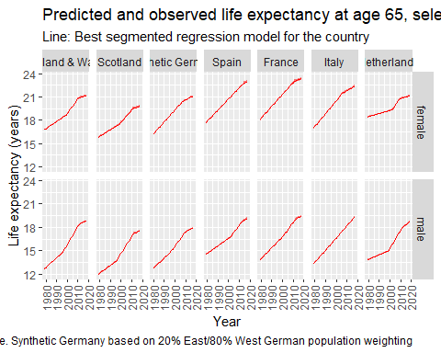

pred_differenced <-   
 best_breakpoint_model_predictions %>%   
 left_join(country_code_lookup) %>%   
 mutate(country = factor(country, levels = c("England & Wales", "Scotland", "Synthetic Germany", "Spain", "France", "Italy", "Netherlands"))) %>%   
 filter(!is.na(country)) %>%   
 group_by(country, sex, x) %>%   
 arrange(year) %>%   
 mutate(  
 diff_ex = 52.25 * (ex - lag(ex)),  
 diff_fit = 52.25 * (fit - lag(fit)),  
 adj_upr = 52.25 * (upr - fit),  
 adj_lwr = 52.25 * (lwr - fit),  
 diff_upr = diff_fit + adj_upr,  
 diff_lwr = diff_fit + adj_lwr  
 ) %>%   
 filter(!is.na(diff_fit))

## Joining, by = "code"

The following shows differences with confidence intervals for life expectancy from birth:

pred_differenced %>%  
 filter(x == 0) %>%   
 ggplot(aes(year)) +   
 geom_point(aes(y = diff_ex), alpha = 0.35) +  
 facet_grid(sex ~ country) +  
 geom_hline(yintercept = 0) +   
 geom_line(aes(y = diff_fit), colour = "red") +  
 geom_ribbon(aes(ymin = diff_lwr, ymax = diff_upr), colour = NA, fill = "red", alpha = 0.35) +  
 theme(  
 axis.text.x = element_text(angle = 90, vjust = 0.5, hjust=1)  
 ) +   
 scale_y_continuous(breaks = seq(-30, 50, by = 10)) +  
 labs(  
 x = "Year",  
 y = "Change in life expectancy from previous year (weeks)",  
 title = "Predicted and observed annual changes in life expectancy at birth, selected countries",  
 subtitle = "Line: Best segmented regression model for the country",  
 caption = "Source: Human Mortality Database. Synthetic Germany based on 20% East/80% West German population weighting"  
 )

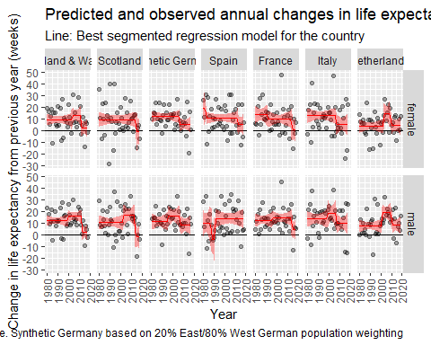

And the following shows the same for life expectancy changes from age 65

pred_differenced %>%  
 filter(x == 65) %>%   
 ggplot(aes(year)) +   
 geom_point(aes(y = diff_ex), alpha = 0.35) +  
 facet_grid(sex ~ country) +  
 geom_hline(yintercept = 0) +   
 geom_line(aes(y = diff_fit), colour = "red") +  
 geom_ribbon(aes(ymin = diff_lwr, ymax = diff_upr), colour = NA, fill = "red", alpha = 0.35) +  
 theme(  
 axis.text.x = element_text(angle = 90, vjust = 0.5, hjust=1)  
 ) +   
 scale_y_continuous(breaks = seq(-30, 50, by = 10)) +  
 labs(  
 x = "Year",  
 y = "Change in life expectancy from previous year (weeks)",  
 title = "Predicted and observed annual changes in life expectancy at age 65, selected countries",  
 subtitle = "Line: Best segmented regression model for the country",  
 caption = "Source: Human Mortality Database. Synthetic Germany based on 20% East/80% West German population weighting"  
 )

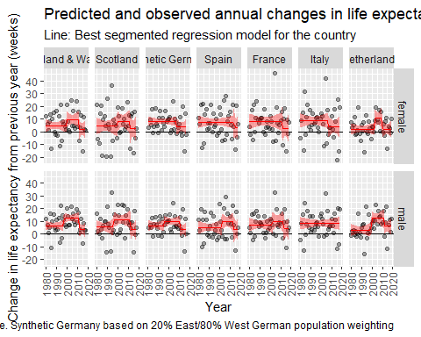 As with the LOESS model, we can can present the point estimates, 95% CIs, and implied probabilities that the values in the last observed year are below zero.

summarise_reg_seg <- function(df, cntry, dp = 2){  
 df <- df %>%   
 filter(country == cntry) %>%   
 filter(year == max(year))  
   
 last_year <- max(df$year)  
   
 y_x0_pt_m <- df %>% filter(x == 0, sex == "male") %>% pull("diff_fit")   
 y_x65_pt_m <- df %>% filter(x == 65, sex == "male") %>% pull("diff_fit")   
 y_x0_pt_f <- df %>% filter(x == 0, sex == "female") %>% pull("diff_fit")   
 y_x65_pt_f <- df %>% filter(x == 65, sex == "female") %>% pull("diff_fit")   
  
 y_x0_lwr_m <- df %>% filter(x == 0, sex == "male") %>% pull("diff_lwr")   
 y_x65_lwr_m <- df %>% filter(x == 65, sex == "male") %>% pull("diff_lwr")   
 y_x0_lwr_f <- df %>% filter(x == 0, sex == "female") %>% pull("diff_lwr")   
 y_x65_lwr_f <- df %>% filter(x == 65, sex == "female") %>% pull("diff_lwr")   
  
 y_x0_upr_m <- df %>% filter(x == 0, sex == "male") %>% pull("diff_upr")   
 y_x65_upr_m <- df %>% filter(x == 65, sex == "male") %>% pull("diff_upr")   
 y_x0_upr_f <- df %>% filter(x == 0, sex == "female") %>% pull("diff_upr")   
 y_x65_upr_f <- df %>% filter(x == 65, sex == "female") %>% pull("diff_upr")   
  
  
 y_x0_se_m <- c(y_x0_upr_m - y_x0_pt_m, y_x0_pt_m - y_x0_lwr_m) %>% `/`(1.96) %>% mean() %>% round(dp)  
 y_x65_se_m <- c(y_x65_upr_m - y_x65_pt_m, y_x65_pt_m - y_x65_lwr_m) %>% `/`(1.96) %>% mean() %>% round(dp)  
 y_x0_se_f <- c(y_x0_upr_f - y_x0_pt_f, y_x0_pt_f - y_x0_lwr_f) %>% `/`(1.96) %>% mean() %>% round(dp)  
 y_x65_se_f <- c(y_x65_upr_f - y_x65_pt_f, y_x65_pt_f - y_x65_lwr_f) %>% `/`(1.96) %>% mean() %>% round(dp)  
   
 y_x0_lwr_m <- y_x0_lwr_m %>% round(dp)  
 y_x65_lwr_m <- y_x65_lwr_m %>% round(dp)   
 y_x0_lwr_f <- y_x0_lwr_f %>% round(dp)  
 y_x65_lwr_f <- y_x65_lwr_f %>% round(dp)  
  
 y_x0_upr_m <- y_x0_upr_m %>% round(dp)  
 y_x65_upr_m <- y_x65_upr_m %>% round(dp)  
 y_x0_upr_f <- y_x0_upr_f %>% round(dp)  
 y_x65_upr_f <- y_x65_upr_f %>% round(dp)   
   
 y_x0_pt_m <- y_x0_pt_m %>% round(dp)  
 y_x65_pt_m <- y_x65_pt_m %>% round(dp)  
 y_x0_pt_f <- y_x0_pt_f %>% round(dp)  
 y_x65_pt_f <- y_x65_pt_f %>% round(dp)   
   
 pfall_x0_m <- pnorm(0, y_x0_pt_m, y_x0_se_m) %>% round(dp)  
 pfall_x65_m <- pnorm(0, y_x65_pt_m, y_x65_se_m) %>% round(dp)  
 pfall_x0_f <- pnorm(0, y_x0_pt_f, y_x0_se_f) %>% round(dp)  
 pfall_x65_f <- pnorm(0, y_x65_pt_f, y_x65_se_f) %>% round(dp)  
   
 glue::glue("{cntry} in {last_year}: \nFor males, segmented/linear estimated annual changes of {y_x0_pt_m} (95% CI {y_x0_lwr_m} to {y_x0_upr_m}) weeks/year for life expectancy at birth, and annual changes of {y_x65_pt_m} (95% CI {y_x65_lwr_m} to {y_x65_upr_m}) weeks/year for life expectancy at age 65; the probability that life expectancy fell in the last observed year was {pfall_x0_m} for life expectancy at birth, and {pfall_x65_m} for life expectancy from age 65. \nFor females, segmented/linear estimated annual changes of {y_x0_pt_f} (95% CI {y_x0_lwr_f} to {y_x0_upr_f}) weeks/year for life expectancy at birth, and annual changes of {y_x65_pt_f} (95% CI {y_x65_lwr_f} to {y_x65_upr_f}) weeks/year for life expectancy at age 65; the probability that life expectancy fell in the last observed year was {pfall_x0_f} for life expectancy at birth, and {pfall_x65_f} for life expectancy from age 65.")   
}

As before, we can produce summary statements for each country as follows:

unique(pred_differenced$country) %>% as.character() %>%   
 map(summarise_reg_seg , df = pred_differenced)

## [[1]]  
## Spain in 2018:   
## For males, segmented/linear estimated annual changes of 14.16 (95% CI 5.92 to 22.4) weeks/year for life expectancy at birth, and annual changes of 3.61 (95% CI -6.76 to 13.97) weeks/year for life expectancy at age 65; the probability that life expectancy fell in the last observed year was 0 for life expectancy at birth, and 0.25 for life expectancy from age 65.   
## For females, segmented/linear estimated annual changes of 5.26 (95% CI -5.23 to 15.76) weeks/year for life expectancy at birth, and annual changes of 3.19 (95% CI -8.41 to 14.78) weeks/year for life expectancy at age 65; the probability that life expectancy fell in the last observed year was 0.16 for life expectancy at birth, and 0.29 for life expectancy from age 65.  
##   
## [[2]]  
## France in 2018:   
## For males, segmented/linear estimated annual changes of 5.12 (95% CI -5.76 to 16) weeks/year for life expectancy at birth, and annual changes of 4.08 (95% CI -6.47 to 14.62) weeks/year for life expectancy at age 65; the probability that life expectancy fell in the last observed year was 0.18 for life expectancy at birth, and 0.22 for life expectancy from age 65.   
## For females, segmented/linear estimated annual changes of 0.68 (95% CI -12.57 to 13.93) weeks/year for life expectancy at birth, and annual changes of 2.89 (95% CI -9.24 to 15.02) weeks/year for life expectancy at age 65; the probability that life expectancy fell in the last observed year was 0.46 for life expectancy at birth, and 0.32 for life expectancy from age 65.  
##   
## [[3]]  
## Italy in 2018:   
## For males, segmented/linear estimated annual changes of 10.06 (95% CI 0.47 to 19.66) weeks/year for life expectancy at birth, and annual changes of 8.18 (95% CI 3.06 to 13.29) weeks/year for life expectancy at age 65; the probability that life expectancy fell in the last observed year was 0.02 for life expectancy at birth, and 0 for life expectancy from age 65.   
## For females, segmented/linear estimated annual changes of 5.46 (95% CI -4.45 to 15.37) weeks/year for life expectancy at birth, and annual changes of 4.07 (95% CI -4.81 to 12.95) weeks/year for life expectancy at age 65; the probability that life expectancy fell in the last observed year was 0.14 for life expectancy at birth, and 0.18 for life expectancy from age 65.  
##   
## [[4]]  
## Netherlands in 2019:   
## For males, segmented/linear estimated annual changes of 8.75 (95% CI 0.38 to 17.11) weeks/year for life expectancy at birth, and annual changes of 6.07 (95% CI -1.26 to 13.4) weeks/year for life expectancy at age 65; the probability that life expectancy fell in the last observed year was 0.02 for life expectancy at birth, and 0.05 for life expectancy from age 65.   
## For females, segmented/linear estimated annual changes of 4.35 (95% CI -4.25 to 12.95) weeks/year for life expectancy at birth, and annual changes of 2.06 (95% CI -4.93 to 9.05) weeks/year for life expectancy at age 65; the probability that life expectancy fell in the last observed year was 0.16 for life expectancy at birth, and 0.28 for life expectancy from age 65.  
##   
## [[5]]  
## England & Wales in 2018:   
## For males, segmented/linear estimated annual changes of 2.55 (95% CI -5.8 to 10.91) weeks/year for life expectancy at birth, and annual changes of 3.3 (95% CI -3.08 to 9.68) weeks/year for life expectancy at age 65; the probability that life expectancy fell in the last observed year was 0.27 for life expectancy at birth, and 0.16 for life expectancy from age 65.   
## For females, segmented/linear estimated annual changes of 2.23 (95% CI -6.95 to 11.41) weeks/year for life expectancy at birth, and annual changes of 1.98 (95% CI -6.2 to 10.17) weeks/year for life expectancy at age 65; the probability that life expectancy fell in the last observed year was 0.32 for life expectancy at birth, and 0.32 for life expectancy from age 65.  
##   
## [[6]]  
## Scotland in 2018:   
## For males, segmented/linear estimated annual changes of -1.57 (95% CI -14.52 to 11.39) weeks/year for life expectancy at birth, and annual changes of 3.49 (95% CI -5.75 to 12.73) weeks/year for life expectancy at age 65; the probability that life expectancy fell in the last observed year was 0.59 for life expectancy at birth, and 0.23 for life expectancy from age 65.   
## For females, segmented/linear estimated annual changes of -1.15 (95% CI -17.55 to 15.25) weeks/year for life expectancy at birth, and annual changes of 2.59 (95% CI -9.14 to 14.33) weeks/year for life expectancy at age 65; the probability that life expectancy fell in the last observed year was 0.55 for life expectancy at birth, and 0.33 for life expectancy from age 65.  
##   
## [[7]]  
## Synthetic Germany in 2017:   
## For males, segmented/linear estimated annual changes of 8.74 (95% CI -0.57 to 18.05) weeks/year for life expectancy at birth, and annual changes of 3.41 (95% CI -3.06 to 9.87) weeks/year for life expectancy at age 65; the probability that life expectancy fell in the last observed year was 0.03 for life expectancy at birth, and 0.15 for life expectancy from age 65.   
## For females, segmented/linear estimated annual changes of 5.2 (95% CI -2.03 to 12.43) weeks/year for life expectancy at birth, and annual changes of 3.89 (95% CI -2.29 to 10.06) weeks/year for life expectancy at age 65; the probability that life expectancy fell in the last observed year was 0.08 for life expectancy at birth, and 0.11 for life expectancy from age 65.