How do changes in ex vary between countries?

Jon Minton

22/02/2022

# Introduction

This notebook will compare annual changes in life expectancy at both birth () and at age 65 () in the UK and UK nations, with other select European nations, including a ‘Synthetic Germany’ created from a weighted average of East and West German data for common years. The method for creating this ‘Synthetic Germany’ is also described in this and linked documents.

# Methods

## Data

Data were extracted from the [Human Mortality Database](https://mortality.org/) via the R package [HMDHFDplus](http://www.demogr.mpg.de/en/projects_publications/publications_1904/mpidr_technical_reports/reading_human_fertility_database_and_human_mortality_database_data_into_r_5438.htm).

The following countries are included in the comparison:

* England & Wales (GBRTENW)
* Scotland (GBR_SCO)
* UK as a whole (GBR_UK)
* France (FRANTP)
* Spain (ESP)
* Italy (ITA)
* Germany
  + Total Germany (DEUTNP)
  + East Germany (DEUTE)
  + West Germany (DEUTW)
  + Simulated/Synthetic Germany

## Analysis

For each of these countries, and for males and females separately, we are interested in the annual changes in life expectancy at birth () and life expectancy at age 65 (), from 1980 to the last available year for each country.

### Synthetic Germany

* To maybe be moved to the appendix later

To allow UK national trends to be compared with a single German population, we attempted to produce a ‘Synthetic German’ population with data for East and West Germany for years prior to reunification. We estimated that this ‘Synthetic Germany’ could be produced by using a weighted average of 20% East Germany, and 80% West German life expectancy trends. More precise estimates can be produced, and the methods used to reach this conclusion are detailed in Appendix X.

## # A tibble: 3,820 x 5  
## code year x sex ex  
## <chr> <int> <int> <chr> <dbl>  
## 1 DEUTNP 1990 0 female 78.4  
## 2 DEUTNP 1990 65 female 17.6  
## 3 DEUTNP 1991 0 female 78.7  
## 4 DEUTNP 1991 65 female 17.8  
## 5 DEUTNP 1992 0 female 79.1  
## 6 DEUTNP 1992 65 female 18.1  
## 7 DEUTNP 1993 0 female 79.2  
## 8 DEUTNP 1993 65 female 18.1  
## 9 DEUTNP 1994 0 female 79.5  
## 10 DEUTNP 1994 65 female 18.4  
## # ... with 3,810 more rows

# Results

## Descriptive Results /Starter Eyeballing

### Life expectancy trends

The following shows life expectancy at birth and at age 65 for selected nations:

Here it is at birth…

## Joining, by = "code"

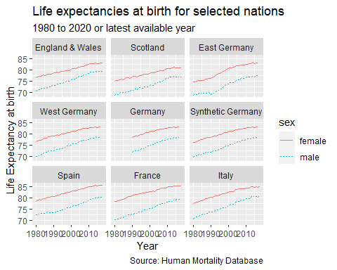

Life Expectancy at birth

Here it is at age 65

## Joining, by = "code"

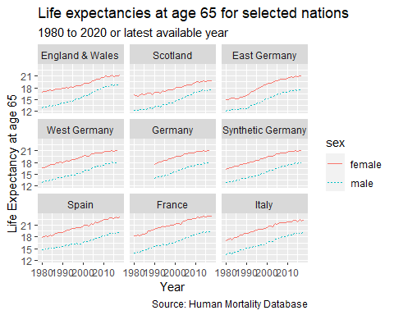

Life Expectancy at age 65

Some insightful comment about what’s going on.

Scotland looks pretty bad compared with the other countries.

## Change in life expectancy in these nations

## # A tibble: 3,972 x 6  
## code year x sex ex delta_ex  
## <chr> <int> <dbl> <chr> <dbl> <dbl>  
## 1 FRATNP 1816 0 female 41.1 NA   
## 2 FRATNP 1816 65 female 10.8 NA   
## 3 FRATNP 1816 0 male 39.1 NA   
## 4 FRATNP 1816 65 male 10.7 NA   
## 5 FRATNP 1817 0 female 40.2 -0.890   
## 6 FRATNP 1817 65 female 11.0 0.210   
## 7 FRATNP 1817 0 male 38.2 -0.830   
## 8 FRATNP 1817 65 male 10.6 -0.140   
## 9 FRATNP 1818 0 female 39.1 -1.13   
## 10 FRATNP 1818 65 female 11.1 0.0300  
## # ... with 3,962 more rows

## Joining, by = "code"

## `geom_smooth()` using method = 'loess' and formula 'y ~ x'

## Warning: Removed 4 rows containing non-finite values (stat_smooth).

## Warning: Removed 4 rows containing missing values (geom_point).

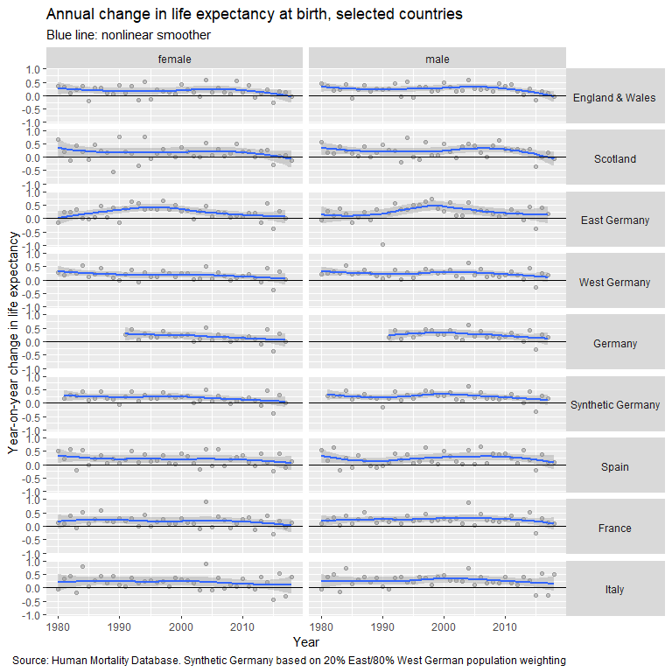

# Discussion

# Bibliography