How do changes in ex vary between countries?

# Introduction

“Even with coronavirus out of the picture, Britain is the sick man, woman and child of Europe”.1 Richard Horton wrote these words in 2020, after the Global Burden of Disease study placed the UK close to the bottom of European rankings on most measures. In 2019, prior to the pandemic, we said much the same.2 Pointing to stalling improvements in life expectancy, rising infant mortality, widening inequalities, and difficulties accessing healthcare, we recalled the words, written by Yeats in a 1919 poem, “things fall apart”.3

Two years on, the world has changed in ways few could have imagined. While the full impact will not be known for some time, so far, the UK has had one of the highest death rates among industrialised countries. We already know that the country was, in many respects, unprepared and, as all countries seek lessons from the pandemic, we need to understand better what had happened to the health of the British population that may have left them more vulnerable to a shock. Here we look at what happened in four other large European countries, Germany, France, Spain, and Italy, in the decades prior to COVID-19.

Before doing so, we need to look at the UK in a broader context. Ho and Hendi examined changes in life expectancy and their determinants in 18 Organisation for Economic Co-operation and Development (OECD) countries between 2014 and 16.4 While life expectancy at birth fell in 12 countries in 2014-15 for women, and 11 for men, most then compensated with robust gains in 2015-16. In Italy, where the initial changes were largest, it fell by 0.44 years for women and 0.43 for men, but recovered by the same amounts the following year. In contrast, the corresponding figures in the UK were initial drops of 0.26 years for women and 0.19 for men but no improvement for women and only 0.01 of a year for men in 2015-16. In 2014-15, all 5 countries in our analysis saw falls in life expectancy at birth and at 65 years for both men and women; at ages 0-65 years, male life expectancy at 65 also fell in all countries except Spain, and in men in Italy and Germany4 but all except the UK largely recovered the following year.

So what happened after that? We use publicly available data to ask whether the UK has remained an anomaly in health terms or whether whatever happened also affected otherwise comparable high-income countries (HICs) in Europe.

Stalling of life expectancy improvements occurred in the UK from 2010 onwards. It was also seen in some other Western European countries. While the reason and severity of this is debated, some also contend the stalling of improvements seen is artefact following an unusual decade of improvement in 2000s (e.g. Murphy 2021).

This paper will compare annual changes in life expectancy at both birth () and at age 65 () from 1980 to 2019 (or the latest available year) in England and Wales, Scotland, France, Italy, Spain, and Germany. Germany includes a ‘Synthetic Germany’ created from a weighted average of East and West German data for common years. The method for creating this ‘Synthetic Germany’ is covered in the methods section in brief and in Appendix 1 for more detail. In order to explore the hypothesis that the recent stalling in life expectancy, most marked in England and Wales, was an expected ‘correction’ after a decade of unusually fast life expectancy improvements, we have selected the years from 1980 onwards.

# Methods

## Data

Data were extracted from the [Human Mortality Database](https://mortality.org/) via the R package [HMDHFDplus](http://www.demogr.mpg.de/en/projects_publications/publications_1904/mpidr_technical_reports/reading_human_fertility_database_and_human_mortality_database_data_into_r_5438.htm).

The following countries are included in the comparison:

* England & Wales (GBRTENW)
* Scotland (GBR_SCO)
* France (FRANTP)
* Spain (ESP)
* Italy (ITA)
* Germany
  + Total Germany (DEUTNP)
  + East Germany (DEUTE)
  + West Germany (DEUTW)
  + Simulated/Synthetic Germany

## Analysis

For each of these countries, and for males and females separately, we are interested in the annual changes in life expectancy at birth () and life expectancy at age 65 (), from 1980 to the last available year for each country. In addition, we compare average life expectancy improvements over the 4 decades: 1980, 1990, 2000, and 2010. We then compared whether the average between the decades was significant, using a regression model. Finally, we compare the annual changes in life expectancy to see if there is any significant breaks.

All code used in the analyses is available online at Github[1].

### Synthetic Germany

To allow UK national trends to be compared with a single German population, we attempted to produce a ‘Synthetic German’ population with data for East and West Germany for years prior to reunification. We estimated that this ‘Synthetic Germany’ could be produced by using a weighted average of 20% East Germany, and 80% West German life expectancy trends. More precise estimates can be produced, and the methods used to reach this conclusion are detailed in Appendix 1.

# Results

### Life expectancy trends

The following figures show life expectancy at birth and at age 65 for selected nations from 1980 to the latest available year for males and females.

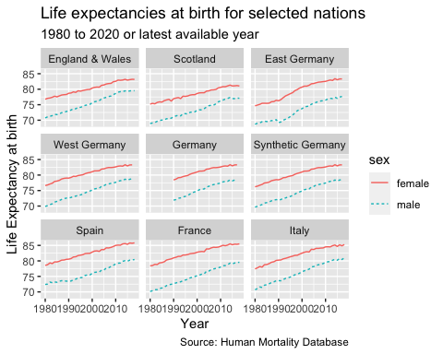

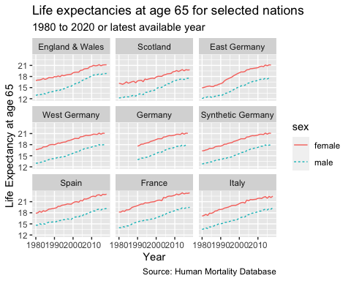

## Change in life expectancy in these nations

Next, we compare the annual change in life expectancy at birth and at aged 65 years for the nations from 1980 to the latest available year, by sex.

### Changes in life expectancy at birth

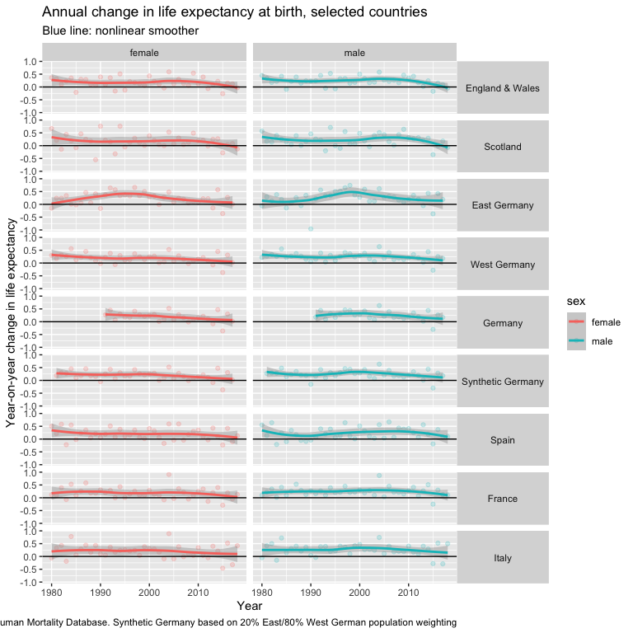

### Changes in life expectancy at age 65

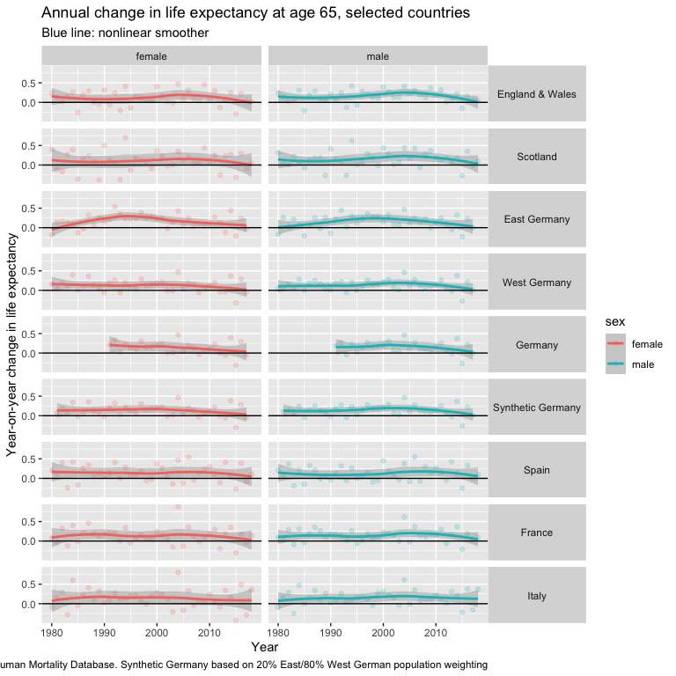

## Time trends

Second, we used time-trend analysis to explore the changes in life expectancy over the 4 decades: 1980s, 1990s, 2000s, and 2010s. This produces the average change for the decade, whether negative or positive, the standard error and its statistical significance for each country by sex.

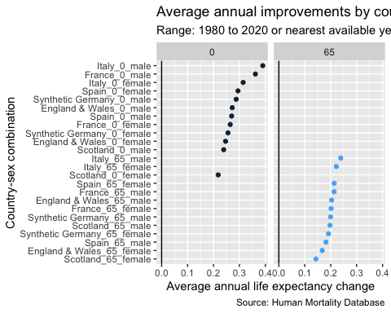

## Graphs of annual change in life expectancy

The below graphs show the annual change in life expectancy at birth and at aged 65 years for males and females for the nations examined. The pink and green lines are non-linear smoothed. The individual figures can be seen in Appendix 2.

## Average improvements by decade

### Are the differences by decade statistically significant?

Are there significant differences in average rates of change in by decade? Another way of expressing this question is to ask whether knowing the decade in which an observation has been observed is informative as to what such values will be. This rephrased question was addressed by, for each starting age (0 or 65 years), sex and country, fitting two competing model specifications - and - and running an F test on the residuals of these two models. The Null model specification, , regresses (observed annual changes in ) against a single intercept term ; put another way: assumes that all observations are drawn from a Normal distribution with a mean value of , and that this is consistent across all observed decades. The alternative model specification, , also includes the term, but also includes dummy variables to indicate which decade the realised value of corresponds to. (Because one of the decades needs to be the reference category against which other decades are compared, there are one fewer decadal dummy variables than decades in the dataset for a given country, and the parameter in estimates the mean change in in the first decade, and so cannot be compared directly with the parameter in .) A P-value from the F test comparing and of less than 0.05 is taken to indicate that should be preferred to , and so that there are systemic differences in average rates of improvement by decade for a given country, sex, and starting age.

We found the only significant change decade-on-decades was for East Germany for females at birth and at aged 65 years (Appendix 3). This is consistent with existing literature in this area, showing the convergence of life expectancy for females in East and West Germany following reunification.

### Segmented regression approach

Though there may be systemic differences in average changes in life expectancy over time, such differences may not be patterned by decade, and so the above model specification may not have been appropriate to detect any such changes. Instead of looking for systemic differences by decade, we can instead look at whether there are any systemic and detectable ‘breaks’ in the trends over time. If our data were life expectancy over time, this could be achieved through joinpoint analysis, in which the slope is allowed to change over time. As instead are data are annual changes in life expectancy, we are interested in detecting changes in intercept over time. The details of this are outlined in Appendix 4.

Table 1 shows the countries where the analysis reveals a statistically significant (at p value <0.05) compared to the null. The full list and results can be seen in Appendix 5.

Table 1: Nations with a statistically significant (p < 0.05) breakpoint in trends by age and sex, 1980-2015, in descending order of significance i.e. highest first.



|  |  |  |  |  |
| --- | --- | --- | --- | --- |
| **Country** | **Age** | **Sex** | **Year of break** | **P Value (to 3 decimal places)** |
| England & Wales | 0 | Male | 2013 | 0.003 |
| Scotland | 0 | Male | 2015 | 0.009 |
| Synthetic Germany | 0 | Female | 2007 | 0.030 |
| England & Wales | 0 | Female | 2012 | 0.037 |
| France | 0 | Male | 2015 | 0.041 |
| Synthetic Germany | 65 | Male | 2015 | 0.042 |
| Synthetic Germany | 0 | Male | 2015 | 0.049 |

# Discussion

* The UK nations examined—England and Wales, Scotland—were outliers
* Slowdown was not happening everywhere
* This was not reflected across Europe
* **Limitations**: fewer years for comparison in 2010s for some nations; comparing different time periods will provide different results e.g. New Labour years in E&W.

# Appendix 1: Construction of Synthetic Germany

* Add further details here.

# Appendix 2: Graphs of annual change in life expectancy by sex and nation

### England and Wales

### Scotland

### France

### Spain

### Italy

### Germany: Synthetic

### Germany: East

### Germany: West

# Appendix 3: Improvements by decade

The table below shows average improvements by decade for England and Wales (standard error).

## `summarise()` has grouped output by 'code', 'x', 'sex'. You can override using  
## the `.groups` argument.

**Table** **1**: Average improvement in life expectancy by decade

| sex | 1980 | 1990 | 2000 | 2010 |
| --- | --- | --- | --- | --- |
| female | 0.19 (0.177) | 0.164 (0.215) | 0.248 (0.211) | 0.083 (0.184) |
| male | 0.252 (0.159) | 0.231 (0.193) | 0.315 (0.148) | 0.137 (0.187) |

# Appendix 4: Segmented regression approach

If we define our Null (no change) model as follows:

Where . i.e. all observations are draws from . The alternative model specification against which this is compared is then:

Where is defined as where and where . ( is used in to indicate that this parameter is not directly comparable with in ).

This specification shows that there is an additional parameter to be determined in order to produce . This parameter is the breakpoint in the series. The selection of will be determined by numeric optimisation, by selecting the value of that minimised AIC.

Once the best possible , using the best value of , is selected, will be compared with using an F-test, allowing us to determine whether there is convincing evidence of any specific break in the data.

We will start with a single country, starting age, and sex, and with manual selection of , then generalise and automate further.

##   
## Call:  
## lm(formula = delta_ex ~ 1, data = example_df)  
##   
## Residuals:  
## Min 1Q Median 3Q Max   
## -0.43359 -0.09359 -0.03359 0.13141 0.41641   
##   
## Coefficients:  
## Estimate Std. Error t value Pr(>|t|)   
## (Intercept) 0.17359 0.03185 5.45 3.24e-06 ***  
## ---  
## Signif. codes: 0 '***' 0.001 '**' 0.01 '*' 0.05 '.' 0.1 ' ' 1  
##   
## Residual standard error: 0.1989 on 38 degrees of freedom  
## (1 observation deleted due to missingness)

##   
## Call:  
## lm(formula = delta_ex ~ year >= 1990, data = example_df)  
##   
## Residuals:  
## Min 1Q Median 3Q Max   
## -0.42793 -0.09897 -0.02793 0.12603 0.42207   
##   
## Coefficients:  
## Estimate Std. Error t value Pr(>|t|)   
## (Intercept) 0.19000 0.06367 2.984 0.00502 **  
## year >= 1990TRUE -0.02207 0.07384 -0.299 0.76671   
## ---  
## Signif. codes: 0 '***' 0.001 '**' 0.01 '*' 0.05 '.' 0.1 ' ' 1  
##   
## Residual standard error: 0.2014 on 37 degrees of freedom  
## (1 observation deleted due to missingness)  
## Multiple R-squared: 0.002408, Adjusted R-squared: -0.02455   
## F-statistic: 0.08933 on 1 and 37 DF, p-value: 0.7667

##   
## Call:  
## lm(formula = delta_ex ~ year >= 1995, data = example_df)  
##   
## Residuals:  
## Min 1Q Median 3Q Max   
## -0.41600 -0.10600 -0.01333 0.12400 0.43667   
##   
## Coefficients:  
## Estimate Std. Error t value Pr(>|t|)   
## (Intercept) 0.20600 0.05161 3.992 0.000299 ***  
## year >= 1995TRUE -0.05267 0.06579 -0.801 0.428486   
## ---  
## Signif. codes: 0 '***' 0.001 '**' 0.01 '*' 0.05 '.' 0.1 ' ' 1  
##   
## Residual standard error: 0.1999 on 37 degrees of freedom  
## (1 observation deleted due to missingness)  
## Multiple R-squared: 0.01703, Adjusted R-squared: -0.009539   
## F-statistic: 0.6409 on 1 and 37 DF, p-value: 0.4285

##   
## Call:  
## lm(formula = delta_ex ~ year >= 1997, data = example_df)  
##   
## Residuals:  
## Min 1Q Median 3Q Max   
## -0.42318 -0.10012 -0.02318 0.12988 0.42682   
##   
## Coefficients:  
## Estimate Std. Error t value Pr(>|t|)   
## (Intercept) 0.18706 0.04880 3.833 0.000475 ***  
## year >= 1997TRUE -0.02388 0.06498 -0.367 0.715379   
## ---  
## Signif. codes: 0 '***' 0.001 '**' 0.01 '*' 0.05 '.' 0.1 ' ' 1  
##   
## Residual standard error: 0.2012 on 37 degrees of freedom  
## (1 observation deleted due to missingness)  
## Multiple R-squared: 0.003636, Adjusted R-squared: -0.02329   
## F-statistic: 0.135 on 1 and 37 DF, p-value: 0.7154

##   
## Call:  
## lm(formula = delta_ex ~ year >= 2008, data = example_df)  
##   
## Residuals:  
## Min 1Q Median 3Q Max   
## -0.40357 -0.09857 -0.00273 0.11143 0.41727   
##   
## Coefficients:  
## Estimate Std. Error t value Pr(>|t|)   
## (Intercept) 0.19357 0.03759 5.149 8.89e-06 ***  
## year >= 2008TRUE -0.07084 0.07078 -1.001 0.323   
## ---  
## Signif. codes: 0 '***' 0.001 '**' 0.01 '*' 0.05 '.' 0.1 ' ' 1  
##   
## Residual standard error: 0.1989 on 37 degrees of freedom  
## (1 observation deleted due to missingness)  
## Multiple R-squared: 0.02636, Adjusted R-squared: 4.468e-05   
## F-statistic: 1.002 on 1 and 37 DF, p-value: 0.3234

##   
## Call:  
## lm(formula = delta_ex ~ year >= 2011, data = example_df)  
##   
## Residuals:  
## Min 1Q Median 3Q Max   
## -0.40839 -0.10794 0.01161 0.12706 0.39161   
##   
## Coefficients:  
## Estimate Std. Error t value Pr(>|t|)   
## (Intercept) 0.19839 0.03507 5.657 1.83e-06 ***  
## year >= 2011TRUE -0.12089 0.07743 -1.561 0.127   
## ---  
## Signif. codes: 0 '***' 0.001 '**' 0.01 '*' 0.05 '.' 0.1 ' ' 1  
##   
## Residual standard error: 0.1953 on 37 degrees of freedom  
## (1 observation deleted due to missingness)  
## Multiple R-squared: 0.0618, Adjusted R-squared: 0.03644   
## F-statistic: 2.437 on 1 and 37 DF, p-value: 0.127

## Analysis of Variance Table  
##   
## Model 1: delta_ex ~ 1  
## Model 2: delta_ex ~ T_param  
## Res.Df RSS Df Sum of Sq F Pr(>F)   
## 1 38 1.5037   
## 2 37 1.3347 1 0.16897 4.6839 0.03697 *  
## ---  
## Signif. codes: 0 '***' 0.001 '**' 0.01 '*' 0.05 '.' 0.1 ' ' 1

## Analysis of Variance Table  
##   
## Model 1: delta_ex ~ 1  
## Model 2: delta_ex ~ T_param  
## Res.Df RSS Df Sum of Sq F Pr(>F)   
## 1 38 1.19312   
## 2 37 0.94298 1 0.25014 9.8149 0.003378 **  
## ---  
## Signif. codes: 0 '***' 0.001 '**' 0.01 '*' 0.05 '.' 0.1 ' ' 1

##   
## Call:  
## lm(formula = delta_ex ~ T_param, data = .)  
##   
## Residuals:  
## Min 1Q Median 3Q Max   
## -0.41143 -0.09665 -0.04188 0.09335 0.60813   
##   
## Coefficients:  
## Estimate Std. Error t value Pr(>|t|)   
## (Intercept) 0.26188 0.03171 8.259 6.41e-10 ***  
## T_paramTRUE -0.10045 0.07484 -1.342 0.188   
## ---  
## Signif. codes: 0 '***' 0.001 '**' 0.01 '*' 0.05 '.' 0.1 ' ' 1  
##   
## Residual standard error: 0.1794 on 37 degrees of freedom  
## (1 observation deleted due to missingness)  
## Multiple R-squared: 0.04642, Adjusted R-squared: 0.02065   
## F-statistic: 1.801 on 1 and 37 DF, p-value: 0.1877

##   
## Call:  
## lm(formula = delta_ex ~ 1, data = .)  
##   
## Residuals:  
## Min 1Q Median 3Q Max   
## -0.49385 -0.11885 -0.02385 0.05615 0.62615   
##   
## Coefficients:  
## Estimate Std. Error t value Pr(>|t|)   
## (Intercept) 0.24385 0.02902 8.402 3.41e-10 ***  
## ---  
## Signif. codes: 0 '***' 0.001 '**' 0.01 '*' 0.05 '.' 0.1 ' ' 1  
##   
## Residual standard error: 0.1812 on 38 degrees of freedom  
## (1 observation deleted due to missingness)

## Analysis of Variance Table  
##   
## Model 1: delta_ex ~ 1  
## Model 2: delta_ex ~ T_param  
## Res.Df RSS Df Sum of Sq F Pr(>F)  
## 1 38 1.2483   
## 2 37 1.1904 1 0.05795 1.8012 0.1877

## # A tibble: 36 × 5  
## # Groups: code, x, sex [36]  
## code x sex data best_tau  
## <chr> <dbl> <chr> <list> <dbl>  
## 1 DEUTNP 0 female <tibble [28 × 2]> 2004.  
## 2 DEUTNP 65 female <tibble [28 × 2]> 2004.  
## 3 DEUTE 0 female <tibble [39 × 2]> 2004.  
## 4 DEUTE 65 female <tibble [39 × 2]> 2015   
## 5 DEUTW 0 female <tibble [39 × 2]> 1999.  
## 6 DEUTW 65 female <tibble [39 × 2]> 1998   
## 7 ESP 0 female <tibble [40 × 2]> 1998.  
## 8 ESP 65 female <tibble [40 × 2]> 1998.  
## 9 FRATNP 0 female <tibble [40 × 2]> 1998.  
## 10 FRATNP 65 female <tibble [40 × 2]> 1998.  
## # … with 26 more rows

# Appendix 5: Breakpoint analysis results

### Table of countries breakpoints with statistical significance

Next, we display a table with those countries where the breakpoint shows as statistically significant (at p value <0.05) compared to the null, where best_tau is the year.

| **Country** | **Age** | **Sex** | **Best_Tau** | **F Test P Value** | **Statistically significant** |
| --- | --- | --- | --- | --- | --- |
| GBRTENW | 0 | male | 2,013 | 0.003378317 | TRUE |
| GBR_SCO | 0 | male | 2,015 | 0.009029495 | TRUE |
| DEUTE | 0 | male | 1,991 | 0.010408898 | TRUE |
| DEUTE | 65 | female | 1,987 | 0.019893564 | TRUE |
| DEUTW | 0 | male | 2,015 | 0.029263626 | TRUE |
| DEUTSYNTH | 0 | female | 2,007 | 0.029845768 | TRUE |
| DEUTNP | 0 | male | 2,015 | 0.033571164 | TRUE |
| DEUTW | 0 | female | 1,988 | 0.035407083 | TRUE |
| GBRTENW | 0 | female | 2,012 | 0.036971650 | TRUE |
| DEUTNP | 65 | male | 2,015 | 0.037615088 | TRUE |
| DEUTE | 65 | male | 1,991 | 0.038763640 | TRUE |
| FRATNP | 0 | male | 2,015 | 0.041175313 | TRUE |
| DEUTSYNTH | 65 | male | 2,015 | 0.041825971 | TRUE |
| DEUTNP | 0 | female | 2,007 | 0.045517734 | TRUE |
| DEUTW | 65 | male | 2,015 | 0.046314979 | TRUE |
| DEUTE | 0 | female | 2,005 | 0.048779675 | TRUE |
| DEUTSYNTH | 0 | male | 2,015 | 0.049476783 | TRUE |
| GBRTENW | 65 | male | 2,012 | 0.051021976 | FALSE |
| GBR_SCO | 0 | female | 1,981 | 0.061953344 | FALSE |
| ESP | 0 | female | 1,983 | 0.064064265 | FALSE |
| FRATNP | 0 | female | 2,015 | 0.067963332 | FALSE |
| DEUTSYNTH | 65 | female | 2,015 | 0.069544115 | FALSE |
| DEUTNP | 65 | female | 2,015 | 0.083031092 | FALSE |
| DEUTW | 65 | female | 2,015 | 0.089238885 | FALSE |
| ESP | 0 | male | 1,983 | 0.092446451 | FALSE |
| ITA | 0 | female | 2,005 | 0.107811573 | FALSE |
| FRATNP | 65 | male | 2,015 | 0.122733887 | FALSE |
| GBRTENW | 65 | female | 2,012 | 0.146051393 | FALSE |
| GBR_SCO | 65 | male | 1,994 | 0.150769256 | FALSE |
| ITA | 65 | male | 1,984 | 0.167066787 | FALSE |
| ITA | 0 | male | 1,981 | 0.169500744 | FALSE |
| FRATNP | 65 | female | 2,015 | 0.172067793 | FALSE |
| GBR_SCO | 65 | female | 1,981 | 0.235879405 | FALSE |
| ITA | 65 | female | 2,005 | 0.260633635 | FALSE |
| ESP | 65 | male | 2,000 | 0.271958077 | FALSE |
| ESP | 65 | female | 2,014 | 0.295177288 | FALSE |

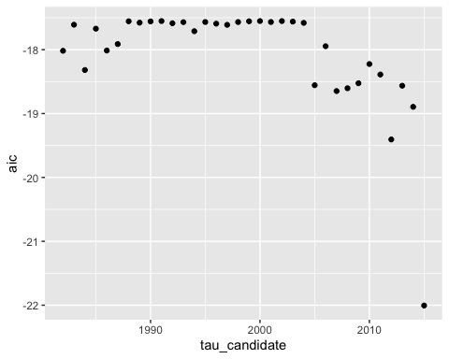

# References

1. Horton R. Alarming new data shows the UK was the 'sick man' of Europe even before Covid 2020 [updated 18 October 2020; cited 2021 12 November]. Available from: <https://www.theguardian.com/commentisfree/2020/oct/18/alarming-data-britain-sick-man-europe-before-covid> accessed 12 November 2021.

2. Hiam L, Dorling D, McKee M. Things Fall Apart: the British Health Crisis 2010-2020. *Br Med Bull* 2020;133(1):4-15. doi: 10.1093/bmb/ldz041 [published Online First: 2020/03/29]

3. Yeats WB. The Collected Poems of WB Yeats. Ware, Hertfordshire2000.

4. Ho JY, Hendi AS. Recent trends in life expectancy across high income countries: retrospective observational study. *BMJ (Clinical research ed)* 2018;362:k2562. doi: 10.1136/bmj.k2562 [published Online First: 2018/08/17]

1. Available at: <https://github.com/JonMinton/change-in-ex> (accessed 15 March 2022)