The exceptions collapse: fertility trends for 45 countries revisited
  - DRAFT v0.1 (2026-07-11) — working paper for preprint; not yet reviewed by all listed contributors
Jon Minton
2026-07-11
Abstract
BACKGROUND — Pattaro, Vanderbloemen and Minton (2020) found, across 45 countries, that once cohorts fell below the replacement milestone (cumulative pseudo-cohort fertility rate, CPCFR, of 2.05) they tended not to return, with two named exceptions: Norway and the United States. Their data ended in 2014–15. OBJECTIVE — To update the 45-country composite lattice plots with Human Fertility Database and Human Fertility Collection data extending to 2023–25 and re-examine the exceptions. METHODS — The published combination rules and visual specification are reapplied to the 2026 source releases, with one code-mapping correction restoring France after 2008. RESULTS — Both exceptions have ended or are ending. Norway’s replacement contour, having returned for cohorts born 1958–68, escapes vertically for cohorts born after ~1972. The United States’ exception persisted longer than its period collapse suggests — cohorts born 1982–84 crossed 2.05 at ages 39–40 — and is fading in the still-censored cohorts beyond. Across the panel, 43 of 45 countries now have post-war cohorts observed beyond age 44 that never reached replacement. CONCLUSIONS — A decade of new data strengthens the 2020 regularity at the cost of both its exceptions; the geometry of the contour escapes points to a structural ceiling developed in a companion paper.
FOR REVIEWERS (Word copy). Please comment using Word’s Comments and Track Changes features — do not edit silently. Return the file to jon.will.minton@gmail.com. Comments will be logged in the project’s public feedback register (manuscript_2026/review/FEEDBACK.md on GitHub), actioned, and credited; substantive contributions meeting authorship criteria are recognized with co-authorship in later preprint versions. This is v0.1, corresponding to SocArXiv preprint version 1.
 Note
Draft status. This is an early working version posted for open comment; the analysis is reproducible from https://github.com/JonMinton/Comparative_Fertility (see UPDATE_WORKPLAN.md there for the decision log). Figures and numbers are machine-generated from the pipeline described in Methods. Comments welcome — and contributions meeting authorship criteria will be recognized with co-authorship in later versions. This update builds on Pattaro et al. (2020), co-authored with Serena Pattaro and Laura Vanderbloemen, who are warmly invited to rejoin.

Background
Using data from the Human Fertility Database (HFD) and Human Fertility Collection (HFC) ending in 2014–15, Pattaro et al. (2020) introduced composite lattice plots — Lexis surfaces combining level-plot shading of age-specific fertility rates (ASFRs) with contour lines marking cumulative pseudo-cohort fertility rate (CPCFR) milestones — and reported a striking regularity across 45 countries: once a country’s cohorts fell below the replacement milestone (CPCFR $<$ 2.05), they tended not to return to it. Two exceptions were named: Norway, where cohorts born after the 1950s regained replacement, and the United States, for cohorts born after the late 1960s.
A decade of new data has since accumulated, covering the years in which period fertility fell to record lows across the Nordic countries (Comolli et al. 2021; Hellstrand et al. 2020), the United States (Kearney et al. 2022), and East Asia (Yoo and Sobotka 2018).

Objective
To update the 45-country composite lattice plots with HFD and HFC data extending to 2023–25, and to re-examine the status of the two named exceptions.

Methods
We reapply the combination rules of Pattaro et al. (2020) to the current HFD (Max Planck Institute for Demographic Research (Germany) and Vienna Institute of Demography (Austria) 2026b) and HFC (Max Planck Institute for Demographic Research (Germany) and Vienna Institute of Demography (Austria) 2026a) releases: HFD is preferred over HFC for any country-year; within the HFC, single-year periods with age in completed years are retained under the collection preference STAT $>$ ODE $>$ RE; small internal gaps (at most four years) are linearly interpolated and flagged. The updated panel spans 1850–2025 (51 populations before the published exclusions; the same 45-country panel after them). One correction to the 2016 build is applied: HFD’s France series (code FRATNP) was previously dropped by an unmapped country code, so the published figures showed France ending in 2008; the updated build restores France to 2023. A back-revision audit against the 2016 dataset is included in the repository; the largest differences (Ireland, Spain, Denmark) reflect HFD’s own revisions of historical exposures. A consequence worth stating plainly: the 2020 findings remain reproducible from the dataset frozen in the repository, but they are not exactly replicable from fresh source downloads, because the source databases have themselves been revised — an inherent property of living data infrastructures, and part of the motivation for periodic updates of this kind.
All figures use the published visual specification: viridis (reversed) level-plot shading of ASFR on birth-year $×$ age panels, solid contours at CPCFR = 2.05 and 1.50, years 1950 onward, ages up to 50, and countries ordered by CPCFR at 2007, the ranking year of the published figures (Sarkar 2008; Garnier 2018).

Results

Norway
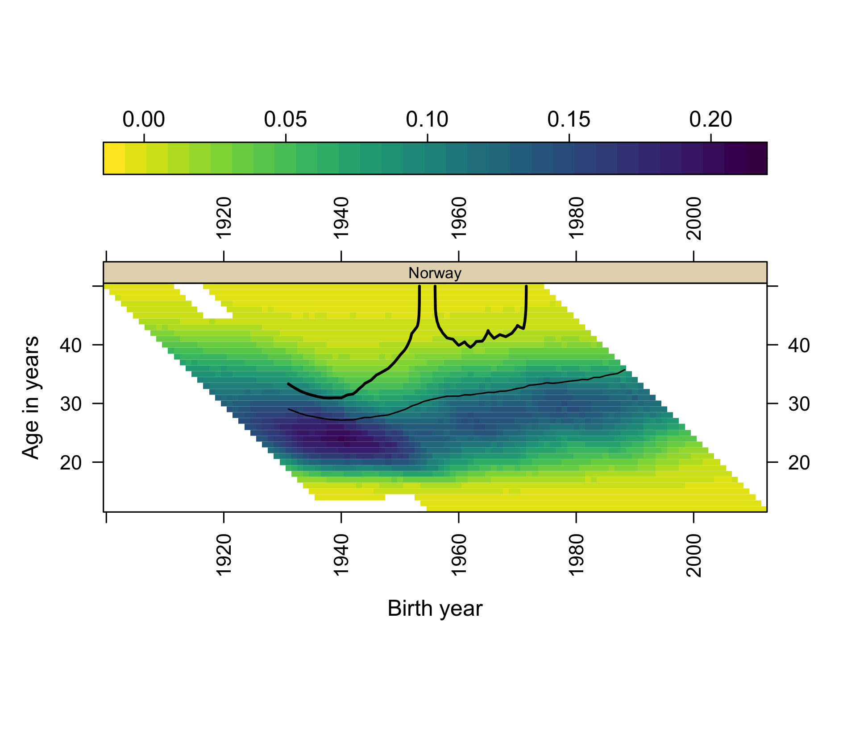
Figure 1: Norway: ASFR surface with CPCFR contours at 2.05 (heavy) and 1.50 (light), cohorts observed to 2024.
The updated Norway panel (Figure 1) now shows a complete arc. The 2.05 contour climbs steeply — effectively vertically — for cohorts born around 1950; returns to the surface at around age 40 for cohorts born 1958–68, the recovery that made Norway the 2020 paper’s leading exception (Kravdal 2016); and then escapes vertically a second time for cohorts born after approximately 1972. On current data no Norwegian cohort born after 1971 reaches replacement at any observed age. The 1.50 contour drifts steadily upward, reaching roughly age 36 for cohorts born in the late 1980s before censoring. Norway’s period TFR fell from 1.98 in 2009 to 1.40 in 2023, a record low (Max Planck Institute for Demographic Research (Germany) and Vienna Institute of Demography (Austria) 2026b).

United States
The United States requires a more careful statement. Its period TFR fell from 2.12 (2007) to 1.59 (2024), a record low. In cohort terms, however, the exception persisted longer than the period collapse suggests: cohorts born 1982, 1983 and 1984 all crossed CPCFR = 2.05, at ages 39, 39 and 40 respectively, with completed cumulative fertility of 2.14, 2.13 and 2.09. The 1985 cohort stood at 2.04 by age 39 (data to 2024) and will plausibly cross; trajectories for cohorts born after the mid-1980s run progressively lower at every age but remain right-censored. The US exception has thus not yet collapsed in cohort terms; it is fading from below, cohort by cohort, exactly as the period-based literature on postponement would predict (Sobotka 2017; Kearney et al. 2022).

The panel as a whole
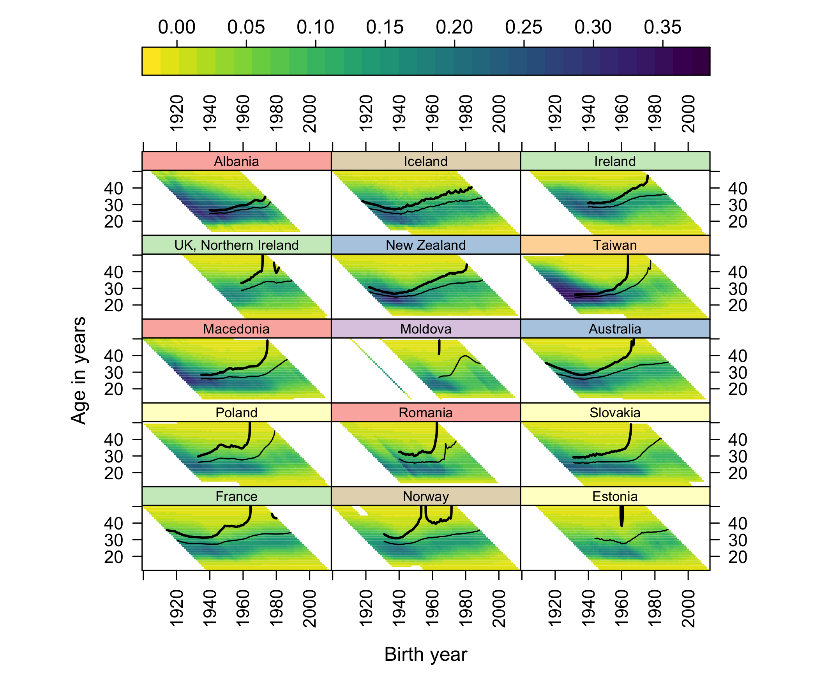
Figure 2: The fifteen highest-ranked countries by CPCFR at 2007, updated to 2023–25.
Across the full panel, 43 of 45 countries now have post-war cohorts observed beyond age 44 that never reached replacement. Only nine countries have any cohort born in 1970 or later that crossed 2.05 — and the most recent crossing cohorts are: United States 1984, Iceland 1983, Northern Ireland 1981, France 1980, New Zealand 1980. South Korea, newly covered here from 1960 (the 2020 panel’s Korean series ended in 2007), last saw a cohort reach replacement with those born in 1958; its period TFR in 2024 was 0.75 (Yoo and Sobotka 2018).

Conclusions
The 2020 regularity — below replacement, no return — has been strengthened rather than weakened by a decade of data, at the cost of both its named exceptions. Norway’s recovery is now bracketed on both sides by vertical contour escapes; the United States’ recovery survives through cohorts born in the early 1980s and is fading in the censored region beyond. The geometry of these escapes — contours climbing through ages at which little fertility remains — points to a structural constraint on any return to replacement, which we develop in a companion paper on the effective upper boundary of the fertility lifecourse.
 Note
Reproducibility and contributions. Code, combined data, validation reports, and this manuscript’s source are public at https://github.com/JonMinton/Comparative_Fertility. Analytical pipeline and drafting were assisted by Claude (Anthropic); all analyses are re-runnable end-to-end and all numbers in this draft are machine-generated from the pipeline.

References
Comolli, Chiara L., Gerda Neyer, Gunnar Andersson, et al. 2021. “Beyond the Economic Gaze: Childbearing During and After Recessions in the Nordic Countries.” European Journal of Population 37: 473–520. https://doi.org/10.1007/s10680-020-09570-0.
Garnier, Simon. 2018. Viridis: Default Color Maps from “Matplotlib”.
Hellstrand, Julia, Jessica Nisén, and Mikko Myrskylä. 2020. “All-Time Low Period Fertility in Finland: Demographic Drivers, Tempo Effects, and Cohort Implications.” Population Studies 74 (3): 315–29. https://doi.org/10.1080/00324728.2020.1750677.
Kearney, Melissa S., Phillip B. Levine, and Luke Pardue. 2022. “The Puzzle of Falling US Birth Rates Since the Great Recession.” Journal of Economic Perspectives 36 (1): 151–76. https://doi.org/10.1257/jep.36.1.151.
Kravdal, Øystein. 2016. “Not so Low Fertility in Norway—a Result of Affluence, Liberal Values, Gender-Equality Ideals, and the Welfare State.” In Low Fertility, Institutions, and Their Policies, edited by Ronald R. Rindfuss and Minja Kim Choe. Springer.
Max Planck Institute for Demographic Research (Germany) and Vienna Institute of Demography (Austria). 2026a. The Human Fertility Collection. https://www.fertilitydata.org.
Max Planck Institute for Demographic Research (Germany) and Vienna Institute of Demography (Austria). 2026b. The Human Fertility Database. https://www.humanfertility.org.
Pattaro, Serena, Laura Vanderbloemen, and Jon Minton. 2020. “Visualizing Fertility Trends for 45 Countries Using Composite Lattice Plots.” Demographic Research 42 (23): 689–712. https://doi.org/10.4054/DemRes.2020.42.23.
Sarkar, Deepayan. 2008. Lattice: Multivariate Data Visualization with r. Use r! Springer.
Sobotka, Tomáš. 2017. “Post-Transitional Fertility: The Role of Childbearing Postponement in Fuelling the Shift to Low and Unstable Fertility Levels.” Journal of Biosocial Science 49 (S1): S20–45.
Yoo, Sam Hyun, and Tomáš Sobotka. 2018. “Ultra-Low Fertility in South Korea: The Role of the Tempo Effect.” Demographic Research 38 (22): 549–76. https://doi.org/10.4054/DemRes.2018.38.22.

