The closing corridor: postponement against the effective ceiling of the fertility lifecourse
  - DRAFT v0.1 (2026-07-11) — working paper for preprint; not yet reviewed by all listed contributors
Jon Minton
2026-07-11
Abstract
Whether a cohort can reach replacement fertility depends on when childbearing starts and when it must end. Ages at first birth have risen five to six years since the 1970s; this paper is about the other boundary. Using the updated 45-country HFD/HFC panel (1850–2025), we define the effective ceiling of the fertility lifecourse as the highest age with ASFR ≥ 1/200 and show it is behavioural, not biological: 47–48 in nineteenth-century populations, pulled down to 41 by the 1980s as parity control truncated high-parity childbearing, and recovered only to about 43 since — one year per fifteen calendar years. The fertility mass above age 40 (0.02–0.07 children) cannot arithmetically substitute for earlier childbearing. Consequently replacement must now be achieved within a corridor roughly thirteen years wide, and on composite lattice plots the replacement contour visibly terminates at the ceiling — distinguishable from right-censoring — in 43 of 45 countries’ recent cohorts. The corridor framing contributes discipline to the debate on accelerating fertility decline: any candidate explanation must match the same age–cohort–timing fingerprint, and postponement converts to quantum loss even under unchanged intentions.
FOR REVIEWERS (Word copy). Please comment using Word’s Comments and Track Changes features — do not edit silently. Return the file to jon.will.minton@gmail.com. Comments will be logged in the project’s public feedback register (manuscript_2026/review/FEEDBACK.md on GitHub), actioned, and credited; substantive contributions meeting authorship criteria are recognized with co-authorship in later preprint versions. This is v0.1, corresponding to SocArXiv preprint version 1.
 Note
Draft status. Early working version posted for open comment. Reproducible from https://github.com/JonMinton/Comparative_Fertility; analytic choices (thresholds, definitions) were fixed in the repository’s workplan before this analysis ran on the updated data, with prototypes on the pre-update data disclosed there.

Introduction
Two quantities jointly determine whether a cohort can reach replacement fertility: when childbearing starts, and when it must end. The first has moved enormously — mean ages at first birth have risen five to six years since the 1970s across the low-fertility world (Sobotka 2017; Beaujouan 2020). This paper is about the second: the effective ceiling of the fertility lifecourse, its history, and its consequence — a corridor between a rising floor and a nearly fixed ceiling within which replacement must now be achieved.
We make three claims. First, the ceiling is behavioural, not biological: in the nineteenth-century populations of our panel it sat at ages 47–48, was pulled down to 41 by the 1980s as parity control truncated high-parity childbearing, and has since crept back only to about 43. Second, the fertility mass above age 40 is small enough (0.02–0.07 children) that no plausible late-fertility recuperation can substitute for earlier childbearing (Beaujouan 2020). Third, the interaction of these facts with cumulative cohort fertility is directly visible on composite lattice plots (Pattaro et al. 2020): the replacement contour goes vertical where it meets the ceiling, and the distinction between contours that hit the wall and contours that are merely right-censored is itself informative.

Data and methods
Data: the updated 45-country HFD/HFC panel described in the companion descriptive finding (combination rules of Pattaro et al. (2020) applied to the 2026 releases (Max Planck Institute for Demographic Research (Germany) and Vienna Institute of Demography (Austria) 2026b, 2026a); 1850–2025).
Definitions, fixed ex ante in the public workplan:
- Effective ceiling of population $c$ in year $t$: the highest age at which ASFR $≥$ 1/200 (primary threshold), with 1/1000 as sensitivity.
- Late-fertility mass: cumulative ASFR at ages 40+ (and 35+) in a given country-year.
- Reachability: for each cohort observed from age 16 or earlier, the age at which CPCFR first reaches 2.05, classified as crossed; never (observed beyond age 44 without crossing); or censored.

Results

The ceiling is behavioural and nearly fixed
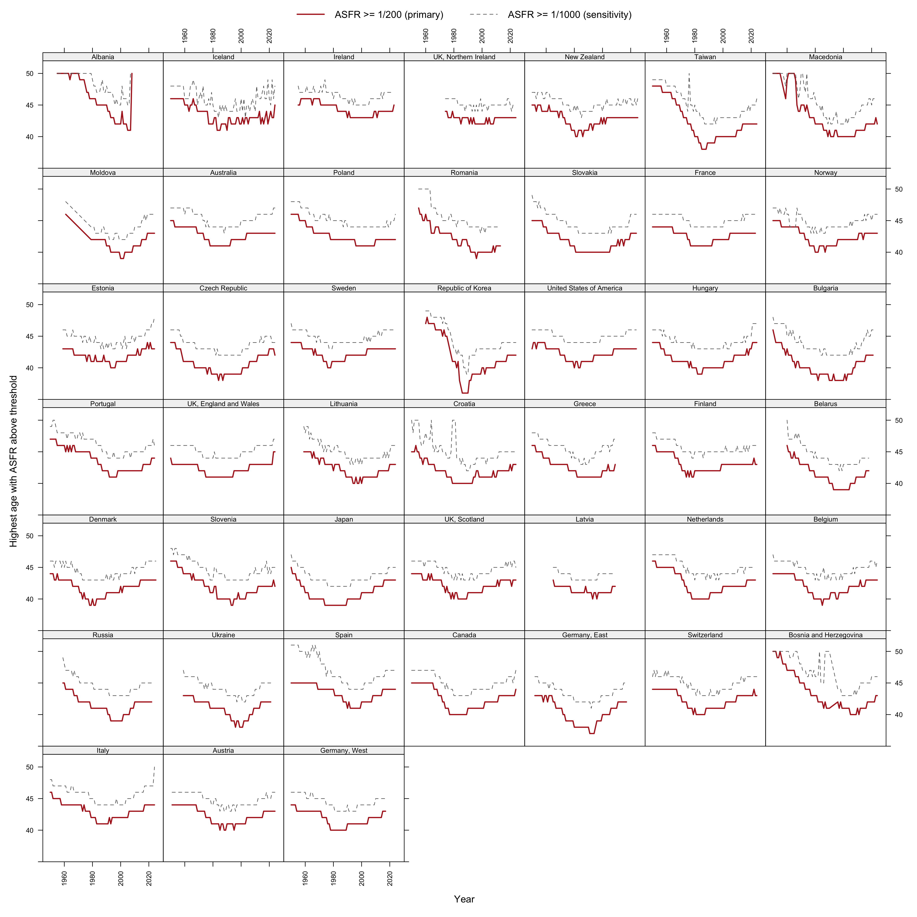
Figure 1: Effective ceiling trajectories by country, 1950–2025: highest age with ASFR at or above 1/200 (solid) and 1/1000 (dashed).
Pooled decade medians of the primary ceiling: 45 (1950s), 44 (1960s), 42 (1970s), 41 (1980s and 1990s), 42 (2000s), 42 (2010s), 43 (2020s). The recovery since the 1990s trough amounts to roughly one year of age per fifteen calendar years (Figure 1).

The mass behind the ceiling is small
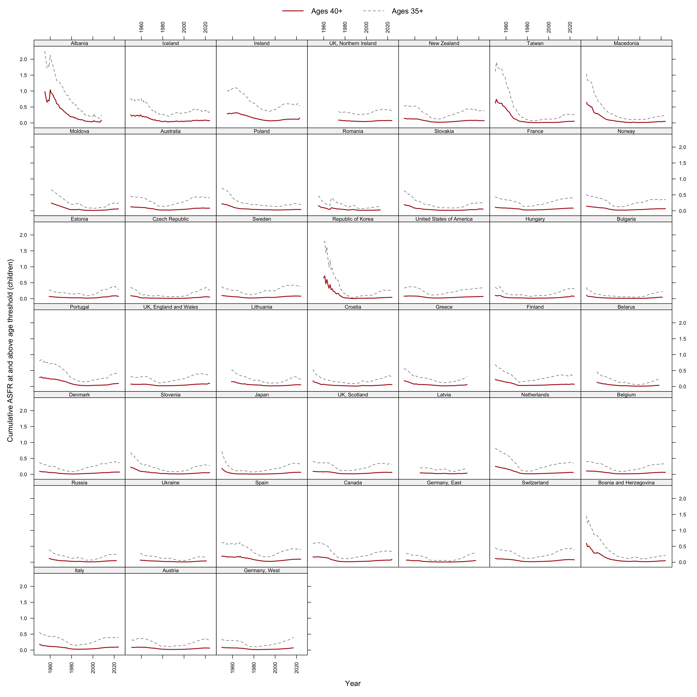
Figure 2: Cumulative ASFR at ages 40+ (solid) and 35+ (dashed), by country, 1950–2025.
Median cumulative fertility above age 40 fell from 0.117 (1950s) to 0.023 (1980s) and has recovered to 0.065 (2020s) (Figure 2) — at its twenty-first-century maximum, about 3 percent of a replacement target. The 40+ segment cannot arithmetically rescue replacement for cohorts entering their forties below roughly 1.99.

Reachability: where the replacement contour meets the wall
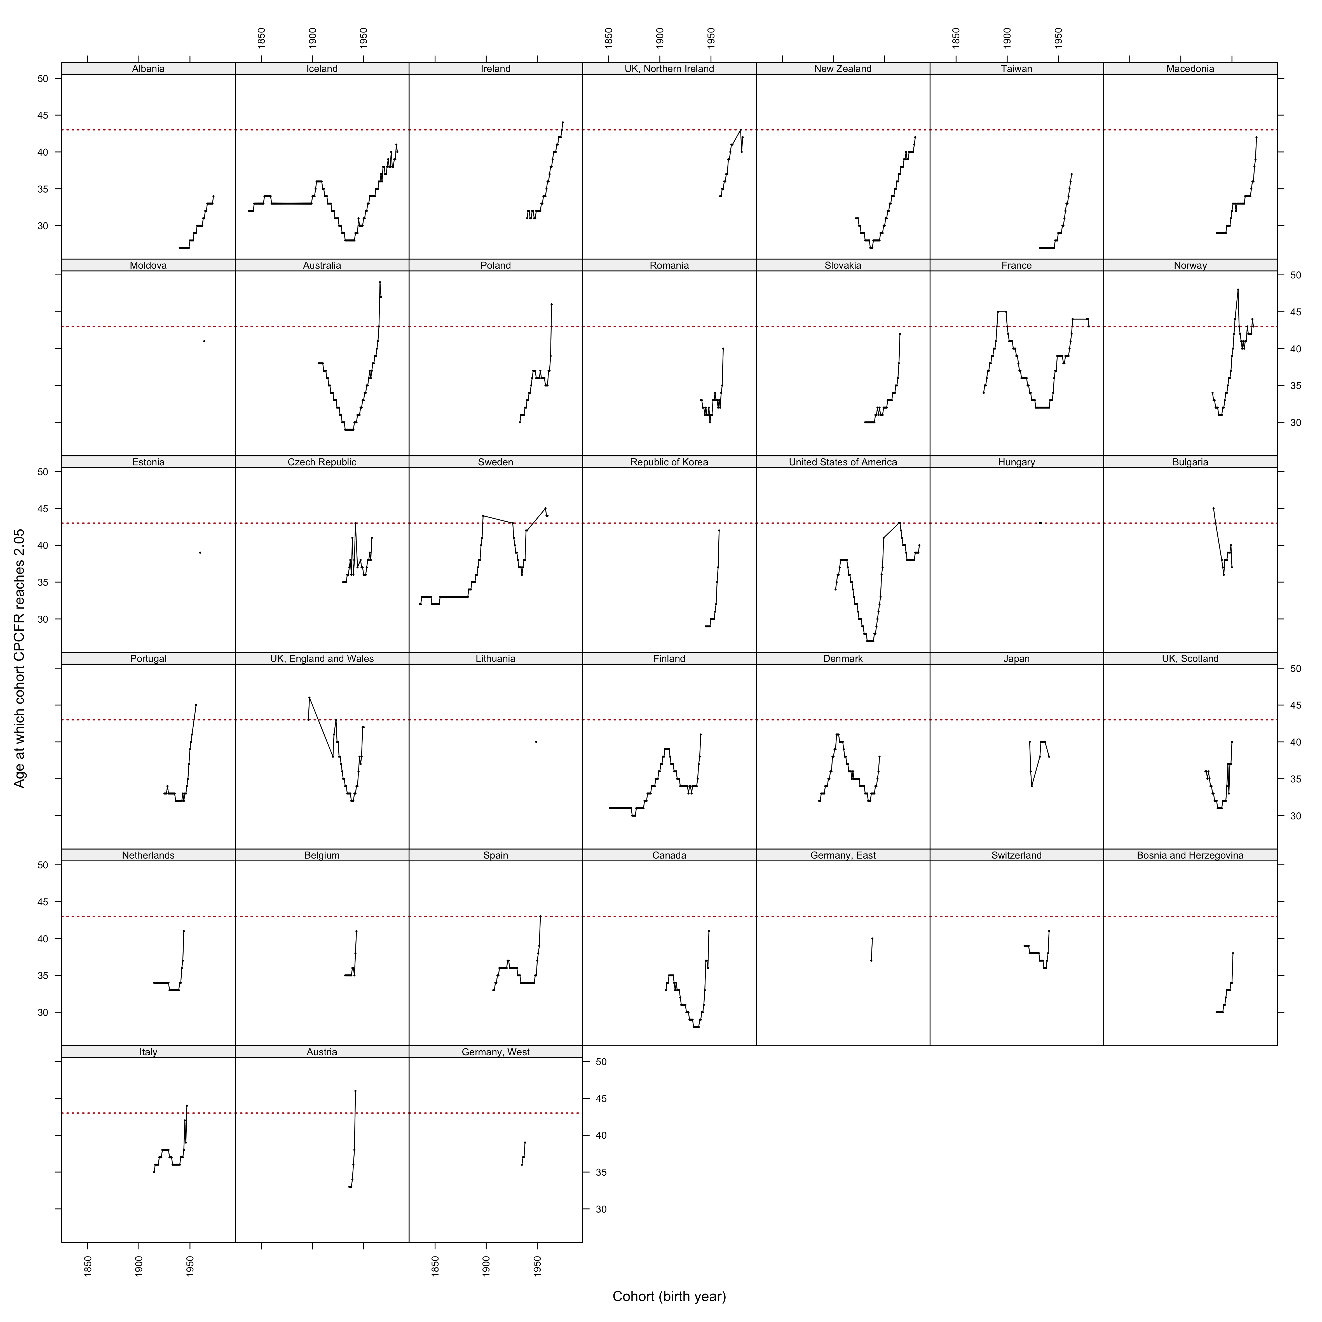
Figure 3: Age at which each cohort’s CPCFR reaches 2.05, by country; the dotted reference line marks age 43.
Forty-three of 45 countries have post-war cohorts observed beyond age 44 that never reached 2.05; only nine have any cohort born after 1970 that crossed. Crossing ages drift upward toward the ceiling before crossings cease (Figure 3).

The wall on the surface
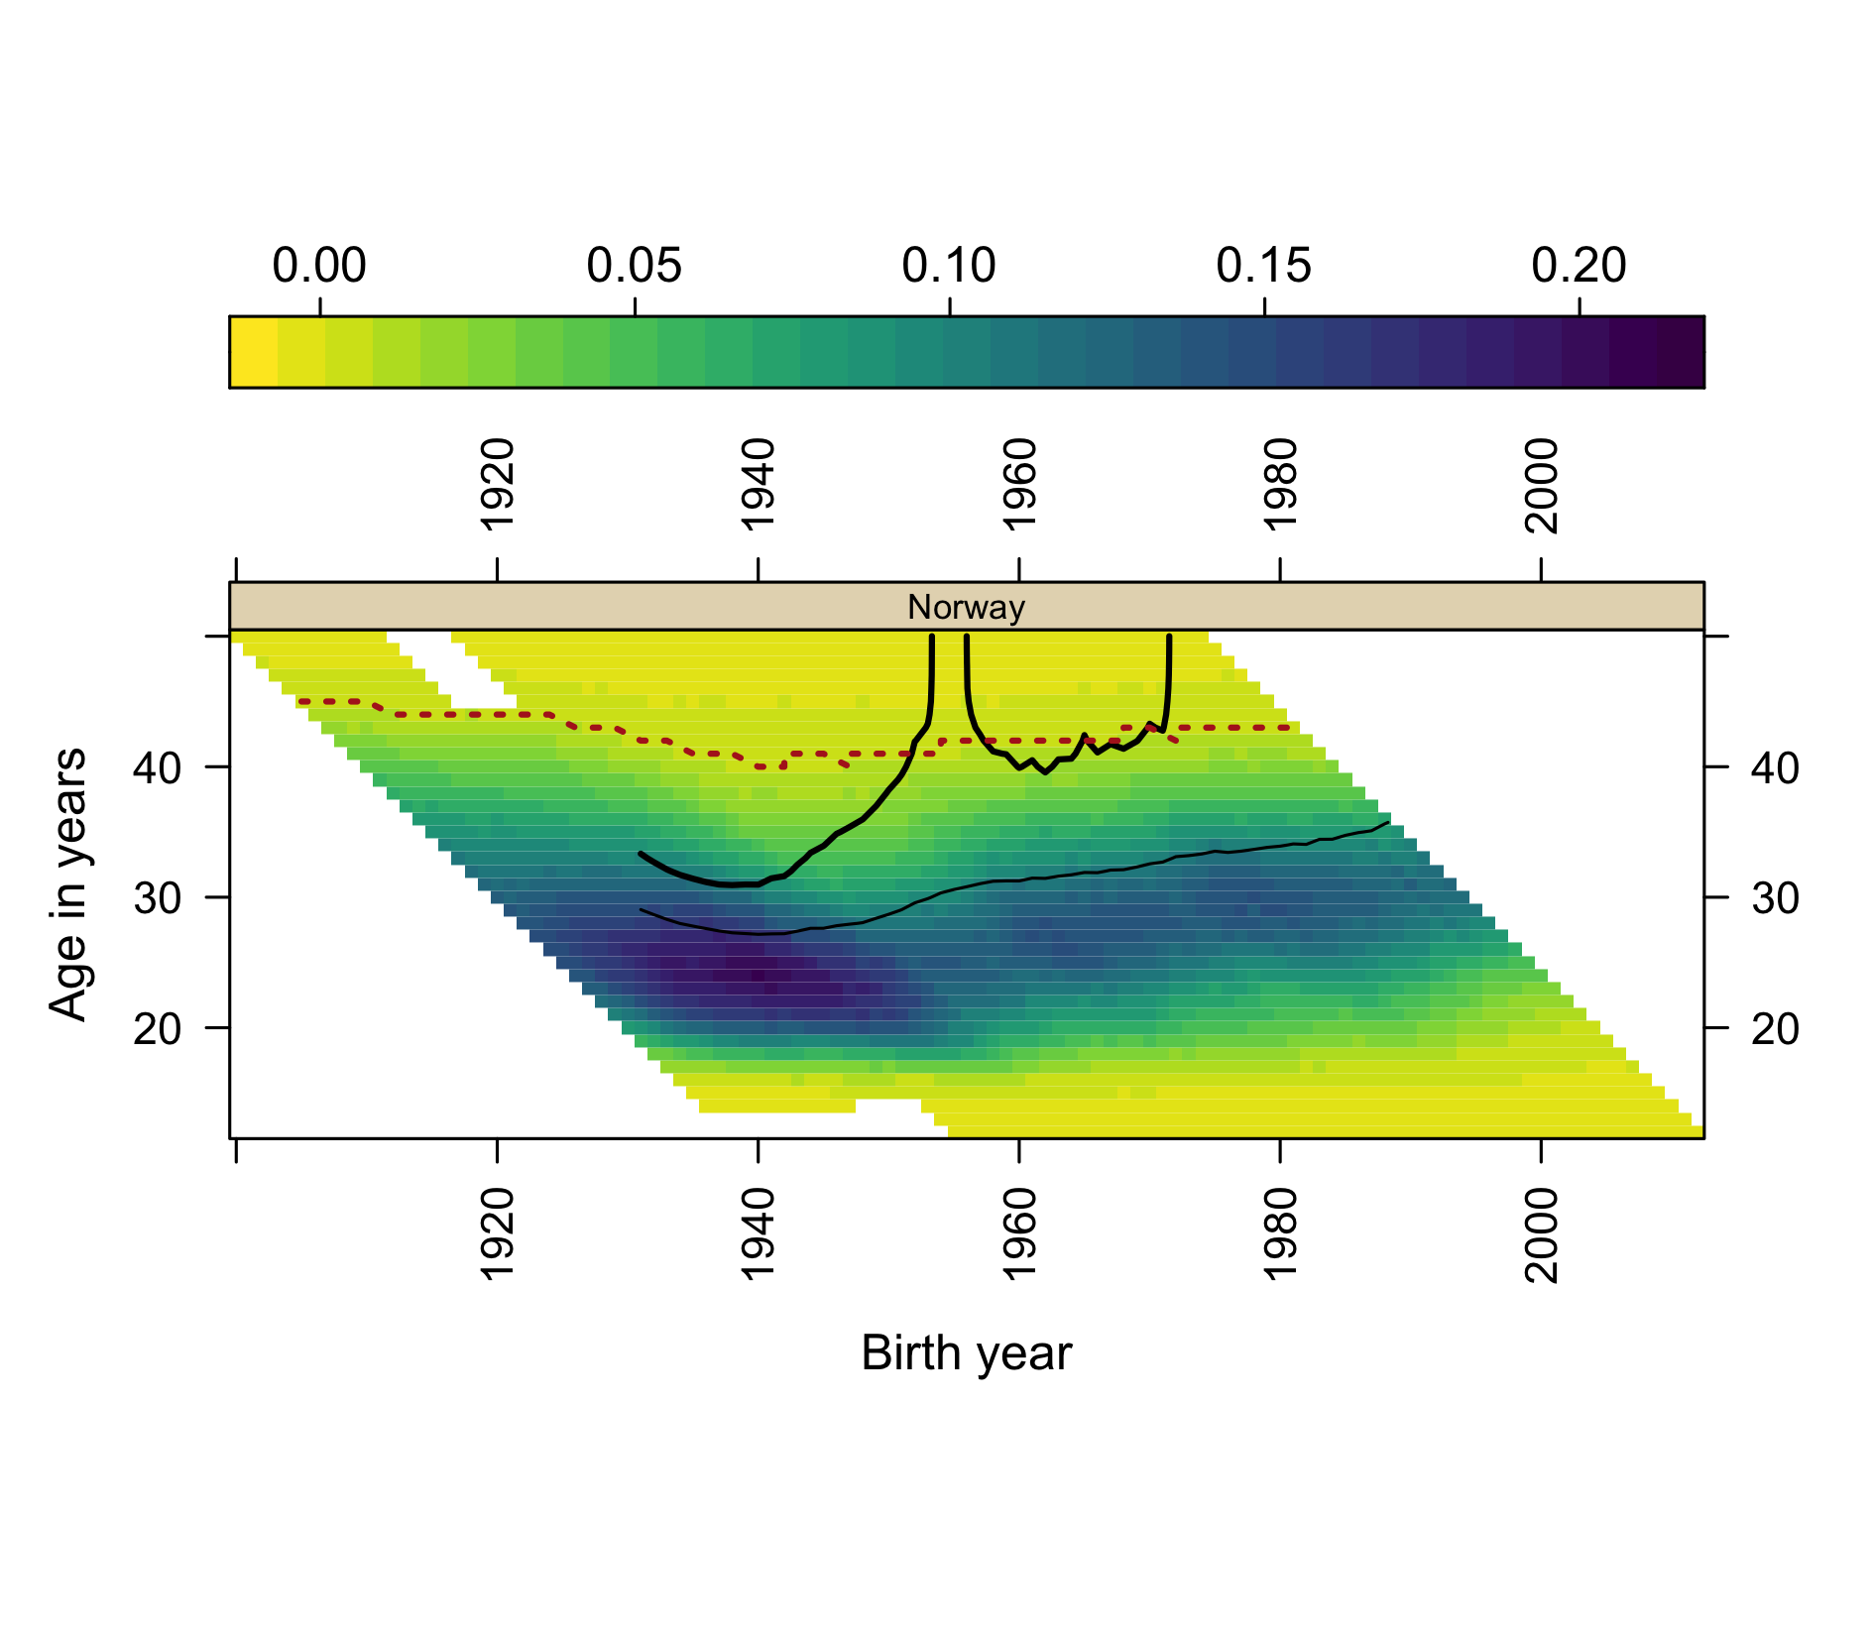
Figure 4: Norway: composite surface with the effective ceiling overdrawn (dotted). Both vertical escapes of the 2.05 contour terminate at the ceiling.
Overlaying the ceiling on the composite surface (Figure 4; US and South Korean panels in the repository) makes the two contour-termination modes visually distinct: contours that climb into the ceiling and end there (wall-terminated) versus contours cut by the right edge of the data (censored). For Norway, both escapes of the replacement contour are wall-terminations, not censoring artifacts.

Discussion
The corridor framing contributes discipline, not adjudication, to the current debate on accelerating fertility decline. Any candidate explanation — economic precarity (Sobotka et al. 2011; Kearney et al. 2022), housing, partnering, smartphone-era social change — must match the same fingerprint: which ages lost fertility, which cohorts carry the loss, whether milestones are delayed (tempo) or abandoned (quantum), and why near-identical exposures produce heterogeneous national responses (Comolli et al. 2021; Hellstrand et al. 2020). The composite surfaces render that fingerprint directly; they cannot, and we do not, pick among co-timed period candidates. What the ceiling adds is arithmetic: postponement is not neutral even under unchanged intentions, because trajectories that start later run into an upper boundary that has moved two years while starting ages moved six. Replacement has become a corridor roughly thirteen years wide.
Limitations: assisted reproduction is shifting the ceiling slowly and unevenly; ceiling estimates at thresholds are sensitive to small-population noise (hence the per-country trajectories as primary output); the cohorts most relevant to the current debate remain right-censored; and single-year ASFR data cannot separate parity-specific dynamics — the natural extension, using the by-birth-order collections already assembled in the repository (Zeman et al. 2018).

References
Beaujouan, Éva. 2020. “Latest-Late Fertility? Decline and Resurgence of Late Parenthood Across the Low-Fertility Countries.” Population and Development Review 46 (2): 219–47. https://doi.org/10.1111/padr.12334.
Comolli, Chiara L., Gerda Neyer, Gunnar Andersson, et al. 2021. “Beyond the Economic Gaze: Childbearing During and After Recessions in the Nordic Countries.” European Journal of Population 37: 473–520. https://doi.org/10.1007/s10680-020-09570-0.
Hellstrand, Julia, Jessica Nisén, and Mikko Myrskylä. 2020. “All-Time Low Period Fertility in Finland: Demographic Drivers, Tempo Effects, and Cohort Implications.” Population Studies 74 (3): 315–29. https://doi.org/10.1080/00324728.2020.1750677.
Kearney, Melissa S., Phillip B. Levine, and Luke Pardue. 2022. “The Puzzle of Falling US Birth Rates Since the Great Recession.” Journal of Economic Perspectives 36 (1): 151–76. https://doi.org/10.1257/jep.36.1.151.
Max Planck Institute for Demographic Research (Germany) and Vienna Institute of Demography (Austria). 2026a. The Human Fertility Collection. https://www.fertilitydata.org.
Max Planck Institute for Demographic Research (Germany) and Vienna Institute of Demography (Austria). 2026b. The Human Fertility Database. https://www.humanfertility.org.
Pattaro, Serena, Laura Vanderbloemen, and Jon Minton. 2020. “Visualizing Fertility Trends for 45 Countries Using Composite Lattice Plots.” Demographic Research 42 (23): 689–712. https://doi.org/10.4054/DemRes.2020.42.23.
Sobotka, Tomáš. 2017. “Post-Transitional Fertility: The Role of Childbearing Postponement in Fuelling the Shift to Low and Unstable Fertility Levels.” Journal of Biosocial Science 49 (S1): S20–45.
Sobotka, Tomáš, Vegard Skirbekk, and Dimiter Philipov. 2011. “Economic Recession and Fertility in the Developed World.” Population and Development Review 37 (2): 267–306.
Zeman, Krystof, Éva Beaujouan, Zuzanna Brzozowska, and Tomáš Sobotka. 2018. “Cohort Fertility Decline in Low Fertility Countries: Decomposition Using Parity Progression Ratios.” Demographic Research 38 (25): 651–90. https://doi.org/10.4054/DemRes.2018.38.25.

