The closing corridor: fertility trends for 45 countries revisited
  - MERGED DRAFT v0.1 (2026-07-14) — sole-authored working paper; comments welcome
Jon Minton
2026-07-14
Abstract
BACKGROUND — Pattaro, Vanderbloemen and Minton (2020) introduced composite fertility lattice plots and reported, across 45 countries, that once cohorts fell below the replacement milestone (cumulative pseudo-cohort fertility rate, CPCFR, of 2.05) they tended not to return, with two named exceptions: Norway and the United States. Reading the geometry of their surfaces, the authors extrapolated: Norway looked “likely to lose replacement fertility levels over the next few years,” while replacement seemed likely to “be sustained for longer in the United States.” Their data ended in 2014–15. OBJECTIVE — To update the panel to 2023–25, resolve those extrapolations, explain their shared error, and draw out what the exercise shows about surface visualization as a source of demographic hypotheses. METHODS — The published combination rules and visual specification are reapplied to the 2026 HFD/HFC releases (1850–2025), with one code-mapping correction restoring France after 2008. An effective ceiling of the fertility lifecourse — the highest age with ASFR ≥ 1/200 — is defined ex ante, alongside late-fertility mass and per-cohort replacement reachability. RESULTS — Both extrapolations resolved in the predicted direction and erred the same way, understating severity: Norway’s contour does not climb but terminates (no cohort born after 1971 reaches replacement at any observed age); the United States’ crossings continue through the 1984 cohort but at ages 39–40, not near the annotated “replacement age 37.” What the visual forecasts could not see is the boundary they extrapolated toward: the ceiling is behavioural, not biological — 47–48 in nineteenth-century populations, 41 by the 1980s, recovered only to about 43 since — and the fertility mass above age 40 (0.02–0.07 children) cannot arithmetically substitute for earlier childbearing. Replacement must now be achieved inside a corridor roughly thirteen years wide, and on the updated surfaces the replacement contour visibly terminates at the ceiling, distinguishably from right-censoring, in 43 of 45 countries’ recent cohorts. CONCLUSIONS — A decade of new data strengthens the 2020 regularity at the cost of both its exceptions. The same surface-reading practice that produced falsifiable forecasts in 2020, applied to the post-2008 acceleration of fertility decline, generates the discriminating hypotheses — period shock versus young-first diffusion versus cohort-carried change — that we have registered for formal test on a global panel. CONTRIBUTION — An update and forecast resolution for a widely used visualization method; a documented, nearly fixed effective ceiling and the corridor arithmetic it implies; and an explicit account of surface visualization as informal model building, with a preregistered bridge to formal modelling.
FOR REVIEWERS (Word copy). Please comment using Word’s Comments and Track Changes features — do not edit silently. Return the file to jon.will.minton@gmail.com. Comments will be logged in the project’s public feedback register (manuscript_2026/review/FEEDBACK.md on GitHub), actioned, and credited; substantive contributions meeting authorship criteria are recognized with co-authorship in later versions, with consent. This is the MERGED draft v0.1 (2026-07-14), not yet submitted anywhere.
 Note
Draft status and authorship. This is a sole-authored working version posted for open comment; Jon Minton is the only author and is solely responsible for its content. It merges and supersedes two working papers of 11 July 2026 (“The exceptions collapse” and “The closing corridor”), which remain in the project repository for provenance. The manuscript updates and builds on Pattaro et al. (2020), whose co-authors Serena Pattaro and Laura Vanderbloemen are acknowledged for the original work and for review comments on the working papers, but are not authors of this version; contributions meeting authorship criteria will be recognized with co-authorship in later versions, with consent. The manuscript was drafted with AI assistance (Claude, Anthropic) under the author’s direction; the role of AI-assisted workflow in this project is described in Section 7.3. The analysis is reproducible from https://github.com/JonMinton/Comparative_Fertility; analytic choices (thresholds, definitions) were fixed in the repository’s public workplan before the analysis ran on the updated data, with prototypes on the pre-update data disclosed there.

Introduction
Fertility decline appears to have accelerated. Across rich and poor countries alike, period fertility rates that had been drifting downward — or in some cases recovering — turned more steeply downward at some point after the late 2000s, and the near-simultaneity of the turn has attracted an explanation to match: the arrival, from 2007–08 onward, of the smartphone and the social-media ecology it carries. That thesis now has a substantial popular following and a growing research literature, from broadband and mobile-phone studies (Billari et al. 2019; Guldi and Herbst 2017; Rotondi et al. 2020) to recent working papers attributing much of the post-2007 decline in the United States to digital-technology exposure (Hudson and Moscoso Boedo 2026; Moscoso Boedo and Hudson 2026; Myers and Hooper 2026). It also has competitors of long standing — economic precarity after the 2008 crisis (Sobotka et al. 2011; Kearney et al. 2022), housing, partnership formation, and the older diffusion tradition in demography, which knew well before the smartphone that fertility behaviour spreads through communication networks in ways that need not respect economic gradients (Bongaarts and Watkins 1996; Casterline 2001).
This paper does not adjudicate that debate. Its claim is that the debate is running ahead of its descriptive foundations, and mostly on the wrong summary statistic. Total fertility rates collapse precisely the structure on which the candidate explanations differ: which ages lost fertility, which cohorts carry the loss, whether milestones are delayed or abandoned, and whether the change arrived everywhere at once or diffused. What preserves that structure is the fertility surface — age by cohort by rate — and a practice of reading it that a 2020 paper by Pattaro, Vanderbloemen and Minton developed for exactly this comparative purpose (Pattaro et al. 2020).
We proceed in three movements. First, an update with a resolution: the 2020 paper did something unusual for a descriptive visualization piece — it made forecasts, in print, by extrapolating the geometry of its surfaces for its two exceptional countries, Norway and the United States. A decade of new data lets those forecasts resolve, and their resolution is instructive: both were right in direction and wrong in the same way, understating severity. Second, a diagnosis: what the visual extrapolations could not see was the boundary they were extrapolating toward. We define and measure the effective ceiling of the fertility lifecourse across the panel’s 175 years, show it to be behavioural rather than biological, and derive the corridor arithmetic that now governs any return to replacement. Third, a bridge: we argue that the 2020 forecasts exemplify a general practice — surface visualization as informal model building — and show how the same practice, applied to the post-2008 acceleration, generates the discriminating hypotheses that separate the smartphone thesis from its competitors. Those hypotheses are not tested here: they are frozen in a preregistered protocol for a global panel, registered before its outcome data were downloaded, to which this paper is the descriptive companion.

The 2020 baseline and its forecasts
Using data from the Human Fertility Database (HFD) and Human Fertility Collection (HFC) ending in 2014–15, Pattaro et al. (2020) introduced composite fertility lattice plots — Lexis surfaces combining level-plot shading of age-specific fertility rates (ASFRs) with contour lines marking cumulative pseudo-cohort fertility rate (CPCFR) milestones at 1.50 and 2.05 (“replacement”) children per woman — and reported a striking regularity across 45 countries: once a country’s cohorts fell below the replacement milestone, they tended not to return to it. Two exceptions were named: Norway, where cohorts born after the 1950s regained replacement, and the United States, for cohorts born after the late 1960s.
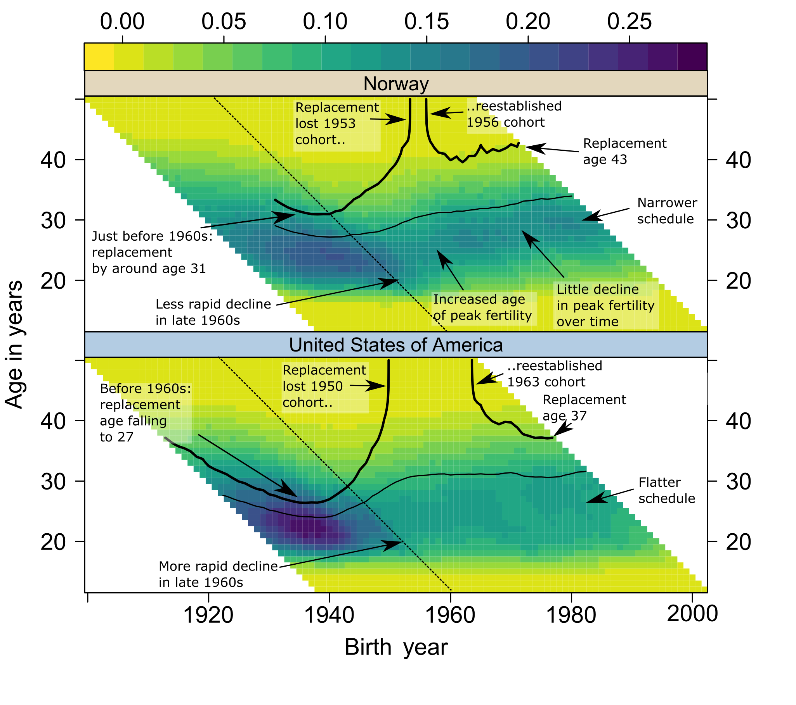
Figure 1: Figure 2 of Pattaro et al. (2020) as published: composite fertility lattice plots for Norway and the United States with the original annotations, including the terminal contour readings “Replacement age 43” (Norway) and “Replacement age 37” (United States). Reproduced from the open-access original (CC BY 3.0 DE).
The 2020 paper did more than describe its two exceptions: reading the trajectories of the replacement contours in its Figure 2 (reproduced here as Figure 1), it extrapolated them. The published discussion reasoned that the contour “has been trending upwards for Norway but falling for the United States,” that cumulative fertility by age 43 is in practice close to completed fertility, and concluded that “Norway looks likely to lose replacement fertility levels over the next few years,” whereas “we might assume that replacement levels will be sustained for longer in the United States” (Pattaro et al. 2020, 699–700). These are qualitative forecasts, formed by visual reasoning about where each contour was heading and how much childbearing remained available above it.
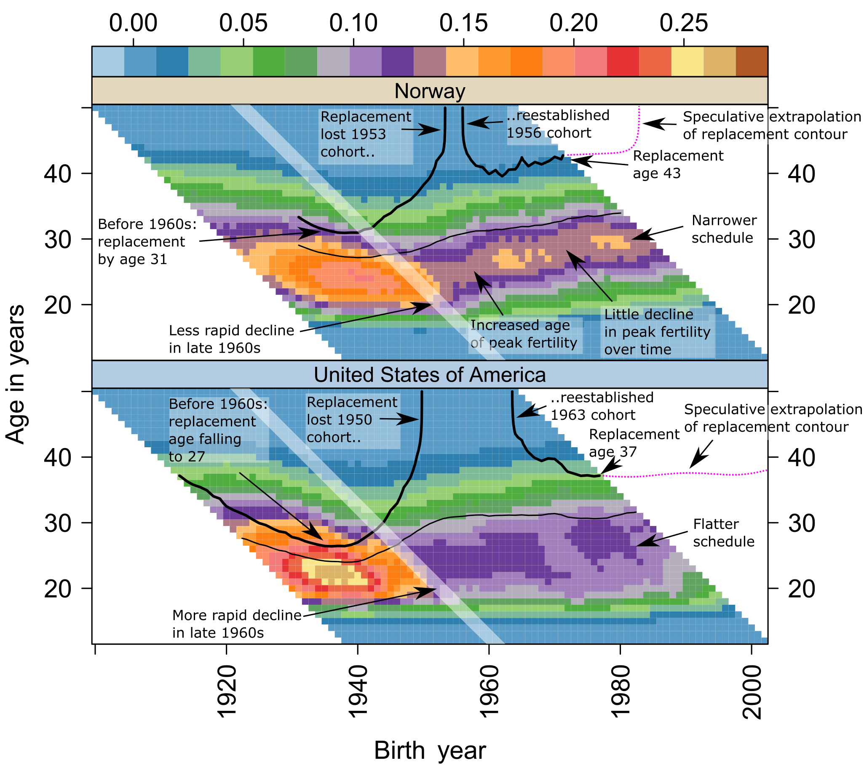
Figure 2: Pre-publication working version of the same figure (project repository, September 2018), in which the extrapolations were drawn rather than stated: dotted lines labelled “speculative extrapolation of replacement contour” rise steeply for Norway and continue nearly flat, near age 37–38, for the United States. The drawn lines were dropped in revision; the published text retained their verbal equivalents. Draft-era colour palette differs from the published specification.
The forecasts were, in an earlier working version of the figure, drawn explicitly (Figure 2). That version — publicly timestamped in the project repository in September 2018, before publication — shows the extrapolations as dotted “speculative extrapolation” lines: for Norway a steep rise, replacement reached only at ever-later ages and hence soon not at all; for the United States a near-flat continuation just above age 37. The drawn lines did not survive review, but their verbal counterparts did, and the repository provenance makes the informal forecast concrete and datable. A decade of new data has since accumulated, covering the years in which period fertility fell to record lows across the Nordic countries (Comolli et al. 2021; Hellstrand et al. 2020), the United States (Kearney et al. 2022), and East Asia (Yoo and Sobotka 2018) — enough observation for the forecasts to resolve.

Data and methods

The 2026 rebuild
We reapply the combination rules of Pattaro et al. (2020) to the current HFD (Max Planck Institute for Demographic Research (Germany) and Vienna Institute of Demography (Austria) 2026b) and HFC (Max Planck Institute for Demographic Research (Germany) and Vienna Institute of Demography (Austria) 2026a) releases: HFD is preferred over HFC for any country-year; within the HFC, single-year periods with age in completed years are retained under the collection preference STAT $>$ ODE $>$ RE; small internal gaps (at most four years) are linearly interpolated and flagged. The updated panel spans 1850–2025 (51 populations before the published exclusions; the same 45-country panel after them). One correction to the 2016 build is applied: HFD’s France series (code FRATNP) was previously dropped by an unmapped country code, so the published figures showed France ending in 2008; the updated build restores France to 2023. A back-revision audit against the 2016 dataset is included in the repository; the largest differences (Ireland, Spain, Denmark) reflect HFD’s own revisions of historical exposures.
A consequence worth stating plainly: the 2020 findings remain reproducible from the dataset frozen in the repository, but they are not exactly replicable from fresh source downloads, because the source databases have themselves been revised — an inherent property of living data infrastructures, and part of the motivation for periodic updates of this kind.
All surface figures use the published visual specification: viridis (reversed) level-plot shading of ASFR on birth-year $×$ age panels, solid contours at CPCFR = 2.05 and 1.50, years 1950 onward, ages up to 50, and countries ordered by CPCFR at 2007, the ranking year of the published figures (Sarkar 2008; Garnier 2018).

Ceiling, mass, and reachability
Three quantities, with definitions fixed ex ante in the repository’s public workplan before the analysis ran on the updated data:
- Effective ceiling of population $c$ in year $t$: the highest age at which ASFR $≥$ 1/200 (primary threshold), with 1/1000 as a sensitivity threshold. The thresholds operationalize “ages at which childbearing is still a live behavioural possibility” rather than a biological limit.
- Late-fertility mass: cumulative ASFR at ages 40+ (and 35+) in a given country-year — the arithmetic maximum that childbearing at those ages could contribute to a cohort’s total.
- Reachability: for each cohort observed from age 16 or earlier, the age at which CPCFR first reaches 2.05, classified as crossed; never (observed beyond age 44 without crossing); or censored (still unobserved at the ages that would decide it).
Per-country trajectories are the primary outputs throughout; pooled decade medians are reported as context only.

Results I: the forecasts resolve
Table 1 states the resolutions first; the sections that follow show them on the updated surfaces.
Table 1: The 2020 extrapolations and their resolutions.
Reading in Pattaro et al. (2020) | Outcome on data to 2023–25
“Once countries have fallen below a replacement fertility level, they tend to not return to it.” | Strengthened: 43 of 45 countries now have post-war cohorts observed beyond age 44 that never reached replacement.
Norway “looks likely to lose replacement fertility levels over the next few years.” | Correct in direction, exceeded in severity: no cohort born after 1971 reaches replacement at any observed age; the contour escapes vertically rather than drifting. Period TFR 1.98 (2009) → 1.40 (2023).
“Replacement levels will be sustained for longer in the United States” (annotated “Replacement age 37”). | Correct so far, but eroding faster than drawn: crossings continue through the 1984 cohort, at ages 39–40 rather than near 37; cohorts beyond are censored and running lower at every age.

Norway
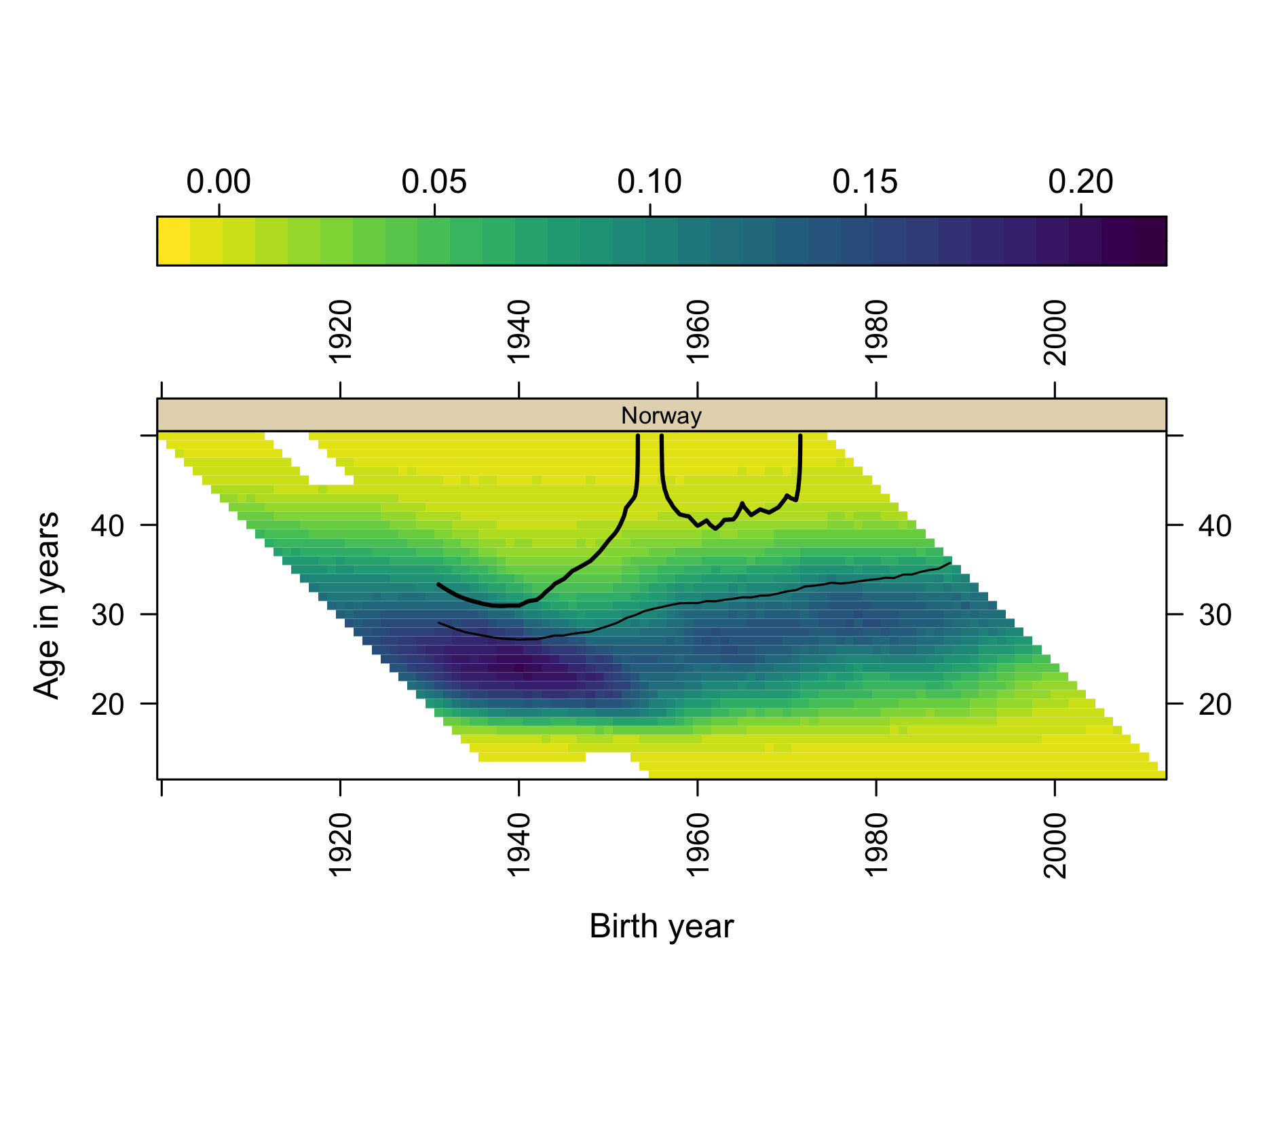
Figure 3: Norway: ASFR surface with CPCFR contours at 2.05 (heavy) and 1.50 (light), cohorts observed to 2024.
The updated Norway panel (Figure 3) now shows a complete arc. The 2.05 contour climbs steeply — effectively vertically — for cohorts born around 1950; returns to the surface at around age 40 for cohorts born 1958–68, the recovery that made Norway the 2020 paper’s leading exception (Kravdal 2016); and then escapes vertically a second time for cohorts born after approximately 1972. On current data no Norwegian cohort born after 1971 reaches replacement at any observed age. The 1.50 contour drifts steadily upward, reaching roughly age 36 for cohorts born in the late 1980s before censoring. Norway’s period TFR fell from 1.98 in 2009 to 1.40 in 2023, a record low (Max Planck Institute for Demographic Research (Germany) and Vienna Institute of Demography (Austria) 2026b).
Set against the 2020 extrapolation, this is a resolution in the predicted direction but of greater severity. The drawn version of the forecast (Figure 2) had the replacement contour climbing over roughly fifteen further cohorts; the verbal version anticipated loss “over the next few years.” What the updated surface shows instead is that the loss was already complete at the data edge the 2020 authors were reading: the contour does not climb — it terminates. The forecast erred only in imagining a gradual exit where the exit was, in the event, immediate and total.

United States
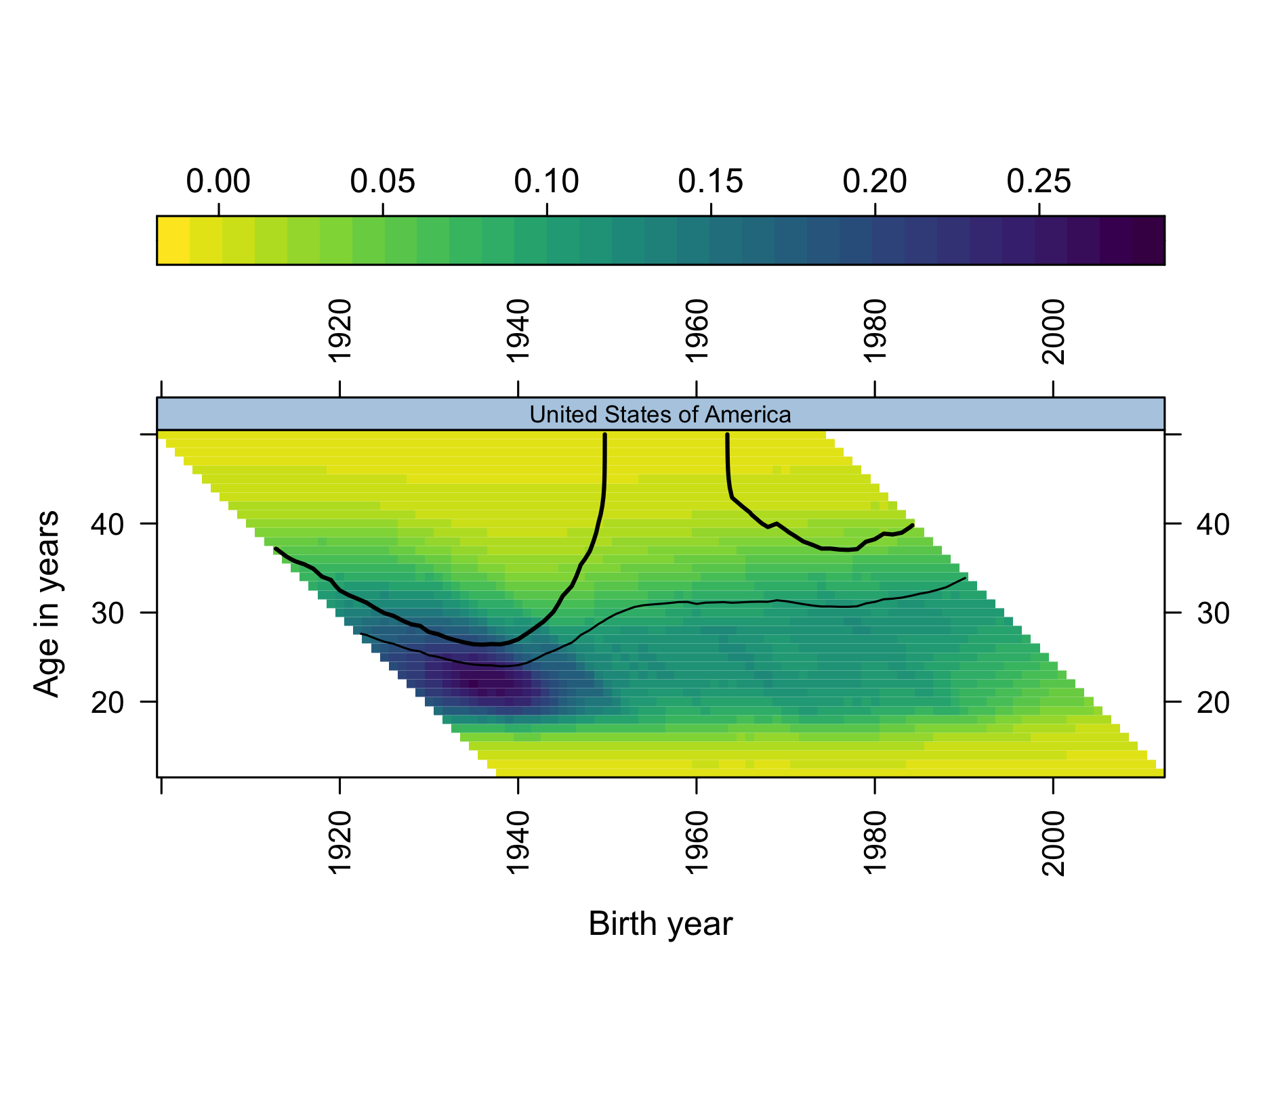
Figure 4: United States: ASFR surface with CPCFR contours at 2.05 (heavy) and 1.50 (light), cohorts observed to 2024.
The United States requires a more careful statement (Figure 4). Its period TFR fell from 2.12 (2007) to 1.59 (2024), a record low. In cohort terms, however, the exception persisted longer than the period collapse suggests: cohorts born 1982, 1983 and 1984 all crossed CPCFR = 2.05, at ages 39, 39 and 40 respectively, with completed cumulative fertility of 2.14, 2.13 and 2.09. The 1985 cohort stood at 2.04 by age 39 (data to 2024) and will plausibly cross; trajectories for cohorts born after the mid-1980s run progressively lower at every age but remain right-censored. The US exception has thus not yet collapsed in cohort terms; it is fading from below, cohort by cohort, exactly as the period-based literature on postponement would predict (Sobotka 2017; Kearney et al. 2022).
This too resolves the 2020 extrapolation as directionally right and too gentle. Replacement was “sustained for longer in the United States” — by some twenty further birth cohorts. But the drawn forecast continued the contour near-flat from “replacement age 37” (Figure 2), and the realized crossings occurred at 39–40: the contour rose by two to three years of age in under two decades of cohorts, converging on the terminal ages at which the Norwegian contour had already escaped. Sustained, that is, not by stable timing but by pushing childbearing against the upper edge of the reproductive lifecourse — a distinction invisible in period TFR and legible only on the surface.

The panel as a whole
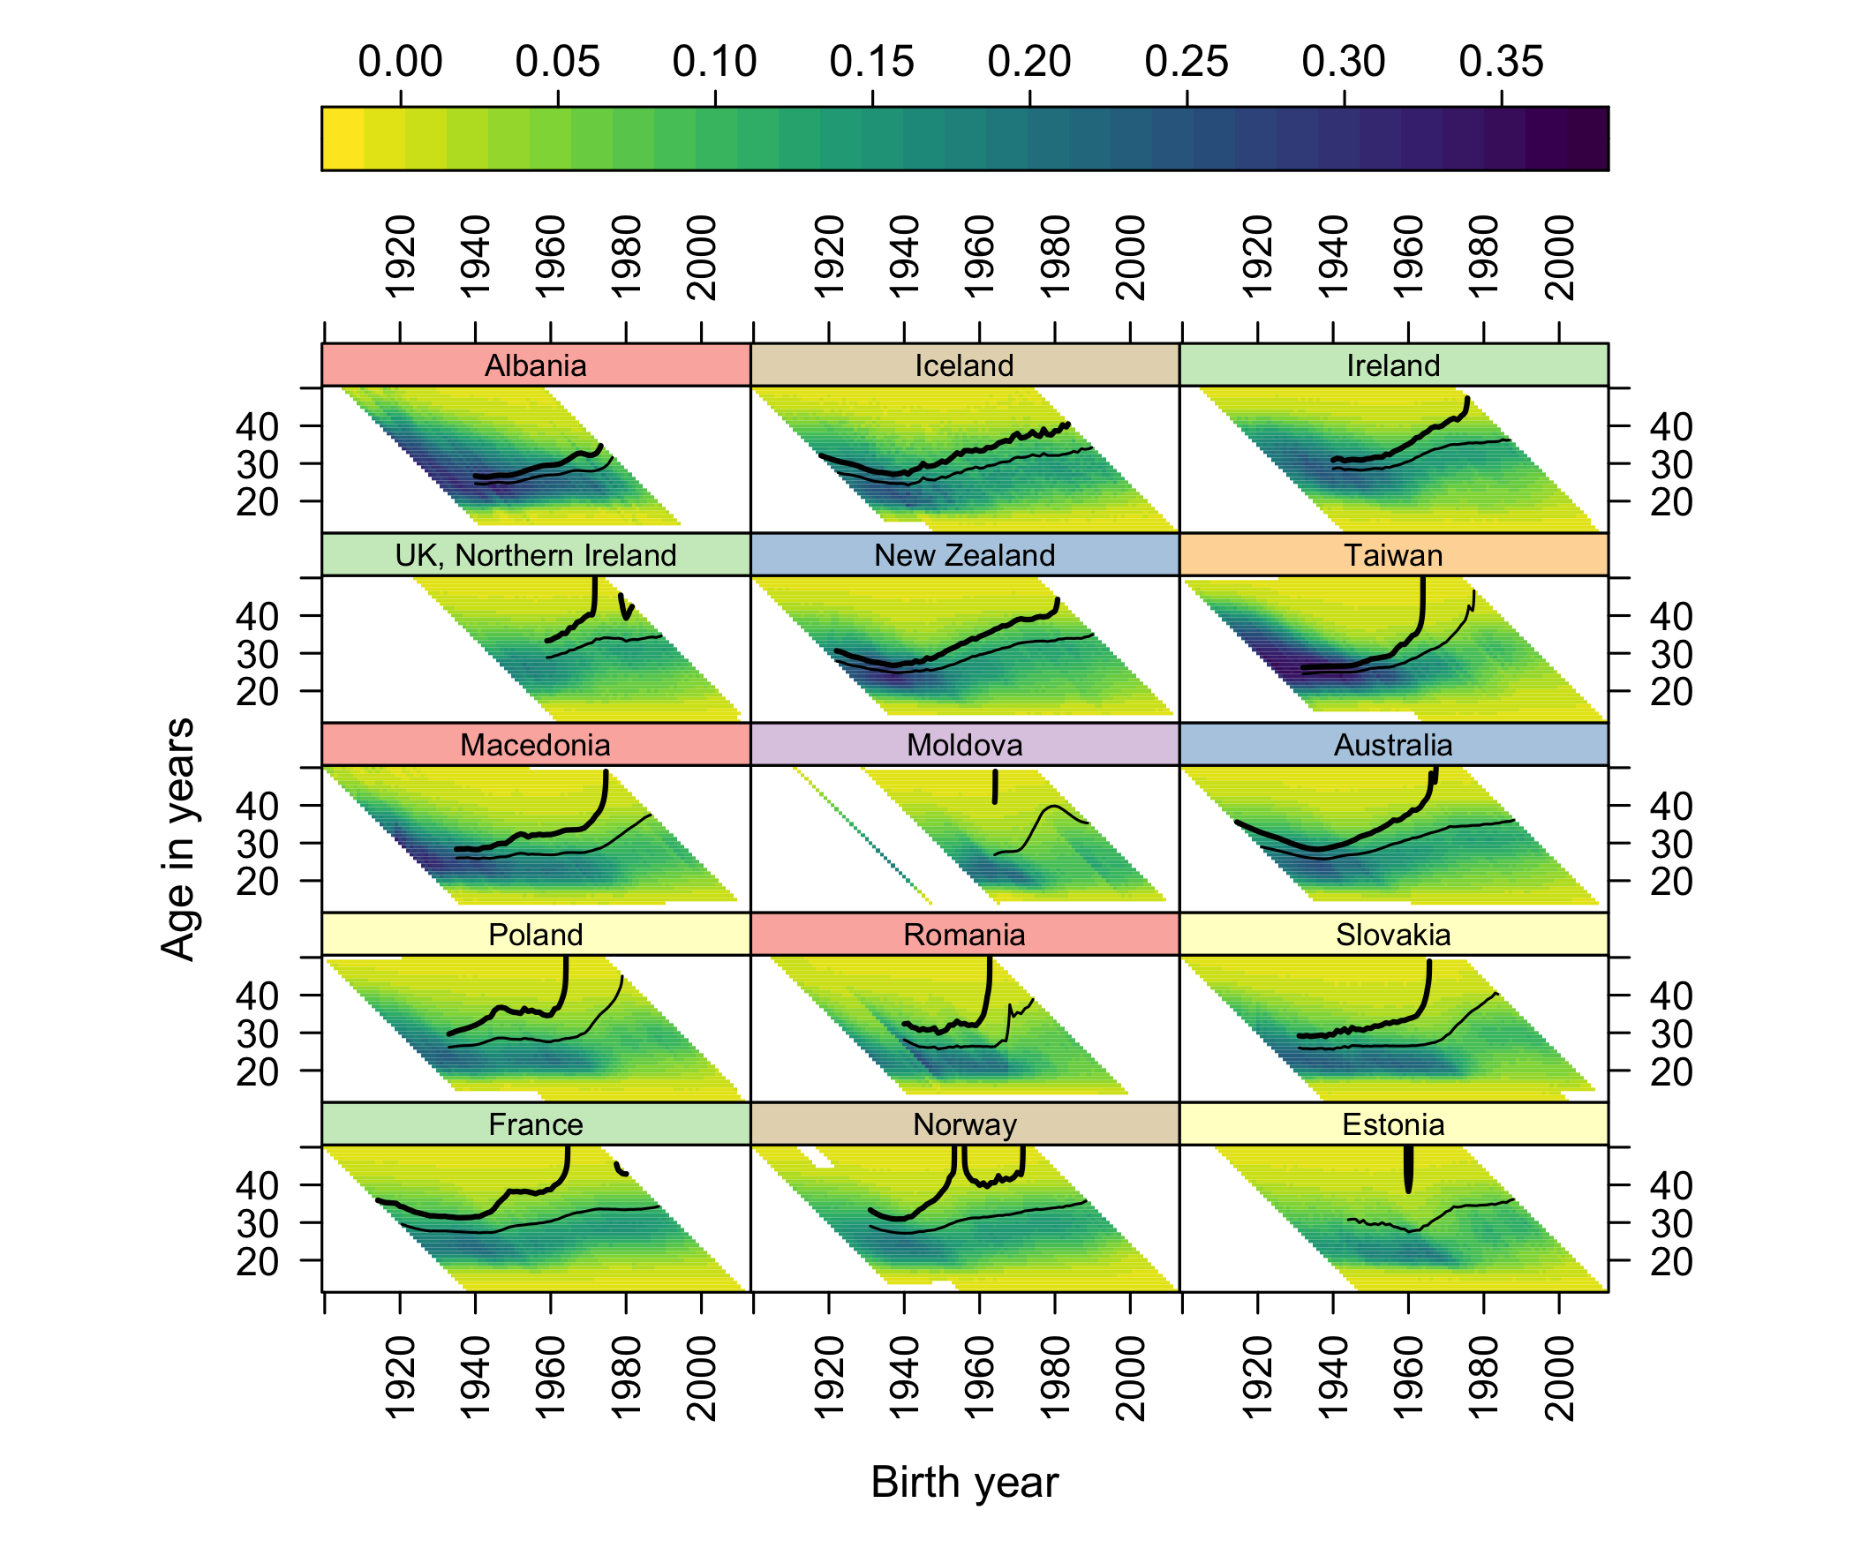
Figure 5: The fifteen highest-ranked countries by CPCFR at 2007, updated to 2023–25. The remaining thirty panels are in the repository and online appendix.
Across the full panel, 43 of 45 countries now have post-war cohorts observed beyond age 44 that never reached replacement (Figure 5). Only nine countries have any cohort born in 1970 or later that crossed 2.05 (Table 2) — and the most recent crossing cohorts are: United States 1984, Iceland 1983, Northern Ireland 1981, France 1980, New Zealand 1980. Norway and the United States were therefore never the only populations at or above replacement: Iceland, France, New Zealand and Northern Ireland also saw cohorts born around 1980 cross the milestone, as did several south-eastern European populations for cohorts born into the mid-1970s (Macedonia 1974, Albania 1973). What made Norway and the United States the named exceptions of the 2020 paper was narrower: among the notably rich populations of the panel, they were the two whose cohort fertility had recovered to replacement after earlier decline. It is that recovery, specifically, that the new data shows ending. South Korea, newly covered here from 1960 (the 2020 panel’s Korean series ended in 2007), last saw a cohort reach replacement with those born in 1958; its period TFR in 2024 was 0.75 (Yoo and Sobotka 2018).
Table 2: The nine countries with any cohort born in 1970 or later reaching CPCFR = 2.05, most recent first. Full 45-country table in the repository (data/derived_2026/last_cohort_replacement.csv).
Country | Last cohort crossing 2.05 | Age at crossing
United States | 1984 | 40
Iceland | 1983 | 40
UK, Northern Ireland | 1981 | 42
France | 1980 | 43
New Zealand | 1980 | 42
Ireland | 1975 | 44
Macedonia | 1974 | 42
Albania | 1973 | 34
Norway | 1971 | 43

Note the ages in Table 2’s third column: with one exception (Albania, whose crossing at 34 belongs to an earlier fertility regime), every terminal crossing since 1970 occurred at ages 40–44. The regularity’s final exceptions did not end at random ages; they ended pressed against a common boundary. That observation motivates the second half of the paper.

Results II: the ceiling and the corridor
Both 2020 forecasts failed in the same direction: reality was more severe. A shared failure mode suggests a shared missing term, and the terminal crossing ages point to what it is — a boundary on late childbearing that visual extrapolation treated as open space. The 2020 figure had, in fact, annotated it without theorizing it: “Replacement age 43.”

The ceiling is behavioural and nearly fixed
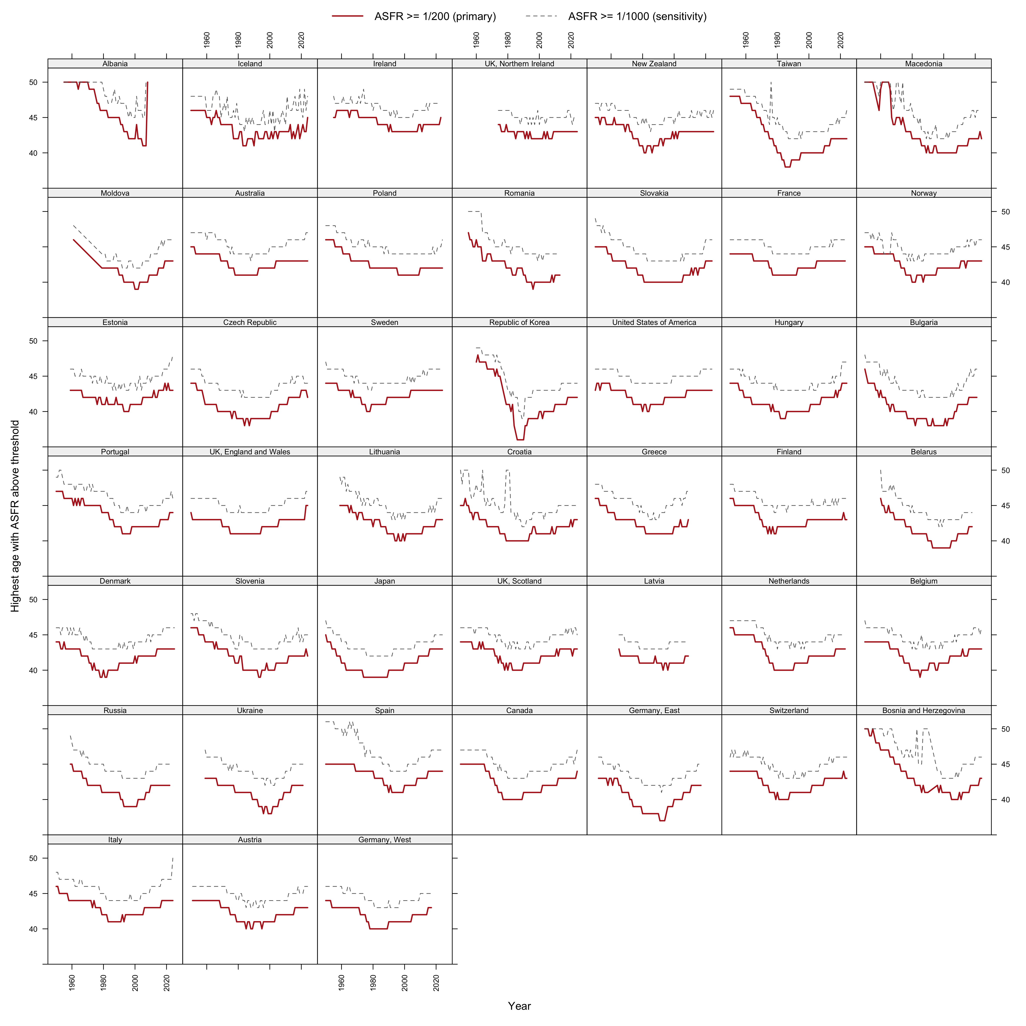
Figure 6: Effective ceiling trajectories by country, 1950–2025: highest age with ASFR at or above 1/200 (solid) and 1/1000 (dashed).
Defining the effective ceiling as the highest age with ASFR $≥$ 1/200, the pooled decade medians run: 45 (1950s), 44 (1960s), 42 (1970s), 41 (1980s and 1990s), 42 (2000s), 42 (2010s), 43 (2020s) (Figure 6). Three features matter. First, the nineteenth-century populations of the panel show ceilings at 47–48: childbearing at those ages was an ordinary part of high-parity regimes, so the modern ceiling is not biology. Second, the descent to 41 by the 1980s tracks the spread of parity control: stopping behaviour truncated high-parity childbearing from the top down. Third, the recovery since the 1990s trough has been slow and remarkably uniform — roughly one year of age per fifteen calendar years — despite three decades of assisted reproduction, postponement, and policy variation. The ceiling behaves like a structural feature, not a margin under active renegotiation.

The mass behind the ceiling is small
Median cumulative fertility above age 40 fell from 0.117 children (1950s) to 0.023 (1980s) and has recovered to 0.065 (2020s) — at its twenty-first-century maximum, about 3 percent of a replacement target (per-country trajectories in the repository; late_mass_trends.png). The arithmetic is unforgiving: for a cohort entering its forties with cumulative fertility below roughly 1.99, no historically observed amount of 40+ childbearing reaches 2.05. Late recuperation can and does finish journeys that are nearly complete (Beaujouan 2020); it cannot substitute for the years the corridor has consumed.

Reachability: where the replacement contour meets the wall
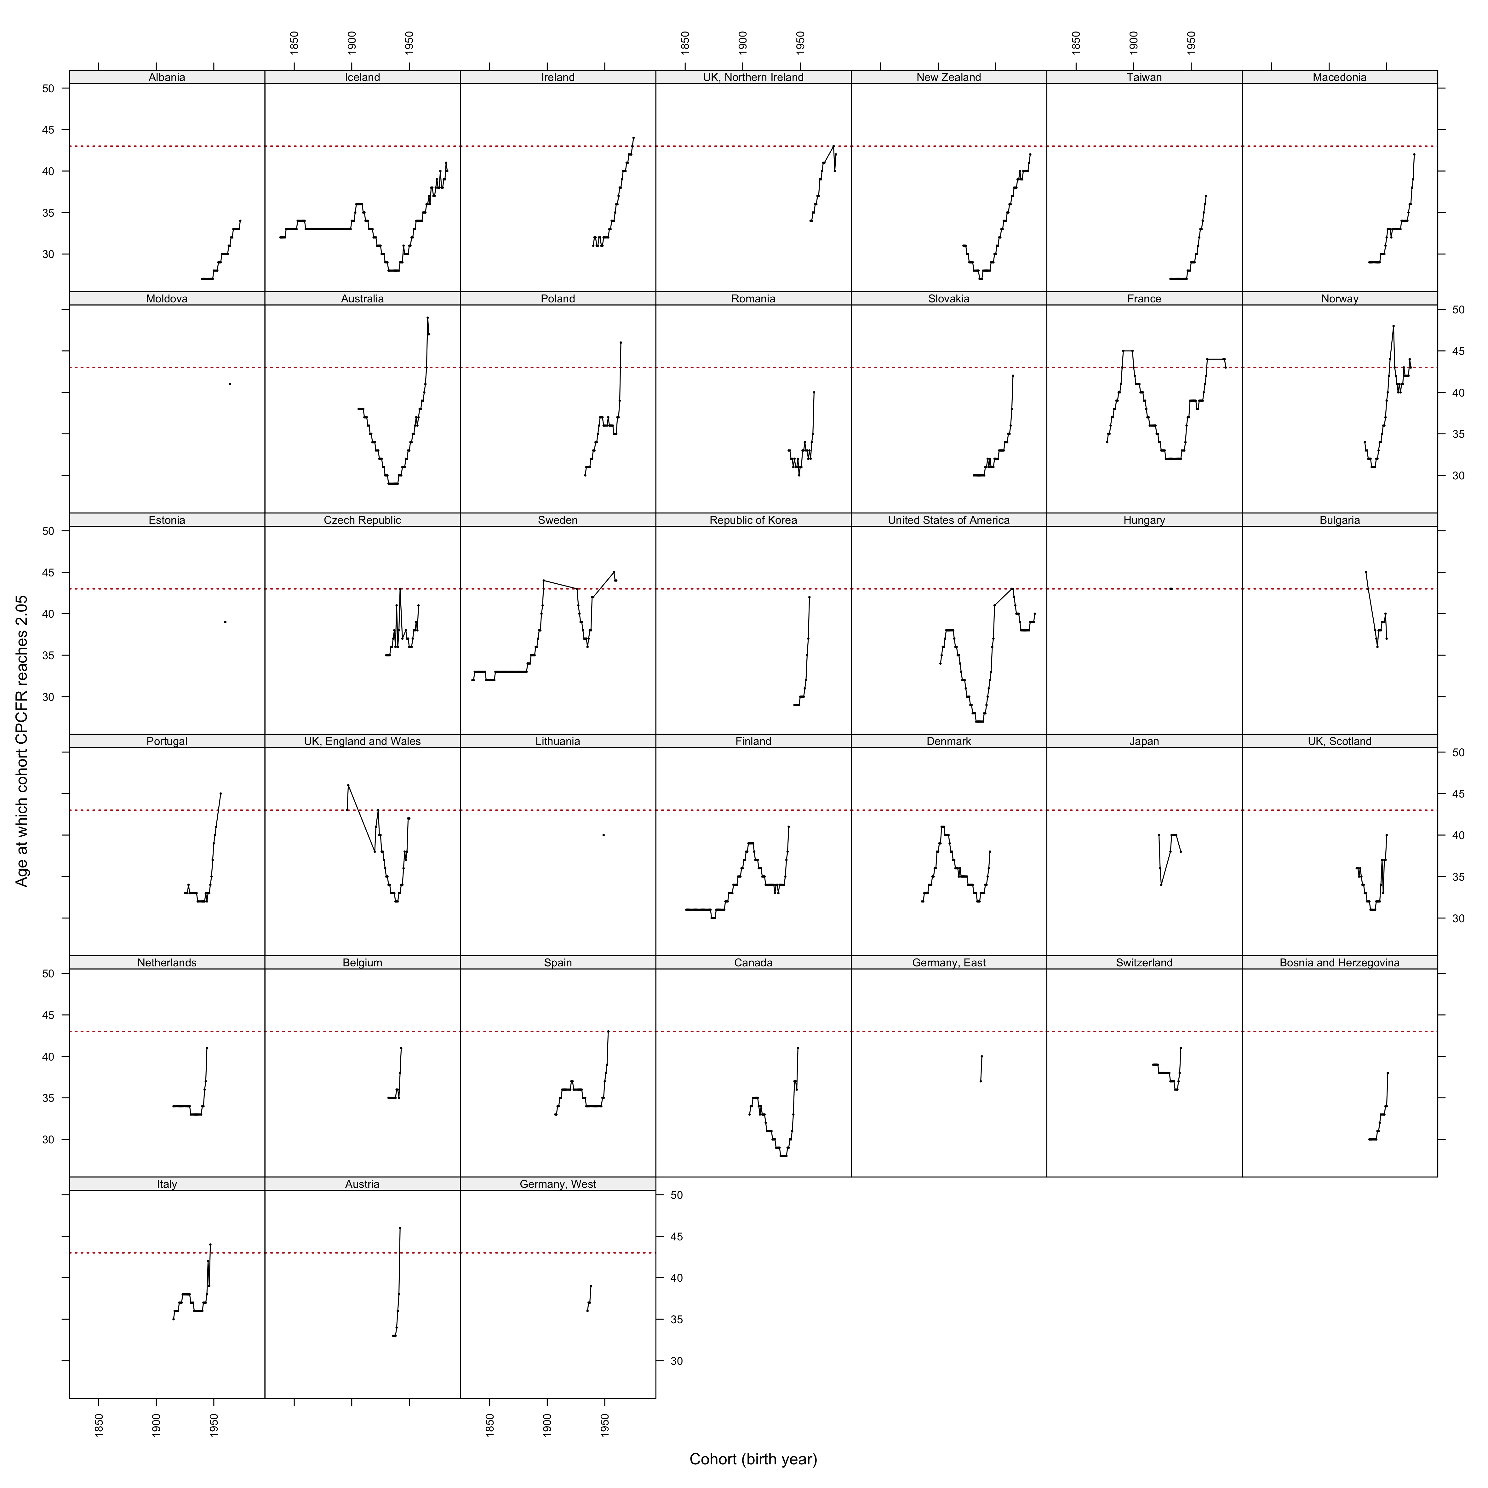
Figure 7: Age at which each cohort’s CPCFR reaches 2.05, by country; the dotted reference line marks age 43.
Plotting each cohort’s age at crossing 2.05 (Figure 7) shows the regularity’s kinematics: in country after country, crossing ages drift upward toward the low-40s reference line before crossings cease altogether. Combined with the rise in ages at first birth of five to six years since the 1970s (Sobotka 2017; Beaujouan 2020) against a ceiling that recovered two, the corridor within which replacement remains arithmetically reachable now spans roughly thirteen years — approximately ages 30 to 43 — for a cohort starting childbearing at today’s median ages.

The wall on the surface
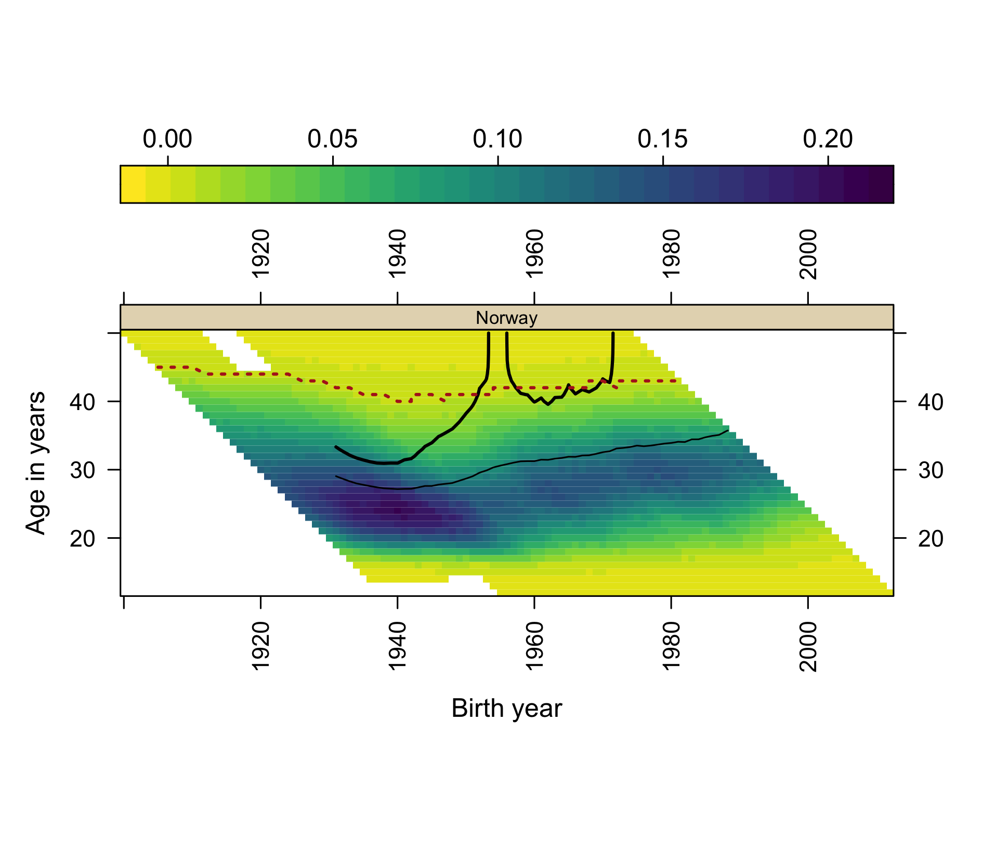
Figure 8: Norway: composite surface with the effective ceiling overdrawn (dotted). Both vertical escapes of the 2.05 contour terminate at the ceiling.

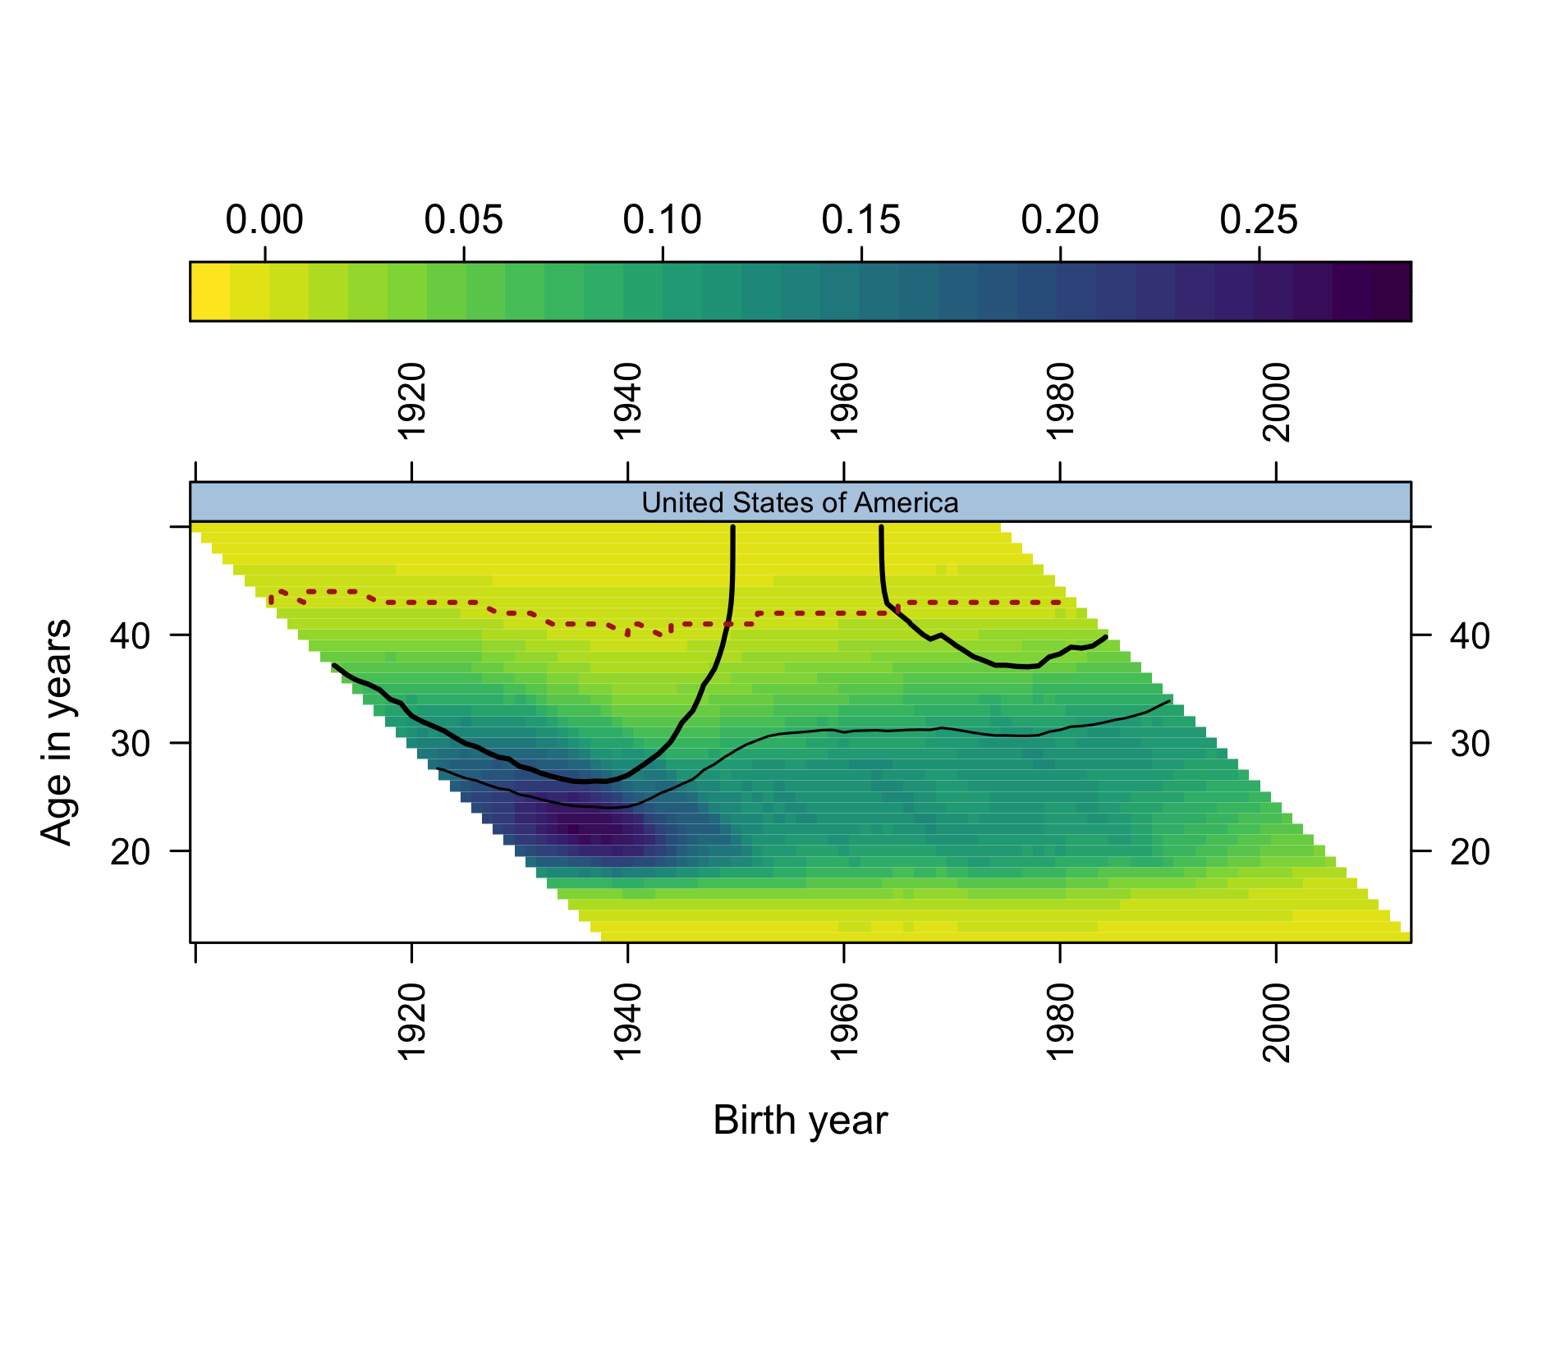
Figure 9: United States: composite surface with the effective ceiling overdrawn (dotted). The replacement contour climbs toward the ceiling but its right end is cut by the data edge: censored, not wall-terminated — the verdict on the 1985+ cohorts is still open.
Overlaying the ceiling on the composite surface makes the two contour-termination modes visually distinct: contours that climb into the ceiling and end there (wall-terminated) versus contours cut by the right edge of the data (censored). For Norway (Figure 8), both escapes of the replacement contour are wall-terminations, not censoring artifacts: the 2020 forecast’s error is visible as the gap between open space assumed and boundary present. For the United States (Figure 9), the right end of the contour is censored — the honest statement is that the US verdict remains open, with the contour three years’ age from the ceiling and closing. The South Korean panel, the panel’s extreme case, is in the repository.
A note on visual complexity: in grammar-of-graphics terms the ceiling adds a fifth encoding to an already four-dimensional composite (x, y, shading, contour weight) — though it is better understood as a third reading of the single underlying ASFR field: its level (shading), its accumulation (contours), and its effective boundary (the ceiling), each a computation the eye cannot perform unaided. Because four encodings already approach the limit of comfortable readability for many audiences (Pattaro et al. 2020), we confine this densest form to the two featured panels above and use the established four-encoding composite everywhere else.

From reading surfaces to building models

What the 2020 forecasts were
The 2020 extrapolations were not outputs of a formal model: they were acts of informal model building — qualitative, falsifiable forecasts formed by reading the geometry of a fertility surface, using visible structure (where a contour is heading; how much childbearing remains available above it) as the model. Both forecasts resolved in the predicted direction, and both erred the same way, understating severity. That shared failure mode is itself informative: what the visual extrapolations could not see was the boundary they were extrapolating toward — the effective upper edge of the fertility lifecourse, annotated in 2020 as “replacement age 43” without being theorized, and measured in Section 5 of this paper. This is the ordinary dialectic of model building — a model fails in a patterned way; the pattern names the missing structure; the structure enters the next model — carried out in the visual register.

The same practice, applied to the acceleration
The practice generalizes, and the post-2008 acceleration is the natural next application, because the candidate explanations differ precisely in the surface geometry they imply. A period shock — the 2008 financial crisis and its long shadow (Sobotka et al. 2011; Goldstein et al. 2009) — should appear as a vertical front: fertility falling across all childbearing ages in the same calendar years, with intensity graded by each country’s economic exposure. A diffusion process riding a new communication technology — the smartphone thesis in its behaviourally explicit form (Hudson and Moscoso Boedo 2026; Moscoso Boedo and Hudson 2026; Myers and Hooper 2026; Billari et al. 2019) — should appear, in its simplest young-first variant, as a sloped front: onset earliest at the youngest, most-connected ages and arriving at older ages with a lag, in country after country regardless of development level, as the older diffusion literature would expect of behaviour spreading through communication networks (Bongaarts and Watkins 1996; Casterline 2001; Rosero-Bixby and Casterline 1993). A cohort-carried change — new cohorts bringing revised intentions with them as they age through the childbearing years — should travel along the 45-degree diagonal of the Lexis surface.
The updated panels are suggestive on inspection: post-2008 lightening of the surface is visible at young ages in many countries, including several where the crisis narrative fits poorly. But we decline to adjudicate by eye, for exactly the reason Part I of this paper teaches: the 2020 forecasts show that unaided surface reading is powerful at generating hypotheses and systematically fallible at extrapolating them. Two specific mimics discipline any reading of the acceleration. Tempo mimicry: postponement alone moves fertility out of young ages first, so a young-first front can be produced by delay without any quantum change — distinguishing them requires following cohort cumulative milestones, which the CPCFR contours carry. Mean-reversion mimicry: several countries entered 2008 at the top of a recuperation upswing (Goldstein et al. 2009; Myrskylä et al. 2013), so a post-2008 “break” can be manufactured by reversion to an older trend. Existing evidence on the digital thesis, moreover, is largely teen-focused or single-country (Guldi and Herbst 2017; Kearney and Levine 2015; Jaeger et al. 2020), and the most prominent null for ages 25+ rests on a detrending that removes any effect common to all ages by construction (Moscoso Boedo and Hudson 2026) — so the question of a level response across the full age range remains open.
These considerations — hypotheses legible on the surface, mimics that defeat the eye — are the motivation for the formal companion to this paper: a preregistered universality test on a global panel (UN World Population Prospects 2024, chosen to escape the rich-country selection of the HFD/HFC), with break-date estimation, an age-gradient classification of onset (period-shock versus young-first versus cohort-carried), tempo guards built from CPCFR milestones, and equivalence tests against development gradients. The protocol was frozen and registered publicly (OSF registration osf.io/j3tbq, 12 July 2026) before the outcome data were downloaded; this paper deliberately runs none of its estimators on the present panel. The division of labour is the paper’s method made explicit: surfaces to see with, models to decide with.

What COVID did and did not do
A reader of Part I may reasonably ask how the 2020 forecasts could resolve cleanly across years that included a pandemic. The answer visible on the surfaces is that COVID-19 arrived as texture, not trend: dips in 2020–21 births and partial rebounds in several countries, superimposed on an acceleration that was already a decade old by the pandemic’s onset. The corridor quantities in Section 5 move smoothly through the pandemic years. Whether the pandemic nonetheless left a persistent mark — or shared causes with the broader decline — is exactly the kind of question the eye cannot settle; the preregistered protocol excludes 2020–24 from its estimation windows and treats pandemic-era displays as exploratory, and we follow the same discipline here.

Discussion

Stylized facts any explanation must match
The corridor framing contributes discipline, not adjudication, to the acceleration debate. Any candidate explanation — economic precarity, housing, partnering, smartphone-era social change — must match the same fingerprint: which ages lost fertility, which cohorts carry the loss, whether milestones are delayed (tempo) or abandoned (quantum), why near-identical exposures produce heterogeneous national responses (Comolli et al. 2021; Hellstrand et al. 2020), and — the constraint this paper adds — why the final departures from replacement, in country after country, occurred pressed against a nearly fixed ceiling in the low forties. The ceiling also converts postponement arithmetic into quantum consequences even under unchanged intentions: trajectories that start later run into an upper boundary that has moved two years while starting ages moved six. Replacement has become a corridor roughly thirteen years wide, and the corridor is closing from below.

Limitations
Assisted reproduction is shifting the ceiling slowly and unevenly, and a technology-driven acceleration of that shift would loosen the corridor arithmetic prospectively. Ceiling estimates at fixed thresholds are sensitive to small-population noise (hence per-country trajectories as the primary output and the 1/1000 sensitivity threshold). CPCFRs built from Lexis squares are pseudo-cohort quantities, not true cohort rates (Pattaro et al. 2020). The cohorts most relevant to the acceleration debate remain right-censored — the US verdict in particular is open. Single-year all-parity ASFRs cannot separate parity-specific dynamics; the natural extension uses the by-birth-order collections already assembled in the repository (Zeman et al. 2018). And the panel itself is rich-country selected, which is precisely why the preregistered companion moves to a global panel for the universality question.

A note on workflow: agentic updating and the staleness problem
Descriptive papers built on living databases decay. The sources revise their histories (Section 3.1’s back-revision audit), extend their coverage, and accumulate exactly the years that would test a published reading — and the papers, being labour-intensive to rebuild, are rarely rebuilt. The present update is a documented experiment in closing that gap: the 2016 pipeline was revived, re-validated against archived data, extended to the 2026 releases, and carried through new analysis, manuscript drafting, and a preregistered follow-on protocol within days of the decision to revisit the 2020 paper, by agentic AI assistance (Claude, Anthropic) working under the author’s direction in the project’s public repository. The comprehensiveness mattered as much as the speed: a 45-country revalidation, a back-revision audit, a France code-mapping bug caught and fixed, and an ex-ante-registered analysis plan are each the kind of due diligence that a human-only side project realistically defers or drops. The epistemic safeguards are public and inspectable rather than testimonial: a decision log fixing analytic choices before they ran, a feedback register recording reviewer comments and their disposition, versioned manuscripts, and a preregistration for the confirmatory step. We record this not as a disclosure liability but as a finding about method: periodic, audited, AI-assisted rebuilds are a practical answer to staleness in descriptive demography, and the update cadence of a paper can become a property of its repository rather than of its authors’ spare time.

Conclusions
The 2020 regularity — below replacement, no return — has been strengthened rather than weakened by a decade of data, at the cost of both its named exceptions. Norway’s recovery is now bracketed on both sides by vertical contour escapes; the United States’ recovery survives through cohorts born in the early 1980s and is fading in the censored region beyond. The forecasts the 2020 paper ventured for both countries resolved in the predicted direction and erred identically in magnitude, and the error had a name: an effective ceiling of the fertility lifecourse, behavioural in origin, nearly fixed on the timescale of the postponement transition, and now measured across 175 years of surfaces. Between a floor that has risen six years and a ceiling that has recovered two, replacement fertility has become a thirteen-year corridor — and the practice of reading surfaces that found the corridor is also, we have argued, the right generator of hypotheses about why the corridor’s traffic thinned so suddenly after 2008. Those hypotheses are registered; the global test is next.
 Note
Reproducibility and contributions. Code, combined data, validation reports, figure pipelines, the feedback register, and this manuscript’s source are public at https://github.com/JonMinton/Comparative_Fertility. The preregistered companion protocol is at https://osf.io/j3tbq. Analytical pipeline and drafting were assisted by Claude (Anthropic) under the author’s direction; all analyses are re-runnable end-to-end and all numbers in this draft are machine-generated from the pipeline. The author thanks Serena Pattaro and Laura Vanderbloemen, co-authors of the 2020 paper, for the original work this paper updates and for review comments on the working papers.

References
Beaujouan, Éva. 2020. “Latest-Late Fertility? Decline and Resurgence of Late Parenthood Across the Low-Fertility Countries.” Population and Development Review 46 (2): 219–47. https://doi.org/10.1111/padr.12334.
Billari, Francesco C., Osea Giuntella, and Luca Stella. 2019. “Does Broadband Internet Affect Fertility?” Population Studies 73 (3): 297–316. https://doi.org/10.1080/00324728.2019.1584327.
Bongaarts, John, and Susan Cotts Watkins. 1996. “Social Interactions and Contemporary Fertility Transitions.” Population and Development Review 22 (4): 639–82. https://doi.org/10.2307/2137804.
Casterline, John B., ed. 2001. Diffusion Processes and Fertility Transition: Selected Perspectives. National Academy Press. https://doi.org/10.17226/10228.
Comolli, Chiara L., Gerda Neyer, Gunnar Andersson, et al. 2021. “Beyond the Economic Gaze: Childbearing During and After Recessions in the Nordic Countries.” European Journal of Population 37: 473–520. https://doi.org/10.1007/s10680-020-09570-0.
Garnier, Simon. 2018. Viridis: Default Color Maps from “Matplotlib”.
Goldstein, Joshua R., Tomáš Sobotka, and Aiva Jasilioniene. 2009. “The End of ‘Lowest-Low’ Fertility?” Population and Development Review 35 (4): 663–99.
Guldi, Melanie, and Chris M. Herbst. 2017. “Offline Effects of Online Connecting: The Impact of Broadband Diffusion on Teen Fertility Decisions.” Journal of Population Economics 30 (1): 69–91. https://doi.org/10.1007/s00148-016-0605-0.
Hellstrand, Julia, Jessica Nisén, and Mikko Myrskylä. 2020. “All-Time Low Period Fertility in Finland: Demographic Drivers, Tempo Effects, and Cohort Implications.” Population Studies 74 (3): 315–29. https://doi.org/10.1080/00324728.2020.1750677.
Hudson, Nathan, and Hernan J. Moscoso Boedo. 2026. “The Collapse of Teen Fertility in the Digital Era.” Unpublished manuscript.
Jaeger, David A., Theodore J. Joyce, and Robert Kaestner. 2020. “A Cautionary Tale of Evaluating Identifying Assumptions: Did Reality TV Really Cause a Decline in Teenage Childbearing?” Journal of Business & Economic Statistics 38 (2): 317–26.
Kearney, Melissa S., and Phillip B. Levine. 2015. “Media Influences on Social Outcomes: The Impact of MTV’s 16 and Pregnant on Teen Childbearing.” American Economic Review 105 (12): 3597–632. https://doi.org/10.1257/aer.20140012.
Kearney, Melissa S., Phillip B. Levine, and Luke Pardue. 2022. “The Puzzle of Falling US Birth Rates Since the Great Recession.” Journal of Economic Perspectives 36 (1): 151–76. https://doi.org/10.1257/jep.36.1.151.
Kravdal, Øystein. 2016. “Not so Low Fertility in Norway—a Result of Affluence, Liberal Values, Gender-Equality Ideals, and the Welfare State.” In Low Fertility, Institutions, and Their Policies, edited by Ronald R. Rindfuss and Minja Kim Choe. Springer.
Max Planck Institute for Demographic Research (Germany) and Vienna Institute of Demography (Austria). 2026a. The Human Fertility Collection. https://www.fertilitydata.org.
Max Planck Institute for Demographic Research (Germany) and Vienna Institute of Demography (Austria). 2026b. The Human Fertility Database. https://www.humanfertility.org.
Moscoso Boedo, Hernan J., and Nathan Hudson. 2026. “Wide and Shallow: Digital Technology and the Post-2007 Fertility Decline.” Unpublished manuscript.
Myers, Caitlin Knowles, and Ezekiel Hooper. 2026. “Is the iPhone Birth Control? Causal Evidence from AT&T’s 2007–2011 Carrier Monopoly.” Unpublished manuscript.
Myrskylä, Mikko, Joshua R. Goldstein, and Yen-hsin Alice Cheng. 2013. “New Cohort Fertility Forecasts for the Developed World: Rises, Falls, and Reversals.” Population and Development Review 39 (1): 31–56.
Pattaro, Serena, Laura Vanderbloemen, and Jon Minton. 2020. “Visualizing Fertility Trends for 45 Countries Using Composite Lattice Plots.” Demographic Research 42 (23): 689–712. https://doi.org/10.4054/DemRes.2020.42.23.
Rosero-Bixby, Luis, and John B. Casterline. 1993. “Modelling Diffusion Effects in Fertility Transition.” Population Studies 47 (1): 147–67. https://doi.org/10.1080/0032472031000146786.
Rotondi, Valentina, Ridhi Kashyap, Luca Maria Pesando, Simone Spinelli, and Francesco C. Billari. 2020. “Leveraging Mobile Phones to Attain Sustainable Development.” Proceedings of the National Academy of Sciences 117 (24): 13413–20. https://doi.org/10.1073/pnas.1909326117.
Sarkar, Deepayan. 2008. Lattice: Multivariate Data Visualization with r. Use r! Springer.
Sobotka, Tomáš. 2017. “Post-Transitional Fertility: The Role of Childbearing Postponement in Fuelling the Shift to Low and Unstable Fertility Levels.” Journal of Biosocial Science 49 (S1): S20–45.
Sobotka, Tomáš, Vegard Skirbekk, and Dimiter Philipov. 2011. “Economic Recession and Fertility in the Developed World.” Population and Development Review 37 (2): 267–306.
Yoo, Sam Hyun, and Tomáš Sobotka. 2018. “Ultra-Low Fertility in South Korea: The Role of the Tempo Effect.” Demographic Research 38 (22): 549–76. https://doi.org/10.4054/DemRes.2018.38.22.
Zeman, Krystof, Éva Beaujouan, Zuzanna Brzozowska, and Tomáš Sobotka. 2018. “Cohort Fertility Decline in Low Fertility Countries: Decomposition Using Parity Progression Ratios.” Demographic Research 38 (25): 651–90. https://doi.org/10.4054/DemRes.2018.38.25.

