Running out of runway: fertility trends for 45 countries revisited - Supplementary materials
  - Supplement to the MERGED DRAFT v0.2 (2026-07-19); sections S1-S8
Jon Minton
2026-07-19
 Note
All materials here are generated from the public project repository (https://github.com/JonMinton/comparative_fertility); each section names its generating script. The 2020-vintage state of the repository is preserved at tag demres-2020. Terms: AAPF = age and amount of peak fertility; ANR = age of no return; CPCFR = cumulative pseudo-cohort fertility rate; definitions in the main paper, Section 3.2.

S1. The full 45-country composite panel
The main paper features Norway and the United States; the full panel, updated to 2023-25 and ordered by CPCFR at 2007 as in Pattaro et al. (2020), is shown here in three blocks of fifteen. An interactive version, with country selection and animation over time, is maintained at https://datascapes.shinyapps.io/cumulative_fertility_app/. Script: scripts/figures_2026.R.
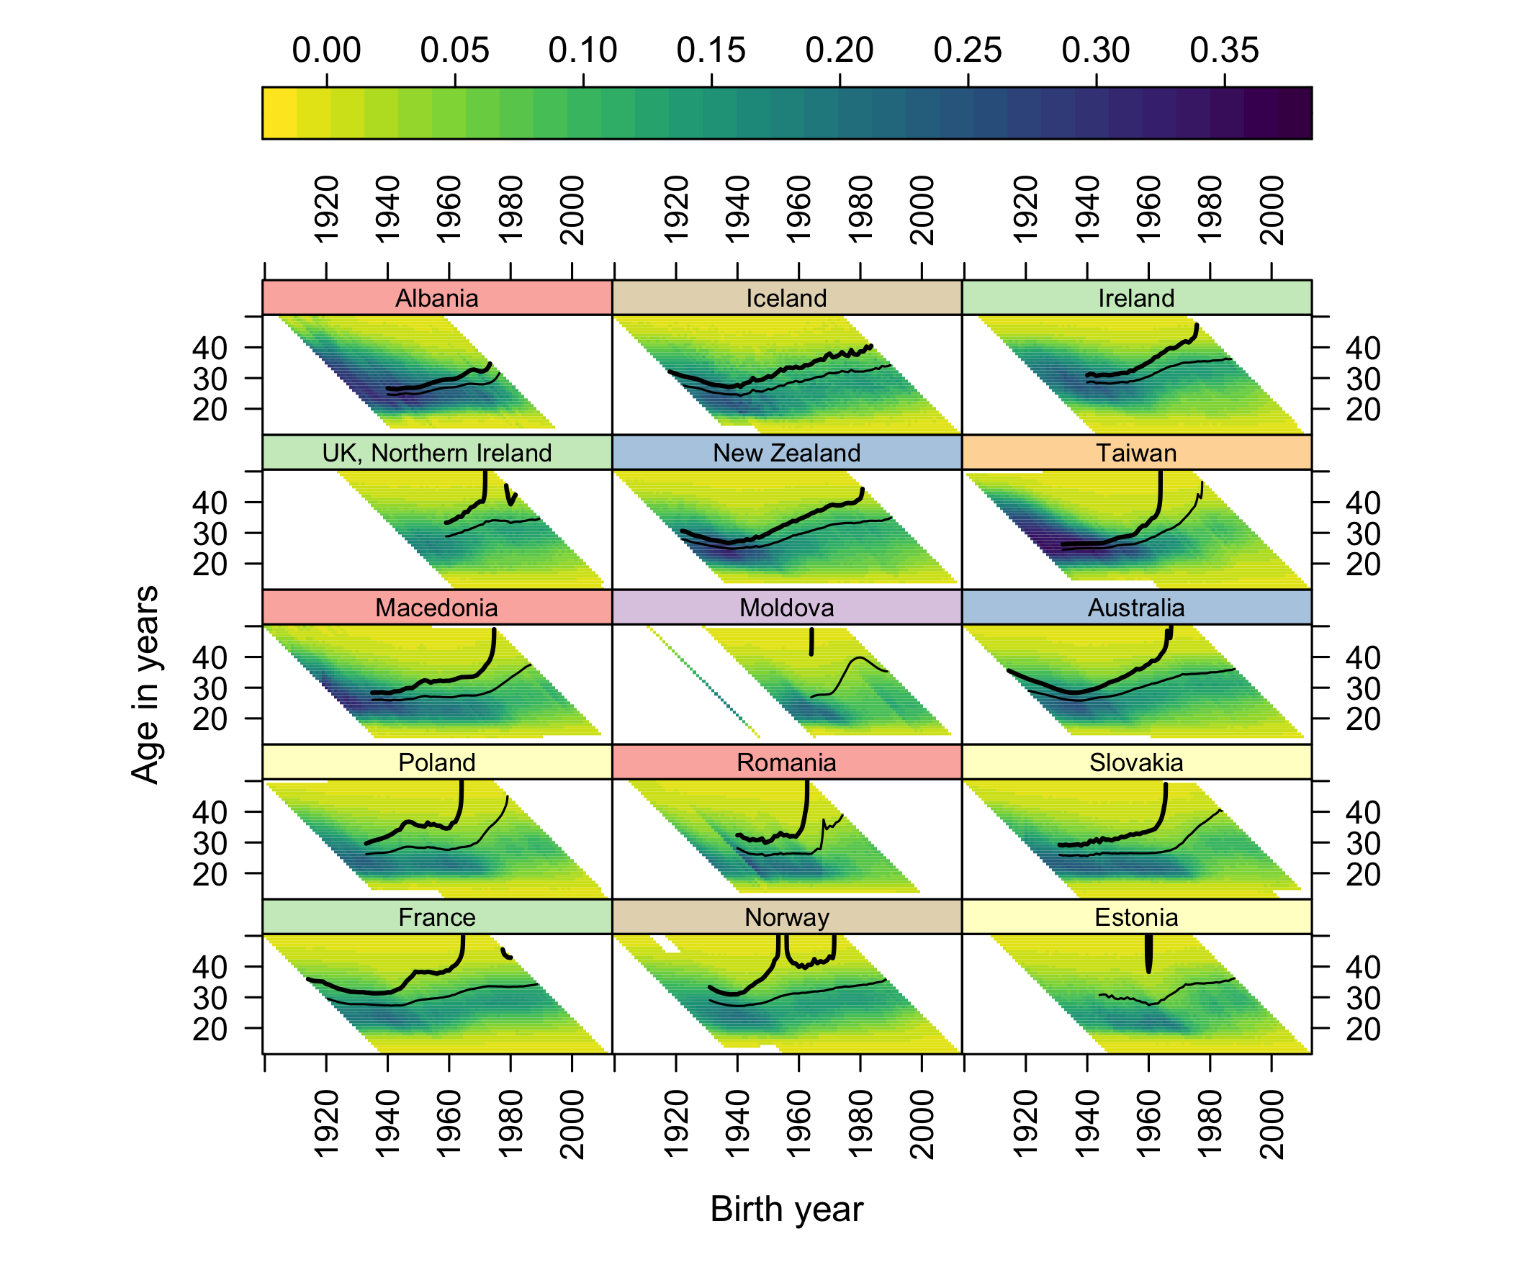
Figure 1: Countries ranked 31-45 by CPCFR at 2007, updated to 2023-25.

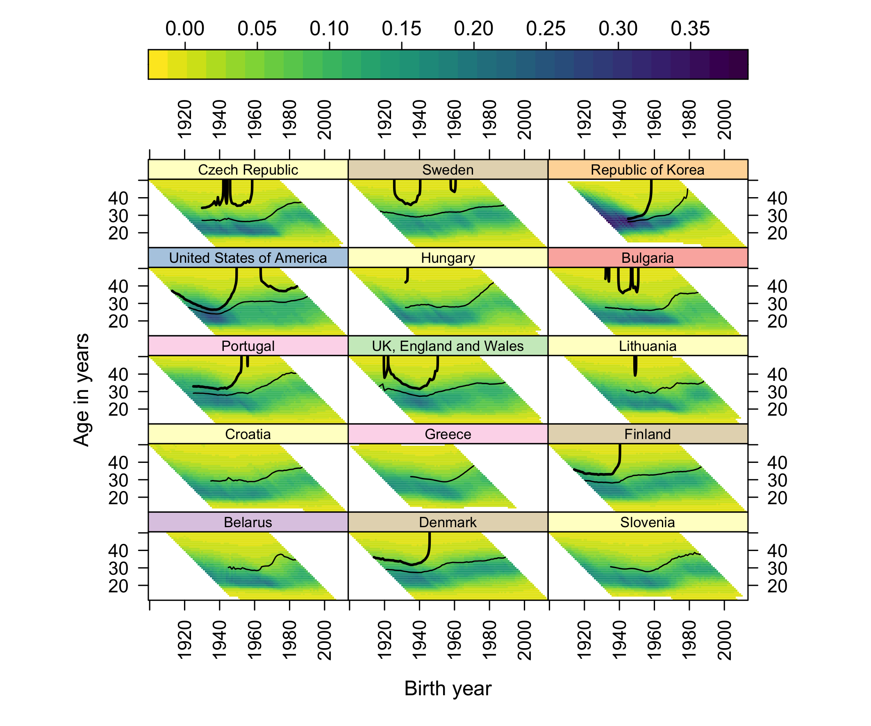
Figure 2: Countries ranked 16-30 by CPCFR at 2007, updated to 2023-25.

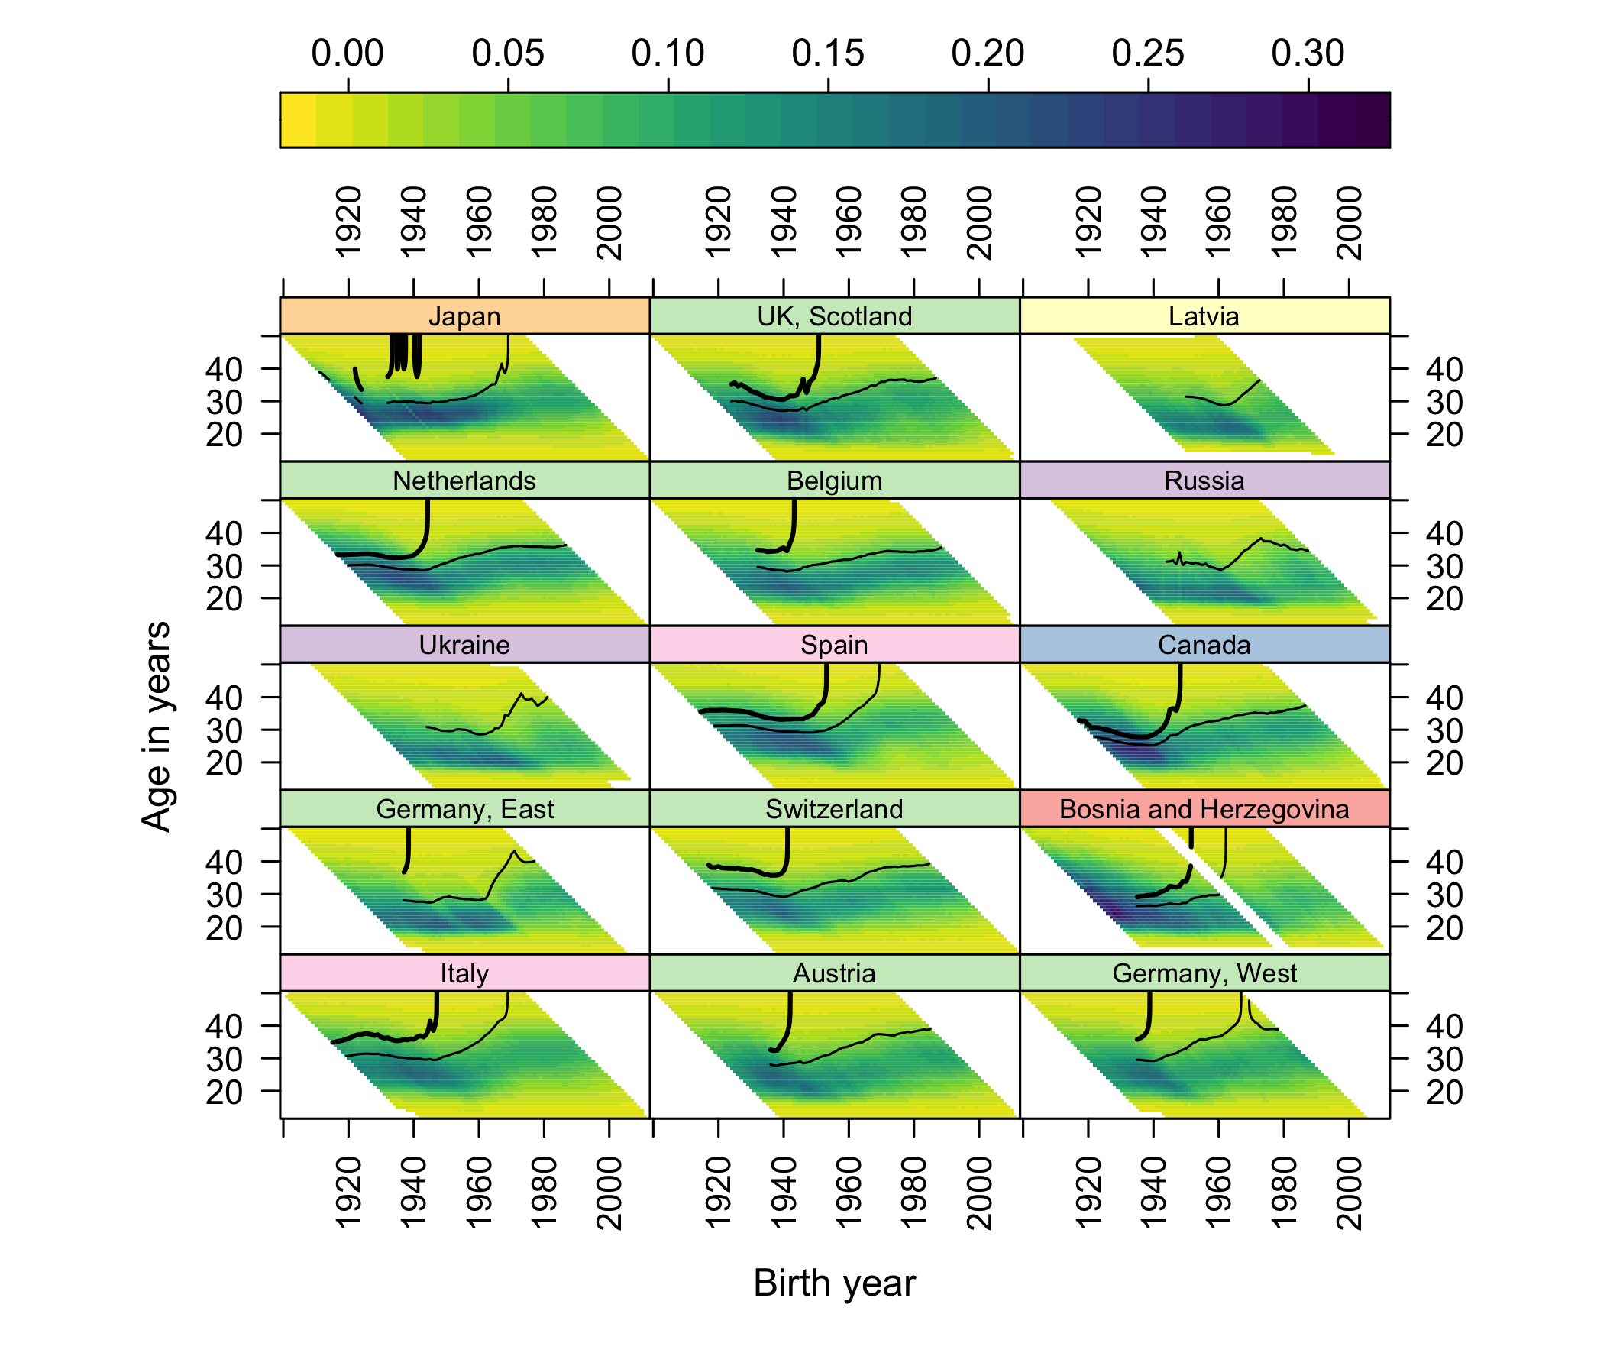
Figure 3: Countries ranked 1-15 by CPCFR at 2007, updated to 2023-25.

S2. Featured ANR overlays: censored versus wall-terminated
The main paper’s featured Norway panel shows both escapes of the replacement contour terminating at the ANR. The United States panel below shows the contrast that matters for the still-open US verdict: its contour’s right end is cut by the data edge - censored, not wall-terminated. South Korea, the panel’s extreme case, is included for comparison. Script: scripts/wall_2026.R.
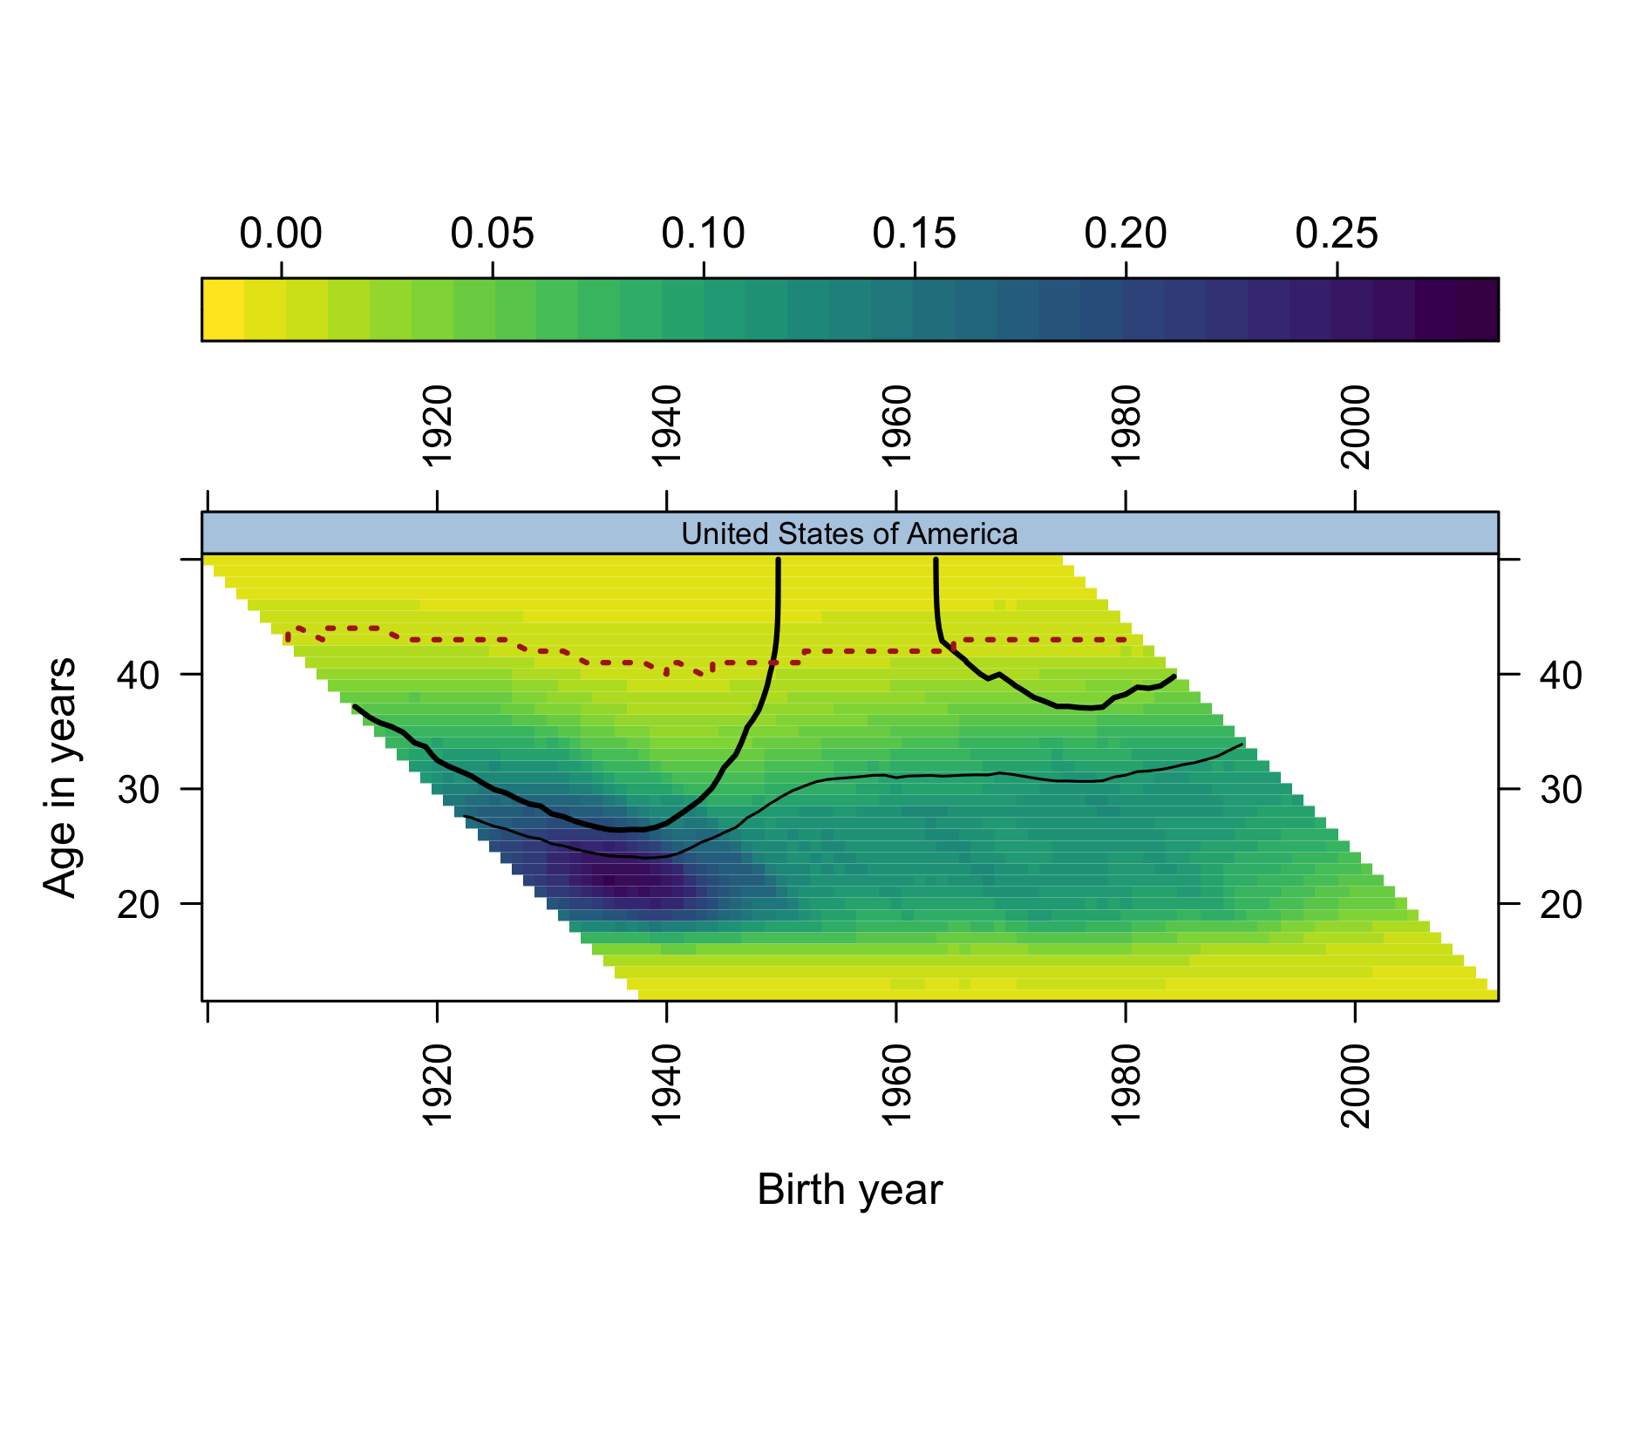
Figure 4: United States: composite surface with the ANR overdrawn (dotted). The replacement contour climbs toward the boundary but its right end is censored - the verdict on the 1985+ cohorts is still open.

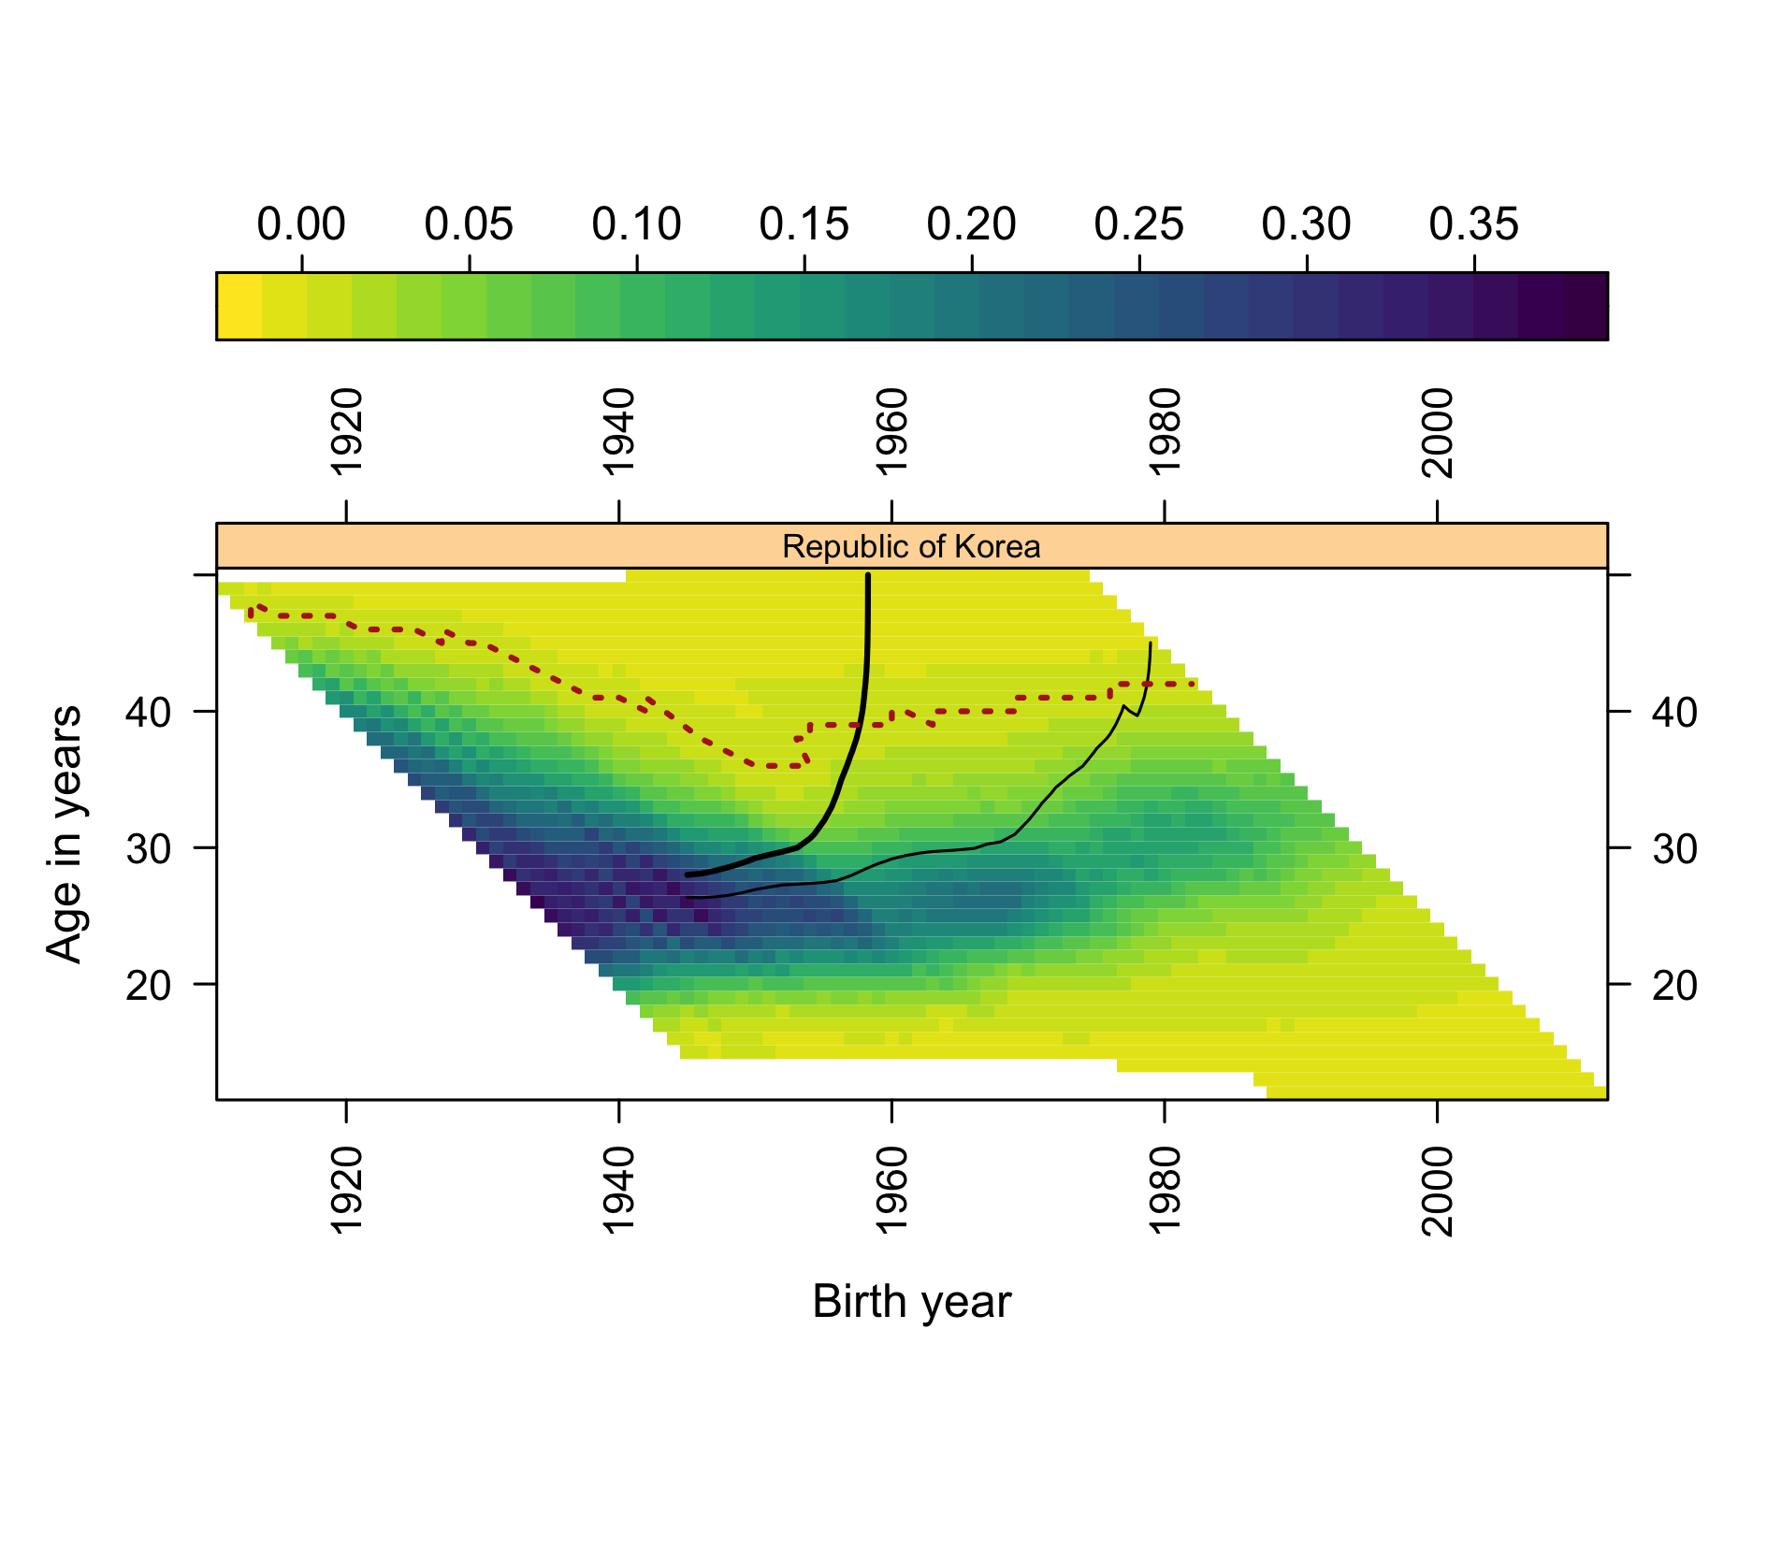
Figure 5: South Korea: composite surface with the ANR overdrawn (dotted).

S3. Per-country squeeze trajectories
The pooled-median squeeze chart in the main paper summarises 45 per-country trajectories; they are shown in full here. Single-year modal ages are noisy in small populations, and ties are broken to the youngest age (see S8), which is why the per-country panels - not the pooled medians - are the primary output. Derived data: data/derived_2026/squeeze_by_country_year.csv. Script: scripts/squeeze_2026.R.
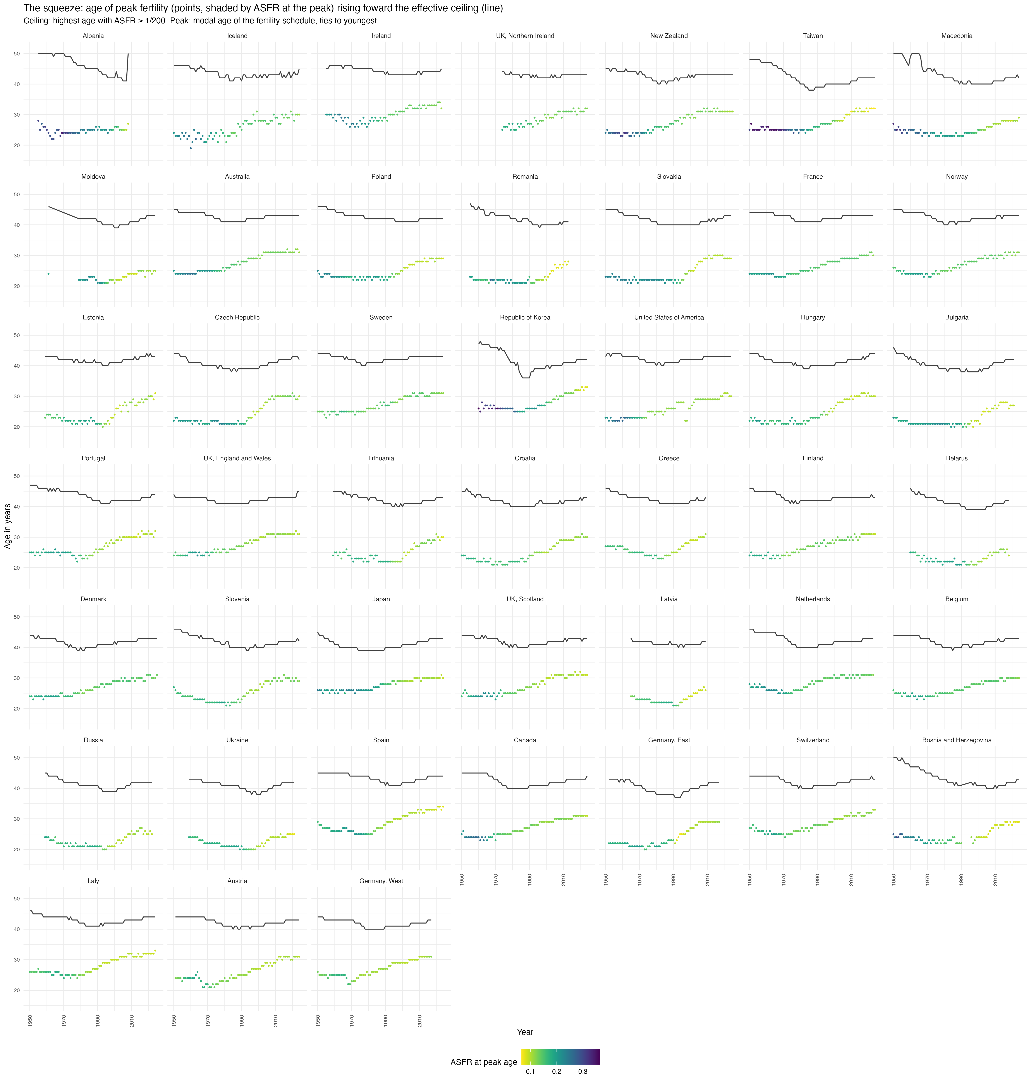
Figure 6: The squeeze by country, 1950-2025: modal age of the fertility schedule (points, shaded by the ASFR at the peak) and the ANR (line).

S4. ANR trajectories, sensitivity, and the full last-cohort table
Per-country ANR trajectories at both thresholds are shown below: the 1/1000 boundary sits roughly two years above the primary 1/200 boundary and moves in parallel, so the narrative in the main paper is not sensitive to the choice. Late-fertility mass trajectories (cumulative ASFR at ages 40+ and 35+) are in the repository (late_mass_trends.png). The full 45-country version of the main paper’s last-cohort table is at data/derived_2026/last_cohort_replacement.csv. Script: scripts/wall_2026.R.
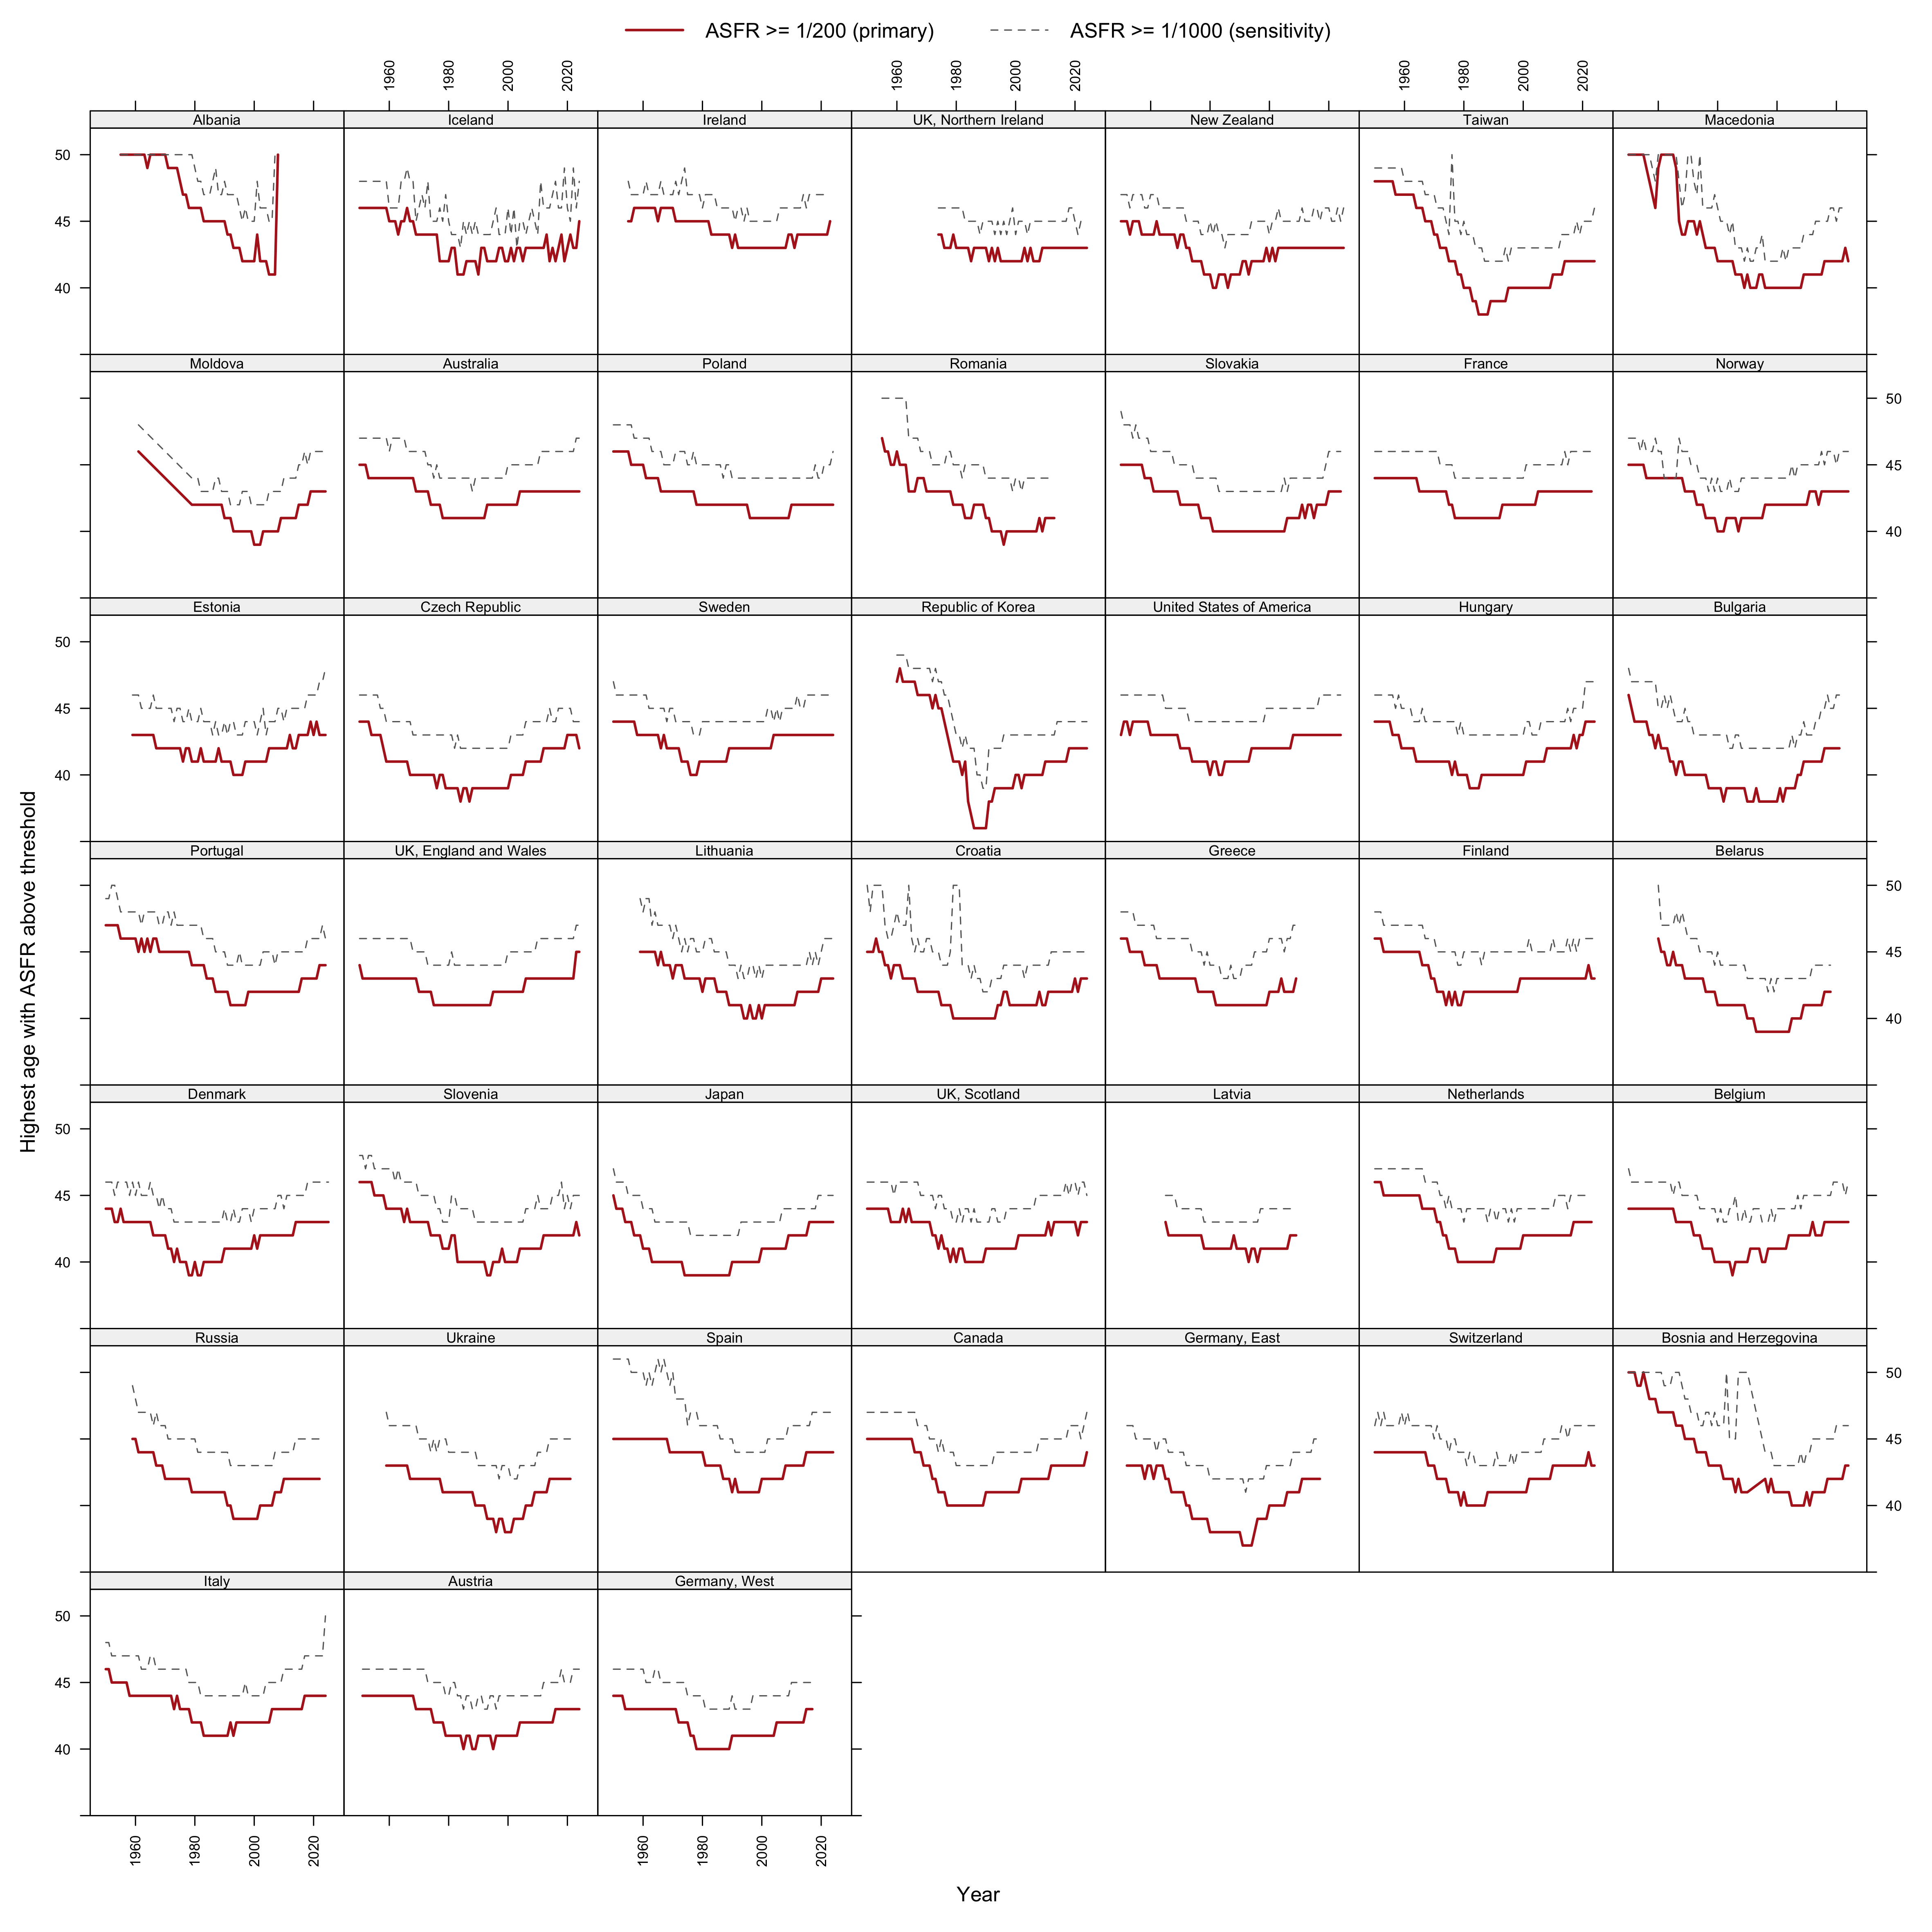
Figure 7: Effective ANR trajectories by country, 1950-2025: highest age with ASFR at or above 1/200 (solid) and 1/1000 (dashed).

S5. From reading surfaces to testing causes: candidate geometries and their mimics
This section sets out the reasoning, summarised in the main paper’s Discussion, that connects surface reading to the preregistered protocol (osf.io/j3tbq).
The candidate explanations for the post-2008 acceleration differ precisely in the surface geometry they imply. A period shock - the 2008 financial crisis and its long shadow (Sobotka et al. 2011; Goldstein et al. 2009) - should appear as a vertical front: fertility falling across all childbearing ages in the same calendar years, with intensity graded by each country’s economic exposure. A diffusion process riding a new communication technology - the smartphone thesis in its behaviourally explicit form (Hudson and Moscoso Boedo 2026; Moscoso Boedo and Hudson 2026; Myers and Hooper 2026; Billari et al. 2019) - should appear, in its simplest young-first variant, as a sloped front: onset earliest at the youngest, most-connected ages and arriving at older ages with a lag, in country after country regardless of development level, as the older diffusion literature would expect of behaviour spreading through communication networks (Bongaarts and Watkins 1996; Casterline 2001; Rosero-Bixby and Casterline 1993). A cohort-carried change - new cohorts bringing revised intentions with them as they age through the childbearing years - should travel along the 45-degree diagonal of the Lexis surface.
The updated panels are suggestive on inspection: post-2008 lightening of the surface is visible at young ages in many countries, including several where the crisis narrative fits poorly. But adjudication by eye fails, for exactly the reason the main paper’s forecast check teaches: unaided surface reading is powerful at generating hypotheses and systematically fallible at extrapolating them. Two specific mimics discipline any reading of the acceleration. Tempo mimicry: postponement alone moves fertility out of young ages first, so a young-first front can be produced by delay without any quantum change - distinguishing them requires following cohort cumulative milestones, which the CPCFR contours carry. Mean-reversion mimicry: several countries entered 2008 at the top of a recuperation upswing (Goldstein et al. 2009; Myrskylä et al. 2013), so a post-2008 “break” can be manufactured by reversion to an older trend. Existing evidence on the digital thesis, moreover, is largely teen-focused or single-country (Guldi and Herbst 2017; Kearney and Levine 2015; Jaeger et al. 2020), and the most prominent null for ages 25+ rests on a detrending that removes any effect common to all ages by construction (Moscoso Boedo and Hudson 2026) - so the question of a level response across the full age range remains open.
These considerations motivate the preregistered universality test: a global panel (UN World Population Prospects 2024, escaping the rich-country selection of the HFD/HFC), break-date estimation, an age-gradient classification of onset (period-shock versus young-first versus cohort-carried), tempo guards built from CPCFR milestones, and equivalence tests against development gradients. The protocol was frozen and registered publicly on 12 July 2026, before its outcome data were downloaded; the main paper deliberately runs none of its estimators.

S6. COVID-19 on the surfaces
COVID-19 arrived on these surfaces as texture, not trend: dips in 2020-21 births and partial rebounds in several countries, superimposed on an acceleration that was already a decade old at the pandemic’s onset. The runway quantities (AAPF, ANR, late mass, reachability) move smoothly through the pandemic years in the per-country trajectories of S3 and S4. Whether the pandemic left a persistent mark - or shared causes with the broader decline - is exactly the kind of question the eye cannot settle; the preregistered protocol excludes 2020-24 from its estimation windows and treats pandemic-era displays as exploratory.

S7. Provenance of the 2020 extrapolations
The main paper’s forecast-check figure redraws the 2020-era extrapolations onto re-rendered surfaces. The two source artifacts are reproduced here.
The published Figure 2 of Pattaro et al. (2020) carried pedagogic annotations - including the terminal contour readings “Replacement age 43” (Norway) and “Replacement age 37” (United States) - but no drawn extrapolation lines; the forecasts appear in the published text: the contour “has been trending upwards for Norway but falling for the United States”; “Norway looks likely to lose replacement fertility levels over the next few years”; “we might assume that replacement levels will be sustained for longer in the United States” (Pattaro et al. 2020, 699–700).
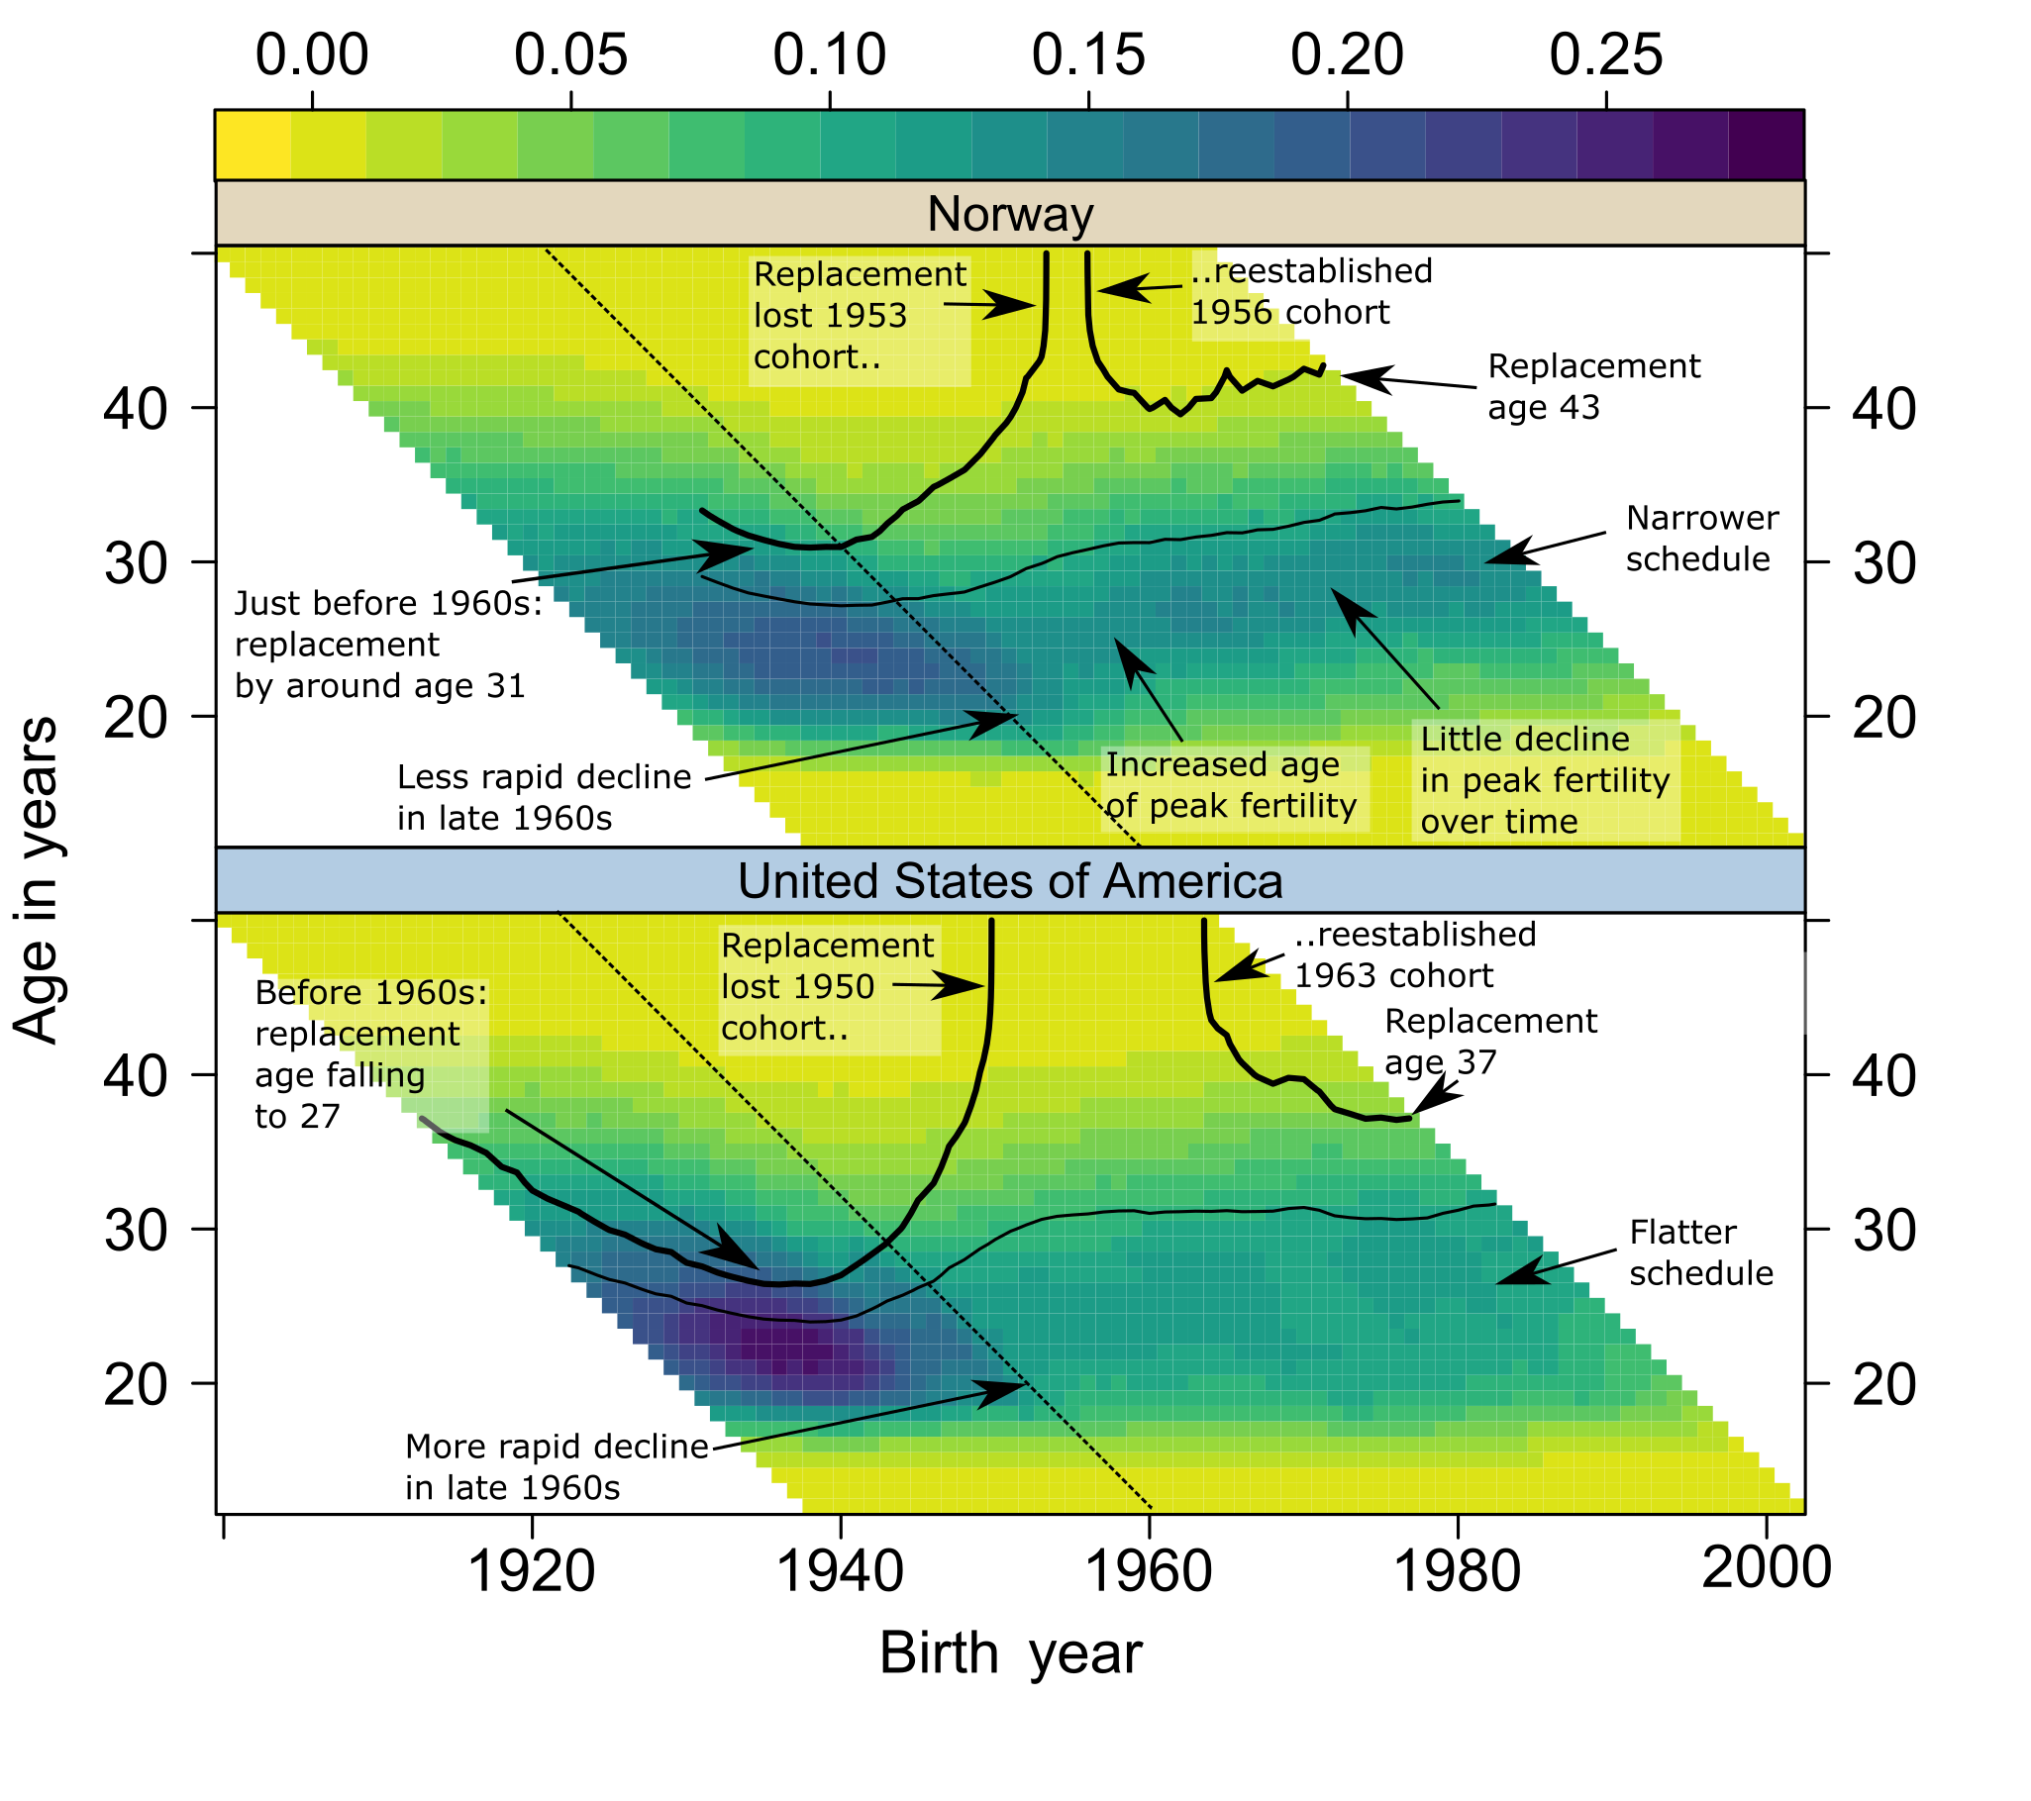
Figure 8: Figure 2 of Pattaro et al. (2020) as published (CC BY 3.0 DE): composite fertility lattice plots for Norway and the United States with the original annotations.
The extrapolations were drawn explicitly in a pre-publication working version of the figure, publicly timestamped in the project repository in September 2018, as dotted lines labelled “speculative extrapolation of replacement contour”: rising steeply for Norway; continuing nearly flat, near age 37-38, for the United States. The drawn lines were dropped in revision; the published text retained their verbal equivalents. The working figure uses a draft-era colour palette that differs from the published specification - one reason the main paper re-renders the 2020-vintage data (repository tag demres-2020, data/data_combined_and_standardised.csv) in the current specification rather than reproducing this figure in the comparison.
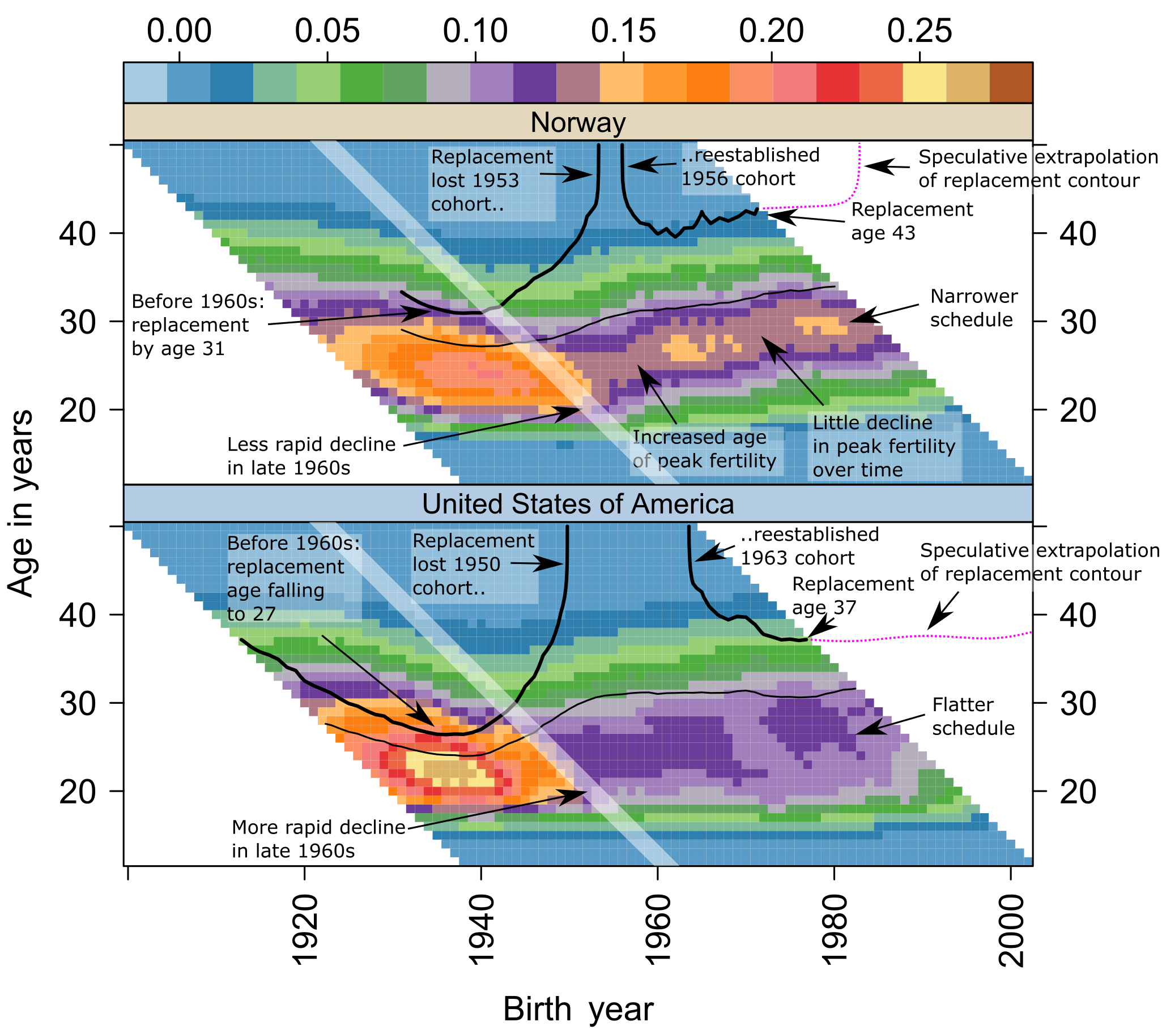
Figure 9: Pre-publication working version (project repository, September 2018), with the drawn “speculative extrapolation” lines.
Digitized coordinates for the redrawn magenta lines in the main paper’s forecast check are recorded in scripts/forecast_check_2x2_2026.R; they are approximate to the eye against Figure 9.

S8. The vanished US plateau
The United States was historically unusual for a flat-peaked - potentially bimodal, subgroup-mixture - ASFR age profile, which is why the AAPF’s tie-to-youngest rule matters there and why the US is not used as the terrain example in the main paper. Operationalising plateau width as the number of single-year ages whose ASFR is within 90% of that year’s maximum, and calling a country-year a plateau year at width 9 or more: the United States had thirteen plateau years, 1992-2006 - by far the longest run in the panel (the next longest is Albania’s six years in the 1950s-60s; only five countries have any). The plateau collapsed from the left after the late 2000s with the teen and early-twenties fertility decline, and by the 2020s the US profile is a conventional late single peak (median width 6, matching its pre-1990 value). Total-schedule analysis cannot distinguish subgroup convergence from early-subgroup collapse; birth-order data would (Zeman et al. 2018), and the by-birth-order collections already assembled in the repository are the natural extension. Derived data: data/derived_2026/plateau_width_by_country_year.csv. Script: scripts/us_plateau_2026.R.
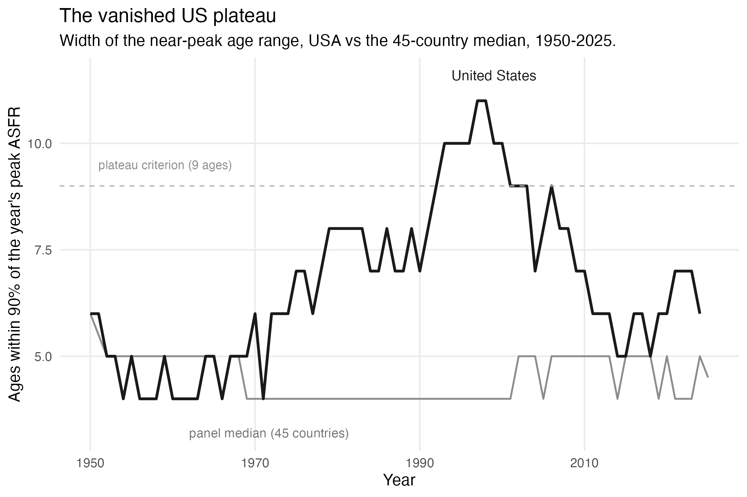
Figure 10: Width of the near-peak age range (ages within 90% of the year’s peak ASFR): United States versus the 45-country median, 1950-2025. Dashed line: the plateau criterion (9 ages).

References
Billari, Francesco C., Osea Giuntella, and Luca Stella. 2019. “Does Broadband Internet Affect Fertility?” Population Studies 73 (3): 297–316. https://doi.org/10.1080/00324728.2019.1584327.
Bongaarts, John, and Susan Cotts Watkins. 1996. “Social Interactions and Contemporary Fertility Transitions.” Population and Development Review 22 (4): 639–82. https://doi.org/10.2307/2137804.
Casterline, John B., ed. 2001. Diffusion Processes and Fertility Transition: Selected Perspectives. National Academy Press. https://doi.org/10.17226/10228.
Goldstein, Joshua R., Tomáš Sobotka, and Aiva Jasilioniene. 2009. “The End of ‘Lowest-Low’ Fertility?” Population and Development Review 35 (4): 663–99.
Guldi, Melanie, and Chris M. Herbst. 2017. “Offline Effects of Online Connecting: The Impact of Broadband Diffusion on Teen Fertility Decisions.” Journal of Population Economics 30 (1): 69–91. https://doi.org/10.1007/s00148-016-0605-0.
Hudson, Nathan, and Hernan J. Moscoso Boedo. 2026. “The Collapse of Teen Fertility in the Digital Era.” Unpublished manuscript.
Jaeger, David A., Theodore J. Joyce, and Robert Kaestner. 2020. “A Cautionary Tale of Evaluating Identifying Assumptions: Did Reality TV Really Cause a Decline in Teenage Childbearing?” Journal of Business & Economic Statistics 38 (2): 317–26.
Kearney, Melissa S., and Phillip B. Levine. 2015. “Media Influences on Social Outcomes: The Impact of MTV’s 16 and Pregnant on Teen Childbearing.” American Economic Review 105 (12): 3597–632. https://doi.org/10.1257/aer.20140012.
Moscoso Boedo, Hernan J., and Nathan Hudson. 2026. “Wide and Shallow: Digital Technology and the Post-2007 Fertility Decline.” Unpublished manuscript.
Myers, Caitlin Knowles, and Ezekiel Hooper. 2026. “Is the iPhone Birth Control? Causal Evidence from AT&T’s 2007–2011 Carrier Monopoly.” Unpublished manuscript.
Myrskylä, Mikko, Joshua R. Goldstein, and Yen-hsin Alice Cheng. 2013. “New Cohort Fertility Forecasts for the Developed World: Rises, Falls, and Reversals.” Population and Development Review 39 (1): 31–56.
Pattaro, Serena, Laura Vanderbloemen, and Jon Minton. 2020. “Visualizing Fertility Trends for 45 Countries Using Composite Lattice Plots.” Demographic Research 42 (23): 689–712. https://doi.org/10.4054/DemRes.2020.42.23.
Rosero-Bixby, Luis, and John B. Casterline. 1993. “Modelling Diffusion Effects in Fertility Transition.” Population Studies 47 (1): 147–67. https://doi.org/10.1080/0032472031000146786.
Sobotka, Tomáš, Vegard Skirbekk, and Dimiter Philipov. 2011. “Economic Recession and Fertility in the Developed World.” Population and Development Review 37 (2): 267–306.
Zeman, Krystof, Éva Beaujouan, Zuzanna Brzozowska, and Tomáš Sobotka. 2018. “Cohort Fertility Decline in Low Fertility Countries: Decomposition Using Parity Progression Ratios.” Demographic Research 38 (25): 651–90. https://doi.org/10.4054/DemRes.2018.38.25.

