# Exploring age-specific and cumulative cohort rates using composite fertility lattice plots: an international comparison of Human Fertility Database and Human Fertility Collection data

Serena Pattaro, School of Social and Political Sciences, University of Glasgow

E-mail: [Serena.Pattaro@glasgow.ac.uk](mailto:Serena.Pattaro@glasgow.ac.uk)

Laura Vanderbloemen, School of Public Health, Imperial College London

E-mail: [l.vanderbloemen@imperial.ac.uk](mailto:l.vanderbloemen@imperial.ac.uk)

Jon Minton, School of Social and Political Sciences, University of Glasgow

E-mail: [Jonathan.Minton@glasgow.ac.uk](mailto:Jonathan.Minton@glasgow.ac.uk)

# Abstract

## BACKGROUND

The Human Fertility Database (HFD) and Human Fertility Collection (HFC) provide disaggregated data on age-specific fertility rates for 45 countries. These sources offer the opportunity to learn about the development of different pathways of transition to low fertility both within and between countries.

## OBJECTIVE

The aim of this paper is to use composite fertility lattice plots, which combine information from different visualization techniques of the Lexis surface, namely level plots and contour plots, to explore changes in age-specific fertility rates and derived cumulative cohort fertility rates across countries and geographic regions.

## METHODS

Through key examples we introduce a new refinement of the Lexis surface, combining level plots which use colour/shade to indicate age-specific fertility rates, and contour lines to indicate cumulative cohort fertility milestones.

## RESULTS

Results show that once countries have fallen below a replacement fertility level they tend to not return to it. Exceptions are Norway and the USA, which saw rising fertility rates for cohorts born after 1950s and late 1960s, respectively. The age-specific fertility trends, as well as broader political and socioeconomic conditions are very different in these countries, suggesting different paths by which replacement fertility rates can be achieved.

## CONTRIBUTION

Complex data visualizations show, in an intuitive way, how age-specific fertility rates are related to cumulative cohort fertility rates. Combining this information enables us to explore differences between countries and can make an important contribution to comparative demographic research on fertility trends.

## Keywords:

Fertility, Lexis Surfaces, Data Visualization, Human Fertility Database, International Comparative Analysis.

# Introduction

Exploring timely and accurate vital statistics information, such as birth rates and other population characteristics, through using data visualization techniques such as Lexis surfaces, has become increasingly popular in recent years (Burkimsher 2017; Campbell and Robards 2014; Schöley and Willekens 2017; Rau et al. 2018; Vaupel, Gambill, and Yashin 1987). Lexis surfaces, by providing convenient visual arrangements of birth rates and related indicators, by calendar time, age, and/or cohort, provide an effective tool for both the exploration and the identification of dynamic patterns and relationships arising from fertility data.

The transition to low fertility has been identified as one of the key drivers underpinning population change (Billari and Kohler 2004). The fertility transition to below replacement levels is one a cornerstone of the demographic transition(s), (Davis 1945; Notestein 1945) (Lesthaeghe and van de Kaa 1986; Lesthaeghe 1995; 2010). Low fertility transitions correlate with life expectancy gains (Oeppen and Vaupel 2002; Shkolnikov et al. 2011) and increased international migration (Adserà and Ferrer 2014; Sobotka 2008;).

But will all rich countries’ fertility rates fall below replacement, and if so by similar magnitudes? With reversals in period fertility trends for some European countries (e.g. Goldstein, Sobotka, and Jasilioniene 2009; Myrskylä, Goldstein, and Cheng 2013), the persistence of low fertility is increasingly debated. Recent analyses emphasise increasing instability and divergence between populations, characterising distinct fertility transition pathways (Billari 2018; Sobotka 2017). Key drivers include: the diffusion of modern contraceptive methods; the expansion of higher education; the increase in economic uncertainty; and the large-scale entry of women into the labour force and gender role changes (for reviews see e.g. Balbo, Billari, and Mills (2013) and Basten, Sobotka, and Zeman (2014)).

The aim of this paper is to show how some of these differences in pathways can be identified using composite fertility lattice plots (CFLPs), a variant of the Lexis surface visualisation that we have developed, in which both the colour/shade, and contour lines, represent different but related variables: age-specific fertility rates, and cumulative cohort fertility rates, respectively..

This novel approach may be useful in providing a more efficient at-a-glance comparison of multiple pieces of information that, when combined, provides insights into how the experience of the fertility transition varies across countries and geographic regions. Our approach provides a useful tool to analyse different interrelated aspects of fertility decline, offering insights into its causes and long-term sustainability, by facilitating both a more comprehensive assessment of extant hypotheses and further questions that may lead to new explanatory narratives.

To illustrate the benefits of this approach we offer step-by-step descriptions of the process involved in producing a composite fertility lattice plot through key examples. We provide a comparison of West and East Germany; followed by a comparison of Norway and the USA. In these examples we provide practical suggestions on how to interpret and decode the information contained in CFLPs, before concluding with a plot comparing 45 countries, which we suggest are best printed out as a large-scale (e.g. A2-sized) colour poster.

.

Methods

## 2.1 Data

Data from the Human Fertility Database (HFD) and Human Fertility Collection (HFC) were combined (Max Planck Institute for Demographic Research (Germany) and Vienna Institute of Demography (Austria) 2015, 2016). The HFD includes age-specific fertility rates (ASFRs) for 28 countries over different periods, drawn from official vital statistics from each country.. (Max Planck Institute for Demographic Research (Germany) and Vienna Institute of Demography (Austria) 2016)

The HFC is a complementary database to the HFD, supplementing the HFD’s high-quality, official vital statistics with data from additional sources (Grigorieva et al., 2015). Data disaggregated by age in single year was used from both the HFD and HFC, and Lexis squares (one year by one year) rather than Lexis triangles or Lexis parallelograms were used, as in practice the use of squares only has limited effect on precision of cohort estimates (Caselli and Vallin, 2005). In addition to the 28 countries from the HFD, data from 48 countries were used, but not all were included in the final visualization because of limited periods of observation. Further details are provided in the online appendix.

Data from the HFD and HFC are overlapping for some years and countries. Where more than one country- and year-specific ASFR was available, the value from the HFD was used; otherwise, records from the HFC were used in the following order of preference according to the ‘collection’ field of the HFC dataset: 1) STAT (Official Statistical Data); 2) ODE (Data from the European Demographic Observatory, L’Observatoire Démographique Européen); 3) RE (Research estimates). For almost all countries, this approach produced a dataset comprising ASFRs for many contiguous years; linear interpolations of ASFRs were used for the few countries and years where this was not the case. The code for both combining data across sources and interpolating values where necessary are available in the online appendix.

## 2.2 Lexis surface mappings

For each country, ASFRs were arranged onto a Lexis surface with birth cohort year on the horizontal axis and age in years on the vertical axis. As Lexis squares rather than triangles or parallelograms were used throughout, these are not true cohort estimates, but are sufficient to illustrate the visualization principles, and the R code is available for researchers to iterate the approach further. ASFRs for each country and year were mapped to colours and shades using the Paired colour palette from the RColorBrewer R package (Neuwirth 2014). The R packages Lattice and LatticeExtra were used to produce the visualizations (Sarkar 2008).

For cohorts where ASFRs were available from age 15 years, CCFRs were produced for each age and cohort year. If refers to the ASFR for country , in year , and at age , then the CCFR for age can be defined as , where is the simple index of cohort (. Within the Lexis surfaces, contour lines were added at positions across the cohort-age surface where reached specific values. A thin dashed contour indicates of 1.30 babies per woman, a thin solid contour indicates of 1.50, a thick dashed contour indicates of 1.80, and a thick solid contour indicates a replacement fertility level of 2.05. Because is a cumulative quantity, the contour lines will always have the same monotonic ordering - thin dashed, thin solid, thick dashed then thick solid - from bottom to top. The position, presence/absence, and trajectories of these contour lines across different cohorts, and between countries, all indicate how fertility trends change over time and place, and how far short of replacement fertility levels most affluent world nations now fall. All countries are arranged in order of highest CCFR in 2007, the last common year of observation for all populations being compared.

# Results

## 3.1 Unpacking composite fertility lattice plots: the case of West and East Germany

Figure 1a provides an illustration of how the cumulative cohort fertility contour lines are constructed from the age-specific fertility schedules for any specific birth cohort. West German cohorts born in 1935 and 1938 are used in this example. For both cohorts, cumulative fertility schedules are constructed indicating the ages at which different levels of cumulative fertility are reached. Four vertical ‘milestones’ are placed at 1.3, 1.5, 1.8 and 2.05 (‘replacement’) babies per woman, each uniquely identified with a thick or thin solid or dashed line. As the figure shows, the contour lines for any given cohort are the ages at which that cohort’s cumulative fertility schedule intersects with the corresponding fertility milestone. In the example used, there is little difference in between cohorts in the ages at which the 1.3 (thin dashed line), 1.5 (thin solid line), and 1.8 cohorts (thick dashed line) are placed, but the replacement fertility contour (thick solid line) has moved upwards by around five years between the 1935 and 1938 cohorts.

By looking at the furthest right of the cumulative schedule, we can see that each schedule becomes vertical after a particular age: for later cohorts, this tends to be around the age of 44, and for earlier cohorts, a slightly earlier age. This is the maximum cumulative fertility reached by each cohort, and we can see that this has shifted to the left (become lower) for the 1938 cohort compared with the 1935 cohort. Although the age-specific fertility schedules (on the left of the figure) look similar for both cohorts, the effect of the slight differences in terms of the position of the replacement fertility contour is thus sizeable.

This simple case study highlights two important features for interpreting the contour lines: firstly, and as shown in the inset subfigure, the ordering of the four contour lines will always be consistent: the thin dashed 1.3 line will always be at the lowest of the four lines, followed by the thin solid 1.5 line, then the thick dashed 1.8 line, with the thick solid 2.05 replacement line always the highest of the four contours. Because of this consistent ordering and the limited number of lines displayed, line width and dash type alone can be used to uniquely identify the contours, meaning colour can be used to represent other features in the data, namely the age-specific fertility rates.

Secondly, we can see how, as the total cumulative fertility of a cohort falls below any of the four fertility milestones, the corresponding contour line will swiftly become vertical on the contour plot. This necessarily occurs first with the 2.05 contour, and then for the 1.80 contour, and then (for some populations) the 1.50 contour. In the case of West Germany, the total cumulative fertility first falls below replacement for the 1939 cohort, and has never exceeded this level since.

[Figure 1a about here]

Figure 1b continues the focus on West Germany, by showing the two components of the composite plot separately, and pointing out a number of key features about the data that they each reveal. The top subpanel shows the level plot component of the composite plot, in which different age-specific fertility rates are mapped onto different colours, as per the key shown at the top of the figure. The colour of the tile containing the name of the population indicates the region in which the country is grouped. Annotation features have been added to highlight substantive patterns in the data. These include the fall in fertility rates at all ages seen in the late 1960s, as more effective contraceptive methods became available. (As each vertical section through the figure is a cohort, a period effect, such as this, will appears as a striation across the data moving bottom right to top left at 45 degrees.) After the 1960s, the age of peak fertility increased, whereas the level of fertility at the peak fertility age tended to fall.

The middle subpanel shows the contour lines only, in which each contour line corresponds to a different cumulative fertility milestone. A vertical dotted orange line on the left of the figure shows the first cohort for which the contour lines were shown; earlier cohorts have incomplete age-specific fertility data at some younger ages, and so the cumulative fertility schedules for such cohorts would be incomplete, and misleading if plotted. The diagonal dotted orange line shows the last period for which data are available, and so the highest ages at which cumulative cohort fertility schedules can be calculated for more recent cohorts.

Starting with the 2.05 contour line, we can see that this line quickly becomes vertical with the 1939 cohort; this was the last cohort which reached replacement fertility levels. The 1.8 babies/woman milestone (thick dashed line) was last observed for the 1944 cohort, and not reached for any subsequent cohorts. We therefore know from the presence and absence of particular contour lines on the figures that cohorts over the next generation or so each reached total fertility levels of between 1.5 and 1.8 babies/woman, as the 1.5 (thin solid) contour is present for each of these cohorts but the 1.8 (thick dashed) contour line is absent.

Though we can never know with certainty, we can make some reasonable informal extrapolations of the contour lines for more recent cohorts by assuming the following: firstly, that so long as the contour lines are within ages ranging up to around 43 years, they can probably be assumed to continue linearly; secondly, that if the contour lines trend upwards towards older ages (around 44 years and older), the total cumulative fertility of later cohorts is likely to become less than the level indicated by the contour line, and so the contour line is likely to move vertically upwards. If is by making these assumptions that the purple dashed lines show speculative extrapolations of the 1.8 and 1.5 contour lines. Towards the end of the series, the 1.8 contour line is reached around the age of 43 years, for around the 1967 cohort; we therefore expect later cohorts’ total cumulative fertility levels to be below 1.8, and so this contour line will likely trend vertically upwards. By contrast, the 1.3 cohort line, last observed for around the 1977 cohort, is reached around the age of 35, and appears to have stabilised at around this age; we therefore expect it will continue to be reached at similar ages for subsequent cohorts. The bottom subfigure shows the composite plot which bring together both level plot and contour line elements.

[Figure 1b about here]

Figure 1c shows the composite plots for both West and East Germany, using a common colour palette for the colour tiles. As many features regarding West Germany have been previously discussed, no further annotations have been added to the West German subfigure. Instead, corresponding features, relating both to the level plot and contour plot aspects of the composite plot visualisation, are highlighted for East Germany.

These annotations reveal that, unlike West Germany, and the majority of European and other rich nations, East Germany experienced two substantial period effects, rather than just one. Though, like most European nations, there was a sharp fall in fertility in the late 1960s, there was then a recovery in age-specific rates for most of the 1970s and 1980s. However, in the late 1980s, with the collapse of the Berlin Wall, fertility rates fell rapidly again, with fertility rates at many ages falling below corresponding rates in West Germany. Afterwards, there was a rapid convergence of East German fertility schedules to those seen in West Germany, with a rapid rise in the age of peak fertility.

By looking at the contour lines, we can see the effects that these changes in age-specific fertility had on completed cohort fertility rates. Replacement fertility rates were last reached for almost the same cohort for both East Germany (1938) and West Germany (1939). Whereas in West Germany, persistently low birth rates after the 1960s led to cumulative rates falling below 1.8 soon after, total cohort fertility rates remained above 1.8 in subsequent years, though were not achieved for those cohorts who were in their early to mid-20s in the late 1960s (i.e. the 1.8 contour first ‘disappears’ then ‘reappears’ for East Germany). For cohorts in East Germany who were of childbearing age in the 1970s and 1980s, cumulative fertility levels of 1.5 were reached before the age of 30. However, after the late 1980s, the 1.5 fertility milestone was reached by cohorts at ever older ages, and in the last observed period after the age of 40 years. Because of this, it appears likely that East Germany will not sustain fertility rates above 1.5 babies/woman in later years.

[Figure 1c about here]

## 3.2 Comparing Norway and the USA

Figure 2 compares the fertility patterns for Norway with those in the USA. When these and other rich nations are compared across a range of internationally comparable measures, they tend to sit at opposite ends of the distribution (Esping-Andersen 1999; Esping‐Andersen and Billari 2015). However, the contour lines in the composite plots show that they have in common a feature shared with almost no other country recorded in the Human Fertility Database or Human Fertility Collection: Norway and the USA both ‘regained’ replacement cohort fertility levels after first losing them for several successive cohorts. We can see this visually by noting the arcing of the thick black contour lines: for both countries these arc vertically upwards for cohorts born in the early 1950s (1950 for the USA, 1953 for Norway), then arc vertically downwards from some particular cohort onwards, then remain plotted for later cohorts. Norway ‘regained’ replacement fertility levels after having lost these levels for three cohorts (1953-1956). The USA ‘regained’ replacement fertility levels after a much longer period of absence: cohorts born between 1950 and 1962 did not reach replacement fertility, but cohorts from 1963 onwards did.

Although the USA and Norway both re-established replacement fertility levels, whereas almost all other nations have not, more careful exploration of the composite plots shows that they did so in different ways. Firstly, if we compare the late 1960s period effects (grey diagonal band) for both countries, the fall in fertility appears to be larger for the USA and more gradual in Norway. Secondly, if we compare the changing age schedules after the late 1960s, we can see that in Norway (as in West Germany), the age of peak fertility has moved upwards, from around 25 to 30 years of age. Unlike in West Germany, there was not a pronounced fall in peak birth rates along with the increase in the age of peak birth rate; it has remained at or close to 0.15. In the USA, the post-1960s fertility schedules have not so much *shifted* as *spread*, producing a flatter age schedule than in Norway: there is a comparatively wide range of ages, from around 20 to 30 years of age, at which women in the USA have *moderate* birth rates (around 0.10-0.12 babies/woman/year). In Norway, the peak birth rates have tended to be higher (around 0.14-0.15), but the drop off in birth rates the further a woman’s age moves from this peak age is greater. So, replacement fertility levels were reached in Norway through high fertility at a narrow range of ages, and in the USA by moderate fertility at a broader range of ages.

If we consider the trajectories of the replacement contour lines for the USA and Norway after they were re-established, we can see that the line has been trending upwards for Norway, but falling for the USA. By the end of the series, the age of replacement fertility was around 43 in Norway, but 37 in the USA; if we apply the rule of thumb that cumulative fertility of a cohort by age 43 is likely to be close to that cohort’s total completed fertility, we can assume that Norway looks likely to lose replacement fertility levels over the next few years. By contrast, we might assume that replacement levels will be sustained for longer in the USA.

[Figure 2 about here]

## 3.3 All countries

Figure 3 shows the composite fertility lattice plots for 45 countries, representing a visual summary of hundreds of thousands of separate ASFRs. Because of the number of populations being compared, HFC/HFD population codes are used and no gridlines are added to avoid overplotting (see the online appendix for a higher-resolution version of the figure with full country names and gridlines). Country labels are coloured according to their geographic region. Different fertility pathways can be further explored by comparing the fertility trends of countries by geographic group.

[Figure 3 about here]

# Summary and conclusions

In this paper we describe a new refinement and adaptation of the Lexis surface optimised to fertility data. By using both colour/shade and contour lines to mark age-specific fertility rates, and cumulative cohort fertility milestones, respectively, we show how these two types of data are related, and can both be concisely represented in a single visualization. We present extensive pedagogic examples which introduce and comment on different features within specific countries, to provide conceptual ‘stepping stones’ for developing familiarisation with this novel visualisation approach. We conclude with a visualization of 45 countries, based on hundreds of thousands of specific data points.

Our study reveals that once countries have fallen below a replacement fertility level they tend to not return to it. However, the USA and Norway are both exceptions, and the plots reveal much heterogeneity in fertility pathways across countries, which appears to reflect contextual differences between geographic regions.

Among low fertility countries, we illustrated the cases of West and East Germany, where replacement fertility levels were lost for cohorts born before World War II. After a sharing a fall in fertility in late 1960s, East and West Germany experienced different pathways of fertility transitions during the 1970s and 1980s, with a rapid convergence of fertility schedules after the collapse of the Berlin Wall. As reported in other studies (Frejka 2017; Sobotka et al. 2011), cohort fertility rates kept decreasing in East and West Germany and now appear to have stabilised between 1.30 and 1.50 babies per woman.

The contributions of this paper are both substantive and methodological. The case studies have focused on two paired comparisons at the low and higher end of the fertility spectrum in rich nations. But perhaps the greatest potential value in this paper is in demonstrating how the visualisation can be decoded and applied to understanding and comparing many other populations. Further methodological developments based on the approach include: providing three dimensional representations of the data alongside these map-inspired visualisations; and developing and iteratively refining an interactive app for making it easier to select particular populations and compare associated attributes within the visualisation. This would include options to select different colour palettes, as well as to add, remove and shift the fertility milestones being represented with the contour lines. An interactive app with such features would, for example, make it easier to make informal predictions of the fertility trajectories based on current observations.

# References

Adserà, A. and Ferrer, A. (2014). Immigrants and demography: Marriage, divorce, and fertility. In B. R. Chiswick and P. W. Miller (eds) *Handbook of the economics of international migration*. Oxford: Elsevier: 315–358.

Balbo, N., Billari, F. C., and Mills, M. (2013) Fertility in advanced societies: A review of research. *European Journal of Population/Revue européenne de Démographie* 29(1): 1–38.

Basten, S., Sobotka, T., and Zeman, K. (2014. Future fertility in low fertility countries. In W. Lutz, W.P. Butz, and S. KC (eds) *World Population and Human Capital in Twenty-First Century*. Oxford: Oxford University Press: 39–146.

Billari, F. C. (2018). A “great divergence” in fertility? In D. L. Poston, Jr. (ed.) *Low fertility regimes and demographic and societal change*. New York: Springer: 15–35.

Billari, F. and Kohler, H.-P. (2004). Patterns of low and lowest-low fertility in Europe. *Population studies* 58(2): 161–176.

Burkimsher, M. (2017). Evolution of the shape of the fertility curve: Why might some countries develop a bimodal curve? *Demographic Research* 37(11): 295–324.

Campbell, M. and Robards, J. (2014). Comparing changing age-specific fertility across the United Kingdom using Lexis diagrams.Southampton: ESRC Centre for Population Change (ESRC CPC Working Paper 50).

Caselli, G. and Vallin, J. (2005). From situation events in time to the Lexis Diagram and the Computing of rates. In G. Caselli, J. Vallin, and G. Wunsch (eds) *Demography: Analysis and Synthesis*. Boston, MA: Academic Press.

Choi, K. H. (2014). Fertility in the context of Mexican migration to the United States: A case for incorporating the pre-migration fertility of immigrants. *Demographic Research*: 30(24): 703–737.

Coleman, D. (2006). Immigration and ethnic change in low‐fertility countries: A third demographic transition. *Population and development review*: 32(3): 401–446.

Davis, K. (1945). The World Demographic Transition. *The Annals of the American Academy of Political and Social Science*, 237(Jan.): 1–11.

Esping-Andersen, G. (1999). *Social foundations of postindustrial economies*. Oxford: Oxford University Press.

Esping‐Andersen, G. and Billari, F. C. (2015). Re‐theorizing Family Demographics. *Population and Development Review* 41(1): 1–31.

Frejka, T. (2017). The Fertility Transition Revisited: A Cohort Perspective. *Comparative Population Studies*, 42: 89–116.

Goldstein, J. R., Sobotka, T., and Jasilioniene, A. (2009). The End of “Lowest-Low” Fertility? *Population and Development Review* 35(4): 663–699.

Grigorieva, O., Jasilioniene, A., Jdanov, D. A., Grigoriev, P., Sobotka, T., Zeman, K., and Shkolnikov, V. M. (2015). Methods Protocol for the Human Fertility Collection. Available at: http://www.fertilitydata.org/docs/methods.pdf (Accessed: 25 August 2017).

Kravdal, Ø. (2016). Not so Low Fertility in Norway—A Result of Affluence, Liberal Values, Gender-Equality Ideals, and the Welfare State. In R. R. Rindfuss and M. K. Choe (eds) *Low Fertility, Institutions, and their Policies*. New York: Springer: 13–47.

Lesthaeghe, R. (1995). The second demographic transition in Western countries: An interpretation. In K. Oppenheim Mason and A.-M.Jensen (eds) *Gender and family change in industrialized countries*. Oxford: Clarendon Press: 17–62.

Lesthaeghe, R. (2010). The unfolding story of the Second Demographic Transition. *Population and Development Review* 36(2): 211–251.

Lesthaeghe, R. and van de Kaa, D. (1986). Twee demografische transities? In R. Lesthaeghe and D. van de Kaa (eds) *Bevolking: Groei en krimp. Mens an Maatschappij*. Deventer: Van Loghum-Slaterus: 9–24.

Max Planck Institute for Demographic Research (Germany) and Vienna Institute of Demography (Austria) (2015). *Human Fertility Collection*. Available at: http://www.fertilitydata.org/cgi-bin/terms.php (Accessed: 19 November 2016).

Max Planck Institute for Demographic Research (Germany) and Vienna Institute of Demography (Austria) (2016). *Human Fertility Database*. Available at: www.humanfertility.org (Accessed: 1 January 2015).

Myrskylä, M., Goldstein, J. R., and Cheng, Y. A. (2013). New cohort forecasts for the developed world : Rises, falls, and reversals. *Population and Development Review*  39(1): 31–56.

Neuwirth, E. (2014). RColorBrewer: ColorBrewer Palettes. R Foundation for Statistical Computing, Vienna, Austraia (http://www.R-project.org/.

Notestein, F. W. (1945). Population: the long view. In T. Schultz (ed.) *Food for the World*. Chicago: Chicago University Press: 36–57.

Oeppen, J. and Vaupel, J. W. (2002). Broken limits to life expectancy. *Science*, 296(10 May): 1029–1031.

Rau, R., Bohk-Ewald, R., Muszyńska, M. M., and Vaupel, J. W. (2018). *Visualizing Mortality Dynamics in the Lexis Diagram*. New York: Springer.

Sarkar, D. (2008) *Lattice: Multivariate Data Visualization with R*. New York: Springer.

Schöley, J. and Willekens, F. (2017). Visualizing compositional data on the Lexis surface. *Demographic Research* 36(21): 627–658.

Shkolnikov, V. M., Jdanov, D. A., Andreev, E. M., and Vaupel, J. W. (2011). Steep increase in best-practice cohort life expectancy. *Population and Development Review* 37(3): 419–434.

Sobotka, T. (2008). Overview chapter 7: The rising importance of migrants for childbearing in Europe. *Demographic Research* 19(9): 225–248.

Sobotka, T., Zeman, K., Lesthaeghe, R., Frejka, T., and Neels, K. (2011). Postponement and Recuperation in Cohort Fertility: Austria, Germany and Switzerland in a European Context. *Comparative Population Studies* 36(2–3): 417–452.

Sobotka, T. (2017). Post-transitional fertility: the role of childbearing postponement in fuelling the shift to low and unstable fertility levels. *Journal of biosocial science* 49(S1): S20–S45.

Vaupel, J. W., Gambill, B. A., and Yashin, A. I. (1987) Thousands of Data at a Glance: Shaded Contour Maps of Demographic Surfaces. Laxenburg, Austria: International Institute for Applied Systems Analysis (IIASA Research Report 87-016).

Figure 1a Illustration of construction of cumulative cohort fertility contours

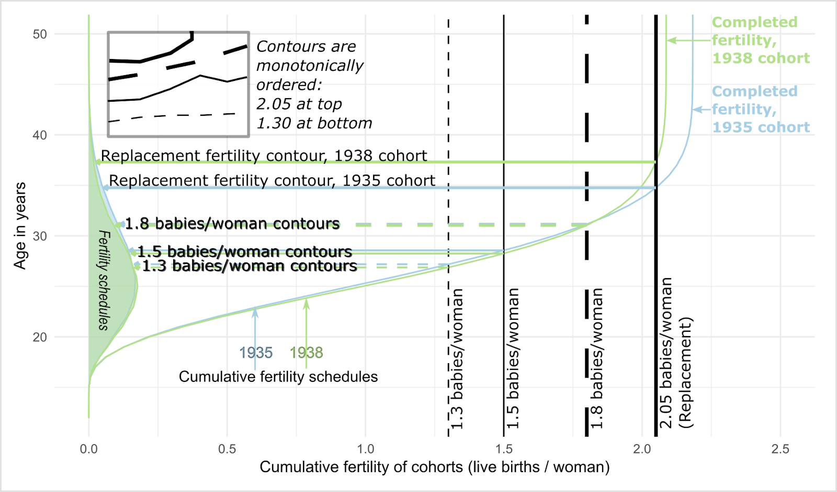

Notes: Illustration of how the cumulative cohort fertility contours are constructed, using fertility schedules from West Germany for cohorts born in 1935 and 1938.

Source: Human Fertility Database (HFD) and Human Fertility Collection (HFC), own calculations.

Figure 1b Production of composite fertility lattice plot for West Germany

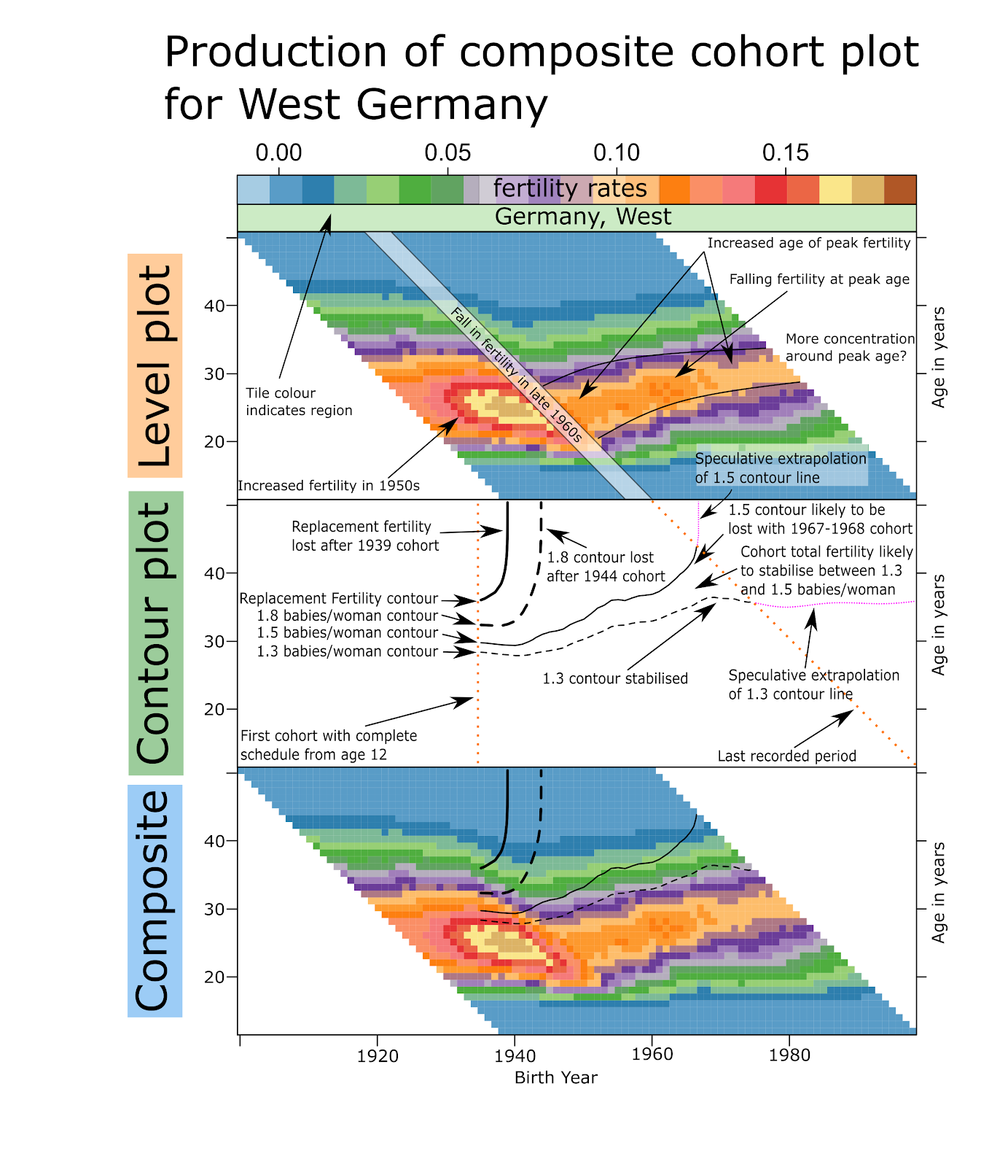

Source: Human Fertility Database (HFD) and Human Fertility Collection (HFC), own calculations.

Figure 1c Comparison of West and East Germany

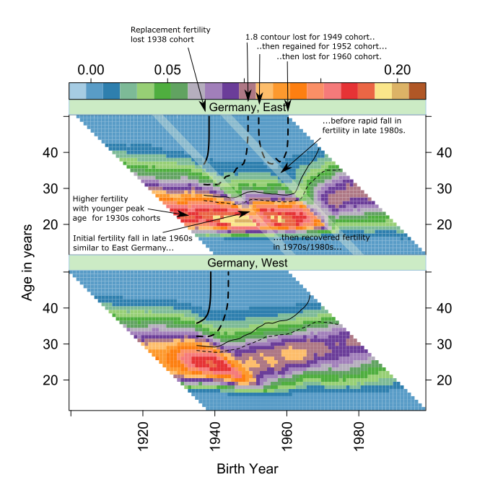

Source: Human Fertility Database (HFD) and Human Fertility Collection (HFC), own calculations.

Figure 2 Comparison of Norway and the USA

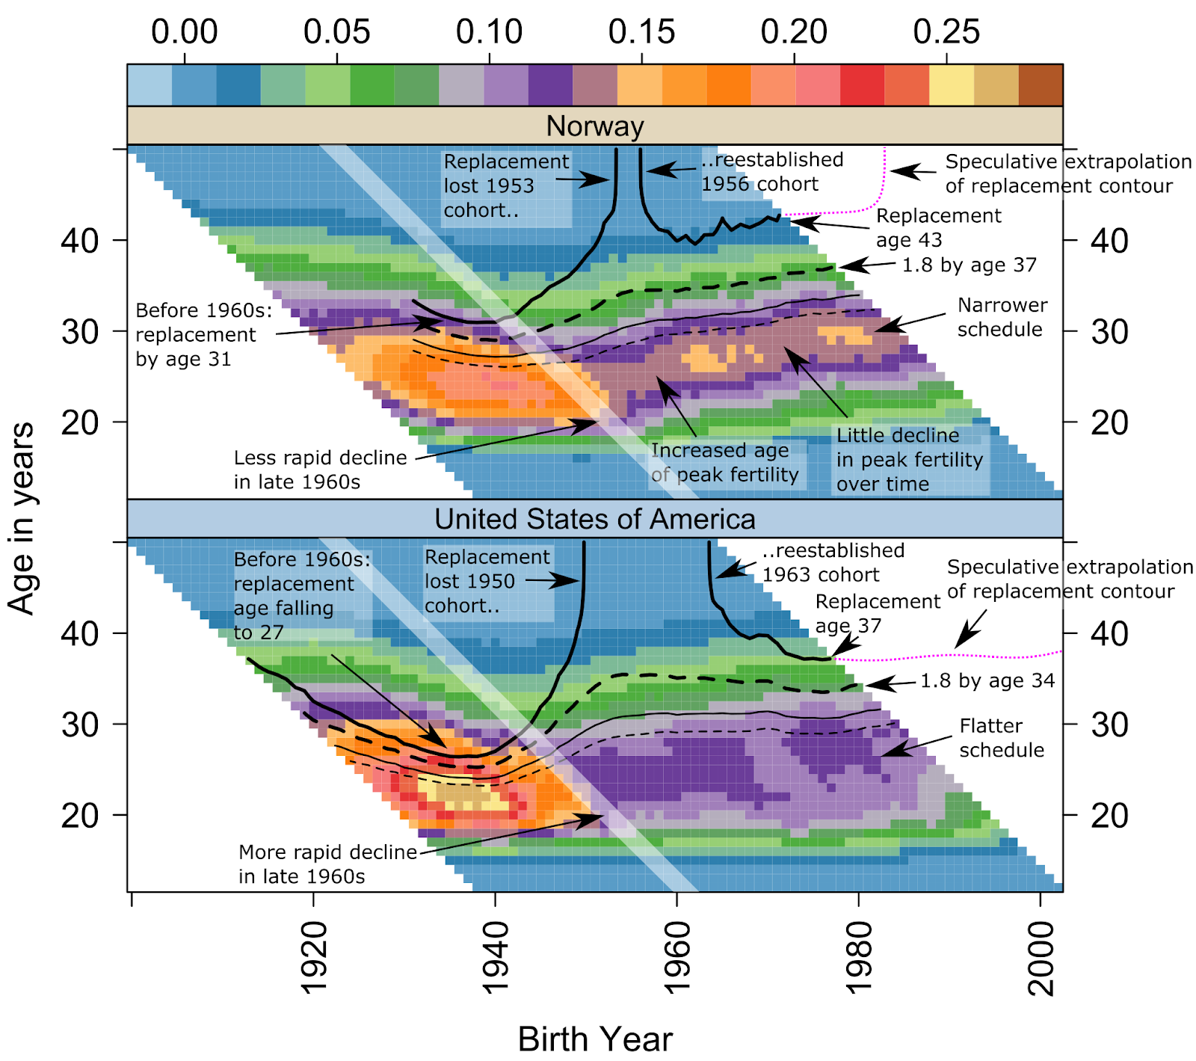

Source: Human Fertility Database (HFD) and Human Fertility Collection (HFC), own calculations.

Figure 3 Composite Fertility Lattice Plot for 45 countries by geographic region

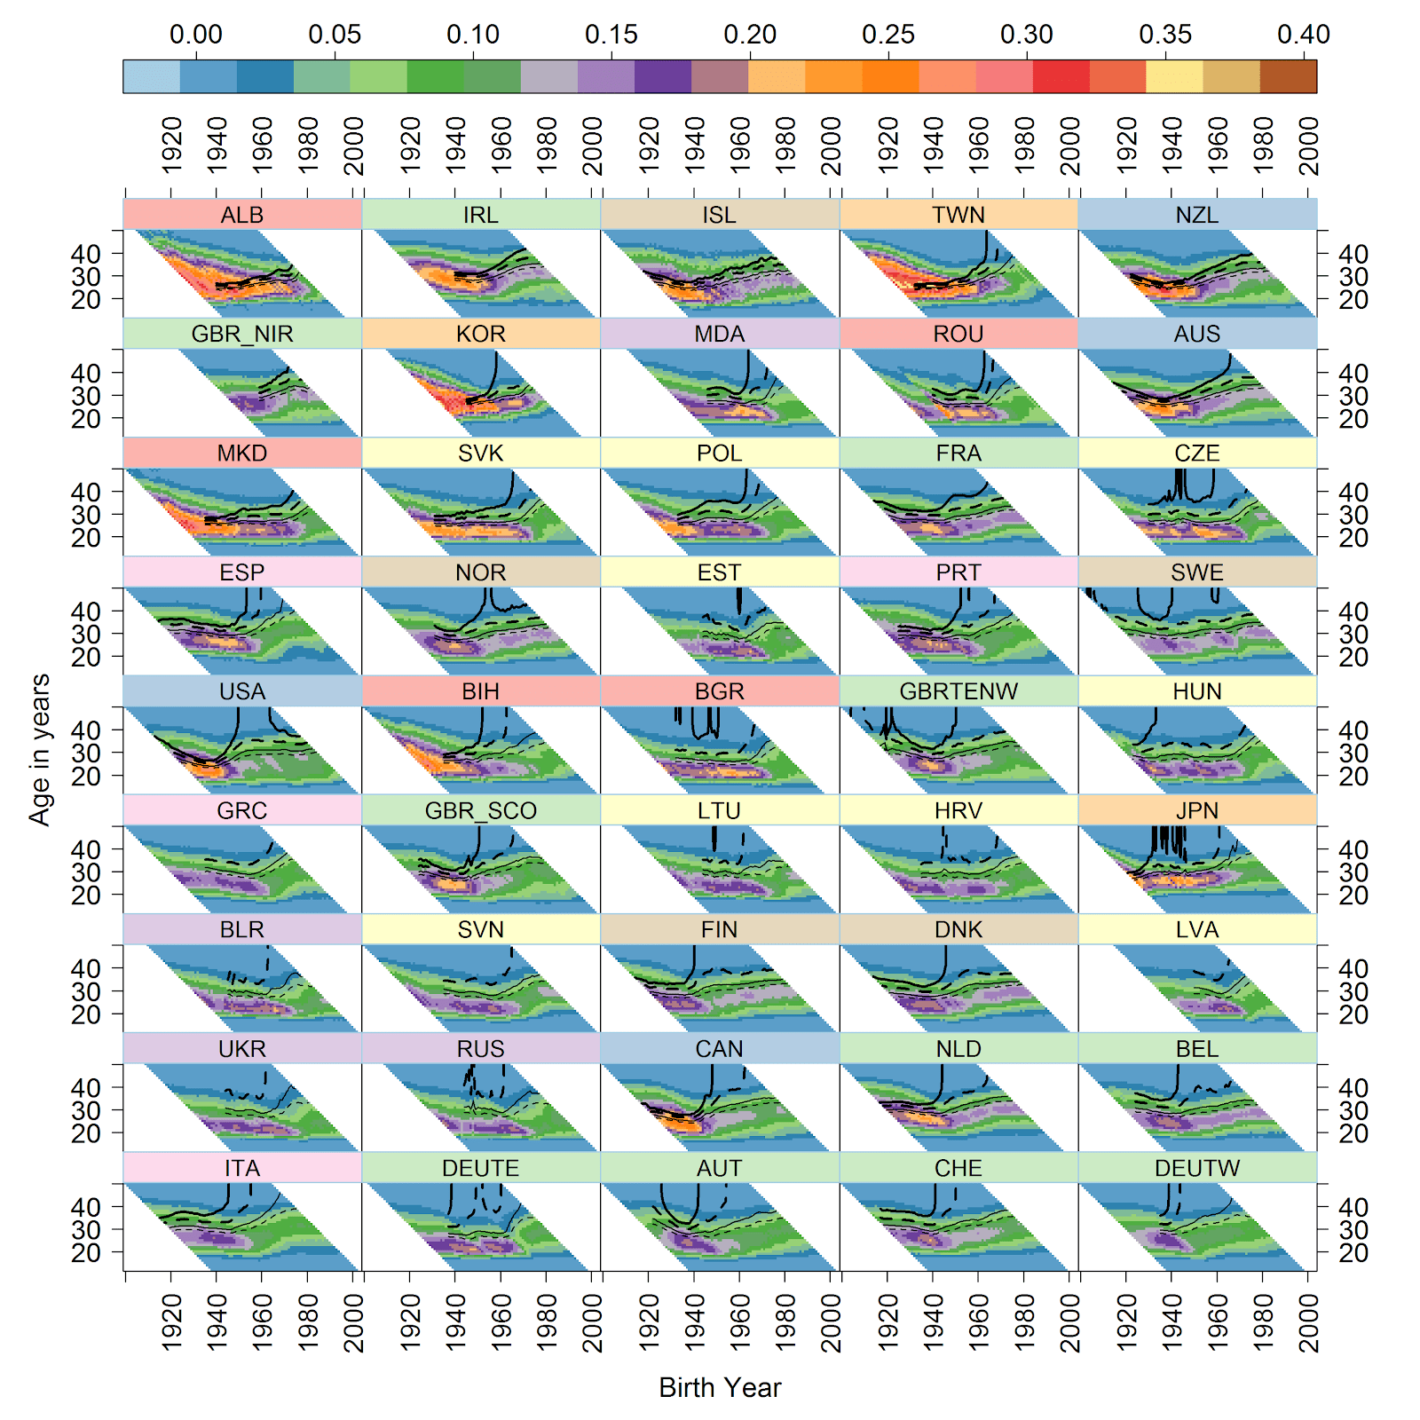

Notes: (a) The shaded scale bar on the right indicates age-specific fertility rates (ASFRs). (b) Thick solid contour lines indicate cumulative cohort fertility rate (CCFR)=2.05 (replacement fertility); thick dashed contour lines indicate CCFR=1.80; thin solid contour lines indicate CCFR=1.50; thin dashed contour lines indicate CCFR=1.30. (c) Countries are ranked in descending order by CCFR in 2007 (last common year of observation). (d) Countries are grouped in geographic macro-regions as follows: (1) South-Eastern Europe: Albania (ALB), Romania (ROU), Macedonia (MKD), Bosnia and Herzegovina (BIH), Bulgaria (BGR); (2) Western Europe: Ireland (IRL), UK-Northern Ireland (GBR_NIR), France (FRA), UK-England and Wales (GBRTENW), UK-Scotland (GBR_SCO), Netherlands (NLD), Belgium (BEL) and German-speaking countries: East Germany (DEUTE), Austria (AUT), Switzerland (CHE), West Germany (DEUTW); (3) Northern Europe: Iceland (ISL), Norway (NOR), Sweden (SWE), Finland (FIN), Denmark (DNK); (4) East and South-East Asian countries: Taiwan (TWN), Republic of Kora (KOR), Japan (JPN); (5) Non-European English-speaking countries: New Zealand (NZL), Australia (AUS), United States of America (USA), Canada (CAN); (6) Eastern Europe: Moldova (MDA), Belarus (BLR), Ukraine (UKR), Russia (RUS); (7) Central Europe: Slovakia (SVK), Poland (POL), Czech Republic (CZE), Estonia (EST), Hungary (HUN); Lithuania (LTU), Croatia (HRV), Slovenia (SVN), Latvia (LVA); (8) Southern Europe: Spain (ESP), Portugal (PRT), Greece (GRC), Italy (ITA).

Source: Human Fertility Database (HFD) and Human Fertility Collection (HFC), own calculations.