# Exploring age-specific and cumulative cohort rates using composite fertility lattice plots: an international comparison of Human Fertility Database and Human Fertility Collection data

Serena Pattaro, School of Social and Political Sciences, University of Glasgow

E-mail: [Serena.Pattaro@glasgow.ac.uk](mailto:Serena.Pattaro@glasgow.ac.uk)

Laura Vanderbloem, School of Public Health, Imperial College London

E-mail: [l.vanderbloemen@imperial.ac.uk](mailto:l.vanderbloemen@imperial.ac.uk)

Jon Minton, School of Social and Political Sciences, University of Glasgow

E-mail: [Jonathan.Minton@glasgow.ac.uk](mailto:Jonathan.Minton@glasgow.ac.uk)

# Abstract

## BACKGROUND

The Human Fertility Database (HFD) and Human Fertility Collection (HFC) provide disaggregated data on age-specific fertility rates for 45 countries. These sources offer the opportunity to learn about the development of different pathways of transition to low fertility both within and between countries.

## OBJECTIVE

To use composite fertility lattice plots, which combine information from different visualization methods of the Lexis surface, namely heat maps and shaded contour plots, to explore changes in age-specific fertility rates and derived cumulative cohort fertility rates across countries and geographic regions.

## METHODS

Standard shaded contour maps use both shade and contour to represent the same variable. In our plots we instead use colour/shade to indicate age-specific fertility rates, and contour lines to indicate the cumulative fertility rates reached by different cohorts at different ages.

## RESULTS

Results show that once countries have fallen below a replacement fertility level they tend to not return to it. Exceptions are Norway and the USA, which saw rising fertility rates for cohorts born after 1950s and late 1960s, respectively. The age-specific fertility trends, as well as broader political and socioeconomic conditions are very different, suggesting different paths by which replacement fertility rates can be achieved.

## CONTRIBUTION

Complex data visualizations show, in an intuitive way, how age-specific fertility rates are related to cumulative cohort fertility rates. Combining this information enables us to explore differences between countries and can make an important contribution to comparative demographic research on fertility trends.

## Keywords:

Fertility, Lexis Surfaces, Data Visualization, Human Fertility Database, International Comparative Analysis.

# Introduction

One of the key drivers underpinning population change is the continuing transition to low fertility (Billari and Kohler, 2004). The fertility transition, as a process of fertility decline from high to below replacement levels, is one of the cornerstones of the demographic transition, both in its classic proposition (Davis, 1945; Notestein, 1945) and in the proposition of the ‘second demographic transition’ (Lesthaeghe and van de Kaa, 1986; Lesthaeghe, 2010). The transition to low fertility interrelates with improvements in life expectancy (Oeppen and Vaupel, 2002; Shkolnikov *et al.*, 2011) and international migration patterns ( Sobotka, 2008; Adserà and Ferrer, 2014).

Since the late 1960s, most countries from the Western world underwent rapid fertility decline, and increasing postponement of childbearing to older ages.Within Europe, there is an emerging debate about the persistence of low fertility, with some studies reporting recuperation in cohort fertility trends (see Caltabiano, Castiglioni, and Rosina (2009) for Italy;and Sobotka et al. (2011) for German-speaking countries and the United States) and others revealing a reversal in period fertility trends among European countries (Goldstein, Sobotka and Jasilioniene, 2009; Myrskylä, Goldstein and Cheng, 2013). Yet the transition to low and later fertility is not solely restricted to Europe and, more generally, the West, but also encompasses an increasing number of countries, particularly those in East and Southern Asia(Frejka, Jones and Sardon, 2010; Basten, Sobotka and Zeman, 2014).

The transition to low fertility has been shaped by a complex and dynamic combination of technological, socioeconomic, political and cultural factors. Driving forces include the diffusion of modern contraception (Montgomery and Casterline, 1996; Kohler, 2001), educational expansion (Blossfeld and Huinink, 1991; Lutz, Butz and KC, 2014), the large-scale entry of women into the labour force ( Oppenheimer, 1994; Adserà, 2011), family policies (Thévenon, 2011; Rindfuss and Choe, 2015), globalisation and economic uncertainty (Mills and Blossfeld, 2005), ideational changes (Lesthaeghe and Surkyn, 1988), gender roles and gender equality (Esping‐Andersen and Billari, 2015; Goldscheider, Bernhardt and Lappegård, 2015; McDonald, 2006).

The aim of this paper is to provide an illustration of different fertility trends across 45 countries from major geographic regions within and outside Europe (for full details see the online appendix). The latter reflect different contextual conditions which have shaped different pathways of low fertility. Changes in age-specific and cumulative cohort fertility rates are explored by using composite fertility lattice plots, which combine information from different visualization methods of the Lexis surface, namely heat maps and shaded contour plots (see also Schöley and Willekens (2017)).

We describe the processes involved in producing a lattice plot showing both age-specific fertility rates (ASFRs) by year, and implied cumulative cohort fertility rates (CCFRs) for 45 countries included in HFD or HFC. The end result is a lattice of Lexis surface visualizations, arranged by cohort on the horizontal axis and age on the vertical axis. Within these visualizations the ASFRs are represented graphically by cell shade, CCFRs by a series of easily distinguishable contour lines, and the strips which label each of the small multiples within the visualization are coloured according to geographic region. We refer to this visualization as a Composite Fertility Plot (CFP), as both colour/shade, and contour lines, are used to represent different variables.

We suggest that the full visualization produced is best viewed by being printed out in colour as a poster, which we have found to greatly facilitate ‘at-a-glance’ comparison between countries (Vaupel, Gambill and Yashin, 1987). To this end we make a high resolution version of the final visualization available online, along with the R code used for it and additional figures for individual countries. Here we present the final visualization, as well as smaller visualizations for small subsets of countries.

# Methods

## 2.1 Data

Data from the Human Fertility Database (HFD) and Human Fertility Collection (HFC) were combined (Max Planck Institute for Demographic Research (Germany) and Vienna Institute of Demography (Austria), 2015, 2016). The HFD includes age-specific fertility rates (ASFRs) for 28 countries over different periods, and is based on official vital statistics from each country; data from each country are rigorously checked and standardised according to a detailed methods protocol. In addition to overall ASFRs, birth-order specific fertility rates are also included in the HFD, alongside summary statistics, namely crude birth rates, mean age at birth, and total fertility rates (Max Planck Institute for Demographic Research (Germany) and Vienna Institute of Demography (Austria), 2016) however for the present visualizations only overall ASFRs are used.

The HFC is a complementary database to the HFD, created by the same institutions, which aims to supplement the high-quality, official vital statistics contained in the HFD with data from additional sources whose data quality may not be of the same standard (Grigorieva *et al.*, 2015). Data disaggregated by age in single year was used from both the HFD and HFC, and Lexis squares (one year by one year) rather than Lexis triangles or Lexis parallelograms were used, as in practice the use of squares only has limited effect on precision of cohort estimates (Caselli and Vallin, 2005). In addition to the 28 countries from the HFD, data from 48 countries were used, but not all were included in the final lattice visualization because of limited periods of observation. Further details are provided in the online appendix.

Data from the HFD and HFC are overlapping for some years and countries. Where more than one country- and year-specific ASFR was available, the value from the HFD was used; otherwise, records from the HFC were used in the following order of preference according to the ‘collection’ field of the HFC dataset: 1) STAT (Official Statistical Data); 2) ODE (Data from the European Demographic Observatory, L’Observatoire Démographique Européen); 3) RE (Research estimates). For almost all countries, this approach produced a dataset comprising ASFRs for many contiguous years; linear interpolations of ASFRs were used for the few countries and years where this was not the case. The code for both combining data across sources and interpolating values where necessary are available in the online appendix.

## 2.2 Lexis surface mappings

For each country, ASFRs were arranged onto a Lexis surface with birth cohort year on the horizontal axis and age in years on the vertical axis. As Lexis squares rather than triangles or parallelograms were used throughout, these are not true cohort estimates, but are sufficient to illustrate the visualization principles, and the R code is freely available for researchers to iterate the approach further. ASFRs for each country and year were mapped to colours and shades using the Spectral colour palate from the RColorBrewer R package (Neuwirth, 2014). The R packages Lattice and LatticeExtra were used to produce the visualizations (Sarkar, 2008).

For birth cohorts where ASFRs were available from age 15 years, CCFRs were produced for each age and cohort year. If refers to the ASFR for country , in year , and at age , then the CCFR for age can be defined as , where is the simple index of birth cohort (. Within the Lexis surfaces, contour lines were added at positions across the cohort-age surface where reached specific values.A thin dashed contour indicates of 1.30 children per woman, a thin solid contour indicates of 1.50, a thick dashed contour indicates of 1.80, and a thick solid contour indicates a replacement fertility level of 2.05. Because is a cumulative quantity, the contour lines will always have the same monotonic ordering - thin dashed, thin solid, thick dashed then thick solid - from bottom to top. The position, presence/absence, and trajectories of these contour lines across different cohorts, and between countries, all indicate how fertility trends change over time and place, and how far short of replacement fertility levels most affluent world nations now fall. All countries are arranged in order of highest CCFR in 2007, the last common year of observation for all populations being compared.

# Results

## 3.1 Low fertility European countries: Spain, Italy,East and West Germany

Figure 1 shows the CFP for Spain, Italy, East and West Germany. Each of these countries currently have fairly low fertility levels, and by looking at both the colour of the cells and the trajectories of the contours we can explore other similarities and differences between these countries. Firstly, if we look at the trajectory of the thick solid contour line we can identify the last cohorts that reached replacement fertility levels; this is around 1938-9 for Germany, 1945 for Italy, and 1954 for Spain. The thick dashed lines, indicating 1.80 children per woman, are more dissimilar within Germany, and were first not achieved in West Germany for the 1944 cohort, and for East Germany, for the 1949 cohort; in East Germany this fertility level was then re-established briefly, for cohorts born around 1952-1960, before being lost again; this fertility level was last observed for Italian cohorts born in 1955, and Spanish cohorts born in 1960. The thin solid line, 1.50 children per woman, looks like it may last be achieved for the 1970-75 cohortin all four countries; and in all four populations it appears levels of 1.30 will continue to be met for future cohorts, though by around the age of 35 years in East/West Germany, and by age 40 in Spain and Italy; Spain and Italy therefore appear at greater risk of future cohorts not reaching even the 1.30 level, and so for total fertility in these countries to fall below those in Germany, though recent research suggests a fertility rebound may have occurred since the 2000s in Italy (Caltabiano, Castiglioni and Rosina, 2009), and may also be increasing in Germany (Sobotka *et al.*, 2011). In all four populations, a shift from lower to higher ages of peak fertility is observed by noting that cell colours between around age 20 and 25 years change from yellow to green over time.

[Figure 1 about here]

## 3.2 Norway and non-European English-speaking countries

Figure 2 compares fertility trends of Norway with two pairs of English-speaking countries - New Zealand and Australia; and the USA and Canada. Each of these countries have relatively high fertility for affluent nations. Compared with Australia, New Zealand has somewhat higher fertility with total cohort fertility levels (thick solid contour) being achieved by age 40 years in the 1975 cohort, and with this contour appearing to level off at around this age; this is in contrast to Australia, where replacement levels were last met for the 1966 cohort.

Norway and the USA, though different in many ways, are similar in their fertility trends, in that they are the only populations within the dataset where replacement fertility (RF) levels by cohort were ‘recovered’ by latter cohorts after being ‘lost’ by earlier cohorts; this can be seen from the parallel pairs of thick black vertical contour lines in both countries. In Norway, RF was first ‘lost’ after around the 1953 cohort then ‘recovered’ after the 1956 cohort; and in the USA RF was ‘lost’ by the 1950 cohort then ‘recovered’ after the 1964 cohort. Within Norway RF levels look set to disappear with latter cohorts, as the RF line hovers around age 43 in the latest period, whereas in the USA it appears to have stabilised around age 36. Of these populations, Canada has the lowest fertility, and appears to have stabilised at levels between 1.50 and 1.80 children per woman.

Looking at the colour and shading of cells, the USA is distinct amongst affluent world nations in having a wider range of ages of high fertility, with less evidence of fertility postponement within the population overall than in most other comparable nations.

[Figure 2 about here]

## 3.3 East and South Asian Countries

3 compares Taiwan, Japan and the Republic of Korea: countries which industrialised very rapidly, leading to very different experiences by cohort. This is reflected in very rapid changes in both total fertility by cohort, and the ages of peak fertility. Japan is characterised by long-standing low fertility, and fertility levels by cohort were very close to 2.05 for the cohorts born between 1933 and 1944, with some cohorts reaching this level but not others of very similar birth year; this variability between cohorts as to whether RF levels were met results in a series of vertical lines after around the age of 43 for these cohorts. After the 1944 cohort, fertility fell briefly below 1.80 for around the 1945 cohort, then again after the 1960 cohort; cohorts born around 1970 look unlikely to meet 1.50, and the age at which the latter cohorts are reaching 1.30 children per woman is now approaching 40 years, so fertility may decline yet further.

Taiwan perhaps saw the fastest decline of the three populations in fertility, moving from high fertility for cohorts born up to around 1955, to very low fertility for cohorts born after around 1970. Of the three populations, the Republic of Korea appears more likely to sustain fertility levels of between 1.50 and 1.80 children per woman, and so fall less far behind RF levels than the other countries.

[Figure 3 about here]

## 3.4 All countries

Figure 4 shows the composite fertility lattice plots for 45 countries, representing a visual summary of hundreds of thousands of separate ASFRs. Because of the number of populations being compared, HFC/HFD population codes are used and no gridlines are added to avoid overplotting (see the online appendix for a higher-resolution version of the figure with full country names and gridlines). Country labels are coloured according to their broad geographic macro-region; different fertility pathways can be further explored by comparing the fertility trends of countries by geographic group.

[Figure 4 about here]

# Summary and conclusions

Complex data visualizations through composite fertility lattice plots reveal a considerable degree of heterogeneity in the development of fertility trends over time both within and across geographic regions. Fertility patterns reconstructed by combining data visualizations of age-specific and implied cumulative cohort fertility rates appear to reflect contextual differences, suggesting different pathways of transition to low fertility.

Among low fertility countries, we illustrated the cases of Italy and Spain versus East and West Germany. For Germany, it appears that replacement fertility levels were lost for cohorts born before World War II, compared to Italy and Spain, where replacement fertility was lost for cohorts born in subsequent periods. As with other studies (Sobotka *et al.*, 2011; Frejka, 2017), in East and West Germany cohort fertility rates kept decreasing; they now appear to have stabilised at levels between 1.30 and 1.50 children per woman. Conversely, future Spanish and Italian cohorts may struggle to achieve even 1.30 children per woman.

Exceptions are Norway and the USA, which ‘lost’ then ‘recovered’ replacement fertility over time. Recuperation patterns may be due to the influence of immigrant fertility (for the USA, see Choi (2014) and Fernández and Fogli (2009); for Norway, see Østby (2002)). In the case of Norway, sustained replacement fertility levels may also be explained by generous welfare provisions and the ideals of gender equality widely spread at the societal level (Kravdal, 2016).

Among East and South Asian countries, Japan features long-standing low fertility patterns, with earlier cohorts showing a high level of variability in high fertility and recent cohorts stabilising at very low fertility levels. Taiwan stands out for having witnessed the fastest transition to low fertility, moving from high to very lowfertility in the space of 15 years, whereas the Republic of Korea appears to have stabilised at higher fertility levels. The fertility patterns among Asian countries may reflect contextual and policy differences (Westley, Choe and Retherford, 2010; Gauthier, 2016).

The composite data visualizations, presented as illustrative cases in this paper, provide an initial basis intended to encourage further investigation of different transition pathways to low fertility across ages, cohorts and countries. We hope that at-a-glance comparisons of these different analytical dimensions may help to formulate new research questions and hypotheses on the possible mechanisms underlying different fertility trends.

# References

Adserà, A. (2011). Where are the babies? Labor market conditions and fertility in Europe. *European Journal of Population* 27(1), 1–32.

Adserà, A. and Ferrer, A. (2014). Immigrants and demography: Marriage, divorce, and fertility. In Chiswick, B. R. and Miller, P. W. (eds.). *Handbook of the economics of international migration*. Oxford: Elsevier: 315–358.

Basten, S., Sobotka, T., and Zeman, K. (2014). Future fertility in low fertility countries. In Lutz, W., Butz, W. P., and KC, S. (eds.). *World Population and Human Capital in Twenty-First Century*. Oxford: Oxford University Press: 39–146.

Billari, F. and Kohler, H.-P. (2004). Patterns of low and lowest-low fertility in Europe. *Population Studies* 58(2): 161–176.

Blossfeld, H.-P. and Huinink, J. (1991). Human capital investments or norms of role transition? How women’s schooling and career affect the process of family formation. *American Journal of Sociology* 97(1): 143–168.

Burkimsher, M. (2017). Evolution of the shape of the fertility curve: Why might some countries develop a bimodal curve? *Demographic Research* 37(11): 295–324.

Caltabiano, M., Castiglioni, M., and Rosina, A. (2009). Lowest-low fertility: Signs of a recovery in Italy? *Demographic Research* 21(23): 681–718.

Caselli, G. and Vallin, J. (2005). From situation events in time to the Lexis Diagram and the computing of rates. In Caselli, G., Vallin, J., and Wunsch, G. (eds.). *Demography: Analysis and Synthesis2*. Boston, MA: Academic Press.

Choi, K. H. (2014). Fertility in the context of Mexican migration to the United States: A case for incorporating the pre-migration fertility of immigrants. *Demographic Research* 30(24): 703–737.

Davis, K. (1945). The World Demographic Transition. *The Annals of the American Academy of Political and Social Science* 237(Jan.): 1–11.

Esping‐Andersen, G. and Billari, F. C. (2015). Re‐theorizing family demographics. *Population and Development Review* 41(1): 1–31.

Fernández, R. and Fogli, A. (2009). Culture: An empirical investigation of beliefs, work, and fertility. *American Economic Journal: Macroeconomics* 1(1): 146–177.

Frejka, T. (2017). The fertility transition revisited: A cohort perspective. *Comparative Population Studies* 42: 89–116.

Frejka, T., Jones, G. W. and Sardon, J. (2010). East Asian childbearing patterns and policy developments. *Population and Development Review* 36(3): 579–606.

Gauthier, A. H. (2016). Governmental support for families and obstacles to fertility in East Asia and other industrialized regions. In Rindfuss, R. R. and Choe, M. K. (eds.). *Low fertility, institutions, and their policies*. Springer: 283–303.

Goldscheider, F., Bernhardt, E. and Lappegård, T. (2015). The gender revolution: A framework for understanding changing family and demographic behavior. *Population and Development Review* 41(2): 207–239.

Goldstein, J. R., Sobotka, T., and Jasilioniene, A. (2009). The end of “lowest-low” fertility? *Population and Development Review* 35(4): 663–699.

Grigorieva, O. *et al.* (2015). *Methods protocol for the Human Fertility Collection*, *www.fertilitydata.org*. Available at: http://www.fertilitydata.org/docs/methods.pdf (Accessed: 25 August 2017).

Kohler, H.-P. (2001). *Fertility and social interaction: An economic perspective*. Oxford: Oxford University Press.

Kravdal, Ø. (2016). Not so low fertility in Norway—A result of affluence, liberal values, gender-equality Ideals, and the welfare state. In Rindfuss, R. R. and Choe, M. K. (eds.). *Low fertility, institutions, and their policies*. Springer: 13–47.

Lesthaeghe, R. (2010). The unfolding story of the Second Demographic Transition. *Population and Development Review* 36(2): 211–251.

Lesthaeghe, R. and van de Kaa, D. (1986). Twee demografische transities? In Lesthaeghe, R. and van de Kaa, D. (eds.). *Bevolking: Groei en krimp. Mens an maatschappij*. Deventer: Van Loghum-Slaterus: 9–24.

Lesthaeghe, R. and Surkyn, J. (1988). Cultural dynamics and economic theories of fertility change. *Population and Development Review* 14(1): 1–45.

Lutz, W., Butz, W. P., and KC, S. (2014). (Eds.). *World population and human capital in the twenty-first century*. Oxford: Oxford University Press.

Max Planck Institute for Demographic Research (Germany) and Vienna Institute of Demography (Austria) (2015) *Human Fertility Collection*. Available at: http://www.fertilitydata.org/cgi-bin/terms.php (Accessed: 19 November 2016).

Max Planck Institute for Demographic Research (Germany) and Vienna Institute of Demography (Austria) (2016) *Human Fertility Database*. Available at: www.humanfertility.org (Accessed: 1 January 2015).

McDonald, P. (2006). Low fertility and the state: The efficacy of policy. *Population and Development Review* 32(3): 485–510.

Mills, M. and Blossfeld, H.-P. (2005). Globalization, uncertainty and the early life course In Blossfeld, H.-P. et al. (eds.). *Globalization, uncertainty and youth in society*. London: Routledge: 1–23.

Montgomery, M. R. and Casterline, J. B. (1996). Social Influence, social learning, and new models of fertlity’, *Population and Development Review* 22: 151–175.

Myrskylä, M., Goldstein, J. R., and Cheng, Y. A. (2013). New cohort fertility forecasts for the developed world : Rises, falls and reversals 39(1): 31–56.

Neuwirth, E. (2014). RColorBrewer: ColorBrewer Palettes.

Notestein, F. W. (1945). Population: The long view. In Schultz, T. (ed.). *Food for the world*. Chicago: Chicago University Press: 36–57.

Oeppen, J. and Vaupel, J. W. (2002). Broken limits to life expectancy. *Science* 296(10 May): 1029–1031.

Oppenheimer, V. K. (1994). Women’s rising employment and the future of the family in industrial societies. *Population and Development Review* 20(2): 293–342.

Østby, L. (2002). The demographic characteristics of immigrant population in Norway.Oslo: Statistics Norway(Statistics Norway Report No. 22).

Rindfuss, R. R. and Choe, M. K. (2015) (eds.). *Low fertility, institutions, and their policies*. Springer

Robards, J. and Berrington, A. (2016). The fertility of recent migrants to England and Wales. *Demographic Research* 34(36): 1037–1052.

Sarkar, D. (2008). *Lattice: Multivariate data visualization with R*. New York: Springer.

Schöley, J. and Willekens, F. (2017). Visualizing compositional data on the Lexis surface. *Demographic Research* 36(21): 627–658.

Shkolnikov, V. M. *et al.* (2007). The concentration of reproduction in cohorts of women in Europe and the United States. *Population and Development Review* 33(1): 67–100.

Shkolnikov, V. M. *et al.* (2011). Steep increase in best-practice cohort life expectancy. *Population and Development Review* 37(3): 419–434.

Sobotka, T. (2008). Overview chapter 7: The rising importance of migrants for childbearing in Europe. *Demographic Research*, 19(9): 225–248.

Sobotka, T. *et al.* (2011). Postponement and recuperation in cohort fertility: Austria, Germany and Switzerland in a European context. *Comparative Population Studies* 36(2–3): 417–452.

Thévenon, O. (2011). Family policies in OECD countries: A comparative analysis. *Population and Development Review* 37(1): 57–87.

Vaupel, J. W., Gambill, B. A. and Yashin, A. I. (1987). *Thousands of data at a glance: Shaded contour maps of demographic surfaces*. Laxenburg, Austria: International Institute for Applied Systems Analysis.

Westley, S. B., Choe, M. K. and Retherford, R. D. (2010). Very low fertility in Asia: Is there a problem? Can it be solved? *AsiaPacific Issues* 94.

Figure 1 Composite Fertility Lattice Plot for Spain, Italy, East and West Germany

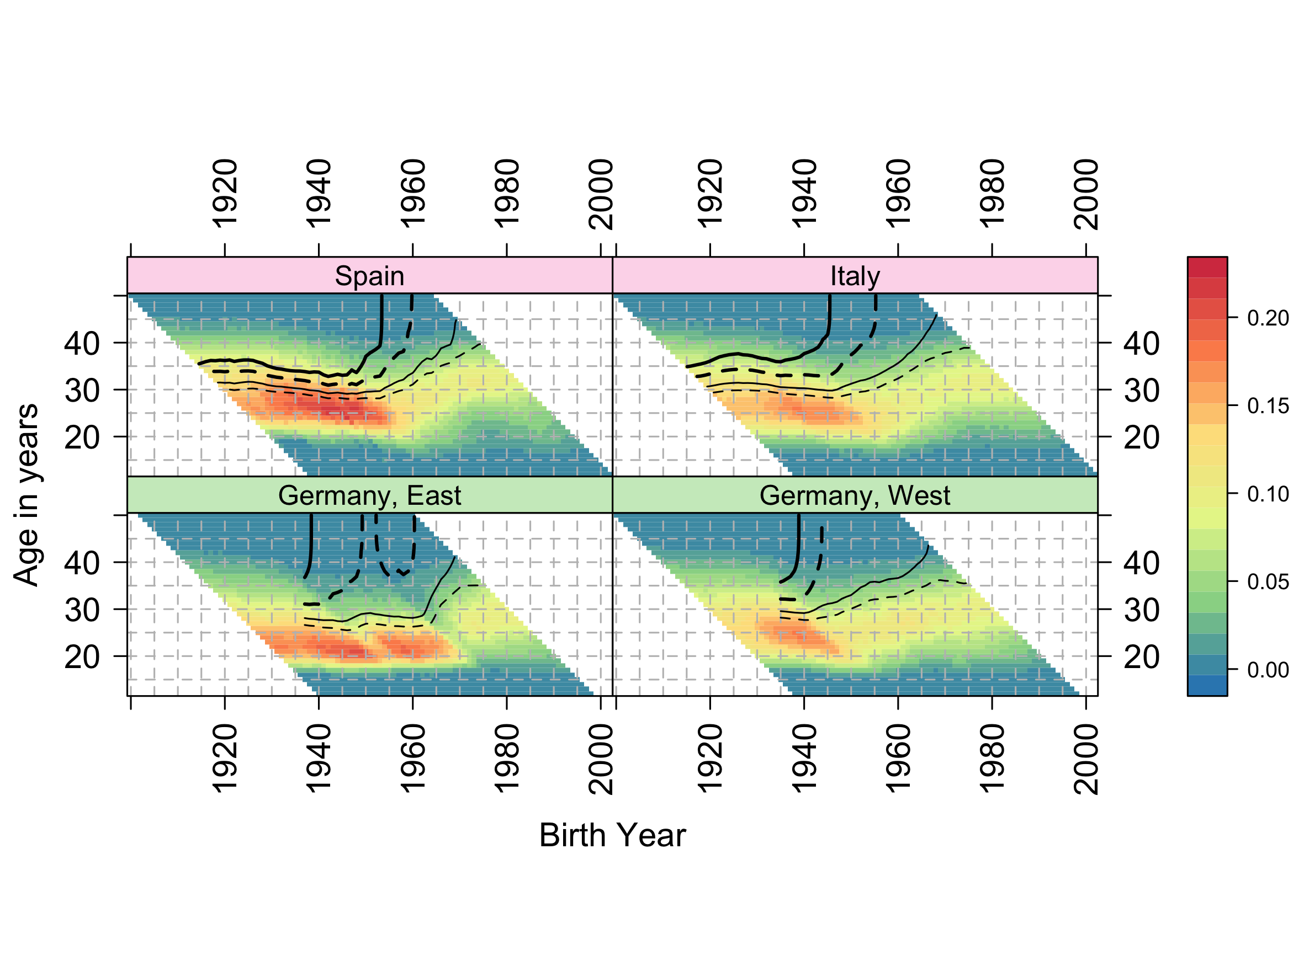

Notes: The shaded scale bar on the right indicates age-specific fertility rates (ASFRs); thick solid contour lines indicate cumulative cohort fertility rate (CCFR)=2.05 (replacement fertility); thick dashed contour lines indicate CCFR=1.80; thin solid contour lines indicate CCFR=1.50; thin dashed contour lines indicate CCFR=1.30.

Source: Human Fertility Database (HFD) and Human Fertility Collection (HFC), own calculations.

Figure 2 Composite Fertility Lattice Plots for Norway and non-European English-speaking countries

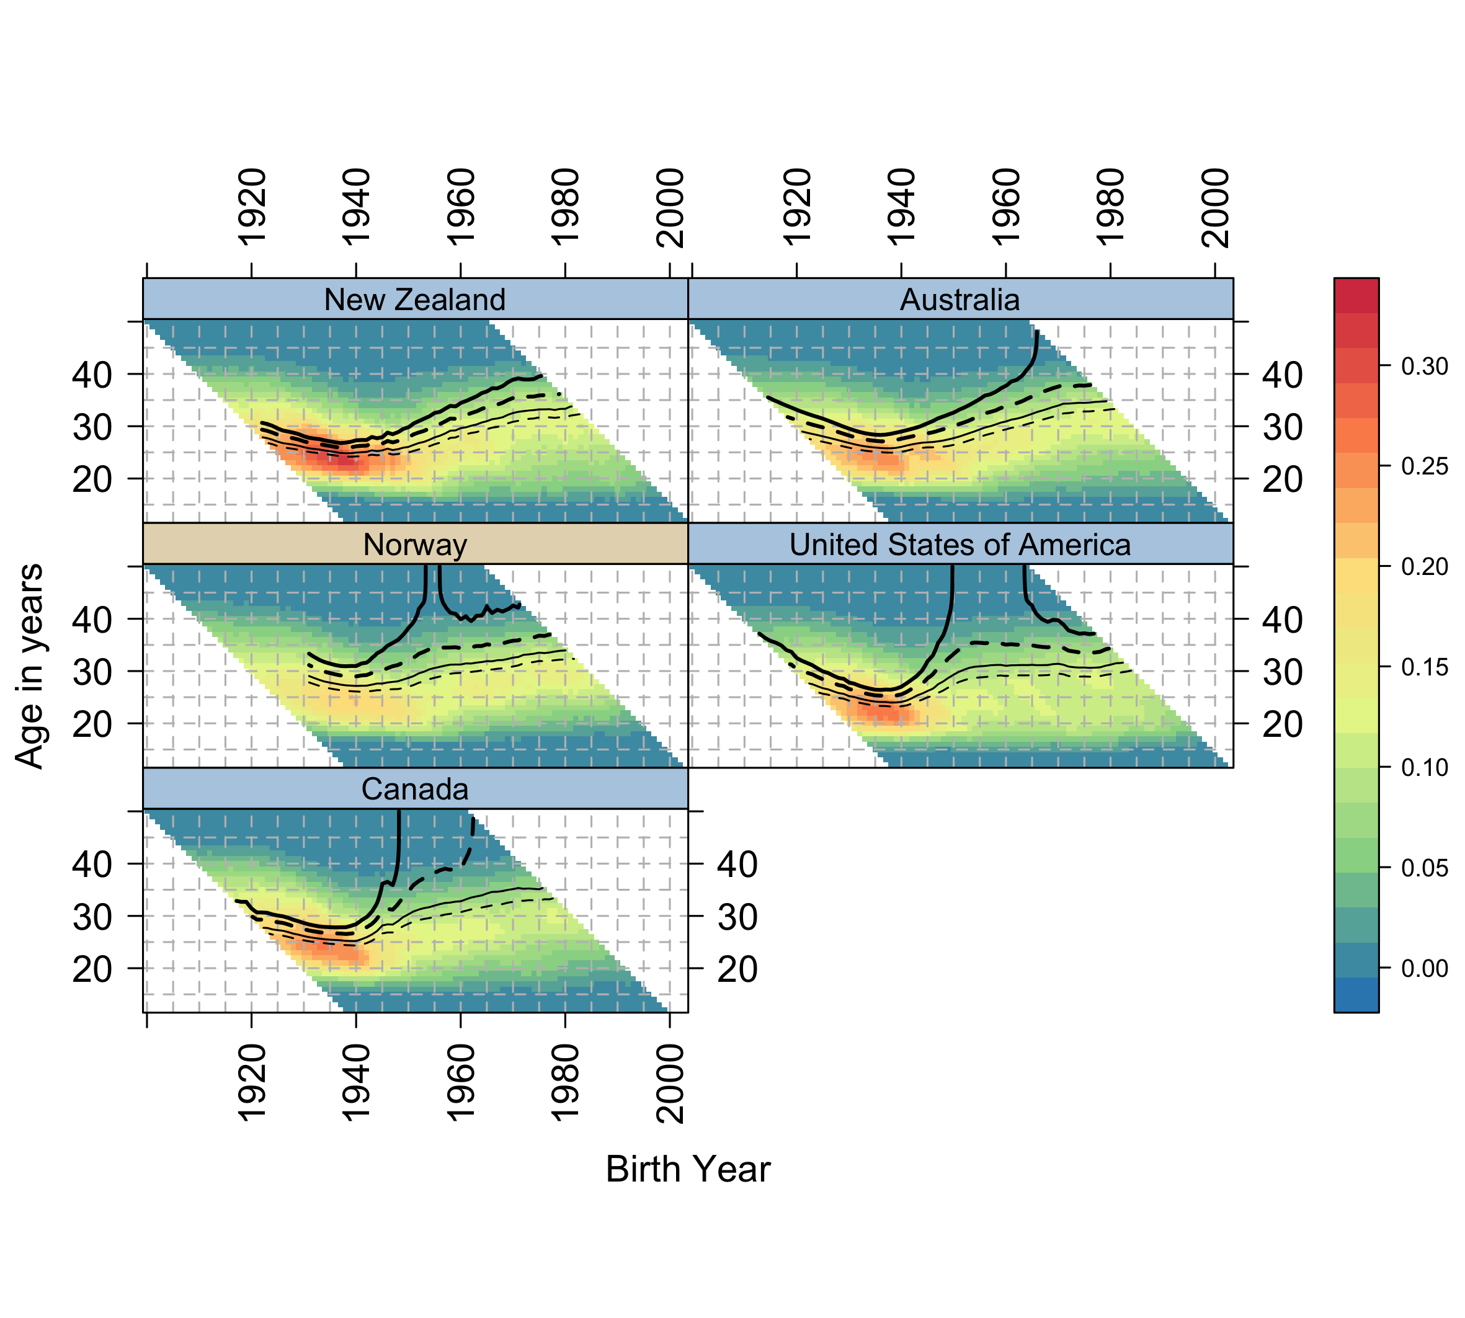

Notes: The shaded scale bar on the right indicates age-specific fertility rates (ASFRs); thick solid contour lines indicate cumulative cohort fertility rate (CCFR)=2.05 (replacement fertility); thick dashed contour lines indicate CCFR=1.80; thin solid contour lines indicate CCFR=1.50; thin dashed contour lines indicate CCFR=1.30.

Source: Human Fertility Database (HFD) and Human Fertility Collection (HFC), own calculations.

Figure 3 Composite Fertility Lattice Plots for Taiwan, Republic of Korea, and Japan

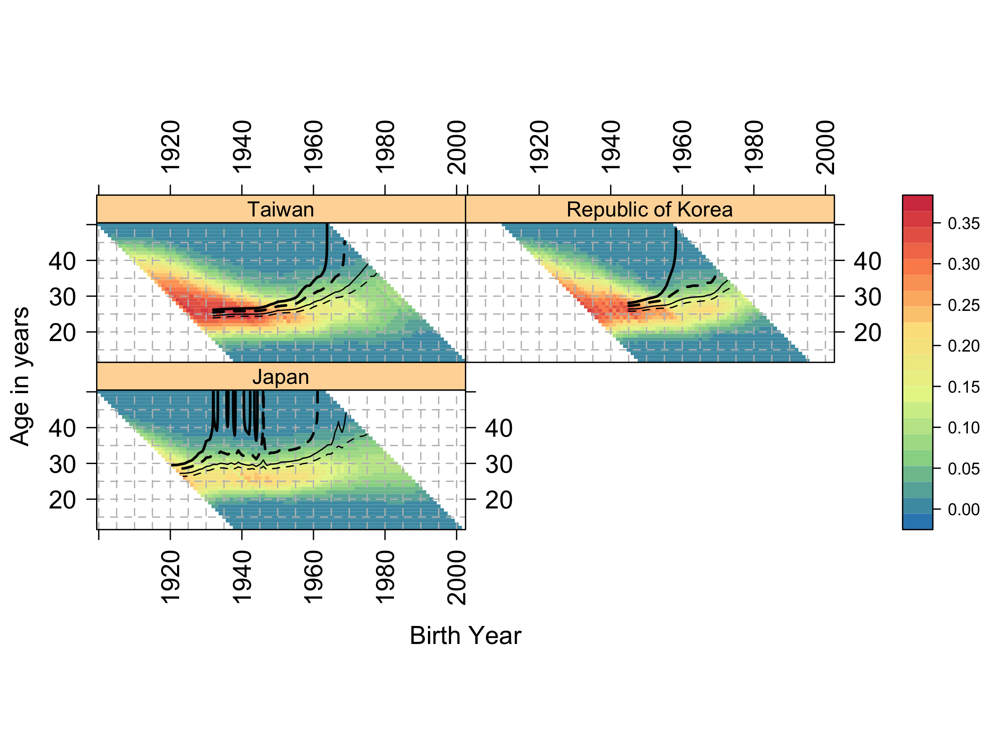

Notes: The shaded scale bar on the right indicates age-specific fertility rates (ASFRs); thick solid contour lines indicate cumulative cohort fertility rate (CCFR)=2.05 (replacement fertility); thick dashed contour lines indicate CCFR=1.80; thin solid contour lines indicate CCFR=1.50; thin dashed contour lines indicate CCFR=1.30.

Source: Human Fertility Database (HFD) and Human Fertility Collection (HFC), own calculations.

Figure 4 Composite Fertility Lattice Plot for 45 countries

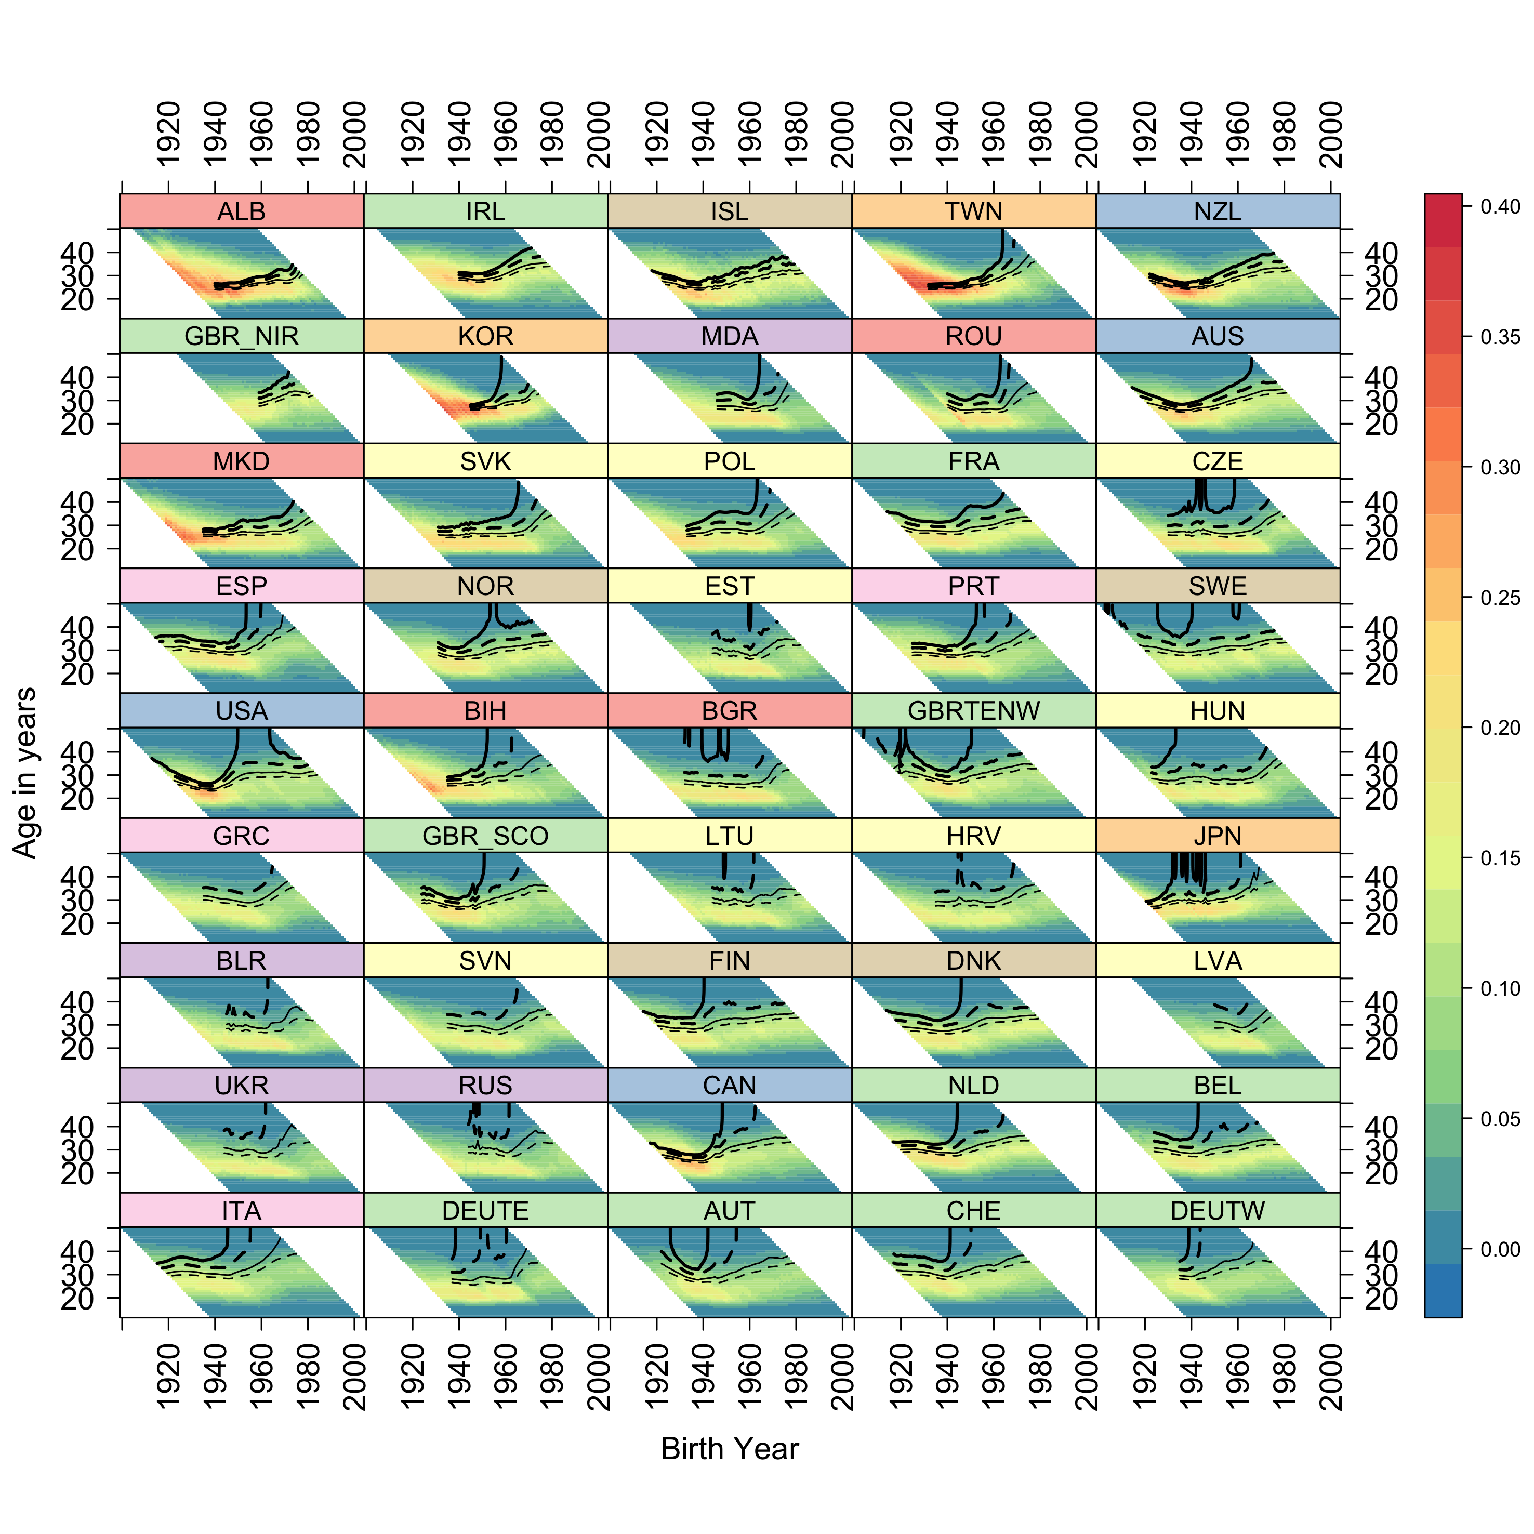

Notes: (a) The shaded scale bar on the right indicates age-specific fertility rates (ASFRs). (b) Thick solid contour lines indicate cumulative cohort fertility rate (CCFR)=2.05 (replacement fertility); thick dashed contour lines indicate CCFR=1.80; thin solid contour lines indicate CCFR=1.50; thin dashed contour lines indicate CCFR=1.30. (c) Countries are ranked in descending order by CCFR in 2007 (last common year of observation). (d) Countries are grouped in geographic macro-regions as follows: (1) South-Eastern Europe: Albania (ALB), Romania (ROU), Macedonia (MKD), Bosnia and Herzegovina (BIH), Bulgaria (BGR); (2) Western Europe: Ireland (IRL), UK-Northern Ireland (GBR_NIR), France (FRA), UK-England and Wales (GBRTENW), UK-Scotland (GBR_SCO), Netherlands (NLD), Belgium (BEL) and German-speaking countries: East Germany (DEUTE), Austria (AUT), Switzerland (CHE), West Germany (DEUTW); (3) Northern Europe: Iceland (ISL), Norway (NOR), Sweden (SWE), Finland (FIN), Denmark (DNK); (4) East and South-East Asian countries: Taiwan (TWN), Republic of Kora (KOR), Japan (JPN); (5) Non-European English-speaking countries: New Zealand (NZL), Australia (AUS), United States of America (USA), Canada (CAN); (6) Eastern Europe: Moldova (MDA), Belarus (BLR), Ukraine (UKR), Russia (RUS); (7) Central Europe: Slovakia (SVK), Poland (POL), Czech Republic (CZE), Estonia (EST), Hungary (HUN); Lithuania (LTU), Croatia (HRV), Slovenia (SVN), Latvia (LVA); (8) Southern Europe: Spain (ESP), Portugal (PRT), Greece (GRC), Italy (ITA).

Source: Human Fertility Database (HFD) and Human Fertility Collection (HFC), own calculations.