# Aim

The aim of this paper is to present and describe the processes involved in producing a lattice plot which shows both age-specific fertility rates (ASFRs) available by year, and implied cumulative cohort fertility rates (CCFRs) for dozens of countries whose data is available either within the HFD or HFC. The end result is a lattice of Lexis surface visualisations, arranged by cohort on the horizontal axis and age on the vertical axis. Within this visualisation the ASFRs are represented graphically by cell shade, CCFRs by a series of easily distinguishable contour lines, and the strips which label each of the small multiples within the visualisation are coloured according to geographic region.

We suggest that the full visualisation produced is best viewed by being printed out in colour as an A3 or A2 poster, which we have found to greatly facilitate at-a-glance comparison between countries; to this end we make a high resolution version of the final visualisation available online, along with the R code used to produce this final visualisation and additional figures for individual countries. Within this paper we present this final visualisation, as well as smaller visualisations comprising a small subset of countries to illustrate the value of this approach for both within-country and cross-country comparison of fertility trends.

# Methods

## Data

To provide broad geographic and temporal coverage, data from the Human Fertility Database (HFD) and Human Fertility Collection (HFC) were combined.1,2 The Human Fertility Database (HFD) includes age-specific fertility rates (ASFRs) for 28 countries over a range of periods, and is entirely based on official vital statistics from each country; data from each country are rigorously checked and standardised according to a detailed methods protocol. In addition to overall ASFRs birth-order specific fertility rates are also included in the HFD, alongside summary statistics such as crude birth rates, mean age at birth, and total fertility rates;2 however for the present visualisations only overall ASFRs are used. The HFC is a complementary database to the HFD, created by the same institutions, which aims to supplement the high-quality, official vital statistics contained in the HFD with data from additional sources whose data quality may not be of the same standard.3 Data disaggregated by age in single year was used from both the HFD and HFC, and Lexis squares (one year by one year) rather Lexis triangles or Lexis parallelograms were used. In addition to the 28 countries from the HFD, data from 48 countries were used, but not all were included in the final lattice visualisation because of limited periods of observation.

Data from the HFD and HFC are overlapping for some years and countries. Where more than one country- and year-specific ASFR was available, the value from the HFD was used in first preference; otherwise, records from the HFC were used in the following order of preference according to the ‘collection’ field of the HFC dataset: 1) STAT (Official Statistical Data); 2) ODE (Data from the European Demographic Observatory, L’Observatoire Démographique Européen); 3) RE (Research estimates). For almost all countries, this approach produced a dataset comprising ASFRs for many contiguous years. The only exceptions to this contiguity were Bosnia and Hertzegovina (BIH), where records were missing for the years 1991 to 1995 inclusive, and Belarus (BLR), where records for 2013 were missing. In both of these cases ASFRs for the missing year were imputed through simple interpolation of ASFRs from the last and next observed years (1990 and 1996 for BIH; 2012 and 2014 for BLR).

## Lexis surface mappings

For each country, ASFRs were arranged onto a Lexis surface with birth cohort year on the horizontal axis and age in years on the vertical axis; as mentioned previously Lexis squares rather than triangles or parallelograms were used throughout, so these are not true cohort estimates, but are sufficient to illustrate the principles of the visualisation, and the R code is freely available for researchers to iterate the approach further. ASFRs for each country and year were mapped to colours and shades using the Spectral colour palate from the RColorBrewer R package. [REF] The R packages Lattice and LatticeExtra were used to produce the visualisations.

For birth cohorts where ASFRs were available from age 15 years, CCFRs were produced for each age and cohort year. If refers to the ASFR for country , in year , and at age , then the CCFR for age can be defined as , where is the simple index of birth cohort (. Within the Lexis surfaces, contour lines were added at positions across the cohort-age surface where reached specific values. More specifically, a thin dashed contour indicates of 1.30 babies per woman, a thin solid contour indicates of 1.50, a thick dashed contour indicates of 1.80, and a thick solid contour indicates a replacement fertility level of 2.05. Because is a cumulative quantity, the contour lines will always have the same monotonic ordering - thin dashed, thin solid, thick dashed then thick solid - from bottom to top. The position, presence or absence, and trajectories of these contour lines across different birth cohorts, and between countries, are all useful indicators of how fertility trends have changed over time and place, and how far short of replacement fertility levels most affluent world nations fall. All countries are arranged in order of highest CCFR in 2007, the last common year of observation for all populations being compared.

# Results

This section will first provide the visualisation for two or more countries at a time, in order to both introduce the visualisation and illustrate its utility for both cross-cohort and cross-country comparisons. The complete visualisation will then be presented as the final figure, though as discussed previously we recommend this last visualisation be downloaded and printed in colour as a large landscape poster.

## Low Fertility European Countries: East Germany, West Germany, and Italy

Figure 1 shows the CFP for Spain, Italy and Germany, separated into East and West. Each of these countries currently have fairly low fertility levels, and by looking at both the colour of the cells and the trajectories of the contours we can learn more about other similarities and differences between these countries. Firstly, if we look at the trajectory of the thick solid contour line we can identify the last birth cohorts that reached replacement fertility levels; this is around 1938-9 for Germany, 1945 for Italy, and 1954 for Spain. The thick dashed lines, indicating 1.80 babies/woman, are more dissimilar within Germany, and were first not achieved in West Germany for the 1944 birth cohort, and for East Germany, for the 1949 cohort; in East Germany this fertility level was then re-established briefly, for cohorts born around 1952-1960, before being lost again; this fertility level was last for Italian cohorts born in 1955, and Spanish cohorts born in 1960. The thin solid line, 1.50 babies/woman, looks like it may last be achieved for cohorts born between 1970-75 in all four countries; and in all four populations it appears levels of 1.30 will continue to be met for future cohorts, though by around the age of 35 years in East/West Germany, and by age 40 in Spain and Italy; Spain and Italy therefore appear at greater risk of future cohorts not reaching even the 1.30 level, and so for total fertility in these countries to fall below those in Germany. In all four populations a shift from younger to higher ages of peak fertility is observed by noting that cell colours between around age 20 and 25 years change from yellow to green over time.

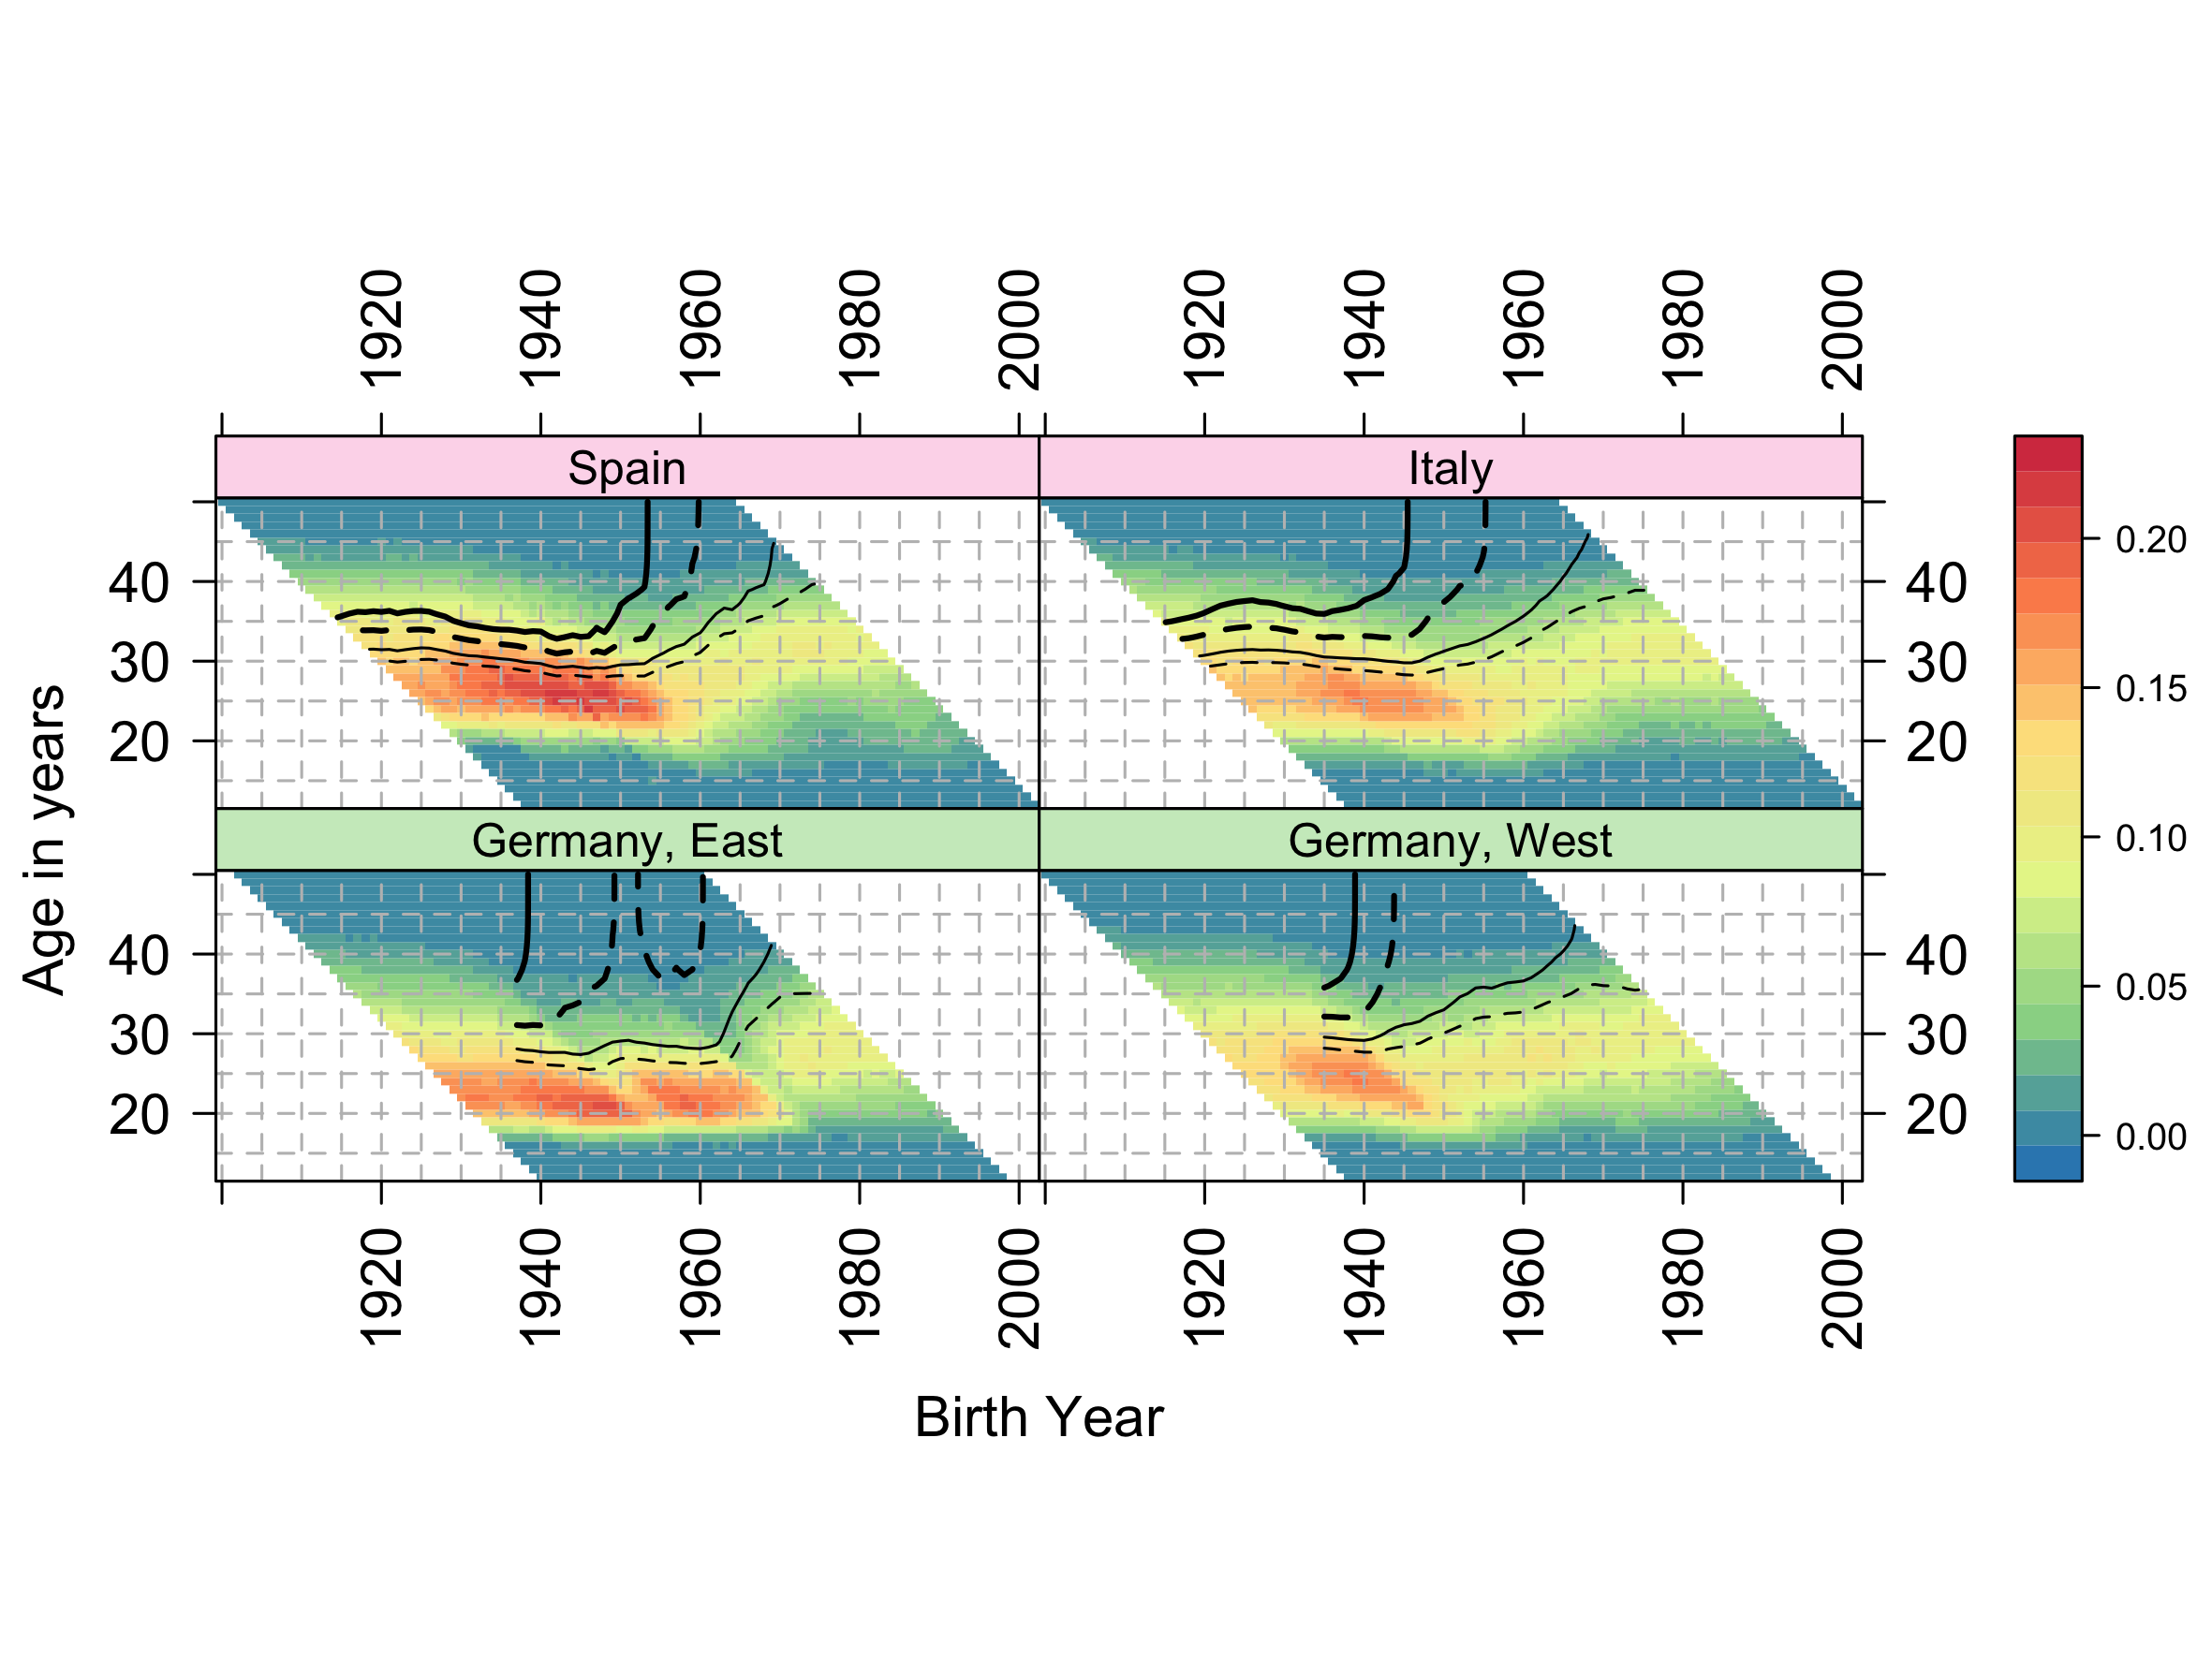

Figure 1 Composite Fertility Plot for Spain, Italy and Germany

## Anglophone Countries and Norway

Figure 2 compares fertility trends in two pairs of Anglphone countries - New Zealand and Australia; and the USA and Canada – with Norway. Each of these countries have relatively high fertility for affluent world nations. Compared with Australia, New Zealand has somewhat higher fertility with total fertility cohort fertility levels (thick solid contour) being achieved by age 40 years in the 1975 cohort, and with this contour appearing to level off at around this age; this is in contrast to Australia, where replacement levels were last met for the 1966 cohort.

Norway and the USA, though different in many ways, are similar in their fertility trends, in that they are the only populations within the dataset where replacement fertility (RF) levels by cohort were ‘recovered’ by latter cohorts after being ‘lost’ by earlier cohorts; this can be seen by noting the parallel pairs of thick black vertical contour lines in both countries. In Norway, replacement fertility was first ‘lost’ after around the 1953 cohort then ‘recovered’ after the 1956 cohort; and in the USA RF was ‘lost’ by the 1950 cohort then ‘recovered’ after the 1964 cohort. Within Norway RF levels look set to disappear with latter cohorts, as the RF line hovers around age 43 in the latest period, whereas in the USA it appears to have stabilised around age 36. Of these populations, Canada has the lowest fertility, and appears to have stabilised at levels between 1.50 and 1.80 babies/woman.

Looking at the colour and shading of cells, the USA is distinct amongst affluent world nations in having a wider range of ages of high fertility, with less evidence of fertility postponement within the population overall than in most other comparable nations.

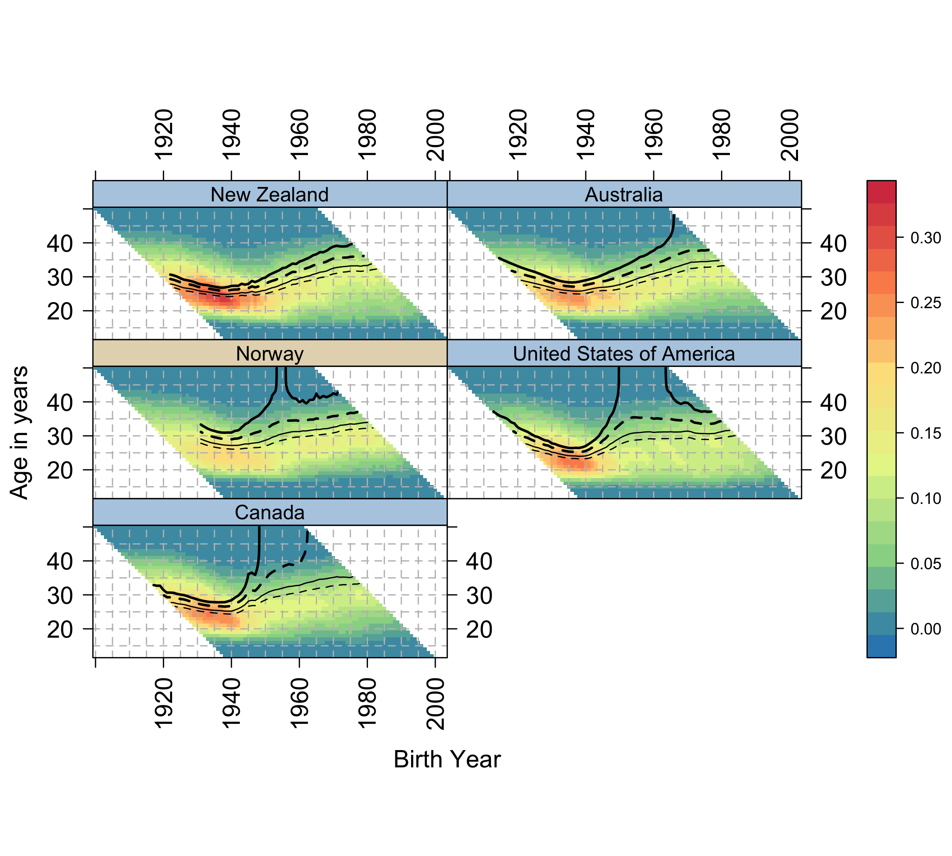

Figure 2 Composite Fertility Plots for Anglophone Countries and Norway