# Exploring age-specific and cumulative cohort rates using composite fertility lattice plots: an international comparison of Human Fertility Database and Human Fertility Collection data

# Abstract

## BACKGROUND

The Human Fertility Database (HFD) and Human Fertility Collection (HFC) provide disaggregated data on age-specific fertility rates for 45 countries. These sources offer the opportunity to learn about the development of different pathways of transition to low fertility both within and between countries.

## OBJECTIVE

The aim of this paper is to use composite fertility lattice plots, which combine information from different visualization techniques of the Lexis surface, namely level plots and contour plots, to explore changes in age-specific fertility rates and derived cumulative cohort fertility rates across countries and geographic regions.

## METHODS

Through key examples we introduce a new refinement of the Lexis surface, combining level plots which use colour/shade to indicate age-specific fertility rates, and contour lines to indicate cumulative cohort fertility milestones.

## RESULTS

Results show that once countries have fallen below a replacement fertility level they tend to not return to it. Exceptions are Norway and the USA, which saw rising fertility rates for cohorts born after 1950s and late 1960s, respectively. The age-specific fertility trends, as well as broader political and socioeconomic conditions are very different in these countries, suggesting different paths by which replacement fertility rates can be achieved.

## CONTRIBUTION

Complex data visualizations show, in an intuitive way, how age-specific fertility rates are related to cumulative cohort fertility rates. Combining this information enables us to explore differences between countries and can make an important contribution to comparative fertility research.

# Introduction

Data visualization techniques such as Lexis surfaces have become an increasingly popular tool to investigate trends in fertility and other population characteristics in recent years (Burkimsher 2017; Campbell and Robards 2014; Schöley and Willekens 2017; Rau et al. 2018; Vaupel, Gambill, and Yashin 1987). They provide convenient visual arrangements of birth rates and related indicators, by calendar time, age, and/or cohort, and are thus an effective tool for both the exploration and the identification of dynamic patterns and relationships arising from fertility data.

The transition to low fertility, below replacement levels, is a cornerstone of both demographic transitions (Davis 1945; Lesthaeghe 1995, 2010; Lesthaeghe and van de Kaa 1986; Notestein 1945), and one of the key drivers underpinning population change. Low fertility transitions correlate with life expectancy gains (Oeppen and Vaupel 2002; Shkolnikov et al. 2011) and increased international migration (Adserà and Ferrer 2014; Sobotka 2008).

A crucial question is whether fertility rates will fall and stabilize at below replacement levels for all developed countries. With reversals in period fertility trends for some European countries (e.g. Goldstein, Sobotka, and Jasilioniene 2009; Myrskylä, Goldstein, and Cheng 2013), the persistence of low fertility is increasingly debated. Recent analyses emphasise increasing instability and divergence between populations, characterising distinct fertility transition pathways (Billari 2018; Sobotka 2017). Key drivers include: the diffusion of modern contraceptive methods; the expansion of higher education; the increase in economic uncertainty; the large-scale entry of women into the labour force and gender role changes (for reviews see e.g. Balbo, Billari, and Mills (2013) and Basten, Sobotka, and Zeman (2014)).

The aim of this paper is to show how differences in fertility trends and pathways can be identified using composite fertility lattice plots (CFLPs), a variant of the Lexis surface visualization in which both the colour/shade, and contours, represent different but related variables: age-specific fertility rates and cumulative cohort fertility rates, respectively.

This novel combination offers a more efficient comparison of multiple pieces of information that provide insights into how the fertility transition varies across countries and geographic regions. Our approach provides a useful tool to analyse different interrelated aspects of fertility decline, giving hints into its causes and long-term sustainability.

To illustrate the benefits of this approach we offer step-by-step descriptions of the process involved in producing a composite fertility lattice plot through key examples. We provide a comparison of West and East Germany, followed by a comparison of Norway and the USA. In these examples we provide practical suggestions on how to interpret and decode the information contained in CFLPs, before concluding with a plot comparing 45 countries. Within this paper the final figure is split into three subfigures, but we also include a version of it as a single figure, which we suggest is best printed out as a large-scale (e.g. A2-sized) colour poster. We also include the R code used to produce them, additional figures for selected clusters of countries by geographical region[1] and an interactive online app[2] which can be used to explore additional features of the data.

# Methods

## 2.1 Data

Data from the Human Fertility Database (HFD) and Human Fertility Collection (HFC) were combined (Max Planck Institute for Demographic Research (Germany) and Vienna Institute of Demography (Austria) 2015, 2016). The HFD includes age-specific fertility rates (ASFRs) for 28 countries over different periods, drawn from national official vital statistics. The HFC supplements the HFD, providing data for sufficient observation periods from additional sources (Grigorieva et al. 2015) to add a further 17 countries. Where data is overlapping the value from the HFD was used first; otherwise, records from the HFC were used in the following order of preference according to the ‘collection’ field of the HFC dataset: 1) STAT (Official Statistical Data); 2) ODE (Data from the European Demographic Observatory, L’Observatoire Démographique Européen); 3) RE (Research estimates). For most countries, this approach produced a dataset comprising ASFRs for contiguous years; linear interpolations of ASFRs were used for the few countries and years where this was not the case. The code for both combining data across sources and interpolating values is available in the online appendix.

Data disaggregated by age in single year were used from both the HFD and HFC, and Lexis squares (one year by one year) rather than Lexis triangles or Lexis parallelograms were used, as in practice the use of squares only has limited effect on precision of cohort estimates (Caselli and Vallin 2005).

## 2.2 Lexis surface mappings

For each country, ASFRs were arranged onto Lexis surfaces with birth year on the horizontal axis and age in years on the vertical axis. As Lexis squares rather than triangles or parallelograms were used, these are not true cohort estimates, but are sufficient to illustrate the visualization principles (the R code is available to iterate the approach further). ASFRs for each country and year were mapped to colours and shades using a modified version of the Paired colour palette from the RColorBrewer R package (Neuwirth 2014), which is deemed to be accessible to readers with the most common forms of colour vision deficiency (CVD) . The R packages Lattice and LatticeExtra were used to produce the visualizations (Sarkar 2008).

For cohorts where ASFRs were available from age 15 years, Cumulative Cohort Fertility Rates (CCFRs) were produced for each age and cohort year. If refers to the ASFR in year , at age and for country , then the CCFR for age can be defined as , where is the simple index of cohort (. Within the Lexis surfaces, contours were added across the cohort-age surface where reached specific values. A thin solid contour indicates of 1.50 children/woman and a thick solid contour indicates of 2.05 (replacement fertility level). These values were selected for their relevance in the comparative cohort fertility literature (e.g.: Myrskylä, Goldstein, and Cheng 2013; Zeman et al. 2018). However, it is important to emphasize that a wider range of monotonically-ordered cumulative values can be identified and analysed; the interactive app allows different numbers and values of threshold values to be selected.Results

## 3.1 Unpacking composite fertility lattice plots: the case of West and East Germany

Figure 1a provides an illustration of how the cumulative cohort fertility contours are constructed from the age-specific fertility schedules for any specific cohort. West German cohorts born in 1935 and 1938 are used in the example. For both cohorts, cumulative fertility schedules are constructed indicating the ages at which different levels of cumulative fertility are reached. Two vertical ‘milestones’ are placed at 1.5 (thin solid line) and 2.05 (‘replacement’; thick solid line) children per woman. As the figure shows, the contours for any given cohort are the ages at which that cohort’s cumulative fertility schedule intersects with the corresponding fertility milestone. In the example used, there is little difference between cohorts in the ages at which the 1.5 children per woman milestone is reached, but the replacement fertility contour has moved upwards by around five years between the 1935 and 1938 cohorts.

Figure 1a: Illustration of construction of cumulative cohort fertility contours

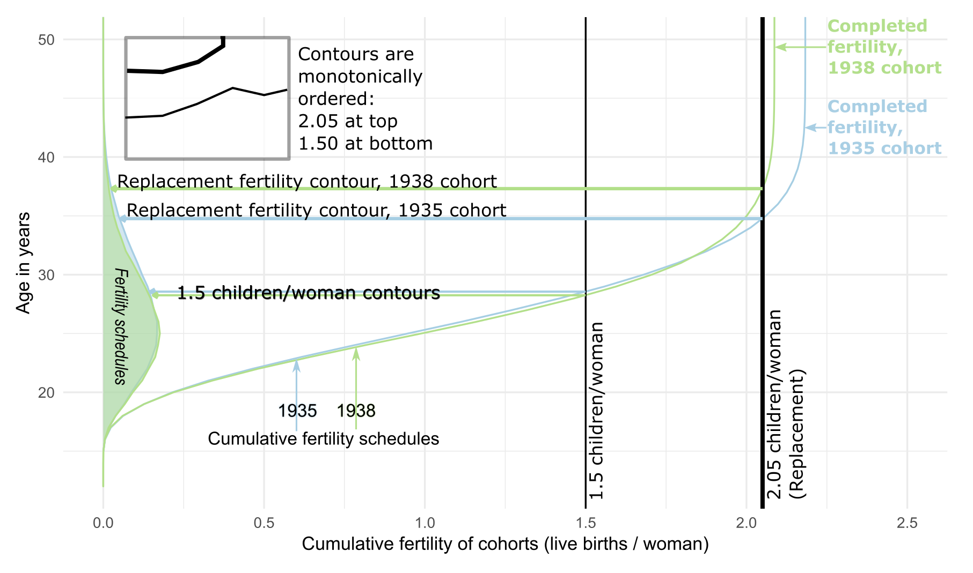

*Note*: Illustration of how the cumulative cohort fertility contours are constructed, using fertility schedules from West Germany for cohorts born in 1935 and 1938.

*Source*: Human Fertility Database (HFD) and Human Fertility Collection (HFC), own calculations.

By looking at the furthest right of the cumulative schedule, we can see that each schedule becomes vertical after a particular age: for later cohorts, this tends to be around the age of 44, and for earlier cohorts, a slightly earlier age. This is the maximum cumulative fertility reached by each cohort, and we can see that this has shifted to the left (become lower) for the 1938 cohort compared with the 1935 cohort. Although the age-specific fertility schedules (on the left of the figure) look similar for both cohorts, the effect of the slight differences in terms of the position of the replacement fertility contour is thus sizeable.

This case study highlights two important features for interpreting the contours: firstly, and as shown in Figure 1b (mid subpanel), the ordering of the two contours will always be consistent: the thin solid 1.5 line will always be lower than and will not intersect with the thick solid 2.05 replacement line. Secondly, we can see how, as the total cumulative fertility of a cohort falls below any of the two fertility milestones, the corresponding contour will swiftly become vertical. In the case of West Germany, the total cumulative fertility first falls below replacement for the 1939 cohort, and has never exceeded this level since.

Figure 1b continues the focus on West Germany, by showing the two components of the composite plot separately, and emphasizing some key features arising from the data. The top subpanel shows the level plot component of the composite plot, in which different age-specific fertility rates are mapped onto different colours, as per the key shown at the top of the figure. The colour of the tile containing the name of the country indicates the region in which the country is grouped (for details see online appendix). Annotation features have been added to highlight substantive patterns in the data. These include the fall in fertility rates at all ages seen in the late 1960s, as more effective contraceptive methods became available. (As each vertical section through the figure is a cohort, a period effect will appear as a diagonal band moving bottom right to top left.) After the 1960s, the age of peak fertility increased, whereas the level of fertility at the peak fertility age tended to fall.

The mid subpanel shows the contours for different cumulative fertility milestones only. A vertical dotted orange line on the left of the figure shows the first cohort for which the contours were shown; earlier cohorts have incomplete age-specific fertility data at some younger ages, and so the cumulative fertility schedules for such cohorts would be incomplete, and misleading if plotted.

Figure 1b: Production of composite fertility lattice plot for West Germany

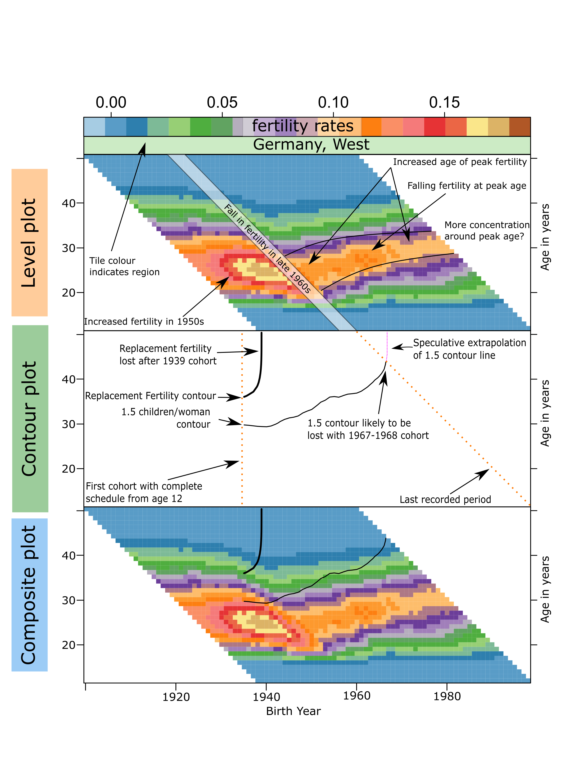

*Source*: Human Fertility Database (HFD) and Human Fertility Collection (HFC), own calculations.

The diagonal dotted orange line shows the last period for which data are available, and so the highest ages at which cumulative cohort fertility schedules can be calculated for more recent cohorts.

Starting with the 2.05 contour, we can see that this line quickly becomes vertical for the 1939 cohort; this was the last cohort which reached replacement fertility levels. The 1.5 children per woman contour is observed to move upwards and is likely to be lost for cohorts born after around 1967-68. Though we cannot know with certainty, we can make some reasonable informal extrapolations of the contours for more recent cohorts by assuming the following: firstly, that so long as the contours are within ages ranging up to around 43 years, they can probably be assumed to continue linearly; secondly, if the contours trend upwards towards older ages (around 44 years and older), the total cumulative fertility of later cohorts is likely to become less than the level indicated by the contour, and so the contour is likely to move vertically upwards (i.e. the speculative extrapolation trend shown by the purple dashed line). The bottom subfigure shows the composite plot which brings together both level plot and contour elements.

Figure 1c shows the composite plots for both West and East Germany, using a common colour palette for the colour tiles. As many features regarding West Germany have been previously discussed, the focus is now on the corresponding features for East Germany, relating both to the level and contour plot aspects of the composite plot visualization.

Unlike West Germany and the majority of European and other developed countries, East Germany experienced two period effects, rather than just one. Though, like most European nations, there was a sharp fall in fertility in the late 1960s, there was then a recovery in age-specific rates for most of the 1970s and 1980s. However, in the late 1980s, with the collapse of the Berlin Wall, fertility rates fell rapidly again, with fertility rates at many ages falling below corresponding rates in West Germany. Afterwards, there was a rapid convergence of East German fertility schedules to those seen in West Germany, with a rapid rise in the age of peak fertility.

Figure 1c: Comparison of West and East Germany

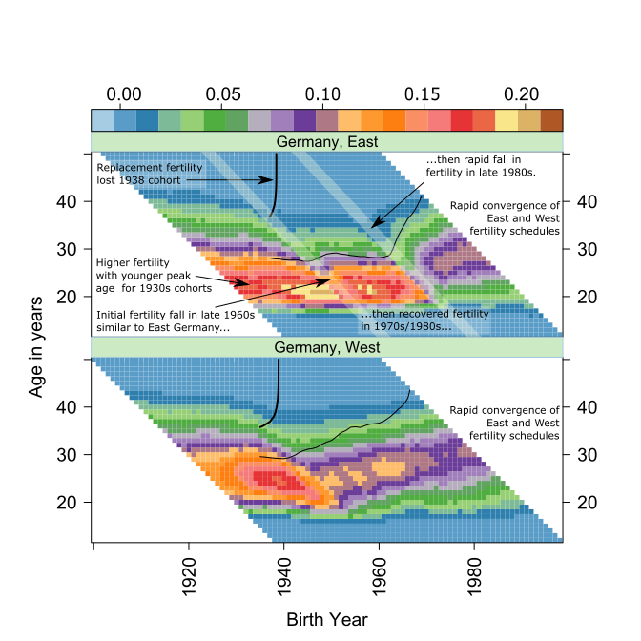*Source*: Human Fertility Database (HFD) and Human Fertility Collection (HFC), own calculations.

By looking at the contours, we can see the effects that these changes in age-specific fertility had on completed cohort fertility rates. Replacement fertility rates were last reached for almost the same cohort for both East Germany (1938) and West Germany (1939). In contrast to West Germany, in East Germany for cohorts who were of childbearing age in the 1970s and 1980s, cumulative fertility levels of 1.5 were reached before the age of 30. However, after the late 1980s, the 1.5 fertility milestone was reached by cohorts at ever older ages, and in the last observed period after the age of 40 years. Because of this, it appears likely that East Germany will not sustain fertility rates above 1.5 children per woman in later years.

## 3.2 Comparing Norway and the USA

Figure 2 compares the fertility patterns for Norway with those in the USA. When these and other developed countries are compared across a range of internationally comparable measures, they tend to sit at opposite ends of the distribution (Esping-Andersen 1999; Esping‐Andersen and Billari 2015). However, the contours in the composite plots show that they have in common a feature shared with almost no other country covered by this study: Norway and the USA both ‘regained’ replacement cohort fertility levels after first losing them for several successive cohorts. We can see this visually by noting the arcing of the thick black contours: for both countries these arc vertically upwards for cohorts born in the early 1950s, then arc vertically downwards from some cohort onwards, then remain plotted for later cohorts. Norway ‘regained’ replacement fertility levels after having lost these levels for three cohorts (1953-1956). The USA ‘regained’ replacement fertility levels after a much longer period: cohorts born between 1950 and 1962 did not reach replacement fertility, but cohorts from 1963 onwards did.

Figure 2: Comparison of Norway and the USA

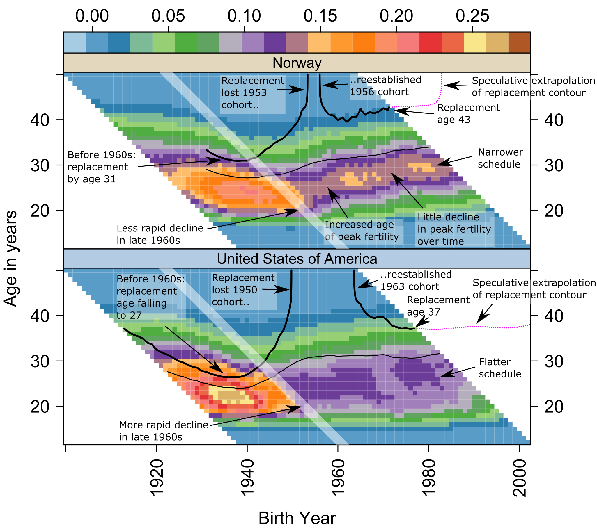

*Source*: Human Fertility Database (HFD) and Human Fertility Collection (HFC), own calculations.

Although Norway and the USA both re-established replacement fertility levels, whereas almost all other countries have not, more careful exploration of the composite plots shows that they did so in different ways. Firstly, if we compare the late 1960s period effects (lighter diagonal band) for both countries, the fall in fertility appears to be larger for the USA and more gradual in Norway. Secondly, if we compare the changing age schedules after the late 1960s, we can see that in Norway (as in West Germany), the age of peak fertility has moved upwards, from around 25 to 30 years of age. Unlike in West Germany, there was not a pronounced fall in peak birth rates along with the increase in the age of peak birth rate; it has remained at or close to 0.15. In the USA, the post-1960s fertility schedules have not so much *shifted* as *spread*, producing a flatter age schedule than in Norway: there is a comparatively wide range of ages, from around 20 to 30 years of age, at which women in the USA have *moderate* birth rates (around 0.10-0.12 children per woman per year). In Norway, the peak birth rates have tended to be higher (around 0.14-0.15), but the drop off in birth rates the further a woman’s age moves from this peak age is greater. So, replacement fertility levels were reached in Norway through high fertility at a narrow range of ages, and in the USA by moderate fertility at a broader range of ages.

If we consider the trajectories of the replacement contours for the USA and Norway after they were re-established, we can see that the line has been trending upwards for Norway, but falling for the USA. By the end of the series, the age of replacement fertility was around 43 in Norway, but 37 in the USA; if we apply the rule of thumb that cumulative fertility of a cohort by age 43 is likely to be close to that cohort’s total completed fertility, we can assume that Norway looks likely to lose replacement fertility levels over the next few years. By contrast, we might assume that replacement levels will be sustained for longer in the USA.

## 3.3 All countries

Figure 3 shows the composite fertility lattice plots for 45 countries, representing a visual summary of hundreds of thousands of separate ASFRs. Country labels are coloured according to their geographic region. A higher-resolution version of the figure, including subfigures and related annotations for smaller clusters of countries by geographic region are included in the online appendix.

Figure 3: Composite Fertility Lattice Plot for 45 countries by geographic region

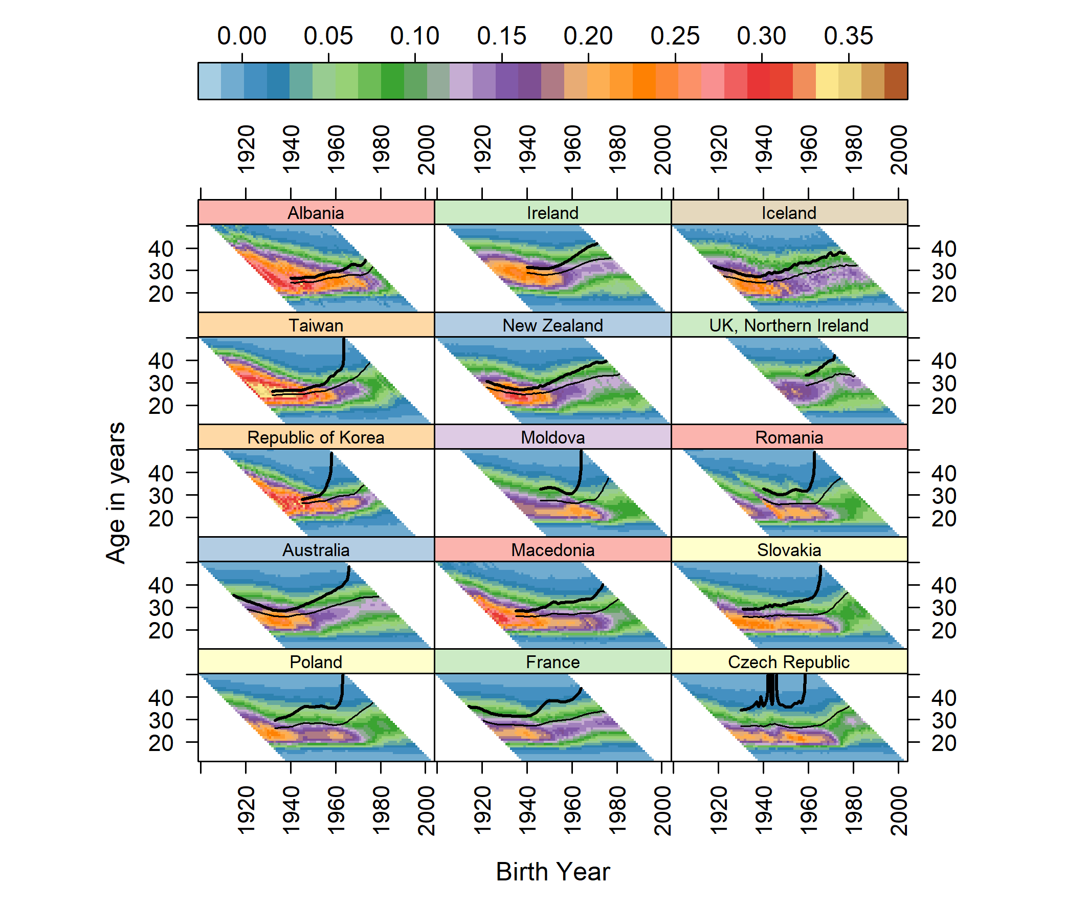

Figure 3: (Continued)

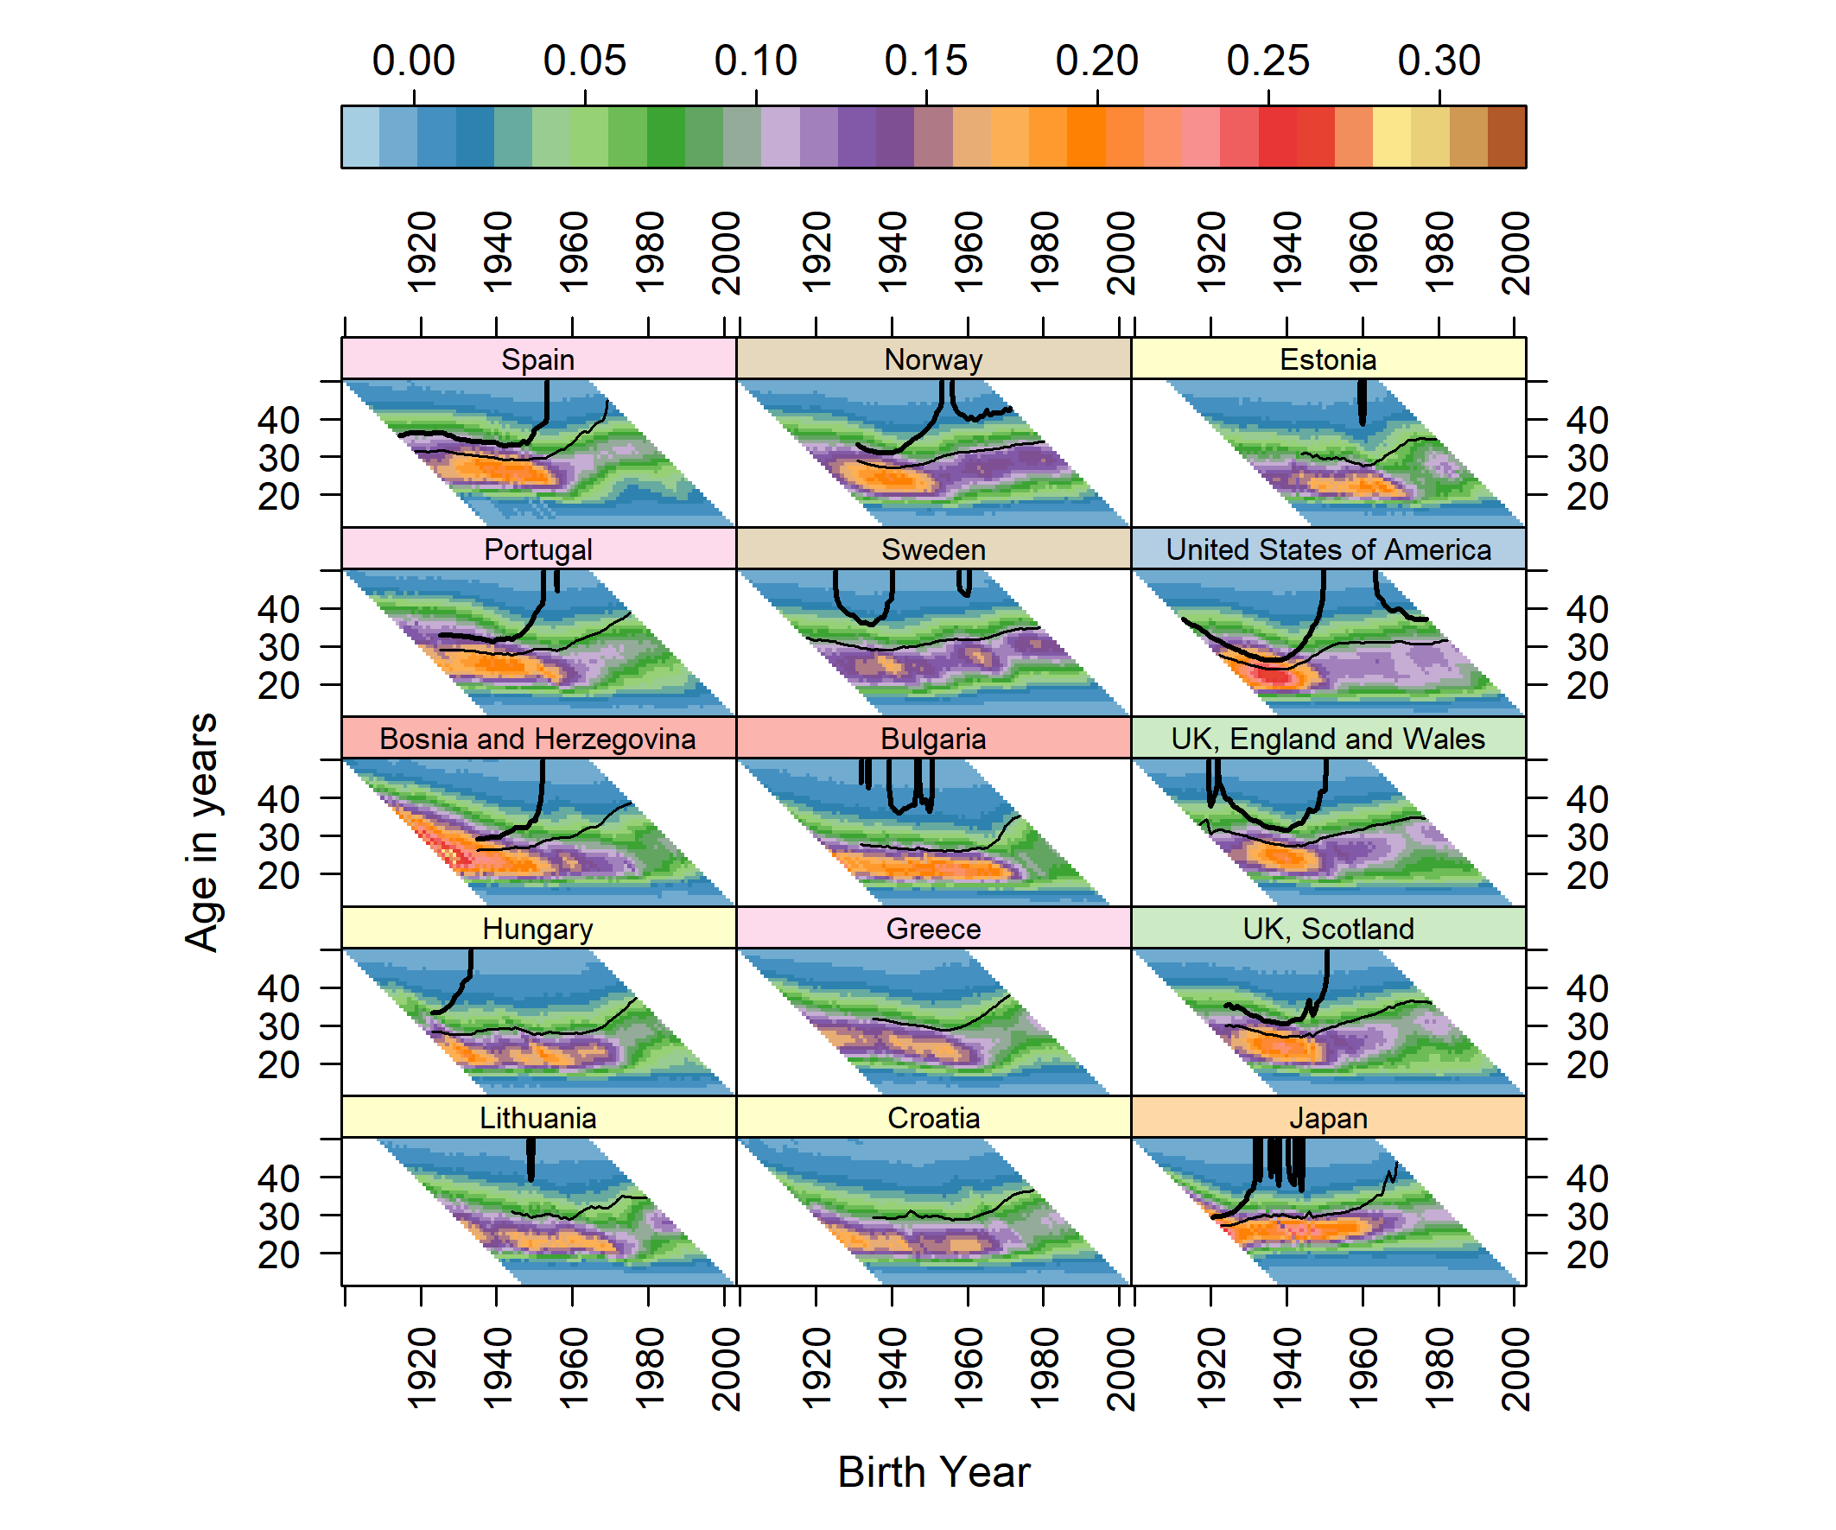

Figure 3: (Continued)

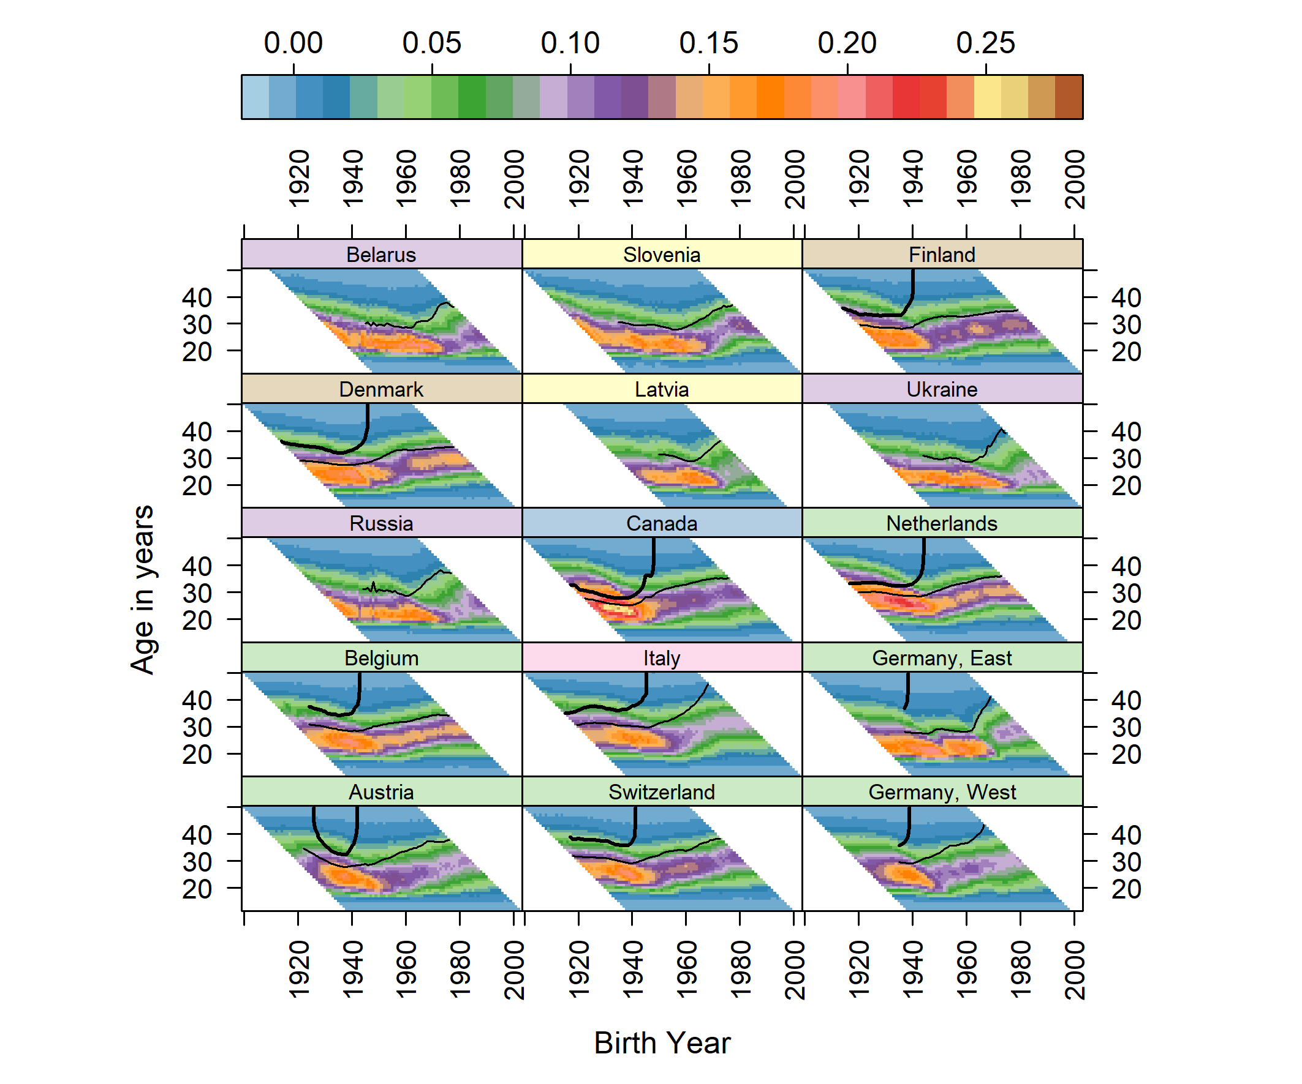

*Note*: (a) The shaded scale bar on the top indicates age-specific fertility rates (ASFRs). (b) The thick solid contour line indicates cumulative cohort fertility rate (CCFR)=2.05 children/woman (replacement fertility) and the thin solid contour line indicates CCFR=1.50 children/woman; (c) Countries are ranked in descending order by CCFR in 2007 (last common year of observation). (d) Countries are grouped by colour-shaded tiles indicating the following geographic macro-regions:

(1) South-Eastern Europe: Albania, Romania, Macedonia, Bosnia and Herzegovina, and Bulgaria;

(2) Western Europe: Ireland, UK-Northern Ireland, France, UK-England and Wales, UK-Scotland, Netherlands, Belgium, East Germany, Austria, Switzerland, and West Germany;

(3) Northern Europe: Iceland, Norway, Sweden, Finland, and Denmark;

(4) East and South-East Asian countries: Taiwan, Republic of Kora, and Japan;

(5) Non-European English-speaking countries: New Zealand, Australia, United States of America (USA), and Canada;

(6) Eastern Europe: Moldova, Belarus, Ukraine, and Russia;

(7) Central Europe: Slovakia, Poland, Czech Republic, Estonia, Hungary, Lithuania, Croatia, Slovenia, and Latvia;

(8) Southern Europe: Spain, Portugal, Greece, and Italy.

*Source*: Human Fertility Database (HFD) and Human Fertility Collection (HFC), own calculations.

# Summary and conclusions

In this paper we describe a new refinement and adaptation of the Lexis surface optimised to fertility data. By using both colour/shade and contours to mark age-specific fertility rates, and cumulative cohort fertility milestones, respectively, we show how these two types of data are related, and can be concisely represented in a single visualization. We present examples which introduce and comment on different features within specific countries, to provide conceptual ‘stepping stones’ for developing familiarization with this novel visualization approach. We conclude with a visualization of 45 countries, based on hundreds of thousands of specific data points.

Our study reveals that once countries have fallen below a replacement fertility level they tend to not return to it. We illustrated the cases of West and East Germany, where replacement fertility levels were lost for cohorts born before World War II. After sharing a fall in fertility in late 1960s, East and West Germany experienced different pathways of fertility transitions during the 1970s and 1980s, with a rapid convergence of fertility schedules after the collapse of the Berlin Wall. As reported in other studies (Frejka 2017; Sobotka et al. 2011), cohort fertility rates kept decreasing in East and West Germany and now appear to have stabilised below 1.50 children per woman.

Among the countries covered by this study, the USA and Norway are exceptions, with the plots revealing much heterogeneity in their fertility pathways, which appears to reflect contextual differences between geographic regions. Recuperation or recovery patterns may be due to the influence of immigrant fertility in the USA (see Choi (2014) and Coleman (2006)). In the case of Norway, sustained replacement fertility levels may also be explained by generous welfare provisions and the ideals of gender equality widely spread at the societal level (Kravdal 2016).

The contributions of this paper are both substantive and methodological. The case studies have focused on two paired comparisons at the low and higher end of the fertility spectrum among developed countries. But perhaps the greatest potential value in this paper is in demonstrating how the visualization can be decoded and applied to understanding and comparing many other populations. Further methodological developments based on this approach are possible using an interactive app which we are currently developing[3]. The app facilitates the selection of specific countries and compare associated attributes within the visualization. Tools provided include options to select different colour palettes, as well as to add, remove and shift the fertility milestones being represented with the contours. In addition, the app provides three dimensional representations of the data alongside these map-inspired visualizations.

# Acknowledgements

We would like to thank Tim Riffe, Sebastian Klüsner, Nikola Sander and Jakub Bijak for providing very helpful comments on earlier versions of this paper. A previous version of this paper was presented as a poster at the second Human Fertility Database Symposium on “Population-level fertility research: State of the art”, which was held at the WissenschaftsForum in Berlin on 23-24 June 2016. We thank participants for their constructive comments.

# References

Adserà, A. and Ferrer, A. (2014). Immigrants and demography: Marriage, divorce, and fertility. In: Chiswick, B. R. and Miller, P. W. (eds.). *Handbook of the economics of international migration*. Elsevier Science & Technology: 315–358.

Balbo, N., Billari, F. C., and Mills, M. (2013). Fertility in advanced societies: A review of research. *European Journal of Population/Revue européenne de Démographie* 29(1): 1–38.

Basten, S., Sobotka, T., and Zeman, K. (2014). Future fertility in low fertility countries. In: Lutz, W., Butz, W. P., and KC, S. (eds.). *World population and human capital in twenty-first century*. Oxford: Oxford University Press: 39–146.

Billari, F. C. (2018). A “great divergence” in fertility? In: Poston, Jr. D. L. (ed.). *Low fertility regimes and demographic and societal change*. Springer: 15–35.

Burkimsher, M. (2017). Evolution of the shape of the fertility curve: Why might some countries develop a bimodal curve? *Demographic Research* 37(11): 295–324.

Campbell, M. and Robards, J. (2014). Comparing changing age-specific fertility across the United Kingdom using Lexis diagrams. Southampton: ESRC Centre for Population Change (CPC Working Paper 50).

Caselli, G. and Vallin, J. (2005). From situation events in time to the Lexis diagram and the computing of rates. In: Caselli, G., Vallin, J., and Wunsch, G. (eds.). *Demography: Analysis and synthesis. A treatise in population*. Boston: Academic Press: 55-68.

Choi, K. H. (2014). Fertility in the context of Mexican migration to the United States: A case for incorporating the pre-migration fertility of immigrants. *Demographic Research* 30(24): 703–737.

Coleman, D. (2006). Immigration and ethnic change in low‐fertility countries: A third demographic transition. *Population and Development Review* 32(3): 401–446.

Davis, K. (1945). The World Demographic Transition. *The Annals of the American Academy of Political and Social Science* 237(Jan): 1–11.

Esping-Andersen, G. (1999). *Social foundations of postindustrial economies*. Oxford: Oxford University Press.

Esping‐Andersen, G. and Billari, F. C. (2015). Re‐theorizing family demographics. *Population and Development Review* 41(1): 1–31.

Frejka, T. (2017). The fertility transition revisited: A cohort perspective. *Comparative Population Studies* 42: 89–116.

Goldstein, J. R., Sobotka, T., and Jasilioniene, A. (2009). The end of “Lowest-Low” fertility? *Population and Development Review* 35(4): 663–699.

Grigorieva, O., Jasilioniene, A., Jdanov, D. A., Grigoriev, P., Sobotka, T., Zeman, K., and Shkolnikov, V. M. (2015). Methods protocol for the Human Fertility Collection [electronic resource]. http://www.fertilitydata.org/docs/methods.pdf (accessed: 25 August 2017).

Kravdal, Ø. (2016). Not so low fertility in Norway—A result of affluence, liberal values, gender-equality ideals, and the welfare state. In: Rindfuss, R. R. and Choe, M. K. (eds.). *Low fertility, institutions, and their policies*. Springer: 13–47.

Lesthaeghe, R. (1995). The Second Demographic Transition in Western countries: An interpretation. In: Oppenheim Mason, K. and Jensen, A.-M. (eds.). *Gender and family change in industrialized countries*. Oxford: Oxford University Press: 17–62.

Lesthaeghe, R. (2010). The unfolding story of the Second Demographic Transition. *Population and Development Review* 36(2): 211–251.

Lesthaeghe, R. and van de Kaa, D. J. (1986). Twee demographische transities. In: Lesthaeghe, R. and van de Kaa, D. J. (eds.). *Bevolking: groei en krimp*. Deventer: Van Loghum Slaterus: 9–24.

Max Planck Institute for Demographic Research (Germany) and Vienna Institute of Demography (Austria) (2015). Human Fertility Collection [electronic resource]. http://www.fertilitydata.org/cgi-bin/terms.php (accessed: 19 November 2016).

Max Planck Institute for Demographic Research (Germany) and Vienna Institute of Demography (Austria) (2016). Human Fertility Database [electronic resource]. www.humanfertility.org (accessed: 1 January 2015).

Myrskylä, M., Goldstein, J. R., and Cheng, Y. A. (2013). New cohort forecasts for the developed world: Rises, falls, and reversals. *Population and Development Review* 39(1): 31–56.

Neuwirth, E. (2014). RColorBrewer: ColorBrewer Palettes [electronic resource]. Vienna: R Foundation for Statistical Computing. http://www.R-project.org/ (accessed: 1 January 2015).

Notestein, F. W. (1945). Population: The long view. In: Schultz, T. (ed.) *Food for the world*. Chicago: Chicago University Press: 36–57.

Oeppen, J. and Vaupel, J. W. (2002). Broken limits to life expectancy. *Science* 296(10 May): 1029–1031.

Rau, R., Bohk-Ewald, C., Muszyńska, M. M., and Vaupel, J. W. (2018). *Visualizing mortality dynamics in the Lexis Diagram*. Springer International Publishing.

Sarkar, D. (2008). *Lattice: Multivariate data visualization with R*. New York: Springer.

Schölley, J. and Willekens, F. (2014). Visualizing compositional data on the Lexis surface. *Demographic Research* 36(21): 627–658.

Shkolnikov, V. M., Jdanov, D. A., Andreev, E. M., and Vaupel, J. W. (2011). Steep increase in best-practice cohort life expectancy. *Population and Development Review* 37(3): 419–434.

Sobotka, T. (2008). Overview chapter 7: The rising importance of migrants for childbearing in Europe. *Demographic Research* 19(9): 225–248.

Sobotka, T. (2017). Post-transitional fertility: the role of childbearing postponement in fuelling the shift to low and unstable fertility levels. *Journal of Biosocial Science* 49(S1): S20–S45.

Sobotka, T., Zeman, K., Lesthaeghe, R. Frejka, T, and Neels, K. (2011). Postponement and recuperation in cohort fertility: Austria, Germany and Switzerland in a European context. *Comparative Population Studies* 36(2–3): 417–452.

Vaupel, J. W., Gambill, B. A., and Yashin, A. I. (1987). Thousands of data at glance: Shaded contour maps of demographic surfaces. Laxemburg: International Institute for Applied System Analysis (IIASA Research Report RR-87-16).

Zeman, K., Beaujouan, E., Brzozowska, Z., and Sobotka, T. (2018). Cohort fertility decline in low fertility countries: Decomposition using parity progression ratios. *Demographic Research* 38(25): 651–690.

1. See https://github.com/JonMinton/comparative_fertility.
2. See https://datascapes.shinyapps.io/cumulative_fertility_app/.
3. See https://datascapes.shinyapps.io/cumulative_fertility_app/.