# **Appendices**

10 October 2016

This section provides a series of supplementary material for the article, “An Unprecedented Demographic Transition: Tens of Thousands of Additional Deaths among the Elderly in England and Wales, 2010-2015”. The structure of the appendix is as follows

* Appendix A: Supplementary figures
* Appendix B: More detailed description of modelling approach
* Appendix C: Alternative model specification and results
* Appendix D: Description and link to R code

## **Appendix A: Supplementary figures**

The following figure shows the projected and observed mortality risk in infancy (age 0), 15, 25, 35 and 45 years.

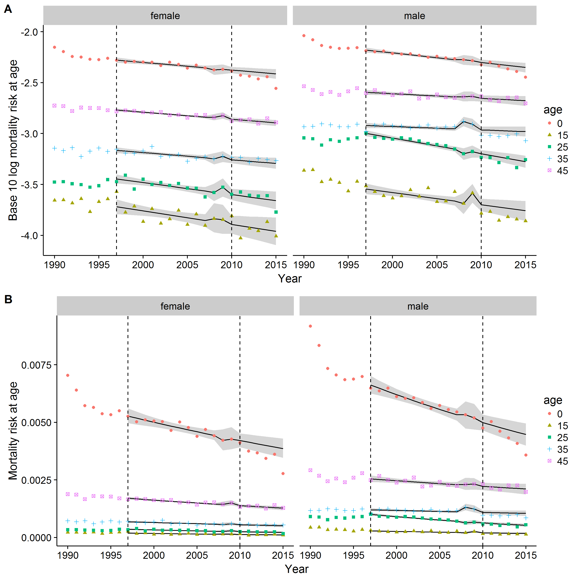

**Figure 1 [Colour Online] Trends in age-specific mortality risks at ages 0, 15, 25, 35 and 45 years. Males and females separately. A) Log10 scale. B) Identity scale.**

## **Appendix B: Modelling approach**

### **Model**

For each sex, and for each age in single years, a, from birth to 95 years old, a separate linear regression model was fit with the following specification:

|  |  |
| --- | --- |
| $$\log_{10}\left(m_{t, a, s}\right)= β_{0, a,s}+ β_{1, a,s}t+β_{2, a,s}L+ β_{3, a,s}Lt+ β_{4,a,s}R+ β_{5,a,s}Rt+ ϵ$$ | (1) |

Where $m_{t, a, s}$ is the mortality rate (death count divided by population count) in year t, at age a, and for sex s; t is year; L is a dummy variable indicating the years, 1997 to 2010, in which New Labour were in government; R is a dummy variable indicating 2008 and 2009, the years in which the UK economy entered a recession as a result of the GFC, and $ϵ$ is an error term. The R term is included to capture any additional short-term changes in mortality rates to be captured in a separate term rather than influence the coefficients including New Labour years, $β_{2}$ and $β_{3}$. The use of interaction terms Lt and Rt allowed for the gradients of change in log mortality rates over time to be different over the New Labour and GFC recession periods.

The above model specification was fit to ONS data for each year from 1990 to 2010 inclusive. Redefining $Y_{t,a,s }=\log_{10}\left(m_{t, a, s}\right)$, projected log mortality rates ${Y_{a,s, t}^{*}}_{ }$ were calculated for years 2011 to 2015 inclusive by setting t to these year values and L to 1, i.e.

|  |  |
| --- | --- |
| $${Y_{t,a, s}^{*}}_{ }=(β_{0, a,s}+ β_{2, a,s})+ {(β}_{1, a,s}+ β_{3, a,s})t$$ | (2) |

Predicted numbers of deaths at each age, for each sex, and in each year from 2011 to 2015 $d_{t,a, s}^{*}$ were therefore calculated by multiplying the relevant age-year-sex specific population counts $p_{t,a,s}$ by the requisite projected mortality rates, i.e.

|  |  |
| --- | --- |
| $${d_{t,a, s}^{*} }_{ }=p_{t,a,s}{10}^{Y_{t,a, s}^{*}}$$ or equivalently $${d_{t,a, s}^{*} }_{ }=p_{t,a,s}m_{t, a, s}^{*}$$ | (3) |

Where $m_{t, a, s}^{*}$ is the projected mortality rate rather than log rate.

The age-sex specific differences in deaths are therefore $∆_{t,a,s}= d_{t,a,s}- d_{t,a, s}^{*}$, and the total difference in deaths by age A, shown in figures xxx, is $D_{t,A,s}= \sum_{a=0}^{A}{∆_{t,a,s}}$.

### **Summary of regression coefficients for different ages in standard model**

The following figure shows the regression coefficients for each of the age-specific models produced. The bands show 1.96 standard deviations above and below the central parameter estimates indicated by the line. GFC: Global Financial Crisis; NL: New Labour.

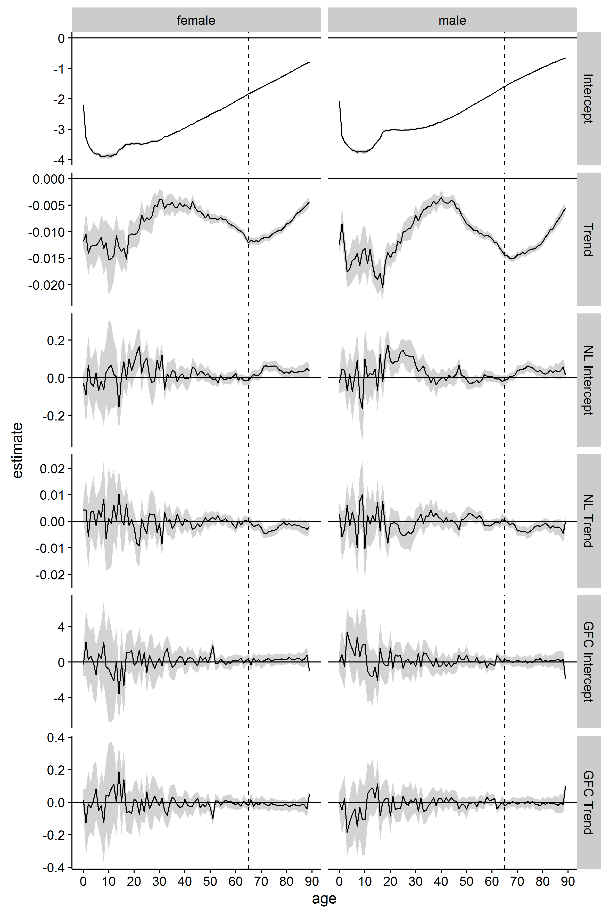

**Figure 2 Visual summary of 180 separate age-year specific regression models. The black lines show the point estimates for each model, and the grey bands indicate the 95% confidence interval around these point estimates. (Terms: Trend: Linear trend in mortality risk over time (since 1990); NL intercept: adjustment to intercept relating to the years 1997-2010; NL trend: adjustment to trend relating to years 1997-2010; GFC Intercept: adjustment to intercept relating to years 2008-2009; GFC trend: adjustment to trend relating to years 2008-2009)**

## **Appendix C: Alternative Model specification**

The alternative model specification includes an additional nonlinear term on year since 1990, i.e.

|  |  |
| --- | --- |
| $$\log_{10}\left(m_{t, a, s}\right)= β_{0, a,s}+ β_{1, a,s}t+β_{2, a,s}L+ β_{3, a,s}Lt+ β_{4,a,s}R+ β_{5,a,s}Rt+ β_{6, a,s}t^{2}+ ϵ$$ | (1) |

**Note**: There were too few observations to include interaction terms between $t^{2}$ and New Labour or the GFC.

**Model fit comparisons**

The figure below shows difference in AIC between the standard linear model and the alternative nonlinear model. A nonlinear smoother is added to show this relationship with age. Overall both models have similar performance in terms of fit to the data, although there is an indication of a nonlinear trend for males in young adulthood. 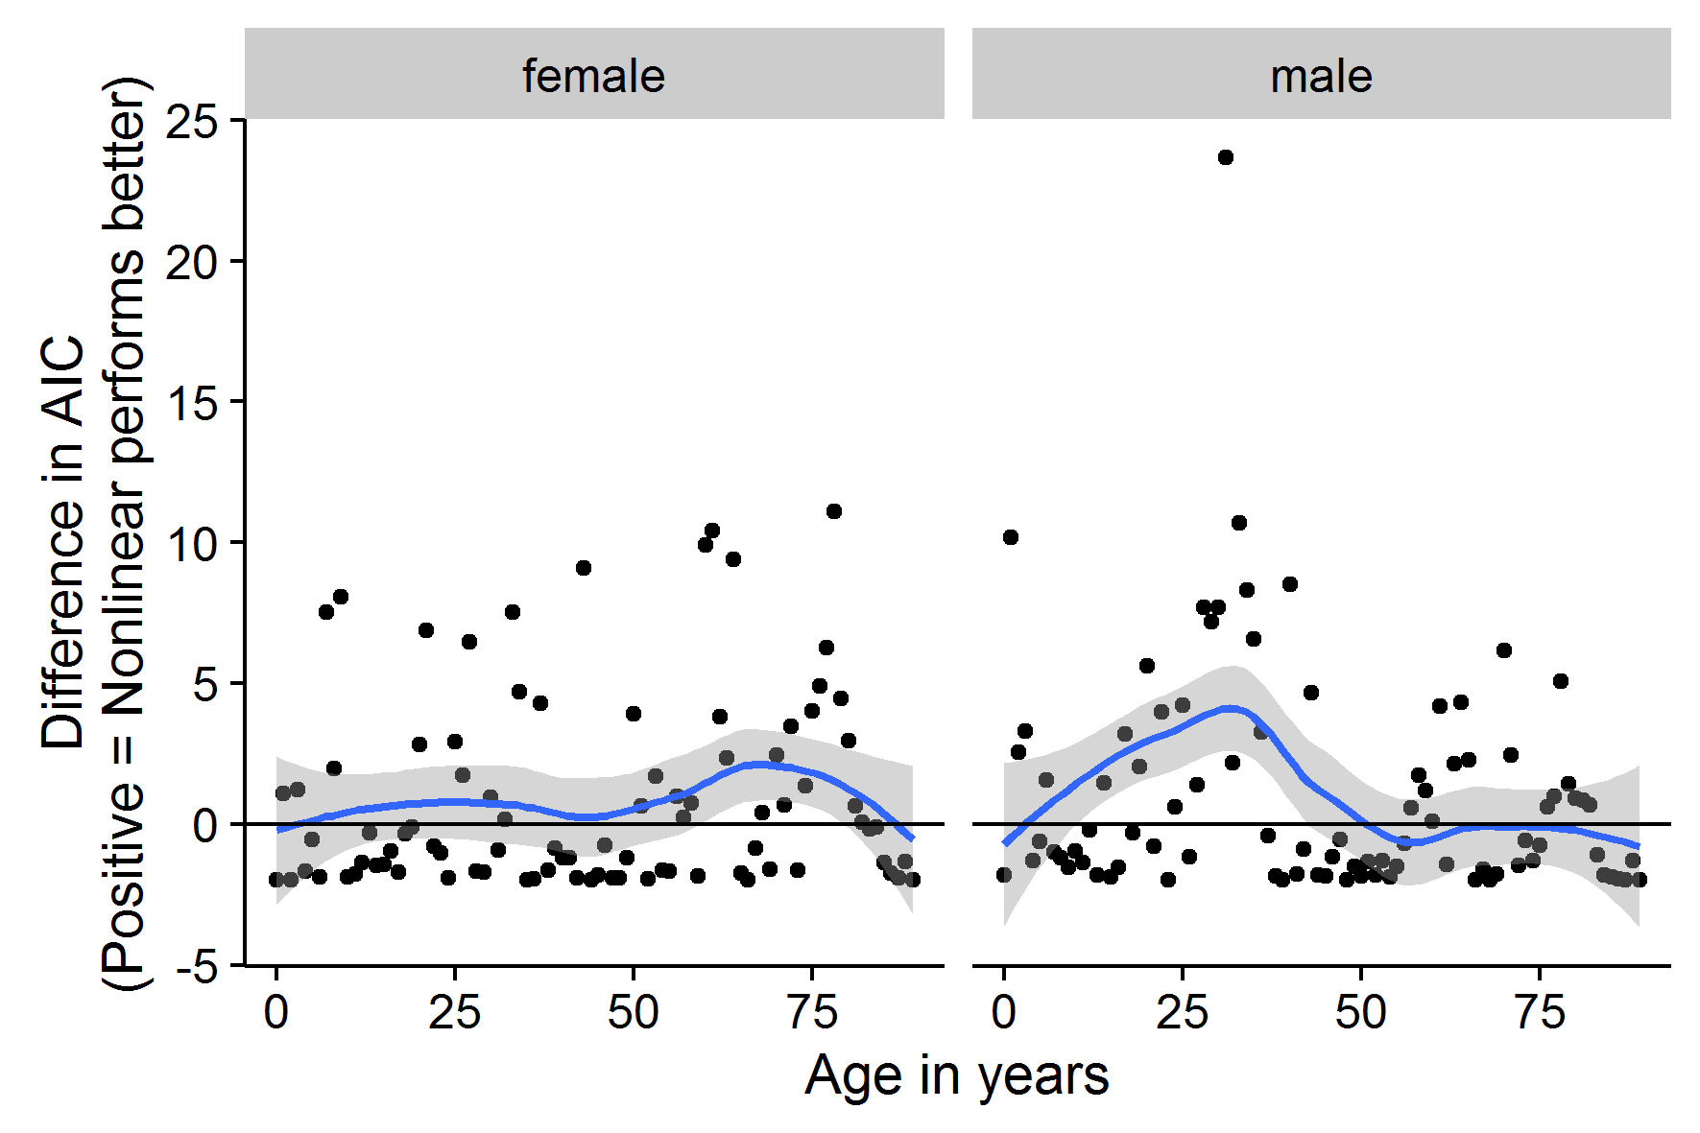

**Figure 3 [Colour online] Visual comparison of AIC between standard model specifications and additional nonlinear model specification**

The figure below shows the coefficients of each of the age-specific models using this alternative model specification. The new trend is labelled ‘Nonlinear trend’, and is statistically significant for males in young adulthood, as implied by the AIC comparison above.

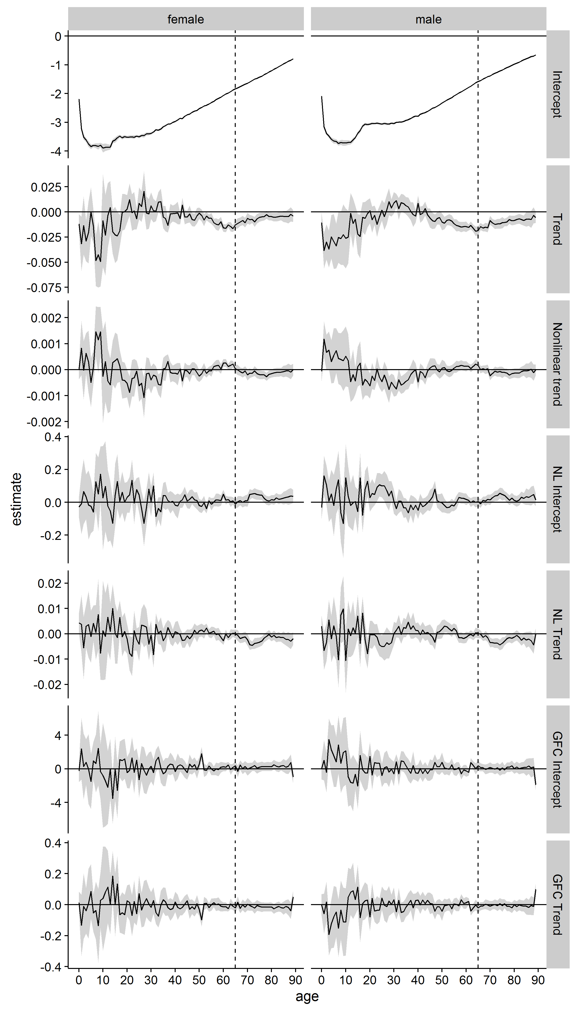

**Figure 4 . Visual summary of 180 separate age-year specific regression models. The black lines show the point estimates for each model, and the grey bands indicate the 95% confidence interval around these point estimates. (Terms: Trend: Linear trend in mortality risk over time (since 1990); NL intercept: adjustment to intercept relating to the years 1997-2010; NL trend: adjustment to trend relating to years 1997-2010; GFC Intercept: adjustment to intercept relating to years 2008-2009; GFC trend: adjustment to trend relating to years 2008-2009)**

The following two figures show projected against actual mortality rates at older ages, and at younger ages. These figures suggest the non-linear model specification appears to have a slightly better fit to the data, but substantively the patterns are very similar:

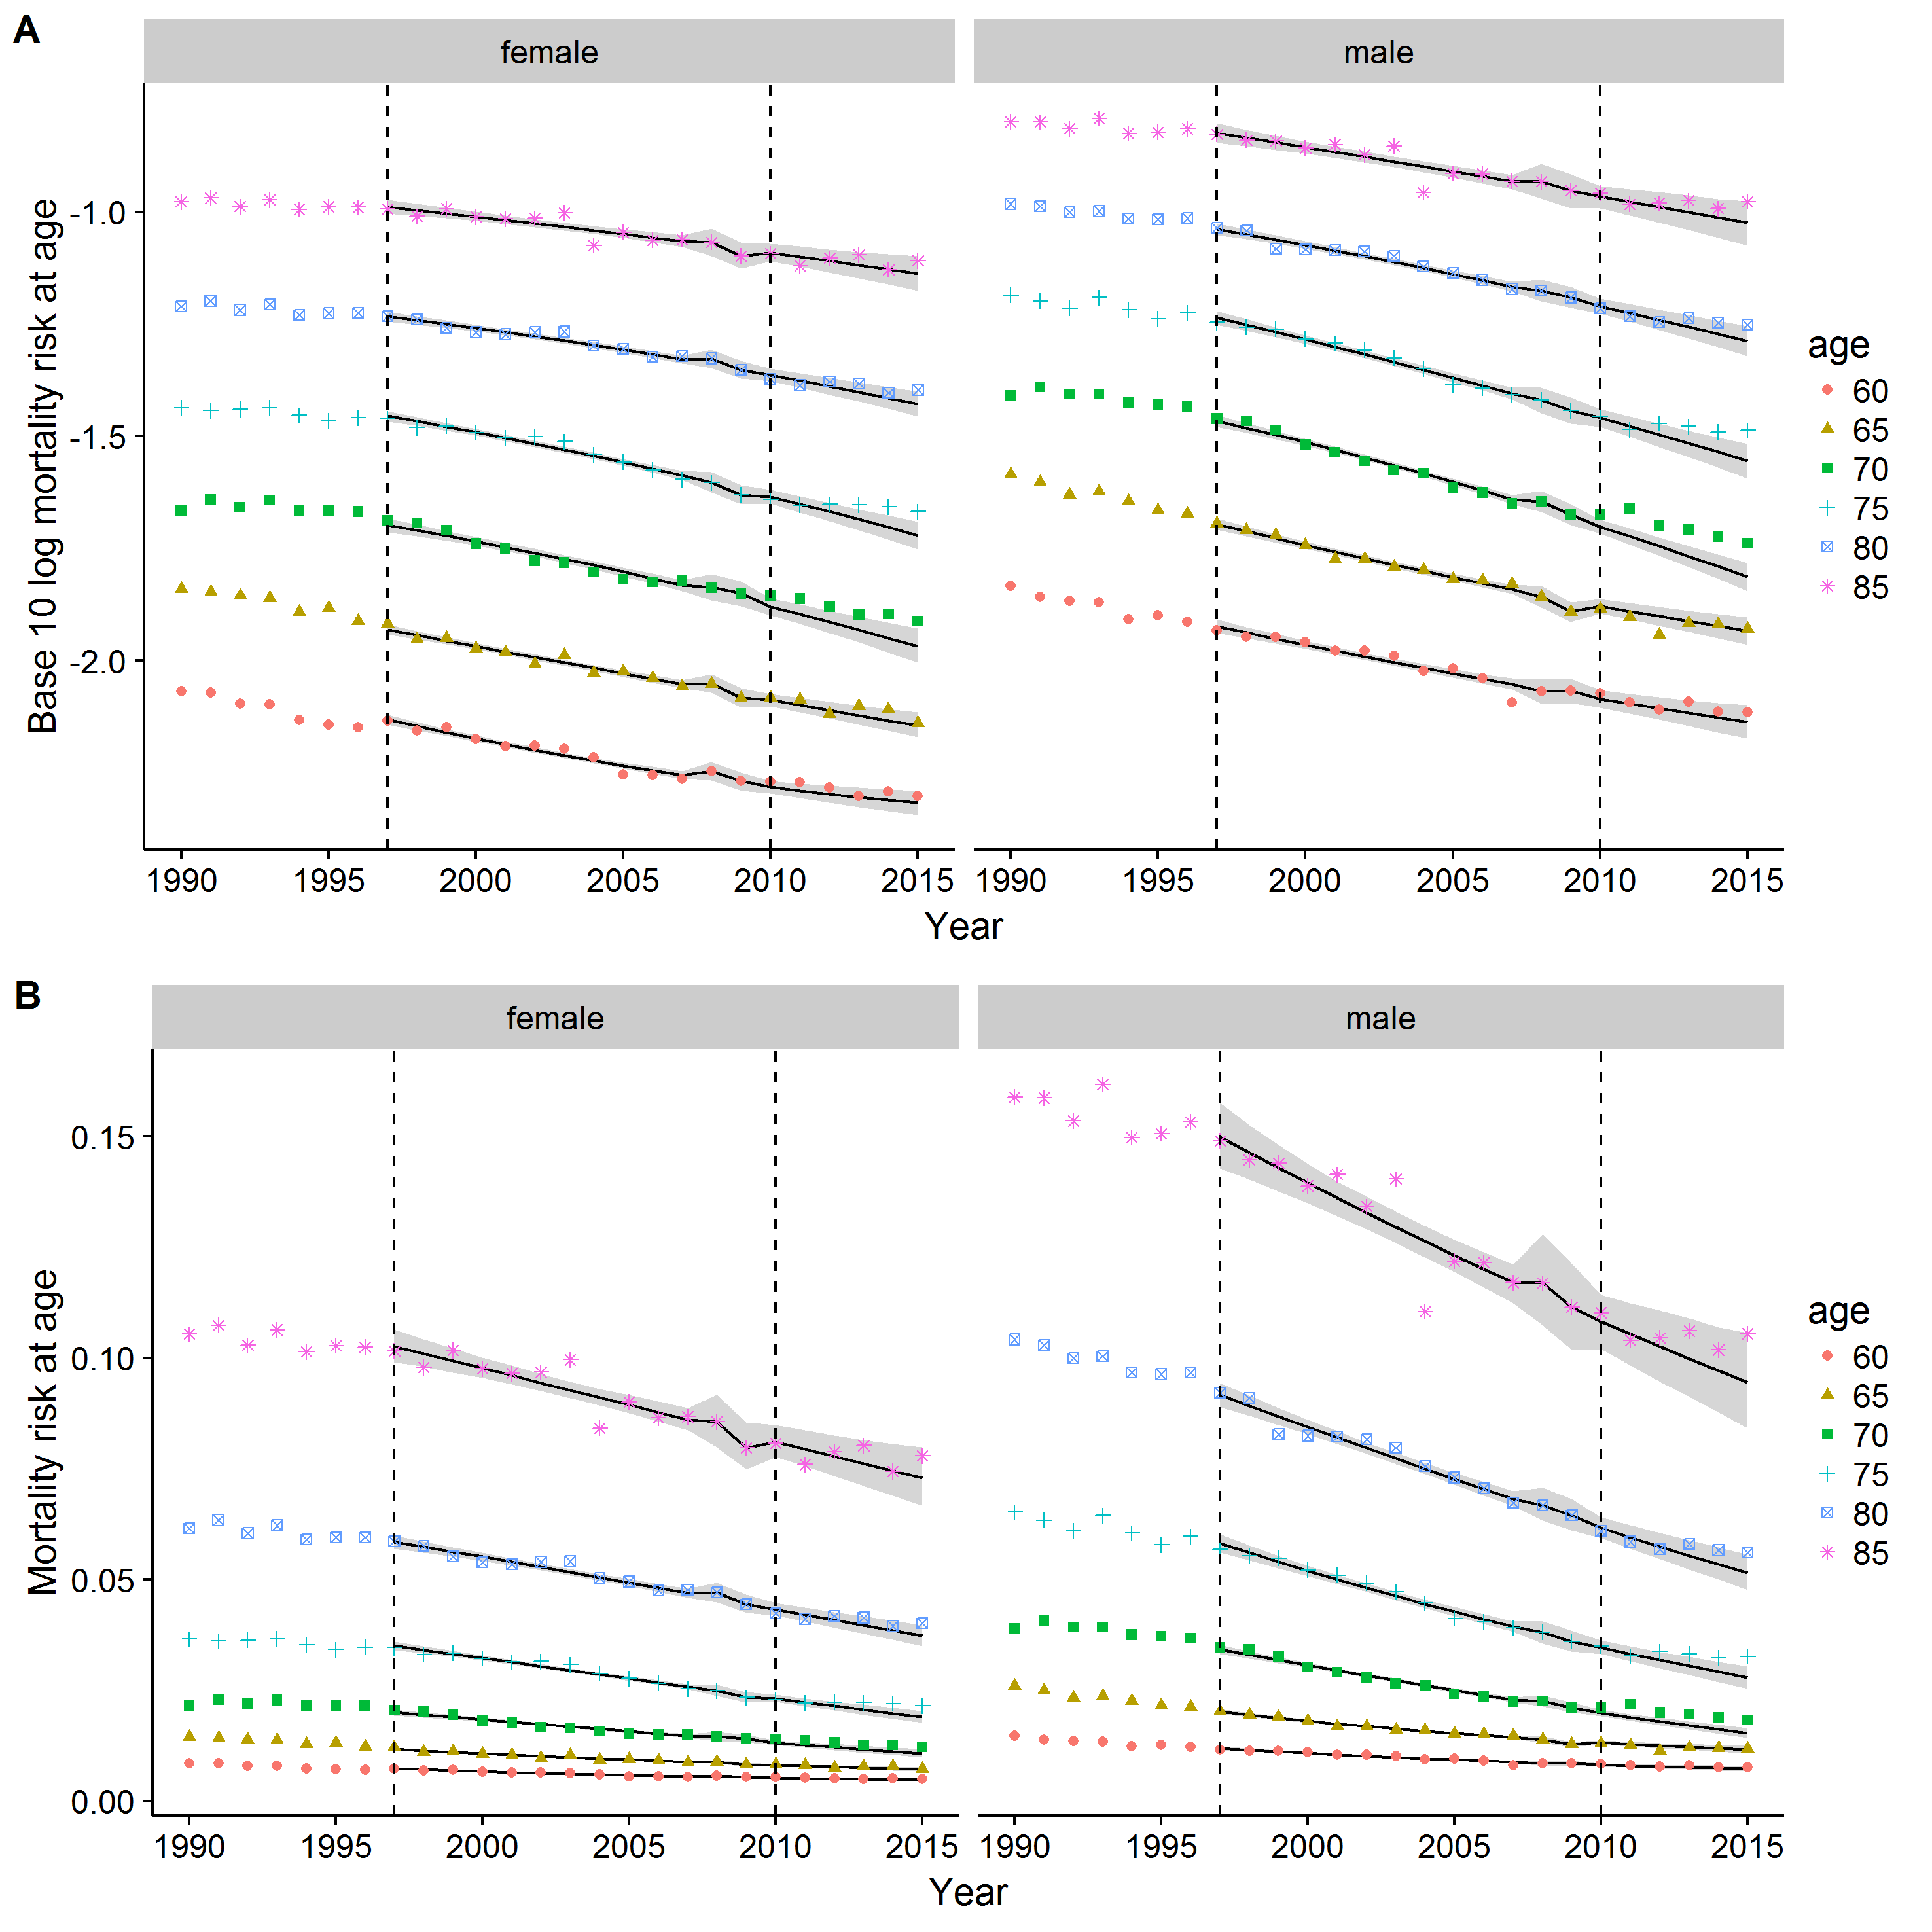

**Figure 5 [Colour online] Comparison of observed (points) and fitted (lines and grey bands) mortality rate changes at older ages, using a nonlinear model specification. A) Log10 scale; B) Identity scale.**

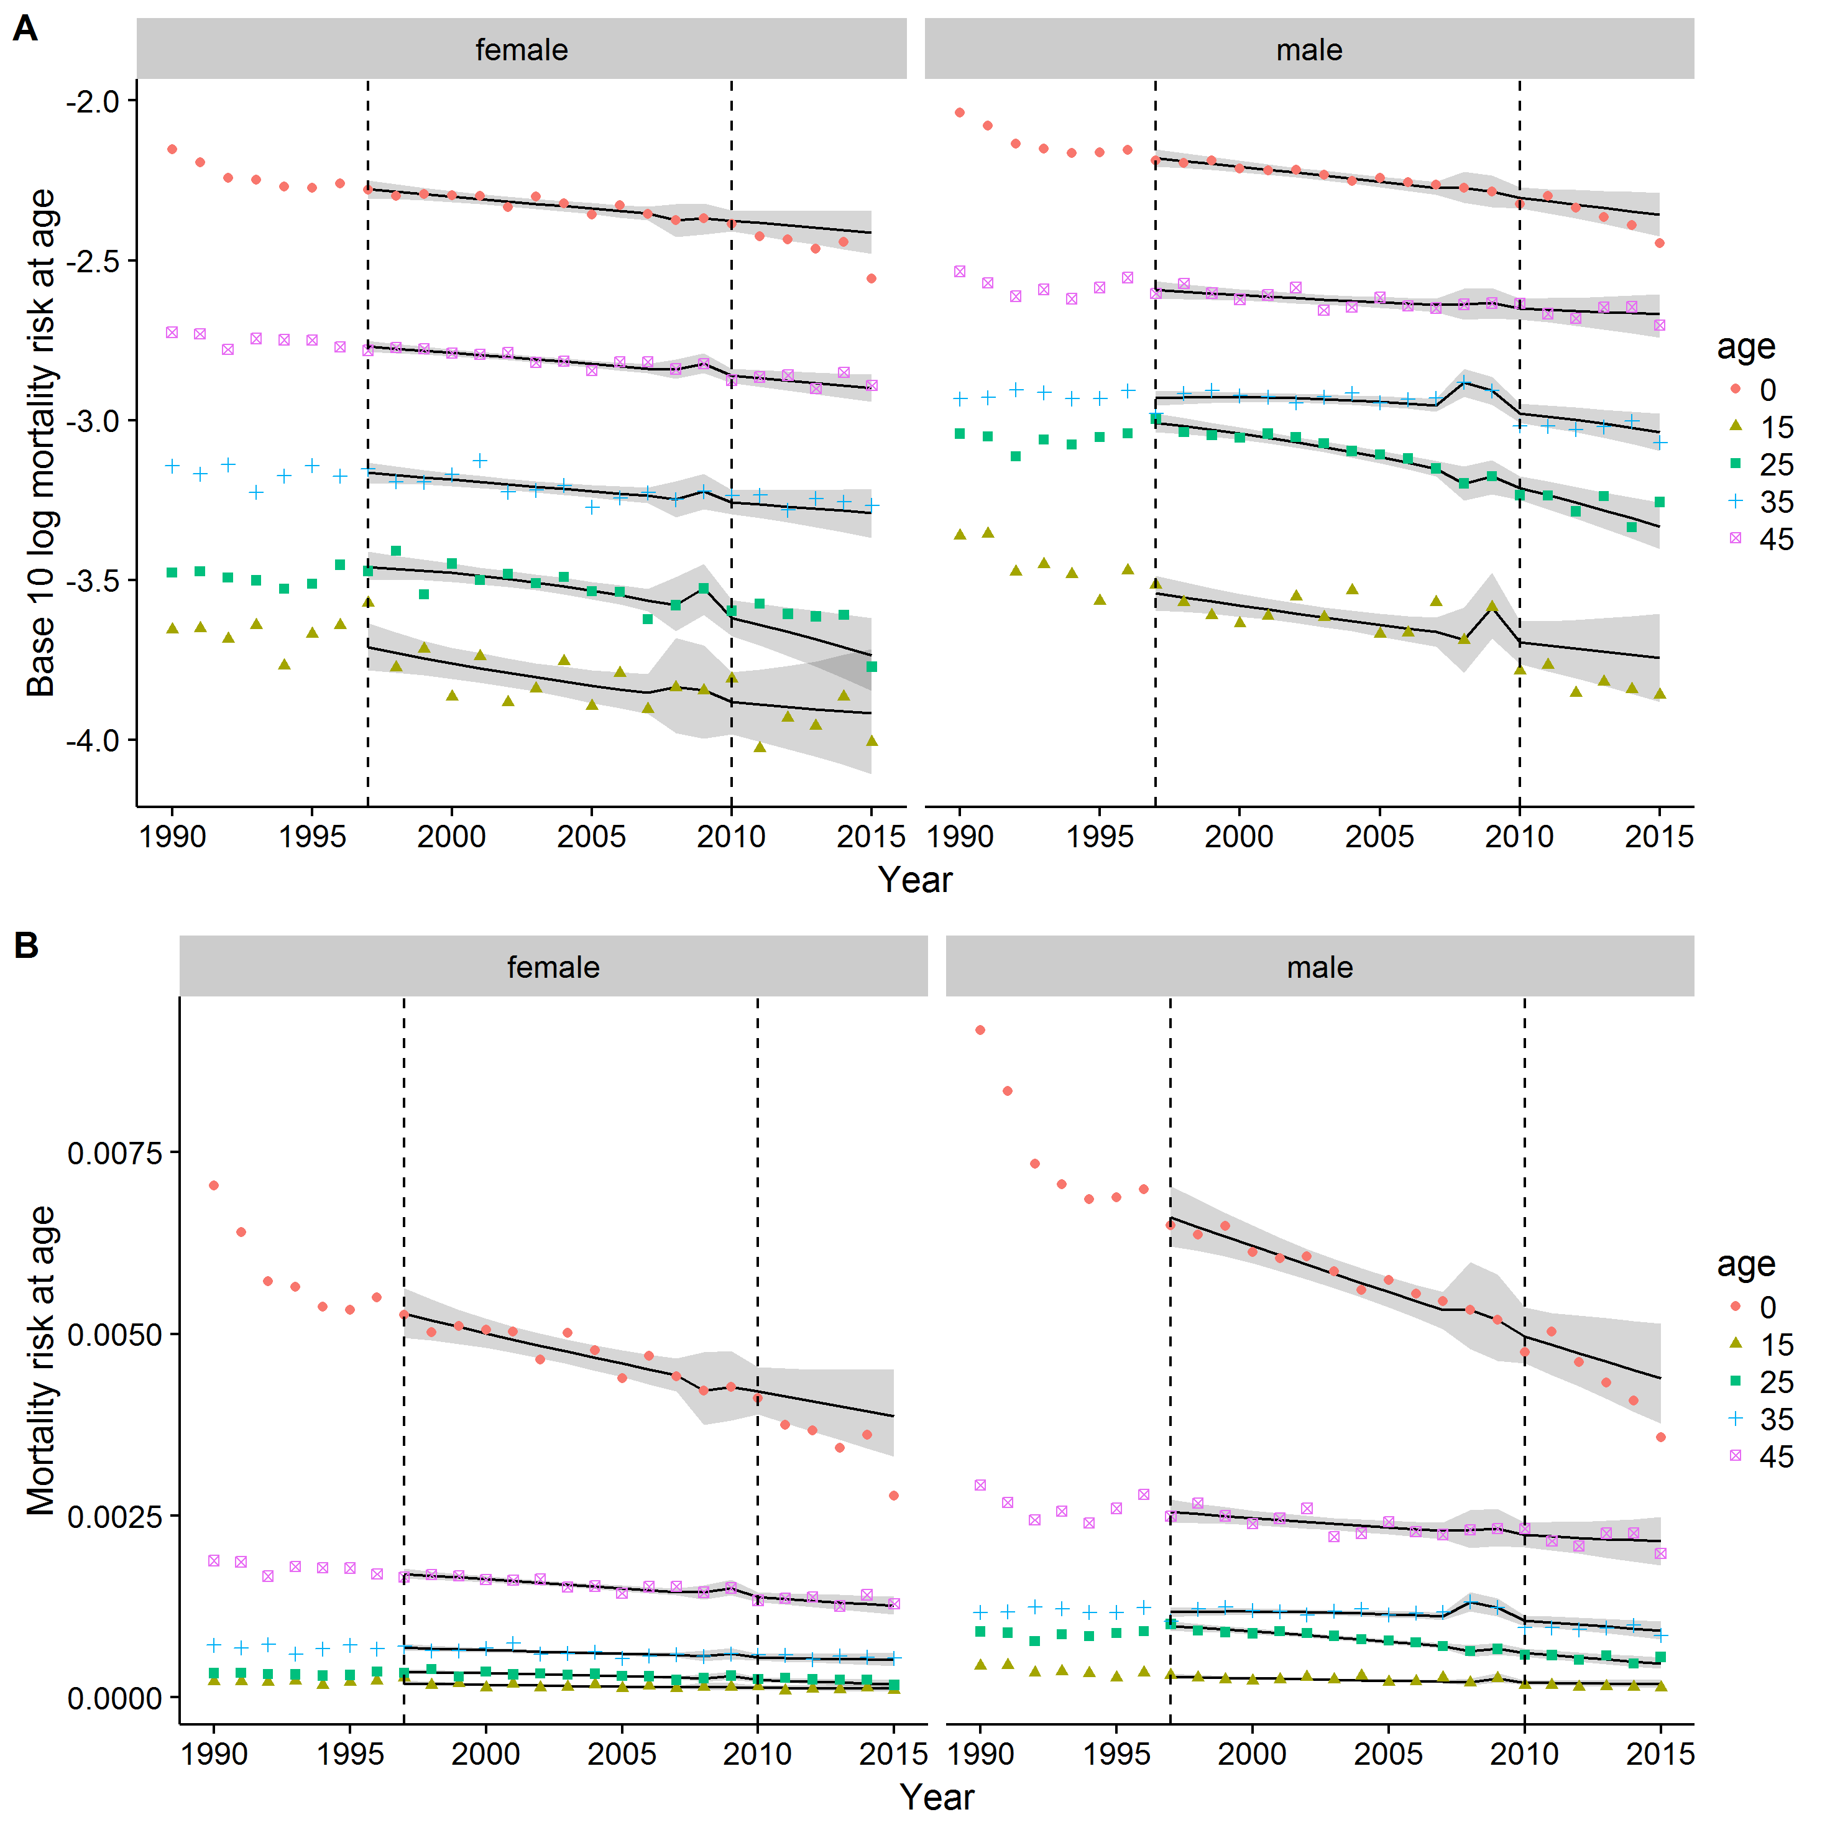

**Figure 6 [Colour online] Observed (points) and estimated (Lines and grey bands) mortality rates at younger ages, using nonlinear model specification**

The following figure shows the accumulated ‘excess’ mortality using this latter model specification. Substantively, these results are very similar to those in the main model specification, though with a smaller difference between actual and projected in 2010 and 2011, and an even faster acceleration of excess mortality in later years.

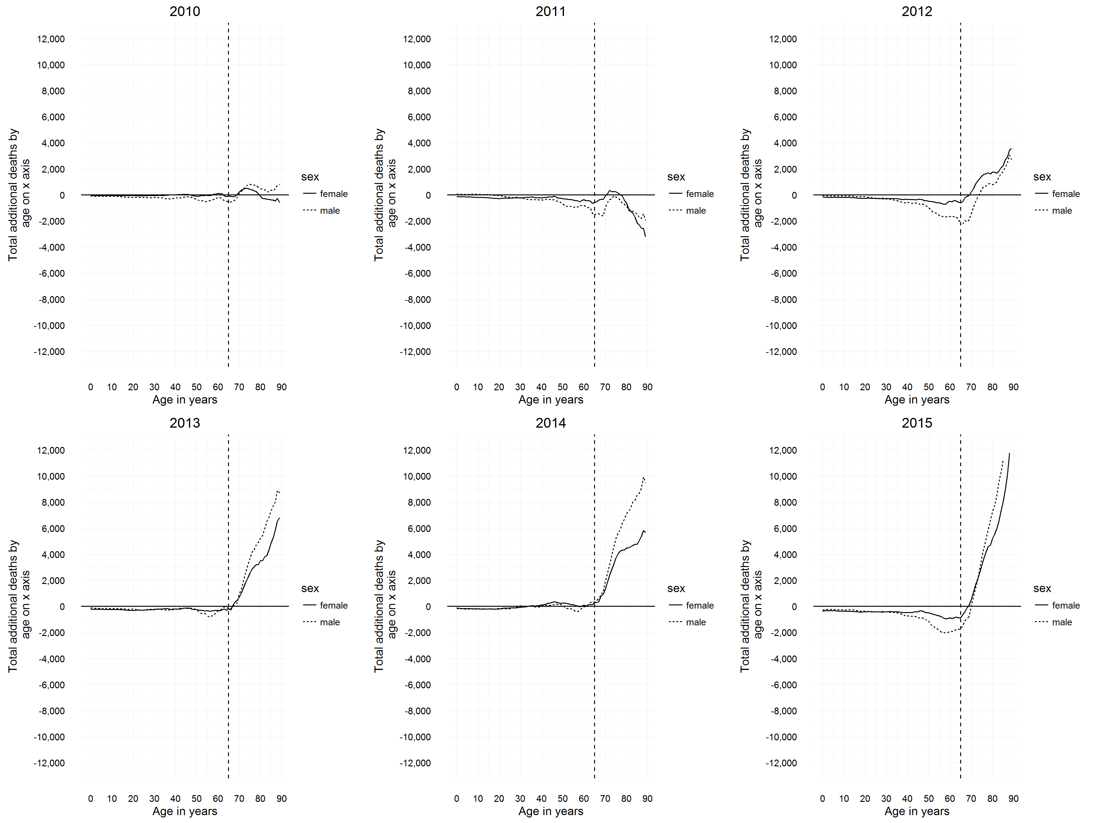

**Figure 7 Accumulated 'excess' deaths for each year from 2010 to 2015, by age, using nonlinear model specification. (Male: dashed line; female: solid line)**

Table 1 summarises the above figure, showing the total excess deaths in each year by ages 50, 70 and 89. Table 2 further summarises these figures, showing the total number of ‘excess’ deaths between the period 2010-2015 and 2012-2015. These suggest there were fewer ‘negative excess’ deaths by age 89 in 2010 and 2011, suggesting a better model fit over this period, and predicts a higher excess death total than the standard model, with 60,073 more deaths than projected between 2010 and 2015, and 65,043 more deaths than projected between 2012 and 2015.

|  |  |  |  |
| --- | --- | --- | --- |
| **Period** | **Males** | **Females** | **Combined** |
| 2010-2015 | 35,032 | 25,041 | 60,073 |
| 2012-2015 | 36,188 | 28,855 | 65,043 |

**Table 1 Summary of accumulated 'excess deaths' by age 89 years using nonlinear model specification, for either the period 2010-2015 or period 2012-2015**

|  |  |  |  |  |  |  |  |  |  |  |  |  |  |  |  |  |  |  |  |
| --- | --- | --- | --- | --- | --- | --- | --- | --- | --- | --- | --- | --- | --- | --- | --- | --- | --- | --- | --- |
| **Year** | **Age** | **Males** |  |  |  |  |  | **Females** | |  |  |  |  | **Combined** | | |  |  |  |
| 2010 | 50 | -347 | ( | 19,094 | - | 19,441 | ) | -112 | ( | 11,786 | - | 11,898 | ) | -459 | ( | 30,880 | - | 31,339 | ) |
|  | 70 | **87** | ( | 75,811 | - | 75,724 | ) | **219** | ( | 49,994 | - | 49,775 | ) | **306** | ( | 125,805 | - | 125,499 | ) |
|  | 89 | **799** | ( | 212,724 | - | 211,925 | ) | -600 | ( | 192,910 | - | 193,510 | ) | **199** | ( | 405,634 | - | 405,435 | ) |
| 2011 | 50 | -703 | ( | 18,455 | - | 19,158 | ) | -290 | ( | 11,460 | - | 11,750 | ) | -993 | ( | 29,915 | - | 30,908 | ) |
|  | 70 | -1,007 | ( | 74,013 | - | 75,020 | ) | -102 | ( | 49,391 | - | 49,493 | ) | -1,109 | ( | 123,404 | - | 124,513 | ) |
|  | 89 | -1,955 | ( | 207,606 | - | 209,561 | ) | -3,214 | ( | 185,925 | - | 189,139 | ) | -5,169 | ( | 393,531 | - | 398,700 | ) |
| 2012 | 50 | -981 | ( | 17,817 | - | 18,798 | ) | -481 | ( | 11,097 | - | 11,578 | ) | -1,462 | ( | 28,914 | - | 30,376 | ) |
|  | 70 | -1,470 | ( | 73,161 | - | 74,631 | ) | **204** | ( | 49,648 | - | 49,444 | ) | -1,266 | ( | 122,809 | - | 124,075 | ) |
|  | 89 | **2,706** | ( | 209,909 | - | 207,203 | ) | **3,560** | ( | 189,135 | - | 185,575 | ) | **6,266** | ( | 399,044 | - | 392,778 | ) |
| 2013 | 50 | -304 | ( | 18,025 | - | 18,329 | ) | -244 | ( | 11,062 | - | 11,306 | ) | -548 | ( | 29,087 | - | 29,635 | ) |
|  | 70 | **907** | ( | 74,741 | - | 73,834 | ) | **713** | ( | 49,853 | - | 49,140 | ) | **1,620** | ( | 124,594 | - | 122,974 | ) |
|  | 89 | **8,714** | ( | 213,466 | - | 204,752 | ) | **6,810** | ( | 189,046 | - | 182,236 | ) | **15,524** | ( | 402,512 | - | 386,988 | ) |
| 2014 | 50 | **40** | ( | 17,908 | - | 17,868 | ) | **254** | ( | 11,291 | - | 11,037 | ) | **294** | ( | 29,199 | - | 28,905 | ) |
|  | 70 | **1,894** | ( | 74,625 | - | 72,731 | ) | **1,348** | ( | 49,967 | - | 48,619 | ) | **3,242** | ( | 124,592 | - | 121,350 | ) |
|  | 89 | **9,495** | ( | 212,499 | - | 203,004 | ) | **5,666** | ( | 185,505 | - | 179,839 | ) | **15,161** | ( | 398,004 | - | 382,843 | ) |
| 2015 | 50 | -1,149 | ( | 16,288 | - | 17,437 | ) | -503 | ( | 10,279 | - | 10,782 | ) | -1,652 | ( | 26,567 | - | 28,219 | ) |
|  | 70 | -3 | ( | 71,541 | - | 71,544 | ) | **508** | ( | 48,525 | - | 48,017 | ) | **505** | ( | 120,066 | - | 119,561 | ) |
|  | 89 | **15,273** | ( | 215,870 | - | 200,597 | ) | **12,819** | ( | 189,683 | - | 176,864 | ) | **28,092** | ( | 405,553 | - | 377,461 | ) |

**Table 2 'Excess deaths' by gender, year, and specific ages using main and alternative model specifications**

**Appendix D: Links to R Code**

All data analyses and formatting were conducted in the R programming environment. The online code repository github was used to store and archive all versions of the code and supplementary material, which is available from the following location:

<https://github.com/JonMinton/danny_elderly_mort/>

Code for combining data from multiple releases of age-specific death and population counts, from different ONS releases, is available below:

<https://github.com/JonMinton/danny_elderly_mort/blob/master/scripts/extract_combined_ons.R>

A script for producing the figure showing how per capita GDP trends have changed is available here:

<https://github.com/JonMinton/danny_elderly_mort/blob/master/scripts/intro_graphs.R>

The main modelling, for both the standard and nonlinear models, is performed in the following script:

<https://github.com/JonMinton/danny_elderly_mort/blob/master/scripts/analyses_with_only_ons.R>