The Suburbanisation of Poverty in Scotland’s Cities: Urban Regeneration or Social Cleansing?

Jon Minton & Nick Bailey

31 August 2016

# Caveats

This is work in progress, not a polished report, but shared on line in order to promote more rapid dissemination and discussion. Comments and constructive criticism welcomed.

# Acknowledgements

AQMeN and ESRC funding.

# Summary

* [CHECK] In all four of Scotland’s major cities, the number of poor or ‘income deprived’ people in inner city areas fell between 2012 and 2016 according to the latest Scottish Index of Multiple Deprivation data, while the number of non-poor people in these areas rose.
* [CHECK] In less central areas, the population of both groups was little changed. Poverty therefore became more ‘suburbanised’ in this period.
* [CHECK] This continues the trend observed over the last four waves of the SIMD, from 2004 to 2012, again across all four cities.
* [CHECK] The total population in the central areas rose in all four cities between 2004 and 2016. This is generally to be welcomed from an environmental point of view. It suggests that planning policies have succeeded in encouraging people to live in higher density locations which tend to be better served by public transport.
* [CHECK] However the displacement of lower income groups suggests these policies will fail to deliver the socially mixed communities which planners have so frequently advocated as part of their vision for sustainable cities.
* [CHECK] The main reason for this change is likely to be the continued reductions in housing subsidies for lower income households. The last 20 years have seen the loss of social rented housing and greater reliance on private renting, combined with the reductions in housing benefits. As a result, inner city locations appear to be increasingly beyond the reach of poorer households.

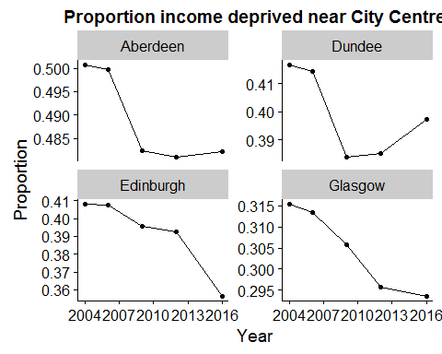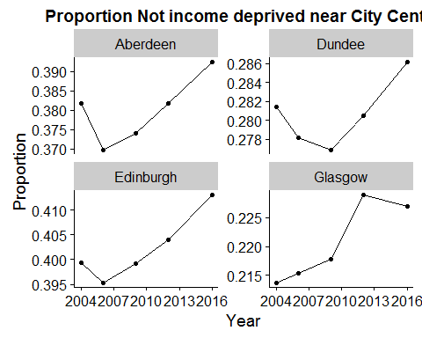

# Introduction: the suburbanization of poverty

Poverty has long been seen as an urban issue and in particular an ‘inner city’ problem. Historically, that is where older housing in worse condition tended to be found, and hence where poorer households could afford to live. Inner city areas were also worst hit by the processes of deindustrialization since they tended to have the oldest, least productive firms. There was little room for new industrial development so businesses moved out. More affluent households who could afford cars also moved to the suburbs and surrounding areas so the inner cities declined further. At the extreme, this could lead to the development of what some US commentators call ‘doughnut cities’, where a ring of relatively affluent suburbs surround an increasingly abandoned, hollowed-out core.

In many European countries, the contrast between inner and outer urban areas was rarely as great, thanks in part to the efforts of planners to limit the outward sprawl of the cities but also to the scale of social policies pursued by European states. Spending on welfare benefits and on public services ensured that inner urban areas retained relatively strong and well-functioning communities.

In recent decades, inner city locations in many developed countries have witnessed a revival their fortunes and hence in demand for housing from more affluent groups. This is partly about economic changes. With manufacturing replaced by services as the basis of the city economy, inner urban locations have not only seen an improvement in their environment, but also now offer better access to higher-skilled employment as well as expanding leisure opportunities. Inner city living has become the basis of a desirable lifestyle.

Governments have often played a strong supporting role in these processes, investing public resources through urban regeneration schemes and seeking to leverage additional private sector investment. They have sought to limit suburbanization and direct new housing development towards brownfield land. In many cases, these policies were driven by a vision of the “sustainable city”, based around higher densities, effective public transport and  
 hoped these changes would bring new opportunities for more deprived communities as well as improvements in the physical environment. They sought to grow the inner city population by developing vacant or underused land, producing mixed communities.

However, critics argue that these programmes have resulted not in urban regeneration where benefits are shared but in ‘gentrification’ and the displacement of poorer communities. The rising value of housing and the associated changes in local facilities may push out the lower income households who have long lived in these areas. Working class communities which had been a source of support and solidarity for their members are eroded. In short, the critics accuse governments of pursuing a form of “social cleansing” where the endpoint is an inner city where only the rich can afford to live while the poor are dispersed to suburban and ex-urban locations, with worse access to employment.

## Suburbanisation of poverty in Scotland

These processes have been little studied in Scotland. In 2014, however, Kavanagh, Lee & Pryce produced an AQMeN briefing paper Poverty in Suburbia: Has Glasgow gone the way of American cities? The paper had a strong methodological focus. To capture decentralisation, they used a measure called the Relative Centralisation Index (RCI) and they developed a new way of assessing uncertainty in this, using a Bayesian spatial statistics approach. This paper argued that there has been a decentralisation or suburbanization of poverty in Glasgow between 2001 and 2011, and that the changes were statistically significant, i.e. the differences were more than we would expect from the random fluctuations which will always occur in a measure from year to year.

The briefing paper measured 'poverty' in three ways, each relating to specific UK state benefit receipts for persons of working age who were not in employment:

1. The proportion of the local population receiving Income Support (IS)
2. The proportion of the local population receiving Incapacity Benefit (IB)
3. The proportion of the local population receiving Jobseekers' Allowance (JSA)

These analyses were expanded to the four major Scottish cities - Aberdeen, Dundee, Edinburgh and Glasgow - for a paper to appear in Annals of the American Association of Geographers, by the same authors. This paper calculated 95% credible intervals (CrIs) for the difference in RCI from 2001 to 2011 for the same three measures of poverty, and for each of the four cities. It found falls in RCI for all benefit types across all four cities, all of which were statistically significant.

These papers were important for developing a new approach to the measurement of decentralization which captured the uncertainty inherent in the RCI measure. They were also valuable for drawing attention to a phenomenon which has been identified in other countries, notably the US, but which had not previously been discussed in the Scottish context. However, they can be criticized for using relatively weak proxies for poverty; in particular, they ignore those who are in work but in poverty, now the majority of working-age poor. They only cover two time points. And they do not shed any light on whether suburbanization is the result of urban regeneration and the growth of the non-poor population or whether it is the result of displacement.

This paper goes beyond the earlier analysis in three ways. First, it uses a more sophisticated measure to identify those in poverty: the Income Deprivation measure within the Scottish Indices of Multiple Deprivation (SIMD). This does not rely on individual ‘out of work’ benefits for the working age but captures people in low-income households of all ages, in- or out-of-work, where they are in receipt of benefits or tax credits. Second, it uses the SIMD data to provide more temporal detail, tracing changes across five time periods from 2004 to 2016 to see if there is continuity in changes. Third, it explores the processes by which decentralization is occurring.

## Purpose

The purposes of this briefing paper are:

1. To reproduce the analysis in Kavanagh, Lee & Pryce 2016 using the proportion of the population 'income deprived' between 2004 and 2016, using Scottish Index of Multiple Deprivation (SIMD) definition. This will allow the dependence of Kavanagh, Lee & Pryce's conclusions on the measures and time periods used to be assessed.
2. To use descriptive statistics and data visualisation to better understand the contribution of changes in both the poor and the non-poor populations to overall changes in RCI.

# Data and methods

## Data

The SIMD is used by the Scottish Government to identify places suffering from multiple deprivation: i.e. a concentration of low income households and associated problems of poor environment, poor housing, crime and social disadvantage. Different editions of the SIMD have been produced in 2004, 2006, 2009 and 2012, with the latest release on 31 August 2016. Data are made available for the small area units known as Datazones, equivalent to the Lower Super Output Area (LSOA) in England & Wales. For the period 2004 to 2012, the Datazone boundaries were those constructed in 2001. For 2016, the SIMD moved over to using the new (2011) Datazone boundaries. The methodology for constructing the SIMD has been consistent over this period although details differ slightly from one edition to the next. As well as producing an overall deprivation score and ranking for each Datazone, all five releases estimate the number of individuals within each Datazone who are 'Income Deprived', i.e. living in a household in receipt of one of a number of low-income benefits or tax credits (and in some cases, subject to a further low income test). Precise definitions change due to changes in the benefit system, but the concept and aim of the measure has remained quite consistent. One year (2006) is perhaps slightly different due to the omission of households in receipt of tax credits on that occasion so results for that year should perhaps be treated with more caution. In a recent assessment, Bailey et al (2016) have shown that there is no evidence of any urban-rural bias in this measure. SIMD data releases for 2004, 2006, 2009, 2012 and 2016 were downloaded from the SIMD website. For each Datazone, the total population count and the Income Deprived count were extracted from each release and combined in a single dataset, and the number not Income Deprived was calculated. The 'Income Deprived' and ‘not Income Deprived' population counts are the focus of this report.

## Methods

The analysis involved the following preparatory stages:

* Converting data for 2004 to 2012 SIMDs from 2001 Datazones to 2011 Datazones.
* Allocating Datazones to cities by defining a centroid for city, identifying the closest centroid for each Datazone and then applying a cut-off distance of around 18-20kms.

### Converting from 2001 to 2011 Datazones

Income deprived and total population counts were converted from 2001 to 2011 Datazone boundaries using a lookup file developed by [Paul Norman](http://www.geog.leeds.ac.uk/people/p.norman). That allowed weights to be produced, based on census output area overlap, allowing weighted 2011 population count estimates to be produced from counts enumerated at 2001 datazone level, based on the level of overlap between 2001 and 2011 datazones. Further details about the lookup file are available from Paul Norman and the code used to perform the reweighting is reproduced below.

### Allocating Datazones to cities

The following definitions of city centres were used

|  |  |  |  |
| --- | --- | --- | --- |
| Place | 2011 Datazone | Postcode | Description |
| Aberdeen | S01006646 | AB10 1AN | Shoe Lane |
| Glasgow | S01010265 | G1 3BU | West End of George Square |
| Edinburgh | S01008677 | EH1 1BQ | 31 Waverley Bridge |
| Dundee | S01007705 | DD1 2AJ | Commercial Street |
| Inverness | S01010620 | IV1 1HY | High Street/Castle Street |
| Perth | S01011939 | PH2 8PA | South Street |
| Falkirk and Stirling | S01013067 | FK8 2LJ | Port Street |

Kavanagh, Lee & Pryce (2016) produced a sensitivity analysis to assess the dependence of their results on the choice of city centroid. They found that results were robust to this choice.

The majority of the results presented will be for the four cities (Aberdeen, Dundee, Edinburgh and Glasgow), as these are the largest and most centralised of the areas considered. Within this Glasgow is the most populous, has the highest population density, and has the highest concentration of deprived areas.

Below is a map of Scotland in which each datazone has been coloured according to the nearest centre.

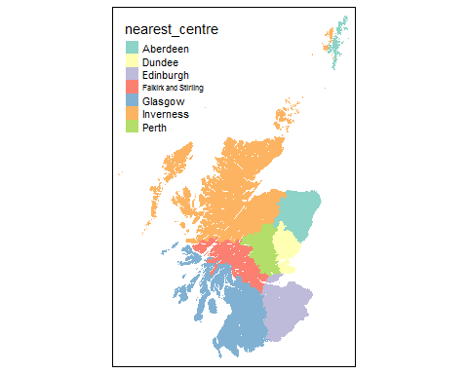

As this map indicates, places in the Orkney and Shetland Islands, and elsewhere in the remote and rural highlands and islands, get assigned to either Aberdeen or Inverness, even though they are not part of any meaningful functional urban geography. However these areas are easily identifiable through their absolute distance from either centre. For the analyses below, we restrict our definition of cities to Datazones within around 20km of the city centroid. (Strictly speaking, we start with a cut-off of 18km but allow this to expand where this process results in ‘islands’ or individual Datazones disconnected from the rest of the city.)

# Results

To begin with, we produce maps to look at how the spatial distribution of poor relative to non-poor has changed over time. We also produce scatterplots to see how changes vary between more or less deprived Datazones.

To address the first research question, we then calculate two simple summary measures to capture changes in the distribution of poor and non-poor groups over time. These are: * The Relative Centralisation Index (RCI): this ranges from -1 to +1, with values greater than zero indicating that the poor group live, on average, closer to the centre of the city than the non-poor group. * The Dissimilarity Index (D): this ranges from 0 to 1, with higher values indicating a greater tendency for poor and non-poor groups to live in different areas.

There are SIMD releases for 2004, 2006, 2009, 2012, and 2016, meaning in RCI and D scores within the period 2001 and 2011 can be observed. The Bayesian spatial modelling approach used by Kavanagh, Lee & Pryce (2016) was applied to each of the SIMD releases, and median RCI and D estimates, along with 95% Credible Intervals (CrIs), were produced for each release and for each city.

To address the second research question, we look at changes in the number of people in the poor and non-poor groups by distance from the city centre.

## Maps

The maps shows the proportion of the population who are classified as Income Deprived for each Datazone, in the years 2004 to 2016. Given that so much of Scotland is rural, few areas appear income deprived using a standard choropleth. However, patterns of high income deprivation are apparent in and near Glasgow.

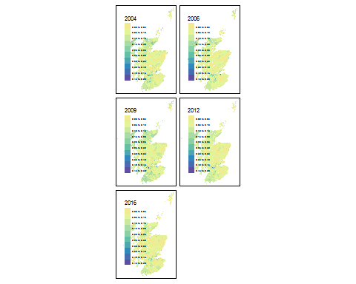

The map below focuses in on income deprivation within Glasgow, and in particular within datazones not more than 15 km from Glasgow city centre. From this map there are suggestions of a decentralisation of poverty, in particular between 2009 and 2012. However there are also clear pockets of areas, in the south, east and north west of Glasgow city, with persistently high levels of income deprivation.

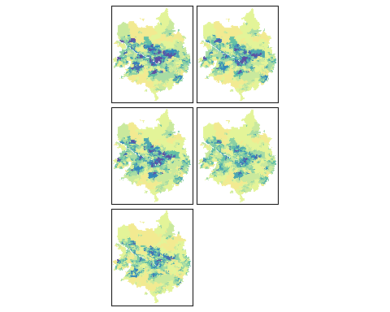

From this map there are suggestions of a decentralisation of poverty, at least as defined as income deprived, in particular between 2009 and 2012. However there are also clear pockets of areas, in the south, east and north west of Glasgow city, with persistently high levels of income deprivation.

An equivalent map for Edinburgh is produced below. This map also suggests that, as in Glasgow, drivers of increasing levels of decentralisation of poverty in Edinburgh include both rapid falls in poverty in the centre, alongside some more suburban areas with persistently high levels of poverty. In Edinburgh's case, in pockets towards the West, North West, and South/South East of the city centre.

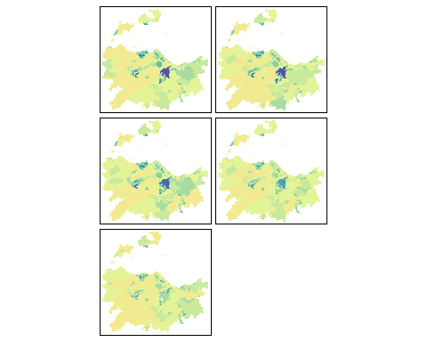

The equivalent map for Dundee is shown below. Within Dundee the patterns of spatial persistence of poverty appear most consistent over time, with a clearer demarcation between urban and non-urban areas. The functional urban geography of Dundee appears more spatially concentrated than for Glasgow and Edinburgh.

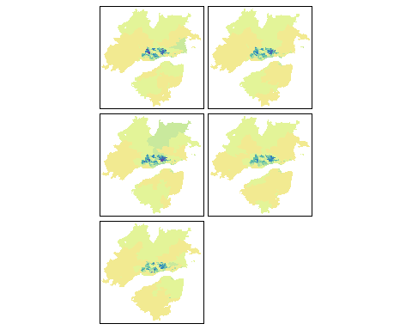

The equivalent map for Aberdeen, historically the most affluent and rural of the four cities, is shown here. As with Glasgow and Edinburgh, it appears both that the greatest changes have occurred between 2009 and 2012, and also that any fall in RCI scores are likely due to persistence of poverty in some local areas, with a high income deprivation area clearly visible in all years to the north west of the city centre.

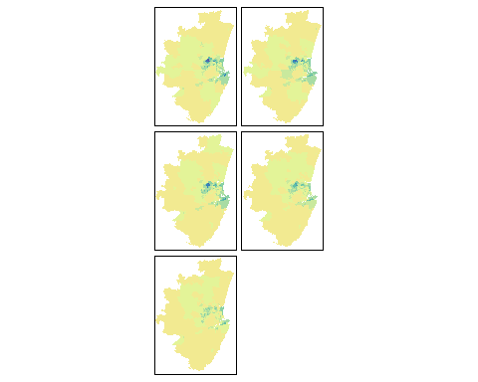

## Plotting temporal dependence

The following plot shows scatterplots of the ID proportions in each Scottish datazone in 2004, 2009 and 2012. Within these plots the blue line indicates parity between values on the x and y axis, and the red dashed line shows a nonlinear smoother function between the two ID proportions being plotted, and hence the level of deviation between the actual relationship over the two years and parity.

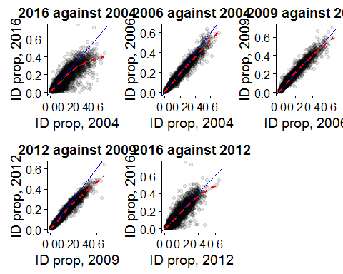

There were indications in the maps above that the greatest changes occurred between the 2009 and 2012 SIMD releases, suggesting that the temporal association between 2004 and 2009 ID proportions would likely be strong compared with the temporal association between 2009 and 2012.

The first of the plots, 2004 compared with 2012, shows strong spatial dependence in areas with low to moderate ID proportions, but much less temporal dependence in areas with high ID proportions in 2004. The second subfigure plots 2004 against 2006 values, and shows a near linear temporal dependence for the complete range of 2004 values, with a global trend towards lower ID proportions throughout Scotland. The temporal relationship between 2006 and 2009 starts to become nonlinear at the upper range of 2006 values, and this nonlinearity at the upper range becomes much stronger between 2009 and 2012.

These plots indicate a complex change in the temporal dependence of ID proportions, likely occurring over the period 2008 to 2012. SIMD 2016 values will be invaluable in indicating whether these changes have continued, altered or settled between 2012 and 2016.

## Income Deprivation by city

Below is a table showing the percentage if the population in each city (within 15 km of the centre) defined as 'income deprived' according to SIMD. In 2004 these percentages ranged from 9.8% in Aberdeen to 20.8% in Glasgow. By 2012 they had fallen to 7.9% in Aberdeen to 17.1% om Glasgow. In every city except Aberdeen the percentage increased from 2006 to 2009, as would be expected given the onset of the 2008 recession within this period, but then fell again from the 2009 to the 2012 SIMD release.

|  |  |  |  |  |  |
| --- | --- | --- | --- | --- | --- |
| City | 2004 | 2006 | 2009 | 2012 | 2016 |
| Aberdeen | 9.8 | 9.7 | 9.4 | 7.9 | 7.0 |
| Perth | 10.0 | 9.9 | 10.7 | 9.7 | 9.3 |
| Inverness | 10.7 | 9.9 | 11.0 | 9.5 | 9.0 |
| Edinburgh | 11.9 | 11.6 | 12.3 | 10.8 | 9.7 |
| Falkirk and Stirling | 13.7 | 12.5 | 13.3 | 12.3 | 11.7 |
| Dundee | 16.7 | 15.4 | 16.9 | 14.5 | 13.9 |
| Glasgow | 20.8 | 18.8 | 19.8 | 17.1 | 16.3 |

The size of the income deprived population is shown below:

|  |  |  |  |  |  |
| --- | --- | --- | --- | --- | --- |
| City | 2004 | 2006 | 2009 | 2012 | 2016 |
| Perth | 8128 | 8295 | 9397 | 8948 | 7515 |
| Inverness | 8345 | 8105 | 10102 | 9492 | 7255 |
| Aberdeen | 26243 | 25288 | 25623 | 22664 | 18925 |
| Falkirk and Stirling | 27218 | 25932 | 29189 | 28012 | 22280 |
| Dundee | 32739 | 30475 | 34497 | 30590 | 26570 |
| Edinburgh | 76612 | 75854 | 84064 | 79110 | 62055 |
| Glasgow | 268118 | 245799 | 265122 | 234194 | 199635 |

And the size of the non-income deprived population is shown below:

|  |  |  |  |  |  |
| --- | --- | --- | --- | --- | --- |
| City | 2004 | 2006 | 2009 | 2012 | 2016 |
| Inverness | 69689 | 73598 | 82084 | 90423 | 73015 |
| Perth | 73174 | 75393 | 78201 | 83056 | 73122 |
| Dundee | 163832 | 167473 | 169428 | 179874 | 164059 |
| Falkirk and Stirling | 171383 | 181083 | 191081 | 199925 | 168317 |
| Aberdeen | 240957 | 236029 | 247887 | 264144 | 250065 |
| Edinburgh | 566077 | 578905 | 601636 | 650887 | 578031 |
| Glasgow | 1022537 | 1061025 | 1070853 | 1136886 | 1028486 |

## RCI calculations

This section presents the results of the RCI calculations, using the Bayesian modelling approach used in Kavanagh et al 2016.

### RCI, Aberdeen

|  |  |  |  |
| --- | --- | --- | --- |
| period | median | lower | upper |
| 2004 | 0.218 | 0.212 | 0.224 |
| 2006 | 0.227 | 0.221 | 0.234 |
| 2009 | 0.200 | 0.194 | 0.206 |
| 2012 | 0.188 | 0.181 | 0.194 |
| 2016 | 0.176 | 0.169 | 0.183 |

### RCI, Dundee

|  |  |  |  |
| --- | --- | --- | --- |
| period | median | lower | upper |
| 2004 | 0.304 | 0.299 | 0.309 |
| 2006 | 0.295 | 0.290 | 0.301 |
| 2009 | 0.266 | 0.261 | 0.272 |
| 2012 | 0.256 | 0.250 | 0.261 |
| 2016 | 0.258 | 0.252 | 0.264 |

### RCI, Edinburgh

|  |  |  |  |
| --- | --- | --- | --- |
| period | median | lower | upper |
| 2004 | 0.013 | 0.009 | 0.017 |
| 2006 | 0.020 | 0.016 | 0.023 |
| 2009 | -0.005 | -0.009 | -0.001 |
| 2012 | -0.013 | -0.017 | -0.009 |
| 2016 | -0.070 | -0.074 | -0.065 |

### RCI, Glasgow

|  |  |  |  |
| --- | --- | --- | --- |
| period | median | lower | upper |
| 2004 | 0.144 | 0.142 | 0.146 |
| 2006 | 0.140 | 0.137 | 0.142 |
| 2009 | 0.125 | 0.123 | 0.128 |
| 2012 | 0.093 | 0.091 | 0.096 |
| 2016 | 0.089 | 0.087 | 0.092 |

## Dissimilarity calculations

This section presents the results of the Dissimilarity index calculations, using the Bayesian modelling approach used in Kavanagh et al 2016.

### D, Aberdeen

|  |  |  |  |
| --- | --- | --- | --- |
| period | median | lower | upper |
| 2004 | 0.382 | 0.377 | 0.388 |
| 2006 | 0.381 | 0.375 | 0.386 |
| 2009 | 0.379 | 0.373 | 0.384 |
| 2012 | 0.362 | 0.356 | 0.367 |
| 2016 | 0.361 | 0.355 | 0.367 |

### D, Dundee

|  |  |  |  |
| --- | --- | --- | --- |
| period | median | lower | upper |
| 2004 | 0.412 | 0.408 | 0.417 |
| 2006 | 0.401 | 0.396 | 0.406 |
| 2009 | 0.383 | 0.378 | 0.387 |
| 2012 | 0.376 | 0.371 | 0.381 |
| 2016 | 0.372 | 0.367 | 0.377 |

### D, Edinburgh

|  |  |  |  |
| --- | --- | --- | --- |
| period | median | lower | upper |
| 2004 | 0.385 | 0.382 | 0.388 |
| 2006 | 0.359 | 0.356 | 0.362 |
| 2009 | 0.339 | 0.336 | 0.342 |
| 2012 | 0.320 | 0.316 | 0.323 |
| 2016 | 0.321 | 0.318 | 0.324 |

### D, Glasgow

|  |  |  |  |
| --- | --- | --- | --- |
| period | median | lower | upper |
| 2004 | 0.367 | 0.366 | 0.369 |
| 2006 | 0.348 | 0.347 | 0.350 |
| 2009 | 0.333 | 0.332 | 0.335 |
| 2012 | 0.316 | 0.314 | 0.317 |
| 2016 | 0.315 | 0.313 | 0.317 |

### Change in RCI and D over time

The graph of RCI over time is shown below. The density of RCI estimates for each place and in each year is shown using a violin plot, with longer shapes indicating a greater range of posterior estimates. The median RCI scores are indicated as points, linked for each city with dashed lines.

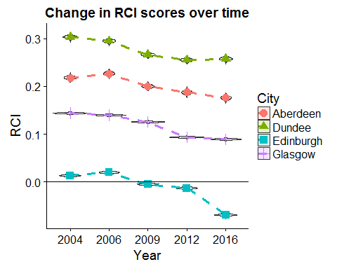

[CHECK] The overall trend for all four cities is for poverty to decentralize between 2004 to 2016. Dundee shows the most centralisation of poverty, then Aberdeen, and Glasgow, with Edinburgh the most decentralised. Indeed, from 2009 onwards, Edinburgh is unique in having poorer households living further from the city centre than non-poor.

[CHECK] For Glasgow and Dundee, the decline in RCI is continuous, whereas for Aberdeen and Edinbugh RCI values increased from 2004 to 2006, before declining in 2009 and 2012. As note above, there is some reason to be more cautious about the comparability of the 2006 data with that from other years.

The equivalent graph for the Dissimilarity index is shown below:

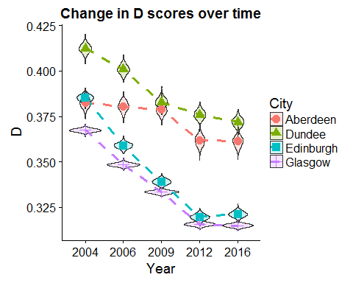

As with RCI, Dissimilarity scores have also fallen over time for all four cities. The greatest contrast in the trends is between Aberdeen and Edinburgh. In 2004 both cities had similar and overlapping D scores, but between 2004 and 2009 segregation fell rapidly for Edinburgh, while remaining fairly stable in Aberdeen, before falling from 2009 to 2012. Glasgow has always had the lowest D scores of the four cities, and Dundee the highest, but since 2009 the distribution of D estimates for Edinburgh have started to overlap those of Glasgow as the rate of decline in D has been slightly greater in Edinburgh than Glasgow. Similarly, the the greatest fall in D occurred between 2006 and 2009.

In general, this suggests segregation is falling or social mix increasing. However, given the findings about about the decentralization of poverty, the concern is that this reduction is merely a temporary phenomenon during a period of structural change: as non-poor groups move back to colonise inner city locations, mixing increases but is then likely to fall again as the poor continue to be displaced.

## Plots of the distance/deprivation relationship

[CHECK] In the figure below, the vertical axis shows the change in the proportion income deprived from 2004 to 2016, and the horizontal axis shows the distance of datazones from the city centres, plotted on a log scale, for each of the four main Scottish cities. Individual datazones are indicated with faint circles, and a nonlinear smoother has been added showing how this the change in income deprivation varies as a function of distance. A dashed horizontal line has been added indicating no change in deprivation between the two period, and vertical lines added at 1km and 12km, as below 1km there are few observations, and above 12km the effect of a functional urban geography appears small.

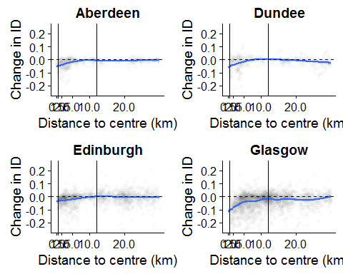

These plots suggest a qualitatively similar relationship between change in deprivation and distance, up to around 12km from city centre, for Aberdeen, Edinburgh and Glasgow, with Glasgow showing the strongest gradient of change between these two periods. Dundee shows a similar kind of relationship, but concentrated within the first 5km, rather than 12km, of distance from city centre. This is consistent with the maps of income deprivation in Dundee, showing much greater levels of spatial concentration than for the other cities.

### Numerator and denominator changes

The falls in income deprivation nearer city centres are a function both of changing numerators - i.e. changes to the number of people income deprived - and changing denominators - i.e. changes to total population sizes. To gain a better understanding of the relative influence of these two changes to the relationship shown in the previous figure, the next two figures show the proportionate change from 2004 to 2012 in income deprived populations, and total populations.

The next figure shows how the income deprived population has changed between the two periods.

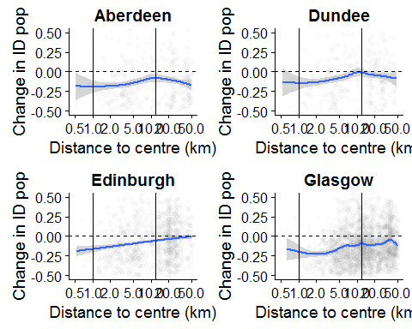 This plot indicates proportionate falls in the ID population shares at distances closes to the city centre, up to around 20% in Aberdeen and Glasgow, and either proportionate rises (Dundee and Edinburgh) or little change in proportions (Aberdeen and Glasgow) at greater distance from the city centre. This seems to suggest, for Aberdeen and Glasgow in particular, that 'gentrification of the centre' could be as much or more of an explanation for falls in RCI as 'impoverishment of the periphery', though that there are somewhat different socioeconomic mechanisms in place for the four cities.

The following plot shows the change in the total population size as a function of distance from city centre. (The smoother line at distances less than 1km should likely be ignored for most cities as it involves extrapolation based on very few observations).

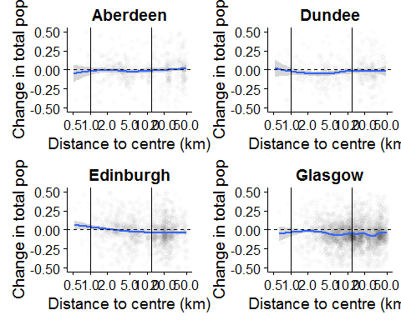

This plot suggests that there have been substantial increases in population sizes in Aberdeen, Edimburgh and Glasgow over this period, in datazones closer to the city centre, with the greatest changes occurring near the centre of Glasgow. In Aberdeen, and to a lesser extent for Dundee, there have also been increases in population shares living at distances of 12km and more from the city, suggesting greatest consistency in population sizes at intermediate distances.

# Limitations and recommendations for further research

Alternative methods of reweighting SIMD values released at 2001 datazone levels could be explored, including those which make use of more sophisticated GIS-based methods to apportion values to 2011 datazones, and of approaches which use SIMD component values available at a higher level of spatial disaggregation (e.g. output areas) to recalculate and reapportion SIMD scores to 2011 datazone geographies.

The robustness of the results to the choice of city centre could be explored in a sensitivity analysis.

# Appendices

## Appendix A: Code for reweighting SIMD available for 2001 datazones onto 2011 datazones

Within the script below, the object lkup is the lookup file produced by Paul Norman, and simd_combined contains data from the 2004, 2006, 2009, 2012 and 2016 releases of the SIMD.

lkup <- read_csv("data/paul_norman_file/paul_norman_dz2011_table.csv")  
simd_combined <- read_csv("data/simd/simd_combined.csv")  
  
lkup

## Source: local data frame [59,492 x 7]  
##   
## oa_2001 oa_nrs dz_2011 oa_2011 dz_2001 la_2011  
## (chr) (chr) (chr) (chr) (chr) (chr)  
## 1 S00000002 60QA000002 S01006732 S00088957 S01000215 S12000033  
## 2 S00000002 60QA000002 S01006732 S00088958 S01000215 S12000033  
## 3 S00000002 60QA000002 S01006732 S00088956 S01000215 S12000033  
## 4 S00000002 60QA000002 S01006736 S00088957 S01000215 S12000033  
## 5 S00000002 60QA000002 S01006736 S00088958 S01000215 S12000033  
## 6 S00000002 60QA000002 S01006736 S00088956 S01000215 S12000033  
## 7 S00000002 60QA000002 S01006737 S00088957 S01000215 S12000033  
## 8 S00000002 60QA000002 S01006737 S00088958 S01000215 S12000033  
## 9 S00000002 60QA000002 S01006737 S00088956 S01000215 S12000033  
## 10 S00000003 60QA000003 S01006710 S00088959 S01000123 S12000033  
## .. ... ... ... ... ... ...  
## Variables not shown: la_name (chr)

simd_combined

## Source: local data frame [32,996 x 7]  
##   
## datazone year pop_total pop_workingage pop_incomedeprived simd_score  
## (chr) (int) (int) (int) (int) (dbl)  
## 1 S01000001 2004 864 575 62 6.706758  
## 2 S01000002 2004 687 505 14 4.187703  
## 3 S01000003 2004 838 568 24 4.829398  
## 4 S01000004 2004 641 460 13 5.345036  
## 5 S01000005 2004 663 470 21 4.636054  
## 6 S01000006 2004 626 346 83 11.475745  
## 7 S01000007 2004 857 464 38 4.003078  
## 8 S01000008 2004 584 358 65 11.374401  
## 9 S01000009 2004 710 453 40 9.133005  
## 10 S01000010 2004 568 410 15 6.649007  
## .. ... ... ... ... ... ...  
## Variables not shown: simd_rank (int)

lkup %>%  
 dplyr::select(dz_2001, dz_2011) %>%  
 arrange(dz_2001, dz_2011) %>%  
 group_by(dz_2001, dz_2011) %>%  
 tally %>% # produce n, giving number of OAs which contain particular groupings of dz_2001 and dz_2011  
 arrange(dz_2011, dz_2001) %>%  
 dplyr::select(dz_2011, dz_2001, n) %>%  
 group_by(dz_2011) %>%  
 arrange(dz_2011, dz_2001) %>%  
 mutate(weight = n / sum(n)) -> weighting  
weighting

## Source: local data frame [15,540 x 4]  
## Groups: dz_2011 [6976]  
##   
## dz_2011 dz_2001 n weight  
## (chr) (chr) (int) (dbl)  
## 1 S01006506 S01000001 9 1.0000000  
## 2 S01006507 S01000005 1 0.1250000  
## 3 S01006507 S01000013 6 0.7500000  
## 4 S01006507 S01000024 1 0.1250000  
## 5 S01006508 S01000001 3 0.3333333  
## 6 S01006508 S01000005 6 0.6666667  
## 7 S01006509 S01000008 6 0.8571429  
## 8 S01006509 S01000013 1 0.1428571  
## 9 S01006510 S01000006 6 0.8571429  
## 10 S01006510 S01000008 1 0.1428571  
## .. ... ... ... ...

weighting %>% # Weighting by dz_2011  
 left_join(simd_combined, by = c("dz_2001" = "datazone")) %>%  
 dplyr::select(-simd_rank) %>% # Not meaningful to reweight rank  
 group_by(dz_2011, year) %>%  
 summarise_each( ~ sum(. * weight), 6:9) -> simd_2011_reweighted  
  
simd_2011_reweighted

## Source: local data frame [27,904 x 6]  
## Groups: dz_2011 [?]  
##   
## dz_2011 year pop_total pop_workingage pop_incomedeprived simd_score  
## (chr) (int) (dbl) (dbl) (dbl) (dbl)  
## 1 S01006506 2004 864.0000 575.000 62.00000 6.706758  
## 2 S01006506 2006 842.0000 566.000 69.00000 9.061800  
## 3 S01006506 2009 836.0000 554.000 60.00000 7.916251  
## 4 S01006506 2012 914.0000 612.000 75.00000 10.043655  
## 5 S01006507 2004 820.3750 507.000 43.87500 8.488053  
## 6 S01006507 2006 756.8750 471.500 39.62500 8.937893  
## 7 S01006507 2009 740.5000 450.750 65.00000 11.280132  
## 8 S01006507 2012 736.7500 466.375 50.62500 9.066177  
## 9 S01006508 2004 730.0000 505.000 34.66667 5.326289  
## 10 S01006508 2006 699.3333 494.000 37.66667 6.905884  
## .. ... ... ... ... ... ...