Economic Status Transitions: Employed ↔︎ Long-term Sick
IFoA Collaboration: Model Results and Counterfactual Analysis
Author: Jon Minton
Published: January 20, 2026
1 Executive Summary
This report presents multinomial logistic regression models for economic status transitions, focusing on movements between Employed and Long-term Sick states. Rising economic inactivity due to long-term sickness has become a significant policy concern in the UK (Tinson, Major, and Finch 2022). Using data from the UK Household Longitudinal Study (UKHLS) waves 1-11 (2009-2020) (Platt et al. 2021), we estimate the role of health (SF-12 mental and physical component scores (Ware, Kosinski, and Keller 1996)) and occupation class (NS-SEC 3-class (Office for National Statistics 2022)) in explaining these transitions.
Key findings:
- Model selection: The best-fitting model (by BIC) includes health scores, occupation class, and a year trend, without interaction terms
- Health effects: Both mental and physical health strongly predict transitions - poorer health increases risk of becoming long-term sick
- Occupation gradient: Routine/manual occupations have higher Employed → LT Sick transition rates than management/professional occupations
- Population Attributable Fraction: Approximately 28% of Employed → LT Sick transitions among 50-year-olds can be attributed to occupational class inequalities

2 Analytical Framework
2.1 Pre-specification of Analytical Decisions
To minimise researcher degrees of freedom and ensure transparency, we document the following decisions made before analysing the data:
Decision | Choice | Rationale
Data source | UKHLS waves 1-11 (2009-2020) | Largest UK panel study with economic status
Transition definition | Adjacent waves only | Avoids complications of variable gap lengths
Age range | 16-64 (working age) | Standard UK working age definition
Economic status categories | 7-level (Level 3) | Distinguishes LT Sick from other inactive
Health measures | SF-12 MCS/PCS (continuous) | More granular than binary measures
Occupation classification | NS-SEC 3-class | Balance between detail and cell counts
Missing data | Complete cases only | Avoids imputation assumptions
Model type | Multinomial logistic regression | Standard for categorical outcomes
Model selection | AIC/BIC comparison | Let data determine best specification

2.2 Alternative Approaches Not Pursued
The analysis could reasonably be extended in other ways:
- Longer transition gaps - e.g., 2-year or 5-year transitions
- NS-SEC 5-class or 8-class - more occupational detail but sparser cells
- Binary health measure - limiting long-term illness (yes/no)
- Imputed missing data - could increase sample size
- Regional variation - sub-national analysis
These alternatives can be explored in subsequent analyses if considered valuable.

3 Data Description
Code
# Sample sizes by dataset
data_core <- readRDS(here::here("reports/ifoa/models/data_core.rds"))
data_health <- readRDS(here::here("reports/ifoa/models/data_health.rds"))

tibble(
Dataset = c("Core (demography only)", "With health scores", "With health + occupation"),
`N observations` = c(nrow(data_core), nrow(data_health), nrow(data_full)),
`N individuals` = c(n_distinct(data_core$pidp), n_distinct(data_health$pidp), n_distinct(data_full$pidp))
) |>
mutate(across(where(is.numeric), ~comma(.))) |>
kable(caption = "Sample sizes by model dataset") |>
kable_styling(bootstrap_options = c("striped", "hover"))
Sample sizes by model dataset
Dataset | N observations | N individuals
Core (demography only) | 305,327 | 58,302
With health scores | 269,786 | 54,082
With health + occupation | 190,465 | 40,604

3.1 Economic Status Distribution
The seven-level economic status categorisation distinguishes between types of economic inactivity:
Code
data_full |>
count(this_status, name = "N") |>
mutate(Percent = percent(N / sum(N), accuracy = 0.1)) |>
arrange(desc(N)) |>
kable(col.names = c("Current Economic Status", "N", "Percent"),
caption = "Distribution of current economic status in analysis sample") |>
kable_styling(bootstrap_options = c("striped", "hover"))
Distribution of current economic status in analysis sample
Current Economic Status | N | Percent
Employed | 183058 | 96.1%
Inactive student | 5492 | 2.9%
Inactive retired | 556 | 0.3%
Unemployed | 461 | 0.2%
Inactive care | 369 | 0.2%
Inactive long term sick | 271 | 0.1%
Inactive other | 258 | 0.1%

3.2 Transition Matrix
Code
data_full |>
count(this_status, next_status) |>
group_by(this_status) |>
mutate(pct = round(100 * n / sum(n), 1)) |>
ungroup() |>
select(-n) |>
pivot_wider(names_from = next_status, values_from = pct, values_fill = 0) |>
kable(caption = "Transition matrix: row percentages (current → next wave status)") |>
kable_styling(bootstrap_options = c("striped", "hover"), font_size = 11) |>
scroll_box(width = "100%")

Transition matrix: row percentages (current → next wave status)
this_status | Employed | Inactive care | Inactive long term sick | Inactive other | Inactive retired | Inactive student | Unemployed
Employed | 94.5 | 0.8 | 0.4 | 0.2 | 1.5 | 0.8 | 1.8
Inactive care | 57.7 | 33.9 | 0.5 | 1.4 | 3.3 | 0.5 | 2.7
Inactive long term sick | 45.0 | 2.6 | 31.0 | 0.4 | 12.2 | 0.4 | 8.5
Inactive other | 60.9 | 7.0 | 2.3 | 12.0 | 4.3 | 8.5 | 5.0
Inactive retired | 31.8 | 1.1 | 0.5 | 0.2 | 66.0 | 0.0 | 0.4
Inactive student | 34.5 | 0.1 | 0.0 | 0.7 | 0.0 | 61.3 | 3.2
Unemployed | 68.5 | 3.7 | 2.2 | 0.9 | 2.4 | 4.3 | 18.0

4 Model Comparison
Eight candidate model specifications were fitted and compared using AIC and BIC criteria. Models were fit separately in a script (_fit_models.R) and saved for reproducibility.
Code
# Load model comparison results (best_model and data_full already loaded in setup)
model_comparison <- readRDS(here::here("reports/ifoa/models/model_comparison.rds"))

4.1 Model Specifications Tested
Model | Formula | N | Description
1 | next_status ~ this_status * sex + bs(age, 5) | 305,327 | Foundation (demography only)
2 | + wave_num | 305,327 | + Year trend
3 | + sf12mcs_std + sf12pcs_std | 269,786 | + Health scores
4 | + health + wave_num | 269,786 | + Health + year
5 | + health + nssec3 | 190,465 | + Health + occupation
6 | + health + occupation + wave_num | 190,465 | + Health + occupation + year
7 | + health × occupation | 190,465 | + Interaction terms
8 | Full (all interactions + year) | 190,465 | Most complex

4.2 AIC/BIC Comparison
Code
model_comparison |>
select(name, n, converged, aic, bic) |>
mutate(
name = str_remove(name, "mod_0") |> str_replace("_", ": "),
aic = comma(round(aic, 0)),
bic = comma(round(bic, 0)),
n = comma(n)
) |>
arrange(bic) |>
kable(
col.names = c("Model", "N", "Converged", "AIC", "BIC"),
caption = "Model comparison ranked by BIC (lower is better)"
) |>
kable_styling(bootstrap_options = c("striped", "hover")) |>
row_spec(1, bold = TRUE, background = "#e6f3ff")
Model comparison ranked by BIC (lower is better)
Model | N | Converged | AIC | BIC
6: health_nssec_year | 190,465 | TRUE | 104,008 | 105,592
5: health_nssec | 190,465 | TRUE | 104,246 | 105,770
8: full | 190,465 | TRUE | 104,028 | 105,857
7: health_nssec_interact | 190,465 | TRUE | 104,267 | 106,034
4: health_year | 269,786 | TRUE | 243,223 | 244,736
3: health | 269,786 | TRUE | 243,528 | 244,977
2: foundation_year | 305,327 | TRUE | 288,848 | 290,251
1: foundation | 305,327 | TRUE | 289,147 | 290,486
Model selection decision: Model 6 (mod_06_health_nssec_year) is selected as it has the lowest BIC. This model includes:
- Current economic status (this_status) with sex interaction
- Age (B-spline with 5 degrees of freedom)
- Standardised SF-12 mental and physical component scores
- NS-SEC 3-class occupation
- Year trend
The interaction models (7 and 8) did not improve BIC despite their additional complexity, indicating that the effect of health on transitions does not differ meaningfully by occupation class.
5 Transition Probabilities by NS-SEC
Using the selected model, we estimate transition probabilities for individuals with specific characteristics.
5.1 Employed → Long-term Sick Transitions
We focus on the transition of interest: movement from Employed to Long-term Sick status. We examine how this varies by occupation class, holding other factors constant.
Code
# Create prediction grid for Employed individuals aged 50
pred_grid_emp <- expand_grid(
this_status = "Employed",
sex = c("male", "female"),
age = 50,
sf12mcs_std = 0, # Average mental health
sf12pcs_std = 0, # Average physical health
nssec3 = nssec_levels, # Use ordinal ordering
wave_num = 11 # Latest wave (2019-2020)
)

# Get predictions
pred_emp <- predict(best_model, newdata = pred_grid_emp, type = "probs")

# Combine with grid and apply factor ordering
pred_emp_df <- bind_cols(pred_grid_emp, as_tibble(pred_emp)) |>
select(sex, nssec3, `Inactive long term sick`) |>
rename(prob_ltsick = `Inactive long term sick`) |>
mutate(nssec3 = factor(nssec3, levels = nssec_levels))

# Display table
pred_emp_df |>
mutate(
prob_ltsick_pct = percent(prob_ltsick, accuracy = 0.01),
prob_ltsick_per_10k = comma(prob_ltsick * 10000, accuracy = 1)
) |>
select(sex, nssec3, prob_ltsick_pct, prob_ltsick_per_10k) |>
kable(
col.names = c("Sex", "NS-SEC Class", "Probability", "Per 10,000"),
caption = "Predicted Employed → LT Sick transition probability (age 50, average health, wave 11)"
) |>
kable_styling(bootstrap_options = c("striped", "hover"))
Predicted Employed → LT Sick transition probability (age 50, average health, wave 11)
Sex | NS-SEC Class | Probability | Per 10,000
male | Routine & Manual | 0.28% | 28
male | Intermediate | 0.17% | 17
male | Management & Professional | 0.13% | 13
female | Routine & Manual | 0.31% | 31
female | Intermediate | 0.18% | 18
female | Management & Professional | 0.15% | 15
Code
pred_emp_df |>
ggplot(aes(x = nssec3, y = prob_ltsick, fill = sex)) +
geom_col(position = "dodge") +
scale_y_continuous(labels = percent_format(accuracy = 0.1)) +
scale_fill_brewer(palette = "Set1", name = "Sex") +
labs(
x = "NS-SEC Occupation Class",
y = "Probability of Transition to LT Sick",
title = "Employed → Long-term Sick Transitions",
subtitle = "Predicted for age 50, average health scores, wave 11 (2019-20)"
) +
theme_minimal() +
theme(axis.text.x = element_text(angle = 15, hjust = 1))
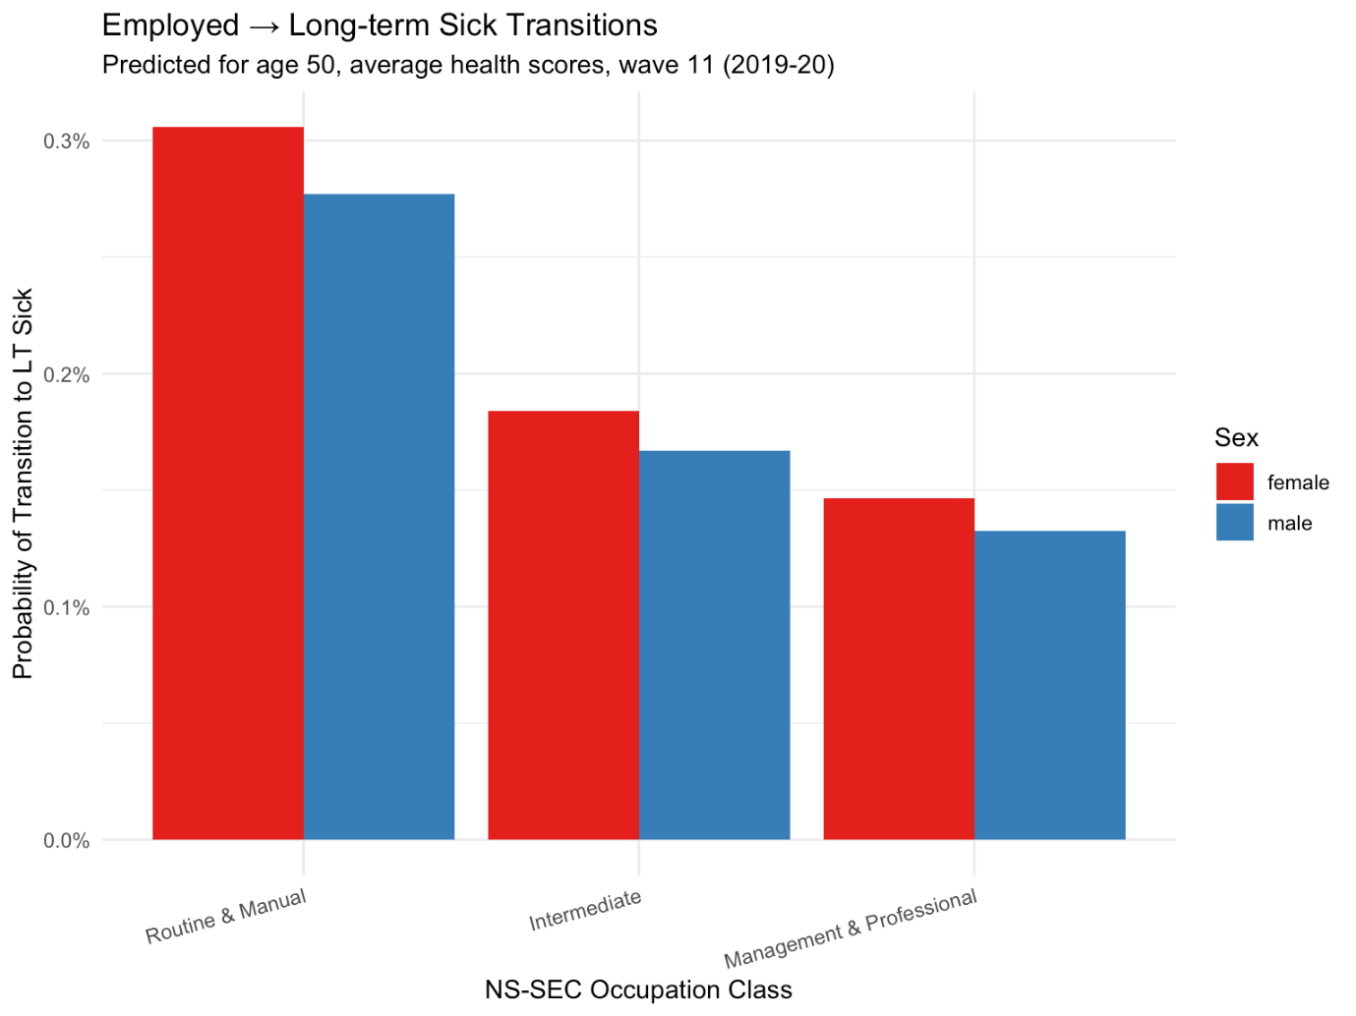
Predicted probability of Employed → LT Sick transition by occupation class (age 50, average health)

6 Counterfactual Analysis: Population Attributable Fraction

6.1 Analytical Approach
To quantify the contribution of occupational class to Employed → LT Sick transitions, we conduct a counterfactual simulation:
- Baseline scenario: 10,000 males aged 50 and 10,000 females aged 50, all currently Employed, distributed across NS-SEC classes proportionally to the observed sample
- Counterfactual scenario: Same population, but everyone assigned to “Management & Professional” (the class with lowest LT Sick transition risk)
- PAF calculation: (Baseline transitions - Counterfactual transitions) / Baseline transitions
Code
# Display NS-SEC distribution (computed in setup)
nssec_dist |>
mutate(prop_pct = percent(prop, accuracy = 0.1)) |>
select(sex, nssec3, n, prop_pct) |>
kable(
col.names = c("Sex", "NS-SEC Class", "N", "Proportion"),
caption = "NS-SEC distribution among employed individuals aged 45-55"
) |>
kable_styling(bootstrap_options = c("striped", "hover"))
NS-SEC distribution among employed individuals aged 45-55
Sex | NS-SEC Class | N | Proportion
female | Routine & Manual | 9003 | 29.2%
female | Intermediate | 7728 | 25.1%
female | Management & Professional | 14096 | 45.7%
male | Routine & Manual | 8075 | 30.8%
male | Intermediate | 5673 | 21.6%
male | Management & Professional | 12466 | 47.6%

6.2 Results: Occupation-Attributable Transitions
Code
paf_results |>
mutate(
baseline_expected = round(baseline_expected, 1),
counter_expected = round(counter_expected, 1),
diff_absolute = round(diff_absolute, 1),
paf = paste0(round(paf, 1), "%")
) |>
select(sex, n, baseline_expected, counter_expected, diff_absolute, paf) |>
kable(
col.names = c("Sex", "N", "Baseline Expected", "Counterfactual Expected",
"Difference", "PAF"),
caption = "Population Attributable Fraction for Employed → LT Sick transitions due to occupational class inequality"
) |>
kable_styling(bootstrap_options = c("striped", "hover"))
Population Attributable Fraction for Employed → LT Sick transitions due to occupational class inequality
Sex | N | Baseline Expected | Counterfactual Expected | Difference | PAF
male | 10000 | 18.5 | 13.3 | 5.2 | 28.1%
female | 10000 | 20.2 | 14.7 | 5.6 | 27.6%

Code
paf_plot_data <- paf_results |>
select(sex, baseline_expected, counter_expected) |>
pivot_longer(
cols = c(baseline_expected, counter_expected),
names_to = "scenario",
values_to = "expected_transitions"
) |>
mutate(
scenario = case_when(
scenario == "baseline_expected" ~ "Baseline\n(observed NS-SEC distribution)",
scenario == "counter_expected" ~ "Counterfactual\n(all Management & Professional)"
)
)

ggplot(paf_plot_data, aes(x = scenario, y = expected_transitions, fill = sex)) +
geom_col(position = "dodge") +
geom_text(aes(label = round(expected_transitions, 0)),
position = position_dodge(width = 0.9), vjust = -0.5) +
scale_fill_brewer(palette = "Set1", name = "Sex") +
labs(
x = "",
y = "Expected Transitions to LT Sick (per 10,000)",
title = "Effect of Equalising Occupational Class",
subtitle = "Among 10,000 employed individuals aged 50"
) +
theme_minimal()
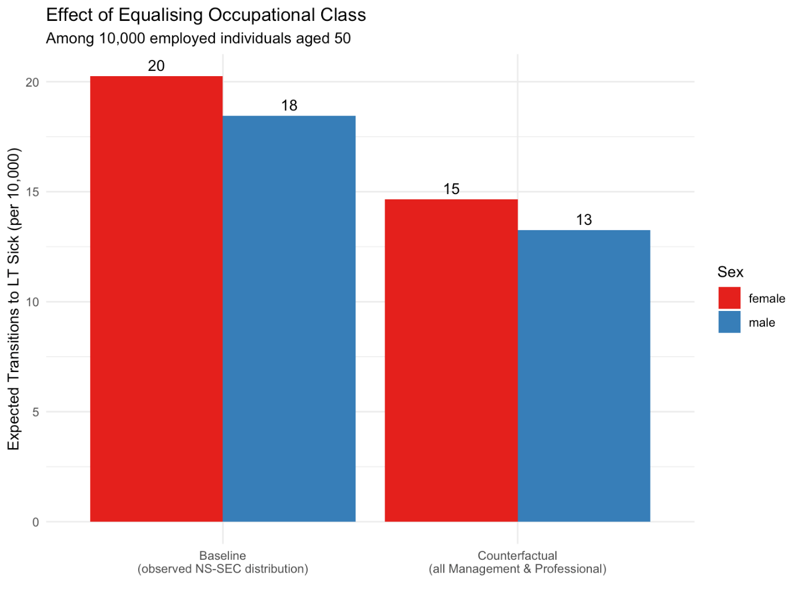
Expected Employed → LT Sick transitions under baseline and counterfactual scenarios

6.3 Interpretation
Among a hypothetical cohort of 10,000 employed 50-year-olds with average health:
- Baseline: With the observed distribution of occupational classes, we expect approximately 18 males and 20 females to transition to long-term sickness over the following year.
- Counterfactual: If everyone had the transition risk of Management & Professional occupations, we would expect approximately 13 males and 15 females to make this transition.
- PAF: Approximately 28% of Employed → LT Sick transitions among 50-year-olds can be attributed to occupational class inequality.
This suggests that if all workers had the same low transition risk as those in management and professional occupations, we could expect roughly 28% fewer transitions from employment to long-term sickness in this age group.

7 Time Trends
The model includes a year trend (wave_num). This captures systematic changes in transition probabilities over the 2009-2020 period.
Code
# Predictions across waves
time_grid <- expand_grid(
this_status = "Employed",
sex = c("male", "female"),
age = 50,
sf12mcs_std = 0,
sf12pcs_std = 0,
nssec3 = "Routine & Manual",
wave_num = 1:11
)

time_preds <- predict(best_model, newdata = time_grid, type = "probs")
time_df <- bind_cols(time_grid, as_tibble(time_preds)) |>
mutate(
year = 2008 + wave_num,
prob_ltsick = `Inactive long term sick`
)

ggplot(time_df, aes(x = year, y = prob_ltsick, colour = sex)) +
geom_line(linewidth = 1) +
geom_point(size = 2) +
scale_y_continuous(labels = percent_format(accuracy = 0.1)) +
scale_colour_brewer(palette = "Set1", name = "Sex") +
scale_x_continuous(breaks = seq(2009, 2019, 2)) +
labs(
x = "Year",
y = "Probability of Transition to LT Sick",
title = "Time Trend in Employed → LT Sick Transitions",
subtitle = "Routine & Manual occupations, age 50, average health"
) +
theme_minimal()
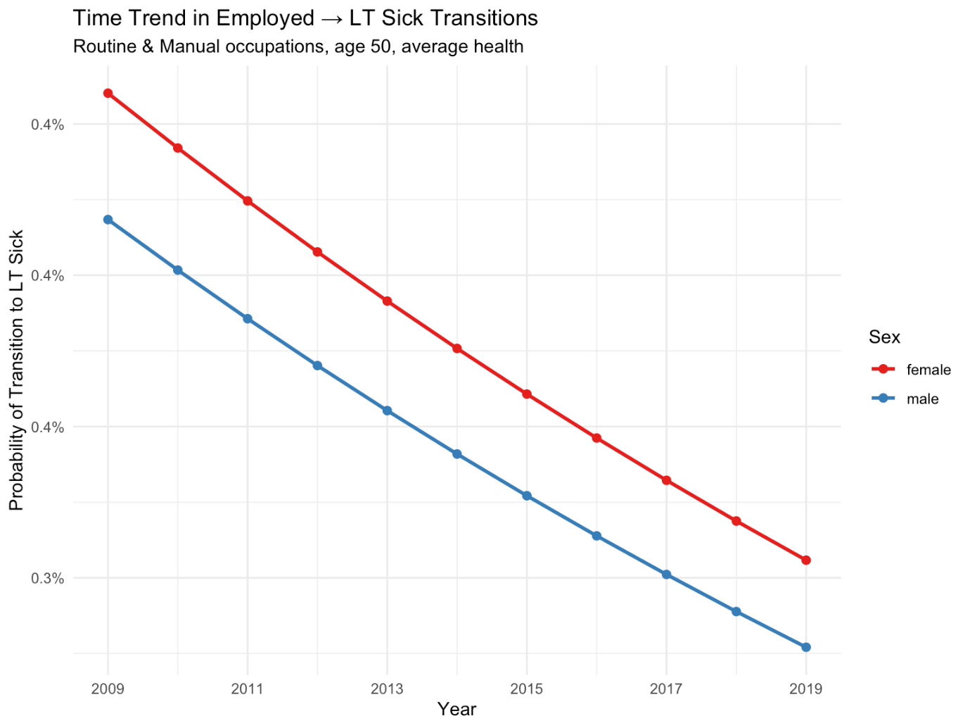
Predicted Employed → LT Sick probability over time (age 50, average health, Routine & Manual)

8 Discussion
8.1 Key Findings
- Health is the strongest predictor: Both mental and physical health scores substantially improve model fit (AIC drops from ~289k to ~244k when health is added).
- Occupation class matters: Adding NS-SEC occupation further improves fit. Those in routine/manual occupations have higher risk of transitioning from employment to long-term sickness.
- No evidence for interaction effects: The relationship between health and transitions does not differ significantly by occupation class (interaction models did not improve BIC).
- Year trend is significant: Transition probabilities have changed systematically over 2009-2020, though the magnitude is modest.
- PAF for occupation: Approximately 28% of Employed → LT Sick transitions among 50-year-olds can be attributed to occupational class inequalities.
8.2 Limitations
- Pre-pandemic data: Analysis uses waves 1-11 (2009-2020). Post-pandemic patterns may differ.
- Complete cases: Individuals missing health or occupation data are excluded, reducing sample size.
- Causal interpretation: These are associations controlling for observed confounders; unobserved confounding may remain.
- NS-SEC measurement: Based on current/recent job; may not capture full occupational history.
8.3 Implications for Actuarial Analysis
- Risk stratification: Occupation class provides meaningful stratification of transition risk beyond health status alone.
- Projection scenarios: The model can be used to project future LT Sick populations under different assumptions about health trajectories or occupational composition.
- Intervention targeting: The PAF analysis suggests that reducing occupational class gradients in transition risk could meaningfully reduce the flow into long-term sickness.

9 Technical Appendix
9.1 Model Coefficients
Code
# Extract and display coefficients for key transitions
coefs <- coef(best_model)

# Focus on Employed → LT Sick (relative to staying Employed)
if ("Inactive long term sick" %in% rownames(coefs)) {
ltsick_coefs <- coefs["Inactive long term sick", ]

# Select key coefficients
key_coefs <- ltsick_coefs[c(
"(Intercept)",
"this_statusEmployed:sexmale",
"sf12mcs_std",
"sf12pcs_std",
"nssec3Intermediate",
"nssec3Routine & Manual",
"wave_num"
)]

tibble(
Coefficient = names(key_coefs),
Estimate = round(key_coefs, 3),
`Odds Ratio` = round(exp(key_coefs), 3)
) |>
kable(caption = "Selected coefficients for Employed → LT Sick transition (reference: Employed, female, Management & Professional)") |>
kable_styling(bootstrap_options = c("striped", "hover"))
}
Selected coefficients for Employed → LT Sick transition (reference: Employed, female, Management & Professional)
Coefficient | Estimate | Odds Ratio
(Intercept) | -6.543 | 0.001
NA | NA | NA
sf12mcs_std | -0.557 | 0.573
sf12pcs_std | -0.914 | 0.401
NA | NA | NA
nssec3Routine & Manual | 0.513 | 1.671
wave_num | -0.043 | 0.958

9.2 Session Information
Code
sessionInfo()
R version 4.1.1 (2021-08-10)
Platform: aarch64-apple-darwin20.0.0 (64-bit)
Running under: macOS 15.7.3

Matrix products: default
BLAS: /Users/JonMinton/anaconda3/lib/R/lib/libRblas.dylib
LAPACK: /Users/JonMinton/anaconda3/lib/R/lib/libRlapack.dylib

locale:
[1] en_GB.UTF-8/en_GB.UTF-8/en_GB.UTF-8/C/en_GB.UTF-8/en_GB.UTF-8

attached base packages:
[1] splines stats graphics grDevices utils datasets methods
[8] base

other attached packages:
[1] patchwork_1.3.2 scales_1.4.0 kableExtra_1.3.4 knitr_1.42
[5] nnet_7.3-19 forcats_1.0.0 stringr_1.5.0 dplyr_1.1.1
[9] purrr_1.0.1 readr_2.1.4 tidyr_1.3.0 tibble_3.2.1
[13] ggplot2_4.0.1 tidyverse_1.3.2 here_1.0.1

loaded via a namespace (and not attached):
[1] svglite_2.1.2 lubridate_1.9.2 rprojroot_2.0.3
[4] digest_0.6.33 utf8_1.2.3 R6_2.5.1
[7] cellranger_1.1.0 backports_1.4.1 reprex_2.0.2
[10] evaluate_0.21 highr_0.10 httr_1.4.5
[13] pillar_1.9.0 rlang_1.1.2 googlesheets4_1.1.0
[16] readxl_1.4.1 rstudioapi_0.14 rmarkdown_2.20
[19] labeling_0.4.2 webshot_0.5.5 googledrive_2.1.0
[22] htmlwidgets_1.6.2 S7_0.2.1 broom_1.0.4
[25] compiler_4.1.1 modelr_0.1.11 xfun_0.38
[28] pkgconfig_2.0.3 systemfonts_1.0.5 htmltools_0.5.5
[31] tidyselect_1.2.0 fansi_1.0.4 viridisLite_0.4.1
[34] crayon_1.5.2 tzdb_0.3.0 dbplyr_2.3.2
[37] withr_2.5.0 grid_4.1.1 jsonlite_1.8.7
[40] gtable_0.3.6 lifecycle_1.0.3 DBI_1.1.3
[43] magrittr_2.0.3 cli_3.6.1 stringi_1.7.5
[46] farver_2.1.1 fs_1.6.1 xml2_1.3.3
[49] generics_0.1.3 vctrs_0.6.1 RColorBrewer_1.1-3
[52] tools_4.1.1 glue_1.6.2 hms_1.1.3
[55] fastmap_1.1.1 yaml_2.3.7 timechange_0.2.0
[58] gargle_1.4.0 rvest_1.0.3 haven_2.5.2

10 References
Office for National Statistics. 2022. “The National Statistics Socio-Economic Classification (NS-SEC).” https://www.ons.gov.uk/methodology/classificationsandstandards/otherclassifications/thenationalstatisticssocioeconomicclassificationnssecrebasedonsoc2010.
Platt, Lucinda, Gundi Knies, Renee Luthra, Alita Nandi, and Michaela Benzeval. 2021. “Understanding Society at 10 Years.” European Sociological Review 36 (6): 976–88. https://doi.org/10.1093/esr/jcaa031.
Tinson, Adam, Alice Major, and David Finch. 2022. “Is Poor Health Driving a Rise in Economic Inactivity?” The Health Foundation. https://www.health.org.uk/news-and-comment/charts-and-infographics/is-poor-health-driving-a-rise-in-economic-inactivity.
Ware, J., M. Kosinski, and S. D. Keller. 1996. “A 12-Item Short-Form Health Survey: Construction of Scales and Preliminary Tests of Reliability and Validity.” Medical Care 34 (3): 220–33. https://doi.org/10.1097/00005650-199603000-00003.

DRB General Observations
- Fascinating paper and results! Many thanks for preparing!
- Can the analysis generate a table of transition rates by age, sex, occupation class? I.e. using the coefficients output.
  - Could these be considered to be "yearly" transition rates? Or are the time periods between survey waves not exactly 1 year.
I.e. at table with rates like this, possibly for each year, or just the average across 2009 – 2020:
Sex --> | female | female | female | male | male | male
NS-SEC Class --> | Routine & Manual | Intermediate | Management & Professional | Routine & Manual | Intermediate | Management & Professional
Age
16
17
18
19
20
:
:
:
60
61
62
63
64

- Maybe consider the transition rates from LT sick back to Employed

