diversity means and sds

Jon Minton

Tuesday, March 10, 2015

# Request from Ade

Jon,

Meantime, do you think you could also produce a table showing the average (mean) values and s.d.s for the diversity scores on each dimension, for all datazones in Greater Glasgow and then also separately by SIMD 2012 quintile?

Yours, Ade

# Mean and SDs for diversity scores

## Mean and SD of raw results

The following shows the means and sds for each diversity type. The first table shows the raw scores; the second shows each after being converted to a percentile rank. The third shows the scores after being converted to the proportion of the range from the minimum to maximum values (i.e. x - min(x) / (max(x) -min(x)))

|  |  |  |
| --- | --- | --- |
| type | mean | sd |
| demographic | 2.385 | 0.077 |
| dtype | 0.812 | 0.387 |
| ethnicity | 0.431 | 0.247 |
| sec | 1.507 | 0.073 |
| tenure | 0.590 | 0.251 |
| space | 0.128 | 0.104 |
| band | 1.161 | 0.393 |
| type | mean | sd |
| demographic | 0.500 | 0.289 |
| dtype | 0.499 | 0.290 |
| ethnicity | 0.500 | 0.289 |
| sec | 0.500 | 0.289 |
| tenure | 0.500 | 0.289 |
| space | 0.499 | 0.291 |
| band | 0.500 | 0.289 |
| type | mean | sd |
| demographic | 0.883 | 0.101 |
| dtype | 0.587 | 0.280 |
| ethnicity | 0.228 | 0.169 |
| sec | 0.756 | 0.079 |
| tenure | 0.538 | 0.229 |
| space | 0.181 | 0.148 |
| band | 0.584 | 0.198 |

## Results by SIMD quintile

Here are the diversity scores by SIMD quintile. The first plot presents the 'raw' results. In the second plot all values are presented as rank percentiles (i.e. 1 is highest rank, 0 lowest rank). In the third plot all values are converted to proportions using (x-min(x))/(max(x)-min(x))

## Joining by: "datazone"

## Warning: joining factors with different levels, coercing to character  
## vector

## Joining by: "datazone"

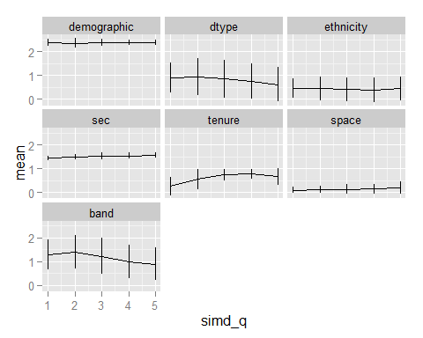 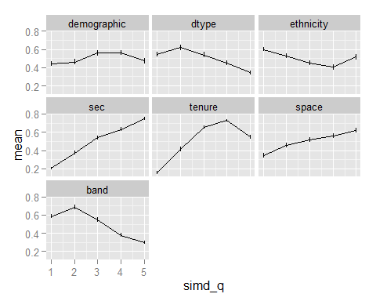 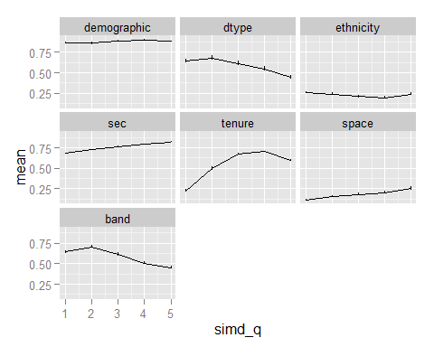

# Entropy scores

As above, but using entropy scores

## Warning: joining factors with different levels, coercing to character  
## vector

## Warning: joining character vector and factor, coercing into character  
## vector

## Warning: joining character vector and factor, coercing into character  
## vector

## Warning: joining character vector and factor, coercing into character  
## vector

## Warning: joining character vector and factor, coercing into character  
## vector

## Mean and SD (Entropy scores)

## Mean and SD of raw results

The following shows the means and sds for each diversity type. The first table shows the raw scores; the second shows each after being converted to a percentile rank.

|  |  |  |
| --- | --- | --- |
| type | mean | sd |
| demographic | 0.186 | 0.006 |
| dtype | 0.168 | 0.078 |
| ethnicity | 0.074 | 0.041 |
| sec | 0.252 | 0.012 |
| tenure | 0.198 | 0.083 |
| space | 0.047 | 0.034 |
| band | 0.150 | 0.048 |
| type | mean | sd |
| demographic | 0.5 | 0.289 |
| dtype | 0.5 | 0.289 |
| ethnicity | 0.5 | 0.289 |
| sec | 0.5 | 0.289 |
| tenure | 0.5 | 0.289 |
| space | 0.5 | 0.289 |
| band | 0.5 | 0.289 |
| type | mean | sd |
| demographic | 0.874 | 0.100 |
| dtype | 0.590 | 0.277 |
| ethnicity | 0.226 | 0.169 |
| sec | 0.758 | 0.079 |
| tenure | 0.533 | 0.231 |
| space | 0.183 | 0.146 |
| band | 0.589 | 0.195 |

## Results by SIMD quintile

Here are the diversity scores by SIMD quintile. The first plot presents the 'raw' results. In the second plot all values are presented as rank percentiles (i.e. 1 is highest rank, 0 lowest rank). In the third plot all values are converted to proportions using (x-min(x))/(max(x)-min(x))

## Joining by: "datazone"

## Warning: joining factors with different levels, coercing to character  
## vector

## Joining by: "datazone"

