diversity means and sds

Jon Minton

Tuesday, March 10, 2015

# Table of contents

# Request from Ade

Jon,

Meantime, do you think you could also produce a table showing the average (mean) values and s.d.s for the diversity scores on each dimension, for all datazones in Greater Glasgow and then also separately by SIMD 2012 quintile?

Yours, Ade

# Mean and SDs for diversity scores

## Mean and SD of raw results

The following shows the means and sds for each diversity type. The first table shows the raw scores; the second shows each after being converted to a percentile rank. The third shows the scores after being converted to the proportion of the range from the minimum to maximum values (i.e. x - min(x) / (max(x) -min(x)))

|  |  |  |
| --- | --- | --- |
| type | mean | sd |
| demographic | 2.385 | 0.077 |
| dtype | 0.812 | 0.387 |
| ethnicity | 0.431 | 0.247 |
| sec | 1.507 | 0.073 |
| tenure | 0.590 | 0.251 |
| space | 0.128 | 0.104 |
| band | 1.161 | 0.393 |

Raw values

|  |  |  |
| --- | --- | --- |
| type | mean | sd |
| demographic | 0.500 | 0.289 |
| dtype | 0.499 | 0.290 |
| ethnicity | 0.500 | 0.289 |
| sec | 0.500 | 0.289 |
| tenure | 0.500 | 0.289 |
| space | 0.499 | 0.291 |
| band | 0.500 | 0.289 |

Percentile rank

|  |  |  |
| --- | --- | --- |
| type | mean | sd |
| demographic | 0.883 | 0.101 |
| dtype | 0.587 | 0.280 |
| ethnicity | 0.228 | 0.169 |
| sec | 0.756 | 0.079 |
| tenure | 0.538 | 0.229 |
| space | 0.181 | 0.148 |
| band | 0.584 | 0.198 |

(x-min(x))/(max(x)-min(x))

## Results by SIMD quintile

Here are the diversity scores by SIMD quintile. The first plot presents the 'raw' results. In the second plot all values are presented as rank percentiles (i.e. 1 is highest rank, 0 lowest rank). In the third plot all values are converted to proportions using (x-min(x))/(max(x)-min(x))

## Joining by: "datazone"

## Warning: joining factors with different levels, coercing to character  
## vector

## Joining by: "datazone"

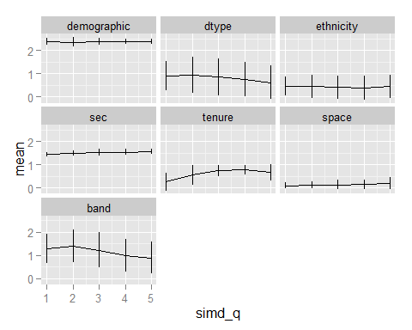 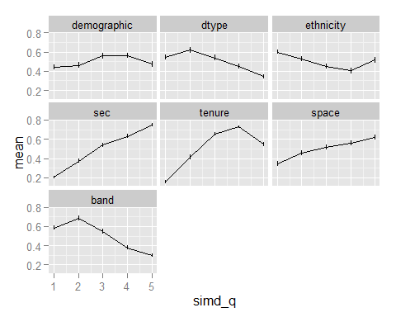 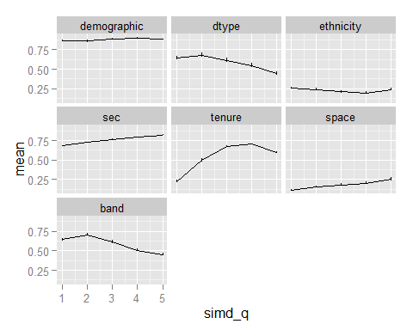

# Entropy scores

As above, but using entropy scores

## Warning: joining factors with different levels, coercing to character  
## vector

## Warning: joining character vector and factor, coercing into character  
## vector

## Warning: joining character vector and factor, coercing into character  
## vector

## Warning: joining character vector and factor, coercing into character  
## vector

## Warning: joining character vector and factor, coercing into character  
## vector

## Mean and SD (Entropy scores)

## Mean and SD of raw results

The following shows the means and sds for each diversity type. The first table shows the raw scores; the second shows each after being converted to a percentile rank.

|  |  |  |
| --- | --- | --- |
| type | mean | sd |
| demographic | 0.186 | 0.006 |
| dtype | 0.168 | 0.078 |
| ethnicity | 0.074 | 0.041 |
| sec | 0.252 | 0.012 |
| tenure | 0.198 | 0.083 |
| space | 0.047 | 0.034 |
| band | 0.150 | 0.048 |

|  |  |  |
| --- | --- | --- |
| type | mean | sd |
| demographic | 0.5 | 0.289 |
| dtype | 0.5 | 0.289 |
| ethnicity | 0.5 | 0.289 |
| sec | 0.5 | 0.289 |
| tenure | 0.5 | 0.289 |
| space | 0.5 | 0.289 |
| band | 0.5 | 0.289 |

|  |  |  |
| --- | --- | --- |
| type | mean | sd |
| demographic | 0.874 | 0.100 |
| dtype | 0.590 | 0.277 |
| ethnicity | 0.226 | 0.169 |
| sec | 0.758 | 0.079 |
| tenure | 0.533 | 0.231 |
| space | 0.183 | 0.146 |
| band | 0.589 | 0.195 |

## Results by SIMD quintile

Here are the diversity scores by SIMD quintile. The first plot presents the 'raw' results. In the second plot all values are presented as rank percentiles (i.e. 1 is highest rank, 0 lowest rank). In the third plot all values are converted to proportions using (x-min(x))/(max(x)-min(x))

## Joining by: "datazone"

## Warning: joining factors with different levels, coercing to character  
## vector

## Joining by: "datazone"

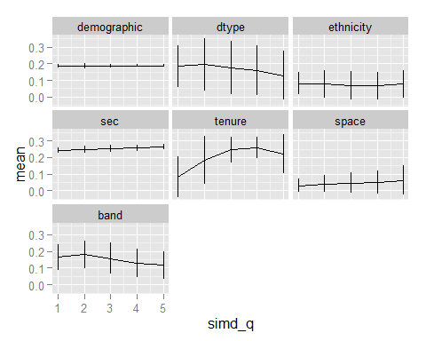 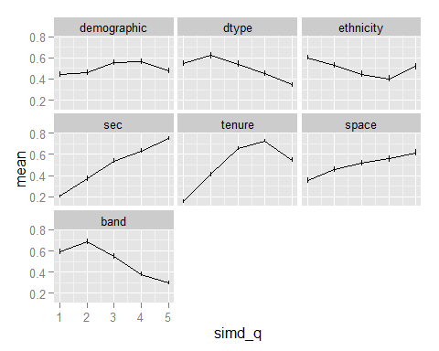 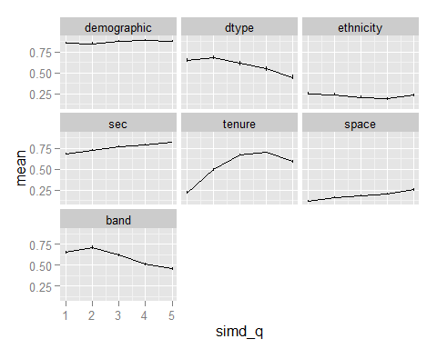

# Additional tasks (23/3/2015)

1. Present all factor loadings as a table as well as figures
2. Look at the relationship between diversity scores and urban/rural class
3. Produce a map of urban categories for greater glasgow, ideally superimposing boundaries on the maps
4. as above, but with quintiles of diversity for each of the diversity types
5. do all of the above for both 2001 and 2011 where possible

## Present all factor loadings as a table as well as figures

[stuff to go here]

## Look at the relationship between diversity scores and urban/rural class

[stuff to go here]

## Produce a map of urban categories for great glasgow, ideally superimposing boundaries on the maps

[stuff to go here]

## as above, but with quintiles of diversity for each of the diversity types

[stuff to go here]

## Do all of the above for both 2001 and 2011 where possible

[stuff to go here]