Assessing diversity, change in diversity, and the role of tenure mix in Greater Glasgow from 2001 to 2011

Dr Jon Minton

28 May 2015

# Introduction

An important question for urban planners is whether changing the mix and diversity of places leads to positive social and health outcomes, such as greater levels of community and public engagement, better employment outcomes, lower crime rates, better education prospects, and better health. The opposite of diversity is segregation, and so asking about diversity in a city is also about asking about segregation within a city. Just as urban segregation can be measured in many ways, and with regard to many different types of variable, so can urban diversity.

The aim of the research presented below is to try to explore the relationships between different types of diversity. Although they cannot be measured directly, are there a small number of fundamental dimensions of diversity, underlying factors which mean that certain forms of urban diversity all tend to be co-located and clustered in both physical and statistical space? Is there, ultimately, a single underlying factor, perhaps something intrinsic to a city or region, that makes it more or less diverse compared with other cities or regions. Or, are there two or more underlying dimensions, meaning that diversity is fundamentally more than a single one urban process or pattern, and so cannot be meaningfully understood by reducing it to a single value?

A particular issue for urban planning is whether changes made to any particular form of diversity could lead to changes in some other forms of diversity. Could shifting a diversity item, consistently found to be linked to other diversity items through a latent factor, lead to these other items shifting accordingly? Or, could adjusting a single diversity item lead to it becoming untethered from the other items that it has historically been associated with?

This research is focused, specifically, on understanding whether changing the diversity of tenure of households living in different parts of Greater Glasgow could be expected to lead to particular patterns of change to other forms of measurable diversity. In order to do this, different areas within Greater Glasgow were measured according to a range of different types of mix, relating to building use, demography, occupation and land use, both around the 2001 and 2011 census. In total, 14 different types of mix were looked at, three relating to building type, four relating to demography, four relating to occupation and employment, and two relating to land use. A full list is shown in table X below. The number of mutually exclusive groups is shown on the column named ‘groupings’. For most mix types the 2001 and 2011 censuses were used; other sources of data included the postcode address file and the SNS website.

| **Outer Group** | **Mix Type** | **2001** | **2011** | **File** | **Groupings** |
| --- | --- | --- | --- | --- | --- |
| Primary | Tenure Mix | YES | YES | data/derived/tenure_by_dz.csv | Social; rented; owned |
| Building Type | Council Tax Band | YES[1] | YES | Data/derived/dwellings_by_band.csv | Each band from A to H |
|  | Number of Rooms | YES[2] | YES | Data/derived/dwellings_by_size.csv | 1 room; 2 rooms etc; up to 10 or more rooms |
|  | Dwelling Type | YES[3] | YES | Data/derived/dwellings_by_type.csv | Flats; terraced properties; semi-detached properties; detached properties |
| Demographic | Age and Sex | YES | YES | data/derived/demographic_groupings.csv | Females and males, age ranges 0-15, 16-24, 25-39, 40-54, 55-64, 65-79, 80 and above (i.e. 14 mutually exclusive categories) |
|  | Ethnicity | YES | YES | Data/derived/ethnicity.csv | White Scottish; White but not Scottish; Afro-Caribbean or Black; Asian; Mixed, Other |
|  | Religion | YES | YES | Data/derived/rel.csv | Church of Scotland; Roman Catholic; Other Christian; None; Other Region; Not Announced |
|  | Country of origin | YES | YES | Data/derived/coo.csv | Scotland; England; Northern Ireland; Wales; Republic of Ireland; Other EU country; Elsewhere |
| Occupation and Employment | Highest qualification | YES | YES | Data/derived/highest_qual.csv | No qualifications; level 1; level 2; level 3; level 4 |
|  | Economic Activity | YES | YES | Data/derived/economic_activity.csv | Part time employed; full time employed; self employed; unemployed; students; retired; working age and looking after family; working age and sick and disabled |
|  | Occupation | YES | Yes | Data/derived/sec_by_dz.csv | Class I; Class II; Class III; Class IV; Students; Other |
|  | Industry | YES | Yes | Data/derived/industry.csv | Mining & quarrying; manufacturing; electricity, gas and water supply; construction; wholesale retail trade repairs; hotels and restaurants; transport, storage and communications; financial intermediaries; real estate; public administration, defence and social security; education; health and social work; fishing and agriculture; other |
| Land Use | Vacant/holiday residences | YES | YES | Data/derived/household_space_use.csv | Occupied; unoccupied and vacant; unoccupied and a second residence or holiday home |
|  | Building use (residential/business) | YES | YES[4] | Data/derived/building_use.csv | Residential only; business only; mixed business and residential use |

Conceptually, areas are more diverse if there is more similarity in the numbers counted within each of the groupings, and less mixed if more observations are counted within some groups than others. For example, for dwelling type, an area would be more mixed if, out of 60 residences, 20 are flats, 20 are terraced houses, and 20 are semi-detached properties, than if there are 60 flats, no terraced properties, and no semi-detached properties.

Diversity is measured in two ways, firstly using the entropy index, and secondly using Shannon’s diversity index. The entropy index appeared to produce values that were more consistent over time, and are presented here.

# Results

The first three principal components of the factor analysis on diversity are shown in the figure below, both for years around 2001 (t1) and 2011 (t2).

|  |  |  |
| --- | --- | --- |
|  | t1 mean (SD) | t2 mean (SD) |
| tenure | 0.20 (0.08) | 0.24 (0.08) |
| bld_band | 0.14(0.05) | 0.15 (0.05) |
| bld_size | 0.13 (0.03) | 0.14 (0.03) |
| bld_type | 0.20 (0.10) | 0.21 (0.10) |
| demo_as | 0.18 (0.01) | 0.18 (0.01) |
| demo_eth | 0.06 (0.03) | 0.07 (0.04) |
| demo_rel | 0.23 (0.02) | 0.24 (0.02) |
| demo_coo | 0.09 (0.01) | 0.09 (0.01) |
| econ_qual | 0.28 (0.03) | 0.29 (0.02) |
| econ_act | 0.11 (0.01) | 0.12 (0.01) |
| econ_sec | 0.13 (0.01) | 0.14 (0.02) |
| econ_ind | 0.17 (0.00) | 0.17 (0.00) |
| land_vacant | 0.05 (0.03) | 0.04 (0.03) |
| land_bus | 0.25 (0.03) | 0.25 (0.02) |

|  |  |  |  |
| --- | --- | --- | --- |
| T1 | PC1 | PC2 | PC3 |
| tenure | 0.38 | 0.90 | -0.01 |
| bld_band | -0.26 | 0.15 | -0.68 |
| bld_size | -0.16 | 0.04 | -0.38 |
| bld_type | -0.85 | 0.37 | 0.26 |
| demo_as | -0.01 | 0.02 | 0.03 |
| demo_eth | 0.06 | -0.07 | -0.41 |
| demo_rel | 0.05 | -0.01 | -0.11 |
| demo_coo | 0.01 | 0.00 | -0.13 |
| econ_qual | -0.11 | -0.06 | -0.29 |
| econ_act | 0.03 | 0.03 | 0.05 |
| econ_sec | 0.00 | 0.02 | -0.06 |
| econ_ind | -0.01 | 0.00 | -0.01 |
| land_vacant | 0.10 | 0.10 | -0.11 |
| land_bus | 0.02 | 0.05 | -0.13 |

|  |  |  |  |
| --- | --- | --- | --- |
| T2 | PC1 | PC2 | PC3 |
| tenure | 0.39 | 0.91 | -0.01 |
| bld_band | -0.23 | 0.12 | -0.67 |
| bld_size | -0.16 | 0.02 | -0.39 |
| bld_type | -0.85 | 0.36 | 0.12 |
| demo_as | -0.02 | 0.01 | 0.05 |
| demo_eth | 0.18 | -0.11 | -0.52 |
| demo_rel | 0.03 | -0.05 | -0.14 |
| demo_coo | 0.04 | -0.01 | -0.17 |
| econ_qual | -0.07 | 0.01 | -0.04 |
| econ_act | 0.03 | 0.03 | 0.04 |
| econ_sec | 0.01 | 0.03 | -0.17 |
| econ_ind | 0.00 | 0.01 | 0.00 |
| land_vacant | 0.05 | 0.06 | -0.11 |
| land_bus | 0.02 | 0.04 | -0.14 |

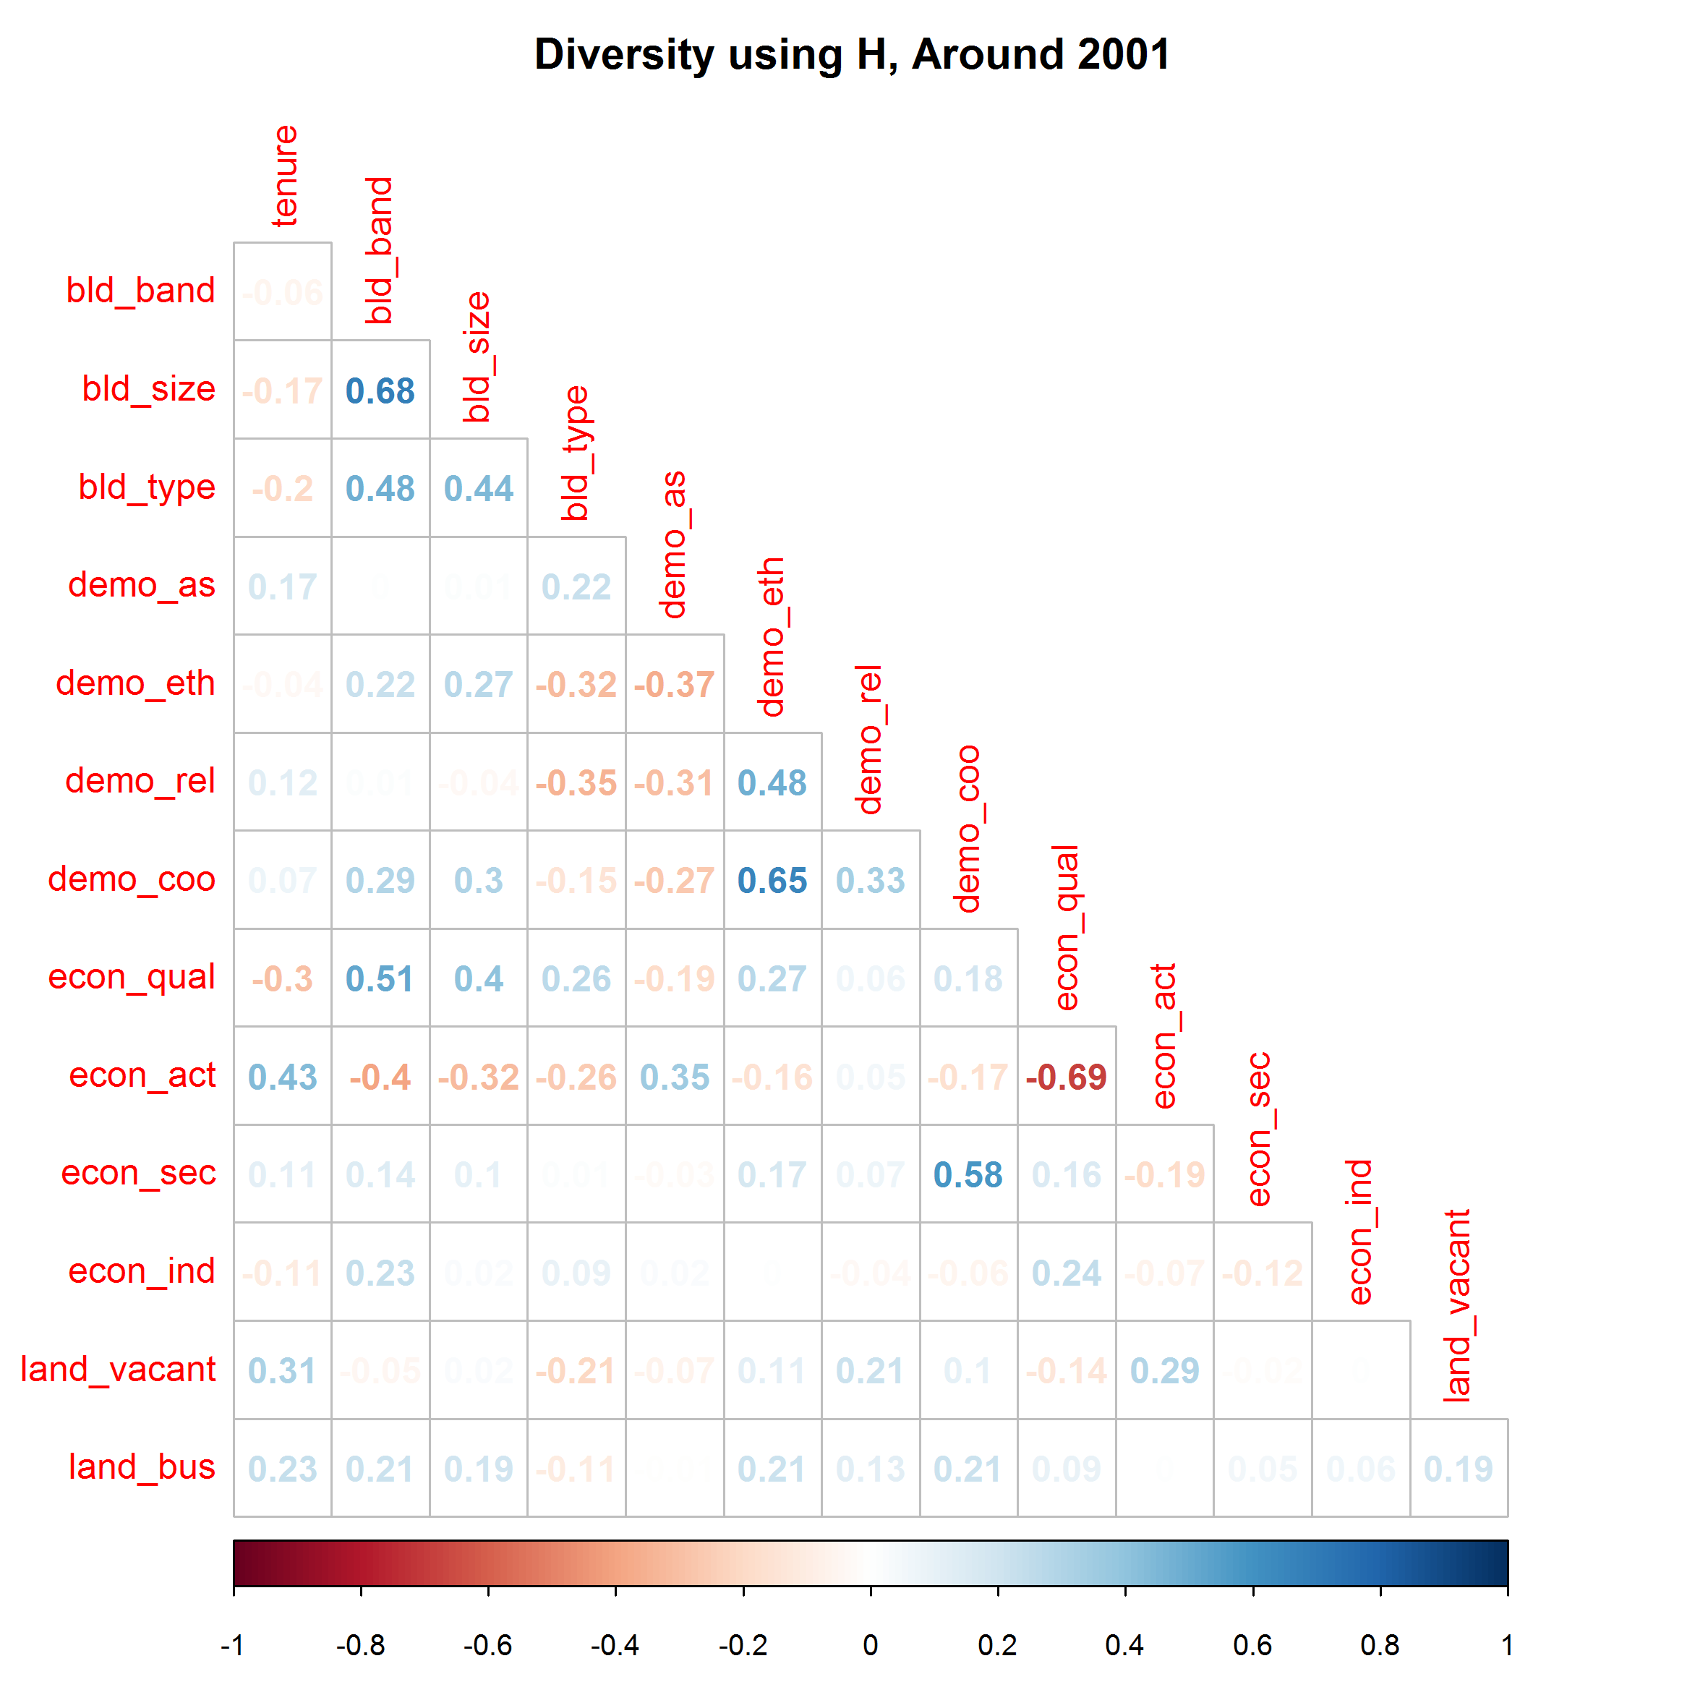

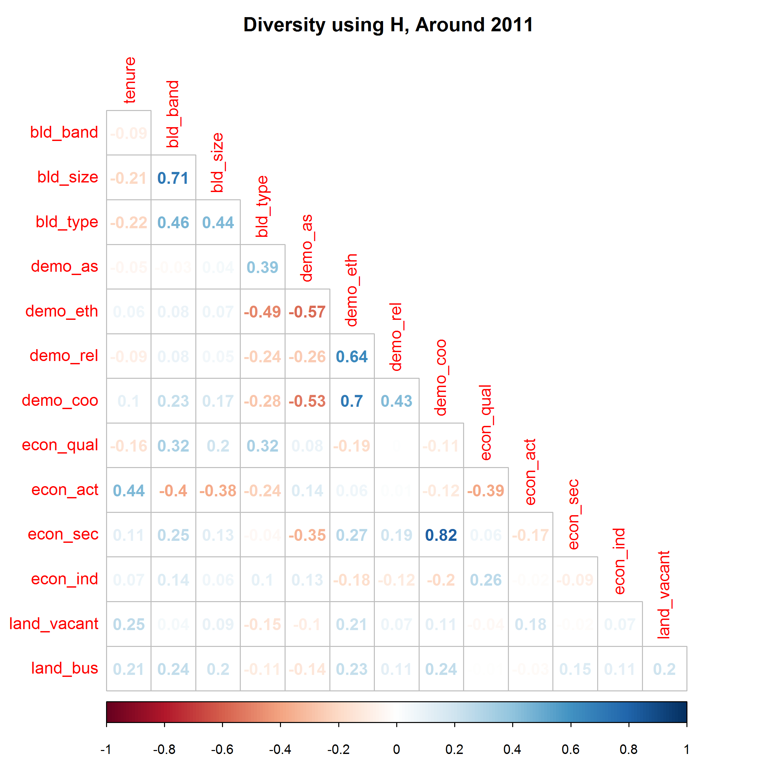

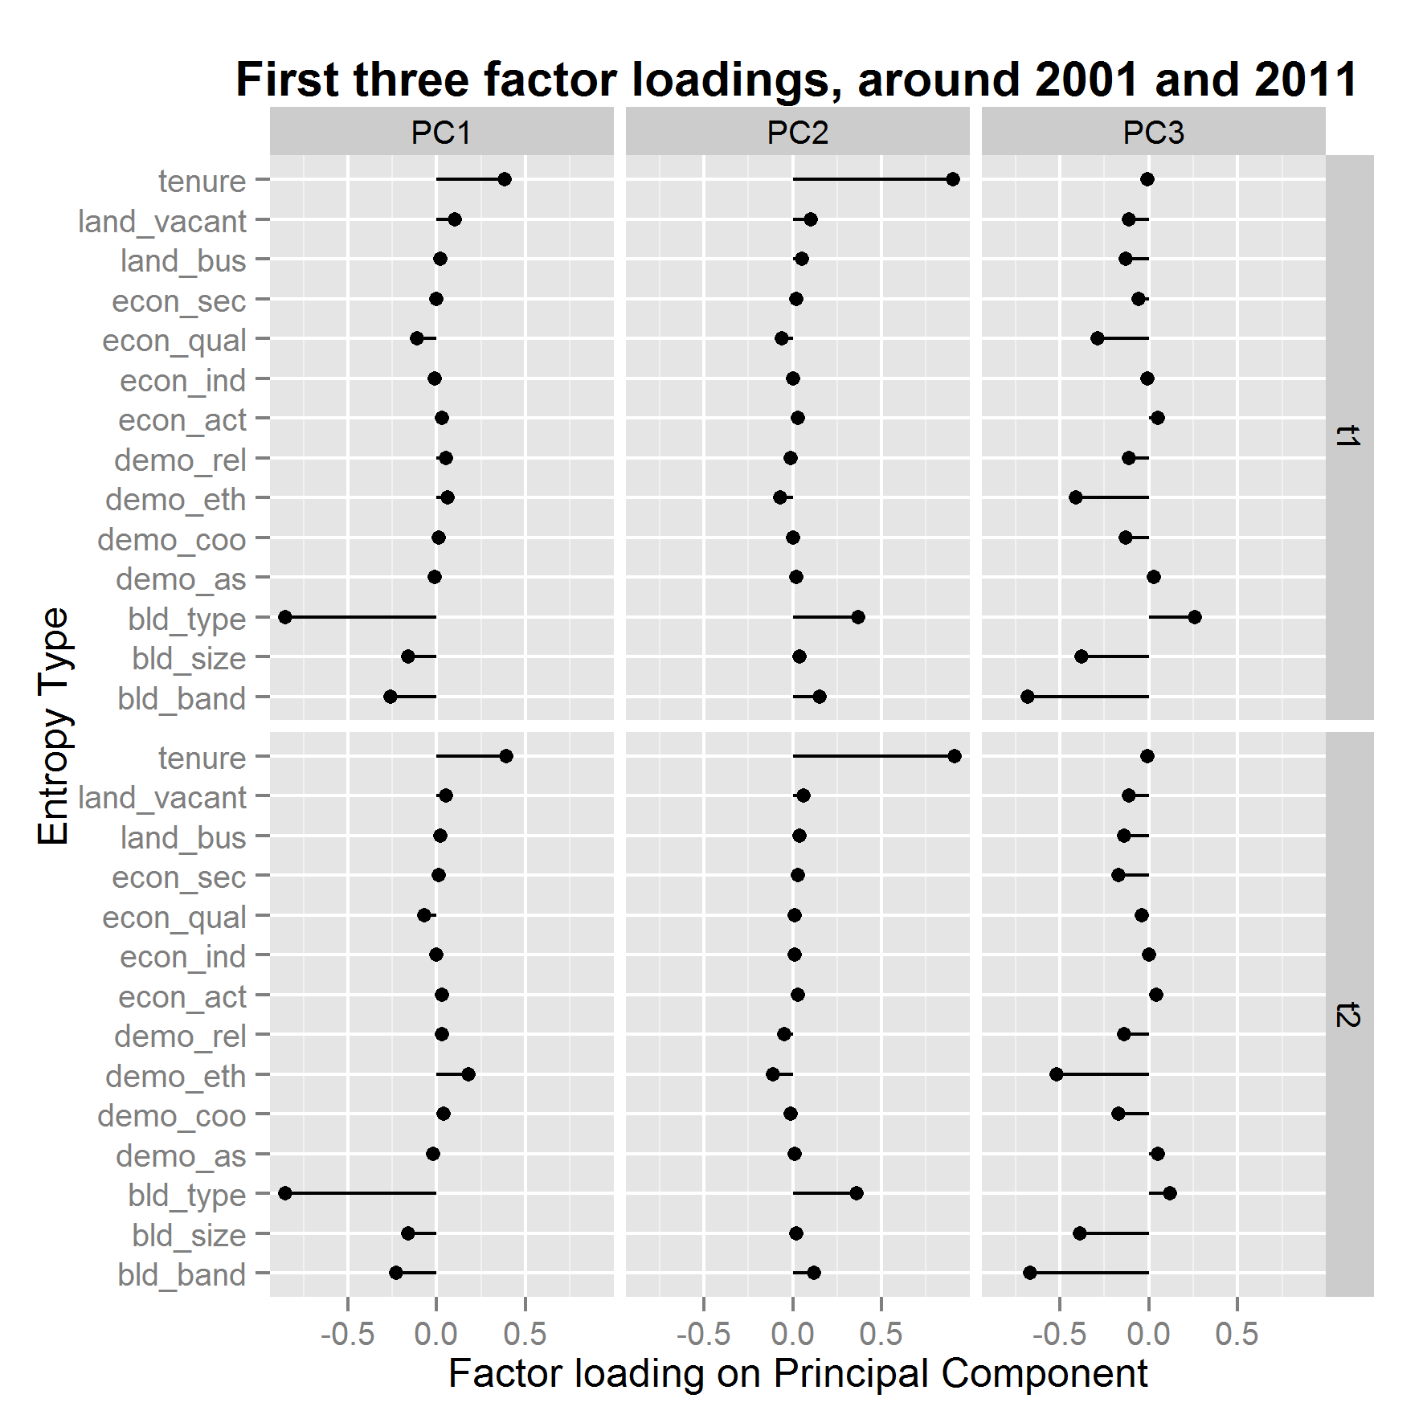

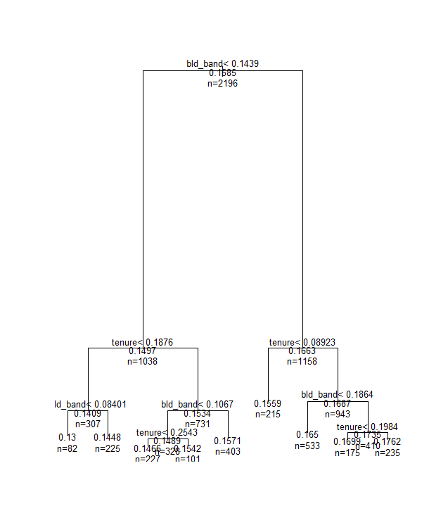

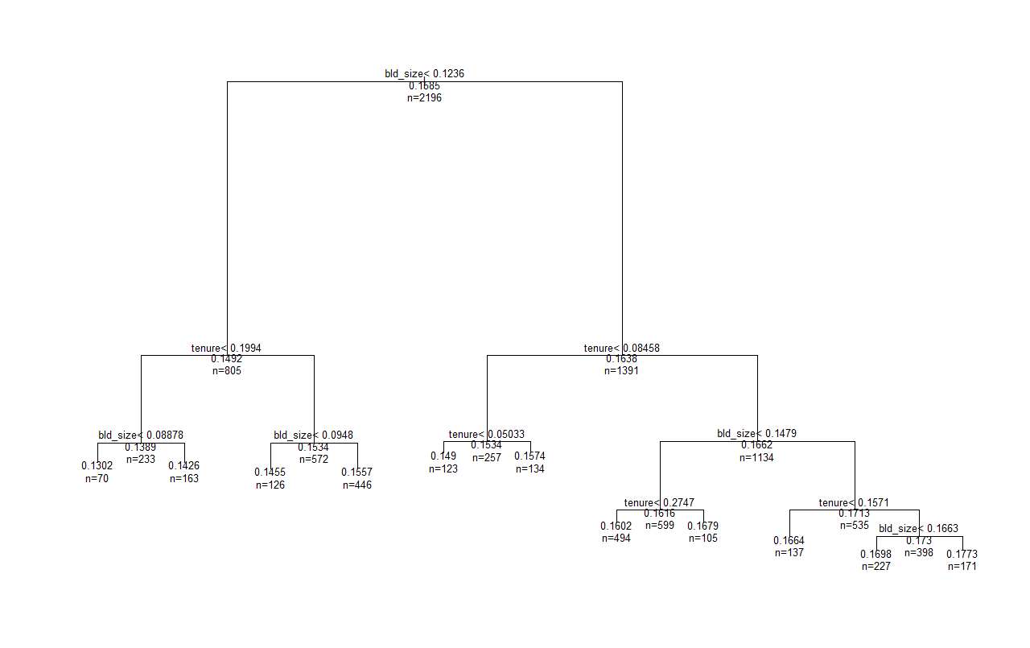

1. Using 2003 instead
2. Using 2006 instead
3. Using 2006 instead
4. 2010 not 2011. Using Postcode Address File