Mix in Glasgow: some initial explorations

Jon Minton

Wed 25 Feb 2015

# Introduction

This is a short document showing some of the work done so far.

# Exploration of tenure mix

# Main Analysis -----------------------------------------------------------  
  
greater_glasgow_dzs <- read.csv("data/geographies/dzs_in_greater_glasgow.csv") %>% tbl_df()  
  
#Tenure  
  
tenure_households <- source_DropboxData(  
 file="tenure_households.csv",  
 key="6t6dss41g8fat1y"  
 ) %>% tbl_df() %>% select(  
 dz_2001=datazone, year,   
 all_households=HO.allhouseholds,  
 council_houses=HO.council,  
 rented_from_employer=HO.employ,  
 owned_with_mortgage=HO.ownmortloan,  
 owned_outright=HO.ownoutright,  
 private_rented=HO.privlet,  
 rented_from_relative=HO.relative,  
 shared_ownership=HO.sharedown,  
 other_social_rented=HO.social  
) %>% mutate(  
 social=council_houses + other_social_rented,  
 rented=rented_from_employer + private_rented+ rented_from_relative,  
 owned=owned_with_mortgage + owned_outright + shared_ownership  
 ) %>%  
 mutate(  
 council_houses=council_houses/all_households,  
 rented_from_employer=rented_from_employer/all_households,  
 owned_with_mortgage=owned_with_mortgage/all_households,  
 owned_outright=owned_outright/all_households,  
 private_rented=private_rented/all_households,  
 rented_from_relative=rented_from_relative/all_households,  
 shared_ownership=shared_ownership/all_households,  
 other_social_rented=other_social_rented/all_households,  
 social = social/all_households,  
 rented = rented/all_households,  
 owned=owned/all_households  
 )

## Downloading data from: https://dl.dropboxusercontent.com/s/6t6dss41g8fat1y/tenure_households.csv   
##   
## SHA-1 hash of the downloaded data file is:  
## 7cb8e90f51d1a3855e4ed4b9a7015a97d03282cd

# 6505 observations - whole of Scotland  
# left join to just Greater Glasgow  
tenure_households <- greater_glasgow_dzs %>% left_join(tenure_households)

## Joining by: "dz_2001"

## Warning: joining character vector and factor, coercing into character  
## vector

## # now 2200 observations # this is 34% of total, dzs are approx equal population # if Scot population is 5.3 million this implies # Pop of Greater Glasgow is about 1.8 Million - # does this seem reasonable? tenure_households <- tenure_households %>% mutate( mix=(social * rented * owned) / (1/3)^3) # this should be the maximum possible mix value tenure_households %>% group_by(year) %>% summarise()

## Source: local data frame [1 x 1]  
##   
## year  
## 1 2001

# unfortunately this is only available for 2001  
  
#   
qplot(  
 x=mix, data=tenure_households  
 )

## stat_bin: binwidth defaulted to range/30. Use 'binwidth = x' to adjust this.

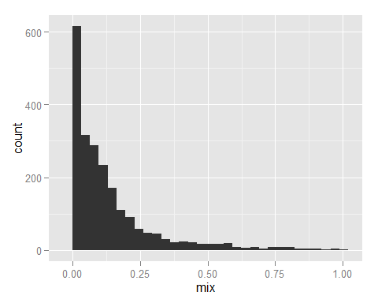

# a lot of excess 0s - no mix  
  
# arrange households by mix, then plot proportions of each tenure type along this linke  
  
tenure_households <- tenure_households %>% arrange(mix)  
  
ggplot(tenure_households) + geom_line(aes(x=mix, y=social))

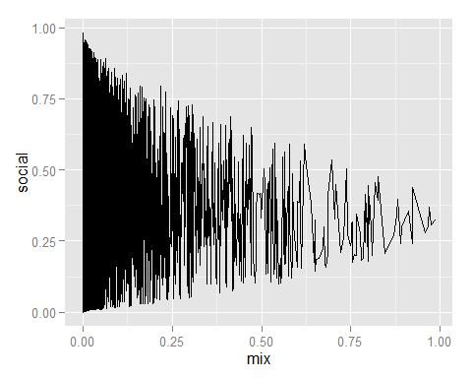

ggplot(tenure_households) + geom_line(aes(x=mix, y=owned))

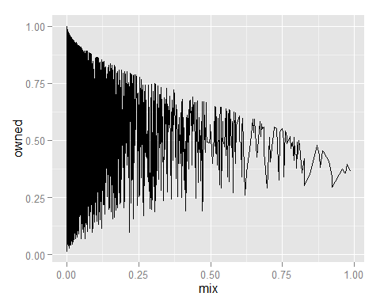

ggplot(tenure_households) + geom_line(aes(x=mix, y=rented))

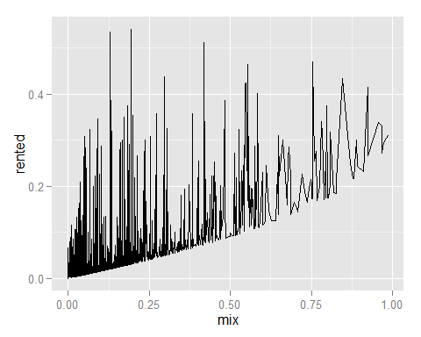

## Ternary plots

Below shows a ternary plot showing the relative mix of social, owned and rented houses in each datazone in Glasgow. The colour indicates the ‘mix’ of the datazone by tenure type, which will be greatest when each type of mix has an equal share.

# ternary plot  
  
ggtern(data=tenure_households, aes(x=social, y=owned, z=rented, colour=mix)) + geom_point()

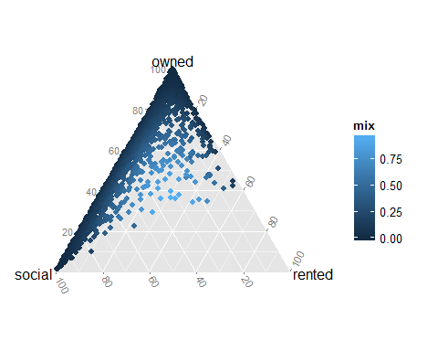

# want social, owned, and rented to be gathered   
  
tenure_households %>%   
 select(dz_2001, mix, social, owned, rented) %>%  
 gather(key = tenure_type, value=tenure_proportion, -dz_2001, -mix) %>%  
 ggplot( aes(x=mix, y=tenure_proportion)) +  
 geom_line() +   
 facet_grid(tenure_type ~ . ) +   
 labs(y="proportion", x="mix")

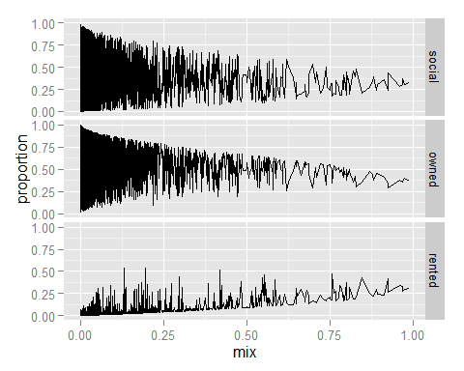

# mix deciles

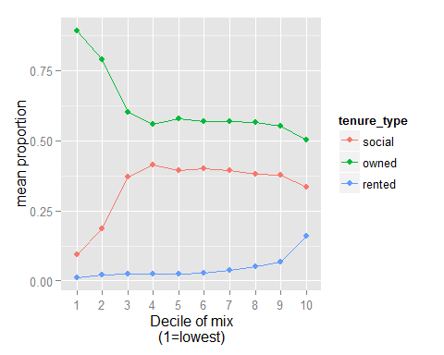

## Correlation plot

# what's the correlation between the tenure types over the deciles?  
  
tenure_deciles %>%   
 select(m10, tenure_type, tenure_mean) %>%  
 spread(key=tenure_type, value=tenure_mean) %>%   
 select(-m10) %>%   
 cor() %>%   
 corrplot.mixed()

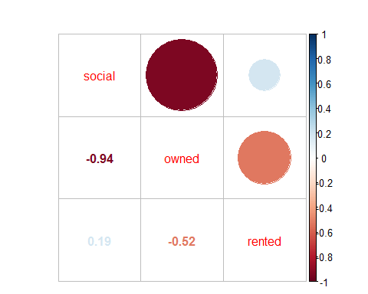

# Populations

This section will look at demographic mix within Glasgow.

The following figure shows how the proportion of the population that are working age has changed in Glasgow over time.

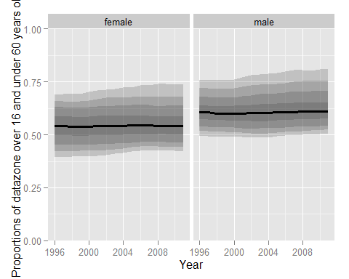

Another way of looking at this is the dependency ratio, as shown below:

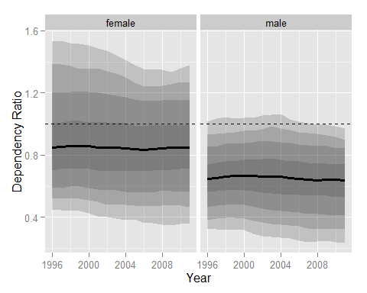

## Correlation between tenure mix and proportion working age in each datazone

For females:

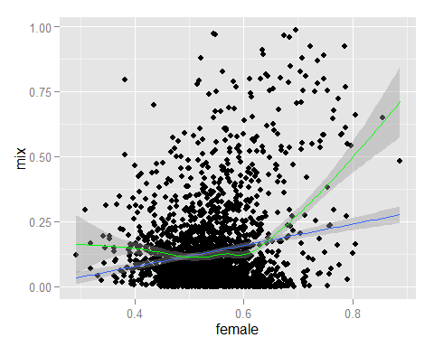

And for males

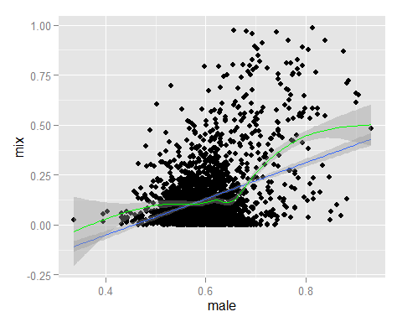

## The diversity index

Rather than using my own bespoke ‘mix’ measure – simply the product of the values divided by the maximum possible value – here are diversity scores calculated using an existing R package, vegan:

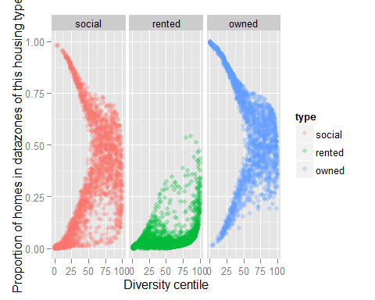

## Diversity by housing stock type:

Data are available at datazone level on the type of housing available in each datazone.

The housing types reported are:

* Number of rooms
* Whether a flat, a terrace, semi-detached, or detached.
* Council tax band

div_by_year <- dwelling_types_wide %>%  
 group_by(year) %>%  
 summarise(  
 q_025=quantile(diversity, 0.025),  
 q_050=quantile(diversity, 0.050),  
 q_100=quantile(diversity, 0.100),  
 q_250=quantile(diversity, 0.250),  
 q_500=quantile(diversity, 0.500),  
 q_750=quantile(diversity, 0.750),  
 q_900=quantile(diversity, 0.900),  
 q_950=quantile(diversity, 0.950),  
 q_975=quantile(diversity, 0.975)  
 )  
  
  
div_by_year %>% ggplot(aes(x=year, y=q_500)) +  
 geom_line(size=1.1) +  
 geom_ribbon(aes(ymin=q_025, ymax=q_975), alpha=0.2) +  
 geom_ribbon(aes(ymin=q_050, ymax=q_950), alpha=0.2) +  
 geom_ribbon(aes(ymin=q_100, ymax=q_900), alpha=0.2) +  
 geom_ribbon(aes(ymin=q_250, ymax=q_750), alpha=0.2) +  
 labs(x="Year", y="Diversity Level")

