The Infer Package and Bayes Factors

Jon Minton

# Introduction

This document will introduce a couple of concepts, and one R package, for performing statistical inference tests in R.

1. The There-is-only-one-test framework, and the R package infer
2. Bayes Factors, as distinct from Neyman-Pearson Hypothesis Testing frameoworks

# Proposed structure

* TIOOT/Infer
  + There-is-only-one-test : background
    - Allen Downey - a computer scientist’s take on statistical inference
      * 2011 - [There is only one test](http://allendowney.blogspot.com/2011/05/there-is-only-one-test.html)
      * 2016 - [There is still only one test](http://allendowney.blogspot.com/2016/06/there-is-still-only-one-test.html)
      * 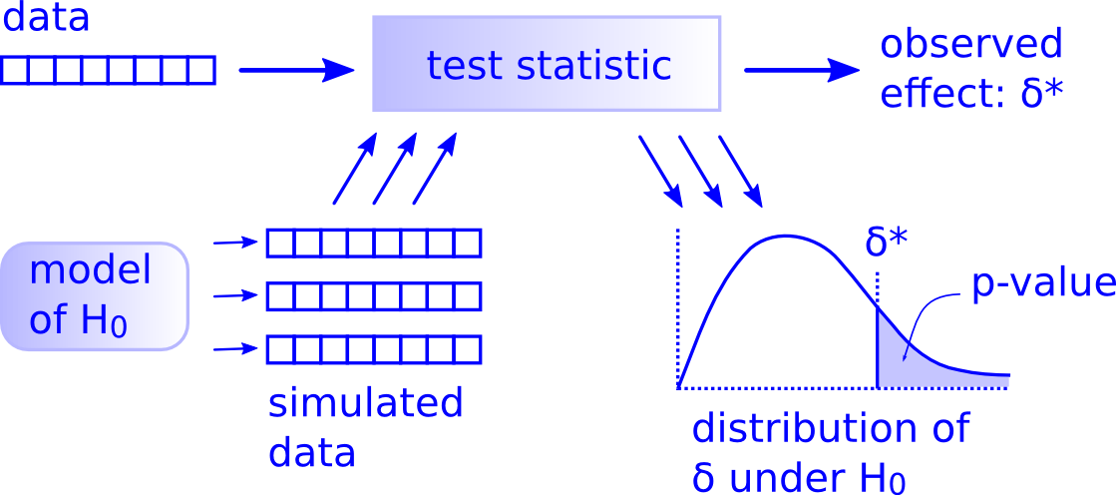
    - Null & Alternative Hypothesis
      * Null $H_{0}$: The (boring) world in which the proposed relationship between predictor and response variables is *false*
      * Alternative $H_{A}$: The (interesting) world in which the proposed relationship between predictor and response is *true*
    - P-values
      * P-values are a measure of conflict between data and a hypothesis, and are certainly not direct expressions of a probability of hypotheses.
        + [Communicating Uncertainty about facts, numbers, and science](https://royalsocietypublishing.org/doi/pdf/10.1098/rsos.181870)
      * P-values are usually *indirect* strategies for investigating support for $H_{A}$, through quantifying *magnitude* and *direction* of conflict between data and $H_{0}$
        + *Direction of conflict*: One-tailed cf two-tailed tests
        + *Magnitude of conflict*: Probability of observing values of effect $δ^{*}$ as or more extreme under $H_{0}$.
      * Neyman-Pearson Approach
        + Also prespecify $α$: The magnitude of conflict between data and Null hypothesis, in expected direction, required to ‘reject the Null’
        + Typical $α$ values: 0.05, 0.01

CERN: ‘Five Sigma’ (almost zero)

* + - * + [The Sizeless Stare](https://www.amazon.co.uk/Cult-Statistical-Significance-Economics-Cognition/dp/0472050079)
      * Permutation approaches
        + A generic, computationally intensive, approach to producing a distribution of expected effect sizes under the Null
        + Key intuition:

$H_{A}$ says $X$ predicts/causes $Y$

Put another way: Values of $X$ are *informative* as to values of $Y$

Say $X$ is categorical, and can either be $A$ or $B$

The data $D$ is a series of values of $Y$, with *labels* attached: the corresponding values of $X$

Another way of expressing $H_{A}$ and $H_{0}$:

$H_{A}$: These labels *matter* (Are informative of $Y$)

$H_{0}$: These labels *don’t matter* (Are not informative of $Y$)

A corollary of $H_{0}$: If the labels don’t matter, there’s no harm (information lost) by reallocating them to $Y$ values at random

Random reallocation: Permutation

Repeat many times to estimate the Null distribution

* + [Infer package](https://github.com/tidymodels/infer)
    - 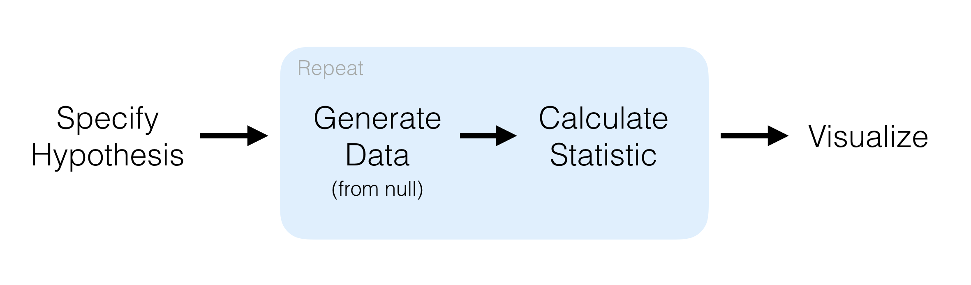
    - Verbs
      * specify
      * hypothesize
      * generate
      * calculate
  + DataCamp courses [(Learner beware)](https://www.buzzfeednews.com/article/daveyalba/datacamp-sexual-harassment-metoo-tech-startup)
    - [Foundations of Inference](https://www.datacamp.com/courses/foundations-of-inference)
    - [Inference for Linear Regression](https://www.datacamp.com/courses/inference-for-linear-regression)
    - [Inference for Numeric Data](https://www.datacamp.com/courses/inference-for-numerical-data)
    - [Inference for Categorical Data](https://www.datacamp.com/courses/inference-for-categorical-data)
  + [Avoiding Datacamp](https://bookdown.org/cteplovs/ismaykim/ismaykim.pdf)

# Examples of infer

pacman::p_load(tidyverse, infer)

# Initial example: mtcars

* [mtcars dataset](https://stat.ethz.ch/R-manual/R-devel/library/datasets/html/mtcars.html)

## Variables of interest

* **vs**: Engine (0 - V-shaped; 1 = straight)
* **am**: Transmission (0 = automatic, 1 = manual)
* **mpg**: Miles per gallon

## Prep the data

mtcars <- as.data.frame(mtcars) %>%  
 mutate(cyl = factor(cyl),  
 vs = factor(vs),  
 am = factor(am),  
 gear = factor(gear),  
 carb = factor(carb))

## First research question

* Does engine type influence(!) Transmission Type
* Null: It does not
* Alternative: It does

# Observed difference in proportions   
obs_diff_rq1 <-   
 mtcars %>%   
 select(am, vs) %>%   
 group_by(vs) %>%   
 summarise(prop = mean(am == 1)) %>%   
 summarise(diff_in_props = diff(prop)) %>%   
 pull(diff_in_props)  
  
obs_diff_rq1

## [1] 0.1666667

# Null distribution:   
null_rq1 <-   
 mtcars %>%  
 specify(am ~ vs, success = "1") %>%  
 hypothesize(null = "independence") %>%  
 generate(reps = 1000, type = "permute") %>%  
 calculate(stat = "diff in props", order = c("1", "0"))

# Visualise the Null  
  
null_rq1 %>%   
 ggplot(aes(x = stat)) +   
 geom_histogram() +   
 geom_vline(xintercept = 0) +   
 geom_vline(xintercept = obs_diff_rq1, colour = "red", size = 2)

## `stat_bin()` using `bins = 30`. Pick better value with `binwidth`.

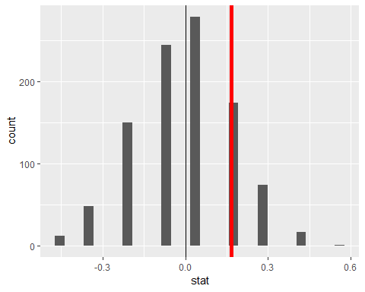

# P-value (two sided)  
  
null_rq1 %>%   
 summarise(p_val = mean(stat > obs_diff_rq1))

## # A tibble: 1 x 1  
## p_val  
## <dbl>  
## 1 0.092

To answer the RQ in Neyman-Pearson terms, with alpha of 0.05, two-tailed: > Is the above value either greater than 0.975, or less than 0.025?

## Second research question

Do manual transmission vehicles (from the 1970s) have higher MPG?

* Alternative: They do
* Null: They don’t

# Observed difference in means  
obs_diff_rq2 <-   
 mtcars %>%   
 group_by(am) %>%   
 summarise(mean_mpg = mean(mpg)) %>%   
 summarise(diff_in_means = diff(mean_mpg)) %>%   
 pull(diff_in_means)  
  
obs_diff_rq2

## [1] 7.244939

null_rq2 <-   
 mtcars %>%  
 specify(response = mpg, explanatory = am) %>%  
 hypothesize(null = "independence") %>%   
 generate(reps = 1000, type = "permute") %>%  
 calculate(stat = "diff in means", order = c("1", "0"))

# Visualise  
  
null_rq2 %>%   
 ggplot(aes(x = stat)) +   
 geom_histogram(bins = 100) +  
 geom_vline(xintercept = 0) +   
 geom_vline(xintercept = obs_diff_rq2, colour = "red", size = 2)

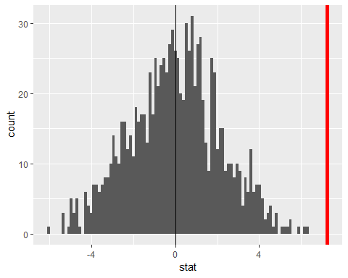

# P-value (one-sided)  
  
null_rq2 %>%   
 summarise(p_val = mean(stat > obs_diff_rq2))

## # A tibble: 1 x 1  
## p_val  
## <dbl>  
## 1 0

To answer the RQ in Neyman-Pearson terms, with alpha of 0.05, two-tailed:

Is the above value either greater than 0.975, or less than 0.025?

# RQ2 using the t-distribution   
  
obs_diff_rq2_t <-   
 mtcars %>%   
 t_test(mpg ~ am, order = c("1", "0"), alternative = "less")  
  
mtcars %>%  
 specify(response = mpg, explanatory = am) %>%  
 hypothesize(null = "independence") %>%   
 generate(reps = 1000, type = "permute") %>%  
 calculate(stat = "t", order = c("1", "0")) %>%   
 visualize(method = "both") +   
 shade_p_value(obs_stat = obs_diff_rq2_t, direction = "greater") +  
 geom_vline(xintercept = 1.96, colour = "darkgreen", size = 1.5, linetype = "dashed")

## Warning: Check to make sure the conditions have been met for the  
## theoretical method. {infer} currently does not check these for you.

## Warning: The first row and first column value of the given `obs_stat` will  
## be used.

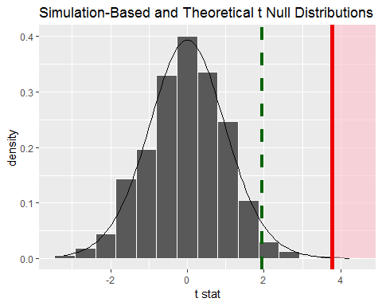

# Second Example (If we get time)

RQ: Are males taller than females (on average)

* $H_{0}$: No!
* $H_{A}$: Yes!

## Data Source - Kaggle

* From [this page](https://www.kaggle.com/majidarif17/weight-and-heightcsv).
* Provenance unknown…
* Unit appears to be inches

The dataset has many observations (though they may be synthetic), and so I’m going to create a variant with far fewer observations too

## Load and standardise data

# pacman::p_load(readxl)  
# height_data <- read_excel("data/height_data.xlsx")  
height_data <- read_csv("data/kaggle_weight-height.csv")

## Parsed with column specification:  
## cols(  
## Gender = col_character(),  
## Height = col_double(),  
## Weight = col_double()  
## )

tidy_height <-   
 height_data %>%   
 select(gender = Gender, height = Height)   
  
set.seed(20)   
tiny_tidy_height <-   
 tidy_height %>%   
 sample_n(size = 40, replace = FALSE)  
  
tidy_height %>%   
 ggplot(aes(x = height, group = gender, fill = gender)) +   
 geom_density(alpha = 0.4)

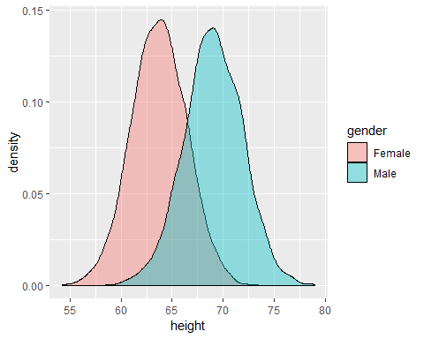

tiny_tidy_height %>%   
 ggplot(aes(x = height, group = gender, fill = gender)) +   
 geom_density(alpha = 0.4)

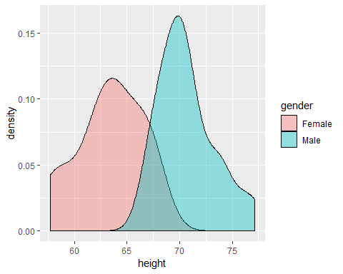

## Hypothesis test

obs_mean_diff <-   
 tidy_height %>%   
 group_by(gender) %>%   
 summarise(mean_height = mean(height)) %>%   
 summarise(mean_diff = mean_height[gender == "Male"] - mean_height[gender == "Female"]) %>%   
 pull(mean_diff)  
  
obs_mean_diff  
  
tiny_obs_mean_diff <-   
 tiny_tidy_height %>%   
 group_by(gender) %>%   
 summarise(mean_height = mean(height)) %>%   
 summarise(mean_diff = mean_height[gender == "Male"] - mean_height[gender == "Female"]) %>%   
 pull(mean_diff)  
  
tiny_obs_mean_diff  
  
  
tidy_height %>%   
 specify(height ~ gender) %>%  
 hypothesize(null = "independence") %>%   
 generate(reps = 1000, type = "permute") %>%  
 calculate(stat = "diff in means", order = c("Male", "Female")) %>%   
 visualize() # %>%  
 # shade_p_value(  
 # obs_stat = obs_mean_diff,  
 # direction = "greater"  
 # )  
  
tiny_tidy_height %>%   
 specify(height ~ gender) %>%  
 hypothesize(null = "independence") %>%   
 generate(reps = 1000, type = "permute") %>%  
 calculate(stat = "diff in means", order = c("Male", "Female")) %>%   
 visualize()

The range of Null differences is far outside the observed difference, and so the probability there’s no true difference given this dataset is effectively zero.

# Bayes Factors

* Analogy: Courts and Burden of Proof
  + Criminal Courts: ‘Beyond Reasonable Doubt’ (Neyman-Pearson/Classical approach)
  + Civil Courts: ‘Balance of Probabilities’ (The Bayes Factor: Likelihood Ratio)
* Likelihood and Probability
  + The likelihood of the model given the data is proportional to the probability of the data given the model
  + Likelihood is always relative rather than absolute
    - A model is never *likely*, just *more/less likely* than another model
* Bayes Factors
 $B(H_{A},H_{0})=\frac{p(D|H_{A})}{p(D|H_{0})}$

 + B > 1 : More support for Alternative Hypothesis
  + B < 1 : More support for Null Hypothesis
  + How much more support?
    - < 3: ‘anecdotal’
    - < 10: ‘moderate’
    - < 30: ‘strong’
    - etc

## Example using mtcars dataset

Given some value of MPG, what’s the relative likelihood the car is manual (Alt) or automatic (Null) transmission?

summaries <-   
 mtcars %>%   
 group_by(am) %>%   
 summarise(  
 mean_mpg = mean(mpg),   
 sd_mpg = sd(mpg)  
 )  
  
mu_manual <- summaries %>% filter(am == 1) %>% pull(mean_mpg)  
sd_manual <- summaries %>% filter(am == 1) %>% pull(sd_mpg )  
mu_automatic <- summaries %>% filter(am == 0) %>% pull(mean_mpg)  
sd_automatic <- summaries %>% filter(am == 0) %>% pull(sd_mpg )

Bayes factor (Manual cf automatic) given MPG

calc_bayes_factor <- function(value, mu_null, sd_null, mu_alt, sd_alt){  
 dnorm(value, mean = mu_alt, sd = sd_alt) / dnorm(value, mean = mu_null, sd = sd_alt)  
}

bf_schedule <-   
 tibble(  
 mpg_vals = seq(0, 50, by = 0.01)  
 ) %>%   
 mutate(bf = map_dbl(mpg_vals, calc_bayes_factor, mu_null = mu_automatic, sd_null = sd_automatic, mu_alt = mu_manual, sd_alt = sd_manual )  
 )   
  
bf_schedule %>%   
 ggplot(aes(x = mpg_vals, y = bf)) +   
 geom_line() +   
 scale_y_log10() +  
 geom_hline(yintercept = 1)

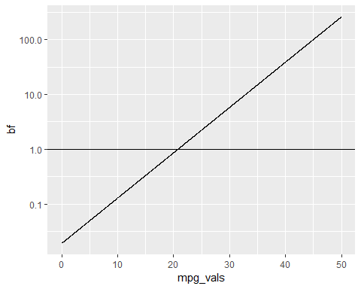

## Example using our heights data

summaries <-   
 tidy_height %>%   
 group_by(gender) %>%   
 summarise(  
 mean_height = mean(height),  
 sd_height = sd(height)  
 )   
  
mu_male <- summaries %>% filter(gender == "Male") %>% pull(mean_height)  
sd_male <- summaries %>% filter(gender == "Male") %>% pull(sd_height )  
mu_female <- summaries %>% filter(gender == "Female") %>% pull(mean_height)  
sd_female <- summaries %>% filter(gender == "Female") %>% pull(sd_height )  
  
tiny_summaries <-   
 tiny_tidy_height %>%   
 group_by(gender) %>%   
 summarise(  
 mean_height = mean(height),  
 sd_height = sd(height)  
 )   
  
mu_male_tiny <- tiny_summaries %>% filter(gender == "Male") %>% pull(mean_height)  
sd_male_tiny <- tiny_summaries %>% filter(gender == "Male") %>% pull(sd_height )  
mu_female_tiny <- tiny_summaries %>% filter(gender == "Female") %>% pull(mean_height)  
sd_female_tiny <- tiny_summaries %>% filter(gender == "Female") %>% pull(sd_height )

bf_schedule <-   
 tibble(  
 height_vals = seq(50, 90, by = 1)  
 ) %>%   
 mutate(bf = map_dbl(height_vals, calc_bayes_factor, mu_null = mu_female, sd_null = sd_female, mu_alt = mu_male, sd_alt = sd_male)  
 )   
  
tiny_bf_schedule <-   
 tibble(  
 height_vals = seq(50, 90, by = 1)  
 ) %>%   
 mutate(bf = map_dbl(height_vals, calc_bayes_factor, mu_null = mu_female_tiny, sd_null = sd_female_tiny, mu_alt = mu_male_tiny, sd_alt = sd_male_tiny)  
 )   
  
  
  
bf_schedule %>%   
 ggplot(aes(x = height_vals, y = bf)) +   
 geom_line() +   
 scale_y_log10() +  
 geom_hline(yintercept = 1)

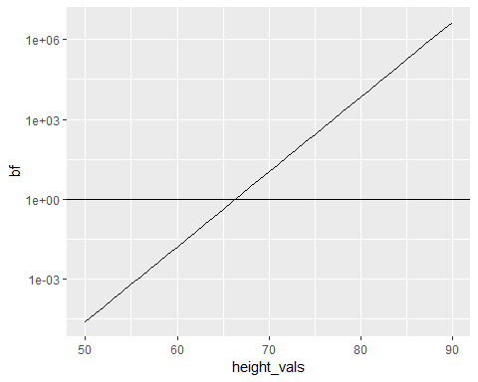

tiny_bf_schedule %>%   
 ggplot(aes(x = height_vals, y = bf)) +   
 geom_line() +   
 scale_y_log10() +  
 geom_hline(yintercept = 1)

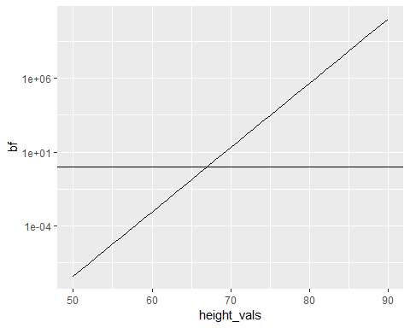

Finally, what’s the relative likelihood that I’m male?

my_height <- 1.7145 * 39.3701 # to get to height in inches  
  
calc_bayes_factor(value = my_height, mu_null = mu_female, sd_null = sd_female, mu_alt = mu_male, sd_alt = sd_male)

## [1] 2.084433

calc_bayes_factor(value = my_height, mu_null = mu_female_tiny, sd_null = sd_female_tiny, mu_alt = mu_male_tiny, sd_alt = sd_male_tiny)

## [1] 1.616706

So, from height alone, it’s twice as likely I’m male than female, if using the full dataset, and about 60% more likely I’m make if using the small sample.

# Conclusion/Discussion

* There-is-only-one-test makes it easy to think through hypothesis testing
* The infer package makes it straightforward to apply this approach
* Computationally intensive and analytic approaches do the same thing in different ways
* Classical (Neyman-Pearson style) hypothesis tests may not answer the question you want to ask
* Bayes Factors are an alterantive and often more pragmatic way of weighing the evidence