Segregations in the cities: exploring change in social, economic and demographic segregation in Aberdeen, Durham, Edinburgh and Glasgow between the 2001 and 2011 censuses

# Introduction

Segregation is a concept that has been operationalised in a variety of ways, resulting in a large number of distinct segregation indices, as well as a variety of derivations and modifications of earlier indices. A pivotal paper by Massey & Denton [1988] used factor analysis to explore similarities and differences between around twenty separate segregation measures when applied to the same binary data, white and non-white population counts by 1980 US Census tracts. The paper argued that these measures should be grouped into five overarching ‘dimensions’ of segregation: evenness, exposure, concentration, centralisation, and clustering. In a later paper they proposed that high levels of segregation according to measures in each of these dimensions should be referred to as ‘hypersegregation’, and argued that a state of ‘hypersegregation’ existed for Black populations in US metropolitan areas in the 1980s

Douglas Massey, one of the authors of the pivotal 1988 paper discussed above, later updated their analyses [1996] (with White & Phua) of these twenty measures to look at equivalent census tract data for the 1990 data, concluding that two of these five dimensions, concentration and clustering, were not as distinct using the 1990 data compared with the 1988 data, casting doubt on the exact number of distinct dimensions that extant measures captures. Two later analyses inspired by Massey & Denton’s approach have argued there may only be two distinct and overarching definitions, though reached different conclusions as to what these two dimensions are: Reardon & O’Sullivan (2004) arguing for evenness-clustering and exposure-isolation, and Brown and Chung (2006) arguing for evenness-concentration and clustering-exposure.

In parallel with debates about the number of dimensions of segregation that exist and the most appropriate ways of measuring them, a number of new and derived measures have been developed which aim to address some real or perceived methodological flaws in earlier indices. For example, in its application to geographic data, such as US census tracts, there are spatial relationships between the ‘observations’ (minority and total population counts), and a number of modifications of earlier measures, predominantly the widely used dissimilarity index (Duncan & Duncan 1955), have been proposed (e.g. Morrill 1991, Wong 1993, 1998, 2005) which aim to ‘adjust’ index values according to the spatial relationship between population areas. Other ways in which extant measures have been modified and generalised have been to allow measures of segregation between three or more mutually exclusive population groups [examples including Reardon & Firebaugh 2008], to allow measures to be calculated based on continuous rather than discrete spatial data [Reardon & Sullivan 2004?], to allow ordinal relationships between population groups to be represented [Reardon 2008, Dawkins 2004, 2007] and to allow the calculation of uncertainty intervals based on spatial statistical methods [Lee et al 2014].

While there has been a great deal of development and innovation in terms of how segregation is measured, much of the focus in terms of what is measured has tended to be on ethnic/racial segregation. However, segregation measures can be applied to a much larger range of spatially varying population characteristics. Within a series of three reports, we calculate a large number of segregation measures for a range of population characteristics in the four largest cities in Scotland: Glasgow, Edinburgh, Dundee and Aberdeen. By extracting and harmonising the definitions of different population categories used within comparable tables from the 2001 and 2011 censuses, we can use these measures to show how much different types of segregation have changed over this decade with regard to a range of spatially varying population characteristics.

# Methods

|  |  |  |
| --- | --- | --- |
| **Variable** | **Group A** | **Group B** |
| Accommodation | Lives in a house in a single household | Lives in a flat, caravan or shared accommodation |
| Car | Household has no car | Household has one or more cars |
| Country of birth | Individual was born in Scotland | Individual was born in the rest of the UK or elsewhere in the world |
| General Health | Individual reports having good health | Individual reports having not good health |
| Limiting Long-Term Illness | Individual reports having a limiting Long-term Illness | Individual reports not having a limiting long-term illness |
| Marital Status | Single (including separated, divorced, separated and widowed) | Married (including remarried) |
| National Statistics Socioeconomic Classification | Higher (higher and lower managerial/professional) | Lower (routine, intermediate, small self-employed) |
| Religion | Any religion | No religion |
| Pensioners | Is a pensioner | Is not a pensioner |
| Home ownership | Owns a house (either outright or with a mortgage) | Does not own a house (including renting from the private sector, living in social housing, or living rent-free) |
| Ethnicity | White | Not White |

Table The census variables which are compared within the four city regions between the 2001 census, including the binary (minority/majority group) category breaks used in segregation analyses

## City region definitions

Segregation measures for each of the above population types were calculated both for the whole of Scotland, and also for the top four city regions. The city regions were defined using travel to work area boundaries. Figure X shows these four city regions on a map, with Glasgow in red, Edinburgh in blue, Dundee in green, and Aberdeen in purple.

Though these four city regions only contain a small proportion of Scotland’s total area, they contain a comparatively large proportion of its population and datazones. Table X shows each of Scotland’s travel to work areas, ordered in descending order from largest to smallest. Of the 48 TTWAs in Scotland, the ten most populous contain slightly more than two thirds of Scotland’s population, and include the four city regions. The four city regions contain around 45 % of Scotland’s datazones, reflecting Scotland’s relatively high level of urbanisation and the importance of investigation these four city regions.

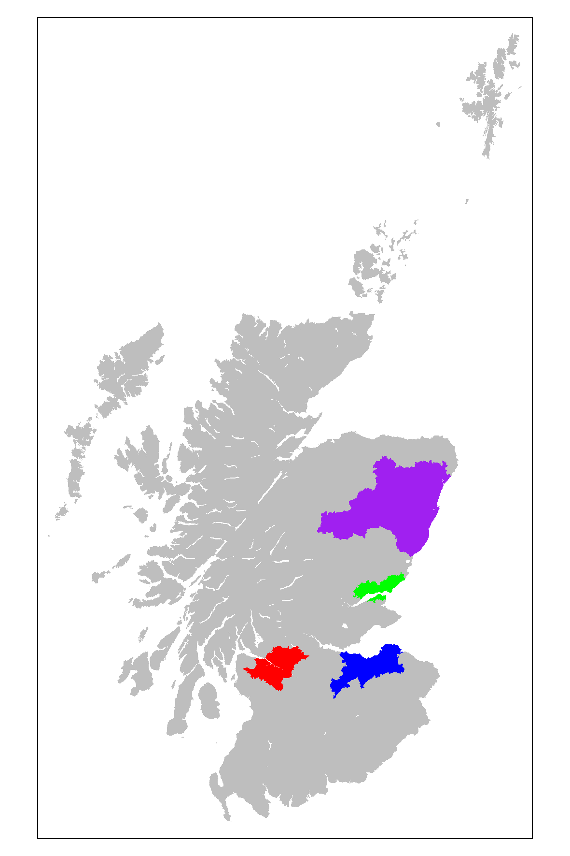

Figure The four travel-to-work areas: Glasgow in red; Edinburgh in blue; Dundee in green; and Aberdeen in purple.

|  |  |  |
| --- | --- | --- |
| **Name of travel to work area** | **Number of datazones covered** | **Cumulative proportion of Scotland's datazones** |
| ***Glasgow*** | 1398 | 0.21 |
| ***Edinburgh*** | 772 | 0.33 |
| Lanarkshire | 627 | 0.43 |
| ***Aberdeen*** | 461 | 0.50 |
| Ayr and Kilmarnock | 296 | 0.55 |
| ***Dundee*** | 265 | 0.59 |
| Falkirk | 215 | 0.62 |
| Kirkcaldy and Glenrothes | 209 | 0.65 |
| Livingston and Bathgate | 200 | 0.68 |
| Irvine and Arran | 180 | 0.71 |
| Stirling and Alloa | 170 | 0.74 |
| Dunfermline | 165 | 0.76 |
| Perth and Blairgowrie | 158 | 0.79 |
| Inverness and Dingwall | 137 | 0.81 |
| Moray | 116 | 0.83 |
| Greenock | 113 | 0.84 |
| Dumfries and Annan | 111 | 0.86 |
| Dumbarton | 97 | 0.87 |
| Forfar and Montrose | 75 | 0.89 |
| Galashiels and Peebles | 63 | 0.90 |
| St Andrews and Cupar | 62 | 0.91 |
| Peterhead | 46 | 0.91 |
| Eilean Siar | 36 | 0.92 |
| Berwick | 35 | 0.92 |
| Banff | 32 | 0.93 |
| Dunoon and Bute | 31 | 0.93 |
| Kirkcudbright | 30 | 0.94 |
| Shetland Islands | 30 | 0.94 |
| Fraserburgh | 29 | 0.95 |
| Invergordon | 29 | 0.95 |
| Lochaber | 27 | 0.96 |
| Orkney Islands | 27 | 0.96 |
| Stranraer | 24 | 0.96 |
| Hawick | 23 | 0.97 |
| Oban | 22 | 0.97 |
| Thurso | 21 | 0.97 |
| Wick | 18 | 0.98 |
| Kelso and Jedburgh | 17 | 0.98 |
| Skye and Lochalsh | 17 | 0.98 |
| Badenoch | 16 | 0.98 |
| Newton Stewart and Wigtown | 15 | 0.99 |
| Pitlochry | 15 | 0.99 |
| Carlisle | 14 | 0.99 |
| Dornoch and Lairg | 14 | 0.99 |
| Lochgilphead | 13 | 0.99 |
| Ullapool and Gairloch | 13 | 1.00 |
| Campbeltown | 11 | 1.00 |
| Mull and Islay | 10 | 1.00 |

Table Scotland's Travel to Work Areas, arranged in descending order by number of datazones. The four city regions are highlighted.

## Travel to work centre

One of the five proposed dimensions of segregation is centralisation, and for centralisation measures to be calculated a population centre needs to be proposed for each travel to work areas. Table X provides definitions of the four travel to work area centres used. Figure X (in the appendix) shows these on separate maps for each city region

|  |  |  |  |
| --- | --- | --- | --- |
| **TTWA Name** | **Description of centre** | **Postcode for centre** | **Datazone code** |
| Glasgow | West End of George Square | G1 3BU | S01003358 |
| Edinburgh | 31 Waverley Bridge | EH1 1BQ | S01002131 |
| Aberdeen | Shoe Lane | AB10 1AN | S01002131 |
| Dundee | Commercial Street | DD1 2AJ | S01001101 |

Table Locations of centres for each TTWA

# Results

## The Four Cities in context

This section will show how the proportion of either households or individuals in various ‘minority’ categories has changed in the four cities between 2001 and 2011, in comparison with the other TTWAs in Scotland. In each of the tables presented the TTWAs are ranked by the proportion in the ‘minority’ category in 2001 compared with other TTWAs in the same year. The proportions in the minority category in both 2001 and 2011 are shown to three decimal places, and the rank in both 2001 and 2011, along with the change in rank between the two censuses. A TTWA can show both a high level of stability in terms of proportions in the minority category between 2001 and 2011, and a large change in the ranks between these two years, because of broader changes in these minority proportions throughout Scotland.

### Car ownership

Cars are one of the most expensive assets that a household can own or rent. Because of this, and because they can be shared between driving licence owning adults within a household, car ownership is a household level rather than individual level attribute. If a household owns one car their ‘friction of distance’ is reduced, meaning that they are generally able to travel much further distances in a given amount of time than if they have to rely on public transport. Indeed, the travel-to-work areas depend largely on commuter flows, differences between where people work and where people live, that are strongly mediated by household car access; if travel-to-work areas were calculated separately for car owners compared with non-car owners, they would likely be much smaller for the latter than the former group.

The UK census has never included questions on income, and because of the expense involved in car ownership, questions on car ownership are sometimes used as proxies for neighbourhood poverty or affluence. For similar reasons, data on car ownership are often used as components in standard measures of neighbourhood deprivation, in Scotland as well as in England. However, car ownership can be problematic as an indicator of deprivation, as not all places are equally car dependent, and not all households can be expected to have identical preferences towards car ownership. This is particularly the case in urban areas where the physical distances needed to travel between home, work and other amenities (schools, shops etc) can be much smaller, the level of public transport provision can be much greater, and so the need for household car access can be much greater. The maps of our four city-region TTWAs help to illustrate large differences in levels of urbanisation, with Glasgow appearing the most ‘urban’ of the four city regions and Aberdeen the least. It is also important, when thinking about what changes in car ownership in TTWAs could mean, to consider that there have been generational shifts in levels of car ownership, with younger adults from more recent cohorts in the UK being less likely to have driving licences and so be in car owning households than less recent cohorts were at the same age.

Within the census tables used, we have calculated the proportion of households that do not own a car as a proportion of all households in the TTWA at each census. This is shown for all TTWAs in table X. Looking at the four city regions, we can see that the ranking of car ownership conforms largely with what we might expect given the apparent levels of urbanisation/density of the four TTWAs, with Glasgow having the lowest levels of car ownership in the whole of Scotland, closely followed by Dundee and Edinburgh. Conversely Aberdeen, with the largest TTWA, has a much higher level of car ownership.

Three of the four city regions (Glasgow, Dundee and Aberdeen) have seen small increases in the proportion of households with car, in the range of around 3%. These small increases seem typical of almost all TTWAs, suggesting that overall levels of household car accessibility increased in Scotland between 2001 and 2011. The exception to this general trend is in Edinburgh, which to three decimal places has seen no change between the two decades, being at 36.0% in both decades. It is worth noting that, within England & Wales, there has been a similar trend towards household car accessibility, with only London reporting a decrease rather than increase in car-owning households between the two censuses.

The TTWAs that have seen the greatest decrease in the proportions of household without access to a car include Eilean Siar in the Western Isles and Invergordon in the Highlands, two relatively remote regions which can be expected to be relatively car dependent. Conversely, the TTWA with the biggest increase in the ranking of households without car access is St Andrews and Cupar, a region well known for its university and relative affluence.

|  |  |  |  |  |  |
| --- | --- | --- | --- | --- | --- |
| **Travel to work area** | **Proportion** | | **Rank** | | **Rank Change** |
| 2001 | 2011 | 2001 | 2011 |
| ***Glasgow*** | 0.438 | 0.406 | 1 | 1 | 0 |
| Greenock | 0.403 | 0.377 | 2 | 2 | 0 |
| ***Dundee*** | 0.384 | 0.356 | 3 | 4 | 1 |
| Irvine and Arran | 0.361 | 0.322 | 4 | 5 | 1 |
| ***Edinburgh*** | 0.360 | 0.360 | 5 | 3 | -2 |
| Dunoon and Bute | 0.355 | 0.304 | 6 | 6 | 0 |
| Campbeltown | 0.344 | 0.292 | 7 | 8 | 1 |
| Lanarkshire | 0.343 | 0.300 | 8 | 7 | -1 |
| Dumbarton | 0.328 | 0.291 | 9 | 9 | 0 |
| Wick | 0.323 | 0.262 | 10 | 13 | 3 |
| Kirkcaldy and Glenrothes | 0.320 | 0.280 | 11 | 10 | -1 |
| Ayr and Kilmarnock | 0.313 | 0.273 | 12 | 12 | 0 |
| Hawick | 0.310 | 0.275 | 13 | 11 | -2 |
| Eilean Siar | 0.298 | 0.228 | 14 | 24 | 10 |
| Falkirk | 0.294 | 0.244 | 15 | 16 | 1 |
| Dunfermline | 0.290 | 0.242 | 16 | 17 | 1 |
| Stranraer | 0.287 | 0.261 | 17 | 14 | -3 |
| Livingston and Bathgate | 0.287 | 0.251 | 18 | 15 | -3 |
| Fraserburgh | 0.284 | 0.235 | 19 | 18 | -1 |
| Invergordon | 0.274 | 0.219 | 20 | 27 | 7 |
| Stirling and Alloa | 0.264 | 0.235 | 21 | 19 | -2 |
| Dumfries and Annan | 0.264 | 0.229 | 22 | 23 | 1 |
| ***Aberdeen*** | 0.262 | 0.232 | 23 | 21 | -2 |
| Lochaber | 0.260 | 0.217 | 24 | 28 | 4 |
| Oban | 0.259 | 0.224 | 25 | 25 | 0 |
| Thurso | 0.257 | 0.216 | 26 | 29 | 3 |
| Forfar and Montrose | 0.256 | 0.233 | 27 | 20 | -7 |
| Inverness and Dingwall | 0.251 | 0.211 | 28 | 30 | 2 |
| Peterhead | 0.249 | 0.209 | 29 | 31 | 2 |
| Perth and Blairgowrie | 0.245 | 0.221 | 30 | 26 | -4 |
| Mull and Islay | 0.242 | 0.170 | 31 | 44 | 13 |
| Newton Stewart and Wigtown | 0.241 | 0.192 | 32 | 35 | 3 |
| Dornoch and Lairg | 0.241 | 0.186 | 33 | 38 | 5 |
| St Andrews and Cupar | 0.239 | 0.231 | 34 | 22 | -12 |
| Moray | 0.236 | 0.199 | 35 | 33 | -2 |
| Shetland Islands | 0.236 | 0.191 | 36 | 36 | 0 |
| Galashiels and Peebles | 0.232 | 0.203 | 37 | 32 | -5 |
| Banff | 0.230 | 0.186 | 38 | 39 | 1 |
| Carlisle | 0.229 | 0.193 | 39 | 34 | -5 |
| Orkney Islands | 0.223 | 0.184 | 40 | 41 | 1 |
| Skye and Lochalsh | 0.219 | 0.164 | 41 | 45 | 4 |
| Berwick | 0.216 | 0.185 | 42 | 40 | -2 |
| Kelso and Jedburgh | 0.216 | 0.188 | 43 | 37 | -6 |
| Lochgilphead | 0.215 | 0.173 | 44 | 42 | -2 |
| Badenoch | 0.198 | 0.158 | 45 | 46 | 1 |
| Kirkcudbright | 0.197 | 0.173 | 46 | 43 | -3 |
| Ullapool and Gairloch | 0.196 | 0.151 | 47 | 47 | 0 |
| Pitlochry | 0.177 | 0.150 | 48 | 48 | 0 |

Table The proportion of households without access to a car, by TTWA, in the 2001 and 2011 censuses. The four TTWAs which this report focuses on highlighted with bold and italic text.

### Country of birth

Scotland and England share a border that runs for almost a hundred miles, and England’s population is around ten times the size of Scotland’s. It should be of no surprise, therefore, that the largest migrant population within Scotland is the English. The long and porous border between Scotland and England also mean that some of TTWAs in Scotland are based around English cities, in particular Carlisle.

Table X shows the proportion of non-Scottish populations in different TTWAs, ranked by non-Scottish population proportions in 2001. To help understand the extent to which these population proportions are driven primarily by distance to the Scottish-English border, figure X highlights the TTWAs with the top five highest proportions of non-Scottish populations in either the 2001 or 2011 censuses. It is clear from this that although the Carlisle TTWA, at the top of the ranking for both years, refers both to an English city and is likely to involve frequent commuting between the two countries, other TTWAs with high non-Scottish populations tend to be widely distributed throughout the country. In the case of the Carlisle TTWA, it may well be that the A7 motorway, stretching south to north from Carlisle to Tweedbank, is a contributory factor in the high non-Scottish population in this TTWA. From table XX (households without car access) it is also apparent that the Carlisle TTWA includes a relatively low proportion of households without car access, implying around four fifths of households in this TTWA have access to a car, which would fit with this explanation.

The TTWAs which rose fastest are Banff and Fraserburgh, both located on the North Coast of Aberdeenshire. By contrast, the fastest fall in ranking between 2001 and 2011 was in Dumbarton, located in the West-Central Lowlands of Scotland north of the River Clyde.

Of the four city regions, Edinburgh has the highest ranking in both censuses, with a population around one fifth non-Scottish in 2001 and one quarter non-Scottish in 2011. This is followed by Aberdeen (from 16.7% to 22.9% non-Scottish), then Dundee (12.3% to 15.9%), and finally Glasgow (9.3% rising to 13.6%). Although Glasgow remains low in the rankings of non-Scottish populations in both censuses, the relative change in this minority population, from 9.3% to 13.6%, represents around a 46% increase in population size, and so this may have been perceived by Scottish populations in the Glasgow TTWA as a relatively large increase.

|  |  |  |  |  |  |
| --- | --- | --- | --- | --- | --- |
| **Travel to work area** | **Proportion** | | **Rank** | | **Rank Change** |
| 2001 | 2011 | 2001 | 2011 |
| Carlisle | 0.361 | 0.391 | 1 | 1 | 0 |
| Ullapool and Gairloch | 0.294 | 0.350 | 2 | 2 | 0 |
| Berwick | 0.275 | 0.307 | 3 | 6 | 3 |
| Pitlochry | 0.270 | 0.318 | 4 | 4 | 0 |
| St Andrews and Cupar | 0.266 | 0.339 | 5 | 3 | -2 |
| Kirkcudbright | 0.248 | 0.294 | 6 | 7 | 1 |
| Badenoch | 0.247 | 0.309 | 7 | 5 | -2 |
| Mull and Islay | 0.225 | 0.282 | 8 | 9 | 1 |
| Newton Stewart and Wigtown | 0.221 | 0.279 | 9 | 10 | 1 |
| Skye and Lochalsh | 0.221 | 0.284 | 10 | 8 | -2 |
| Moray | 0.214 | 0.246 | 11 | 14 | 3 |
| Dornoch and Lairg | 0.213 | 0.271 | 12 | 11 | -1 |
| Kelso and Jedburgh | 0.209 | 0.254 | 13 | 13 | 0 |
| Oban | 0.196 | 0.240 | 14 | 15 | 1 |
| ***Edinburgh*** | 0.194 | 0.256 | 15 | 12 | -3 |
| Lochgilphead | 0.190 | 0.226 | 16 | 18 | 2 |
| Lochaber | 0.185 | 0.236 | 17 | 16 | -1 |
| Galashiels and Peebles | 0.182 | 0.222 | 18 | 19 | 1 |
| Dumbarton | 0.168 | 0.161 | 19 | 36 | 17 |
| ***Aberdeen*** | 0.167 | 0.229 | 20 | 17 | -3 |
| Dumfries and Annan | 0.166 | 0.195 | 21 | 26 | 5 |
| Orkney Islands | 0.166 | 0.220 | 22 | 20 | -2 |
| Thurso | 0.164 | 0.194 | 23 | 28 | 5 |
| Inverness and Dingwall | 0.164 | 0.214 | 24 | 21 | -3 |
| Dunoon and Bute | 0.162 | 0.194 | 25 | 27 | 2 |
| Hawick | 0.160 | 0.204 | 26 | 23 | -3 |
| Perth and Blairgowrie | 0.160 | 0.198 | 27 | 24 | -3 |
| Invergordon | 0.155 | 0.198 | 28 | 25 | -3 |
| Stranraer | 0.154 | 0.186 | 29 | 30 | 1 |
| Stirling and Alloa | 0.147 | 0.176 | 30 | 31 | 1 |
| Shetland Islands | 0.146 | 0.193 | 31 | 29 | -2 |
| Banff | 0.142 | 0.205 | 32 | 22 | -10 |
| Dunfermline | 0.130 | 0.146 | 33 | 39 | 6 |
| Peterhead | 0.127 | 0.171 | 34 | 33 | -1 |
| Campbeltown | 0.124 | 0.164 | 35 | 35 | 0 |
| ***Dundee*** | 0.123 | 0.159 | 36 | 37 | 1 |
| Wick | 0.117 | 0.172 | 37 | 32 | -5 |
| Forfar and Montrose | 0.117 | 0.146 | 38 | 40 | 2 |
| Eilean Siar | 0.105 | 0.149 | 39 | 38 | -1 |
| Livingston and Bathgate | 0.099 | 0.129 | 40 | 42 | 2 |
| Kirkcaldy and Glenrothes | 0.099 | 0.123 | 41 | 43 | 2 |
| ***Glasgow*** | 0.093 | 0.136 | 42 | 41 | -1 |
| Ayr and Kilmarnock | 0.091 | 0.104 | 43 | 44 | 1 |
| Fraserburgh | 0.087 | 0.167 | 44 | 34 | -10 |
| Irvine and Arran | 0.087 | 0.094 | 45 | 46 | 1 |
| Falkirk | 0.083 | 0.103 | 46 | 45 | -1 |
| Greenock | 0.073 | 0.074 | 47 | 48 | 1 |
| Lanarkshire | 0.057 | 0.075 | 48 | 47 | -1 |

Table Proportion of Non-Scottish born populations in different TTWAs in Scotland, based on 2001 and 2011 censuses.

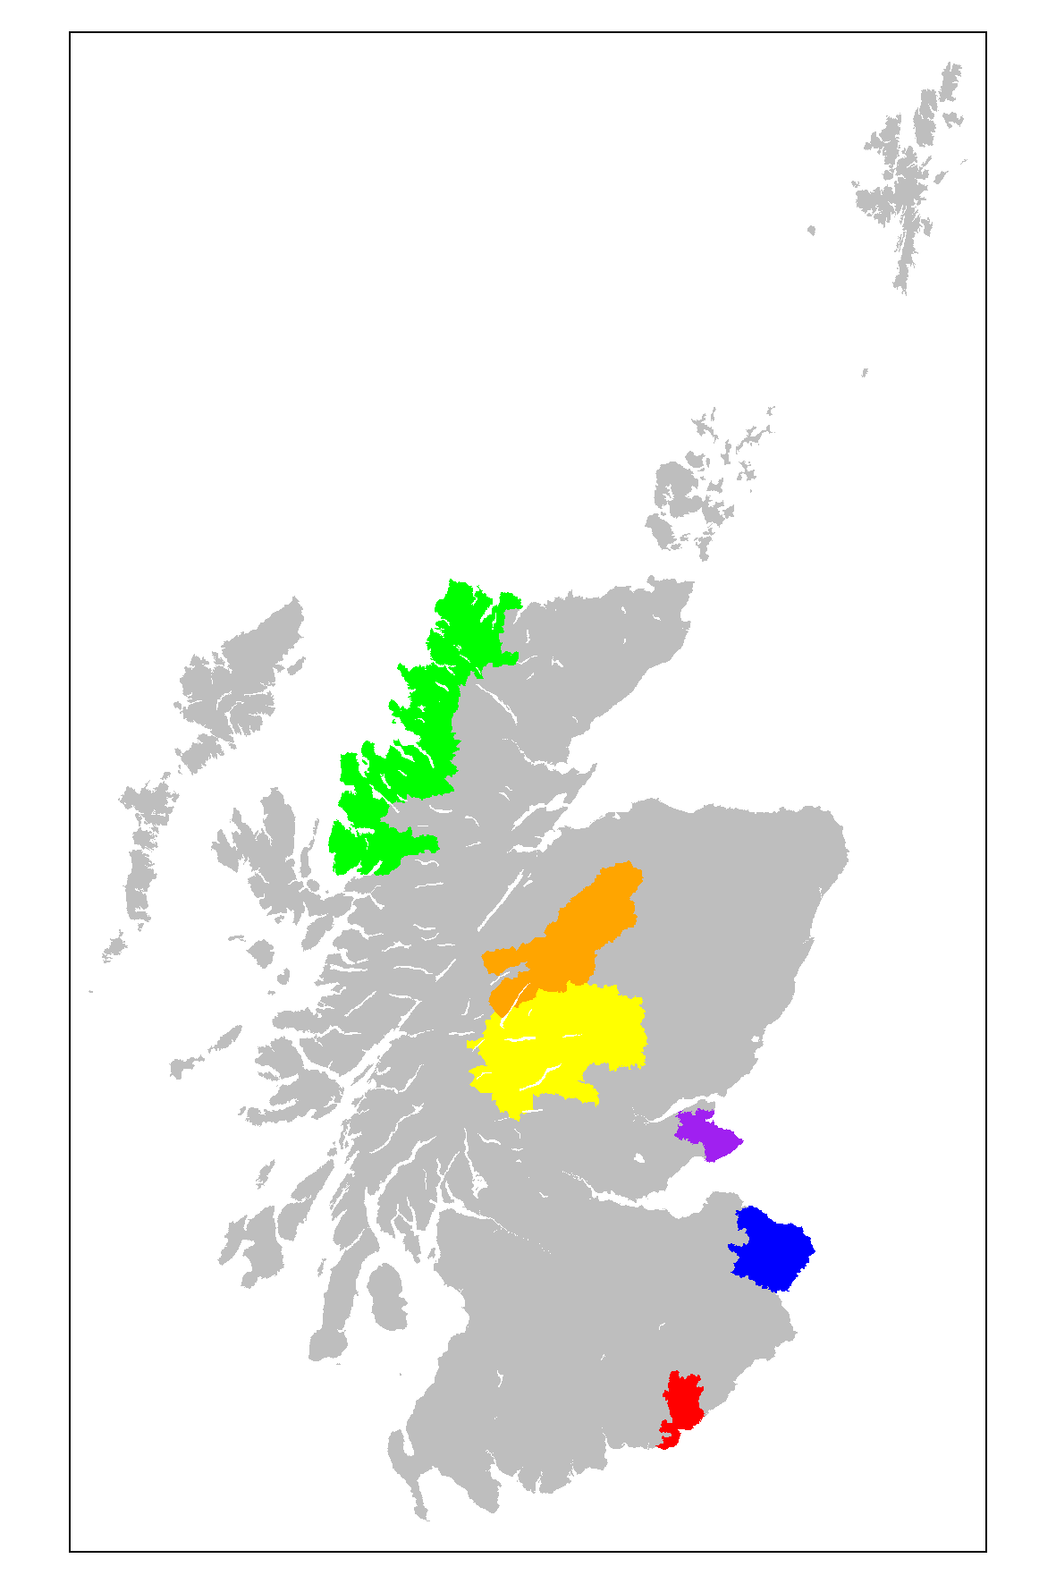

Figure Areas with the top five highest non-Scottish born populations in either 2001 or 2011. Colour code: red for Carlisle, blue for Berwick, purple for St Andrews, yellow for Pitlochry, orange for Badenoch, and green for Ullapool and Gairloch

### Ethnicity

If the populations of two neighbouring countries sharing a large border are of two clearly distinct ethnicities, then it would be expected that trends in the country of origin and ethnicity would be similar. This may be the case for the United States and Mexico, but it is not the case for Scotland and England. Because of this, the proportion of the population of each TTWA which is ‘not white’ shows a very different pattern to that for the proportion of each TTWA’s population which is ‘not Scottish’. This is shown in table XX.

Within this table, the four city regions are at the top of the list, occupying the top four places in 2001, and are all within the top five TTWAs in 2011. The Glasgow TTWA occupies the top ranking for both years, with the non-white share of the population doubling in a decade, from 3.7% to 7.6%. Edinburgh has also seen a doubling in non-white population proportions, from 3.2% in 2001 to 6.5% in 2011. Dundee and Aberdeen, by contrast, have seen the non-white population share rise by around two thirds, rather than doubling. From 2001 to 2011 Dundee fell two places in its non-white population ranking, from third to fifth place, and St Andrews and Cupar, whose non-white proportion increased by a factor of around 2.1, saw its relative position in this ranking rise from fifth to third place.

|  |  |  |  |  |  |
| --- | --- | --- | --- | --- | --- |
| **Travel to work area** | **Proportion** | | **Rank** | | **Rank Change** |
| 2001 | 2011 | 2001 | 2011 |
| ***Glasgow*** | 0.037 | 0.076 | 1 | 1 | 0 |
| ***Edinburgh*** | 0.032 | 0.065 | 2 | 2 | 0 |
| ***Dundee*** | 0.027 | 0.045 | 3 | 5 | 2 |
| ***Aberdeen*** | 0.021 | 0.054 | 4 | 3 | -1 |
| St Andrews and Cupar | 0.015 | 0.047 | 5 | 4 | -1 |
| Livingston and Bathgate | 0.014 | 0.025 | 6 | 7 | 1 |
| Kirkcaldy and Glenrothes | 0.013 | 0.021 | 7 | 8 | 1 |
| Stirling and Alloa | 0.012 | 0.026 | 8 | 6 | -2 |
| Lanarkshire | 0.011 | 0.020 | 9 | 10 | 1 |
| Dunfermline | 0.011 | 0.019 | 10 | 11 | 1 |
| Shetland Islands | 0.010 | 0.015 | 11 | 15 | 4 |
| Falkirk | 0.010 | 0.019 | 12 | 12 | 0 |
| Inverness and Dingwall | 0.010 | 0.018 | 13 | 13 | 0 |
| Perth and Blairgowrie | 0.010 | 0.020 | 14 | 9 | -5 |
| Dumbarton | 0.009 | 0.014 | 15 | 17 | 2 |
| Moray | 0.009 | 0.011 | 16 | 27 | 11 |
| Dumfries and Annan | 0.008 | 0.015 | 17 | 16 | -1 |
| Wick | 0.008 | 0.008 | 18 | 38 | 20 |
| Greenock | 0.008 | 0.014 | 19 | 18 | -1 |
| Oban | 0.008 | 0.013 | 20 | 19 | -1 |
| Dunoon and Bute | 0.007 | 0.010 | 21 | 33 | 12 |
| Pitlochry | 0.007 | 0.013 | 22 | 20 | -2 |
| Irvine and Arran | 0.007 | 0.011 | 23 | 30 | 7 |
| Forfar and Montrose | 0.007 | 0.012 | 24 | 21 | -3 |
| Ullapool and Gairloch | 0.007 | 0.011 | 25 | 29 | 4 |
| Ayr and Kilmarnock | 0.007 | 0.012 | 26 | 22 | -4 |
| Eilean Siar | 0.007 | 0.009 | 27 | 37 | 10 |
| Galashiels and Peebles | 0.006 | 0.016 | 28 | 14 | -14 |
| Peterhead | 0.006 | 0.011 | 29 | 26 | -3 |
| Lochaber | 0.006 | 0.012 | 30 | 24 | -6 |
| Carlisle | 0.006 | 0.008 | 31 | 41 | 10 |
| Lochgilphead | 0.006 | 0.011 | 32 | 28 | -4 |
| Berwick | 0.006 | 0.012 | 33 | 25 | -8 |
| Invergordon | 0.006 | 0.009 | 34 | 36 | 2 |
| Skye and Lochalsh | 0.005 | 0.008 | 35 | 40 | 5 |
| Badenoch | 0.005 | 0.012 | 36 | 23 | -13 |
| Dornoch and Lairg | 0.005 | 0.007 | 37 | 46 | 9 |
| Thurso | 0.005 | 0.007 | 38 | 48 | 10 |
| Campbeltown | 0.005 | 0.010 | 39 | 31 | -8 |
| Hawick | 0.005 | 0.010 | 40 | 32 | -8 |
| Banff | 0.005 | 0.010 | 41 | 35 | -6 |
| Orkney Islands | 0.004 | 0.007 | 42 | 45 | 3 |
| Fraserburgh | 0.004 | 0.008 | 43 | 39 | -4 |
| Kelso and Jedburgh | 0.004 | 0.010 | 44 | 34 | -10 |
| Newton Stewart and Wigtown | 0.004 | 0.008 | 45 | 43 | -2 |
| Kirkcudbright | 0.004 | 0.007 | 46 | 44 | -2 |
| Mull and Islay | 0.004 | 0.008 | 47 | 42 | -5 |
| Stranraer | 0.004 | 0.007 | 48 | 47 | -1 |

Figure Proportion of populations in different TTWAs that are 'not white', according to responses to the 2001 and 2011 censuses

### General Health

A question on self-evaluated general health over the previous 12 months was asked in both the 2001 and 2011 census. The wording on both censuses was not identical, and the scale of response options was increased from three options to five options between censuses. Both questions allowed respondents to be divided into those who reported ‘not good’ health (‘not good’ health in 2001; ‘fair’, ‘bad’ or ‘very bad’ in 2011) and everyone else. The proportion of respondents in TTWAs who reported ‘not good’ health is shown in table XXX. The effects that the changes of wording and types of response option available may have had on how respondents answered the question should be borne in mind when looking at changes in the proportions within TTWAs between censuses, although it may be expected that the relative ranking would be less susceptible to such changes between censuses.

Table XX shows a large change in the ranking and proportions between censuses, possibly because the binary division we used for the response options in 2011 coded ‘fair’ as ‘not good’, whereas respondents to the 2001 census may have interpreted the single option category ‘not good’ as a synonym of ‘bad’. In general, it appears the change of wording, response options, and binary categorisation of these response options, led to large increases in the proportions of people in Scotland with ‘not good’ health.

Despite the large changes in the proportions and rankings of all TTWAs, within the four city region TTWAs the rank order has remained consistent in both censuses, with Glasgow reporting the highest level of ‘not good’ health, followed by Dundee, then Edinburgh, followed by Aberdeen. It is worth noting that each of these city regions are almost equally distributed within the overall TTWA table rankings, unlike in table XX (ethnicity) where they were all clustered towards the top of the table. This seems to suggest that, even despite the inconsistency between censuses, a genuine difference in self-related health between the city regions has been identified.

|  |  |  |  |  |  |
| --- | --- | --- | --- | --- | --- |
| **Travel to work area** | **Proportion** | | **Rank** | | **Rank Change** |
| 2001 | 2011 | 2001 | 2011 |
| ***Glasgow*** | 0.128 | 0.203 | 1 | 7 | 6 |
| Lanarkshire | 0.121 | 0.204 | 2 | 6 | 4 |
| Dunoon and Bute | 0.118 | 0.226 | 3 | 1 | -2 |
| Greenock | 0.113 | 0.210 | 4 | 4 | 0 |
| Irvine and Arran | 0.110 | 0.208 | 5 | 5 | 0 |
| Stranraer | 0.110 | 0.223 | 6 | 2 | -4 |
| Newton Stewart and Wigtown | 0.105 | 0.222 | 7 | 3 | -4 |
| Kirkcaldy and Glenrothes | 0.103 | 0.199 | 8 | 9 | 1 |
| Ayr and Kilmarnock | 0.103 | 0.196 | 9 | 10 | 1 |
| Dumbarton | 0.100 | 0.189 | 10 | 12 | 2 |
| ***Dundee*** | 0.100 | 0.173 | 11 | 24 | 13 |
| Falkirk | 0.100 | 0.177 | 12 | 21 | 9 |
| Livingston and Bathgate | 0.100 | 0.174 | 13 | 23 | 10 |
| Invergordon | 0.099 | 0.187 | 14 | 16 | 2 |
| Fraserburgh | 0.098 | 0.181 | 15 | 20 | 5 |
| Campbeltown | 0.095 | 0.201 | 16 | 8 | -8 |
| Stirling and Alloa | 0.095 | 0.164 | 17 | 31 | 14 |
| Dunfermline | 0.094 | 0.176 | 18 | 22 | 4 |
| Dumfries and Annan | 0.094 | 0.188 | 19 | 14 | -5 |
| Hawick | 0.090 | 0.187 | 20 | 17 | -3 |
| Kirkcudbright | 0.089 | 0.188 | 21 | 15 | -6 |
| Eilean Siar | 0.088 | 0.183 | 22 | 19 | -3 |
| Dornoch and Lairg | 0.086 | 0.192 | 23 | 11 | -12 |
| Peterhead | 0.086 | 0.167 | 24 | 28 | 4 |
| Wick | 0.083 | 0.184 | 25 | 18 | -7 |
| Carlisle | 0.083 | 0.189 | 26 | 13 | -13 |
| Lochgilphead | 0.082 | 0.164 | 27 | 30 | 3 |
| Berwick | 0.082 | 0.166 | 28 | 29 | 1 |
| ***Edinburgh*** | 0.082 | 0.146 | 29 | 43 | 14 |
| Banff | 0.082 | 0.163 | 30 | 33 | 3 |
| Lochaber | 0.081 | 0.163 | 31 | 34 | 3 |
| Forfar and Montrose | 0.080 | 0.163 | 32 | 32 | 0 |
| Skye and Lochalsh | 0.080 | 0.159 | 33 | 36 | 3 |
| Mull and Islay | 0.080 | 0.167 | 34 | 27 | -7 |
| Ullapool and Gairloch | 0.078 | 0.170 | 35 | 26 | -9 |
| Perth and Blairgowrie | 0.077 | 0.148 | 36 | 41 | 5 |
| Oban | 0.077 | 0.155 | 37 | 37 | 0 |
| Inverness and Dingwall | 0.076 | 0.150 | 38 | 39 | 1 |
| St Andrews and Cupar | 0.075 | 0.144 | 39 | 44 | 5 |
| Thurso | 0.073 | 0.170 | 40 | 25 | -15 |
| Galashiels and Peebles | 0.073 | 0.147 | 41 | 42 | 1 |
| Moray | 0.073 | 0.150 | 42 | 38 | -4 |
| ***Aberdeen*** | 0.073 | 0.129 | 43 | 48 | 5 |
| Badenoch | 0.070 | 0.136 | 44 | 46 | 2 |
| Shetland Islands | 0.068 | 0.144 | 45 | 45 | 0 |
| Orkney Islands | 0.066 | 0.135 | 46 | 47 | 1 |
| Kelso and Jedburgh | 0.066 | 0.160 | 47 | 35 | -12 |
| Pitlochry | 0.064 | 0.149 | 48 | 40 | -8 |

### Accommodation type

Both the 2001 and 2011 include questions on the types of accommodation that respondents call their home, and whether they share this home with another household. The UK has built relatively few homes relative to increasing need and demand, and as a result it is expected that the types of accommodation that people in different TTWAs live within will be relatively ‘fixed’ by location, depending largely on the historical stock of accommodation types that had been built in the respective TTWAs. This means only a relatively small changing in both the proportions and the rankings can be expected over a single decade. However, as with other census questions, the response options were not completely consistent between the two censuses, which may have an effect on how a respondent would answer the question if living in the same accommodation in each census. Within our binary recategorisation of responses, a respondent was categorised as ‘living in a house’ if they lived as a single household within a house or bungalow (whether detached, semi-detached or terraced), and ‘not living in a house’ if they had any other form of accommodation, or shared their accommodation with another household.

‘Not living in a house’ includes living in a flat, accommodation where different levels of a building are owned or rented by different households. Multi-story accommodation, like terraced housing or simply building smaller homes, is a means of allowing a greater density of accommodation per unit area, and as such tends to be more attractive as an option for builders when land values are high or available space to build is limited. Put another way, cities tend to have more flats, and so a smaller proportion of people ‘living in a house’, and denser and more ‘urban’ cities tend to have proportionately more flats. Looking at the maps of the TTWAs for the four city regions - in which Glasgow appeared the most ‘urban’, followed by Edinburgh, then Dundee, then Aberdeen – we should expect this same kind of ranking in the proportions of people ‘not living in a house’. We should also expect that, as they are cities, they will appear near the top of the rankings in both years. Table XX shows that these expectations are broadly correct, but with some important caveats and exceptions.

Overall, table XX shows a very wide range in the proportion of people not living in a house in different TTWAs, with only around 4% of individuals not living in a house in the Dornoch and Lairg TTWA (two highland towns in a rural area), and at the other end of the scale over 40% of individuals in the Glasgow TTWA not living in a house. This ten-fold difference is wider than for any of the other variables shown here [confirm].

The four city region TTWAs are all within the top ten in both years, and there is relatively high stability in the ranking between 2001 and 2011 within the top 14 TTWAs, with no TTWA changing its ranking by more than one position. In general, the proportions of individuals not living in houses tends to be increasing in those TTWAs with the largest existing proportions. Greenock, a town on the south of the River Clyde on the West Coast of Scotland and north of the Clyde Muirshiel Regional Park, has the third highest proportion of people not living in houses, above Dundee and much above Aberdeen. Similarly, Dunoon and Bute, to the west of Greenock and also highly rural, ranks in fifth place in both censuses. This could reflect a relatively limited amount of usable land for building accommodation on, despite being in rural locations, creating a similar kind of land scarcity pressure to that faced by large urban centres.

|  |  |  |  |  |  |
| --- | --- | --- | --- | --- | --- |
| **Travel to work area** | **Proportion** | | **Rank** | | **Rank Change** |
| 2001 | 2011 | 2001 | 2011 |
| ***Glasgow*** | 0.426 | 0.453 | 1 | 2 | 1 |
| ***Edinburgh*** | 0.422 | 0.465 | 2 | 1 | -1 |
| Greenock | 0.382 | 0.393 | 3 | 3 | 0 |
| ***Dundee*** | 0.346 | 0.338 | 4 | 4 | 0 |
| Dunoon and Bute | 0.338 | 0.331 | 5 | 5 | 0 |
| Dumbarton | 0.299 | 0.293 | 6 | 7 | 1 |
| Hawick | 0.293 | 0.304 | 7 | 6 | -1 |
| ***Aberdeen*** | 0.268 | 0.279 | 8 | 8 | 0 |
| Campbeltown | 0.260 | 0.243 | 9 | 10 | 1 |
| Oban | 0.259 | 0.245 | 10 | 9 | -1 |
| Lanarkshire | 0.225 | 0.232 | 11 | 11 | 0 |
| Kirkcaldy and Glenrothes | 0.224 | 0.226 | 12 | 12 | 0 |
| Falkirk | 0.222 | 0.225 | 13 | 13 | 0 |
| Galashiels and Peebles | 0.215 | 0.218 | 14 | 14 | 0 |
| Stirling and Alloa | 0.211 | 0.204 | 15 | 17 | 2 |
| Perth and Blairgowrie | 0.210 | 0.214 | 16 | 15 | -1 |
| Forfar and Montrose | 0.209 | 0.207 | 17 | 16 | -1 |
| Dunfermline | 0.196 | 0.190 | 18 | 21 | 3 |
| St Andrews and Cupar | 0.192 | 0.196 | 19 | 18 | -1 |
| Ayr and Kilmarnock | 0.187 | 0.191 | 20 | 20 | 0 |
| Irvine and Arran | 0.186 | 0.193 | 21 | 19 | -2 |
| Kelso and Jedburgh | 0.182 | 0.185 | 22 | 22 | 0 |
| Lochgilphead | 0.182 | 0.158 | 23 | 24 | 1 |
| Peterhead | 0.147 | 0.139 | 24 | 25 | 1 |
| Livingston and Bathgate | 0.134 | 0.159 | 25 | 23 | -2 |
| Stranraer | 0.132 | 0.123 | 26 | 29 | 3 |
| Berwick | 0.131 | 0.131 | 27 | 27 | 0 |
| Dumfries and Annan | 0.129 | 0.125 | 28 | 28 | 0 |
| Inverness and Dingwall | 0.122 | 0.133 | 29 | 26 | -3 |
| Lochaber | 0.117 | 0.118 | 30 | 30 | 0 |
| Pitlochry | 0.114 | 0.116 | 31 | 31 | 0 |
| Wick | 0.104 | 0.095 | 32 | 34 | 2 |
| Kirkcudbright | 0.100 | 0.093 | 33 | 35 | 2 |
| Mull and Islay | 0.100 | 0.080 | 34 | 37 | 3 |
| Fraserburgh | 0.099 | 0.109 | 35 | 32 | -3 |
| Moray | 0.099 | 0.095 | 36 | 33 | -3 |
| Banff | 0.087 | 0.076 | 37 | 38 | 1 |
| Badenoch | 0.075 | 0.091 | 38 | 36 | -2 |
| Newton Stewart and Wigtown | 0.073 | 0.070 | 39 | 39 | 0 |
| Skye and Lochalsh | 0.069 | 0.053 | 40 | 45 | 5 |
| Carlisle | 0.066 | 0.069 | 41 | 40 | -1 |
| Shetland Islands | 0.062 | 0.065 | 42 | 41 | -1 |
| Ullapool and Gairloch | 0.059 | 0.054 | 43 | 44 | 1 |
| Orkney Islands | 0.053 | 0.049 | 44 | 46 | 2 |
| Thurso | 0.052 | 0.057 | 45 | 42 | -3 |
| Invergordon | 0.051 | 0.055 | 46 | 43 | -3 |
| Eilean Siar | 0.048 | 0.046 | 47 | 47 | 0 |
| Dornoch and Lairg | 0.040 | 0.034 | 48 | 48 | 0 |

Table The proportion of people in each TTWA 'not living in a house', in 2001 and 2011.

# Appendices

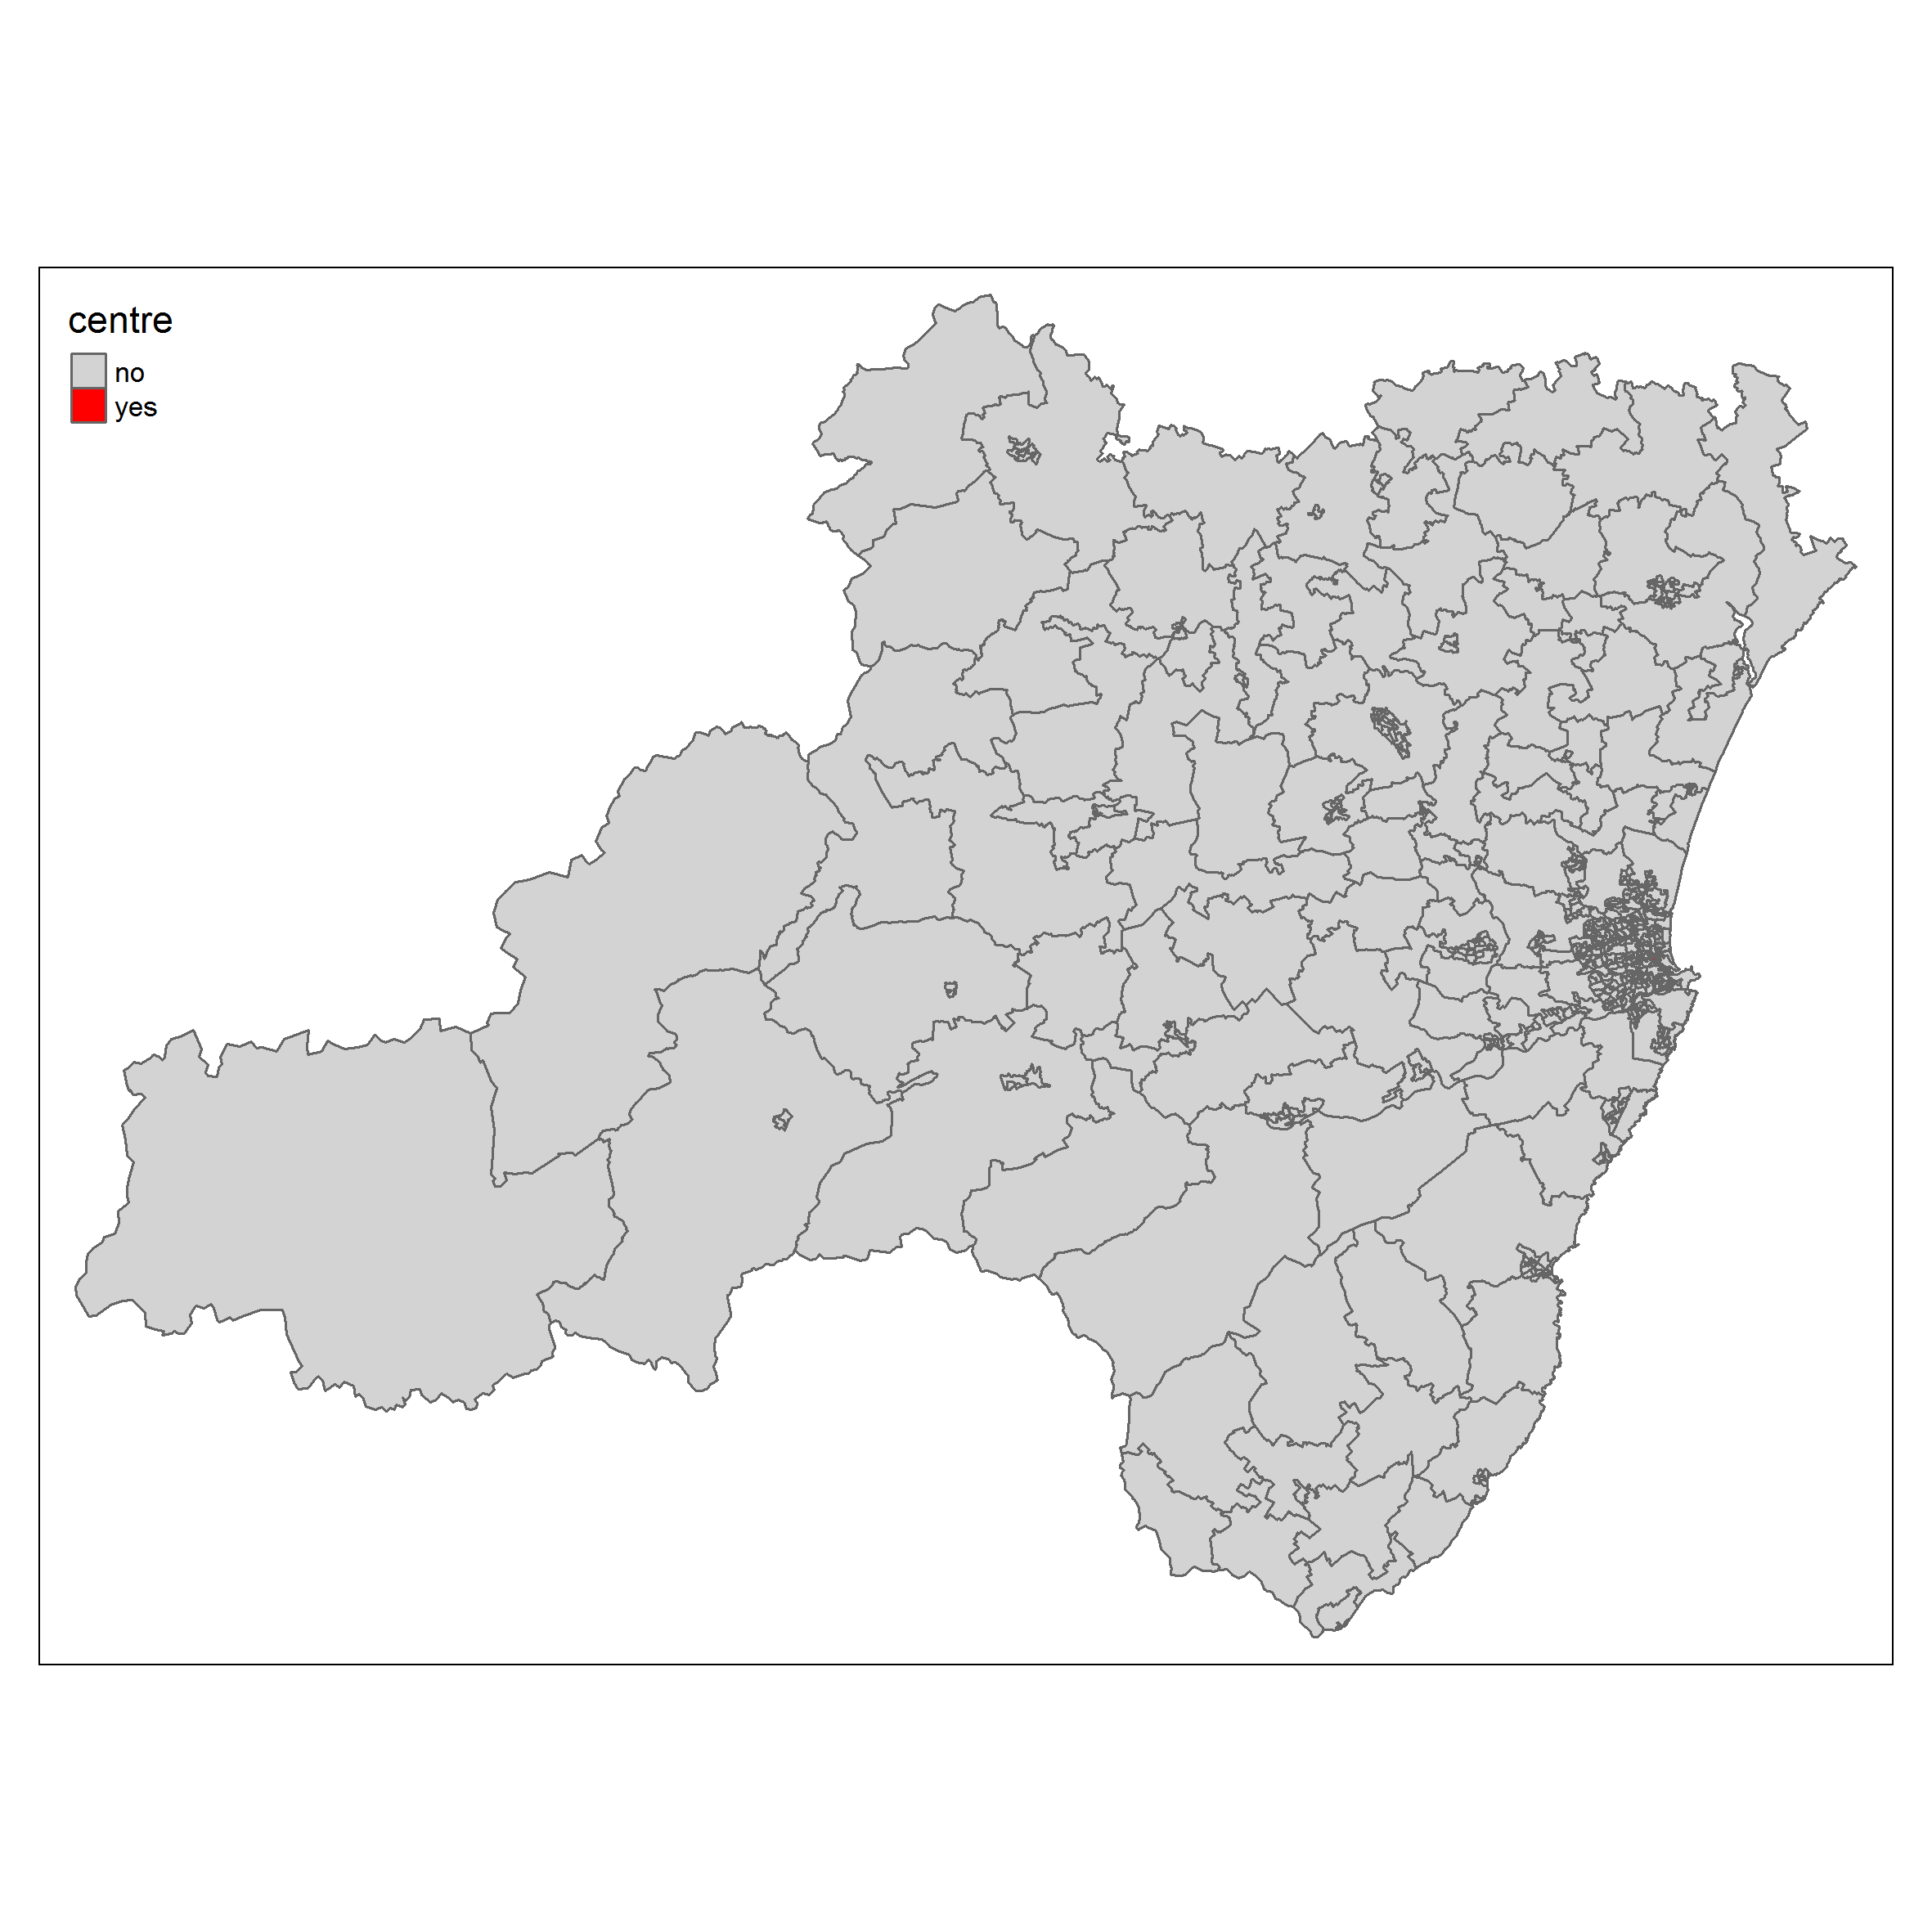

Figure Aberdeen TTWA, with designated centre (barely visible due to large size of TTWA) designated red

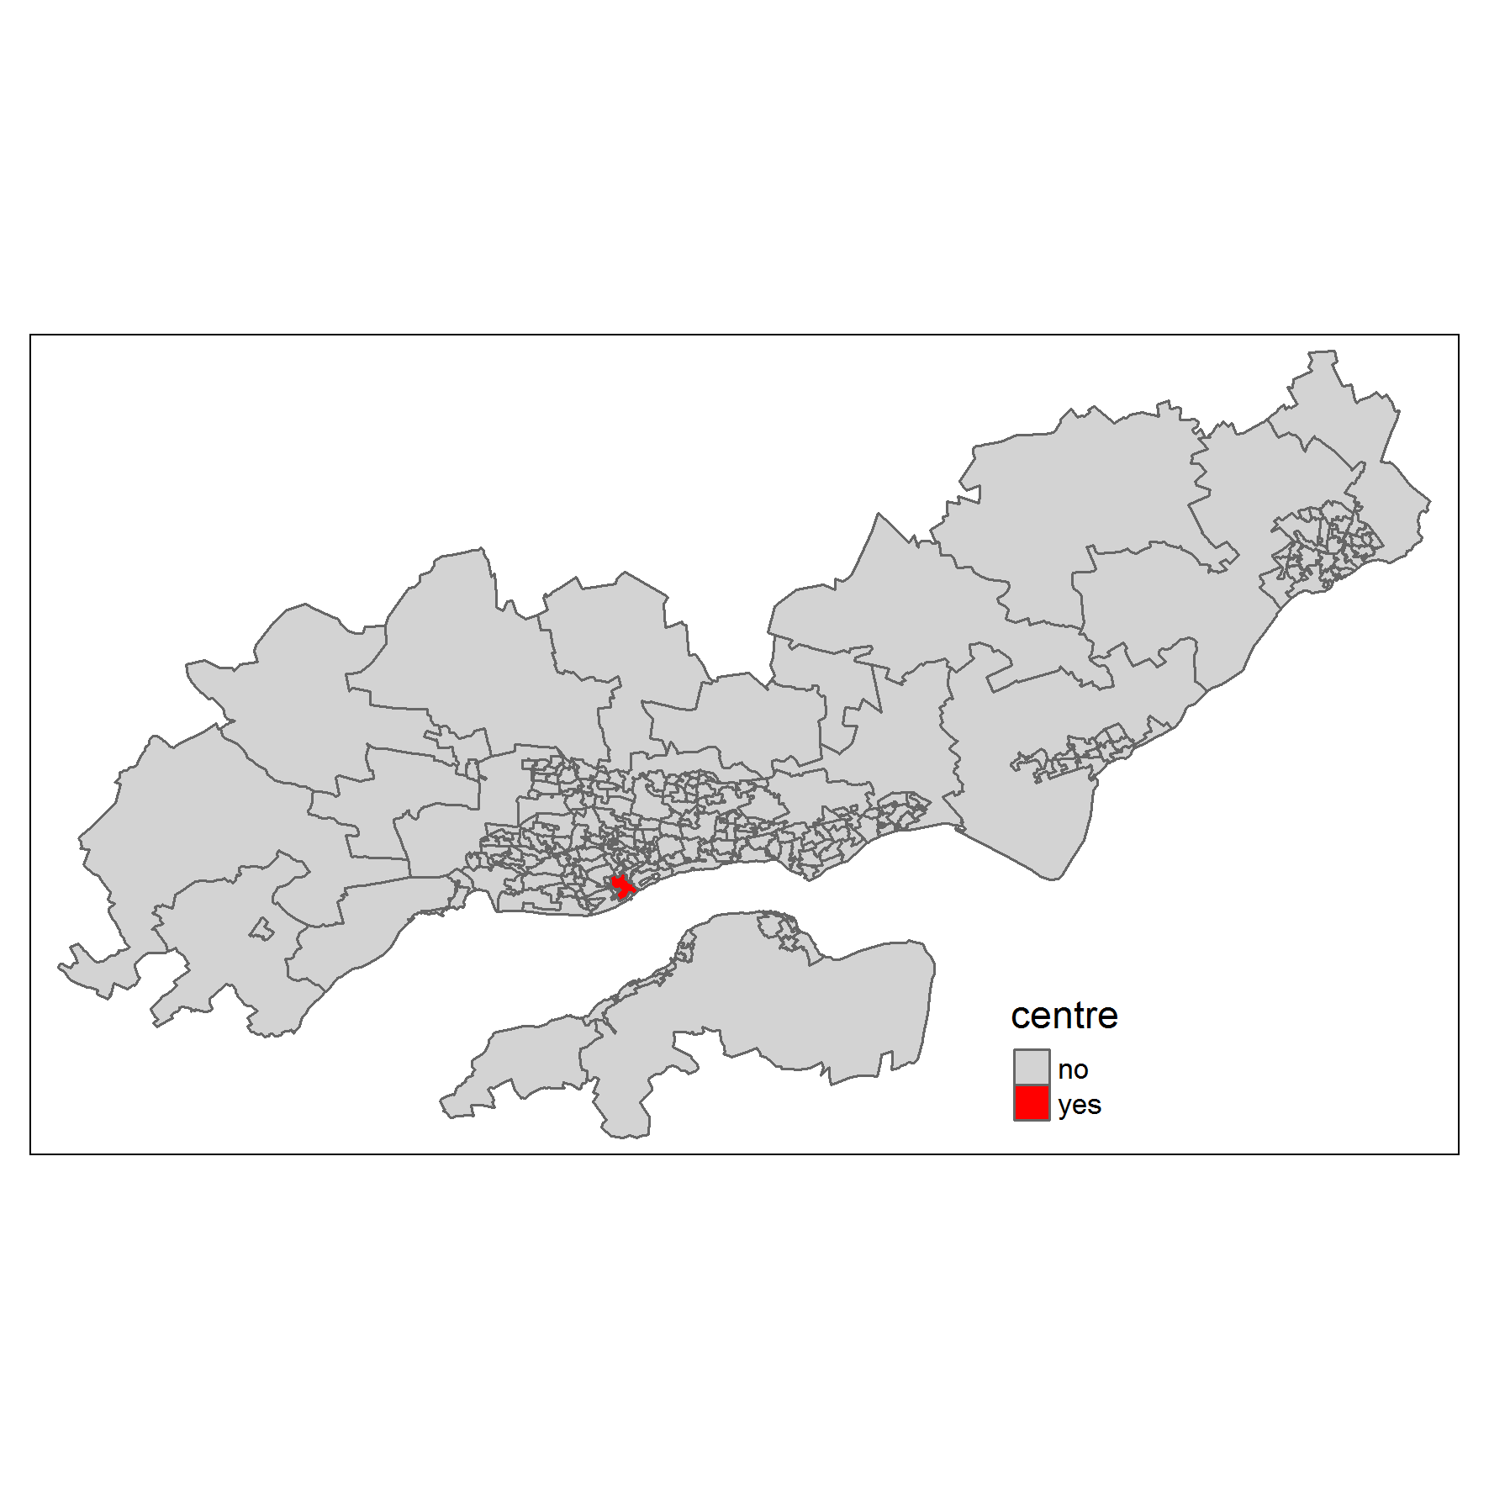

Figure Dundee TTWA, with designated centre in red

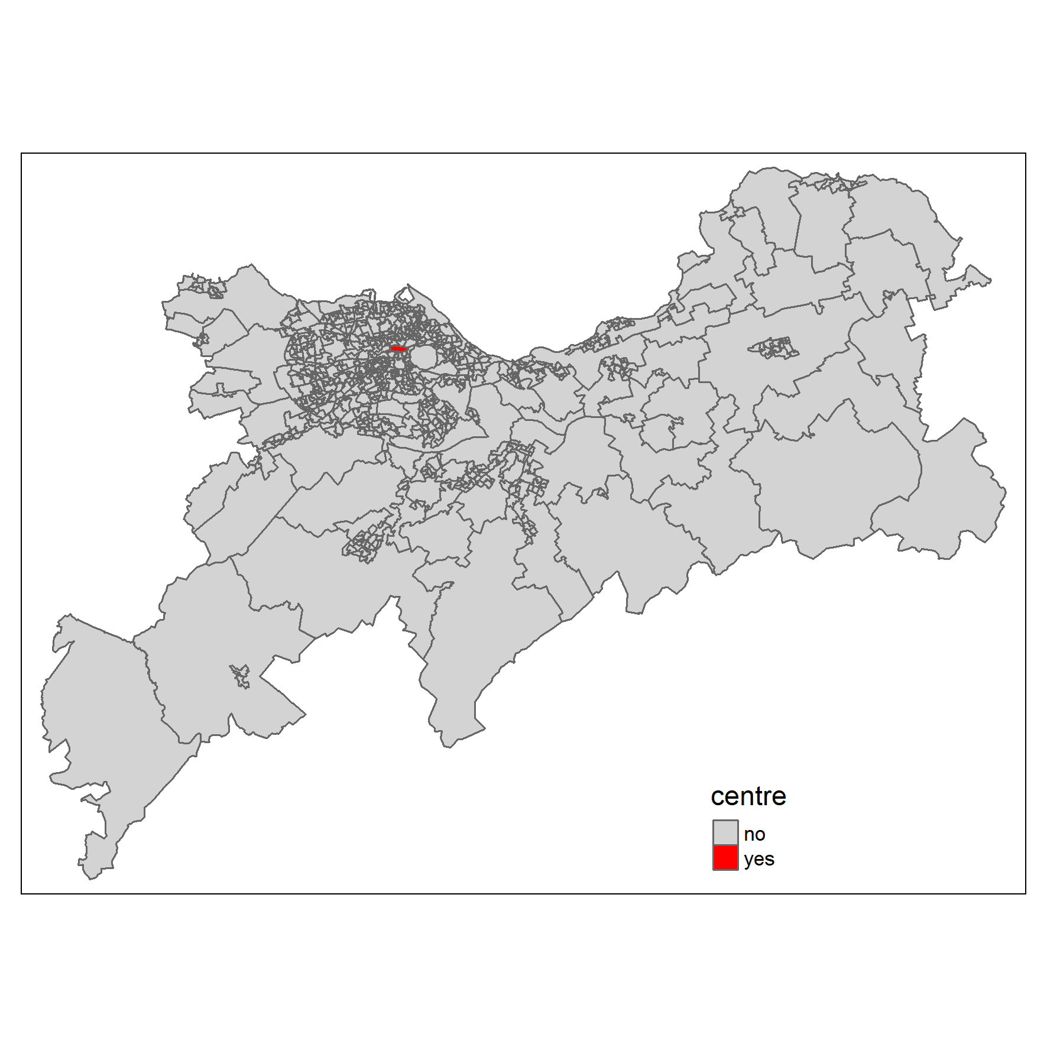

Figure Edinburgh TTWA, with designated centre in red

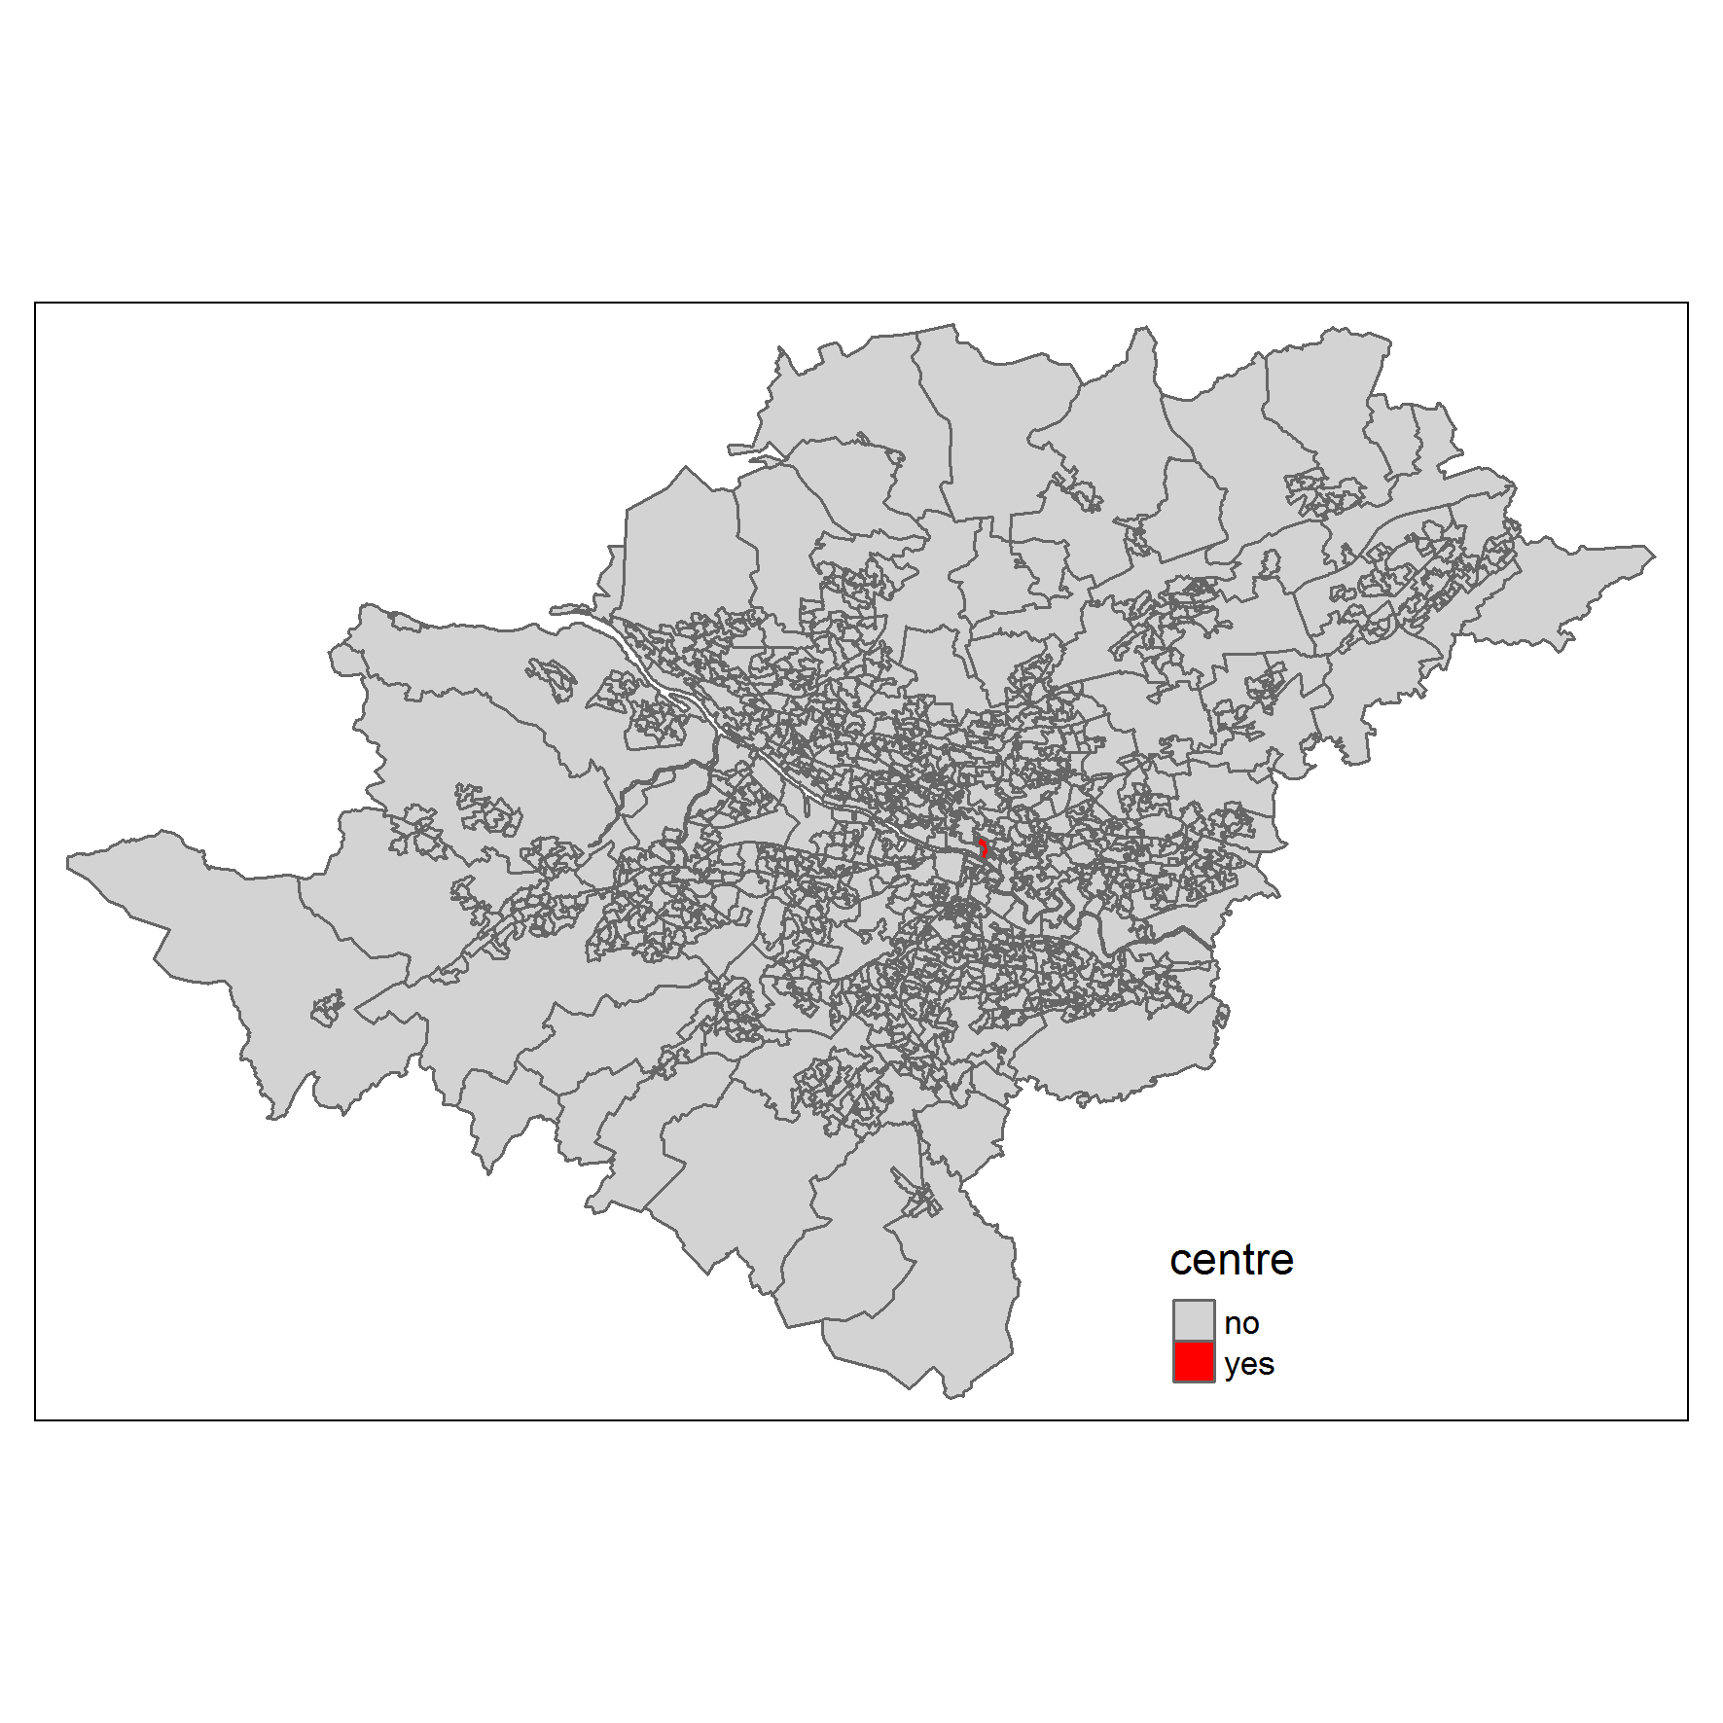

Figure Glasgow TTWA, with designated centre in red