Levelplots and Comparisons between Russia, Bulgaria and Georgia

Dr Jon Minton,

University of Glasgow

[Jonathan.minton@glasgow.ac.uk](mailto:Jonathan.minton@glasgow.ac.uk)

22 December 2016

# Introduction

This document will present some initial findings which look at changing mortality patterns either within Russia, Bulgaria or Georgia; or which compare trends between these countries; or which compare all cause mortality between these countries and neighbouring regions for which data are available in the Human Mortality Database (HMD). The main source of data used is the WHO database, supplemented by comparisons from the HMD.

# All-cause mortality in Russia and Bulgaria using HMD

Within the HMD records are available for all cause mortality by ages in single year for both Russia and Bulgaria. A levelplot showing how log10 mortality risk varies with age and year is shown for both of these countries below.

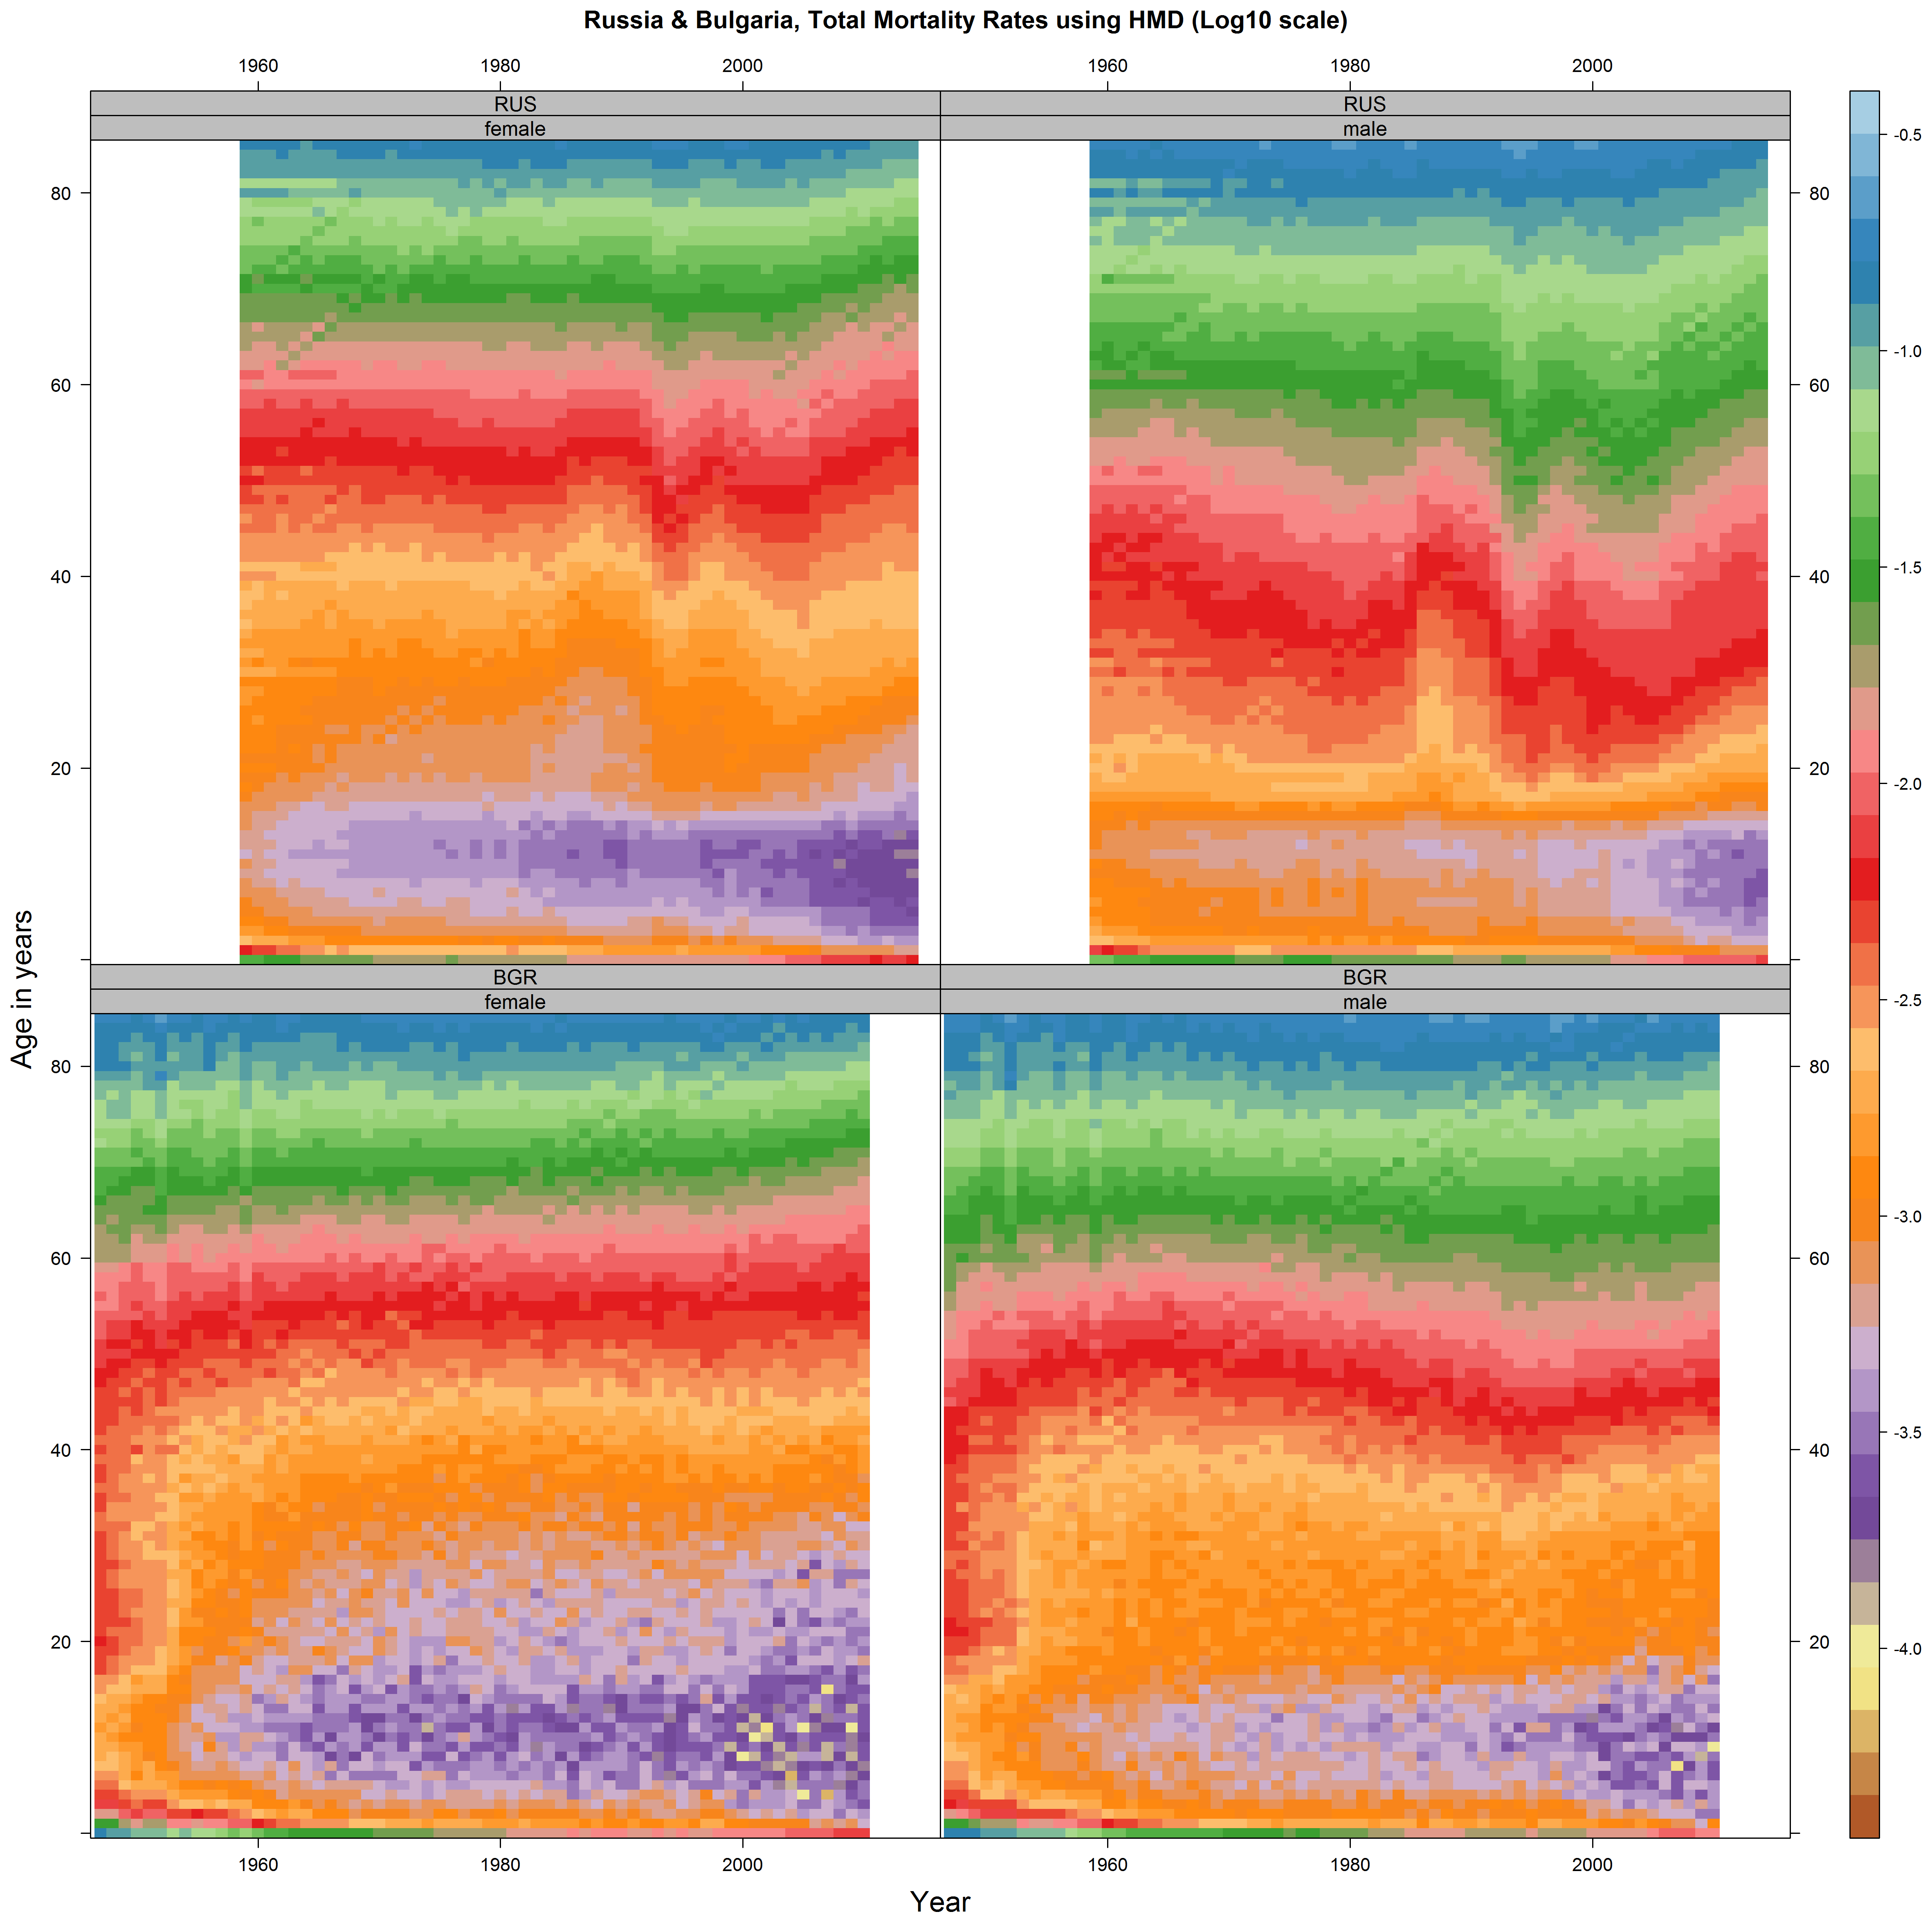

Bulgaria shows evidence of rapidly improving mortality risk in working age in the early/mid 1950s. Age-specific mortality risks did not tend to improve, or improve quickly, throughout the period, which would be evidenced by the appearance of ‘bands’ of colours appearing to move upwards from left to right. However there were notable improvements in child mortality and infant mortality risk. As with almost all countries, the onset of adulthood marks a strong shift in mortality risk for males than for females, and this has been consistent over time.

For Russia, the age-specific mortality risks at most adult ages were also largely fixed rather than improving between the 1950s and the 1980s. This is in contrast to most European countries where they tended to improve continually over many generations, though mainly for people after retirement age. Unlike in many countries in the HMD, mortality risk tended historically to increase rapidly after the onset of adulthood for women as well as men, though the level of increase in risk associated with the onset of adulthood appears steeper for males than females.

In Russia, there is evidence of rapidly improving mortality risks at most adult ages from around 1986 to 1991, then even more rapidly deteriorating mortality risks at adult ages from around 1992 to around 1994. These patterns are both apparent as vertical disruptions to the many horizontal bands. From around 1995 to around 1998 mortality risks in working age adults then began to improve again, before deteriorating again for those aged around 20 to 40 years until around 2003/4. Thereafter mortality rates at most adult ages, both before and after retirement age, have tended to improve again, at a rate not seen during the period 1956 to around 1983. The improvements tend to be slightly more rapid for males than females, suggesting a ‘catch-up’ between the genders.

The figure below shows the log10 mortality surfaces for Bulgarian and Russia, as well as for whole groups of European countries. Though there are some issues apparent with data quality for Southern Europe – evident as vertical discontinuities – for Europe as a whole, and for the individual European regions except Eastern Europe, the overall trends over the post 1950 period are apparent: the coloured bands, indicating specific mortality risks, have tended to ‘drift’ upwards when looking at the plots from left to right. This is indicative of continually improving log10 mortality risks. At older adult ages, from around 45-50 years old onwards, these upwards ‘drifts’ towards improving mortality risks are more consistent over time. Within Western and Northern Europe they are not as consistent in younger adult ages, from around 20-40 years of age. There is evidence of more rapid gains in mortality risk amongst this younger adult age group in Southern Europe, in particular for males.

The plot for Eastern Europe is, as would be expected, more like that for Bulgaria and Russia, but has a smoother appearance as there are more observations. Unlike the other European regions mortality risks at most adult ages did not tend to improve over the long period from 1950 to around 2008. Instead mortality risks at some ages increased, in particular among men of working age between around 1985 and 1995. This is particularly evident by looking at the dark red band, which moves from around the age of 43 years to around 39/40 years of age between the 1960s and the 1990s. The corresponding red band for females in Eastern Europe did not move to earlier ages over time in the same way, but unlike Western Europe did not trend upwards to older ages either.



# All-cause mortality in Russia, Bulgaria and Georgia using the WHO database

Although data are not available disaggregated by ages in single years except during infancy, and do not extend back as many years, the WHO database includes data on all-cause mortality for each of the three countries we wish to profile. A levelplot for all three countries is presented below.

Despite the smaller range of years and lower resolution for age brackets, the same trends are apparent in these data as in the HMD data. There is evidence of improvements in Russia, in particular in working age adult age groups after around the age of 20 years. There is less evidence of improvements over time in Georgia and Bulgaria, though there do appear to be log10 mortality falls in older age groups (65-69, 70-74 and so on), which contribute greatly to improvements in life expectancy in these countries overall.

Both Georgia and Bulgaria appear at first glance to be quite similar in their mortality trends overall.

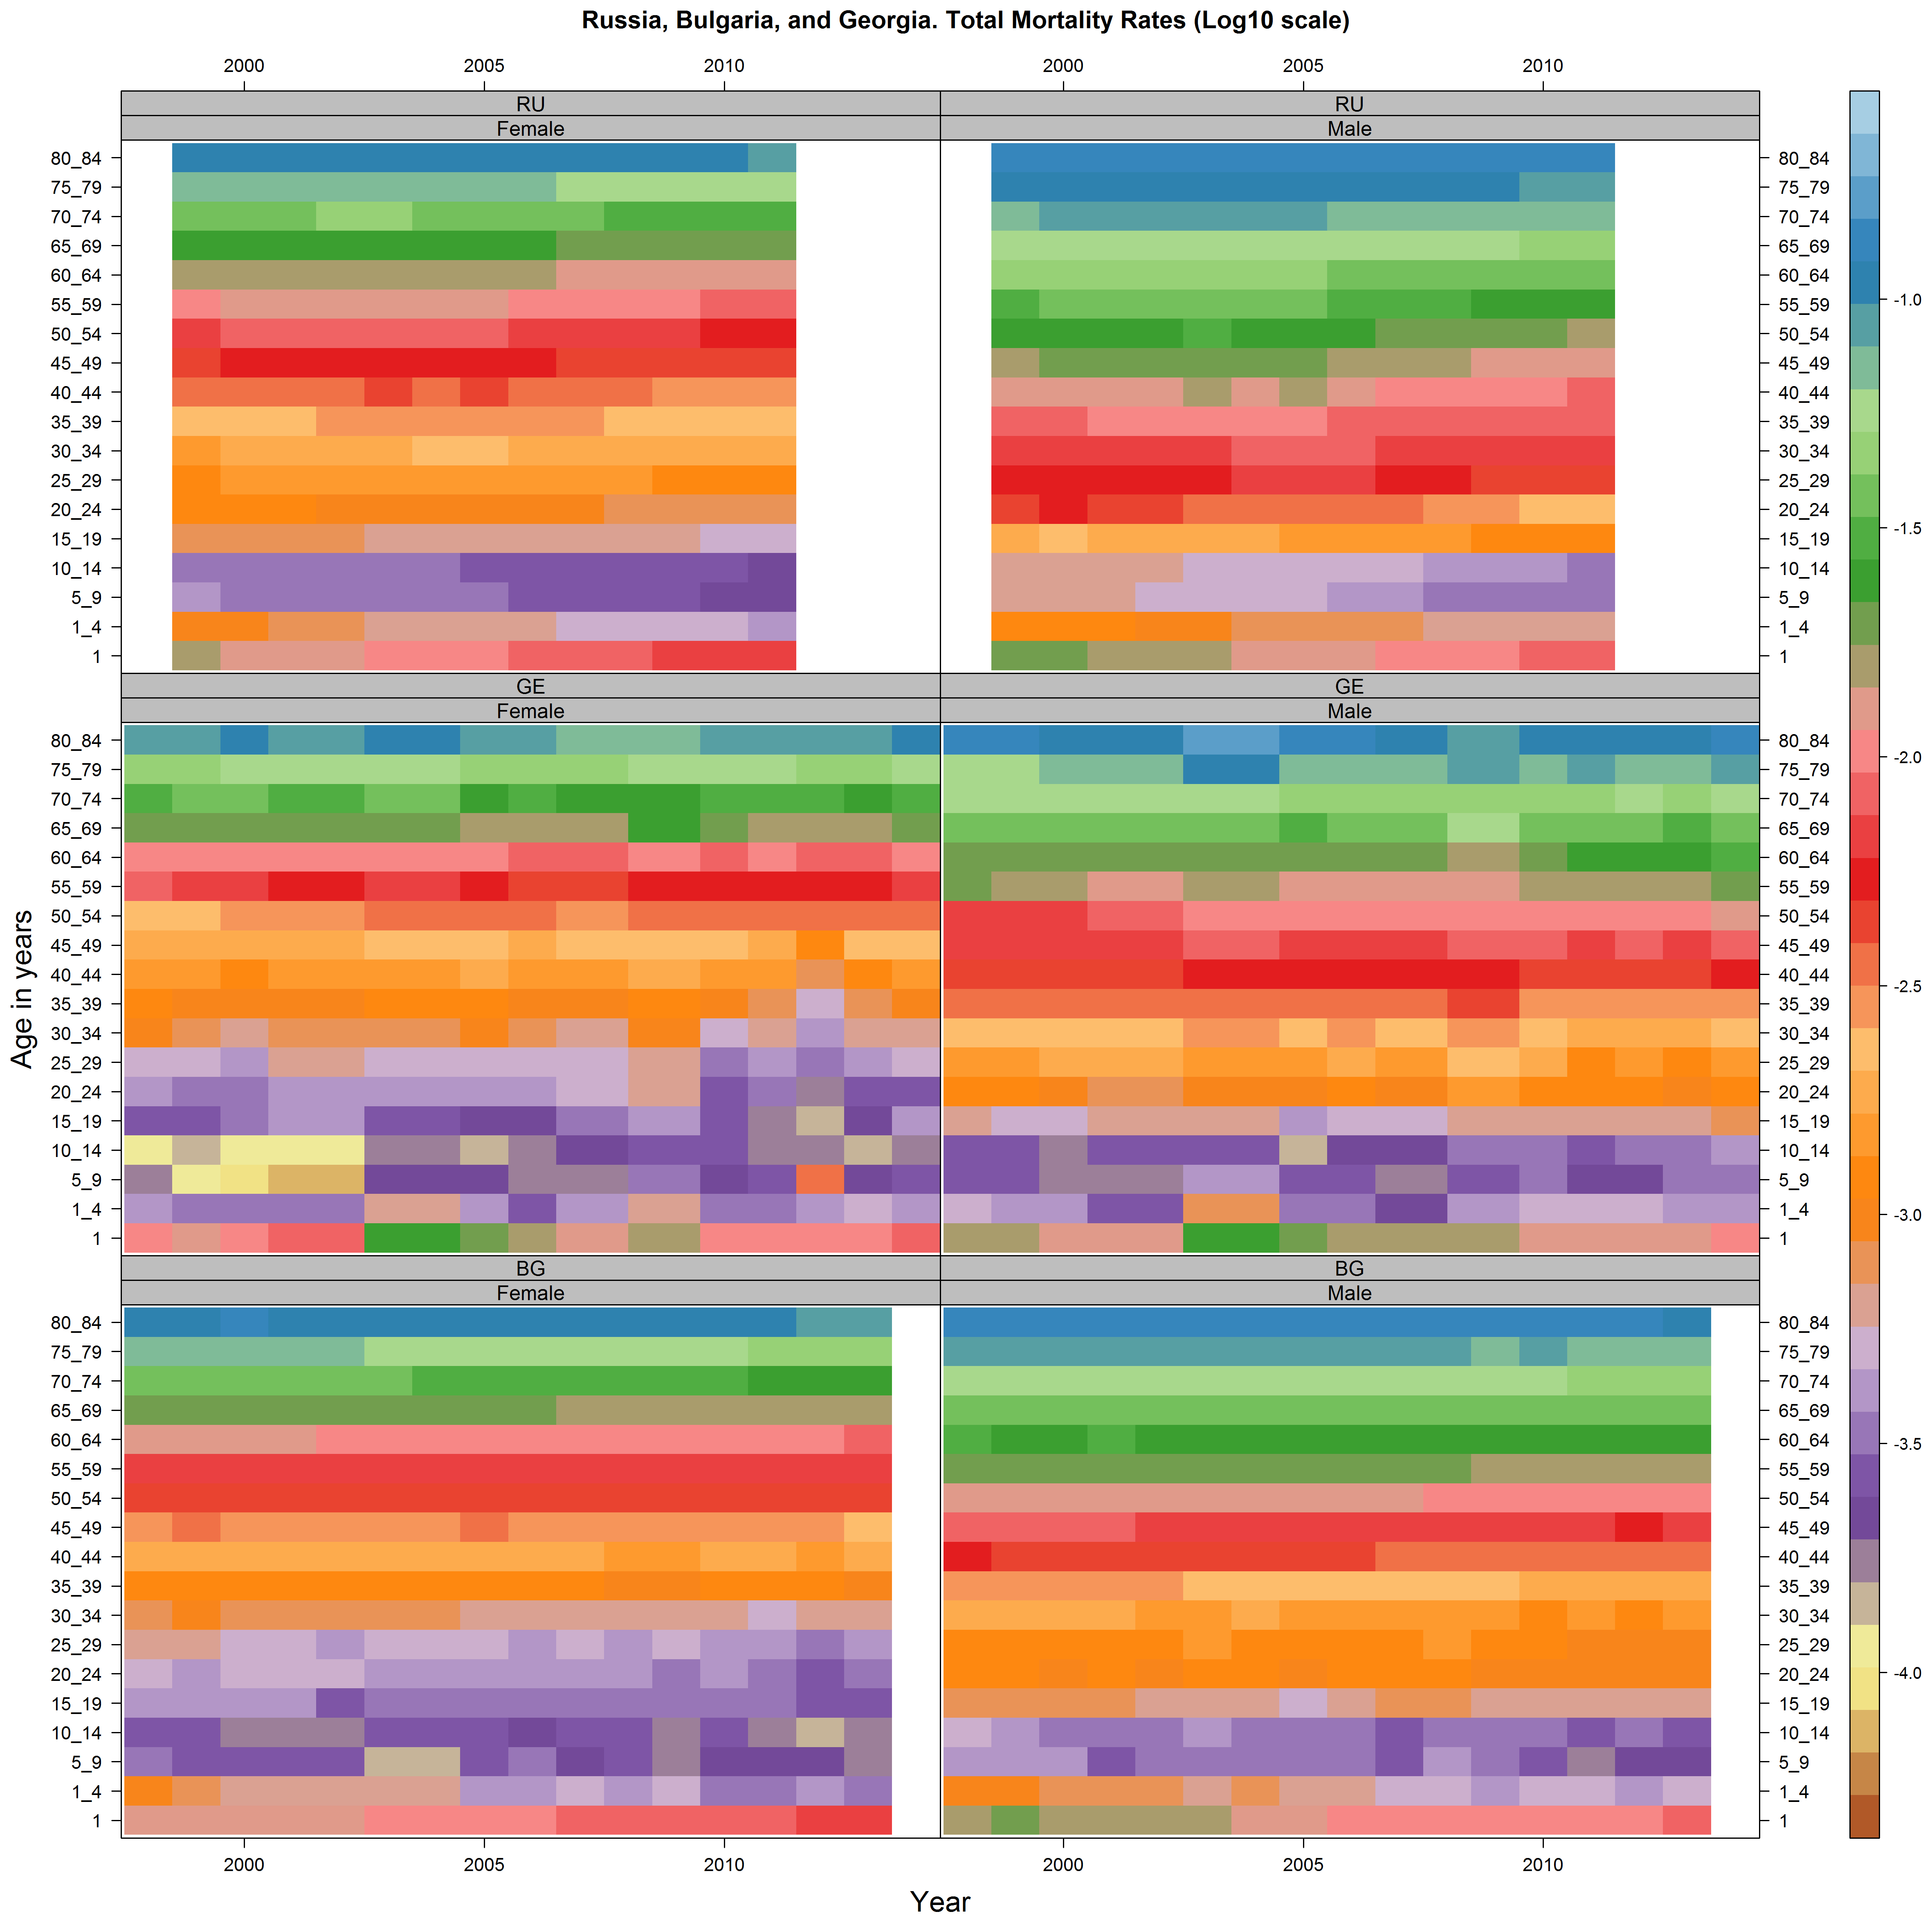

# Comparative mortality for Bulgaria and Russia using HMD

The data from the HMD allows Lexis surfaces to be compared, producing new Lexis surfaces, which I call Comparative Level Plots (CLPs). These CLPs visualise difference in log10 age specific mortality rates in different years at different ages, subtracting the log10 rates for the country/region of interest, B, from the log10 mortality rates with comparator countries/regions, A. Reds indicate that B has a higher mortality rate than A, blue that B has a lower mortality rate than A. The darkness of the shade indicates how lower or small the differences are, with dark shades indicating larger differences in the log10 values.

The CLP for Russia is shown below.

As expected, mortality risks are most similar in Russia to those in Eastern Europe, meaning that the tiles for Eastern Europe are the lightest. The CLPs comparing Russia against Southern Western and Northern Europe are all similar. There is evidence both of a cohort-led change, with comparative mortality for cohorts born after around 1920-1925 faring worse as they aged against these other country groupings than for cohorts born in the decades previously. This leads to a ‘triangular’ appearance in the plots, with darker shades of red moving upwards from left to right at around a 45 degree angle.

The effects of improving health seen previously in the 1980s are also seen, as they lead to a vertical band of lighter red shades during these years. Similarly, the worsening trends in the early 2000s are also apparent, as darker red shades re-establish themselves in working age ranges. Then, rapidly worsening comparative mortality becomes apparent between around the ages of 20 and 40-50 years of age from the 2000s onwards. (The vertical band on the very right is likely caused by not all countries in Europe having records in the most recent year within the HMD.)

In all cases, there are greater differences in log10 mortality rates for males than females, and the cohort-driven change associated with cohorts born after the 1920s is apparent. These differences are greatest from adulthood onwards, though there are also signs of persistently higher child mortality as well.

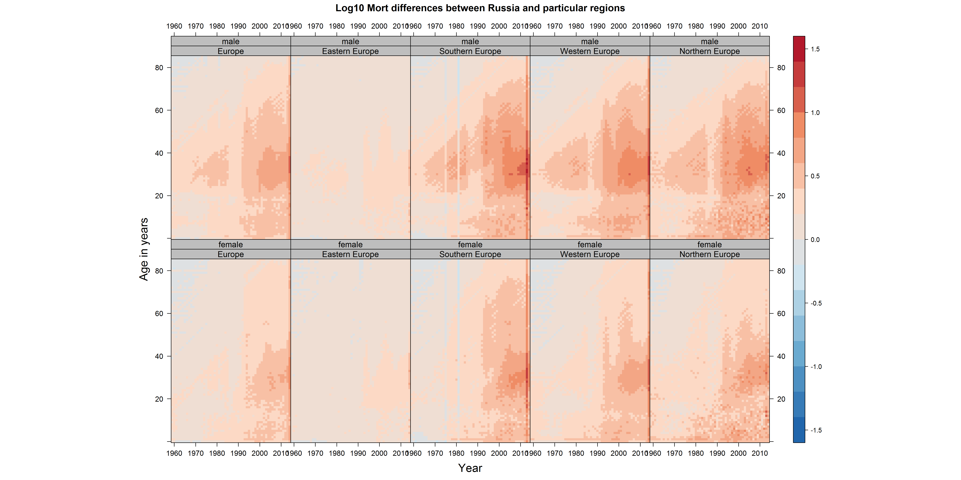

In the figure below, we compare Bulgaria against each of the above regions.

Almost by definition, the mortality rate differences are smallest compared with Eastern Europe. Compared with other Eastern European countries, Bulgaria does not always have worse mortality at all ages and years, hence some blue shades. In particular, mortality may be lower between around the ages of 30 and 40 in Bulgaria compared with other Western European countries from around 2003 onwards, in particular for males.

The comparatively higher childhood mortality rates in Bulgaria, compared with Souther, Western, and Northern Europe – are also apparent. The comparative disadvantage in log mortality seems greatest from around 1980 onwards, although absolute mortality risks at these ages are very low, so the effect on life expectancy is likely very small. There is evidence that, compared with Western Europe and Northern Europe, mortality risks for very young children born in the 1950s were higher in Bulgaria. This can be seen by noting the darker red lines in the bottom left corners of the corresponding tiles. This comparative disadvantage is apparent for both sexes.

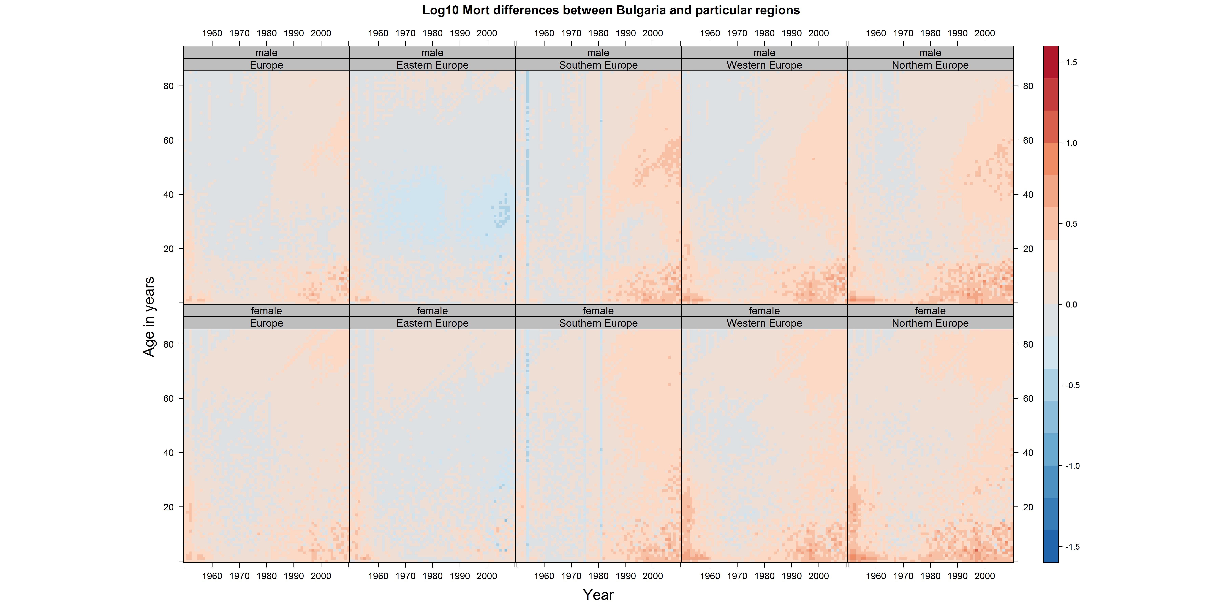

# Next document

In the next document I will show some figures for cause-specific mortality patterns in the three countries of interest. (They can’t be included in this document as the number and size of the images causes Word to crash on this machine!)