Cause specific death rate exploration using the WHO database

Dr Jonathan Minton

[Jonathan.minton@glasgow.ac.uk](mailto:Jonathan.minton@glasgow.ac.uk)

22/12/2016

# Cause-specific mortality using the WHO database

Bulgaria, Georgia, and Russia each include records in the WHO database by cause using a number of distinct ICD classifications. Unfortunately none of the data for Russia seems to be coded using the same ICD schema as for Bulgaria and Georgia. Being relatively small countries, plots of cause-specific death rates in these two countries tend to have quite a ‘noisy’ appearance. They only tend to be available from around 2000 onwards. However, they show some interesting patterns. I have produced over 2000 files in total, for each combination of ICD group and disease class. Just a small selection is shown below.

## Patterns indicating changing preference for particular disease codes

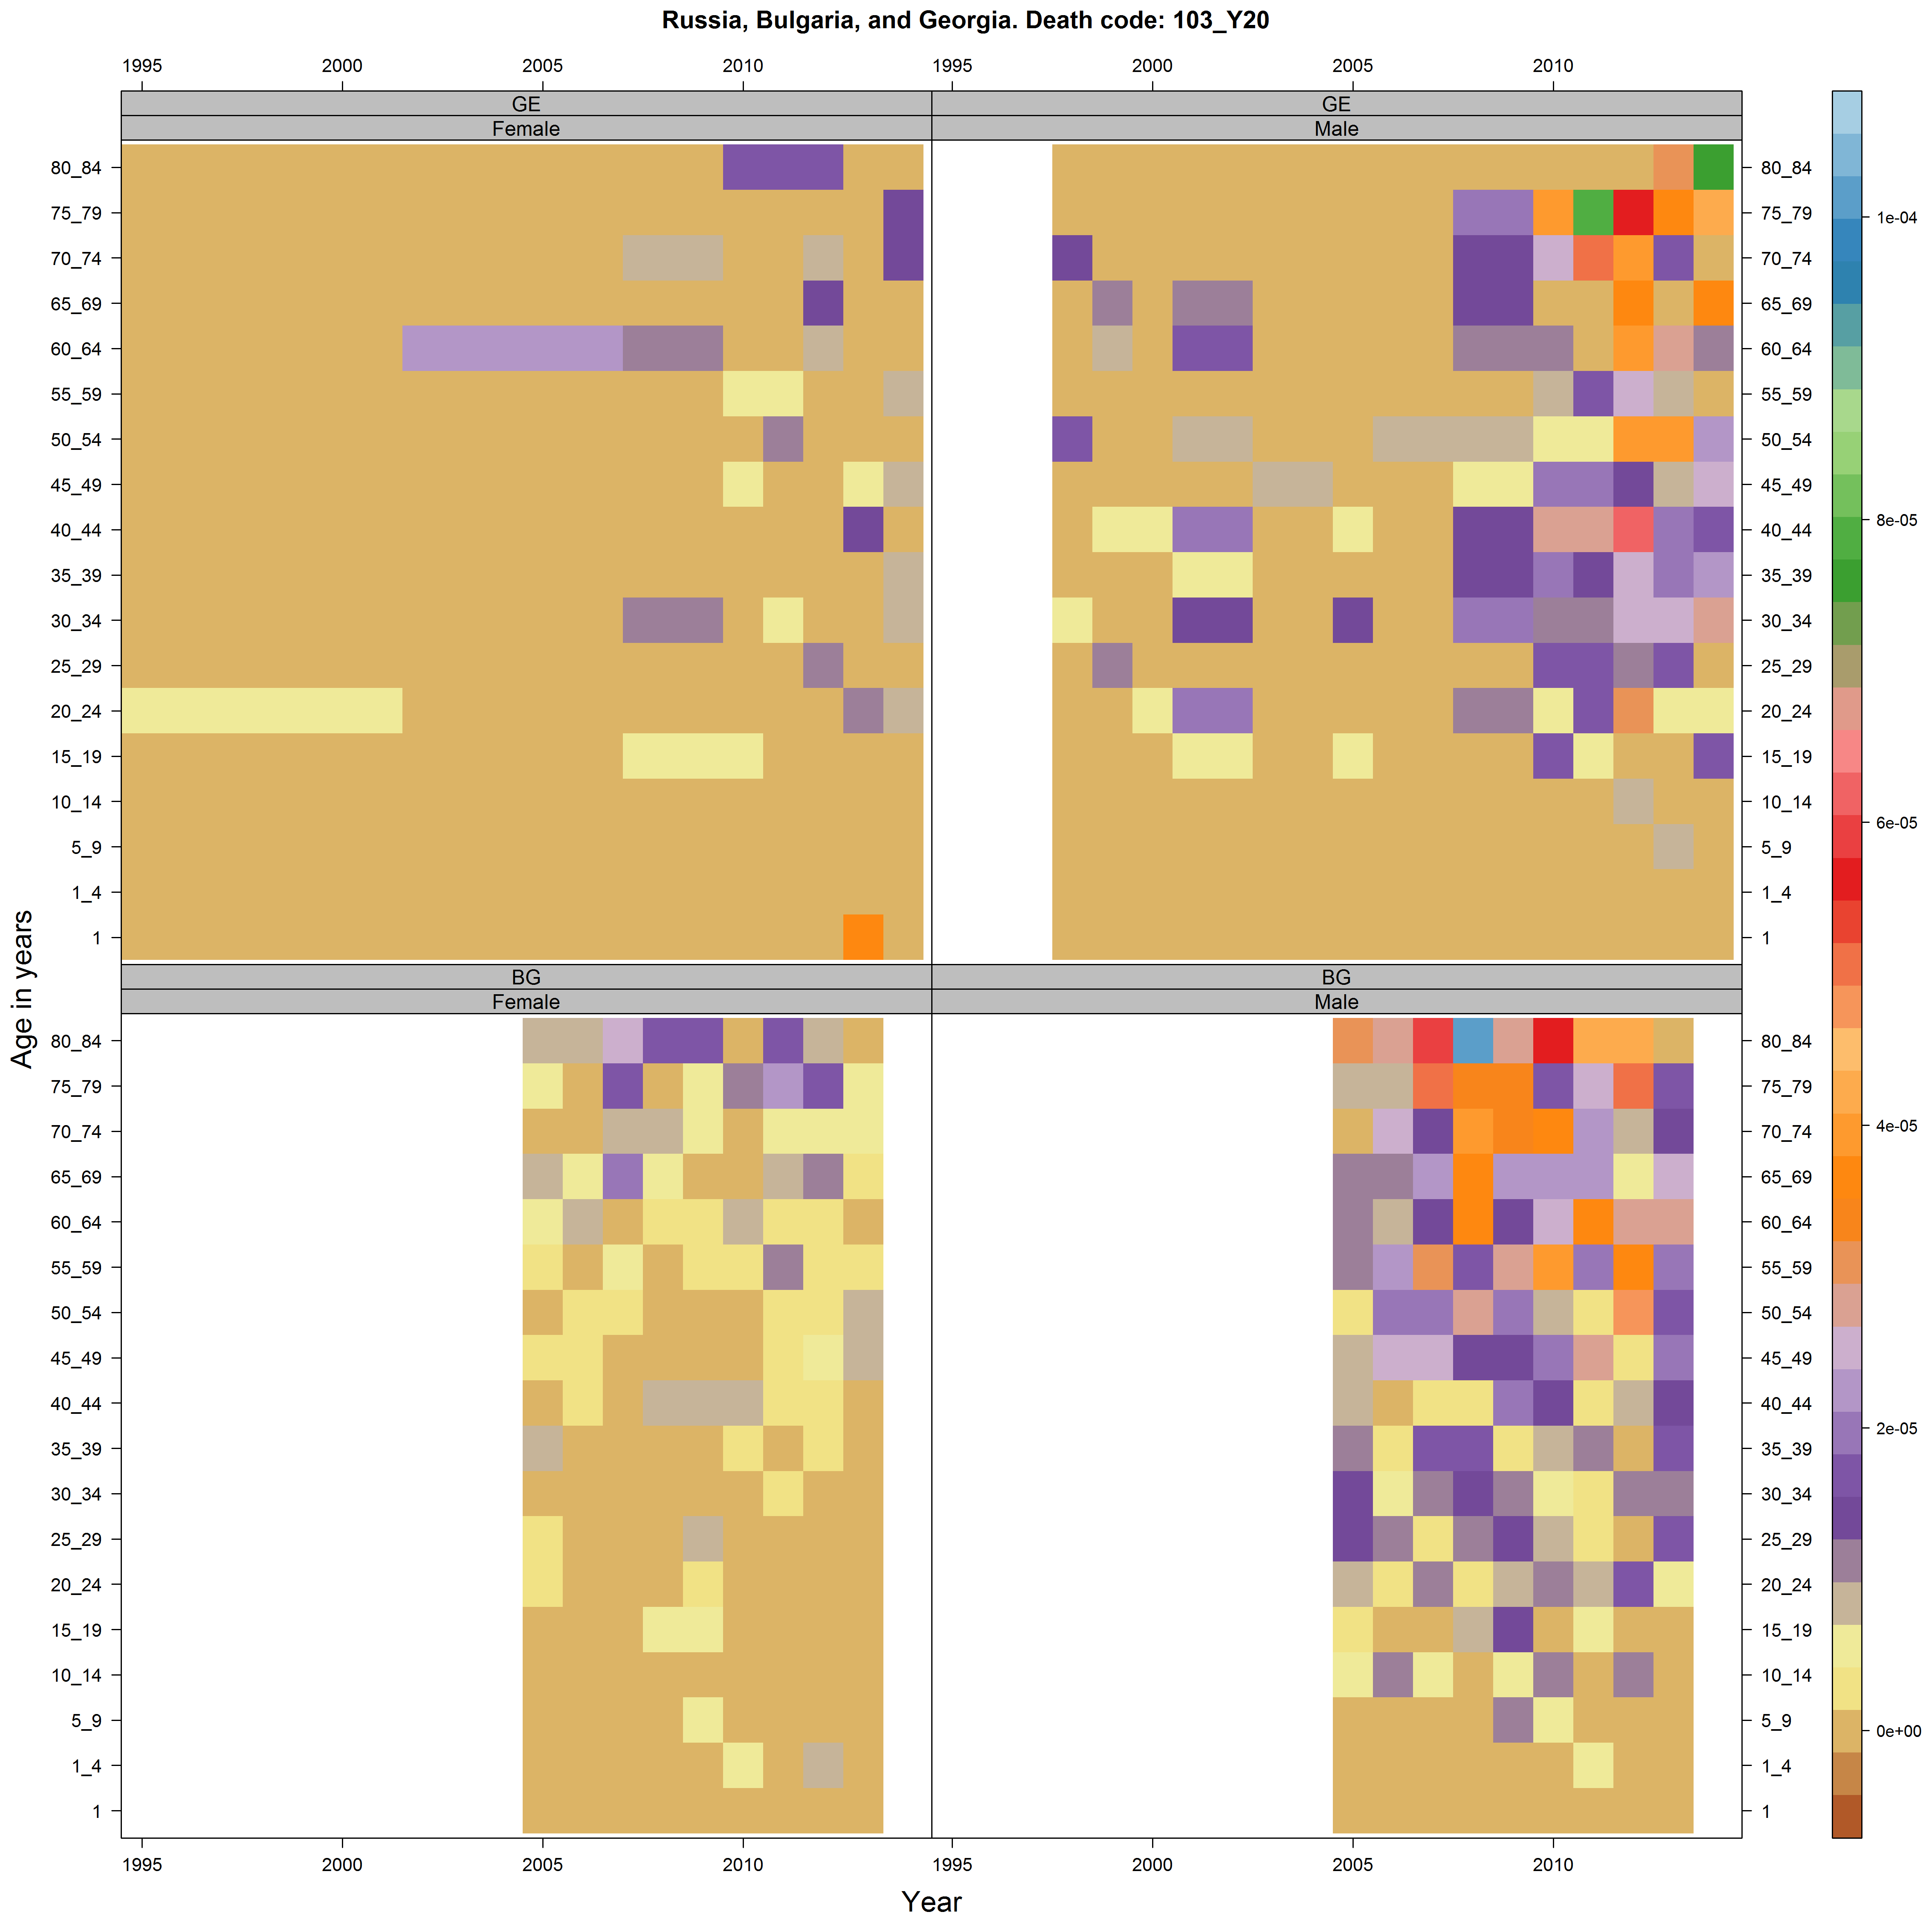

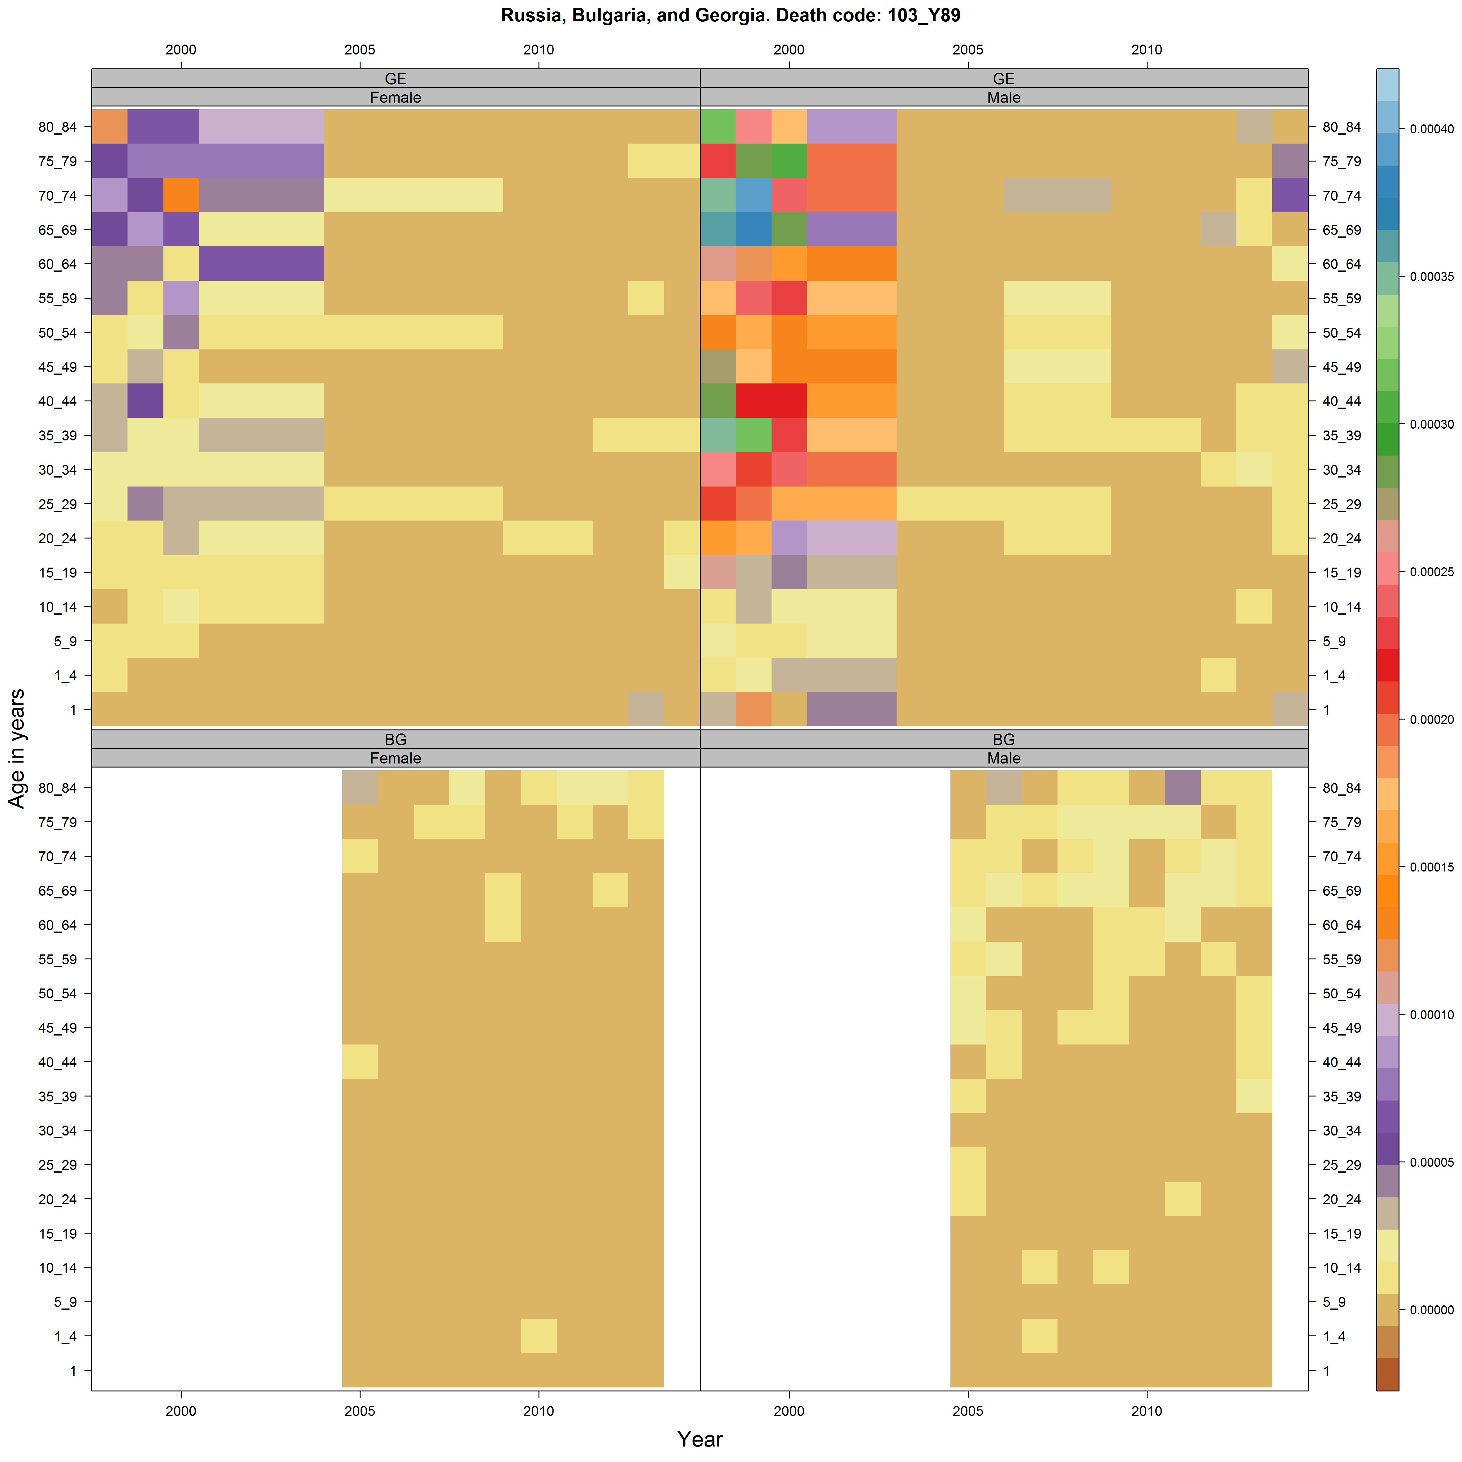

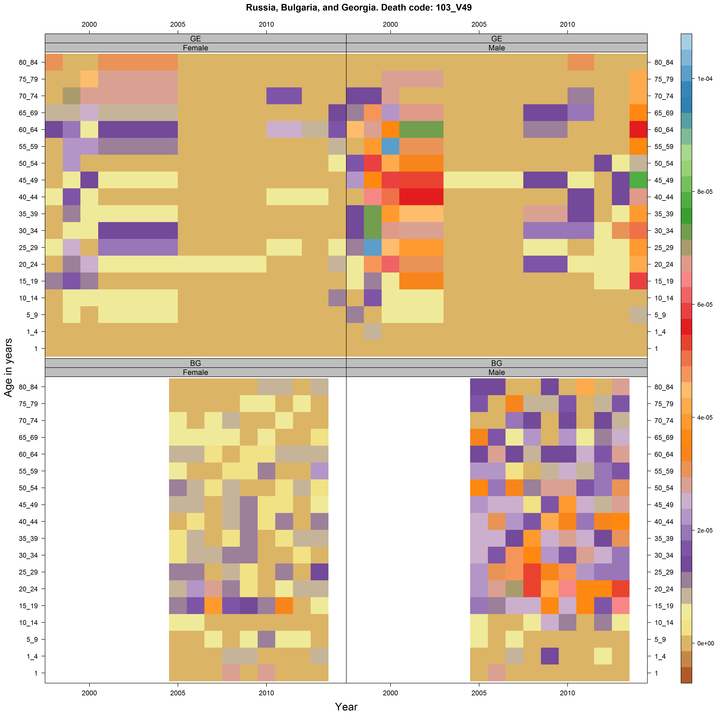

In each of these examples above there are sudden changes running from left to right. This may mean the standards/procedures for categorising particular causes of death changed in the country.

## Diseases of older age

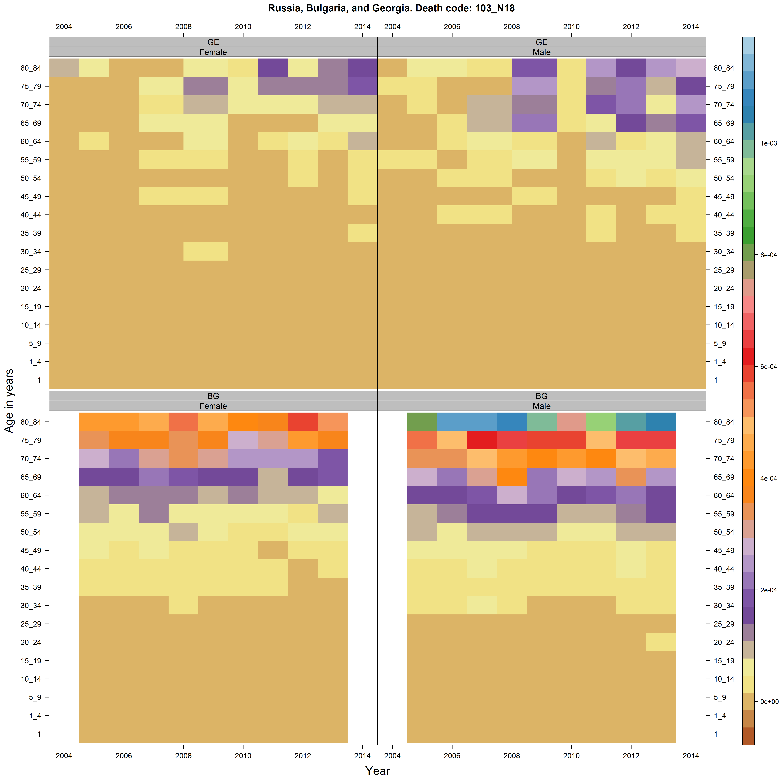

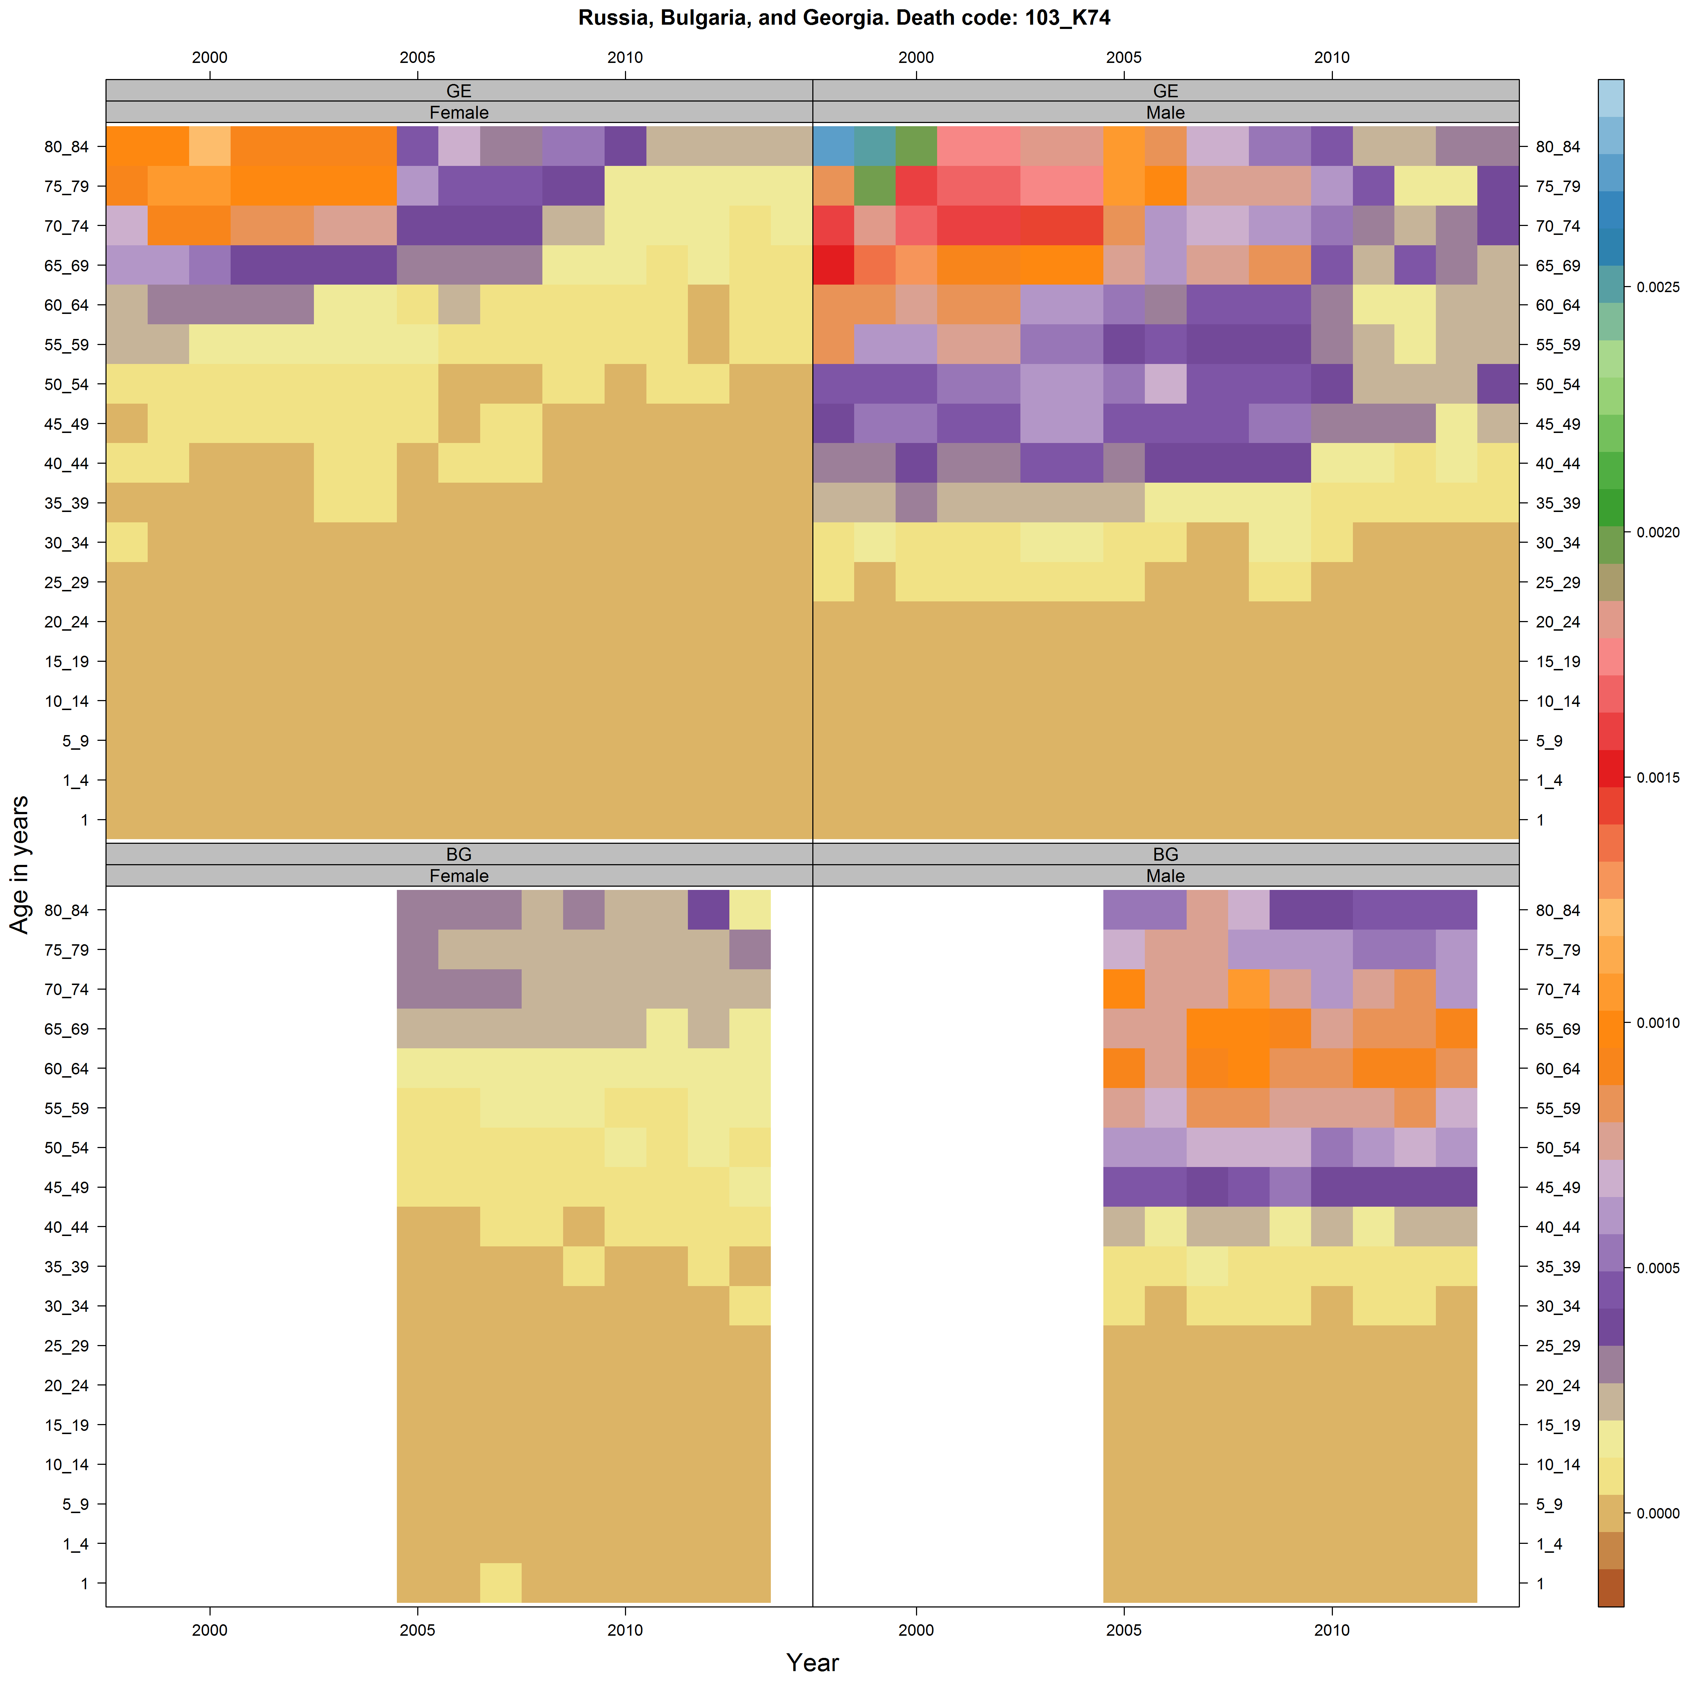

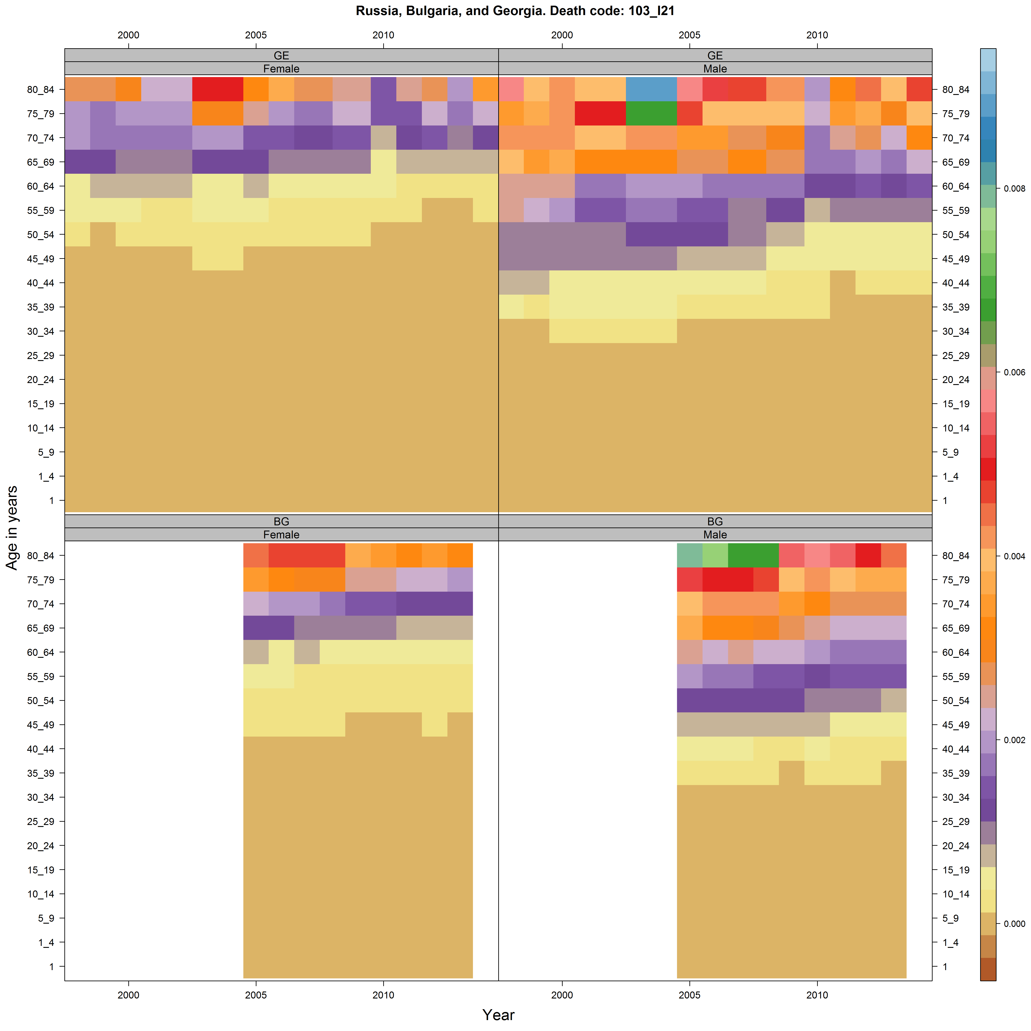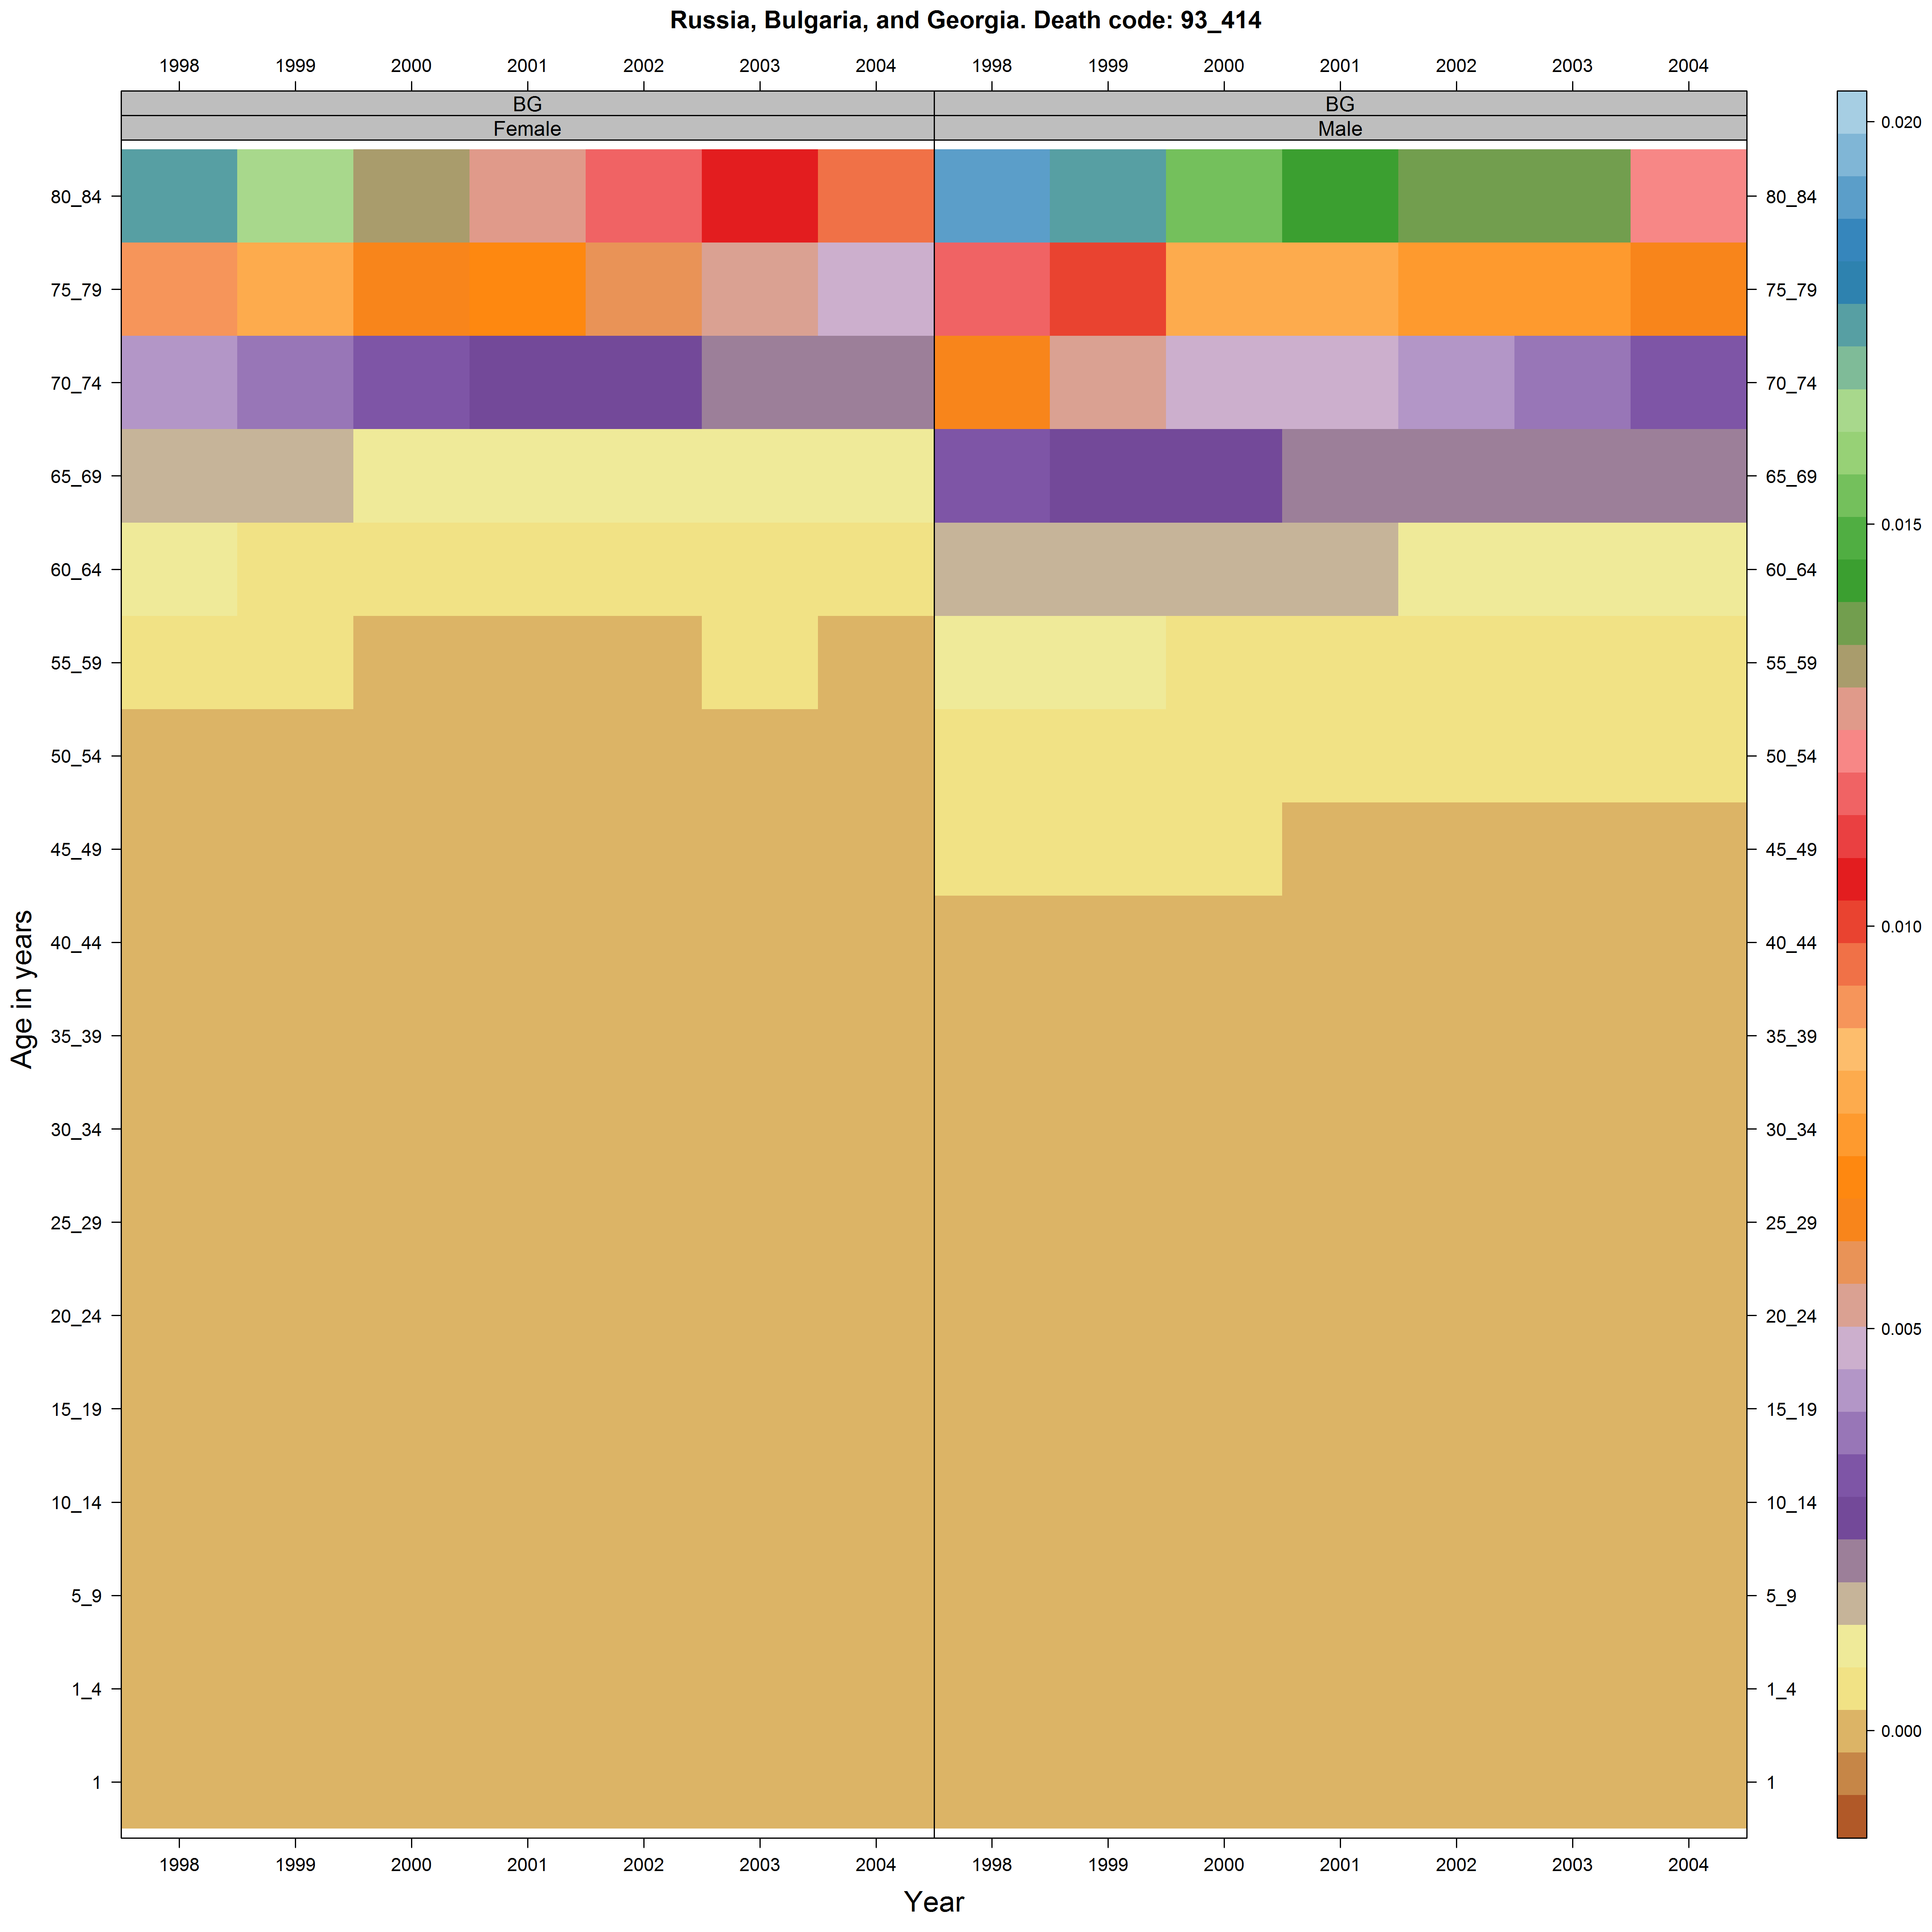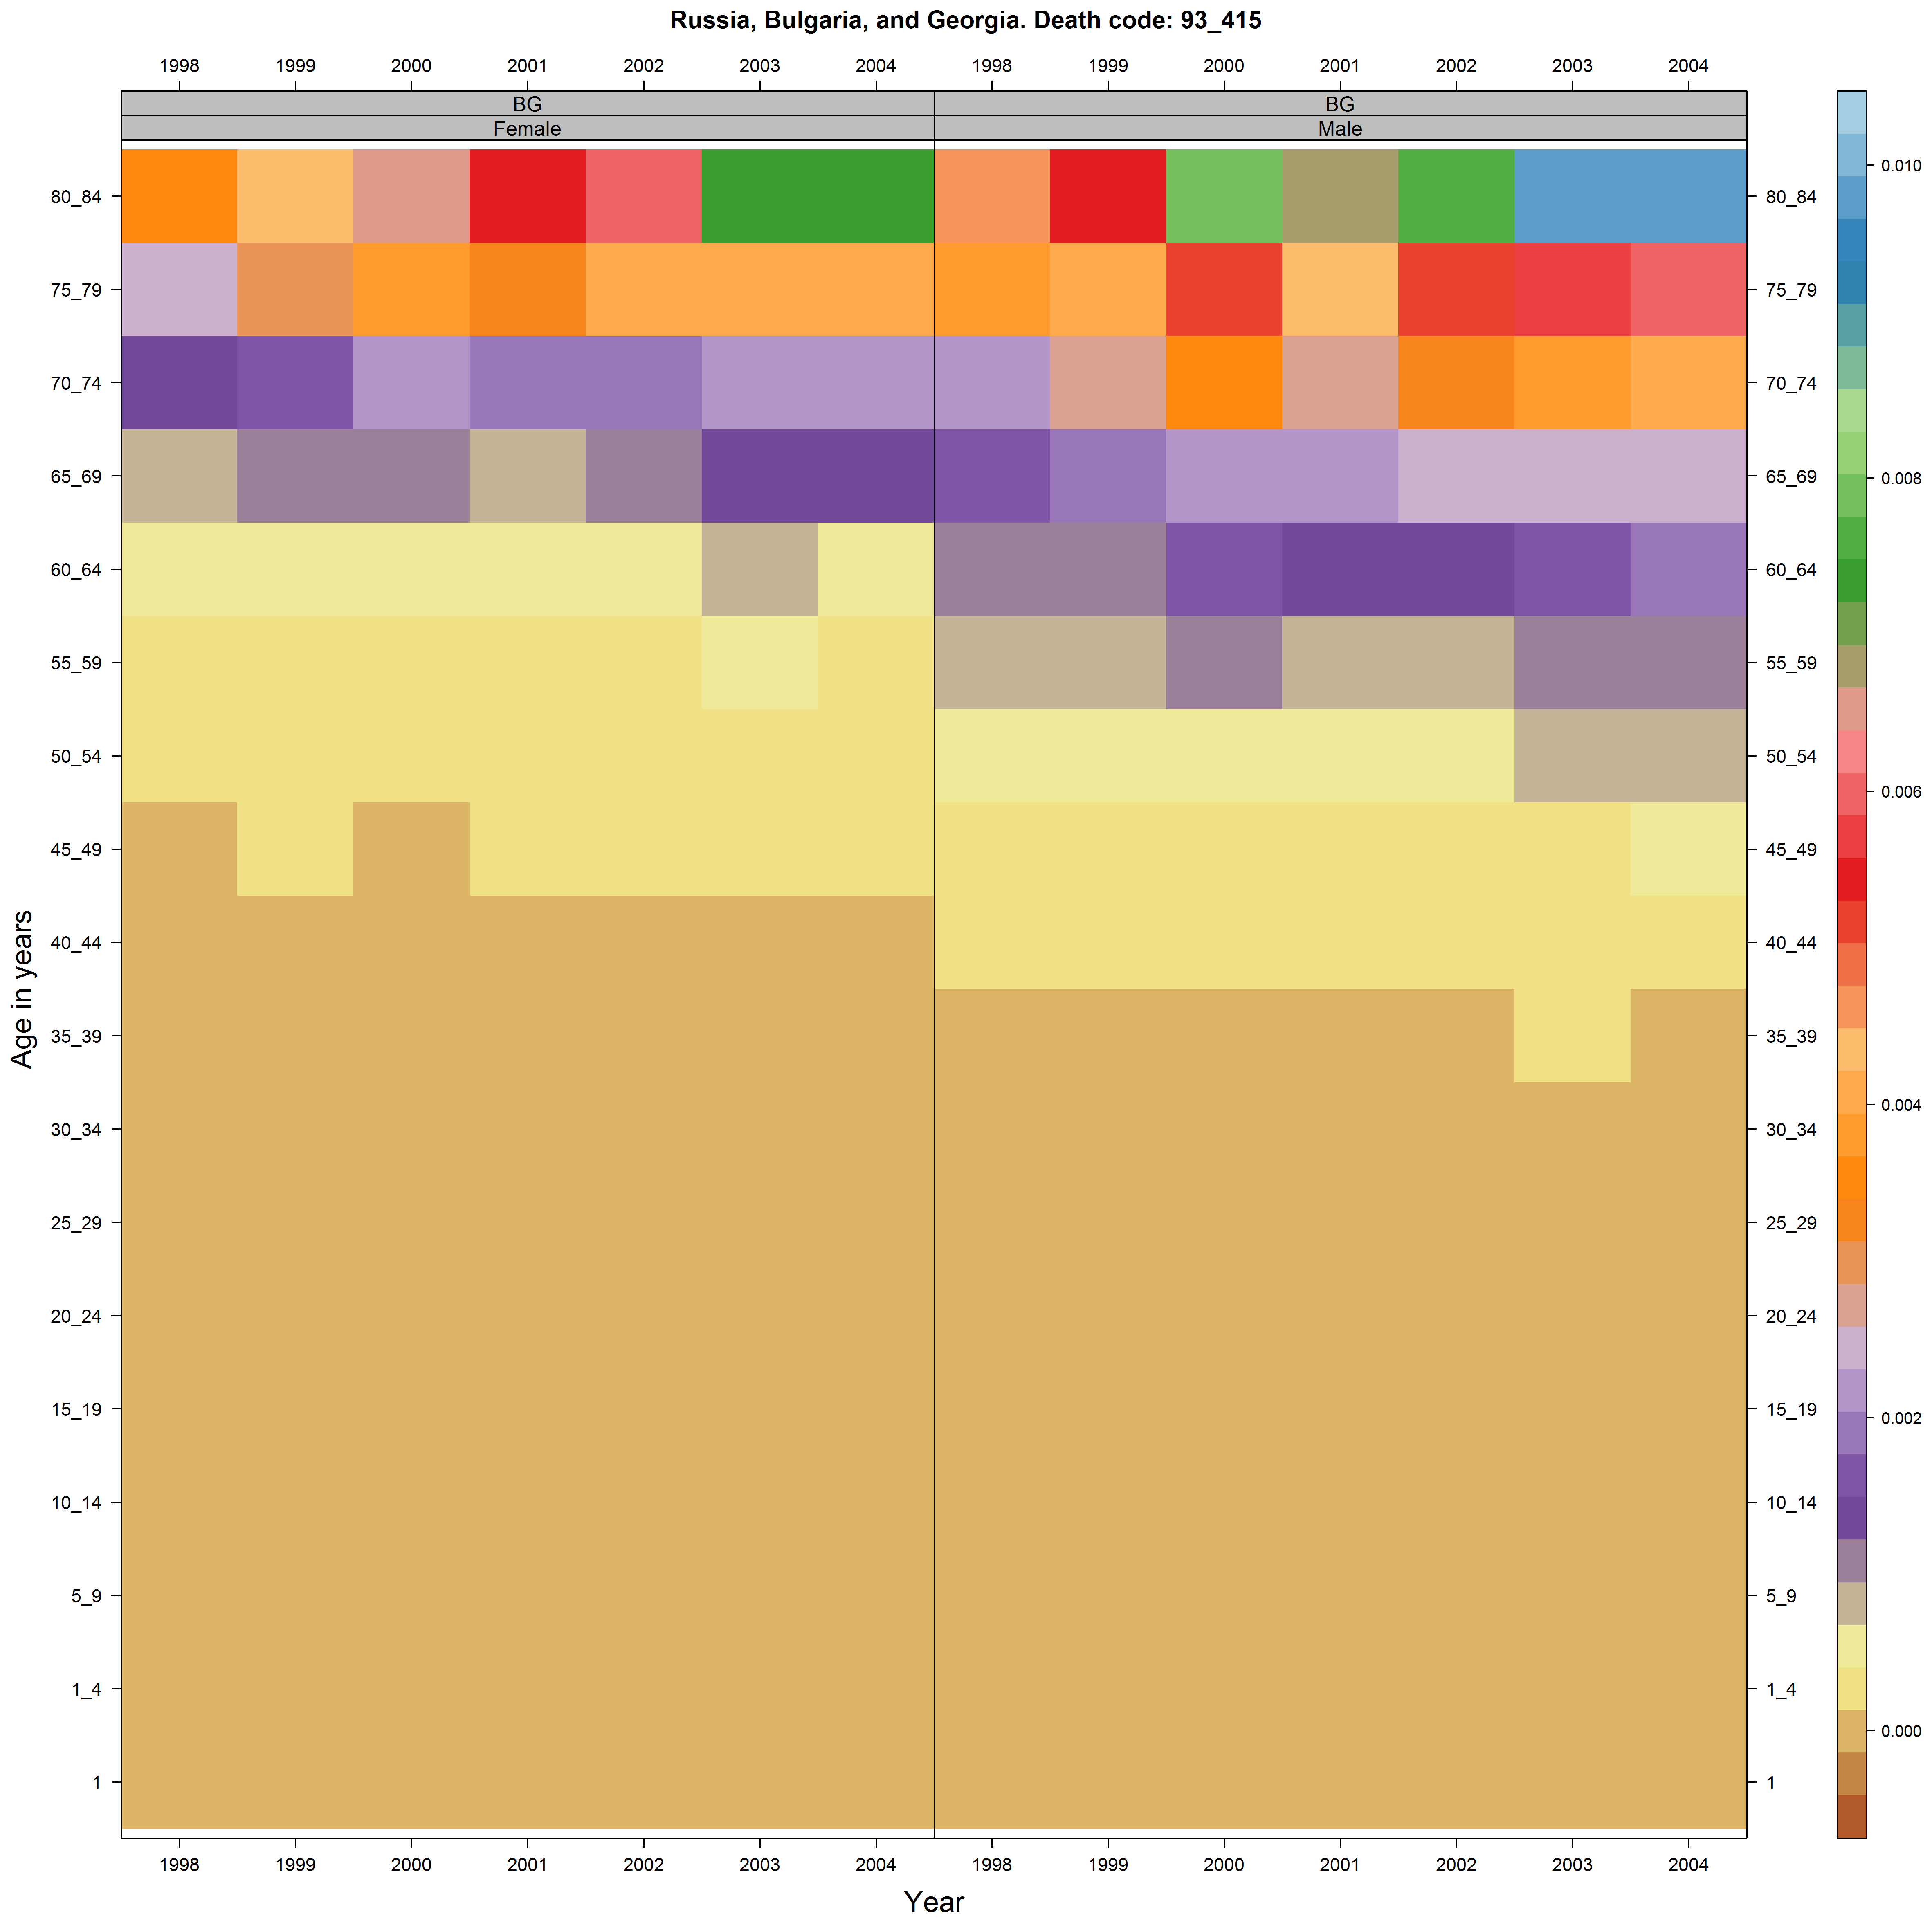

# Data from Russia

By far the most interesting and compelling patterns seem apparent from the Russian data. Many of these clearly show the rapid falls in deaths in the working age population since the mid/late 2000s

## Improving middle aged mortality

