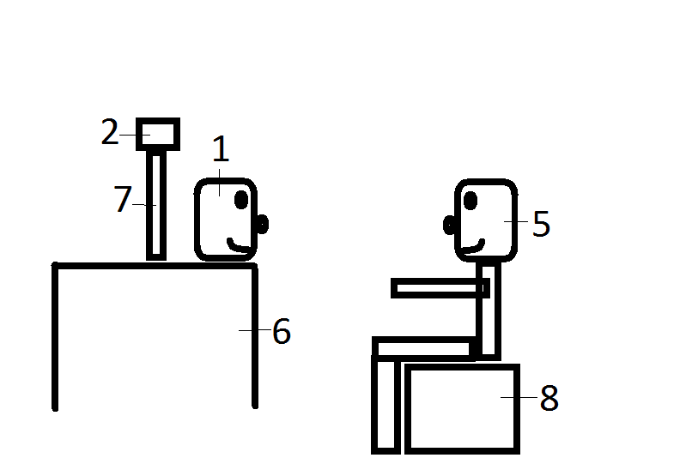

Figure 2: Standard usage schematic indicating relative positioning of key components.

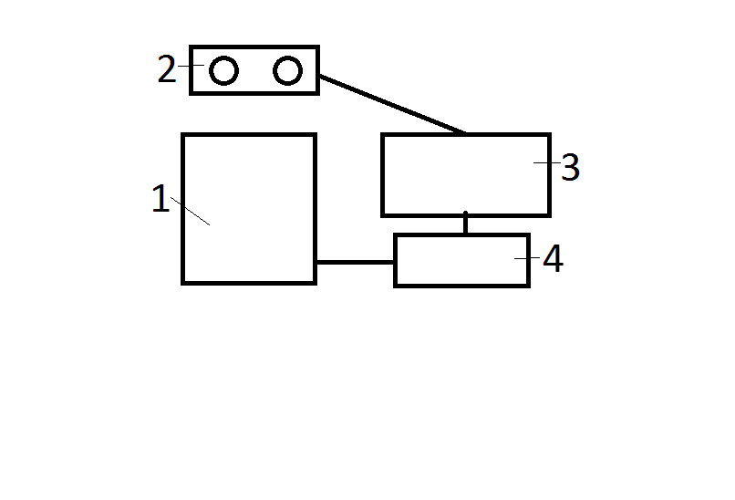

Figure 1: Schematic diagram of major system components. Dark lines indicate data communication connections between components.

Number Label List for figures 1 and 2

1. Expressive facial avatar.
2. Camera system (e.g. Microsoft Kinect).
3. Control electronics (detailed in circuit diagram).
4. Control computer, user supplied.
5. Seated therapy subject, facing toward avatar and camera.
6. Table to support avatar and camera.
7. Camera stand to position camera behind and slightly above avatar.
8. Chair to place subject’s eye level at or near avatar’s eye level.