VOL. 01 · PORTFOLIO REBUILD · 20 AUG 2026
JONONGCA.COM
Developer Workspace Experience Specification
A TUI-first portfolio with draggable terminal and mock-browser windows
Prepared for Jonathan Ong · Recruiter-facing personal portfolio · Proposed direction
CORE DECISION
Make the simulated terminal workspace the portfolio itself. Commands, arrow keys, Enter, and mouse clicks open content inside draggable mock-browser windows.
The new site should feel like Jonathan:
- Like entering Jonathan’s developer workspace, not scrolling through another portfolio template.
- Immediately usable by command line, keyboard selection, or mouse—without forcing visitors to learn commands.
- Playful and technical on the surface, with simple recruiter-friendly content inside each browser window.
$ recommendation
Build a client-side workspace shell in React, backed by real routes and static-rendered content. Keep Vercel; use Railway only if a future feature requires a persistent backend service.

01 · EXECUTIVE DECISION

Turn the portfolio into Jonathan’s developer workspace
The current portfolio already has personality, a coherent green identity, useful project material, and a strong technical foundation. The redesign should not become another conventional landing page. Its differentiator should be an interactive simulated workspace: a large terminal is the homepage, and portfolio destinations open in mock-browser windows above it.
NORTH-STAR CONCEPT
A visitor lands inside Jonathan’s coding workspace, controls a Claude Code/Codex-inspired TUI by command, arrow keys, Enter, or mouse, and opens simple portfolio pages in draggable browser windows.

Decisions at a glance
Decision | Recommendation | Why
Landing experience | Full developer workspace | The first screen immediately communicates a technical, hands-on identity.
Primary surface | Large centred TUI window | It is the portfolio’s control centre, not a decorative widget beside a normal hero.
Input model | Command + arrows + Enter + mouse | Technical users can explore naturally while recruiters never need to memorise commands.
Content display | Draggable mock-browser windows | Experience, projects, story, notes, and life remain clear, familiar webpages inside the workspace.
Routing | Real route behind every browser view | Direct links, refresh, history, metadata, and accessibility continue to work.
Hosting | Keep Vercel | The experience is mostly static; Railway adds value only for a future persistent service.

Non-goals
- Executing real shell commands, evaluating arbitrary JavaScript, or exposing a server terminal.
- Requiring a visitor to type before they can find Experience, Projects, Résumé, or Contact.
- Building a full operating system with files, settings, notifications, or unrelated desktop apps.
- Copying Claude Code, Codex, or macOS window chrome exactly instead of developing a Jonongca identity.
- Opening unlimited overlapping windows that make the recruiter lose their place.
- Migrating to Railway simply because a hobby plan is available.
- Publishing confidential internship architecture, source data, or internal implementation details.
02 · CURRENT-STATE AUDIT

What works, what blocks the next level
Area | Current strength | Current blocker | Target
Brand | Warm palette; recognizable green; real personality | Card-dashboard aesthetic feels template-led | A memorable developer-workspace identity
First 20 seconds | Role and current internship are visible | Too many equally weighted destinations and cards | Identity, role, commands, Projects, and Résumé immediately discoverable
Navigation | Labels are understandable | Pages are React state at the same root URL | Shareable, refresh-safe routes with browser history
Projects | Screenshots and outcome-led copy exist | Index and detail views are shallow and hard to share | Case studies that show role, decisions, architecture, result, and reflection
Interaction | Motion and drag demonstrate frontend ability | Current card dragging lacks a meaningful system model | Drag and resize are purposeful because they control terminal and browser windows
Technical base | React/TypeScript components and Vercel APIs are reusable | Vite SPA, production Tailwind CDN, monolithic page state | Compiled styles, route layouts, static generation, clean content boundary

The most important repository finding is architectural: the current build uses Vite and client-side React state. It does not currently implement server-side rendering. Selecting Projects or Experience changes the visible component but leaves the URL at the site root, so there is no reliable deep link, route-level metadata, or browser-history model.

Concrete repository findings
- App.tsx controls Home, Projects, AI workflow, Experience, Life, and About through one currentPage state value.
- Project detail and experience detail are also state-driven, so a recruiter cannot share or reopen a specific detail view.
- react-grid-layout currently drags individual content cards; the redesign should replace it with a small window manager that drags complete application windows.
- Tailwind is loaded from cdn.tailwindcss.com in production; the live console warns against this production setup.
- TechSphere runs a continuous requestAnimationFrame loop and fetches several icons from an external CDN; those resources are better spent on responsive window interaction.
- The strongest reusable assets are the palette, photography, project imagery, typed experience/project data, and existing Vercel API work.

Design-review scorecard
These are directional review scores, not analytics or user-test results.
Dimension | Current | Target
Personality | 4 / 5 | 5 / 5
Recruiter clarity | 3 / 5 | 5 / 5
Navigation and shareability | 2 / 5 | 5 / 5
Project depth | 2 / 5 | 5 / 5
Accessibility and motion restraint | 3 / 5 | 5 / 5
SEO and route metadata | 2 / 5 | 5 / 5

03 · PRODUCT VISION

The recruiter enters a workspace, then discovers the story
BRAND PROMISE
Jonathan builds reliable systems where data, cloud, and AI meet—and his portfolio behaves like a tool he would enjoy building and using.

Primary audiences
Audience | Question they arrive with | The site must answer
Technical recruiter | Where should I click? | A visible selected row, mouse affordances, useful commands, résumé access, and role summary within seconds.
Hiring manager | Can he make sound engineering decisions? | Simple browser pages with ownership, trade-offs, architecture, testing, reliability, and reflection.
Engineer / peer | Is the interface real? | Responsive keyboard input, deterministic commands, real routes, draggable windows, and readable case studies.
Personal connection | Who is he beyond work? | A Life browser page with books, running, games, cats, travel, and current interests.

Recommended opening copy
jon@portfolio:~ $ ./portfolio
Welcome to Jonathan’s developer workspace.
Data & AI Engineer · cloud foundations · DevOps delivery
Use ↑/↓ + Enter, click a row, or type "help".
> story experience projects skills
notes life contact
A compact system line can show Singapore, graduation timing, and availability. The landing state must avoid a long hero paragraph; the browser pages carry the deeper narrative.

Narrative spine revealed through the TUI
- Started with cloud infrastructure: learning how systems are deployed and operated.
- Moved deeper into DevOps: making releases repeatable, observable, and safer.
- Expanded into data and AI engineering: building pipelines and services that turn data into reliable products.
- Now combines all three: infrastructure awareness, delivery discipline, and data/AI implementation.
04 · INFORMATION ARCHITECTURE

One workspace shell, two application surfaces, real routes
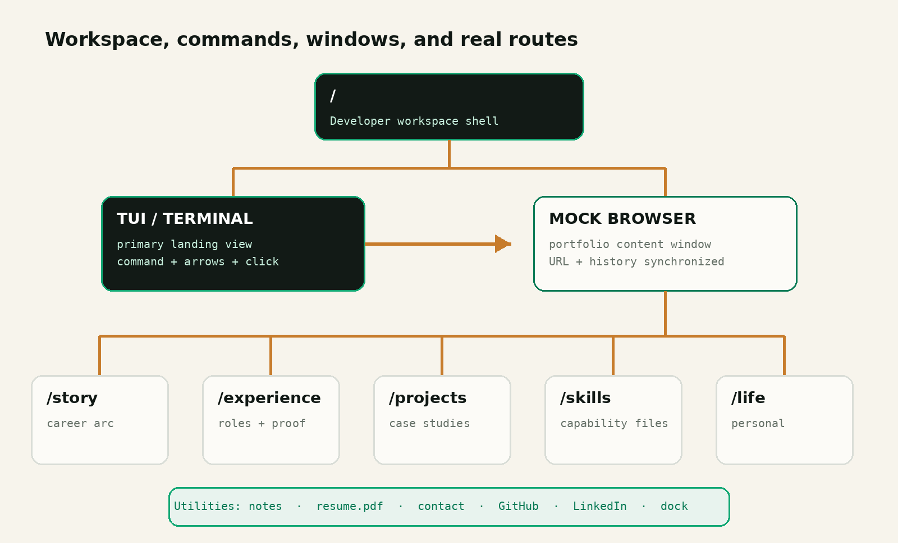
Figure 1. The TUI controls the workspace; browser windows display the portfolio content; URLs preserve normal web behaviour.

Route inventory
Route | Default workspace state | Primary action
/ | Centred terminal focused; no browser window | Choose or type a command
/story | Terminal behind; Story browser focused | Continue to Experience
/experience | Terminal behind; Experience browser focused | Select a public-safe role
/experience/[slug] | Selected role detail in the same browser window | Return to timeline or open résumé
/projects | Terminal behind; Projects folder explorer focused | Expand a project directory
/projects/[slug] | Project README focused at a stable detail URL | Open architecture, decisions, demo, or repository
/skills | Skills directory focused in Terminal or Browser | Open an agent-style capability package
/skills/[slug] | Selected SKILL.md rendered with evidence links | Open the related experience or project proof
/extensions | Small tools and integrations directory focused | Open a shipped extension or return to Projects
/notes | Notes browser focused | Read the latest learning note
/life | Life browser focused | Explore personal interests
/contact | Contact browser focused | Email, LinkedIn, GitHub, résumé

Persistent actions
- The top-right Useful Commands panel remains visible whenever it does not collide with the active window.
- The window dock shows Terminal, active Browser, and Résumé; clicking an icon focuses or restores it.
- A visible Résumé command/button remains available without typing.
- The active mock browser displays a familiar address bar such as jonongca.com/projects/pitchperfect.
- The terminal prompt displays the current virtual path, such as jon@portfolio:~/projects $, so folder navigation always has visible context.
- External destinations such as GitHub and LinkedIn open a real browser tab and are labelled as external.
05 · SIGNATURE INTERACTION

The terminal is the homepage; the browser is the content layer
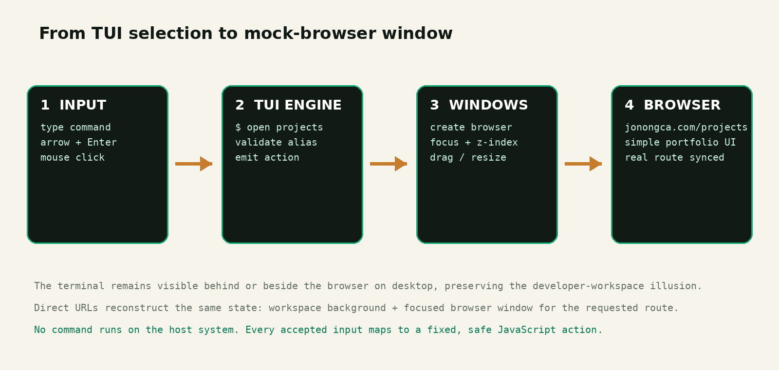
Figure 2. Every input mode triggers the same safe JavaScript action and opens the same routed browser view.

Landing state
The first viewport is a quiet desktop-like canvas with one dominant terminal window centred at roughly 70–78% of the viewport width and 62–72% of its height. A top-right Useful Commands panel explains the basics. The TUI immediately shows Jonathan’s name, focused role, current virtual path, and a selectable destination or folder list—there is no separate marketing hero.

Three equal navigation paths
- Command: type “projects”, “tree projects”, “cd projects”, “open projects/pitchperfect”, or another documented command and press Enter.
- Keyboard: Up/Down changes the highlighted file or destination; Right/Enter expands a folder or opens a file; Left returns to the parent; Escape returns focus to the terminal.
- Mouse/touch: hover or click the same folders, files, rows, breadcrumbs, and title-bar controls; no terminal knowledge is required.

Opening a browser window
A successful selection prints a short response such as “opening projects/pitchperfect/README.md…” for 150–250 ms, then creates or focuses a mock-browser window slightly offset from the terminal. The browser includes a title bar, traffic-light controls, address field, back/forward controls, and a simple light portfolio page or file explorer. On desktop, the terminal remains visible behind or beside it. The route updates immediately so refresh and link sharing reconstruct the same workspace state.

Command grammar
Input | Aliases | Destination / response
help | ?, commands | Show commands, aliases, and controls in the terminal
pwd | where | Print the current virtual directory, beginning at ~/portfolio
ls [path] | dir | List folders and files at the current or supplied virtual path
tree [path] | find | Print an expandable hierarchy such as projects or skills
cd <path> | go <path> | Change the virtual working directory; cd .. returns to the parent
cat <file> | read <file> | Render a concise text file inside the terminal, including SKILL.md
story | about, me | Open Story in the mock browser at /story
experience | exp, work | Open Experience in the mock browser at /experience
projects | project, p | List ~/portfolio/projects and open its folder explorer at /projects
skills | skill, capabilities | List agent-style skill packages and open /skills
extensions | ext, plugins | List shipped small tools and integrations at /extensions
open <path> | view <path> | Open a project, skill, extension, or public-safe role at its real route
notes | blog, learn | Open Notes in the mock browser at /notes
life | elsewhere, personal | Open Life in the mock browser at /life
resume | cv | Open or focus the résumé/PDF viewer
contact | email, sayhi | Open Contact in the mock browser at /contact
clear | cls | Clear terminal history; keep windows unchanged

Window-manager behaviour
Action | Required behaviour
Focus | Clicking or tabbing into a window raises it above others and updates the active-window state.
Drag | Pointer-drag works only from the title bar; the window remains at least 48 px within the viewport.
Resize | Visible edge/corner handles enforce minimum and maximum dimensions; content reflows without scaling text.
Maximise | Double-clicking the title bar or pressing the maximise control fills the workspace below the HUD.
Minimise | The window collapses into the bottom dock and can be restored without losing its route or scroll position.
Close | Browser closes to the terminal workspace; closing Terminal minimises it but never leaves an empty desktop.
Stacking | Use one predictable z-index manager. Cap normal browser windows at three and reuse an existing route window.

Input, safety, and accessibility rules
- The command engine accepts only a fixed command map; never pass user input to eval(), a shell, a server process, or dynamic import.
- The apparent filesystem is a read-only typed JavaScript content map. Normalise paths, reject traversal outside ~/portfolio, and never expose the host or deployment filesystem.
- Every terminal row is a semantic button or link with the same destination as the command alias.
- Up/Down, Left/Right, and Enter work only while the terminal list/input owns focus; Tab keeps normal browser focus order.
- Dragging uses Pointer Events and pointer capture; keyboard users receive Move and Resize controls in a window menu.
- Unknown commands show “command not found” and two or three closest valid commands; focus stays in the input.
- Use aria-live="polite" for terminal output and announce when a browser window opens or receives focus.
- Reduced-motion mode removes boot typing, window fly-in, and inertia while preserving immediate state changes.

Core interaction acceptance tests
Scenario | Expected result
Type “projects” | Terminal confirms the action; a Projects browser opens; URL becomes /projects.
Type “tree projects” | The terminal prints the same project hierarchy exposed by the clickable Projects explorer.
Type “cat skills/data-engineering/SKILL.md” | A concise capability file renders in the terminal with links to supporting evidence.
Arrow to Experience + Enter | The highlighted row is announced; an Experience browser opens and receives focus.
Click a project folder | The folder expands; selecting README.md opens the project route in the existing browser window.
Click Story | Produces the same browser and route state as typing the Story command.
Drag then resize | The active window stays within bounds, reflows correctly, and remains usable at minimum size.
Open an existing route | The existing browser focuses instead of creating a duplicate window.
Load /projects directly | The workspace boots with Terminal behind and the Projects browser focused.
Use reduced motion | No boot typing or fly-in occurs; the requested route appears immediately.
Use mobile touch | The selected surface is full-screen, targets are 44 × 44 px or larger, and typing is optional.

06 · HOMEPAGE SPECIFICATION

A developer workspace, not a conventional scrolling homepage
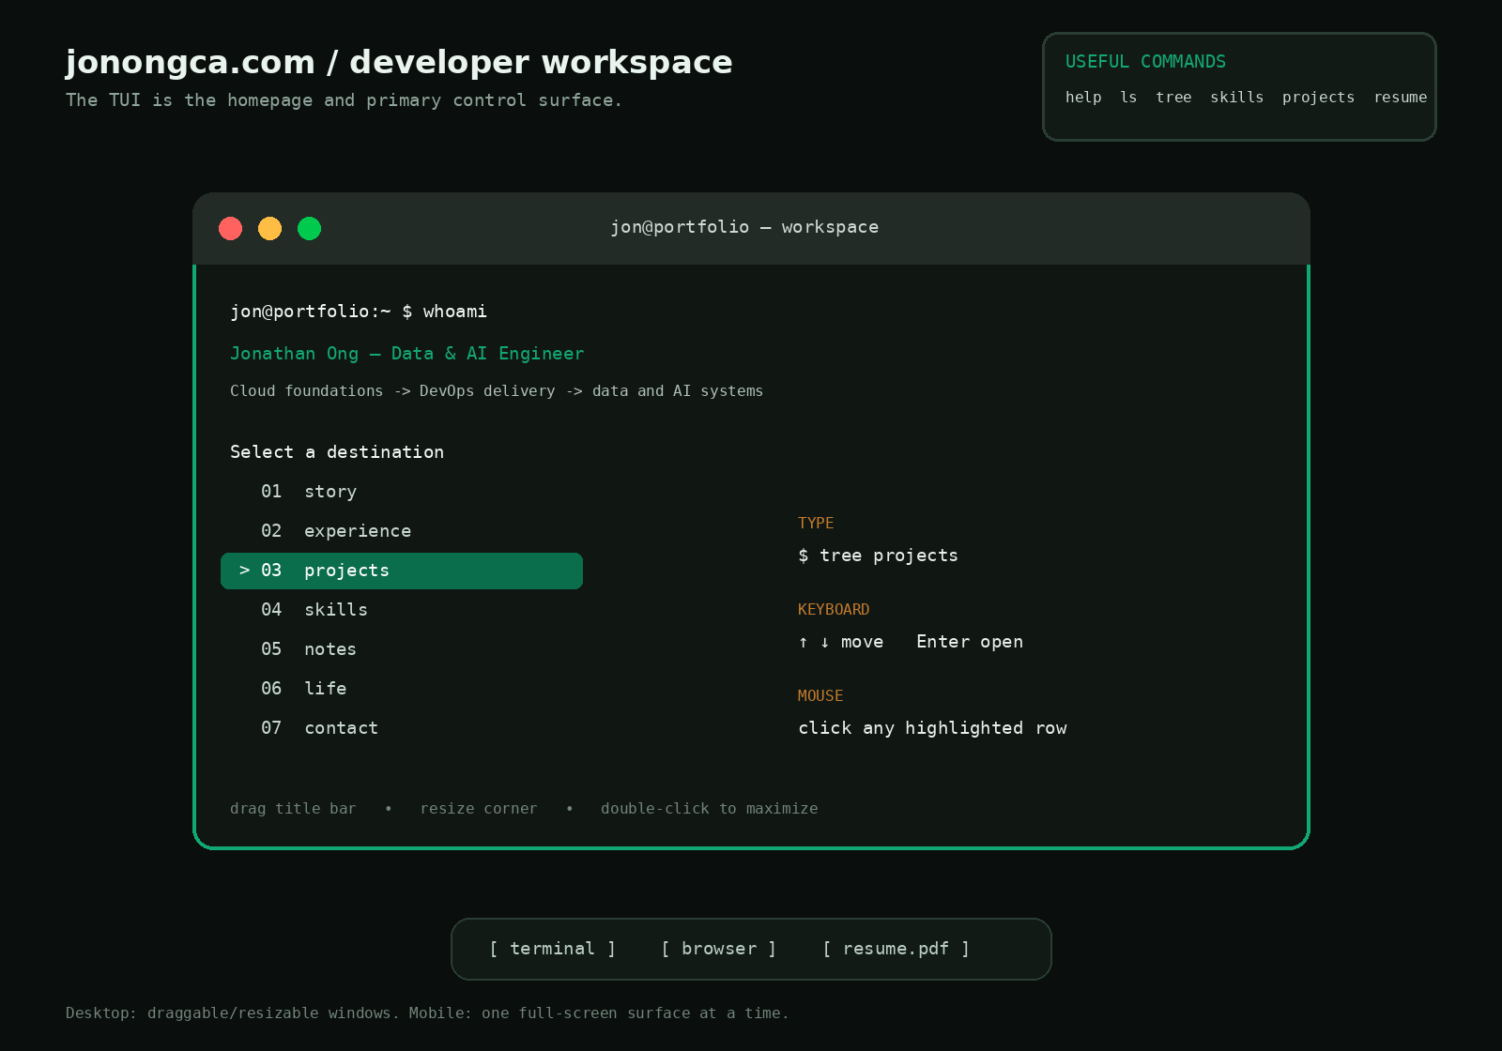
Figure 3. Initial desktop state: one dominant TUI, visible controls, and no browser window until the visitor selects a destination.

Workspace anatomy
Element | Required content | UX requirement
Workspace canvas | Subtle grid/noise, small site label, current time/status if useful | No distracting animation; canvas remains behind all windows
Useful Commands HUD | help, ls, tree, skills, projects, resume | Top-right, collapsible, clickable, and hidden only when a maximised window needs the space
Terminal title bar | Window title, traffic-light controls, drag region | Clear draggable region; buttons are real controls with accessible names
Terminal body | Boot message, role line, current path, folder/file list, prompt, keyboard hints | No scroll needed at 1366 × 768; primary directories and role are immediately visible
Resize affordance | Visible bottom-right handle plus edge hit areas | Cursor changes correctly; minimum 640 × 420 desktop
Window dock | Terminal, active Browser, Résumé/PDF | Focus, restore, and active-state indication; keyboard reachable
Browser window | Chrome, address bar, simple routed content | Created only after selection or direct route; opens within visible bounds

Homepage acceptance criteria
- The terminal—not a hero section—is the largest and most visually dominant object on first load.
- A visitor can open Projects, Experience, Story, or Résumé with one click or one keyboard selection.
- A visitor can inspect ~/skills and ~/projects through commands, arrow-key selection, or mouse clicks without encountering different content in each mode.
- The terminal can be dragged, resized, minimised, restored, and maximised on desktop.
- Opening a destination produces a mock-browser window and a corresponding real URL.
- At 1366 × 768, the TUI, Useful Commands HUD, and dock remain visible without page scrolling.
- The experience remains understandable when boot animation is disabled or JavaScript enhancement loads slowly.
- On mobile, free-form window dragging is removed and each application becomes a full-screen view.
07 · PAGE-BY-PAGE CONTENT SPECIFICATION

Mock-browser page shell
Every portfolio destination appears inside the same browser-window component. The chrome is intentionally familiar: back, forward, refresh, a read-only jonongca.com address field, title, and window controls. The content itself is calm and simple—light background, strong typography, restrained dividers, and no bento grid. Browser chrome must stay visually secondary to the information.
- Back and Forward call the real route history, not a separate fake history stack.
- The address field displays the current route but does not pretend to browse arbitrary external websites.
- Clicking an internal link updates the same browser window unless the visitor explicitly opens a new window.
- Clicking GitHub, LinkedIn, email, or another true external destination opens the real browser in a new tab.
- Each page exposes a plain “Open without workspace” link for visitors who prefer a conventional full-page view.

Virtual portfolio filesystem
The TUI presents portfolio content as a small read-only virtual filesystem. This is a navigation metaphor backed by typed JavaScript data and real routes—not access to the deployment filesystem. Directory names stay familiar, while file names communicate what a recruiter will find before opening anything.
~/portfolio/
README.md # short introduction + recruiter path
experience/ # public-safe roles
projects/
pitchperfect/
README.md # case-study overview
architecture.md # system view + trade-offs
decisions.md # selected engineering decisions
links.json # repository, demo, related note
all-in-one/ menswear/ internship-tracker/
skills/
data-engineering/SKILL.md
ai-engineering/SKILL.md
mlops-delivery/SKILL.md
cloud-devops/SKILL.md
product-ownership/SKILL.md
extensions/ # shipped small tools/integrations
notes/ life/ contact.json resume.pdf
- At ~/portfolio, the selected list shows the key directories plus README.md and resume.pdf; this becomes the default TUI menu.
- Opening a directory updates the prompt path and shows its children. Opening README.md or SKILL.md can render concise text in the terminal or a richer routed version in the mock browser.
- Breadcrumbs, ls/tree output, arrow-key selection, and mouse clicks all read from the same content manifest so the hierarchy cannot drift.
- Use familiar folder and file names, but provide plain labels such as “Projects” and “Skills” beside them for non-technical visitors.

Story
Purpose: connect the internships and projects into a single direction, rather than repeating a résumé chronologically. It opens as a readable editorial page within the browser window.
- Opening: “I became interested in reliable systems before I became interested in AI.”
- Three chapters: Cloud foundations; delivery and DevOps; data and AI systems.
- One horizontal or vertical timeline with a short lesson from each chapter.
- A “How I work” section: ownership, testing, documentation, feedback, and pragmatic iteration.
- Close with current direction and a link to Experience.

Experience
Purpose: make scope, progression, and outcomes easy to scan while keeping employer-confidential material out of the public site. The browser opens to a compact role list; clicking a role expands its public-safe detail in the same window and updates the route or query state.
- Use a vertical timeline or command-log-inspired list, not a card grid. Show company, role, dates, location/work mode, and a two-line scope statement.
- Give every role three evidence bullets: responsibility, engineering action, and result or validation outcome.
- Use public-safe descriptions only. Never expose internal endpoints, table names, tax data, private architecture, source documents, or proprietary metrics.
- Separate team outcome from personal ownership with explicit wording such as “I owned,” “I implemented,” or “I contributed to.”
- Add technology labels after the evidence; do not make the stack the story.

Skills directory
Purpose: adapt the concept of coding-agent skill packages into an evidence-based capability index. Each skill is a folder containing a SKILL.md file. It should describe what Jonathan can do, where he has applied it, the tools involved, and what he is still learning. This replaces generic logo clouds, percentage bars, and unsupported “expert” labels.
Skill package | Capability focus | Required evidence links
data-engineering/SKILL.md | ETL design, PySpark/SQL, schemas, data quality, validation | Relevant experience, pipeline project, learning note
ai-engineering/SKILL.md | RAG, evaluation, agent workflows, model integration | Project case study, architecture, evaluation evidence
mlops-delivery/SKILL.md | Testing, reproducibility, CI, monitoring, release workflow | Deployment or automation decisions and test artefacts
cloud-devops/SKILL.md | Cloud architecture, containers, infrastructure as code, reliability | Cloud/DevOps experience and deployed projects
product-ownership/SKILL.md | Problem framing, backlog decisions, stakeholder and team delivery | Team project, role boundaries, decisions and reflection

- SKILL.md structure: one-line summary; capabilities; tools; evidence; current learning; related commands or links.
- cat skills/<slug>/SKILL.md prints a compact terminal version. open skills/<slug> opens the readable /skills/<slug> browser page.
- Every claimed capability links to at least one project, experience entry, certification, or public learning note. Omit claims that have no publishable evidence.
- Status may use plain words such as “practised,” “working knowledge,” or “currently learning”; do not use arbitrary percentages or five-star ratings.

Projects directory and explorer
Purpose: curate breadth without becoming a repository catalogue. Use ~/portfolio/projects as the main project home, with four to six project folders. The mock-browser page should resemble a clean repository explorer: a collapsible folder tree on the left or top, and the selected README or supporting file on the right. Each folder and file remains clickable from the TUI and browser.
Recommended slot | What it proves | Presentation angle
PitchPerfect | AI product design, evaluation pipeline, product ownership | Use only sponsor-approved, non-confidential scope and clearly state personal contribution
All-In-One | Deployment ownership, CI/CD, Terraform, team delivery | Lead with the six-person delivery context and reliability decisions
Menswear | Cloud architecture and multi-service deployment | Show one architecture decision and why the data stores differed
Internship Tracker | Automation and product usefulness | Lead with the manual workflow removed and the deployment path
AI Agent Workflow | Agent orchestration and human review | Show real artefacts and trade-offs; do not present only model cards
Optional RAG project | Retrieval and LLM grounding | Include only if the case study can demonstrate evaluation, not just a stack list

Project detail template
- Hero: project name, one-sentence outcome, role, team size, timeframe, repository/live links.
- Problem: the user or engineering problem in plain language.
- My role: ownership boundaries and collaboration context.
- Key decisions: two or three decisions with alternatives and trade-offs.
- System view: one readable architecture or workflow diagram with a text alternative.
- Implementation: selected evidence, not a code dump.
- Outcome: measurable result where defensible; otherwise use a validated qualitative result.
- Reflection: what changed, failed, or would be improved next.

Extensions directory
Use ~/portfolio/extensions only for smaller shipped tools that extend another workflow: browser extensions, editor/CLI helpers, automation integrations, agent add-ons, or compact utilities. Do not rename all projects as extensions; recruiters understand “Projects” immediately, while “Extensions” is a useful secondary category. An extension can still link back to a full project case study when it has enough depth.
- Only list working or clearly labelled prototype extensions; planned concepts should not appear as shipped work.
- Each extension folder needs README.md, status, problem solved, installation/demo path where safe, and a related project or note.
- Keep Extensions below Projects in the top-level hierarchy and omit the directory entirely until there is at least one credible item.

Notes and Life
Notes should support learning in public: monthly engineering reflections, selected PySpark certification notes, and safe SQL/DSA learning. Life should hold books, games, running, cats, travel, and photography. Both open as lightweight browser pages and remain secondary to Experience and Projects in the terminal menu order.
08 · VISUAL DESIGN SYSTEM

Developer desktop outside; simple portfolio website inside

What to borrow—and what not to copy
Reference | Borrow | Avoid
Sean Chen | Clear typography, thin rules, decisive copy, paper-like content pages inside the mock browser | Copying the newspaper masthead, bilingual layout, or exact column proportions
Claude Code / Codex / Pi TUI | Prompt rhythm, status line, selectable rows, keyboard navigation, command aliases, restrained developer feel | Copying logos, exact colors, product wording, or presenting the site as an official coding agent
Desktop terminals/browsers | Recognisable title bars, focus states, drag handles, resize behaviour, address field, dock | Heavy skeuomorphism, excessive reflections, fake operating-system complexity
Current jonongca.com | Forest green, warm personal imagery, approachable voice, existing project material | Bento cards, draggable content tiles, decorative tech sphere, equal visual weight everywhere

Design tokens
Token | Value | Use
--workspace | #0A0F0D | Desktop canvas behind windows
--terminal | #101713 | Terminal body
--chrome | #222B26 | Terminal/browser title bars and dock
--paper | #F7F4EC | Mock-browser content background
--ink | #101814 | Content text and dark borders
--green | #087A55 | Content links and secondary focus
--green-bright | #12A874 | Active TUI row, focus ring, terminal accent
--amber | #C77C2C | Command feedback, warning, and rare emphasis
--rule | #D9DDD7 | Browser-page dividers and table rules

Typography
- Workspace and window UI: IBM Plex Mono or JetBrains Mono for prompts, title bars, metadata, commands, and status.
- Mock-browser body/UI: Manrope, preserved from the current site for continuity.
- Optional browser display: Instrument Serif or Newsreader for Story and case-study headings only.
- Terminal body: 15–17 px desktop with 1.55–1.7 line-height; never shrink below 14 px to fit more rows.
- Browser body: 16–18 px; headings 32–56 px depending on window width; metadata 12–14 px mono.

Layout and surfaces
- Initial terminal: approximately 70–78vw × 62–72vh; default 980 × 620 px; minimum 640 × 420 px desktop.
- Mock browser: default 920 × 640 px and offset 48–72 px from the terminal; minimum 680 × 480 px desktop.
- Windows use 12–16 px corner radii, one restrained shadow, 1 px border, and a 42–48 px title bar.
- Browser content has a maximum readable width of 760–920 px inside the viewport; long text remains 640–720 px.
- The Useful Commands HUD stays top-right; the dock stays bottom-centre; both avoid active window controls.
- Photography remains real and warm inside the browser pages; avoid decorative stock imagery and logo clouds.

Motion
- Terminal boot: 300–500 ms maximum and only on the first visit; content remains available immediately.
- Browser open/focus: 160–220 ms using opacity plus a small scale/translate, never a long cinematic sequence.
- Dragging follows the pointer directly with no inertia; use transform updates inside requestAnimationFrame.
- Resize feedback is immediate; content uses responsive CSS rather than scaling the whole window.
- No continuous orbiting icons, parallax, custom cursor, or background motion that competes with window use.
- Reduced-motion mode removes boot typing, caret blinking, window fly-in, and animated minimise/maximise.

09 · FRONTEND ARCHITECTURE

Recommended stack and deployment
ARCHITECTURE DECISION
Use Next.js App Router for static-rendered portfolio routes, with one client-side React WorkspaceShell controlling the terminal, windows, focus, drag, resize, and route synchronisation. Deploy on Vercel.
This concept is intentionally JavaScript- and CSS-driven. The terminal is a deterministic React interface, and the windows are DOM elements—not screenshots, canvas video, iframes, or a real shell. Static rendering keeps each portfolio route indexable; the client workspace hydrates around that content and recreates the appropriate terminal/browser state.
Option | Benefits | Costs | Decision
Next.js + Vercel | SSG routes, metadata, React shell, image/font optimisation, previews | Framework migration; client/server boundaries need care | Recommended
Vite + Router + prerender | Lowest migration cost; natural for a client-heavy workspace | More manual SEO, metadata, fallback, and prerender work | Strong fallback
Next.js/Vite on Railway | Can colocate with a persistent backend later | Serving process and more frontend operations without current benefit | Backend only

Suggested repository structure
app/
layout.tsx # fonts, metadata, WorkspaceShell
page.tsx # initial terminal workspace
story/page.tsx
experience/page.tsx
projects/page.tsx
projects/[slug]/page.tsx
skills/page.tsx
skills/[slug]/page.tsx
extensions/page.tsx
notes/page.tsx
life/page.tsx
components/workspace/
WorkspaceShell.tsx # client state + route sync
WindowManager.tsx # focus, bounds, z-index
AppWindow.tsx # shared drag/resize/chrome
TerminalWindow.tsx
BrowserWindow.tsx
FileExplorer.tsx # shared folder/file hierarchy
WindowDock.tsx CommandHUD.tsx
lib/commands.ts # parser + fixed action map
lib/virtual-fs.ts # read-only nodes + path resolver
lib/window-state.ts # reducer + persistence types
components/pages/ # Story, Experience, Projects…
content/projects/*.mdx
content/skills/*/SKILL.md
content/extensions/*/README.md
content/notes/*.mdx
data/profile.ts data/experience.ts

Window state contract
Field | Purpose
id / app / route | Stable window identity, application type, and routed content.
title | Accessible window title and title-bar label.
x / y / width / height | Viewport-relative position and dimensions, clamped to bounds.
zIndex / isActive | Deterministic stacking and current focus.
state | normal, minimised, or maximised.
restoreBounds | Previous dimensions used when restoring from maximised/minimised state.
scrollPosition | Optional page scroll restoration when a browser window is focused again.

Virtual filesystem contract
Field / service | Purpose
VirtualNode | Typed directory or file node with id, name, path, kind, label, route, children, and optional terminal text.
cwd | Current virtual directory shown in the prompt and used by relative ls, tree, cd, cat, and open commands.
selectedPath | Single highlighted directory/file shared by arrow-key navigation and mouse focus.
resolvePath() | Normalises relative/absolute virtual paths, handles . and .., and rejects escape outside ~/portfolio.
routeForNode() | Maps a virtual node to /projects, /skills, /extensions, or another real route without duplicating navigation logic.
content manifest | One generated source of truth consumed by TerminalWindow, FileExplorer, routes, sitemap, and tests.

Implementation rules
- Install Tailwind through the build pipeline or use CSS Modules; remove the production CDN script.
- Keep routed content statically rendered where possible; isolate window management, command input, and drag/resize behaviour in the client WorkspaceShell.
- Use Pointer Events with setPointerCapture(), CSS transforms during drag, and requestAnimationFrame to avoid layout thrashing.
- Either use a focused utility such as react-rnd for P0 or implement one small shared AppWindow; do not reuse react-grid-layout for desktop windows.
- Generate project routes at build time and assign unique title, description, canonical URL, and social image metadata.
- Keep content separate from components. MDX or typed objects should supply project and experience data.
- Store essential icons and images locally; draw window chrome with CSS and SVG rather than raster screenshots.
- Route changes and window actions flow through one reducer so keyboard, command, and mouse paths cannot drift apart.
- Generate the virtual content manifest from project, skill, extension, and route metadata at build time; do not hand-maintain separate terminal and browser trees.
- Keep the virtual filesystem read-only. Commands may navigate and open content but must never create, edit, execute, upload, or delete files.
- Persist only safe UI preferences such as last window bounds or theme. Do not restore a chaotic pile of old windows on a recruiter’s first visit.
- Use Vercel functions only for features that need secrets or live data. The command parser and window manager require no backend.
- Railway remains appropriate for a future persistent API, worker, database, or agent service—not for the static workspace shell alone.
10 · CONTENT MODEL AND GOVERNANCE

Make content easy to update and safe to publish

Project content contract
Field | Requirement
slug | Stable lowercase route key
title / oneLiner | Plain-language name and outcome sentence
role / teamSize / timeframe | Clarify ownership and collaboration context
problem | User or engineering problem; 60–120 words
decisions | Two or three decisions, alternatives, and trade-offs
evidence | Screenshots, architecture, tests, public repository, or demo
outcome | Defensible metric or validated qualitative result
reflection | What changed, failed, or would be improved
privacy | Explicit public-safe review before publishing

Writing rules
- Use short, direct sentences. Avoid generic claims such as “passionate,” “innovative,” or “cutting-edge.”
- Start bullets with the engineering decision or ownership, not the technology name.
- Only use metrics that can be defended. Prefer “validated X” over inventing a percentage.
- Name the team context and personal contribution separately.
- Every case study must include one honest reflection or trade-off.
- Keep internships public-safe and do not reuse confidential work artefacts as portfolio screenshots.

Content freshness
- Review availability, current role, and résumé link monthly while applying.
- Publish Notes only when there is a useful takeaway; do not create empty cadence pressure.
- Show a “last updated” date on résumé and notes, not on evergreen case-study headlines.
- If a widget relies on an external API, render a useful static fallback and never leave an empty card.
11 · RESPONSIVE, ACCESSIBILITY, SEO AND QUALITY

Definition of done

Responsive behaviour
- Test at 360, 390, 768, 1024, 1366, and 1440 px widths.
- Desktop (1100 px and above): free drag/resize, overlapping Terminal and Browser, visible HUD and dock.
- Tablet (768–1099 px): one dominant centred window; limited drag within bounds; maximise encouraged; HUD collapses.
- Mobile (below 768 px): no free-form drag/resize; Terminal and Browser become full-screen application views with a clear Back to Terminal control.
- Mobile command rows and title-bar controls use touch targets of at least 44 × 44 px and respect safe-area insets.
- Browser-page content responds to the window’s container width, not only the overall viewport width; use container queries where helpful.
- The project/skills hierarchy collapses to a disclosure list above the selected file on narrow browser windows; never force a two-pane layout below its readable width.
- No horizontal scrolling except inside explicitly labelled code or architecture regions.

Accessibility
- Meet WCAG 2.2 AA contrast for text, controls, focus rings, and non-text UI boundaries.
- Provide a skip-to-content link that opens the currently routed page without requiring terminal interaction.
- Treat each application window as a labelled region, not a modal dialog unless it actually blocks other interaction.
- Title-bar controls are real buttons with accessible names; active-window and minimised states are announced.
- All command actions work with keyboard and screen reader; opening, closing, focusing, and restoring a window move focus predictably.
- Implement folder hierarchies as nested lists with disclosure buttons unless the full ARIA tree pattern is correctly supported; announce the current path and expanded/collapsed state.
- Provide keyboard-accessible Move and Resize actions for users who cannot pointer-drag.
- Images have useful alt text; decorative images use empty alt text; diagrams include a text explanation.
- Respect prefers-reduced-motion and do not run hidden requestAnimationFrame loops.

SEO and shareability
- Every public page has a unique title, description, canonical URL, and social image.
- Project detail pages are statically generated and linkable.
- Create sitemap.xml and robots.txt; expose structured Person and CreativeWork/Project data where appropriate.
- The HTML contains core page content before client JavaScript runs.
- Resume remains a stable /resume.pdf URL and should not be hidden behind client state.

Performance budgets
Measure | Target
Largest Contentful Paint | < 2.5 s at the 75th percentile
Interaction to Next Paint | < 200 ms at the 75th percentile
Cumulative Layout Shift | < 0.10
Lighthouse performance | 90+ on representative production pages
Lighthouse accessibility / SEO / best practices | 95+ target; no critical manual-review failures
Initial JavaScript | Keep workspace shell focused; code-split browser pages; remove react-grid-layout from Home
Drag responsiveness | Pointer movement remains visually smooth with no long task above 50 ms

Functional acceptance
- Refreshing /experience reconstructs the workspace with Terminal behind and the Experience browser focused.
- Browser Back/Forward traverses mock-browser pages and project details correctly.
- Typing “projects,” arrow-selecting Projects, and clicking Projects create the same active window and URL.
- Typing “tree projects,” expanding the Projects directory with arrow keys, and clicking it with a mouse expose the same ordered project hierarchy.
- cat skills/<slug>/SKILL.md and /skills/<slug> use the same capability source and link to the same supporting evidence.
- cd .. cannot navigate above ~/portfolio, and no virtual command reads or changes the deployment filesystem.
- Dragging and resizing never move all title-bar controls off-screen or reduce content below minimum dimensions.
- Minimise, maximise, restore, close, dock focus, and duplicate-route reuse behave consistently.
- Unknown commands never break the page or trap focus.
- External links open real tabs; the mock address bar never accepts arbitrary third-party URLs.
- The plain-page fallback exposes the same routed content without the workspace presentation.
- No console warnings from production Tailwind usage remain.
12 · DELIVERY PLAN

Build in proof-first slices
Phase | Scope | Exit condition
0 · Content inventory | Select 4–6 projects, 4–5 evidence-backed skill packages, public-safe experience copy, résumé, images | Project folders and SKILL.md files have real launch content
1 · Route foundation | Next.js scaffold, static routes, content, metadata, compiled CSS | Every page works as a plain shareable route
2 · Window system | Workspace canvas, AppWindow, focus/z-index reducer, drag, resize, dock | Window acceptance tests pass on desktop
3 · TUI engine | Boot state, virtual filesystem, ls/tree/cd/cat/open, aliases, command history, keyboard and mouse paths | All three input methods resolve the same node and action
4 · Mock browser | Browser chrome, history, address display, route sync, direct-link reconstruction | Refresh/Back/Forward and browser focus pass
5 · Recruiter content | Story, Experience, Projects explorer, Skills packages, one full case study, résumé, Contact | 20-second discoverability test succeeds
6 · Responsive + quality | Mobile app mode, a11y, reduced motion, performance, broken-link and production QA | Definition of done passes on preview
7 · Launch | Domain switch, analytics, old URL redirects, README update | jonongca.com points to the verified build

Priority backlog
Priority | Items
P0 · Launch | TUI landing page; virtual ~/portfolio hierarchy; command/arrow/mouse navigation; draggable/resizable Terminal and Browser; real routes; Story; Experience; Projects; Skills; résumé; mobile fallback; a11y/SEO; Vercel
P1 · Stronger workspace | Minimise/maximise polish; dock persistence; Extensions; Notes; Life; richer case-study files/diagrams; social images; privacy-friendly analytics
P2 · Optional integrations | Theme command; build-time Notion import; reading/running data; note search; Railway-backed service only when a persistent feature is justified

Effort guide
A polished P0 is roughly 10–16 concentrated development days once content and assets are ready. The extra effort comes from window focus, drag/resize bounds, route reconstruction, keyboard access, responsive mobile mode, and cross-browser testing. Build the routed content first, then the shared AppWindow, then connect the deterministic TUI. Avoid spending early days on boot animations before the full recruiter path works.
APPENDIX A · REFERENCE BOARD

TUI workspace and browser-content references
These references set interaction and content principles, not a template to copy. The outer experience should feel like Jonathan’s developer workspace; the inner mock-browser pages should remain calm, simple, and recruiter-readable.
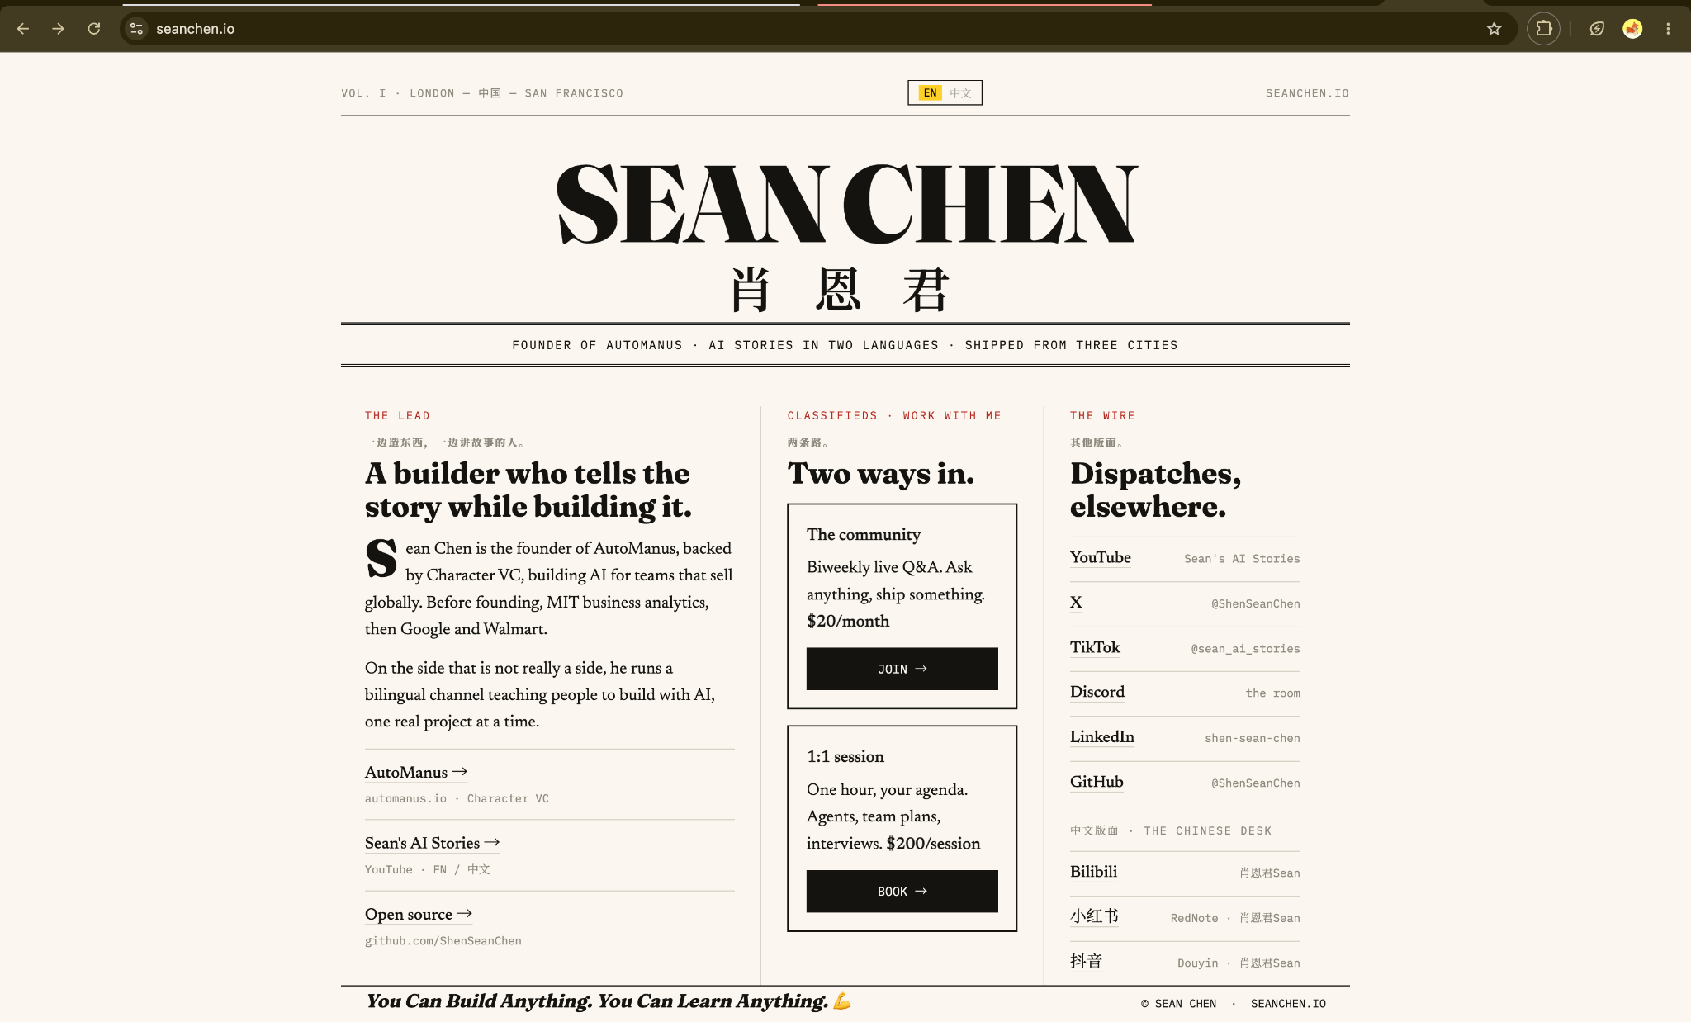
Reference A. Sean Chen: use the disciplined typography and information hierarchy inside mock-browser pages, not as the outer homepage shell.

Terminal interaction reference
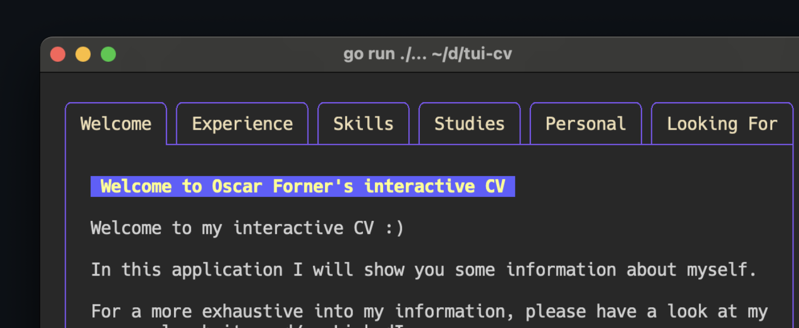
Reference B. TUI résumé: explicit keyboard hints, monospace information, and visible selection state. Jonongca should make this interaction the main landing experience and open deeper content in browser windows.

Sources reviewed
- Live portfolio
- GitHub repository
- Sean Chen reference
- Vite SSR guide
- Vite production build guide
- Vercel Vite guide
- Vercel Functions
- Railway React deployment guide
- Next.js metadata guide

Final recommendation
Commit to the developer-workspace idea rather than diluting it into a normal homepage with a terminal card. The centred TUI should be the first screen, the primary navigation system, and the strongest expression of Jonathan’s identity. Its read-only ~/portfolio hierarchy should make Projects feel like real project folders and Skills feel like evidence-backed agent capability packages, while Extensions remains a smaller category for shipped tools. Commands, arrow keys, Enter, and mouse clicks must all open the same simple content inside managed mock-browser windows. The experience succeeds when it feels like exploring a real coding workspace while remaining as clear, linkable, accessible, and trustworthy as a conventional portfolio.

APPENDIX B · RESUME-GROUNDED CONTENT INVENTORY
Implementation source note: This appendix adds content verified from Jonathan Ong Chong An’s July 2026 and May 2026 résumé PDFs. It is an implementation reference, not a requirement to publish every claim. All experience copy must receive a public-safe review before launch.

Profile and recruiter-facing positioning
- Name: Jonathan Ong Chong An. Location: Singapore, SG. Availability shown on the July 2026 résumé: Jan 2027 – Jul 2027.
- Education: Bachelor of Science in Information Systems (Product Development), Singapore Management University, Jan 2023 – Dec 2027; second major in Computer Science (AI).
- Positioning: production-experienced undergraduate working across data engineering, cloud infrastructure, DevOps delivery, MLOps workflows, and applied AI systems.
- Recruiter summary direction: builds reliable data infrastructure and delivery systems where data, cloud, and AI meet. Keep the landing copy compact; put evidence in the browser pages.

Verified experience to model in /experience
- IRAS · AI & Data Engineering Intern · May 2026 – Nov 2026: migrated legacy SAS data-lake queries to PySpark across millions of production records; validated functional parity against SAS outputs using DataFrame checks.
- IRAS · public-safe evidence: optimised PySpark query performance and code structure; contributed to CI/CD, Dockerisation, and workflow releases for an MLOps codebase across UAT and production; conducted adversarial testing and UAT evaluation for an internal GenAI LLM tool.
- YTL PowerSeraya · DevOps Engineer Intern · Jan 2026 – Apr 2026: built and rolled out Azure DevOps multi-stage YAML pipelines for four Azure applications, reducing deployment time from 60 to 20 minutes.
- YTL PowerSeraya · public-safe evidence: designed a self-hosted agent approach for IaC deployments inside an isolated VNet on application VMs; built two Power BI dashboards for management reporting and facilitated internal Power BI learning sessions.
- Global Enterprise Mobility · Cloud Engineer Intern · May 2025 – Aug 2025: provisioned AWS infrastructure with Terraform; built Jenkins/Groovy CI/CD pipelines integrating GCP Secret Manager; reduced release time from 40 to 20 minutes.
- Global Enterprise Mobility · public-safe evidence: added a DynamoDB idempotency layer that eliminated webhook duplicates and resolved a transaction-impacting bug. Avoid publishing private system names, endpoints, or source data.

Verified projects to model in /projects
- MensWear · Microservices Web Application · Team Lead · Aug 2025 – Nov 2025: led end-to-end AWS deployment using ECS/Fargate and ALB; operated 8+ microservices; designed DynamoDB for sessions, DocumentDB for catalogue data, and RDS for transactions; reported 99.9% uptime through service configuration.
- YilongMa · RAG Data Pipeline · Aug 2025 – Dec 2025: built an end-to-end RAG pipeline using ChromaDB, Llama 3.2 1B, and hybrid retrieval over transcript datasets; processed 50+ hours of audio with Whisper AI; created evaluation notebooks for retrieval quality and grounded response accuracy.
- All-In-One · Team Collaboration Tool: existing repository content supports AWS Amplify deployment ownership, GitHub Actions CI/CD, Terraform, and six-person team delivery. Confirm résumé-level dates, outcomes, and public-safe wording before expanding the case study.
- Internship Tracker: existing repository content supports Python, Notion API, AWS Lambda, Route 53, and S3 automation. Keep the case study focused on the manual workflow removed and the deployment path.

Evidence-backed skill packages
- data-engineering/SKILL.md: PySpark, Hadoop ecosystem, SQL, Pandas, SAS migration, Azure Data Lake, Azure Synapse, DataFrame validation, data-quality checks, and performance optimisation. Evidence: IRAS and YilongMa.
- cloud-devops/SKILL.md: AWS, Azure, Terraform, Docker, Jenkins, GitHub Actions, Azure DevOps/Pipelines, Azure App Service, VMs, ECS/Fargate, ALB, and environment repeatability. Evidence: YTL, GEM, MensWear, and All-In-One.
- mlops-delivery/SKILL.md: CI/CD, Dockerisation, multi-stage YAML pipelines, release workflows, UAT, regression/adversarial testing, performance validation, and production-safe delivery. Evidence: IRAS, YTL, and GEM.
- ai-engineering/SKILL.md: RAG, ChromaDB, Llama, hybrid retrieval, Whisper, retrieval evaluation, grounded-response evaluation, and internal GenAI tool testing. Evidence: YilongMa and public-safe IRAS testing work.
- product-ownership/SKILL.md: team leadership, deployment ownership, developer enablement, reporting, documentation, and translating workload requirements into infrastructure decisions. Evidence: MensWear, YTL, and All-In-One.

Skills and technology inventory
- Languages: Python, SQL, Bash, JavaScript, and Java.
- Big data and analytics: PySpark, Hadoop, Pandas, SAS migration, Azure Synapse, Power BI, and Zeppelin.
- Cloud and infrastructure: AWS, Azure, Azure DevOps, Azure Portal, Azure ML, Azure Synapse, Databricks, Terraform, Docker, and VMs.
- Delivery and data stores: Jenkins, GitHub Actions, Azure Pipelines, Azure Data Lake, DynamoDB, PostgreSQL, MongoDB, RDS, DocumentDB, and Google Firestore.
- AI and retrieval: ChromaDB, Llama 3.2 1B, hybrid retrieval, Whisper AI, RAG evaluation, and GenAI testing.

Content governance changes
- Add explicit fields for ownership, team context, validation method, public-safe status, and evidence links to the project and experience models.
- Use measurable claims only where the résumé supports them: four Azure applications, 60→20 minute deployments, 40→20 minute release time, 50+ hours of audio, 8+ microservices, 99.9% uptime, and the stated transaction-impact range.
- Do not publish internal IRAS system names, endpoints, table names, proprietary metrics, source documents, or confidential architecture. Phrase internal GenAI work as public-safe testing/evaluation evidence only.
- Use status labels such as practised, working knowledge, and currently learning. Do not convert résumé technologies into percentage scores or star ratings.

Implementation priority update
- P0 content: IRAS, YTL, GEM, MensWear, YilongMa, All-In-One, Internship Tracker, three to five evidence-backed skills, Contact, and the résumé link.
- P1 content: deeper architecture files, richer AI workflow evidence, optional RAG case-study expansion, Notes, Life, and Extensions.
- Recruiter first view: show Data & AI Engineering, Cloud/DevOps delivery, and the Singapore/availability line in the terminal status area; keep detailed résumé claims inside /experience and /projects.

APPENDIX C · SLICE RATIONALE AND LIFECYCLE TRACEABILITY
This section explains why the rebuild is delivered as narrow slices. The agentic-software-lifecycle skill is used to keep product decisions, implementation, verification, and human acceptance separate. Each slice must reduce a specific risk before the next layer is added.

Current slice · Plain routed recruiter path
- Purpose: establish real URLs, direct loading, recruiter-readable content, and the first expertise categories before introducing terminal or window complexity.
- Why first: routing and content are the foundation for SEO, sharing, browser history, and the later virtual filesystem. If these are wrong, the TUI would only hide the problem behind an interaction layer.
- What it proves: Projects, Experience, Skills, Story, Contact, and detail pages can stand on their own without JavaScript workspace interaction.
- Explicit boundary: this slice is not the finished visual revamp. The current homepage remains temporarily intact while route/content assumptions are verified.

Planned slice rationale
- Slice 2 · Content manifest and virtual filesystem: create one source of truth so terminal ls/tree/cat, browser explorers, routes, and skill packages cannot drift apart.
- Slice 3 · Window manager: isolate focus, z-index, drag, resize, minimise, maximise, and mobile behaviour before connecting commands. This prevents window mechanics from becoming entangled with content.
- Slice 4 · Terminal engine: add fixed command parsing, safe path resolution, keyboard selection, and mouse actions. Deterministic actions ensure every input mode produces the same result.
- Slice 5 · Mock browser and route synchronisation: connect browser chrome, real history, route reconstruction, and duplicate-window reuse only after routing and window state exist independently.
- Slice 6 · Recruiter content: deepen Projects, Experience, Story, and Skills using résumé-grounded evidence after the information architecture has been proven.
- Slice 7 · Responsive and quality: validate desktop, tablet, mobile, accessibility, reduced motion, performance, and direct-route behaviour before launch.
- Slice 8 · Deployment: verify Vercel preview, rewrites/static output, sitemap, and production metadata. Railway remains out of scope until a real backend requirement exists.

Human gates
- Before implementation: Jonathan approves the named slice and its files.
- After implementation: automated checks run, then Jonathan performs the visual and interaction smoke test.
- After smoke testing: feedback is classified as defect, regression, usability issue, requirement change, unsupported environment, or missing evidence before the next slice is planned.
- Product judgments such as public-safe résumé claims, project priority, skill status, and recruiter clarity remain Jonathan’s decisions.

