Model 1

mod1 <- gamm(logRS ~ s(ReproductiveFemales, k=4) + FHS_lag2,

data = dat, correlation=corAR1())

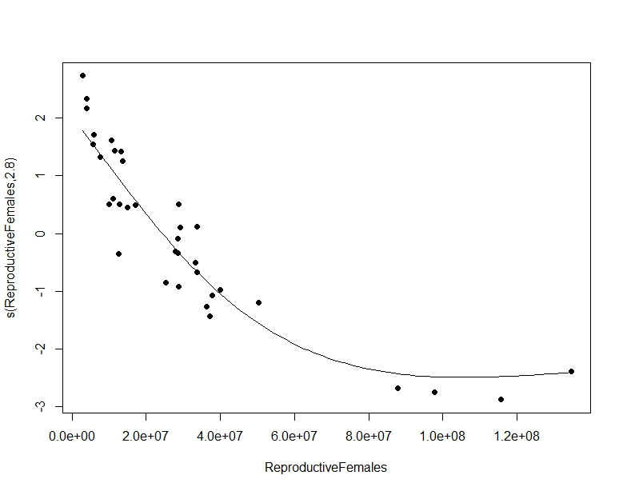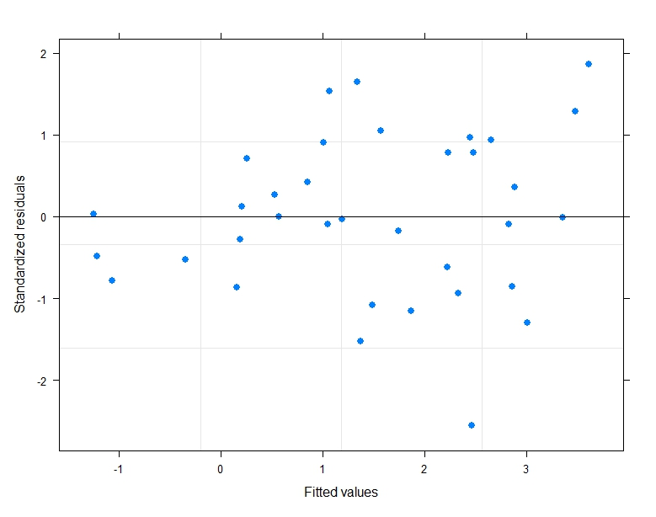

Model 2

mod2 <- gamm(logRS ~ s(ReproductiveFemales, k=4) + FHS_lag2*Era_AICc,

data = dat, correlation=corAR1())

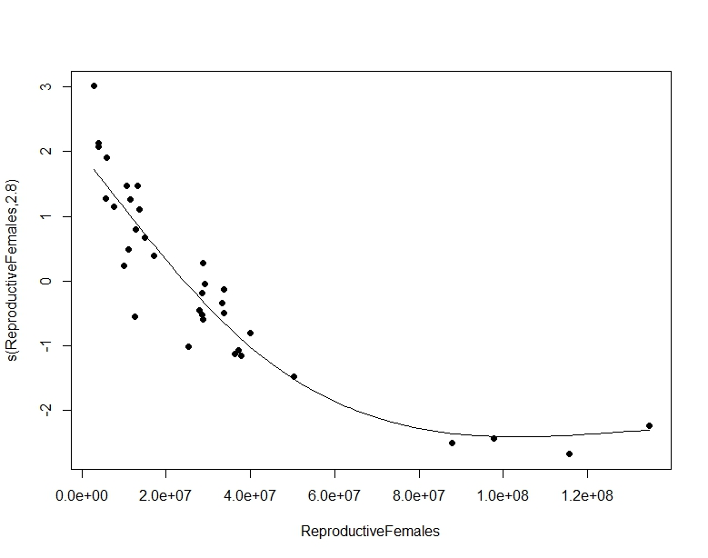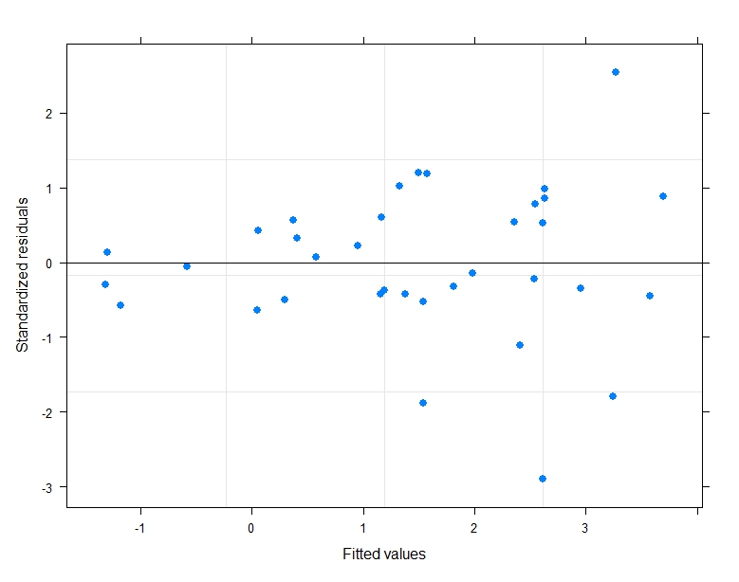

Model 3

mod3 <- gamm(logRS ~ s(ReproductiveFemales, k=4) + s(FHS_lag2, k=4, by = Era_AICc),

data = dat, correlation=corAR1())

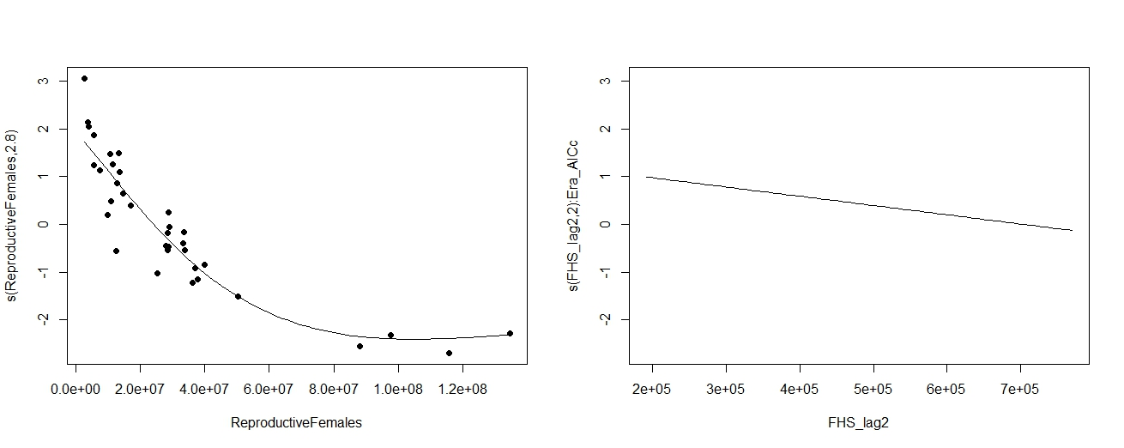

Model 4

mod4 <- gamm(logRS ~ s(ReproductiveFemales, k=4) + AO_RA3,

data = dat, correlation=corAR1())

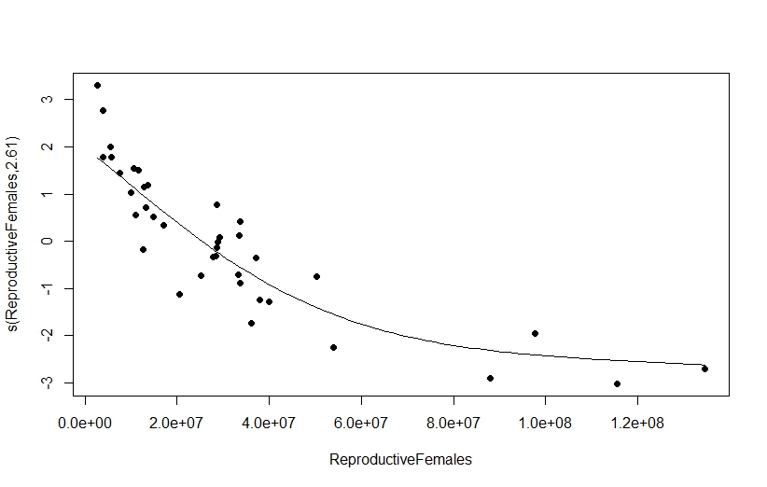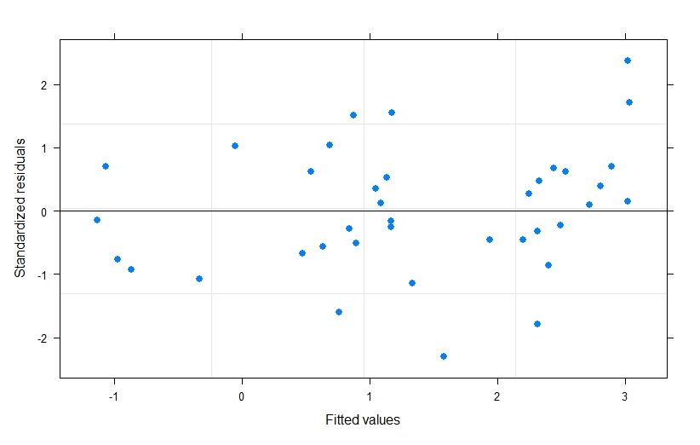

Model 5

mod5 <- gamm(logRS ~ s(ReproductiveFemales, k=4) + AO_RA3*Era_AICc,

data = dat, correlation=corAR1())

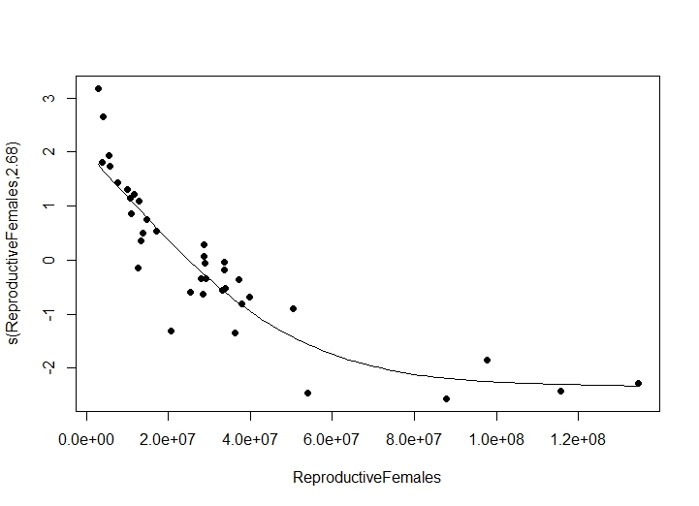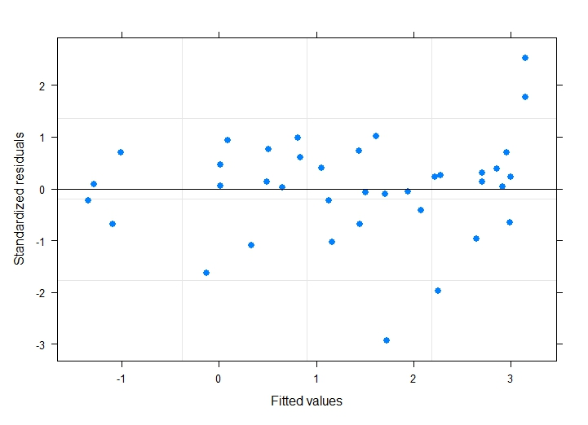

Model 6

mod6 <- gamm(logRS ~ s(ReproductiveFemales, k=4) + s(AO_RA3, k=4, by = Era_AICc),

data = dat, correlation=corAR1())

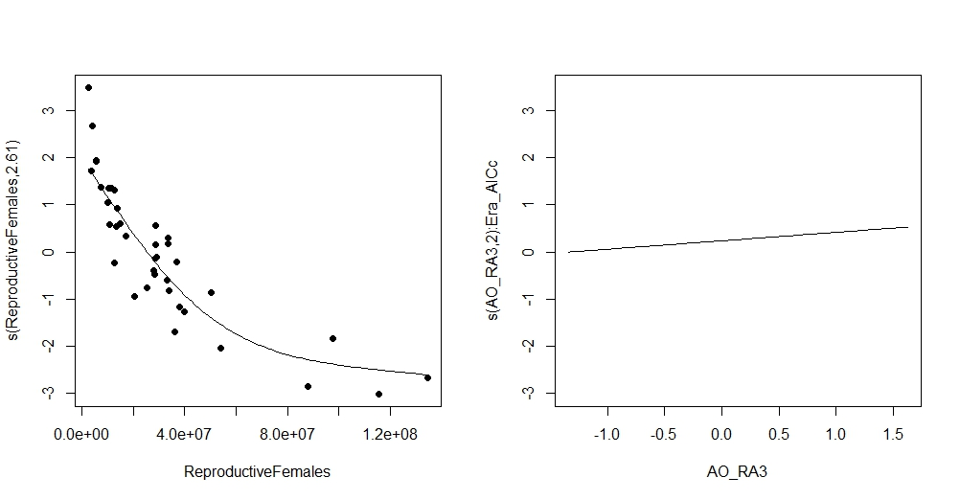

Model 7

mod7 <- gamm(logRS ~ s(ReproductiveFemales, k=4) + PDO_RA3,

data = dat, correlation=corAR1())

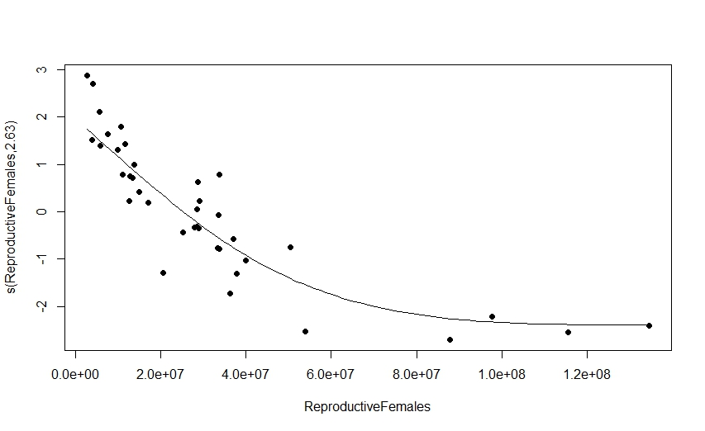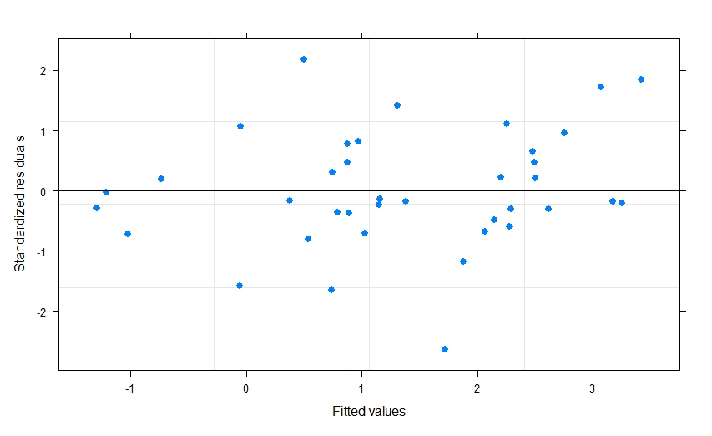

Model 8

mod8 <- gamm(logRS ~ s(ReproductiveFemales, k=4) + PDO_RA3*Era_AICc,

data = dat, correlation=corAR1())

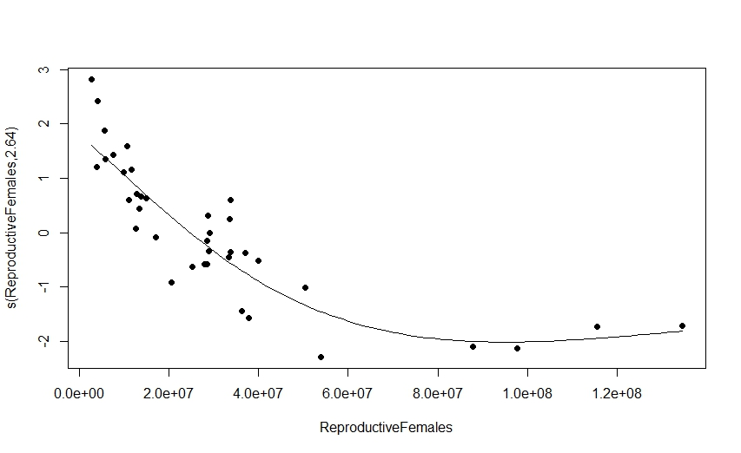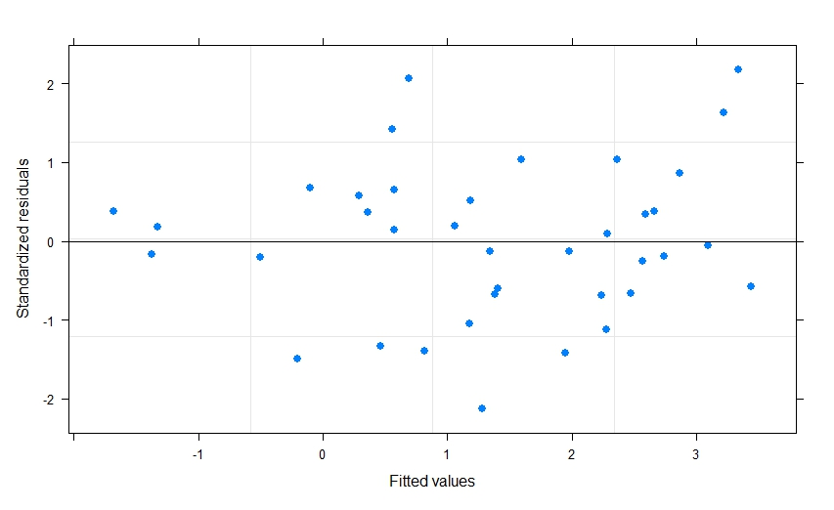

Model 9

mod9 <- gamm(logRS ~ s(ReproductiveFemales, k=4) + s(PDO_RA3, k=4, by =Era_AICc),

data = dat, correlation=corAR1())

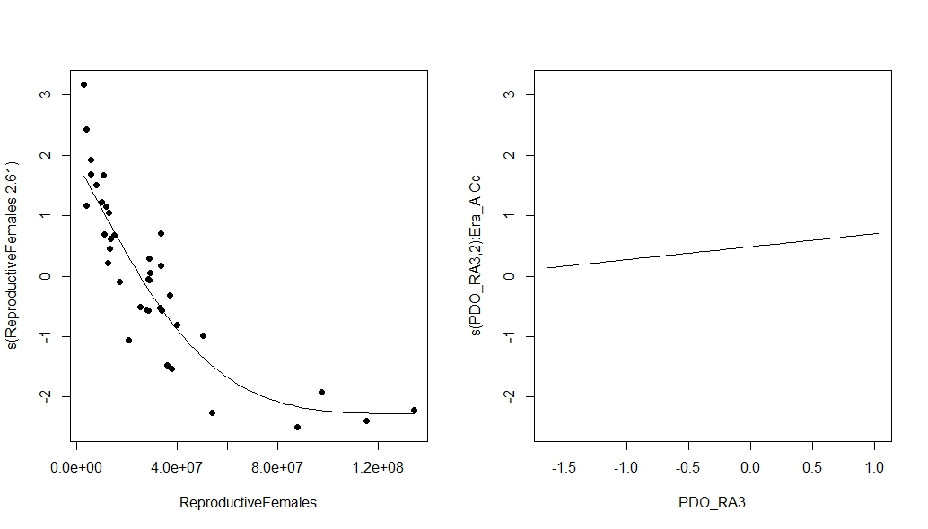

AICc values

df AICc

mod1 6 64.96079

mod2 8 69.17386

mod3 8 69.39805

mod4 6 89.21975

mod5 8 88.32034

mod6 8 93.52032

mod7 6 87.05749

mod8 8 89.06680

mod9 8 91.13765