# EEG Analysis

## Submit final version with complete portfolio on - 15.04.24 10am

**This document should be combined with other assessments in the module PSY4061 Practical Cognitive Neuroscience to form part of your portfolio.**

**There are a total of 9 questions.**

1. Below is an image of the grand average ERP potential you generated from the Jones & Ward (2019) data – this should include two conditions across all the participants you analysed.

1. Write a figure legend for the grand average ERP you pasted in answer to question 1 [~50 words]

General EEG questions: [~250 words total]

1. What filters would you typically apply to EEG data and what is the purpose of each?

Answer:

1. What is electrode interpolation and when is it appropriate to use it?

Answer:

1. Why do you need to perform artefact rejection?

Answer:

The following questions relate to EEG data. So that you can understand the data we have provided a description of the experimental design and procedure below. Read the description, look at the data and answer the questions.

**Method**

This study aimed to investigate the effects of endogenous and exogenous visual spatial attention. EEG and behavioural data, presented below, were collected from 48 participants. All participants data were cleaned and pre-processed before being subject to both ERP and continuous time frequency analysis. The data presented has been averaged across all participants.

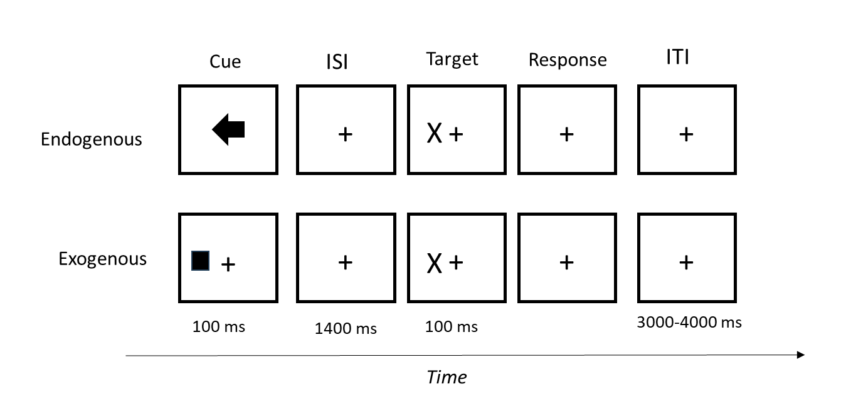

**Figure 1.** Schematic view of events in a trial. Note: ISI= inter stimulus interval, ITI=Inter trial interval. Note – the figure only depicts a cued trial in each task as an example.

In this experiment, participants were seated in front of a monitor which displayed visual stimuli. The participants’ task in the experiment was to respond, as quickly as possible, by pressing the space bar, as soon as they detected a target (an ‘X’) (See Figure 1 for a schematic view of events in a trial). The target could be presented to the left or right of a fixation cross. There were two tasks; endogenous and exogenous attention. In the endogenous attention task, participants were provided with a central cue (an arrow) which informed the participants as to which side the target would appear. After 1500 ms the target (the ‘X’) then appeared at the side indicated by the cue 75% of the time and 25 % of trials, the target appeared at the opposite side of that indicated by the cue In the exogenous task, the cue was a square and appeared to the right or left of the fixation cross. The square did not provide any information about the side (left or right) the target would appear. The target could appear at the same or opposite side to the cue (50%). After the participant had responded, there was an interval (3000-4000 ms) before the next trial started. The participant was instructed to fixate their eyes on the central fixation cross throughout the experiment. Thus, in the endogenous attention task, participants were told to expect the target on one side, without moving their eyes away from the centre. There were 140 trials in each task.

**Data**

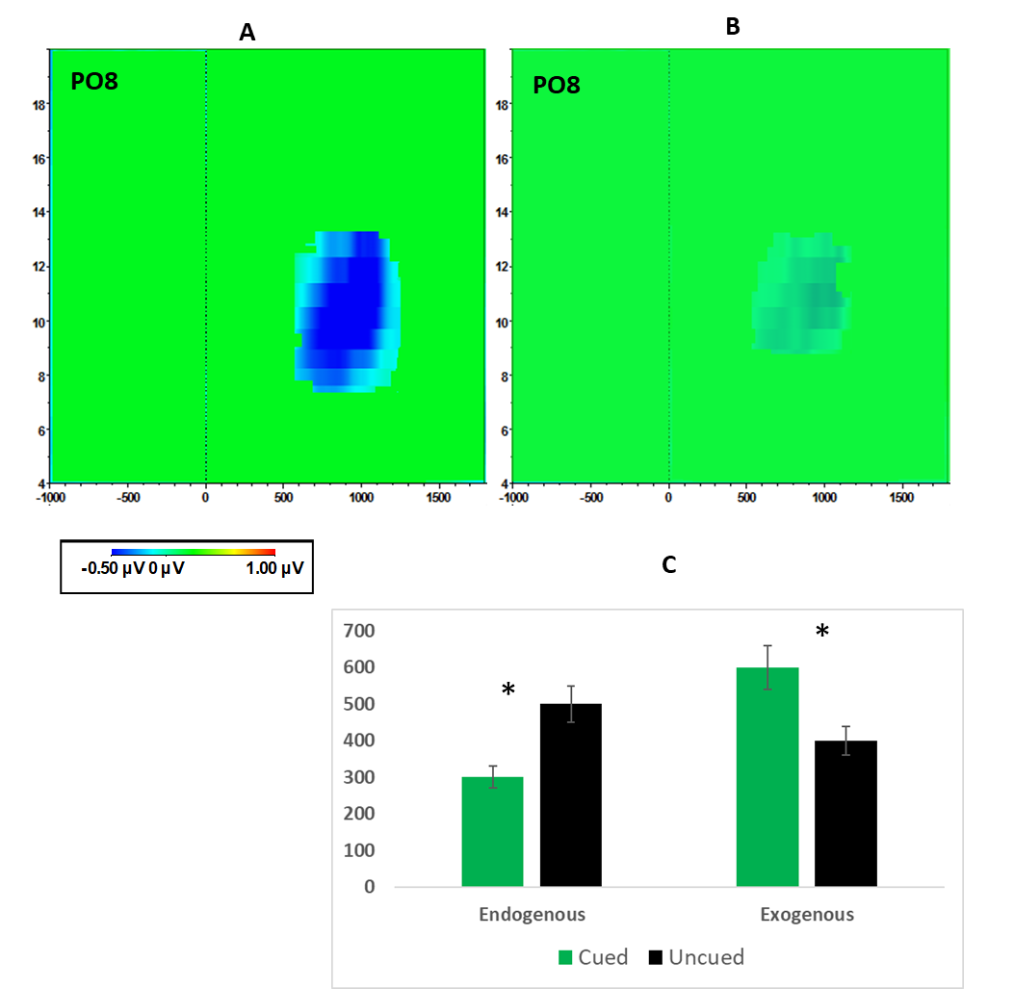

**Figure 2.** EEG analysis results. Graphs A and B represent data from the same electrode (PO8) but for different tasks. Both graphs are locked to the onset of the cue (either the arrow or the square), so that point 0 on the X-axis represents the onset of the cue. The target always appeared 1500 ms after the onset of the cue. Graph A is the endogenous task. The data in the figure is from when participants were cued to expect the target on the left side of the screen (i.e. the arrow pointed left). Graph B is the exogenous task and data represents when the cue was presented to the left of the fixation cross. Assume differences between graphs A and B are statistically significant. Graph C represents response times (in milliseconds) to the target in each task. The asterisk represents significant difference between the conditions.

The following questions should be answered in relation to the data in Figure 2.

1. Label the following [~30 words]:
   * 1. The X axis on the time frequency graphs.

Answer:

* + 1. The Y axis on the time frequency graphs.

Answer:

* + 1. The Z axis on the time frequency graphs.

Answer:

1. Looking at Figure 2, describe the differences between the two tasks and draw some conclusions about spatial attention and its relationship to the brain. [~350 words]

Answer:

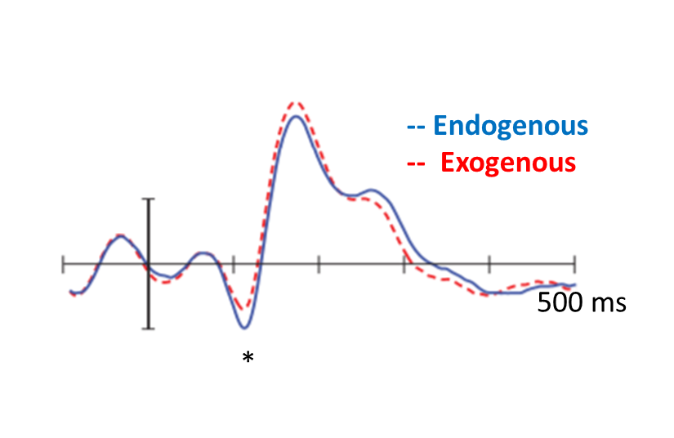

**Figure 3.** Grand averaged ERPs, at electrode PO8, for the endogenous attention task (solid blue line) and the exogenous task (red dashed line). The figure shows the ERPs when the target appeared on the left. In the Attention condition the target was preceded by an informative arrow (pointing left) and in the exogenous task the target was preceded by an uninformative square presented to the left. The waveforms represent ERPs that are locked to the target, that is to say that time point 0 is when the target (the ‘X’) appeared on the screen. Note: The asterisk represents a significant (*p<.05) difference between the two conditions at this component. No other components showed significant effects.

The following question should be answered in relation to the data in Figure 3.

1. Label the following [~20 words]:
   * 1. The X axis on the ERP.

Answer:

* + 1. The Y axis on the ERP.

Answer:

1. Looking at Figure 3, describe the differences between the two conditions and draw some conclusions about spatial attention and its relationship to the brain. [~250 words]

Answer: