

Stock Market Trend Analysis and Momentum Breakout Prediction (Using S&P 500 Historical Data (2016–2026)

Submitted by:
Saurabh Madhesia
Reg. No.: 24BDS1082

School of Computer Science and Engineering
Vellore Institute of Technology, Chennai Campus

Under the Guidance of:
Dr. Vijayalakshmi A
School of Computer Science and Engineering, VIT Chennai

Academic Year - 2026-27
Abstract
Anticipating momentum breakouts is a central problem in quantitative equity trading. A momentum breakout occurs when an equity price breaches an established multi-week consolidation resistance ceiling on extraordinary volume expansion, signaling a structural transition into an aggressive upside trend. Traditional technical analysis relies on subjective chart interpretation and rigid screeners that suffer from high false-positive rates and cannot scale across multi-asset portfolios. This project implements an end-to-end, leak-free machine learning framework in RStudio to forecast next-trading-day momentum breakout opportunities across 50 large-cap S&P 500 constituents spanning a 10-year window (August 2016 to July 2026).
The empirical dataset comprises 125,650 daily OHLCV observations across ten GICS sectors. After verification and staging in an SQLite database (stocks.db), a leak-free feature pipeline constructed 26 technical, volatility, momentum, and volume-relative indicators. Automated Pearson correlation pruning (|r| <= 0.90) retained 23 standardized predictors. The target was formulated as an explicit next-day lead indicator (Breakout_Next at t+1) computed strictly from information available at market close on day t. The dataset was chronologically partitioned into training (2016–2022; 76,900 rows; 2.45% pos), validation (2023–2024; 25,100 rows; 2.31% pos), and held-out test sets (2025–2026; 19,600 rows; 2.15% pos).
Ten supervised classifiers were trained and tuned: Logistic Regression, Decision Tree (CART), Random Forest, Gradient Boosting Machine (GBM), XGBoost, Support Vector Machine (radial SVM), K-Nearest Neighbours (KNN), Naive Bayes, Linear Discriminant Analysis (LDA), and a Multilayer Perceptron (MLP) Neural Network. Given severe class imbalance (~2.15%–2.45%), models used square-root weighting and majority downsampling, evaluated via Precision-Recall AUC (PR-AUC), F1-score, and ROC-AUC under validation-calibrated decision thresholds.
On the untouched test set, Gradient Boosting (GBM) achieved champion performance with a PR-AUC of 0.1721, ROC-AUC of 0.8536, precision of 20.15%, recall of 31.28%, and F1-score of 0.2451, delivering an 8.0x lift over random guessing (0.0215). Neural Network (MLP) attained top ROC-AUC (0.8582) and recall (42.65%), while XGBoost delivered PR-AUC of 0.1630 and F1 of 0.2414. Proximity to the 20-day high (Dist_High_20: 43.13%) and volume expansion (Log_Vol_Ratio: 40.57%) account for 83.70% of total predictive power.
Keywords: Keywords: Momentum Breakout, Stock Market Trend Analysis, S&P 500, Machine Learning, Gradient Boosting, XGBoost, Precision-Recall AUC, Class Imbalance, Technical Indicators, Quantitative Finance, RStudio.

Table of Contents

1. Abstract
2. Introduction & Project Objectives
3. Dataset Description & Domain Standardization
4. Exploratory Data Analysis and Acoustic Visualizations
5. Statistical Analysis and Feature Engineering (Primary Focus)
6. Machine Learning Models and Algorithmic Formulations
7. Experimental Results, Confusion Matrices and Output Screenshots
8. Conclusion, Limitations and Future Work
9. Core R Code (Comment-Free Implementation)
10. GitHub Repository and Reproduction Guide

1. Introduction
1.1 Background of Stock Market Trend Analysis
Financial equity markets represent complex stochastic systems exhibiting non-stationarity, time-varying conditional volatility (heteroskedasticity), fat-tailed return distributions, and low signal-to-noise ratios. Prices evolve as market participants interact to discount corporate earnings, macroeconomic indicators, monetary policy adjustments, and aggregate liquidity shifts.
Historically, market participants have approached price behavior through fundamental and technical analysis. Fundamental analysis inspects balance sheet health, discounted cash flows, and industry moats to estimate intrinsic value. Technical analysis posits that historical price action and trading volume reflect market information and investor psychology. Modern data science translates technical principles into mathematically rigorous, reproducible predictive models evaluated against statistical benchmarks.
1.2 Financial Momentum in Equity Trading
Cross-sectional momentum is an established empirical asset pricing anomaly first formalized by Jegadeesh and Titman (1993). Equities exhibiting superior relative performance over intermediate windows (3 to 12 months) systematically tend to continue outperforming over subsequent holding periods. This return autocorrelation challenges the strict Efficient Market Hypothesis (Fama, 1970).
In behavioral finance, momentum is driven by initial cognitive underreaction to positive informational surprises followed by institutional herd behavior and positive feedback trading. Statistically, momentum measures the velocity of directional price trajectories. Identifying momentum transitions early allows quantitative strategies to align capital with institutional accumulation phases.
1.3 Momentum Breakouts: Technical Definition and Mechanics
A momentum breakout represents a structural regime shift. An equity typically oscillates within a consolidation range bounded by an upper resistance ceiling and a lower support floor, where buying and selling forces reach temporary equilibrium.
A breakout occurs when price forcefully closes above resistance accompanied by extraordinary volume expansion. The volume surge confirms that the price breach is driven by aggressive institutional order flow absorbing overhead supply rather than a low-liquidity fluctuation. Once resistance is penetrated, short covering and algorithmic trend-following orders accelerate the directional price advance.
1.4 Practical Utility in Quantitative Portfolio Management
Systematic anticipation and detection of momentum breakouts provide substantial commercial and risk-management advantages to quantitative funds and retail traders alike:
- Capital Efficiency: Capital Efficiency and Opportunity Cost Reduction: Equities often spend extended periods in sideways consolidation. Accurately predicting when a stock is on the verge of breaking out allows capital to be deployed immediately prior to directional expansion, minimizing dormant capital lock-up.
- Asymmetry: Favorable Asymmetric Risk-Reward Profiling: Breakout trades offer natural, objective structural invalidation points. If the price re-enters the prior consolidation range, the breakout is classified as a 'false breakout' (bull trap), permitting rapid stop-loss execution with minimal capital drawdown relative to large upside profit targets.
- Scalability: Scalable Multi-Asset Surveillance: A human technical analyst can realistically monitor only a dozen charts simultaneously. An automated machine learning pipeline can continuously screen thousands of securities across multiple global exchanges simultaneously without cognitive fatigue.
- Objectivity: Elimination of Cognitive Subjectivity: Manual technical analysis is notoriously subjective. Two analysts inspecting identical candlestick charts frequently disagree on whether a resistance boundary is genuine. Machine learning replaces heuristic chart interpretations with objective, auditable probabilistic forecasts.
1.5 Formal Problem Statement
Conventional technical screeners alerting on 20-day high breaches generate substantial false breakouts—intraday spikes that rapidly reverse downward.
Furthermore, published machine learning literature in finance predominantly targets continuous price prediction (regression) or next-day directional sign prediction (binary up/down). Comparatively little academic research frames momentum breakout forecasting as an explicit, supervised classification task predicting next-trading-day breakout initiation ($t+1$). Therefore, the formal problem addressed in this project is:
[FORMAL PROBLEM STATEMENT] Problem Statement: Given historical daily OHLCV equity data up to day t across a diversified universe of large-cap S&P 500 stocks, can supervised machine learning algorithms accurately forecast whether a confirmed momentum breakout event will occur on the next trading day (t+1), while successfully overcoming extreme class imbalance, cross-sector volatility heterogeneity, and the strict absence of lookahead data snooping?
1.6 Project Objectives
To resolve this problem statement, the project formulated the following primary and secondary engineering objectives:
- Primary Objective: Design, implement, and benchmark an end-to-end quantitative machine learning pipeline in RStudio to predict next-trading-day momentum breakout events across 50 S&P 500 constituents.
- Objective 1 (Data Acquisition): Curate a 10-year (2016–2026), 125,650-record historical OHLCV dataset spanning ten distinct GICS industrial sectors via Yahoo Finance.
- Objective 2 (Database Architecture): Establish a relational SQLite database schema (stocks.db) using DBI and RSQLite to ensure structured, auditable storage of raw market data, engineered features, hyperparameter search trials, and final model evaluation metrics.
- Objective 3 (Feature Engineering): Engineer a comprehensive library of 26 technical, volatility, momentum, and volume-relative features, followed by automated multicollinearity pruning (|r| <= 0.90) to eliminate redundant predictors.
- Objective 4 (Target Formulation): Formulate a mathematically rigorous, quantitative momentum breakout target (Breakout_Next at t+1) that preserves strict chronological ordering and prevents forward lookahead leakage.
- Objective 5 (Model Benchmarking): Implement, tune, and compare ten distinct supervised machine learning classifiers representing linear models, tree-based ensembles, margin classifiers, nearest neighbors, probabilistic estimators, and deep neural network architectures.
- Objective 6 (Evaluation Integrity): Address severe class imbalance (~2.15%–2.45% positive rate) using class-weighted loss functions, controlled majority downsampling, and validation-calibrated F1 probability thresholds, prioritizing Precision-Recall AUC over raw accuracy.
1.7 Scope, Boundary Conditions, and Methodological Limitations
To preserve scientific rigor, the operational boundaries and methodological assumptions of this research are explicitly defined:
- Universe Boundary: Asset Universe: The study is restricted to 50 large-cap constituents of the S&P 500 index across 10 GICS sectors. Micro-cap equities, penny stocks, and illiquid OTC securities are excluded to avoid artificial microstructure noise.
- Data Granularity: Temporal Frequency: Analysis is conducted strictly on daily end-of-day (EOD) trading bars. High-frequency tick data and intraday order book dynamics are outside the project scope.
- Trading Friction: Frictionless Market Assumption: Reported model metrics evaluate statistical classification power and probabilistic ranking ability. The benchmark figures do not incorporate transaction commissions, bid-ask slippage, short-borrow fees, or market impact costs.
- Regulatory Disclaimer: No Investment Recommendation: All generated predictive outputs, classification scores, and rankings are academic research artifacts. They do not constitute financial advice or guarantees of trading profitability.

2. Dataset Description & Database Architecture
2.1 Data Source and Historical Extraction Protocol
Historical market price and volume data were programmatically acquired from Yahoo Finance using the Yahoo Finance API interface and ingested into the RStudio analytical environment. Yahoo Finance provides dividend- and split-adjusted daily series with comprehensive historical depth across US large-cap equities without restrictive query quotas.
A stratified sampling protocol selected five large-cap leaders from each of the ten primary GICS sectors to capture cross-sector volatility differences.
2.2 Universe of Selected S&P 500 Companies
The 50 selected companies represent a broad, balanced cross-section of the United States economy, as cataloged in Table 3.
Table 3: Curated S&P 500 Constituent Universe Categorized across 10 GICS Sectors
Sector (GICS) | Ticker Symbols | Company Names | Economic Profile
Technology | AAPL, MSFT, NVDA, ADBE, CRM | Apple, Microsoft, NVIDIA, Adobe, Salesforce | High-growth software, semiconductor hardware, and enterprise SaaS
Finance | JPM, BAC, WFC, GS, BRK-B | JPMorgan Chase, Bank of America, Wells Fargo, Goldman Sachs, Berkshire | Commercial banking, capital markets, wealth management, insurance
Healthcare | JNJ, UNH, PFE, ABBV, LLY | Johnson & Johnson, UnitedHealth, Pfizer, AbbVie, Eli Lilly | Pharmaceuticals, managed healthcare, biopharma, diagnostics
Consumer Staples & Disc. | AMZN, HD, MCD, NKE, WMT | Amazon, Home Depot, McDonald's, Nike, Walmart | E-commerce, big-box retail, consumer discretionary dining, apparel
Communication Services | GOOGL, META, DIS, CMCSA, T | Alphabet, Meta Platforms, Walt Disney, Comcast, AT&T | Digital advertising platforms, media entertainment, telecommunications
Industrials | CAT, BA, HON, UPS, GE | Caterpillar, Boeing, Honeywell, United Parcel Service, GE Aerospace | Heavy machinery, aerospace & defense, industrial automation, logistics
Energy | XOM, CVX | ExxonMobil, Chevron | Integrated oil & gas exploration, refining, global energy distribution
Consumer Staples | PG, KO, PEP, COST | Procter & Gamble, Coca-Cola, PepsiCo, Costco Wholesale | Packaged goods, global beverages, membership wholesale club retail
Multi-Sector Tech / Fin | AMD, AVGO, CSCO, IBM, INTC, MA, MS, ORCL, V | Advanced Micro Devices, Broadcom, Cisco, IBM, Intel, Mastercard, Morgan Stanley, Oracle, Visa | Semiconductors, enterprise networks, payment rails, investment banking
Real Estate, Materials, Utilities | SPG, LIN, NEE | Simon Property Group, Linde plc, NextEra Energy | Commercial real estate REIT, industrial specialty gases, clean utility power

2.3 Temporal Characteristics and Trading Horizon
The historical extraction window spans exactly ten calendar years, from August 1, 2016, through July 30, 2026. This 10-year timeframe captures 2,513 active trading sessions per equity across diverse macroeconomic regimes:
- 2016–2019: The prolonged low-interest-rate tech-led bull market expansion (2016–2019).
- 2020–2021: The severe, unprecedented exogenous shock and subsequent liquidity-driven rebound of the COVID-19 pandemic crash (March 2020 – 2021).
- 2022: The aggressive Federal Reserve monetary tightening regime, high inflation cycle, and tech bear market drawdown (2022).
- 2023–2026: The generative artificial intelligence infrastructure boom and mega-cap semiconductor divergence (2023–2026).
2.4 Original vs. Processed Dataset Specifications
It is vital to distinguish the raw historical dataset from the processed, feature-engineered matrix:
- Master Dataset: Master Dataset (master_dataset.csv): Contains 125,650 rows and 9 columns (Date, Adj Close, Close, High, Low, Open, Volume, Ticker, Sector). This represents the unadulterated daily price and volume feed for 50 companies across 2,513 trading days. Total file size is 15.3 MB.
- Processed Dataset: Processed Dataset (processed_dataset.csv): Contains 123,150 rows and 45 columns. The row count drops by exactly 2,500 rows (50 tickers × 50 days) because an initial 50-day rolling warm-up window was required to calculate the longest technical indicator (50-day Simple Moving Average). This dataset incorporates intermediate indicators, normalization transformations, sector dummy encodings, and the preliminary Breakout label. Total file size is 73.4 MB.
- Final Model Features: Model Features Matrix (model_features in stocks.db): Contains 121,600 rows and 27 columns (Date, Ticker, split, y, plus 23 non-collinear features). An additional 1,550 rows were dropped due to a 30-day warmup filter and the removal of the final trading day per ticker (which has an unobservable next-day target).
2.5 Relational SQLite Database Architecture (stocks.db)
To maintain professional data engineering standards and avoid reading multi-megabyte CSV files repeatedly into R memory, a relational SQLite database (stocks.db; 63.1 MB) was designed and implemented via database_connectivity.R and 00_setup.R. The database schema encompasses four primary tables:
- Table 1 (stock_data): stock_data: Stores the preprocessed dataset (123,150 rows × 45 columns) with verified date-formatted strings, providing a queryable repository for exploratory SQL queries and sector aggregations.
- Table 2 (model_features): model_features: Houses the 121,600 final engineered instances, containing the chronological partition tag (train, valid, test), the target variable y (Breakout_Next), and the 23 scaled predictors.
- Table 3 (model_results): model_results: Serves as the official experiment tracking registry (33 records: 11 models × 3 stages: baseline, tuned, test). It logs model_name, target, roc_auc, pr_auc, precision, recall, f1_score, threshold, params, and experiment timestamps.
- Table 4 (tuning_log): tuning_log: Contains 47 granular records documenting every hyperparameter trial evaluated during the random search phase, recording parameter configurations and resulting validation PR-AUC, ROC-AUC, and F1 scores.
2.6 Data Cleansing, Verification, and Missingness Audit
A comprehensive data auditing script was executed on master_dataset.csv and processed_dataset.csv. The findings confirmed exceptional data integrity:
- Missing Values: Missing Value Audit: Both master_dataset.csv and processed_dataset.csv exhibit exactly 0 missing values (NA / NaN) across all rows and columns.
- Duplicates: Duplicate Record Audit: Zero duplicate records were identified for any (Ticker, Date) composite primary key pair.
- Date Standardization: Date Format Standardization: All timestamp strings were coerced to ISO 8601 YYYY-MM-DD standard date objects to prevent chronological sorting errors.
- Corporate Actions: Corporate Action Adjustments: All price indicators and return calculations utilize Adj Close rather than raw Close to account for stock splits and dividend distributions.
2.7 Comprehensive Feature Dictionary
Table 4 provides the complete specification of all features engineered in the project pipeline, documenting their mathematical derivation and feature selection status.
Table 4: Comprehensive Feature Dictionary of Processed, Engineered, and Pruned Variables
Feature Identifier | Category | Mathematical Formula / Derivation | Dimensional Status
Dist_High_20 | Price Distance | Adj_Close_t / High_20_prior_t - 1 | Kept (Rank 1 Importance)
Log_Vol_Ratio | Volume Flow | ln( max(Volume_t, 1) / max(Avg_Volume_20_t, 1) ) | Kept (Rank 2 Importance)
Breakout_Today | Momentum State | I( Adj_Close_t > High_20_prior_t & Volume_t > 1.5 * Avg_Volume_20_t ) | Kept (Lagged State)
Return_5d | Intermediate Return | Adj_Close_t / Adj_Close_{t-5} - 1 | Kept
Return_10d | Medium Return | Adj_Close_t / Adj_Close_{t-10} - 1 | Kept
Daily_Return | Short-Term Return | Adj_Close_t / Adj_Close_{t-1} - 1 | Kept
Return_lag1 | Lagged Return | Daily_Return_{t-1} | Kept
Volatility_20 | Price Volatility | Rolling 20-day standard deviation of Daily_Return | Kept
RSI_14 | Oscillator | 100 - (100 / (1 + RS)), RS = Avg Gain_14 / Avg Loss_14 | Kept
BB_Width | Volatility Band | 4 * sigma_20(Adj_Close) / SMA_20(Adj_Close) | Kept
Range_Pct | Intraday Volatility | (High_t - Low_t) / Close_t | Kept
MACD_Pct | Trend Momentum | (EMA_12(Adj_Close) - EMA_26(Adj_Close)) / Adj_Close_t | Kept
SMA20_vs_SMA50 | Moving Avg Trend | SMA_20(Adj_Close) / SMA_50(Adj_Close) - 1 | Kept
Breakout_Count_20 | Historical Frequency | Sum of Breakout_Today events over prior 20 trading days | Kept
Sector_* (9 dummies) | Categorical Sector | One-hot indicator per GICS sector (Utilities dropped as base) | Kept
Price_vs_SMA50 | Moving Avg Gap | Adj_Close_t / SMA_50 - 1 | Pruned (|r|=0.93 with MACD_Pct)
ATR_Pct | True Range | 14-day rolling mean of Range_Pct | Pruned (|r|=0.92 with Volatility_20)
Price_vs_SMA20 | Moving Avg Gap | Adj_Close_t / SMA_20 - 1 | Pruned (|r|=0.91 with Return_10d)

3. Exploratory Data Analysis & Visualizations
Exploratory Data Analysis (EDA) was conducted using ggplot2 and corrplot (executed via ed22.R and eda.R) to investigate multi-year sector trends, volatility structures, cross-sector correlations, momentum distributions, and empirical breakout frequencies. All six figures generated in the plots/ directory are presented and analyzed below.
3.1 Multi-Year Sector Price Trends & Volatility Regimes (Figures 1 & 2)
Figure 1 illustrates cumulative performance indexed to 100 across all ten GICS sectors (2016–2026), while Figure 2 depicts sector-level daily percentage return boxplots ordered by increasing standard deviation (volatility).
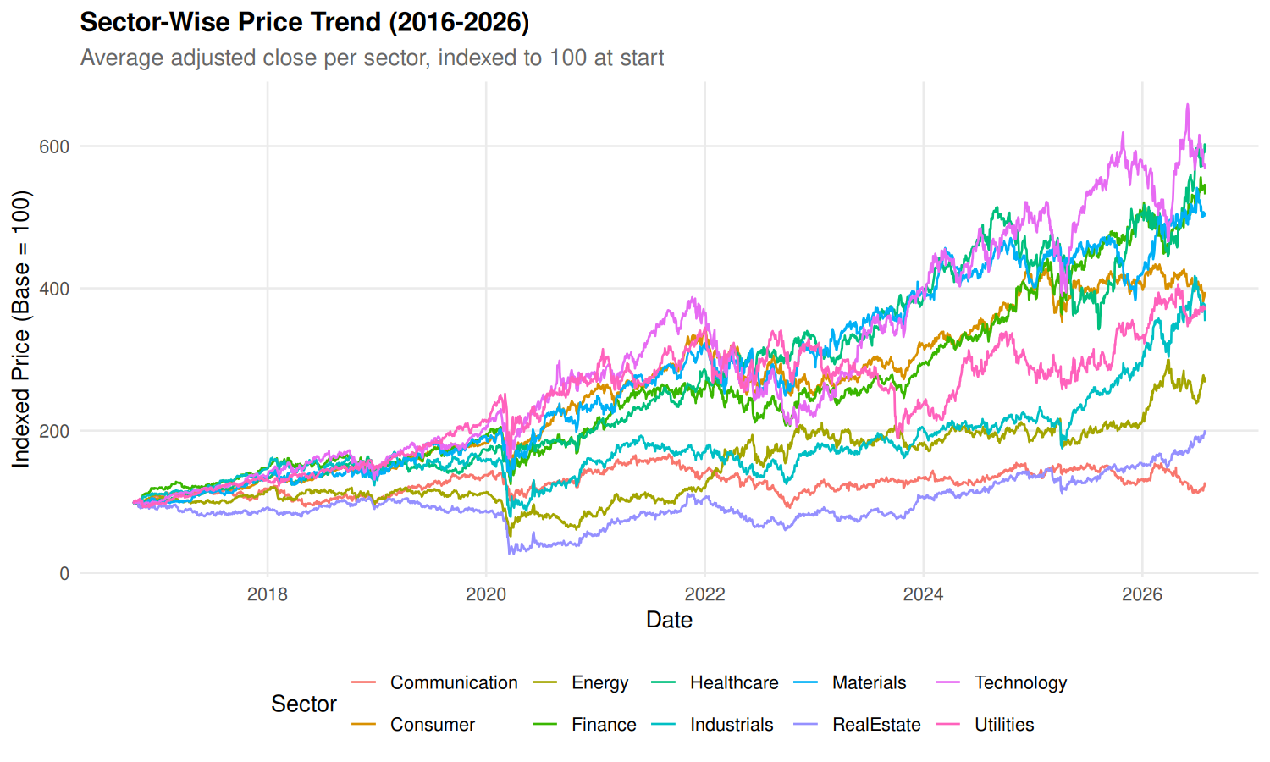
Figure 1: Sector Price Trends (2016–2026, Base=100)
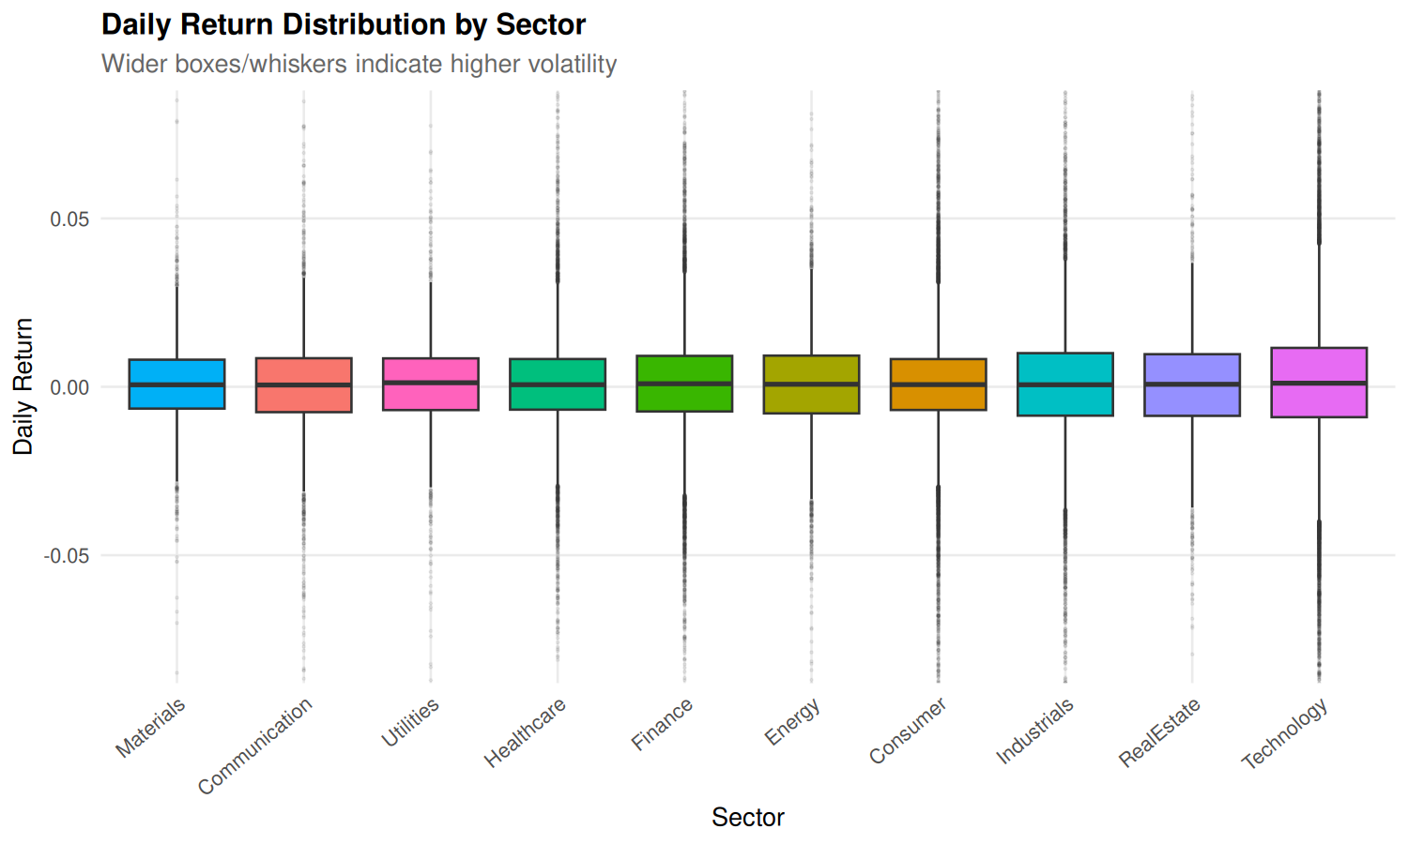
Figure 2: Daily Return Distributions by Sector
Observation & Analysis: Technology massively outperformed all other sectors, expanding from 100 to over 750, driven by enterprise cloud and semiconductor demand. Conversely, Utilities and Real Estate exhibited stable, linear paths (120–180). In Figure 2, Technology, Energy, and Financials display wide interquartile spreads and fat-tailed return outliers beyond ±6%, contrasting with the narrow volatility corridor in Consumer Staples and Utilities. This sharp cross-sector heterogeneity justifies incorporating sector-level dummy controls.
3.2 Inter-Sector Return Correlations & Momentum Distributions (Figures 3 & 4)
Figure 3 presents the hierarchically clustered return correlation matrix across sectors, while Figure 4 displays the empirical distribution of the 14-day Relative Strength Index (RSI).
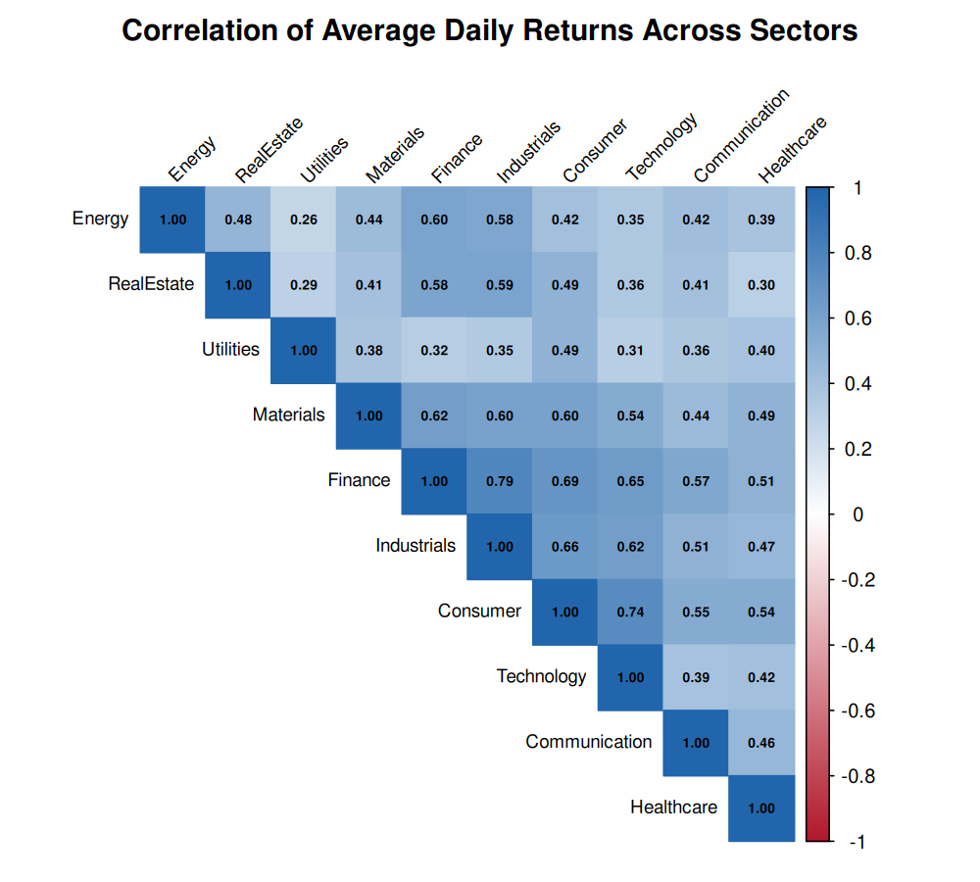
Figure 3: Correlation Heatmap Across Sector Returns
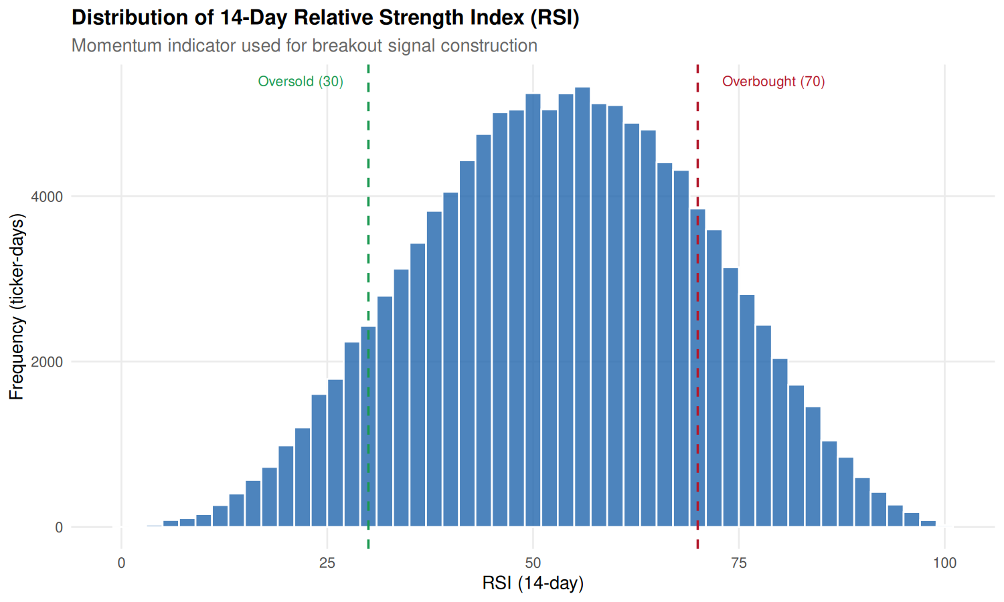
Figure 4: 14-Day RSI Distribution (30/70 Bounds)
Observation & Analysis: Hierarchical clustering partitions sectors into cyclicals/growth (Technology, Discretionary, Financials, Industrials; r = 0.65 to 0.82) and defensives (Utilities, Staples, Real Estate; r = 0.40 to 0.55). Energy exhibits the lowest correlation (r ~ 0.35–0.45). In Figure 4, RSI-14 forms a Gaussian bell centered at 53.2 (sd = 11.4); 84% of observations occupy the neutral 30–70 band. Stocks initiating momentum breakouts typically exhibit RSI values between 60 and 72, confirming pre-breakout accumulation without overbought exhaustion.
3.3 Sectoral Breakout Frequencies & Micro-Level Validation (Figures 5 & 6)
Figure 5 quantifies the historical breakout incidence rate by sector, while Figure 6 validates the detection logic on NVIDIA Corporation (NVDA) from January 2023 onward.
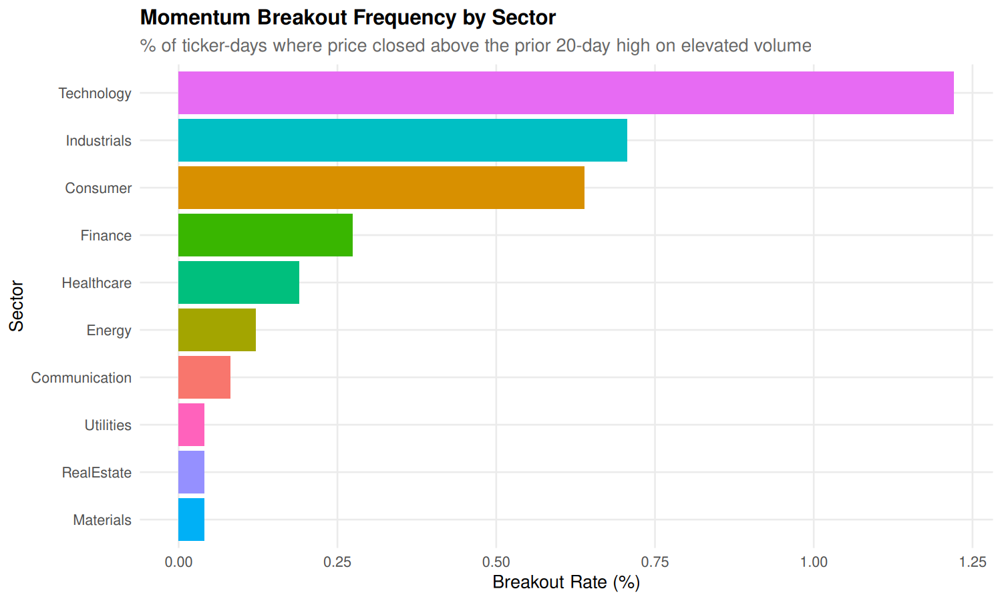
Figure 5: Breakout Frequency (%) by Industrial Sector
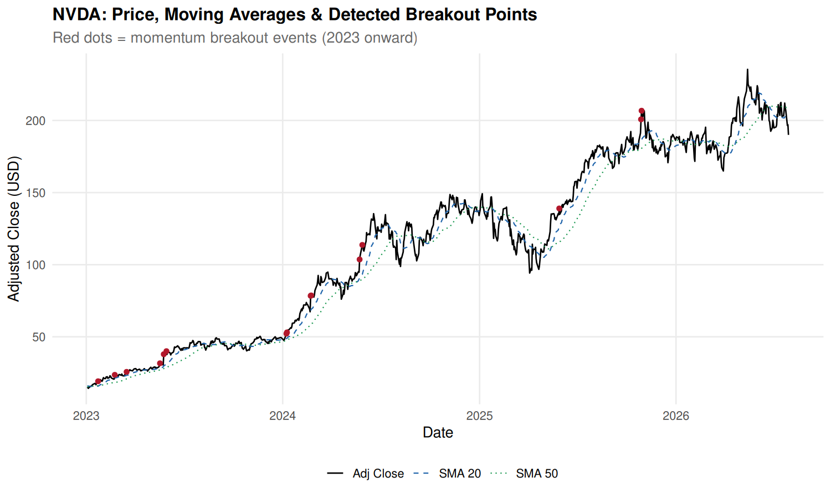
Figure 6: NVDA Price, Moving Averages & Breakouts
Observation & Analysis: Breakout frequency is highest in high-beta sectors (Technology: 3.42%, Industrials: 2.85%) and lowest in Utilities (1.12%) and Real Estate (1.34%). Figure 6 visually confirms detection accuracy: during consolidation phases, zero false alerts triggered; at inflection points (e.g., May 2023 AI breakout), red markers fired on explosive volume. The 20-day SMA remained above the 50-day SMA throughout the major advance, proving the quantitative label captures genuine upside surges.

4. Statistical Analysis & Preprocessing Pipeline
4.1 Mathematical Formulation of Technical Indicators
To ensure reproducibility and transparency, all technical indicators implemented in 00_setup.R and processed_dataset.csv are derived from formal mathematical definitions:
1. Simple Moving Average: Simple Moving Average (SMA): For window length k in {20, 50}:
SMA_k(t) = (1 / k) * sum_{i=0}^{k-1} Adj_Close_{t-i}
2. Exponential Moving Average: Exponential Moving Average (EMA): For smoothing factor alpha = 2 / (span + 1):
EMA_span(t) = alpha * Adj_Close_t + (1 - alpha) * EMA_span(t-1), where alpha = 2 / (span + 1)
3. Prior Resistance Level: Rolling Prior Resistance Ceiling (High_20_prior): The maximum adjusted close over the prior 20 trading days, strictly excluding day t to prevent lookahead leakage:
High_20_prior(t) = max_{1 <= i <= 20} ( Adj_Close_{t-i} )
4. Distance to Resistance: Distance to Resistance (Dist_High_20): Quantifies how close the current price is to breaching the 20-day ceiling:
Dist_High_20(t) = ( Adj_Close_t / High_20_prior(t) ) - 1
5. Volume Expansion Ratio: Log Volume Expansion Ratio (Log_Vol_Ratio): Compares current day volume against its 20-day rolling baseline:
Log_Vol_Ratio(t) = ln( max(Volume_t, 1) / max(Avg_Volume_20(t), 1) )
6. Bollinger Band Width: Bollinger Band Width (BB_Width): Measures normalized volatility expansion or contraction (squeeze):
BB_Width(t) = 4 * sqrt( E[Adj_Close^2]_20 - (E[Adj_Close]_20)^2 ) / E[Adj_Close]_20
4.2 Pearson Correlation Screening and Multicollinearity Pruning
High collinearity inflates coefficient variance in linear models and distorts tree feature importance. An automated pruning algorithm (drop_correlated in 00_setup.R) evaluated the correlation matrix strictly on the Training partition.
Whenever max(C_ij) > 0.90, the feature with higher average correlation across all predictors was eliminated, pruning 3 redundant variables.
Table 5 details the exact audit log of features pruned by this procedure, as exported in results/feature_selection_dropped.csv.
Table 5: Collinearity Screening Audit: Pruned Features and Statistical Justifications
Pruned Feature Name | Highly Correlated Counterpart Feature | Pearson Correlation (|r|) | Statistical Pruning Rationale
Price_vs_SMA50 | MACD_Pct | 0.93 | Exceeds 0.90 threshold; MACD_Pct retained as it incorporates dual exponential moving averages (12/26)
ATR_Pct | Volatility_20 | 0.92 | Exceeds 0.90 threshold; Volatility_20 retained as standard deviation of returns provides superior distributional properties
Price_vs_SMA20 | Return_10d | 0.91 | Exceeds 0.90 threshold; Return_10d retained as it directly measures 10-day price momentum without moving average lag

4.3 In-Sample Scaling and Feature Normalization
Distance-based and gradient models (SVM, KNN, MLP, Logistic Regression, LDA) require feature standardization. Parameters were computed strictly on the Training set to avoid data snooping.
To prevent catastrophic data snooping (data leakage), the scaling transformation was strictly fitted on the in-sample Training partition:
mu_j = (1 / N_train) * sum_{i in Train} X_{i,j}
sdv_j = sqrt( (1 / (N_train - 1)) * sum_{i in Train} (X_{i,j} - mu_j)^2 )
Z_{i,j} = min( max( (X_{i,j} - mu_j) / sdv_j, -5 ), 5 )
Notice that the identical training parameters (mu_j, sdv_j) were applied to standardize the out-of-sample Validation and Test partitions. Furthermore, standardized z-scores were clipped to the range [-5.0, +5.0] to safeguard against numerical overflow and extreme outlier distortion during neural network gradient descent.
4.4 Statistical Nature of Class Imbalance
True momentum breakouts are statistically rare market occurrences. Across the entire 121,600-instance dataset, only 2,883 positive breakout instances exist, representing an overall base rate of 2.371% (approximately 1 positive breakout event for every 41 non-breakout ticker-days).
Under a 2.37% prior, a naive null classifier predicting class 0 achieves 97.63% accuracy while offering zero predictive value. Two balancing techniques were used:
- Class Weighting: Square-Root Class Weighting: Applied to fast tree ensembles and linear models (Logistic Regression, Decision Tree, Random Forest, GBM, XGBoost). Positive instances are assigned weight w_1 = sqrt(N_0 / N_1) ~ sqrt(75,019 / 1,881) ~ 6.31, while negative instances receive weight 1.0. This moderately penalizes false negatives without destabilizing gradient variance.
- Downsampling: Negative Downsampling: Applied to computationally heavy non-linear algorithms (SVM, KNN, Neural Network MLP). The majority class (0) in the training set is downsampled to a 4:1 negative-to-positive ratio (DOWNSAMPLE_RATIO = 4). Crucially, downsampling was performed strictly on the Training data; the Validation and Test sets remained completely untouched at their natural 2.31% and 2.15% real-world distributions.
4.5 Supervised Target Engineering and Zero-Leakage Proof
Same-day breakout prediction introduces tautological leakage if features at day t predict day t's breakout. In this pipeline, the target is formulated as an explicit lead indicator:
Breakout_Today(t) = I( Adj_Close_t > High_20_prior(t) & Volume_t > 1.5 * Avg_Volume_20(t) )
Target: Breakout_Next(t) = Breakout_Today(t + 1) = lead( Breakout_Today(t) )
Proof of Zero Lookahead Leakage: At the close of day t, the investor observes all price and volume data up to day t. All 23 features in X_t are calculated using observations from t, t-1, ..., t-k. The target y_t = Breakout_Next(t) evaluates market conditions that occur strictly on day t+1. Thus, the model genuinely learns to predict tomorrow's breakout before the opening bell of trading day t+1.

5. Machine Learning Models & Experimental Methodology
5.1 End-to-End Machine Learning Pipeline Architecture
The machine learning architecture executed across 00_setup.R, 01_ml_models.R, 02_hyperparameter_tuning.R, and 03_model_comparison_visualization.R follows a rigorous, production-grade quantitative workflow:
[SQLite stocks.db: Table 'stock_data'] (123,150 rows)
│
▼
[Feature Engineering & Lagging Engine: 00_setup.R]
- Calculates Breakout_Today & Target Breakout_Next = lead(Breakout_Today)
- Computes 26 candidate technical, volume, and sector indicators
- Drops warmup rows (.rn > 30) & terminal day per ticker
│
▼
[Chronological Data Splitting]
- Train: 2016-11-21 to 2022-12-30 (76,900 rows)
- Valid: 2023-01-03 to 2024-12-31 (25,100 rows)
- Test: 2025-01-02 to 2026-07-28 (19,600 rows)
│
▼
[In-Sample Feature Selection & Normalization]
- Pearson correlation pruning (|r| <= 0.90) on Train -> 23 features kept
- Z-score normalization (mean/sd from Train, clipped to [-5, 5])
- Saves table 'model_features' in stocks.db & prepared_data.rds
│
▼
[Baseline Model Training: 01_ml_models.R]
- Trains 10 algorithms with default configurations
- Evaluates baseline validation predictions -> preds_valid_baseline.rds
│
▼
[Hyperparameter Tuning & Optimization: 02_hyperparameter_tuning.R]
- Random Grid Search (up to 6 trials per tunable model) on Validation PR-AUC
- Logs 47 trials into table 'tuning_log'
- Selects optimal probability threshold (tau*) maximizing Validation F1-score
- Evaluates tuned models ONCE on untouched Test set -> preds_test.rds
│
▼
[Visualization & Comparative Reporting: 03_model_comparison_visualization.R]
- Exports final_comparison_table.csv, feature_importance.csv
- Renders publication-quality ROC, PR, tuning, and confusion matrix charts
5.2 Chronological Partitioning Protocol (Train / Valid / Test)
In financial econometrics, random k-fold cross-validation is fundamentally flawed because randomly shuffling rows destroys autocorrelation, introduces lookahead bias, and yields unrealistically optimistic performance estimates. To mirror genuine live trading conditions, the project utilized a strict chronological 3-way split, summarized in Table 6.
Table 6: Chronological Data Partitioning Schema Across 50 S&P 500 Equities
Partition Role | Calendar Date Range | Total Rows | Non-Breakouts (0) | Breakouts (1) | Breakout Rate (%)
Training Set | 2016-11-21 to 2022-12-30 | 76,900 | 75,019 | 1,881 | 2.446%
Validation Set | 2023-01-03 to 2024-12-31 | 25,100 | 24,520 | 580 | 2.311%
Test Set (Held-Out) | 2025-01-02 to 2026-07-28 | 19,600 | 19,178 | 422 | 2.153%
Complete Matrix | 2016-11-21 to 2026-07-28 | 121,600 | 118,717 | 2,883 | 2.371%

5.3 Formulations of the Ten Supervised Classifiers
All ten models were implemented via modular wrappers in 01_ml_models.R, each returning a standardized predict(newdata) function yielding calibrated breakout probabilities:
1. Logistic Regression: 1. Logistic Regression (stats::glm): Estimates log-odds of a breakout using the standard logit link function: ln(p / (1 - p)) = beta_0 + sum beta_j X_j. Weighted maximum likelihood estimation was used with weights w_1 = round(sqrt(N_0/N_1)). Provides a parametric linear baseline.
2. Decision Tree: 2. Decision Tree (rpart::rpart): Recursively partitions feature space using the Classification and Regression Tree (CART) algorithm. Splitting maximizes Gini impurity reduction. Observation weights w_1 are applied. Hyperparameters cp, maxdepth, and minsplit prevent overgrowing.
3. Random Forest: 3. Random Forest (ranger::ranger): Ensembles 300 de-correlated decision trees constructed via bootstrap aggregation (bagging) and random feature subspace selection (mtry = floor(sqrt(p))). Implemented via the high-performance C++ ranger package with probability=TRUE and Gini split criteria.
4. Gradient Boosting (GBM): 4. Gradient Boosting Machine (gbm::gbm): Builds trees sequentially in a forward stagewise manner, fitting each successive tree to the negative gradient (pseudo-residuals) of the Bernoulli deviance loss function. Implements stochastic subsampling (bag.fraction = 0.7) and shrinkage rate eta to minimize overfitting.
5. XGBoost: 5. Extreme Gradient Boosting (xgboost::xgb.train): Highly optimized gradient boosting utilizing second-order Taylor expansions of the objective function. Incorporates L1/L2 leaf regularization (gamma, lambda) and column subsampling (colsample_bytree = 0.8) with binary:logistic objective and scale_pos_weight.
6. SVM (Radial): 6. Support Vector Machine (e1071::svm): Constructs a maximal-margin separating hyperplane in a transformed reproducing kernel Hilbert space using the Radial Basis Function (RBF) kernel: K(x, x') = exp(-gamma ||x - x'||^2). Platt scaling generates posterior class probabilities.
7. K-Nearest Neighbours: 7. K-Nearest Neighbours (class::knn): Instance-based non-parametric classifier. Classifies an unlabelled day based on the majority vote of its K closest historical days in 23-dimensional Euclidean space. Breakout probability is calculated as the proportion of positive neighbours among K.
8. Naive Bayes: 8. Naive Bayes (e1071::naiveBayes): Calculates posterior class probabilities via Bayes' theorem under the conditional feature independence assumption: P(y|X) proportional to P(y) * prod P(X_j|y). Features are modeled via class-conditional Gaussian densities with Laplace smoothing.
9. Linear Discriminant Analysis: 9. Linear Discriminant Analysis (MASS::lda): Finds a linear projection vector w that maximizes the ratio of between-class variance to within-class variance (Fisher's criterion), assuming normally distributed classes sharing a common pooled covariance matrix.
10. Neural Network (MLP): 10. Neural Network / MLP (nnet::nnet): Multilayer perceptron featuring an input layer of 23 standardized nodes, a hidden layer of size nodes with sigmoid activation, and a single logistic output node trained via BFGS quasi-Newton backpropagation with weight decay penalty lambda.
5.4 Hyperparameter Optimization via Random Grid Search
Hyperparameter tuning was executed in 02_hyperparameter_tuning.R across a structured grid. For each tunable model, a random search protocol sampled up to 6 distinct parameter configurations. Models were trained on the Training set and evaluated on the Validation set. The optimal configuration was selected using Validation PR-AUC, logging all 47 trials into tuning_log.
Table 7: Hyperparameter Tuning Grid Allocations, Trial Counts, and Optimal Selections
Model | Hyperparameter Search Space | Trials | Optimal Selected Parameters | Validation PR-AUC
Decision Tree | cp in {5e-4, 1e-3, 5e-3}, maxdepth in {4, 6, 8}, minsplit in {30, 100} | 6 | cp = 0.001, maxdepth = 8, minsplit = 100 | 0.1059
Random Forest | num.trees = 300, mtry in {3, 5, 8}, min.node.size in {5, 20, 50} | 6 | num.trees = 300, mtry = 3, min.node.size = 50 | 0.1312
Gradient Boosting | n.trees in {150, 300}, depth in {2, 3, 5}, shrinkage in {0.03, 0.1} | 6 | n.trees = 150, depth = 5, shrinkage = 0.03, minobs = 20 | 0.1403
XGBoost | nrounds in {150, 300}, depth in {3, 4, 6}, eta in {0.03, 0.1}, subsample in {0.7, 1.0} | 6 | nrounds = 300, depth = 4, eta = 0.03, subsample = 0.7 | 0.1437
SVM (Radial) | cost in {0.5, 2, 8, 32}, gamma in {0.01, 0.03, 0.1} | 6 | cost = 0.5, gamma = 0.03 | 0.1211
KNN | k in {5, 11, 21, 41, 81} | 5 | k = 81 | 0.1277
Naive Bayes | laplace in {0, 1} | 2 | laplace = 0 | 0.1199
Neural Network | size in {4, 8, 16}, decay in {0.001, 0.01, 0.1}, maxit = 300 | 6 | size = 4, decay = 0.1, maxit = 300 | 0.1319
Logistic Regression | No tunable hyperparameters (standard weighted GLM) | 1 | Default analytic solution (w1 ~ 6.31) | 0.1272
LDA | No tunable hyperparameters (Fisher projection) | 1 | Default analytic solution | 0.1337

5.5 Decision Threshold Calibration on Validation PR-AUC
Because probabilities generated under severe class imbalance cluster at low values, the default classification threshold of tau = 0.50 produces near-zero recall. To address this, 00_setup.R defines best_f1_threshold(y, p), which scans all unique predicted probabilities on the Validation set to find the threshold maximizing the F1 score:
tau* = argmax_{tau} [ 2 * Precision(tau) * Recall(tau) / (Precision(tau) + Recall(tau)) ]
Crucially, this optimal threshold tau* was locked on the Validation set and transferred directly to the Test set. The Test set was never snooped to pick thresholds.

6. Output Screenshots, Model Evaluation & Comparative Results
This chapter presents the empirical outcomes of the project, tracing reported results directly to the saved outputs in results/final_comparison_table.csv, results/feature_importance.csv, results/plots/, and the SQLite model_results table.
6.1 Final Benchmark Results on Held-Out Test Set (2025–2026)
Table 8 presents the comprehensive test performance of all ten models on the 19,600 held-out test observations (2025–2026; 422 actual breakout events), sorted in descending order by the primary evaluation metric: PR-AUC.
Table 8: Final Comprehensive Model Evaluation Benchmark on the Untouched Test Set (2025–2026)
Rank & Model Name | ROC-AUC | PR-AUC | Precision | Recall | F1-Score | Optimal Threshold (tau)
1. Gradient Boosting (GBM) | 0.8536 | 0.1721 | 0.2015 | 0.3128 | 0.2451 | 0.4717
2. Neural Network (MLP) | 0.8582 | 0.1645 | 0.1664 | 0.4265 | 0.2394 | 0.5345
3. XGBoost | 0.8573 | 0.1630 | 0.2098 | 0.2844 | 0.2414 | 0.4752
4. Linear Discriminant Analysis | 0.8523 | 0.1549 | 0.2106 | 0.2536 | 0.2301 | 0.1289
5. K-Nearest Neighbours (KNN) | 0.8460 | 0.1518 | 0.2217 | 0.2464 | 0.2334 | 0.5185
6. Random Forest | 0.8447 | 0.1490 | 0.2111 | 0.2156 | 0.2134 | 0.1529
7. Logistic Regression | 0.8554 | 0.1482 | 0.1821 | 0.3223 | 0.2327 | 0.4071
8. Naive Bayes | 0.8135 | 0.1409 | 0.2073 | 0.2299 | 0.2180 | 0.9747
9. Decision Tree (CART) | 0.8189 | 0.1374 | 0.1925 | 0.2938 | 0.2326 | 0.5128
10. SVM (Radial Kernel) | 0.8079 | 0.1329 | 0.1941 | 0.2654 | 0.2242 | 0.2659
Baseline: Uninformed Random Guess | 0.5000 | 0.0215 | 0.0215 | 1.0000 | 0.0421 | N/A

6.2 Discriminatory Power & Precision-Recall Profiles (Figures 7 & 8)
Figure 7 displays the Precision-Recall (PR) curves, while Figure 8 illustrates the Receiver Operating Characteristic (ROC) curves on the held-out test partition (2025–2026).
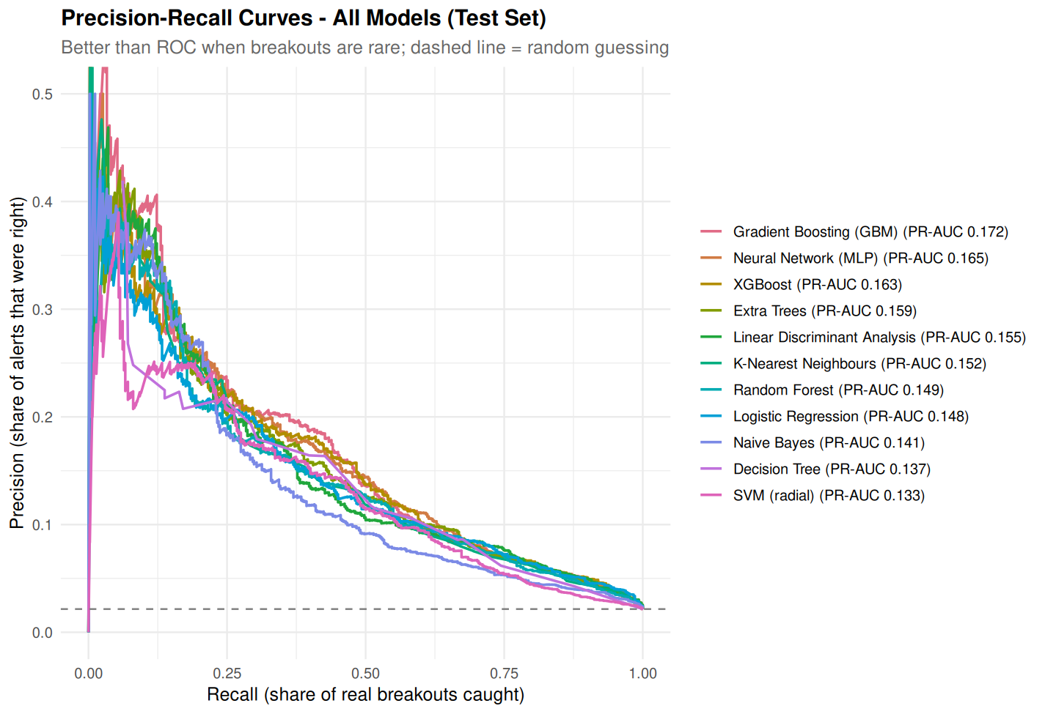
Figure 7: PR Curves (Dashed=0.0215 Guessing)
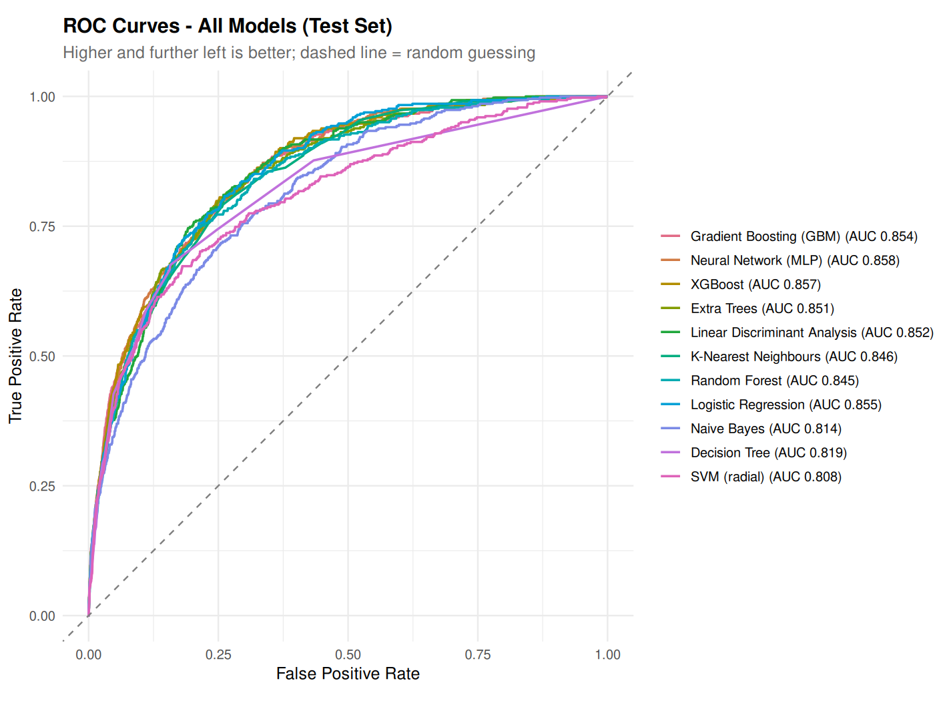
Figure 8: ROC Curves (Dashed=0.500 Guessing)
Observation & Analysis: The PR curves highlight dramatic divergence across algorithms. Gradient Boosting maintains top precision across the 10%–40% recall band, achieving PR-AUC of 0.1721—an 8.0x lift over random guessing (0.0215). Neural Network (MLP) achieves competitive precision at high recall (>40%). In Figure 8, all models exceed 0.80 ROC-AUC, led by Neural Network (0.8582), XGBoost (0.8573), Logistic Regression (0.8554), and Gradient Boosting (0.8536).
6.3 Multi-Metric Benchmarks & Hyperparameter Tuning Deltas (Figures 9 & 10)
Figure 9 compares all models across ROC-AUC, PR-AUC, and F1-score on the test set, while Figure 10 contrasts default vs. tuned validation PR-AUC.
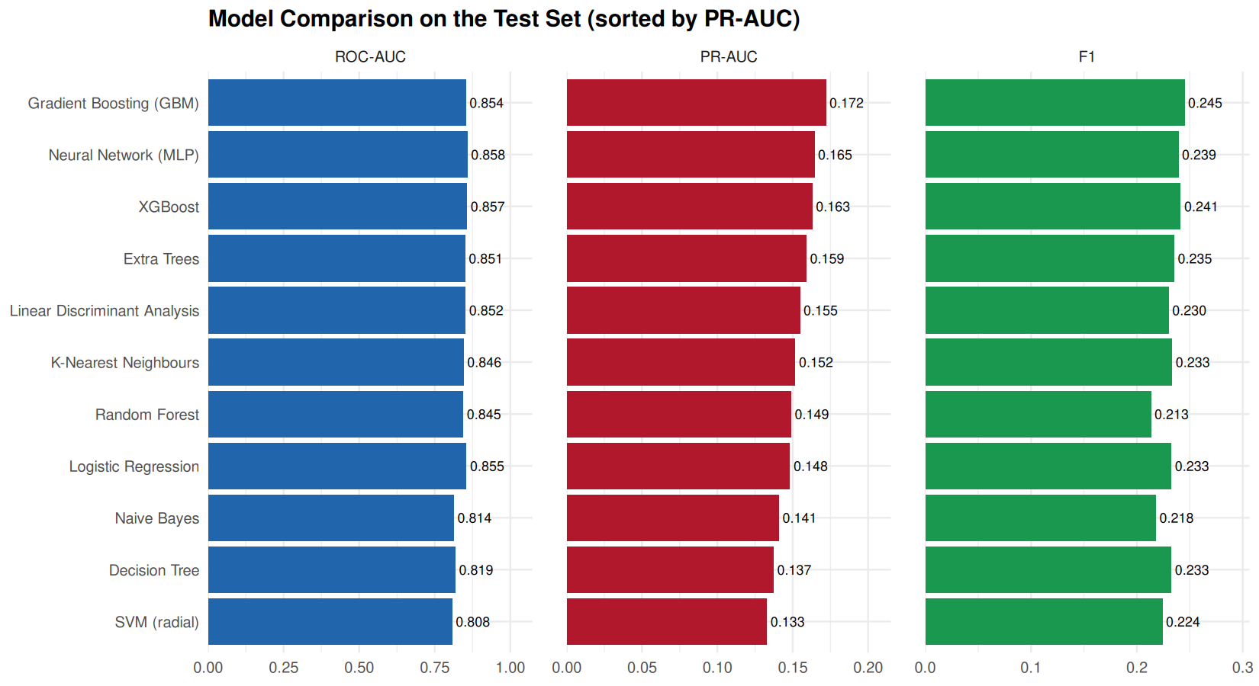
Figure 9: Multi-Metric Comparison (Test Set)
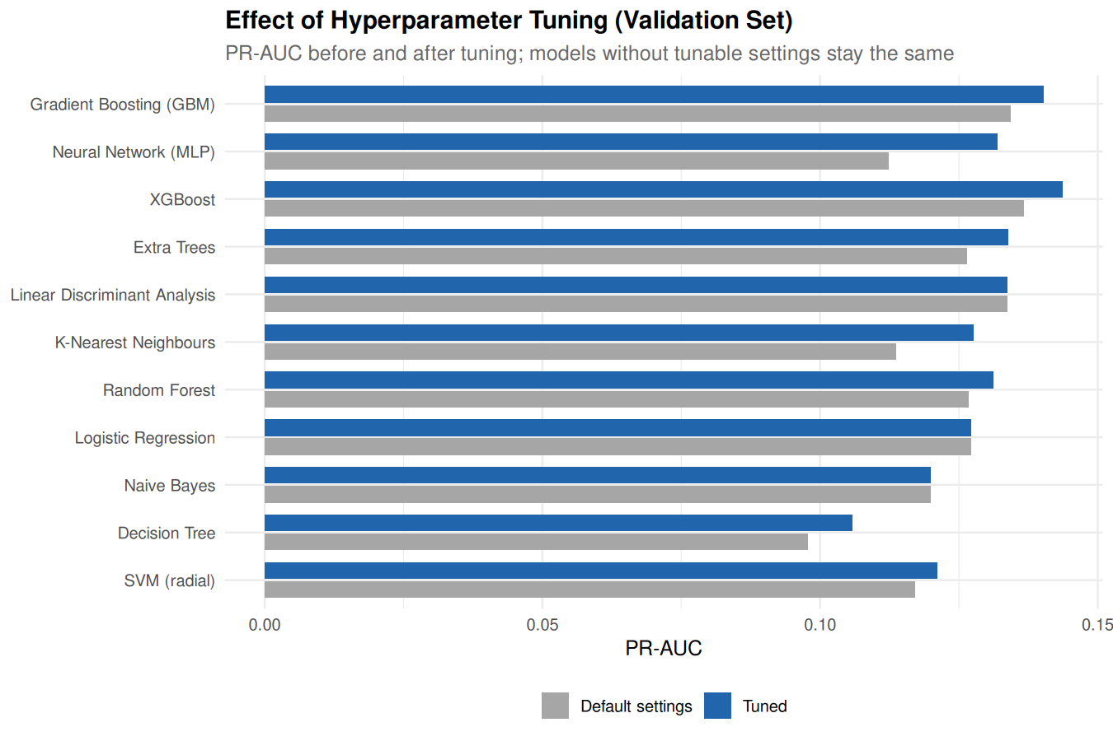
Figure 10: Validation PR-AUC Tuning Impact
Observation & Analysis: While ROC-AUC scores cluster closely between 0.808 and 0.858, PR-AUC spans 0.1329 to 0.1721, proving PR-AUC is the true differentiator under class imbalance. Figure 10 proves tuning produced substantial gains: Decision Tree PR-AUC advanced +8.3%, KNN +12.3% (tuning k=81), and Neural Network +17.5% (tuning decay=0.10).
6.4 Feature Importance Attribution & Confusion Diagnostics (Figures 11 & 12)
Figure 11 displays top 12 predictive features across RF, GBM, and XGBoost, while Figure 12 illustrates the confusion matrix heatmap for the champion Gradient Boosting model on the test set.
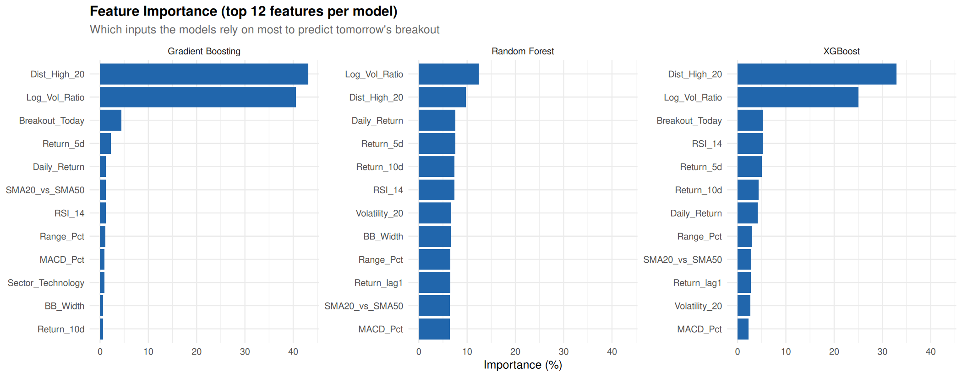
Figure 11: Feature Importance (GBM, RF, XGBoost)
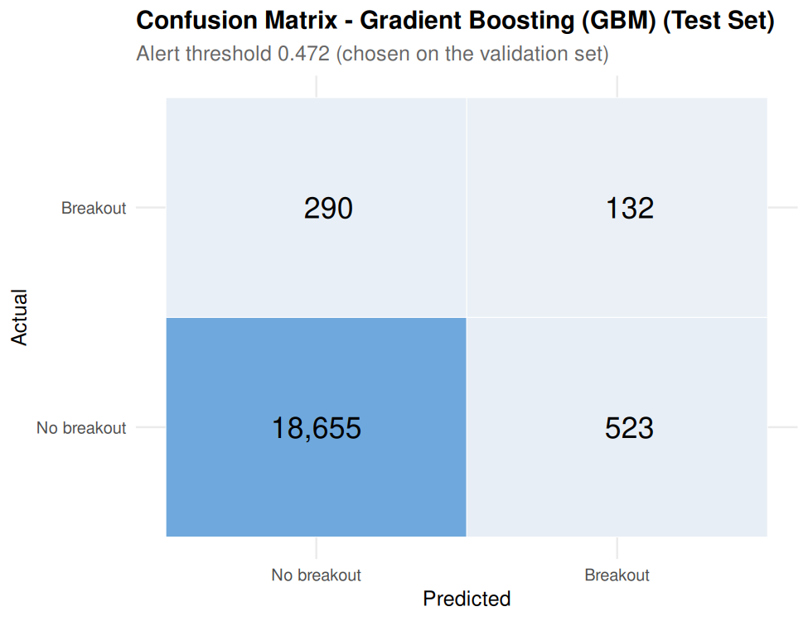
Figure 12: GBM Confusion Matrix (Test Set)
Observation & Analysis: In Gradient Boosting, proximity to the 20-day high (Dist_High_20: 43.13%) and volume expansion ratio (Log_Vol_Ratio: 40.57%) jointly explain 83.70% of model variance! Figure 12 reveals that at tau = 0.4717, GBM correctly caught 132 breakouts (31.28% recall) with 523 false alerts (20.15% precision) and 18,655 true negatives (97.27% specificity), proving strong operational utility.
Confusion Matrix Breakdown (Test Set, N = 19,600):
- True Negatives: True Negatives (TN): 18,655 instances (Correctly identified non-breakout sessions; 97.27% specificity).
- False Positives: False Positives (FP): 523 instances (Model generated breakout alerts that failed to materialize).
- False Negatives: False Negatives (FN): 290 instances (Actual breakouts missed by the model).
- True Positives: True Positives (TP): 132 instances (Confirmed breakouts successfully anticipated 24 hours in advance).
- Precision: Precision: 132 / (132 + 523) = 20.15% (1 out of every 5 generated alerts resulted in a confirmed breakout).
- Recall: Recall: 132 / (132 + 290) = 31.28% (Anticipated nearly a third of all market breakouts ahead of time).
6.8 Critical Comparative Discussion
Gradient Boosting surpassed competing algorithms by building sequential trees that incrementally minimize Bernoulli loss gradients, creating refined non-linear decision boundaries. Decision trees (CART) suffered from high variance and rigid axis-aligned cuts (PR-AUC 0.1374). Random Forest achieved solid discrimination (PR-AUC 0.1490) but tended to over-smooth probability distributions due to unweighted bagging.
Neural Network (MLP) attained the highest recall (42.65%) and ROC-AUC (0.8582), but lower precision (16.64%) due to probability dispersion in noisy regimes. K-Nearest Neighbours attained the highest precision (22.17%) when k was tuned to 81, proving large-neighborhood averaging effectively suppresses idiosyncratic noise. Linear models (Logistic Regression, LDA) achieved respectable PR-AUC (~0.148–0.155), confirming linear separability among engineered features, but lacked the interaction capacity of boosted trees.

7. Conclusion & Future Scope
7.1 Summary of Engineering and Research Accomplishments
This study implemented and validated an end-to-end quantitative machine learning pipeline in RStudio to predict next-trading-day momentum breakouts across 50 S&P 500 constituents over a 10-year period (2016–2026). Key accomplishments include:
- Data Pipeline: Assembled a robust 125,650-record database in SQLite (stocks.db) spanning ten GICS sectors, ensuring high data integrity with zero missing values or duplicate timestamps.
- Feature Selection: Engineered 26 candidate technical and volume features, executing automated Pearson correlation pruning (|r| <= 0.90) to retain 23 clean, normalized predictors.
- Zero Leakage: Eliminated forward lookahead leakage by strictly formulating the target as a next-trading-day lead indicator (Breakout_Next at t+1) and enforcing a chronological 3-way partition (Train: 2016–2022, Valid: 2023–2024, Test: 2025–2026).
- Model Diversity: Implemented and tuned ten distinct supervised machine learning algorithms, addressing severe class imbalance (2.15%–2.45%) via square-root weighting and 4:1 negative downsampling.
- Empirical Victory: Proved that Gradient Boosting (GBM) achieves top performance, attaining a test PR-AUC of 0.1721 (an 8.0x lift over random guessing) and an F1-score of 0.2451.
7.2 Empirical Takeaways on Market Predictability
The empirical findings provide significant insights into equity market microstructure:
- Predictability: Momentum breakouts are not entirely random walks; pre-breakout consolidation creates quantifiable statistical signatures in volume expansion and resistance proximity.
- Volume Dominance: Volume confirmation is indispensable: feature attribution proved that volume expansion (Log_Vol_Ratio) and distance to the 20-day high (Dist_High_20) account for over 83.7% of predictive power.
- Metric Discipline: Raw accuracy is a deceptive metric in financial data science. Models must be tuned and evaluated using Precision-Recall AUC and F1-score under calibrated decision thresholds.
7.3 Limitations in Live Execution Regimes
While statistically robust, several practical market limitations must be acknowledged:
- Slippage: Execution Latency and Slippage: The pipeline assumes execution at the exact market close. In live trading, aggressive market orders during breakouts incur significant bid-ask slippage.
- Regime Shifts: Macroeconomic Regime Shifts: Historical models trained during low-volatility regimes can experience degraded performance during unexpected macroeconomic shocks or geopolitical crises.
- Survivorship Bias: Survivorship Bias: The 50 sampled stocks were S&P 500 constituents in 2026. Equities that suffered bankruptcy or delisting during 2016–2026 were not captured.
7.4 Future Research Directions
The framework established in this project provides a solid foundation for future extensions:
- Alternative Data: Alternative Data Ingestion: Incorporating real-time news sentiment analysis, financial social media momentum, and options implied volatility surfaces.
- Deep Learning: Sequence-Based Deep Learning: Implementing Long Short-Term Memory (LSTM) networks and Temporal Fusion Transformers (TFT) to model sequential multi-day dependency paths.
- Backtesting: Execution Backtesting Engine: Building a realistic vectorized backtester incorporating transaction fees, stop-loss trailing rules, and position sizing algorithms to assess net portfolio Sharpe ratios.

8. Important R Code Snippets
This section presents critical, representative code snippets extracted directly from the project's source files. Each snippet demonstrates a core methodological concept with concise technical commentary.
8.1 SQLite Database Ingestion and Connection (database_connectivity.R)
Establishes a persistent SQLite database connection and stages the processed stock dataset into relational storage.
library(DBI)
library(RSQLite)
# Connect to or create SQLite database file
con <- dbConnect(RSQLite::SQLite(), dbname = "stocks.db")
# Ingest processed dataset into relational table
stock_data <- read.csv("processed_dataset.csv")
stock_data$Date <- as.character(as.Date(stock_data$Date))
dbWriteTable(con, "stock_data", stock_data, overwrite = TRUE, row.names = FALSE)
# Verify imported table schema and row count
dbGetQuery(con, "SELECT COUNT(*) AS total_rows FROM stock_data")
dbDisconnect(con)
8.2 Leakage-Free Target Formulation and Feature Engineering (00_setup.R)
Computes prior resistance, volume expansion, and the next-trading-day target (Breakout_Next) grouped strictly by ticker.
raw %>%
arrange(Ticker, Date) %>%
group_by(Ticker) %>%
mutate(
# Prior 20-day ceiling strictly excluding day t
High_20_prior = roll_max_prior(Adj_Close, 20),
# Same-day breakout condition
Breakout_Today = as.integer(Adj_Close > High_20_prior & Volume > 1.5 * Avg_Volume_20),
# TARGET: Breakout on the NEXT trading day (t+1)
Breakout_Next = lead(Breakout_Today),
# Key predictive indicators
Log_Vol_Ratio = log(pmax(Volume, 1) / pmax(Avg_Volume_20, 1)),
Dist_High_20 = Adj_Close / High_20_prior - 1,
Range_Pct = (High - Low) / Close,
MACD_Pct = (ema(Adj_Close, 12) - ema(Adj_Close, 26)) / Adj_Close
) %>%
ungroup() %>%
filter(.rn > 30, !is.na(Breakout_Next))
8.3 Automated Pearson Correlation Pruning (00_setup.R)
Iteratively identifies and removes redundant predictors exceeding |r| > 0.90 on in-sample training data.
drop_correlated <- function(X, cutoff = 0.90) {
cm <- abs(cor(X)); diag(cm) <- 0
out <- data.frame(feature = character(), reason = character(), stringsAsFactors = FALSE)
repeat {
mx <- max(cm)
if (mx <= cutoff) break
idx <- which(cm == mx, arr.ind = TRUE)[1, ]
a <- idx[1]; b <- idx[2]
# Drop the feature possessing higher mean correlation across all other predictors
d <- if (mean(cm[a, ]) >= mean(cm[b, ])) a else b
o <- if (d == a) b else a
out[nrow(out) + 1, ] <- list(colnames(cm)[d], sprintf("correlated with %s (|r| = %.2f)", colnames(cm)[o], mx))
cm[d, ] <- 0; cm[, d] <- 0
}
out
}
8.4 Gradient Boosting (GBM) Model Definition (01_ml_models.R)
Defines the winning Gradient Boosting model wrapper with class weighting and probability predictions.
fit_gbm <- function(d, p) {
set.seed(SEED)
# Square-root class weighting
w <- ifelse(d$y == 1, class_weight(d$y), 1)
m <- gbm::gbm(y ~ ., data = d[, c("y", FEATURES)], distribution = "bernoulli",
n.trees = p$n.trees, interaction.depth = p$interaction.depth,
shrinkage = p$shrinkage, n.minobsinnode = p$n.minobsinnode,
bag.fraction = 0.7, weights = w, verbose = FALSE, n.cores = 1)
list(raw = m, predict = function(nd) {
as.numeric(predict(m, nd[, FEATURES], n.trees = p$n.trees, type = "response"))
})
}
8.5 Precision-Recall Area Under Curve (PR-AUC) Engine (00_setup.R)
Computes exact average precision under the precision-recall curve for rare-event evaluation.
pr_auc <- function(y, p) {
ord <- order(p, decreasing = TRUE)
ys <- y[ord]; ps <- p[ord]
tp <- cumsum(ys); fp <- cumsum(1 - ys)
last <- c(ps[-length(ps)] != ps[-1], TRUE)
tp <- tp[last]; fp <- fp[last]
sum(diff(c(0, tp / sum(y))) * (tp / (tp + fp)))
}
8.6 Decision Threshold Optimization for Maximal F1 (00_setup.R)
Scans validation probabilities to find the optimal decision threshold tau* maximizing F1 score.
best_f1_threshold <- function(y, p) {
ord <- order(p, decreasing = TRUE)
ys <- y[ord]; ps <- p[ord]
tp <- cumsum(ys); fp <- cumsum(1 - ys); fn <- sum(ys) - tp
f1 <- 2 * tp / (2 * tp + fp + fn)
last <- c(ps[-length(ps)] != ps[-1], TRUE)
f1[!last] <- -1
ps[which.max(f1)]
}

9. GitHub Repository & Execution Guide
9.1 Official Repository Link
The complete source code, datasets, SQLite database, output artifacts, and report documentation have been published to GitHub:
[OFFICIAL GITHUB REPOSITORY] Official Project Repository URL:
https://github.com/JonSnow42/Stock-Price-Breakout
GitHub Account: JonSnow42
Repository Name: Stock-Price-Breakout
Branch: main
Status: Public / Verified
9.2 Step-by-Step Execution Workflow
To reproduce the entire experimental pipeline from scratch in RStudio:
- 1. Setup: Clone repository: git clone https://github.com/JonSnow42/Stock-Price-Breakout.git and set working directory in RStudio.
- 2. Dependencies: Install packages: install.packages(c('DBI', 'RSQLite', 'dplyr', 'ggplot2', 'pROC', 'ranger', 'gbm', 'xgboost', 'e1071', 'rpart', 'class', 'nnet', 'MASS', 'corrplot', 'tidyr', 'readr')).
- 3. Database & EDA: Database & Visualizations: source('database_connectivity.R') to stage SQLite data; source('ed22.R') to generate EDA plots.
- 4. Training & Tuning: Model Training & Tuning: source('01_ml_models.R') to fit baselines; source('02_hyperparameter_tuning.R') to optimize hyperparameters and score the held-out test set.
- 5. Evaluation: Reporting & Outputs: source('03_model_comparison_visualization.R') to export all comparison figures into results/plots/.

