温州大学瓯江学院
爬虫 实验报告
实验名称：
班 级： | 计算机三班 | 姓 名： | 潘以超 | 学 号： | 16219111325
实验地点： |  | 日 期：

一、实验目的：

二、实验环境：

三、实验内容和要求：

四、实验步骤：
（对实验步骤的说明应该能够保证根据该说明即可重复完整的实验内容，得到正确结果。）

五、实验结果与分析（含程序、数据记录及分析和实验总结等）：
豆瓣250：
爬虫代码：
import requests
import lxml
import csv
import pymysql
from lxml import etree

def get_page():
result = []
for a in range(0, 10):
url = 'https://movie.douban.com/top250?start=%s&filter=' % a*25
res = requests.get(url)
tree = etree.HTML(res.text)
top250 = tree.xpath('//span[@class="title"][1]/text()')
result += top250
return result
res = get_page()
print(res)

db = pymysql.connect("localhost", "root", "123456", "test")
cursor = db.cursor()
print(res)
sql = "INSERT INTO testmodel_test(movie_name) VALUES(%s)"
for a in res:
cursor.execute(sql, (a))
db.commit()
db.close()

数据库：
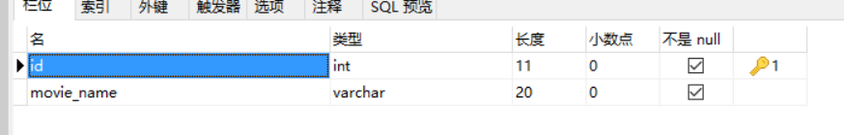
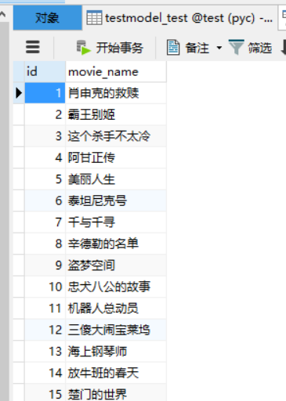
网站效果：
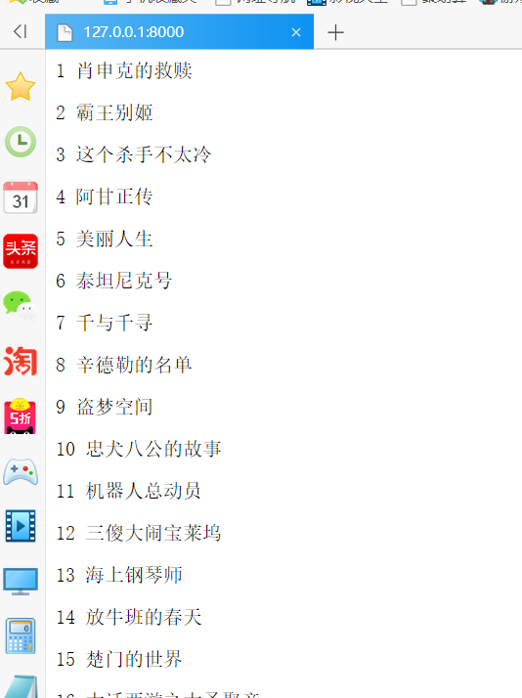
京东手机：
爬虫代码：
from selenium import webdriver
from selenium.webdriver.support.wait import WebDriverWait
from selenium.webdriver.support import expected_conditions as EC
from selenium.webdriver.common.by import By
import selenium.common.exceptions
import json
import csv
import time
import pymysql

class JdSpider():
def open_file(self):
self.fm = input('请输入文件保存格式（txt、json、csv）：')
while self.fm!='txt' and self.fm!='json' and self.fm!='csv':
self.fm = input('输入错误，请重新输入文件保存格式（txt、json、csv）：')
if self.fm=='txt' :
self.fd = open('E:\爬虫\Jd.txt','w',encoding='utf-8')
elif self.fm=='json' :
self.fd = open('E:\爬虫\Jd.json','w',encoding='utf-8')
elif self.fm=='csv' :
self.fd = open('E:\爬虫\Jd.csv','w',encoding='utf-8',newline='')

def open_browser(self):
self.browser = webdriver.Firefox()
self.browser.implicitly_wait(10)
self.wait = WebDriverWait(self.browser,10)

def init_variable(self):
self.data = zip()
self.isLast = False

def parse_page(self):
try:
skus = self.wait.until(EC.presence_of_all_elements_located((By.XPATH,
'//li[@class="gl-item"]')))
skus = [item.get_attribute('data-sku') for item in skus]
links = ['https://item.jd.com/{sku}.html'.format(sku=item) for item in skus]
prices = self.wait.until(EC.presence_of_all_elements_located((By.XPATH,
'//div[@class="gl-i-wrap"]/div[3]/strong/i')))
prices = [item.text for item in prices]
names = self.wait.until(EC.presence_of_all_elements_located((By.XPATH,
'//div[@class="gl-i-wrap"]/div[4]/a')))
names = [item.text for item in names]
comments = self.wait.until(EC.presence_of_all_elements_located((By.XPATH,
'//div[@class="gl-i-wrap"]/div[5]/strong')))
comments = [item.text for item in comments]
self.data = zip(links,prices,names,comments)
except selenium.common.exceptions.TimeoutException:
print('parse_page: TimeoutException')
self.parse_page()
except selenium.common.exceptions.StaleElementReferenceException:
print('parse_page: StaleElementReferenceException')
self.browser.refresh()

def turn_page(self):
try:
self.wait.until(EC.element_to_be_clickable((By.XPATH,'//a[@class="pn-next"]'))).click()
time.sleep(1)
self.browser.execute_script("window.scrollTo(0,document.body.scrollHeight)")
time.sleep(2)
except selenium.common.exceptions.NoSuchElementException:
self.isLast = True
except selenium.common.exceptions.TimeoutException:
print('turn_page: TimeoutException')
self.turn_page()
except selenium.common.exceptions.StaleElementReferenceException:
print('turn_page: StaleElementReferenceException')
self.browser.refresh()

def write_to_file(self):
if self.fm == 'txt':
for item in self.data:
self.fd.write('----------------------------------------\n')
self.fd.write('link：' + str(item[0]) + '\n')
self.fd.write('price：' + str(item[1]) + '\n')
self.fd.write('name：' + str(item[2]) + '\n')
self.fd.write('comment：' + str(item[3]) + '\n')
if self.fm == 'json':
temp = ('link','price','name','comment')
for item in self.data:
json.dump(dict(zip(temp,item)),self.fd,ensure_ascii=False)
if self.fm == 'csv':
writer = csv.writer(self.fd)
for item in self.data:
writer.writerow(item)

#def close_file(self):
#self.fd.close()

def close_browser(self):
self.browser.quit()

def crawl(self):
#self.open_file()
self.open_browser()
self.init_variable()
print('开始爬取')
self.browser.get('https://search.jd.com/Search?keyword=
%E6%89%8B%E6%9C%BA&enc=utf-8&pvid=ba6714c00a9a404a98475700b49df2f2')
time.sleep(1)
self.browser.execute_script("window.scrollTo(0,document.body.scrollHeight)")
time.sleep(2)
count = 0
while not count==5:
count += 1
print('正在爬取第 ' + str(count) + ' 页......')
self.parse_page()
#self.write_to_file()
self.write_to_mysql()
self.turn_page()
#self.close_file()
self.close_browser()
print('结束爬取')

def write_to_mysql(self):
db = pymysql.connect("localhost", "root", "123456", "test")
cursor = db.cursor()
sql = "INSERT INTO testmodel_jd(link,price,name,comment)VALUES(%s,%s,%s,%s)"
for item in self.data:
cursor.execute(sql, (item[0],item[1],item[2],item[3]))
db.commit()
db.close()

if __name__ == '__main__':
spider = JdSpider()
spider.crawl()

数据库：
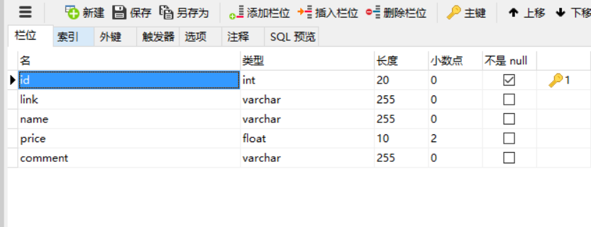
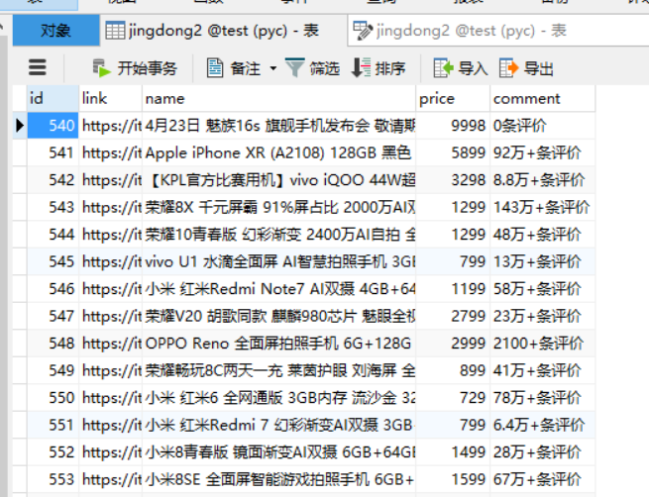
网站效果图：
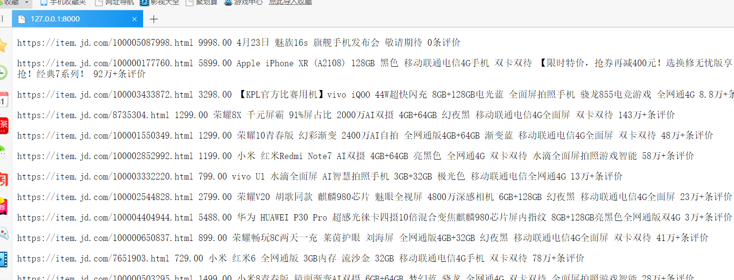
Setting.py:
"""
Django settings for HelloWorld project.

Generated by 'django-admin startproject' using Django 2.2.

For more information on this file, see
https://docs.djangoproject.com/en/2.2/topics/settings/

For the full list of settings and their values, see
https://docs.djangoproject.com/en/2.2/ref/settings/
"""

import os

# Build paths inside the project like this: os.path.join(BASE_DIR, ...)
BASE_DIR = os.path.dirname(os.path.dirname(os.path.abspath(__file__)))

# Quick-start development settings - unsuitable for production
# See https://docs.djangoproject.com/en/2.2/howto/deployment/checklist/

# SECURITY WARNING: keep the secret key used in production secret!
SECRET_KEY = 'yy$oayqa+)z(!_578(+i=2$mk0mp$vnin)+2e(hwkfwuatoaya'

# SECURITY WARNING: don't run with debug turned on in production!
DEBUG = True

ALLOWED_HOSTS = []

# Application definition

INSTALLED_APPS = [
'django.contrib.admin',
'django.contrib.auth',
'django.contrib.contenttypes',
'django.contrib.sessions',
'django.contrib.messages',
'django.contrib.staticfiles',
'TestModel', # 添加此项
]

MIDDLEWARE = [
'django.middleware.security.SecurityMiddleware',
'django.contrib.sessions.middleware.SessionMiddleware',
'django.middleware.common.CommonMiddleware',
'django.middleware.csrf.CsrfViewMiddleware',
'django.contrib.auth.middleware.AuthenticationMiddleware',
'django.contrib.messages.middleware.MessageMiddleware',
'django.middleware.clickjacking.XFrameOptionsMiddleware',
]

ROOT_URLCONF = 'HelloWorld.urls'

TEMPLATES = [
{
'BACKEND': 'django.template.backends.django.DjangoTemplates',
'DIRS': [BASE_DIR+"/templates",],
'APP_DIRS': True,
'OPTIONS': {
'context_processors': [
'django.template.context_processors.debug',
'django.template.context_processors.request',
'django.contrib.auth.context_processors.auth',
'django.contrib.messages.context_processors.messages',
],
},
},
]

WSGI_APPLICATION = 'HelloWorld.wsgi.application'

# Database
# https://docs.djangoproject.com/en/2.2/ref/settings/#databases

DATABASES = {
'default': {
'ENGINE': 'django.db.backends.mysql', # 或者使用 mysql.connector.django
'NAME': 'test',
'USER': 'root',
'PASSWORD': '123456',
'HOST':'localhost',
'PORT':'3306',
}
}

# Password validation
# https://docs.djangoproject.com/en/2.2/ref/settings/#auth-password-validators

AUTH_PASSWORD_VALIDATORS = [
{
'NAME': 'django.contrib.auth.password_validation.UserAttributeSimilarityValidator',
},
{
'NAME': 'django.contrib.auth.password_validation.MinimumLengthValidator',
},
{
'NAME': 'django.contrib.auth.password_validation.CommonPasswordValidator',
},
{
'NAME': 'django.contrib.auth.password_validation.NumericPasswordValidator',
},
]

# Internationalization
# https://docs.djangoproject.com/en/2.2/topics/i18n/

LANGUAGE_CODE = 'en-us'

TIME_ZONE = 'UTC'

USE_I18N = True

USE_L10N = True

USE_TZ = True

# Static files (CSS, JavaScript, Images)
# https://docs.djangoproject.com/en/2.2/howto/static-files/

STATIC_URL = '/static/'

Models.py:
#创建数据库
$python manage.py makemigrations TestModel #让Django知道我们的模型有一些变更
$python manage.py migrate TestModel #创建表结构
# models.py
from django.db import models

class Test(models.Model):
movie_name = models.CharField(max_length=20)

class JD(models.Model):
link = models.CharField(max_length=255)
price = models.CharField(max_length=10)
name = models.CharField(max_length=255)
comment = models.CharField(max_length=255)

testdb.py:
#读取数据并输出
from django.http import HttpResponse

from TestModel.models import Test
from TestModel.models import JD
# 数据库操作
def testdb(request):
response = ""
response1 = ""
list = Test.objects.all()
for var in list:
response1 +=str(var.id) + " "+var.movie_name + " " +"</p>"
list2 = JD.objects.all()
for var in list2:
response1 += var.link + " " + var.price + " " + var.name + " " + var.comment + " "+"</p>"
response = response1
return HttpResponse("<p>" + response + "</p>")

urls.py:
#注册页面并将数据传递到该页面
from django.conf.urls import *
from . import view,testdb

urlpatterns = [

url(r'^$', testdb.testdb)
]
项目文件截图：
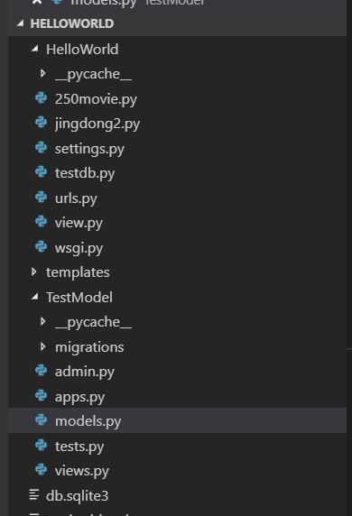
六：思考题：

七、教师评语：

实验成绩： 教师：（签名要全称） 年 月 日

注：1。此模板为专业实验报告的基本要求，若有特殊要求的实验，可在此模板基础上增加，但不可减少。
２．实验报告必须在学生提交报告后一星期内批改。
说明：
- 上下页边距改成2厘米，左边距为2.0厘米，右边距为1.5厘米。
- 表格位置为居中

