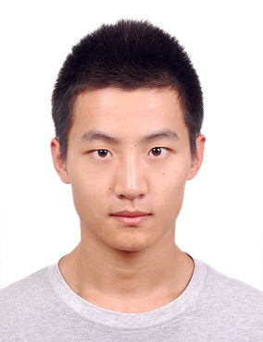**Ziyi Guo**

Jämeräntaival 6B 106, Espoo, 02150 

+358-046-639-0408 

[ziyi.guo@aalto.fi](mailto:ziyi.guo@aalto.fi) 

<https://github.com/Ziyi-Guo> 

**EDUCATION**

SWUFE--Southwestern University of Finance and Economics

Computer Science and Technology (expected June 2016)

GPA: 3.63

Exchanging in Aalto University, Computer Science

**NOTABLE PROJECTS**

Image Facial Recognition (Dec. 2015 to Now)

Thesis project

I'm studying Computer Vision and trying to build a face recognition program on images. I'm also learning Machine Learning courses, thus quite interested in implementing some ML algorithms (recurrent neuron network, etc.) in my work, to improve the recognizing algorithm.

Yuanfang on-line voting system (Aug. 2015)

Team project

Considering the traditional paper voting system costs a lot of resources and time, we built an on-line voting system that helps to make quicker decision and costs less resources, with beautifully designed app and fluent user experience.

Implementation of Quantitative-Investment strategies (Summer 2014)

Summer research internship

Learned basic methods of developing investment strategies. Implemented dynamic time warping algorithm on stock's dataset, to find the most similar history environment to the present and predict the recent future. Tried to improve it, failed.

**HONORS**

Meritorious Winner of the Mathematical Contest in Modeling, 2015

First Prize Winner in Sichuan Prov. of National Undergraduates Mathematical

Modeling Competition, 2014

Third Prize of Chinese Undergraduate Computer Design Contest, 2015

National Stipend, 2015

Scientific Research Scholarship in 3 semesters

**SKILLS**

Programming Languages: C/C++, Java, Python, MATLAB

Web Development: HTML, J2EE, Basic JavaScript

Developing Environment: Linux, Windows

Language: Chinese (native), English (fluent)

**SELF EVALUATION**

Motivated, responsible, team-spirited, and have a sense of Humor