Ziyi Guo
520137

The curves:
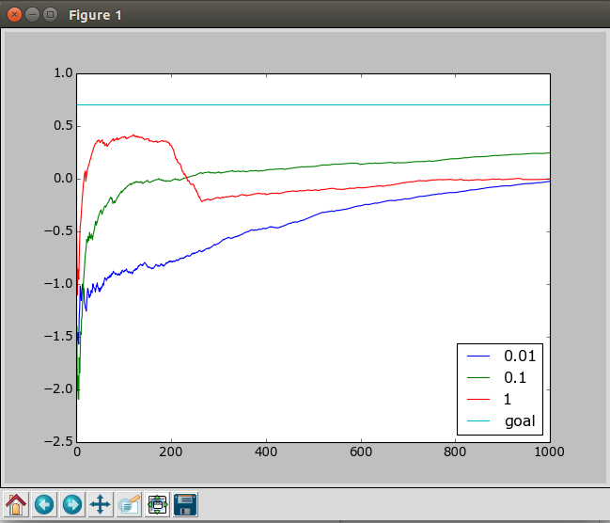

My code:

import numpy as np
import random
import matplotlib.pyplot as plot

def policy_iter(learning_rate,max_episodes,max_steps):
records = []
w = []
for i in range(4):
w.append([0.0]*4)

sum_reward = 0.0
theta = []
posib = []
for i in range(3): # init theta and posibilities
theta.append(w)
posib.append(w)
terminals = [{'cordinate':[0,3],'reward':1},{'cordinate:':[1,3],'reward':-1}]

for episod in range(max_episodes):
cur_cor = [0,0]
if_ter = False
tracks = []

for x in range(3):
for y in range(4):
for p in range(4):
posib[x][y][p] = soft_max(p,[x,y],theta)

for step in range(max_steps):
# randomly choose a action
# 0 1 2 3 stands for west north east south
action_chose = random.randint(0,3)

# for 80% it'll go right direction, 20% right angle
rnd = random.random()
if rnd>0.9:
action_chose = (action_chose + 1) % 4
elif rnd>0.8:
action_chose = (action_chose - 1) % 4

last_cor = cur_cor[:]

# decide next cordinate
if action_chose == 0:
cur_cor[1] = cur_cor[1]-1 if cur_cor[1]>0 else 0
elif action_chose == 2:
cur_cor[1] = cur_cor[1]+1 if cur_cor[1]<3 else 3
elif action_chose == 1:
cur_cor[0] = cur_cor[0]+1 if cur_cor[0]<2 else 2
elif action_chose == 3:
cur_cor[0] = cur_cor[0]-1 if cur_cor[0]>0 else 0

reward = -0.04
# if reaches the terminals
for terminal in terminals:
if terminal['cordinate'] == cur_cor:
if_ter = True
reward = terminal['reward']
tracks.append({'cordinate':cur_cor[:],'last_cor':last_cor[:],
'reward':reward,'action':action_chose})
if if_ter:
break
w = [0.0]*4
rewards = []
for i in range(3):
rewards.append(w)
counter = [[0,0,0,0],[0,0,0,0],[0,0,0,0]]

reward = 0.0
for i in reversed(xrange(step+1)):
reward += tracks[i]['reward']
state = track[i]['last_cor'][:]
rewards[state[0]][state[1]] += reward
counter[state[0]][state[1]] += 1
for i in range(3):
for j in range(4):
rewards[i][j] = rewards[i][j]/counter[i][j] if counter[i][j]!= 0 else rewards[i][j]

for i in reversed(xrange(step+1)):
state = tracks[i]['last_cor'][:]
for k in range(4):
if k == tracks[i]['action']:
x = 1.0 - posib[state[0]][state[1]][k]
else:
x = -posib[state[0]][state[1]][k]

theta[state[0]][state[1]][k] += learning_rate * x * rewards[state[0]][state[1]]

sum_reward += rewards[0][0]
records.append(sum_reward/(episod+1))
return records

def soft_max(a, s, theta):
e = np.exp(theta[s[0]][s[1]][a])
sum = np.sum(np.exp(theta[s[0]][s[1]]))
dist = e / sum
return dist

if __name__ == "__main__":
rates = [1,0.1,0.01]
records = [[],[],[]]
standard = [0.705]*1000
for i in range(3):
records[i].append(policy_iter(rates[i],1000,100))

plts = [0,0,0,0]
for i in range(3):
plts[i], = plot.plot(records[i],range(1000))
plts[3] = plot.plot(standard,range(1000))
plt.legend(plots, legends, loc=4)
plt.show()

