SWE202 – Software Modeling and Design
Clinic Queue and Appointment Management System
Use Case Diagram – Full System
Team Leader: Jona Kovaci | Ersia Coku • Fatime Fejzo • Klesta Ademaj • Deivid Koci • Geri Gerdoci • Gersi Moli
Document Version: 2.0 | March 14, 2026 | 29 Use Cases | 8 Actors | 8 Functional Domains
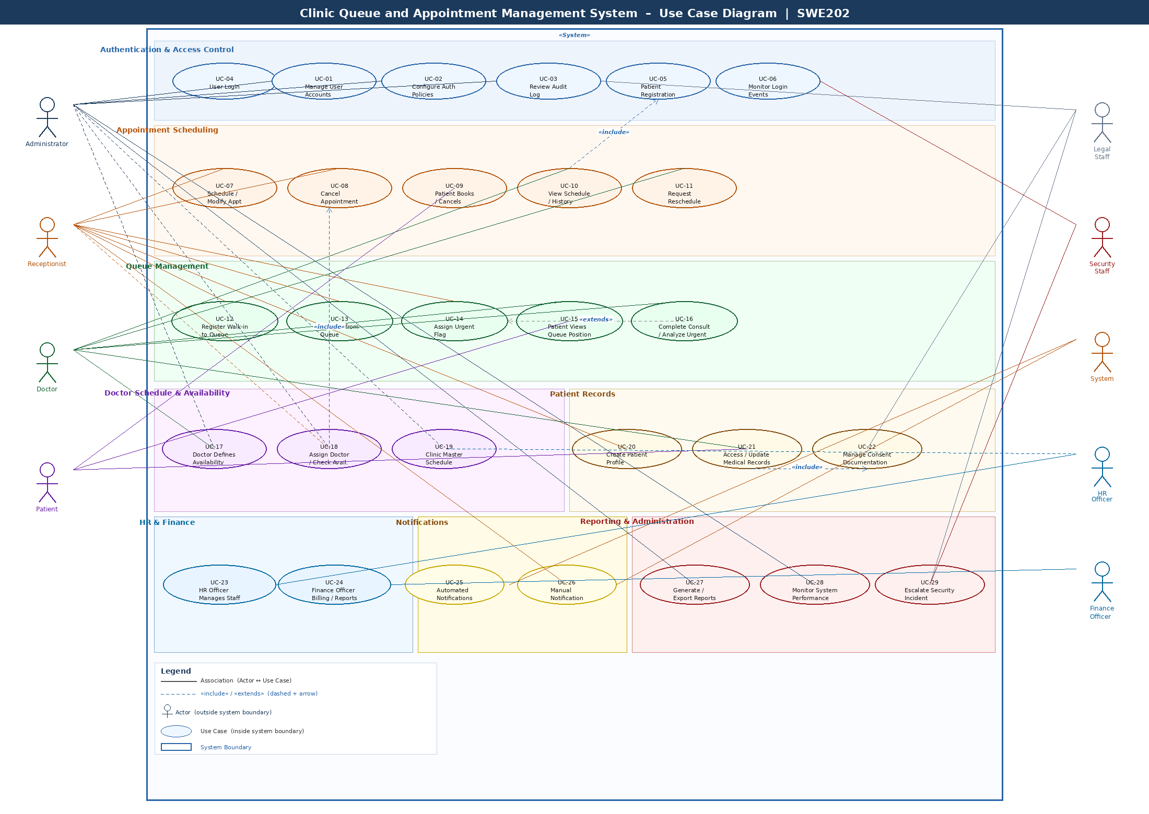
Figure 1: Complete UML Use Case Diagram – Clinic Queue and Appointment Management System

