Entity Relationship Diagram
CQAMS — Clinic Queue & Appointment Management System
SWE202 — Software Modeling and Design · April 2026
Document | CQAMS ERD v2.0 — Corrected
Entities | 10 entities, 12 relationships
Notation | Crow's foot (Barker), FK/PK labelled
Team Leader | Jona Kovaci
Contributors | Deivid Koci (primary), full team review

Legend
PK | Primary Key — uniquely identifies a record in this table
FK | Foreign Key — references the primary key of another table
1 : 1 | One-to-one relationship (e.g. USER → PATIENT specialisation)
1 : 0..* | One-to-many: one record on the left side, zero or more on the right
1 : 0..1 | One-to-zero-or-one: at most one matching record on the right
opt FK | Optional / nullable foreign key — the relationship may not exist

See next page for the full diagram, followed by the entity reference and relationship table.

Entity Relationship Diagram — Full System
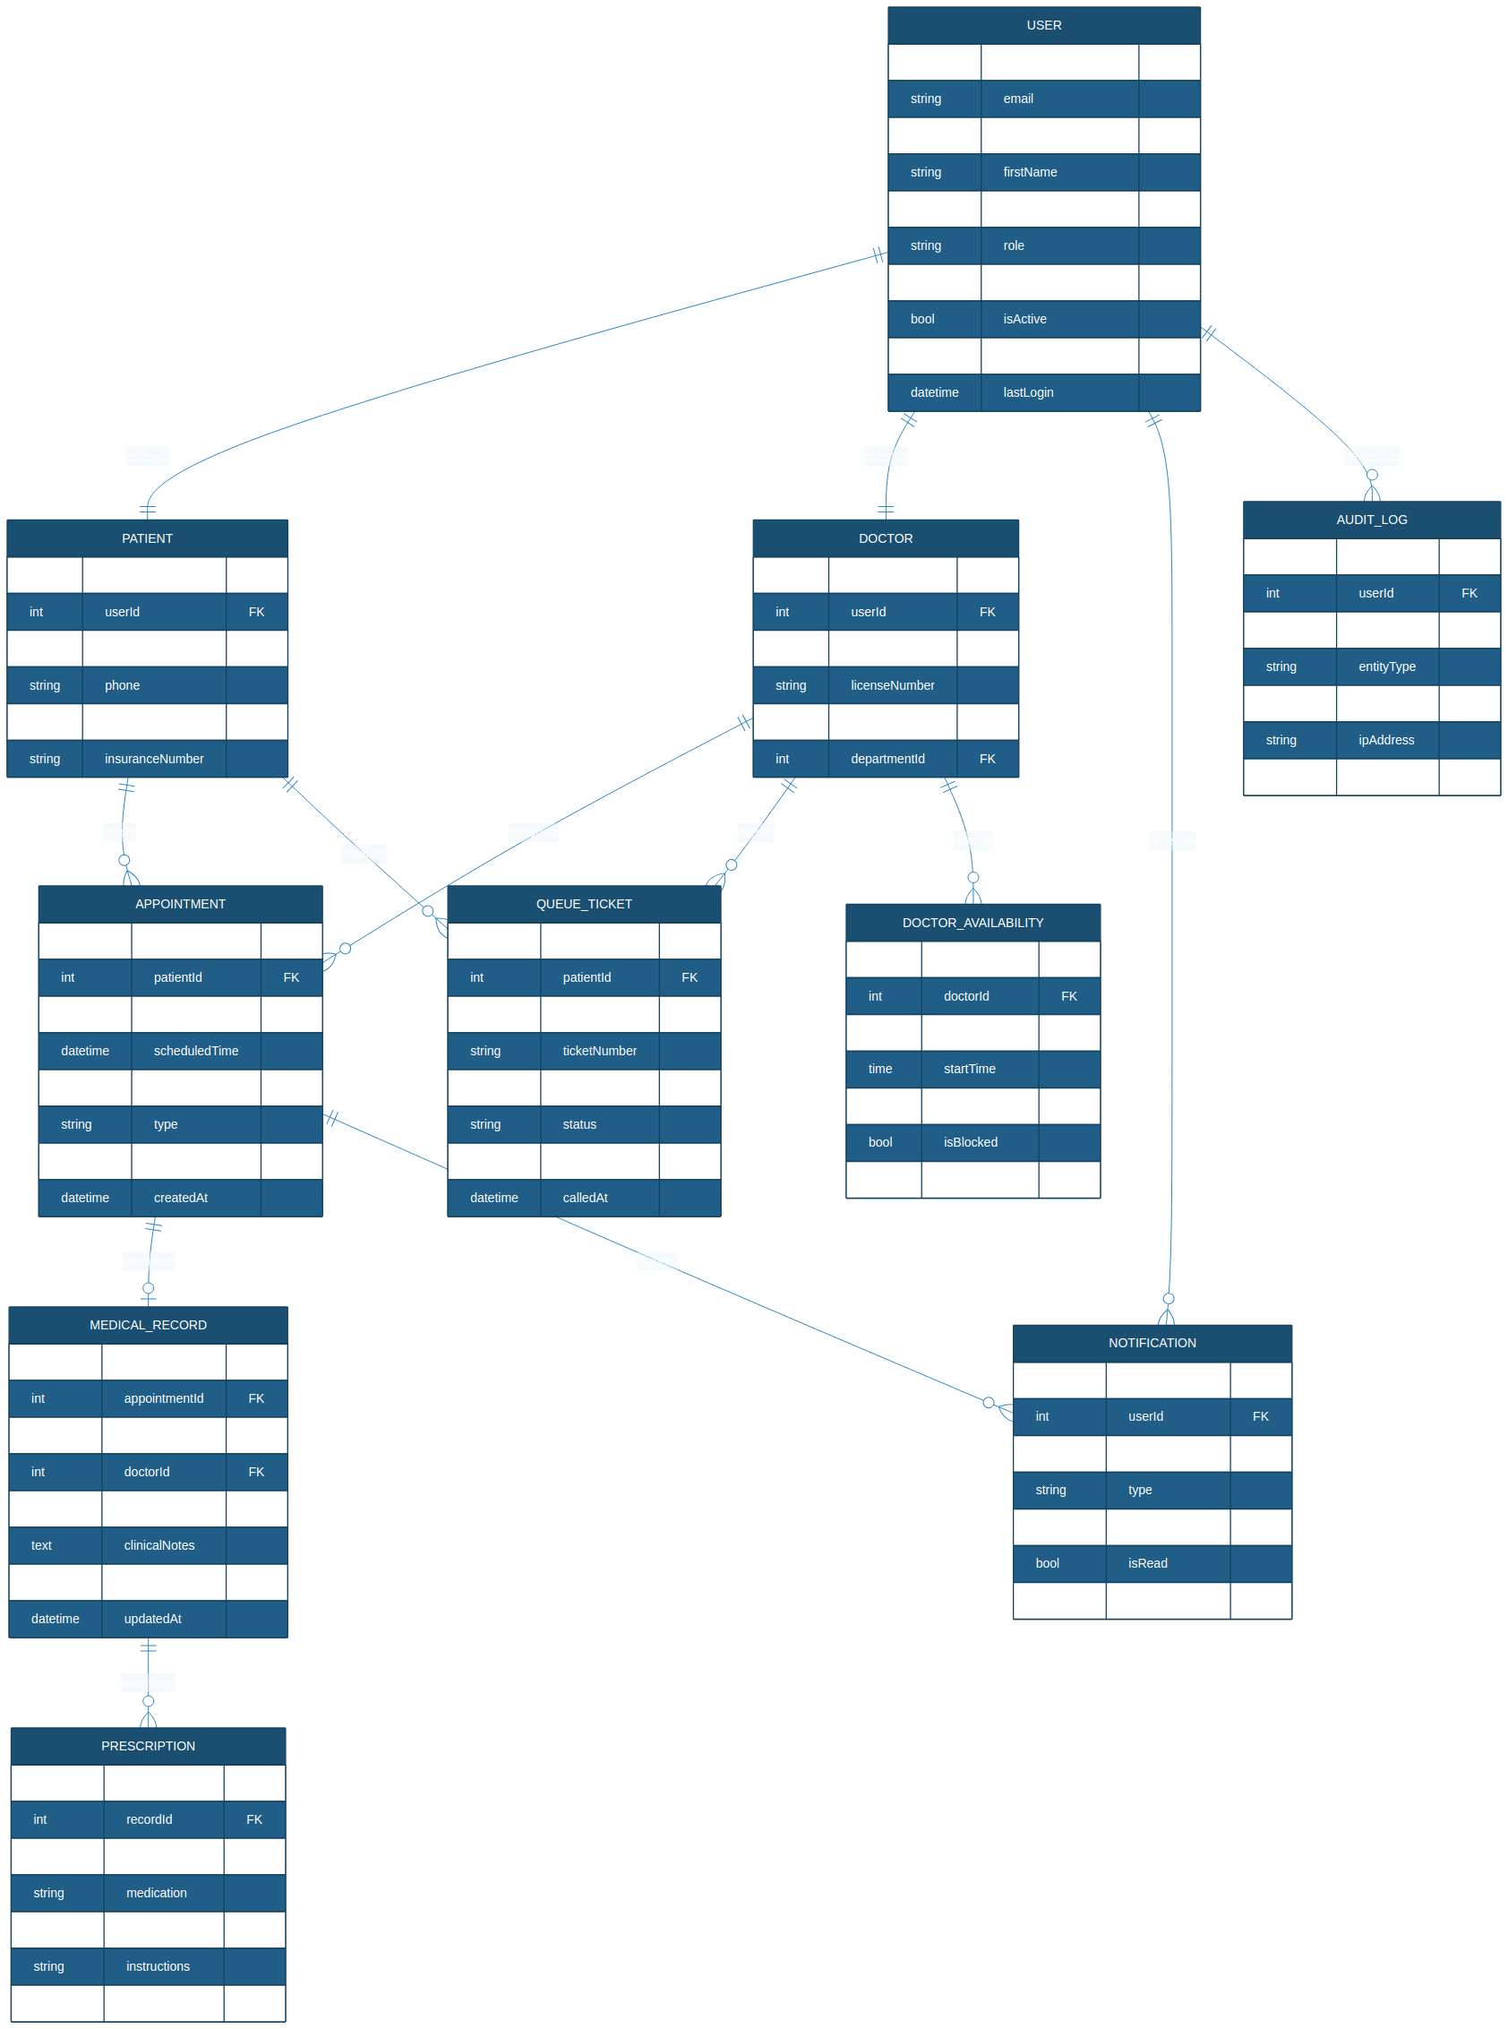

1. Entity Reference
Attributes, keys, and purpose for each entity in the CQAMS data model.
Entity | Primary Key | Foreign Keys | Purpose & Notes
USER | userId | — | Central identity record. Drives RBAC via the role ENUM. All roles authenticate through this table.
PATIENT | patientId | userId | Extends USER 1:1. Stores patient-specific data: date of birth, phone, address, insurance number.
DOCTOR | doctorId | userId  departmentId | Extends USER 1:1. Stores clinical credentials and the assigned consultation room and department.
APPOINTMENT | appointmentId | patientId  doctorId | A pre-scheduled booking linking one patient to one doctor. Holds status, type, and clinical notes.
QUEUE_TICKET | ticketId | patientId  doctorId | A walk-in queue entry. Independent of APPOINTMENT. Holds auto-generated ticket number and priority.
MEDICAL_RECORD | recordId | appointmentId  patientId  doctorId | The outcome of a completed consultation: diagnosis, clinical notes. Created 0..1 per appointment.
PRESCRIPTION | prescriptionId | recordId  doctorId | Issued by a doctor against a medical record. One record can produce multiple prescriptions.
NOTIFICATION | notificationId | userId  appointmentId (opt) | System-generated alerts: confirmations, 24-hour reminders, queue updates. appointmentId is nullable.
AUDIT_LOG | logId | userId | Immutable record of every user action. Insert-only. Satisfies NFR-05 (12-month retention) and FR-54.
DOCTOR_AVAILABILITY | availabilityId | doctorId | Weekly schedule slots per doctor. Supports blocked periods. Queried before any appointment is booked.

2. Relationship Reference
All 12 relationships: cardinality, direction, and business rule rationale.
Relationship | Cardinality | Business Rule
USER → PATIENT | 1 : 1 | Specialisation / extension. Each patient record maps to exactly one user account (dashed inheritance).
USER → DOCTOR | 1 : 1 | Specialisation / extension. Each doctor record maps to exactly one user account (dashed inheritance).
PATIENT → APPOINTMENT | 1 : 0..* | A patient accumulates multiple appointments over time. Zero if they have never booked.
DOCTOR → APPOINTMENT | 1 : 0..* | A doctor holds multiple appointments. Zero if none are scheduled yet.
APPOINTMENT → MEDICAL_RECORD | 1 : 0..1 | A completed appointment produces at most one medical record. Cancelled/pending appointments produce none.
MEDICAL_RECORD → PRESCRIPTION | 1 : 0..* | One consultation may result in multiple prescriptions (one per medication).
PATIENT → QUEUE_TICKET | 1 : 0..* | A patient can hold multiple queue tickets across visits.
DOCTOR → QUEUE_TICKET | 1 : 0..* | A doctor serves multiple queued patients per shift.
USER → NOTIFICATION | 1 : 0..* | Every user receives system-generated notifications.
APPOINTMENT → NOTIFICATION | 1 : 0..* | Booking, cancellation, and reminder events each trigger a notification.
USER → AUDIT_LOG | 1 : 0..* | Every authenticated user action generates an immutable audit entry.
DOCTOR → DOCTOR_AVAILABILITY | 1 : 0..* | A doctor defines many weekly availability slots.

ERD Corrections from Previous Version
Change | Rationale
APPOINTMENT → MEDICAL_RECORD changed to 1:0..1 | Not every appointment produces a record — cancelled and pending appointments do not. The previous 1:1 was incorrect.
NOTIFICATION.appointmentId made nullable (opt FK) | System-wide notifications (e.g. security alerts, session expiry) do not relate to any appointment. Strict FK would prevent these.
DOCTOR gains departmentId FK | Satisfies FR-28: Administrator assigns doctors to clinic departments. The previous version had no department reference on DOCTOR.
Cardinality labels standardised to crow's foot notation | Consistent notation across all connectors for academic presentation readability.

