CQAMS
Clinic Queue & Appointment Management System
SWE202 — Software Modeling and Design

Week Deliverables: State Diagrams & ERD
April 2026

1. State Diagrams
This section presents UML state diagrams for each of the four user roles defined in the CQAMS system: Patient, Doctor, Receptionist, and Administrator. Each diagram captures the full lifecycle of states and transitions a user of that role can experience within the system.

1.1 Patient
The Patient role begins as Unregistered. After registering, the patient enters the Registered state and may then either book an appointment (moving to Appointment Pending) or join the walk-in queue (moving to Queued). Appointments can be confirmed or cancelled at any point. Queued patients are called into consultation and, upon completion, reach the Consultation Complete terminal state.
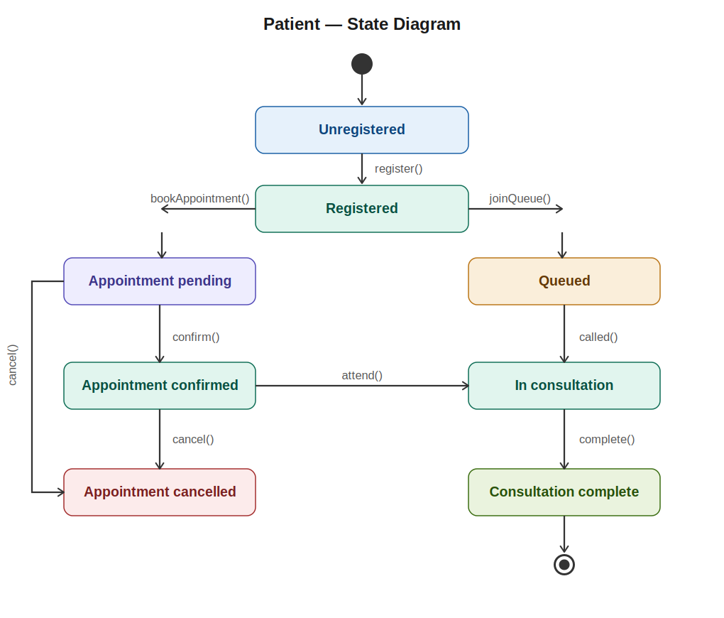
Figure 1.1 — Patient state diagram

1.2 Doctor
Doctors start Inactive / Off Duty. When available, the doctor transitions to the Available state and may either block schedule slots (Schedule Blocked) or call the next patient (In Consultation). During a consultation the doctor records clinical notes (Documenting), and upon submission the consultation is closed and a prescription may be issued. The doctor then returns to Available.
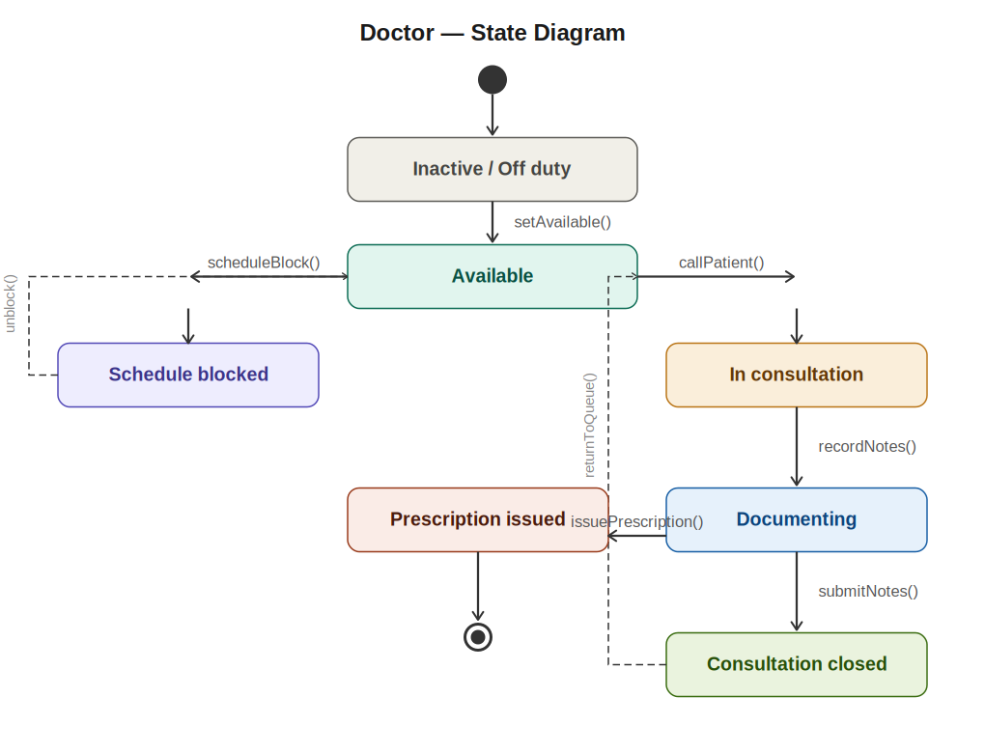
Figure 1.2 — Doctor state diagram

1.3 Receptionist
The Receptionist logs in to reach the Idle (Dashboard) state. From the dashboard, three parallel workflows are available: registering a new patient, managing the live queue, and booking appointments on behalf of patients. The queue workflow includes a Calling Patient sub-state. All workflows return the receptionist to Idle upon completion.
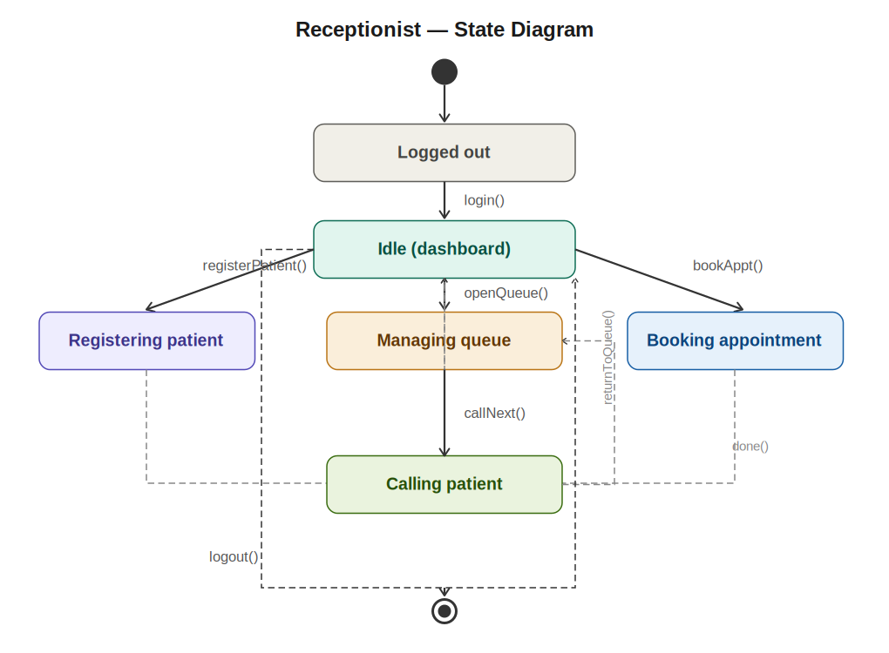
Figure 1.3 — Receptionist state diagram

1.4 Administrator
The Administrator authenticates to reach the Admin Dashboard. From there, four parallel task states are available: Managing Users (add/deactivate accounts), System Configuration (update settings and notification rules), Viewing Reports (generate and export operational reports), and Audit Log Review (filter and inspect system activity). All tasks return to the dashboard upon completion.
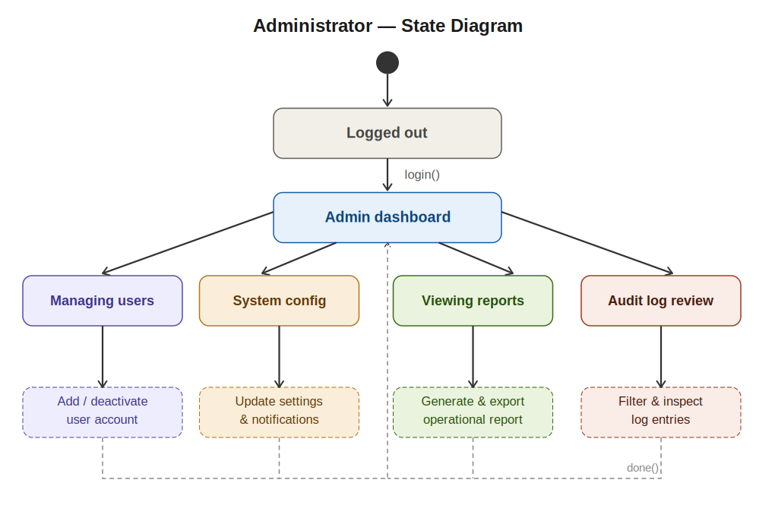
Figure 1.4 — Administrator state diagram

2. Entity Relationship Diagram
The ERD below defines the full relational data model for CQAMS across ten entities arranged in a clean four-column grid. Entities in the same logical group share a column. All connectors are orthogonal (no diagonal lines). Primary keys are labeled PK, foreign keys FK.

2.1 Entities
USER — central identity record shared by all roles. The role field (ENUM: patient, doctor, receptionist, admin) drives RBAC. Language preference and active status are stored here.
PATIENT — extends USER for patients, adding date of birth, phone, address, and insurance number.
DOCTOR — extends USER for doctors, storing specialization, license number, and assigned room.
APPOINTMENT — a scheduled booking linking a patient and doctor, with status, type, and notes.
QUEUE_TICKET — a walk-in queue entry with an auto-generated ticket number, priority level, and live status.
MEDICAL_RECORD — the outcome of a consultation: diagnosis, clinical notes, linked to the originating appointment.
PRESCRIPTION — issued by a doctor against a medical record, storing medication, dosage, and instructions.
NOTIFICATION — system-generated alerts (confirmation, 24-hour reminder, queue status) linked to a user and optionally an appointment.
AUDIT_LOG — immutable log of all significant system actions, storing the acting user, entity type/ID, and IP address.
DOCTOR_AVAILABILITY — weekly schedule slots per doctor including blocked periods.

2.2 Key relationships
USER → PATIENT / DOCTOR: 1:1 specialization — each patient or doctor record extends exactly one user account (dashed lines).
PATIENT → APPOINTMENT: 1:N — a patient accumulates multiple appointments over time.
DOCTOR → APPOINTMENT: 1:N — a doctor holds multiple appointments.
APPOINTMENT → MEDICAL_RECORD: 1:1 — each completed appointment produces exactly one medical record.
MEDICAL_RECORD → PRESCRIPTION: 1:N — one consultation may result in multiple prescriptions.
PATIENT → QUEUE_TICKET: 1:N — a patient can join the queue across multiple visits.
DOCTOR → QUEUE_TICKET: 1:N — a doctor serves multiple queued patients.
USER → NOTIFICATION: 1:N — a user receives many system notifications.
APPOINTMENT → NOTIFICATION: 1:N — notifications are triggered by appointment events.
USER → AUDIT_LOG: 1:N — every user action generates an audit entry.
DOCTOR → DOCTOR_AVAILABILITY: 1:N — a doctor has many weekly schedule slots.

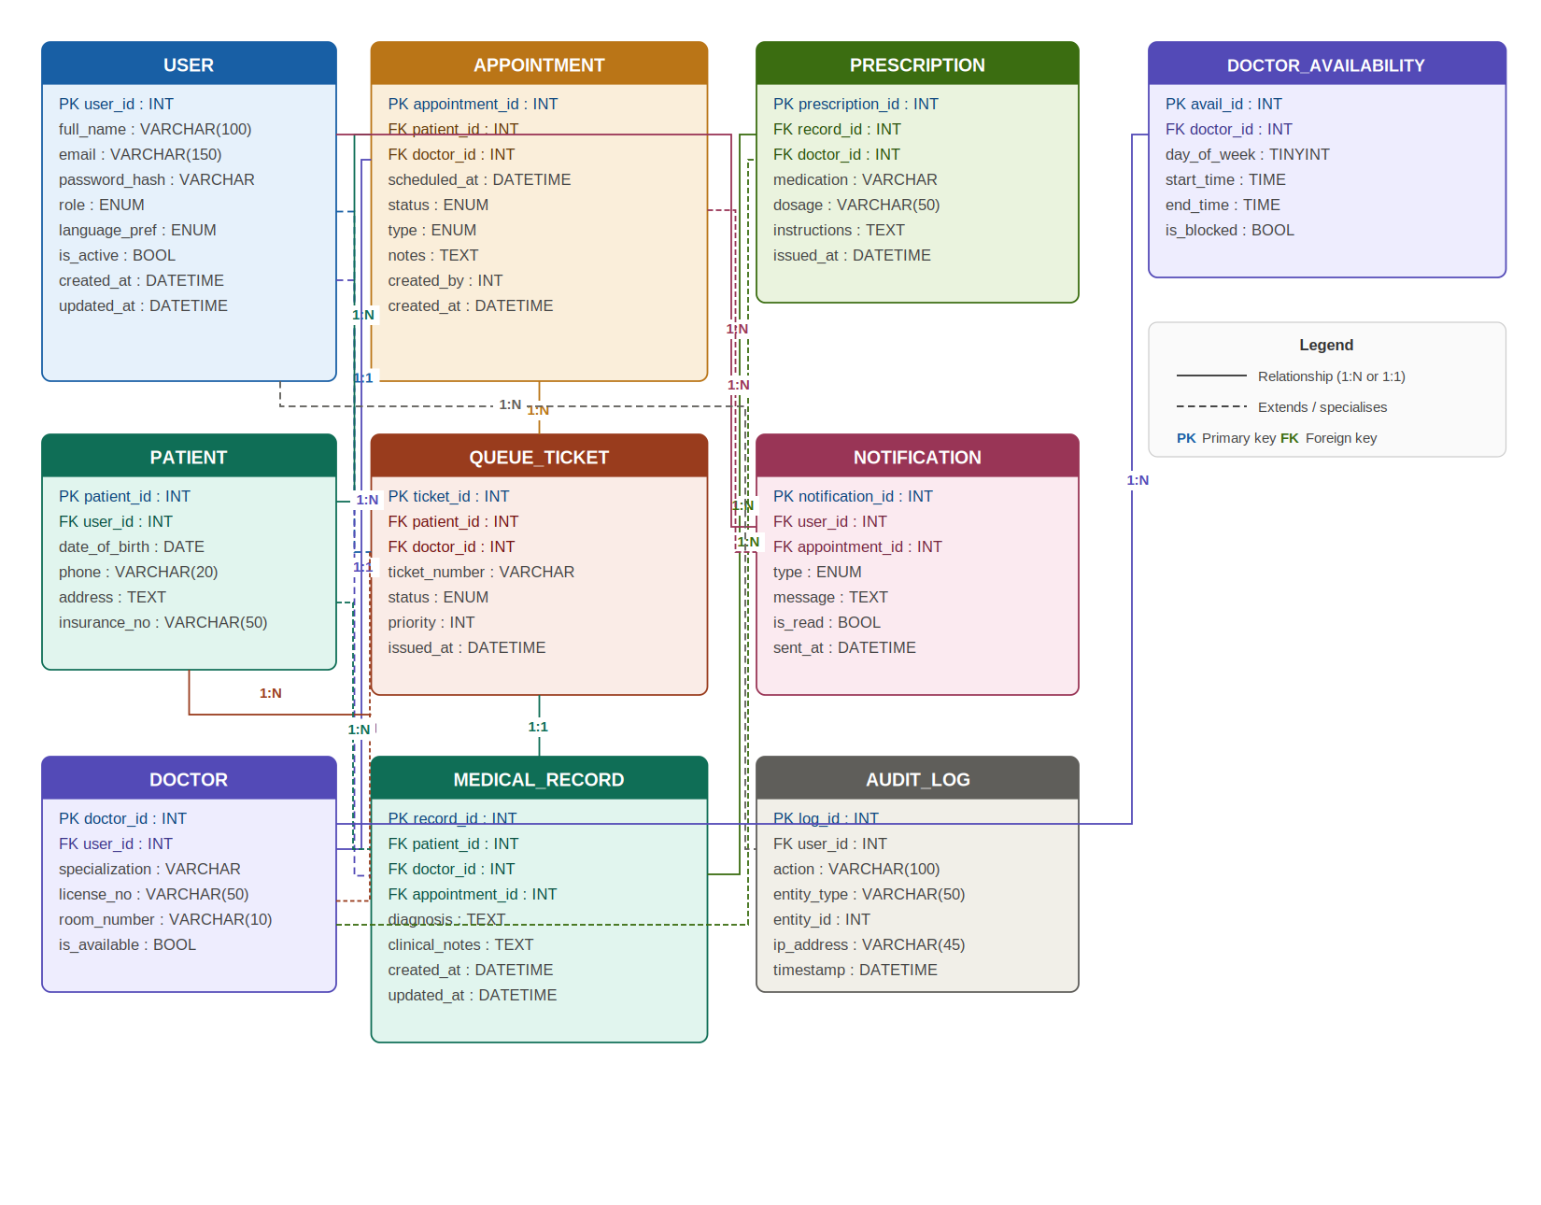
Figure 2.1 — CQAMS Entity Relationship Diagram

