Design Patterns in CQAMS
Clinic Queue and Appointment Management System — SWE202 Software Modeling and Design

This document selects and explains two design patterns that are naturally present in the CQAMS project. Each pattern is justified based on actual system behavior and is supported by one dedicated UML class diagram.

Selected Design Patterns
Item | Description
Observer Pattern | Used for automatic notifications when queue tickets or appointments change status.
Factory Method Pattern | Used for creating role-based users such as Patient, Doctor, Receptionist, and Administrator.
These two patterns are selected because they directly match the core responsibilities of the project: real-time status updates and controlled creation of different user roles.

1. Observer Pattern
Purpose:
The Observer Pattern defines a one-to-many dependency between objects. When the subject changes state, all registered observers are notified automatically.
Why it fits CQAMS:
- When a QueueTicket changes from WAITING to CALLED, the patient must be notified.
- When an appointment is confirmed, cancelled, or rescheduled, the patient and doctor may need updates.
- The receptionist dashboard should refresh when queue status changes.
- The notification logic should not be hard-coded inside every queue or appointment operation.
In this design, QueueTicket and Appointment act as Subjects. PatientNotificationObserver, DoctorNotificationObserver, and ReceptionistDashboardObserver act as Observers. NotificationService is used by observers to send SMS, email, or in-app notifications.

Observer Pattern Class Diagram
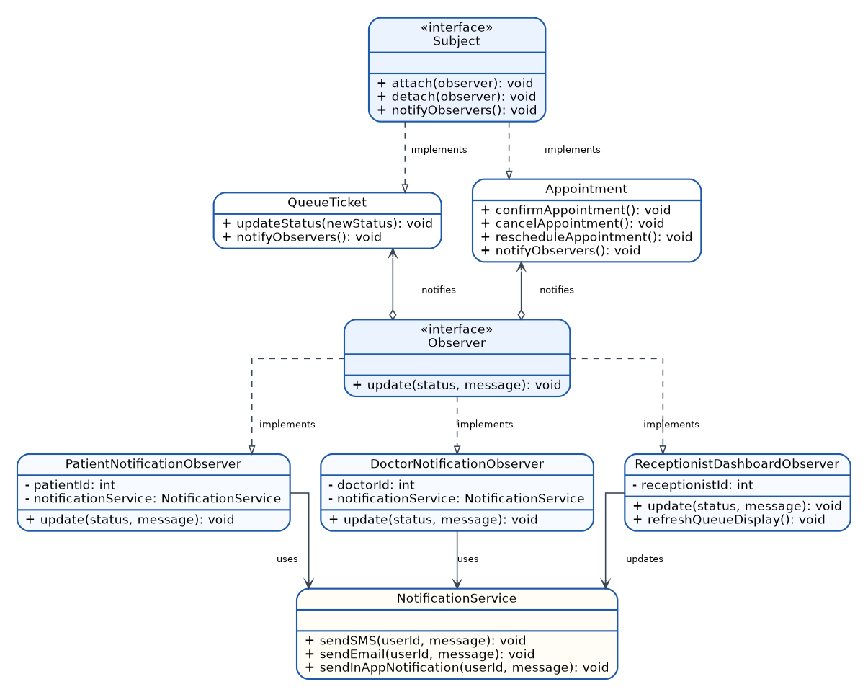

Observer Pattern Justification
Item | Description
Problem solved | Multiple parts of the system need to react whenever a queue ticket or appointment changes status.
Subject classes | QueueTicket and Appointment.
Observer classes | PatientNotificationObserver, DoctorNotificationObserver, and ReceptionistDashboardObserver.
Main benefit | The system becomes more flexible because new observers can be added without changing the main queue or appointment logic.
CQAMS example | When the doctor requests the next patient, QueueTicket changes to CALLED and notifies the patient and queue dashboard automatically.
The Observer Pattern improves separation of concerns. QueueTicket and Appointment only manage their own state, while notification and dashboard update responsibilities are handled by observer classes. This makes the model easier to maintain and extend.

2. Factory Method Pattern
Purpose:
The Factory Method Pattern defines a common interface for creating objects while allowing subclasses to decide which concrete object should be created.
Why it fits CQAMS:
- CQAMS has several user roles: Patient, Doctor, Receptionist, and Administrator.
- All roles inherit from User, but each role has different attributes and responsibilities.
- The system should avoid repeated if/else creation logic scattered across registration and admin modules.
- The system should remain easy to extend if another role is added later.
In this design, UserFactory defines the createUser() method. Concrete factories such as PatientFactory and DoctorFactory create the correct subclass of User. RegistrationService depends on the factory abstraction instead of directly instantiating concrete user classes.

Factory Method Pattern Class Diagram
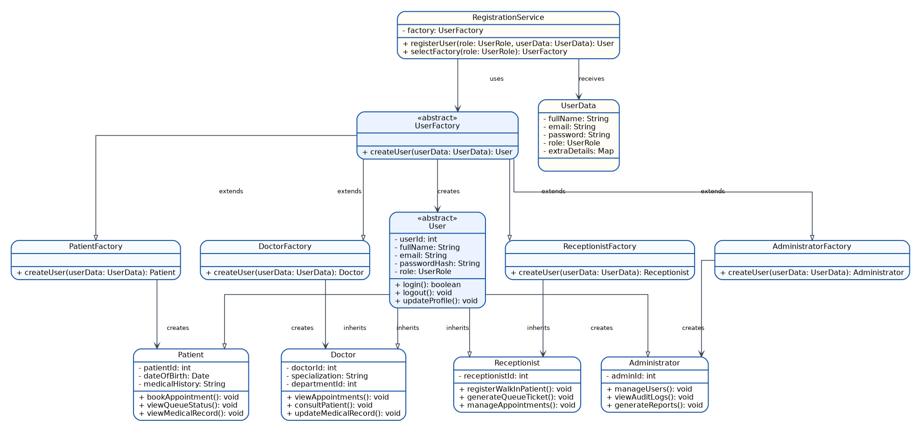

Factory Method Pattern Justification
Item | Description
Problem solved | The system must create different types of users based on role while keeping object creation controlled and consistent.
Product hierarchy | User is the abstract product; Patient, Doctor, Receptionist, and Administrator are concrete products.
Creator hierarchy | UserFactory is the abstract creator; PatientFactory, DoctorFactory, ReceptionistFactory, and AdministratorFactory are concrete creators.
Main benefit | Role creation is centralized, cleaner, and easier to extend.
CQAMS example | During registration, RegistrationService selects the correct factory based on the chosen role and creates the appropriate user object.
The Factory Method Pattern supports role-based access control because every user type is created through a consistent structure. This reduces duplication and helps preserve the integrity of user creation across the system.

Conclusion
The two selected patterns are strongly connected to the CQAMS domain. The Observer Pattern supports real-time notification behavior for queue and appointment updates. The Factory Method Pattern supports clean creation of different user roles. Together, these patterns improve maintainability, flexibility, and separation of responsibilities in the system design.

Short Presentation Summary
For our CQAMS project, we selected the Observer Pattern and the Factory Method Pattern. The Observer Pattern is used because queue tickets and appointments frequently change status, and those changes must automatically notify patients, doctors, and receptionists. The Factory Method Pattern is used because the system creates several role-based users, including Patient, Doctor, Receptionist, and Administrator. Both patterns make the system cleaner, easier to maintain, and easier to extend in the future.

