Figures
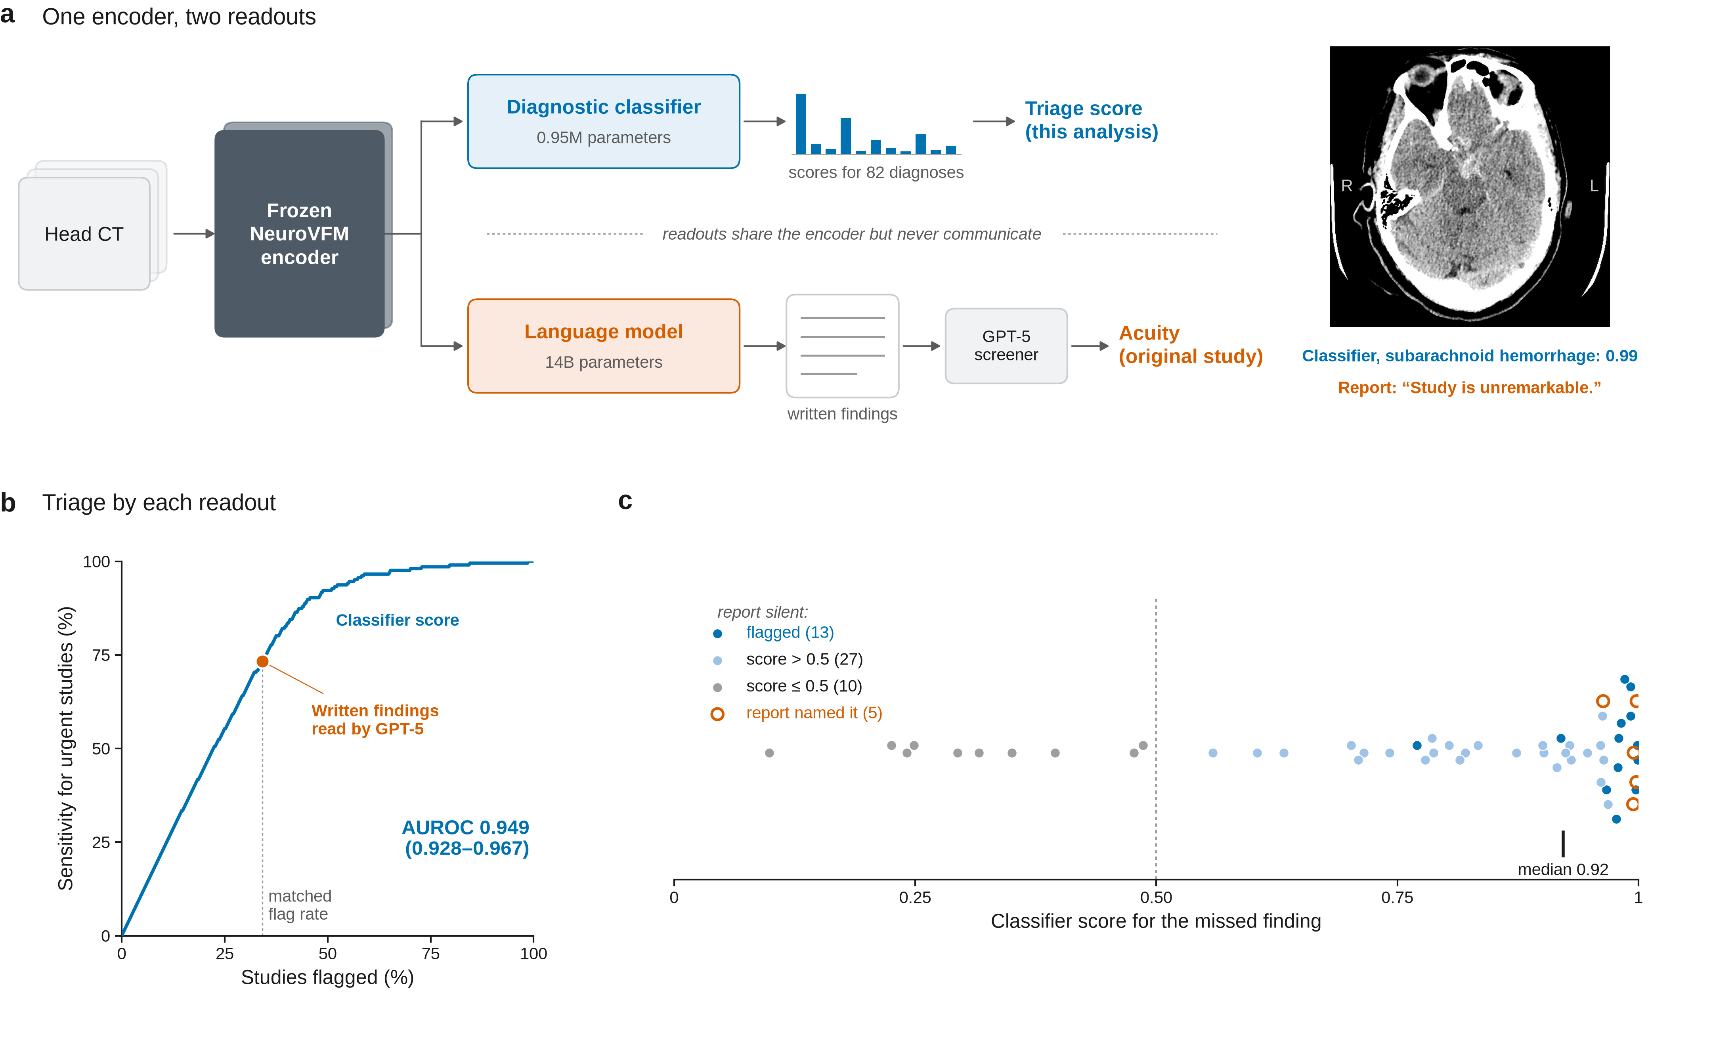
Fig. 1. NeuroVFM’s diagnostic classifier triages as well as its written reports, and many reports omit findings the classifier scored highly. a, The released NeuroVFM system and the change we evaluated. One frozen encoder feeds two readouts that do not share information. In the original study, perception and triage were evaluated through the report path, in which a 14-billion-parameter language model writes findings that GPT-5 reads to assign acuity (orange). We also read the diagnostic classifier (about 0.95 million parameters) directly (blue). Shown for one CQ500 study with subarachnoid hemorrhage, the classifier scored the finding at 0.99 and flagged the study, whereas the generated report read “Study is unremarkable” and the study was not escalated. b, Sensitivity for urgent studies versus fraction of studies flagged (n = 472, 206 urgent). Blue curve and band, the classifier’s highest score across the nine critical findings used directly as a triage score, with 95% CI (AUROC 0.949, 95% CI 0.928–0.967). Orange point, the report pipeline (sensitivity 0.733 at a flag rate of 0.341). Blue point, the classifier at the same flag rate, a threshold chosen without labels. The difference in sensitivity was 0.000 (95% CI −0.029 to 0.030). c, Classifier score for the missed finding in each of the 55 urgent studies the report pipeline missed. Filled blue, report silent and study flagged by the classifier at the matched alarm rate (n = 13). Light blue, report silent and score above 0.5 but study not flagged (n = 27). Grey, report silent and score of 0.5 or below (n = 10). Open orange, the report named a critical finding that GPT-5 did not escalate (n = 5). Dotted line, score of 0.5. Tick, median score of silent reports scored above 0.5 (0.92). Confidence intervals in b are from 2,000 study-level bootstrap resamples.

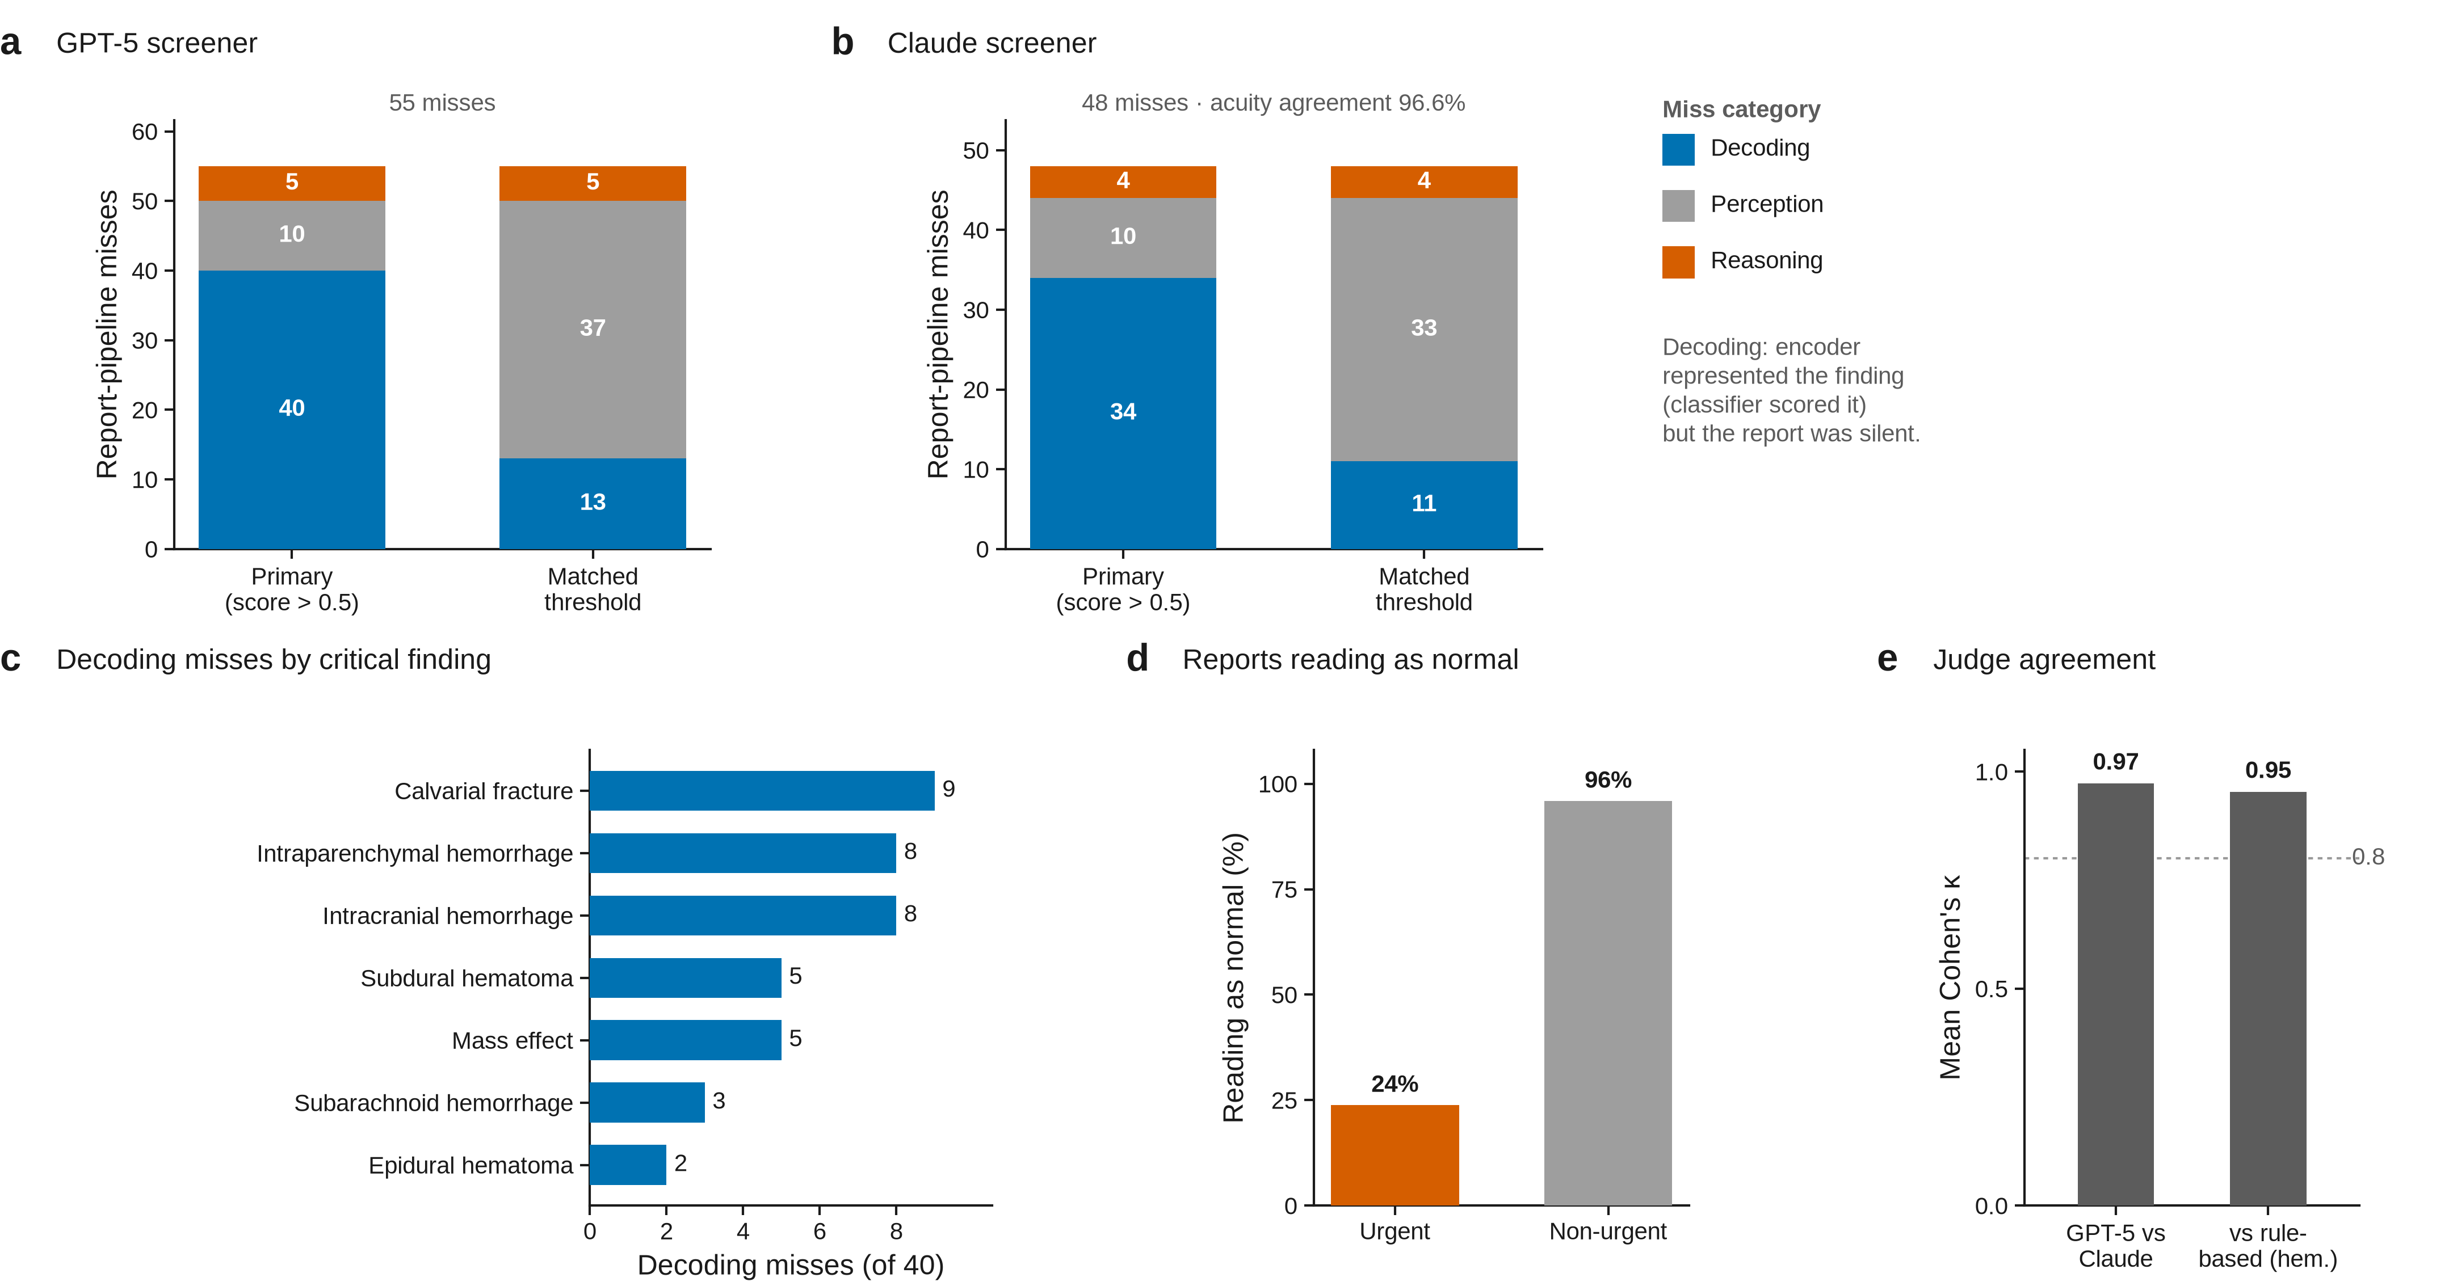
Extended Data Fig. 1. Classification of report-pipeline misses under two definitions and two screening models. Each miss was classified as reasoning (the report named a critical finding that was not escalated), decoding (the report was silent and the classifier detected the finding) or perception (the report was silent and the classifier did not detect the finding). a, Classification of the 55 misses when classifier detection is defined as a score above 0.5 on the highest-scoring positive finding (40 decoding, 10 perception, 5 reasoning), and when it is defined as flagging the study at the matched alarm rate (13 decoding, 37 perception, 5 reasoning). b, The same classification with Claude as the screening model (of 48 misses, 34 decoding, 10 perception and 4 reasoning with the 0.5 score, and 11 decoding, 33 perception and 4 reasoning at the matched alarm rate). Acuity agreement between the two screeners was 96.6%. c, Decoding misses by critical finding with the 0.5 score (calvarial fracture 9, intraparenchymal hemorrhage 8, intracranial hemorrhage 8, subdural hematoma 5, mass effect 5, subarachnoid hemorrhage 3, epidural hematoma 2). d, Fraction of generated reports reading as normal among urgent (24%) and non-urgent (96%) studies. e, Agreement on whether each reference finding was mentioned, between GPT-5 and Claude as judges (mean κ 0.97) and between each judge and a rule-based detector (κ 0.92 or higher for hemorrhage findings).

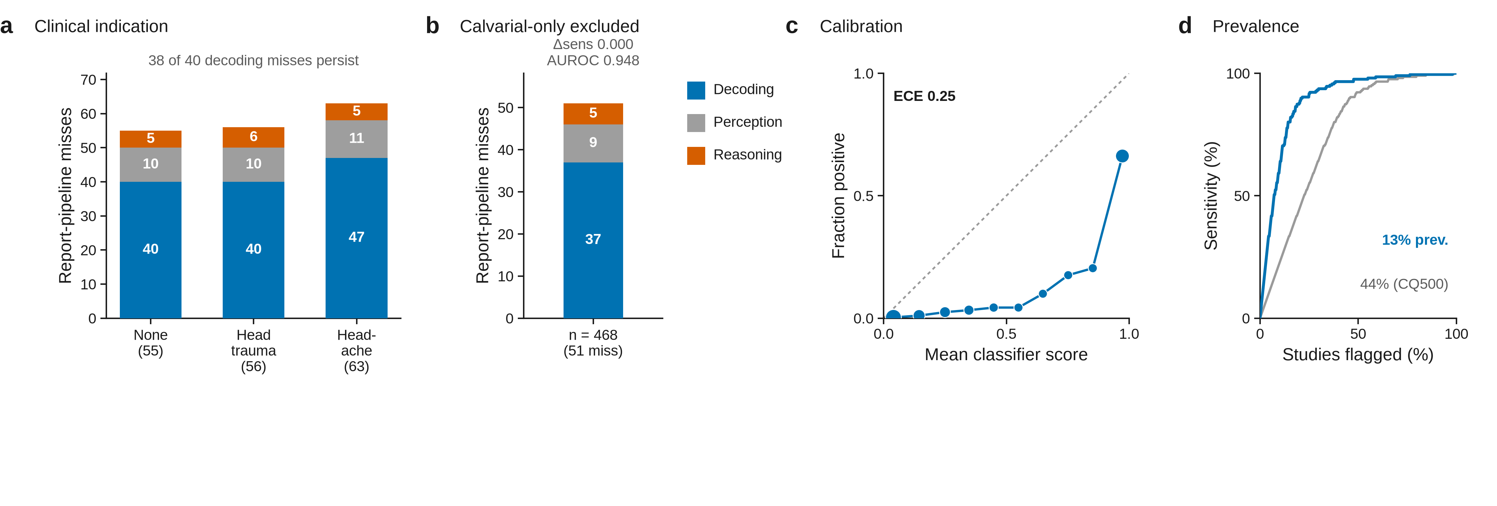
Extended Data Fig. 2. Clinical indication, urgency definition, calibration and prevalence. a, Classification of misses with no clinical indication (as in the main analysis, 40 decoding, 10 perception and 5 reasoning of 55), with the indication “head trauma” (40, 10 and 6 of 56) and with the indication “headache” (47, 11 and 5 of 63). Of the 40 decoding misses in the main analysis, 38 persisted under each indication and 37 under both. b, Results after excluding the four studies whose only critical finding was a calvarial fracture (n = 468, 202 urgent). The sensitivity difference remained 0.000 (95% CI −0.030 to 0.030, AUROC 0.948), and the 51 misses comprised 37 decoding, 9 perception and 5 reasoning misses. c, Reliability diagram for classifier scores pooled over the nine critical findings (expected calibration error 0.25). The classifier discriminates well on external data but is not calibrated to it, so we describe its outputs as scores rather than probabilities. d, Sensitivity versus fraction flagged with the flag-rate axis reweighted to the 13% urgent prevalence of the original prospective study.

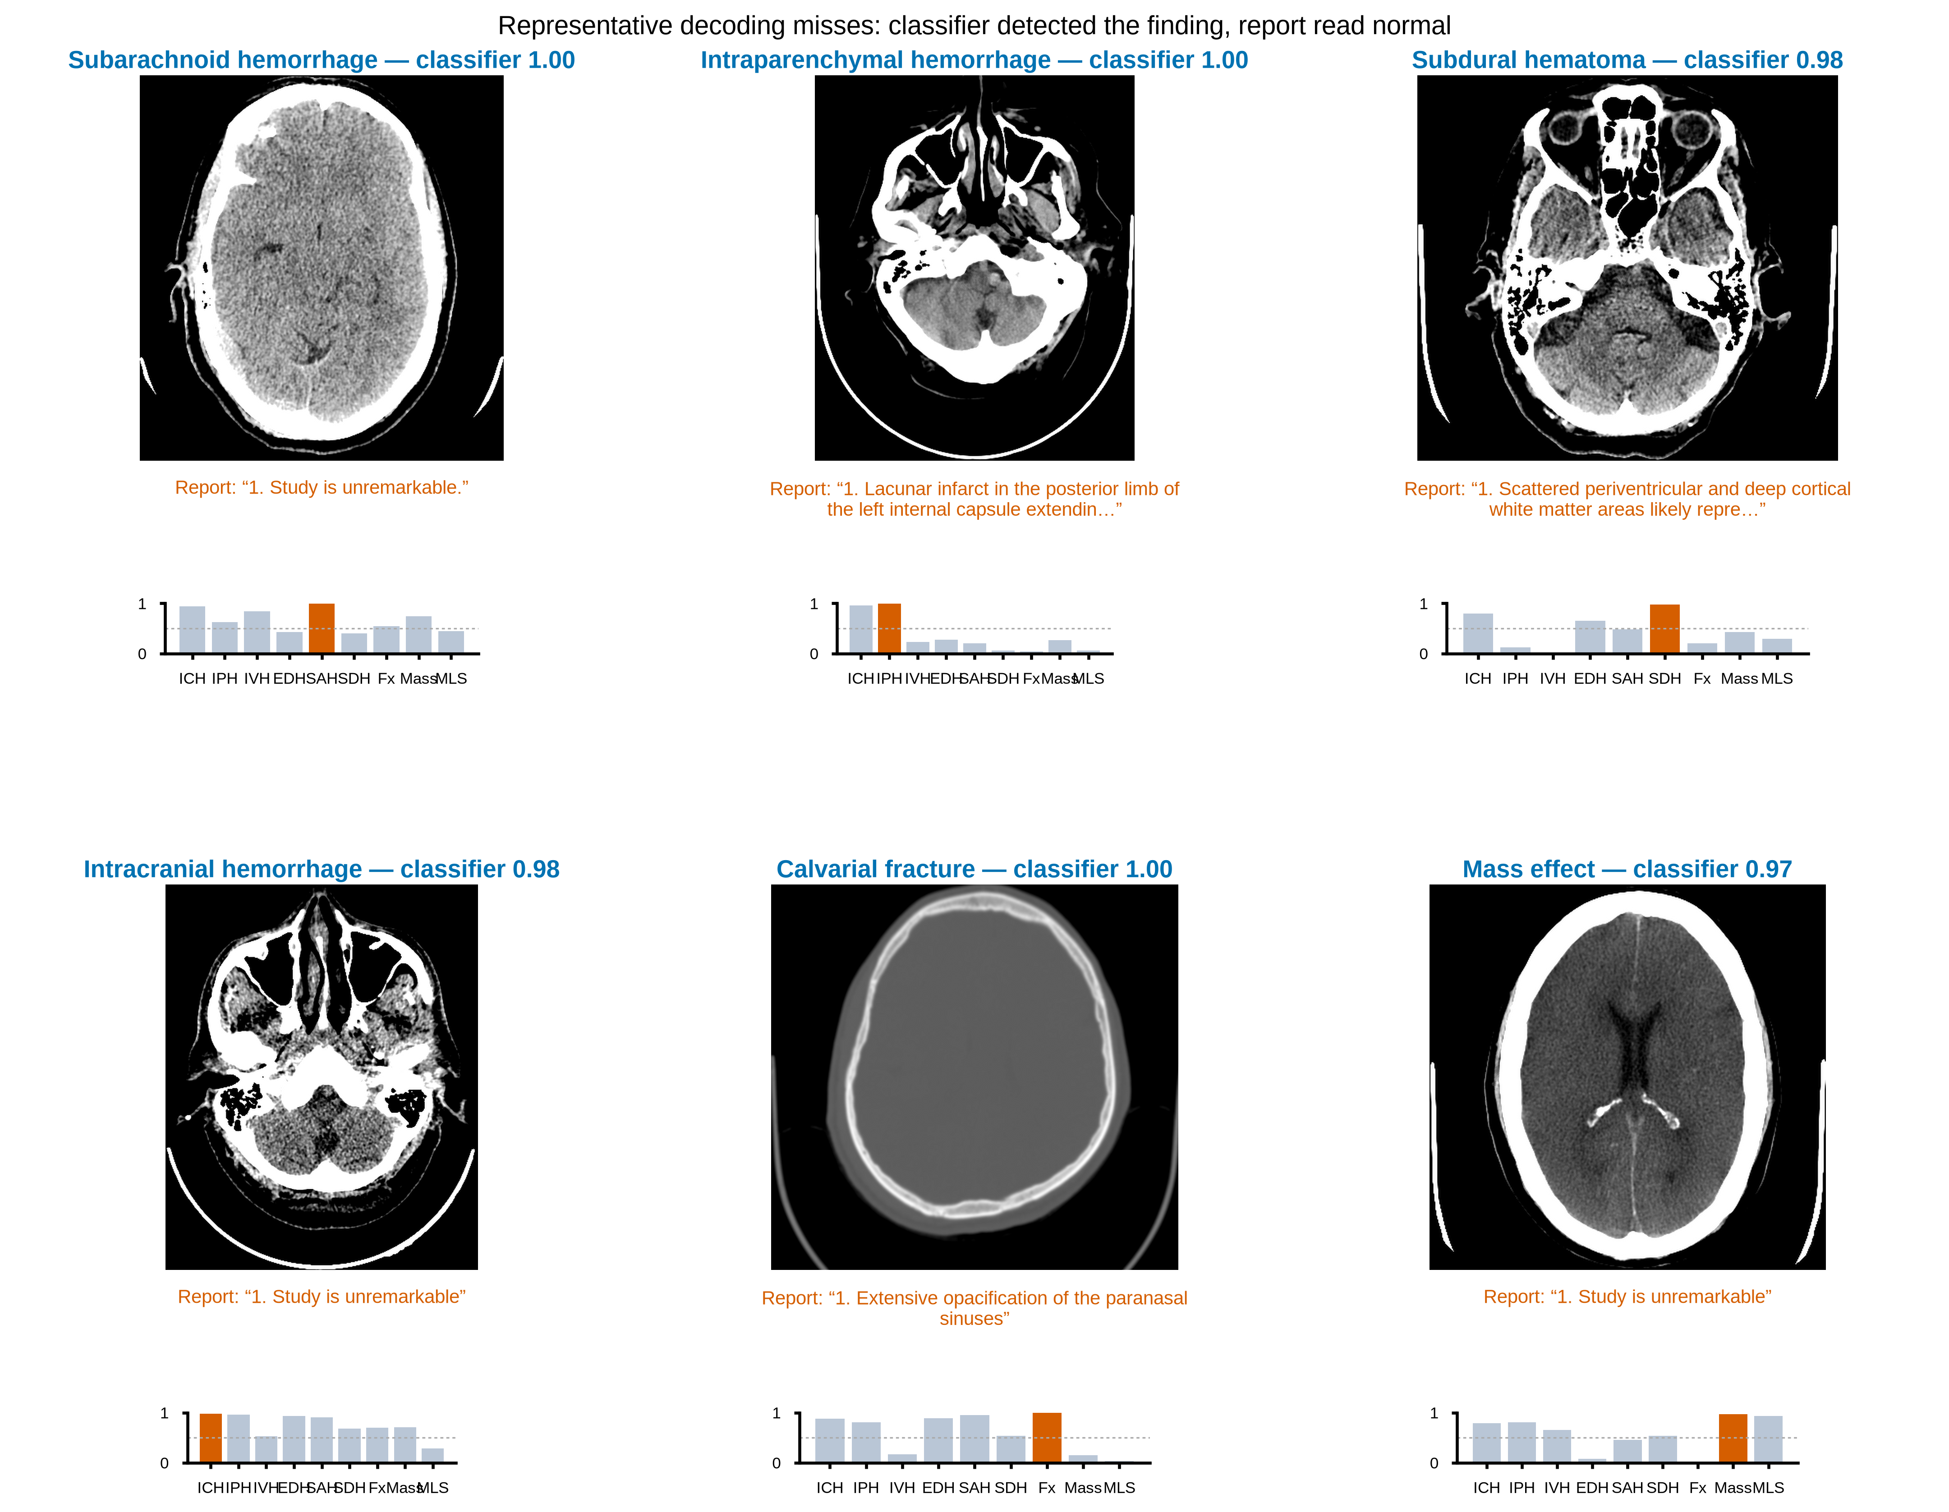
Extended Data Fig. 3. Representative decoding misses. Six CQ500 studies in which the generated report omitted an urgent finding. For each, a key axial slice, the classifier’s scores for the nine critical findings and the generated report verbatim. The examples span subarachnoid hemorrhage, intraparenchymal hemorrhage, subdural hematoma, intracranial hemorrhage, calvarial fracture and mass effect. In each, the classifier scored the finding above 0.96 while the report read as normal.

