Synergism

Iteration 01

2019-02-11

ABJ Software Solutions

Alyssa Jia 300261497

Bogdan Bielka 300281578

Jonah Roesler 300279311

Supervisor: Rahim Virani

Team Leader Jonah Roesler

## Iteration 01 Use Cases

## 

Use Cases Written

Login Use Case

1. The use case starts when the user opens the main or default page of the web app.
2. The user proceed to the login page via a link or button.
3. The login page presents a form and accepts a username and password
   1. It also presents a link to the register page
4. From there they can enter their credentials and hit “Login” to proceed to their profile page and the use case ends.

Register Use Case

1. The use case starts when the user opens the main or default page of the web app.
2. The user proceed to the login page via a link or button.
3. From the login page the user clicks the “Register” link to the register page
4. From there the user enters their credentials and hits “Register”
5. A new record is made of the user’s name and password
6. The user can return to the login page via link and the use case ends.

## High Level Diagram of Iteration 01

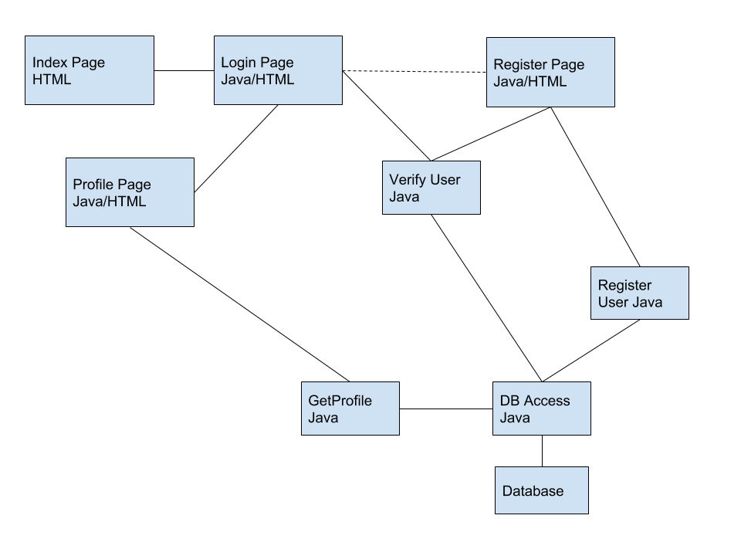

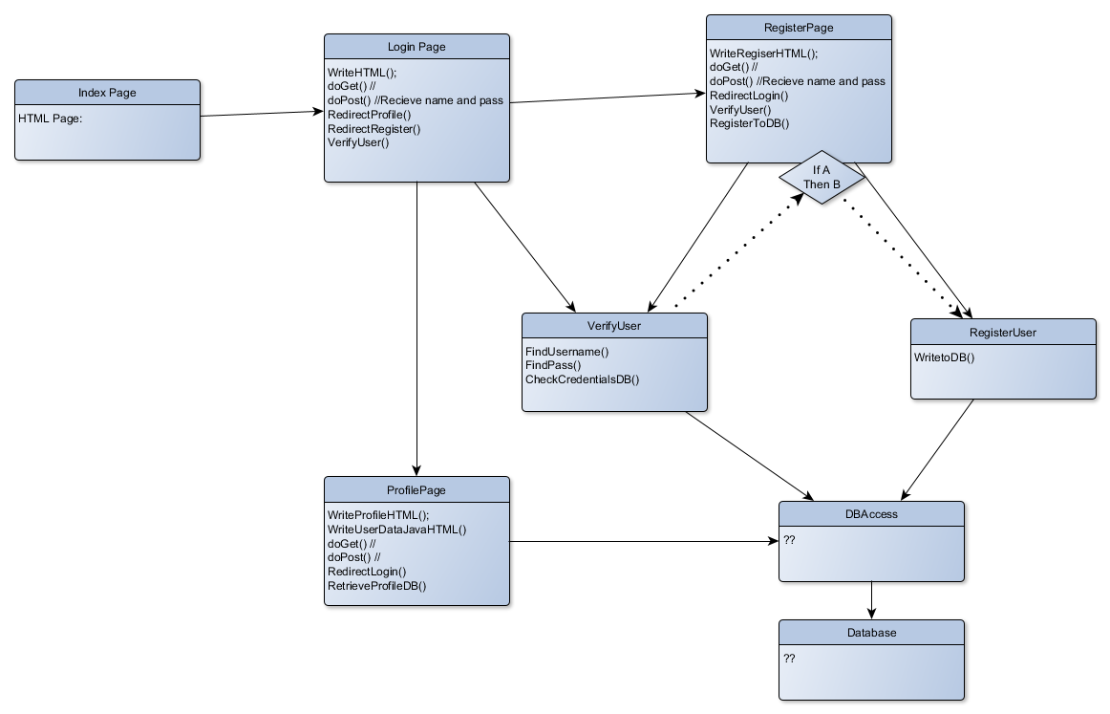

Note: Profile page class and GetProfile class not written, the diagram does not fully reflect current system.

## Metrics and Measurement

Metrics: Performance attribute (Example: Speed)

Measurement: Measures attribute (Example KM/H)

Goal: Target value for that metric (Example: “We need to reach 20 KM/H or greater….”)

Goals are target values *for Iteration 01*.

* Web Pages implemented
  + Measured in accessible pages that have some interactivity
  + Goal is 4
  + Currently have 4
* Database Objects Implemented
  + Measured in the amount of data objects connected to web
  + Goal is >4
  + Currently have 2*
* Web Service Response time
  + Measured in milliseconds
  + Goal is <100 ms
  + Currently have ?

## 

## CRC Cards

|  |  |
| --- | --- |
| HTML_Login |  |
| RESPONSIBILITIES | COLLABORATOR |
| Writes HTML login page for user |  |
| Accepts input Username and Password | LoginPage class |
| Submits input to POST | LoginPage class |

|  |  |
| --- | --- |
| HTML_Register |  |
| RESPONSIBILITIES | COLLABORATOR |
| Writes HTML register page for user |  |
| Accepts input   * First name (username) * Last name * Email * Password | RegisterPage class |
| Submits input to POST | RegisterPage class |

|  |  |
| --- | --- |
| LoginPage |  |
| RESPONSIBILITIES | COLLABORATOR |
| calls HTML_Login page on GET | HTML_Login |
| Passes data to validation method | Utilities class |
| Extracts input from POST   * Username * Password | HTML_Login class |

|  |  |
| --- | --- |
| RegisterPage |  |
| RESPONSIBILITIES | COLLABORATOR |
| calls HTML_Register page on GET | HTML_Register |
| Extracts input from POST   * First name (username) * Last name * Email * Password | HTML_Register |
| Passes data to validation method | Utilities class |
| Passes data to be written to database | Utilities class |

|  |  |
| --- | --- |
| Utilities |  |
| RESPONSIBILITIES | COLLABORATOR |
| Reads database to validate Username and Password credentials and integrity | LoginPage class RegisterPage class |
| Writes new records to database | RegisterPage class |