如何集成MCAL到S32DS？

作者：张敏

时间：2024年3月23日星期六

**前言**

S32DS默认支持配置，但它是基于SDK，使用LLD库的代码来实现具体功能。但MCAL代码如何在S32DS工程当中运行？

本文档指导如何新建S32DS工程，并使用EB的配置代码，编译运行程序的步骤。不指导EB的配置过程。

**1 目标和实验环境**

主控芯片：S32K358

编译器：S32DS for S32 Platform

实验环境：

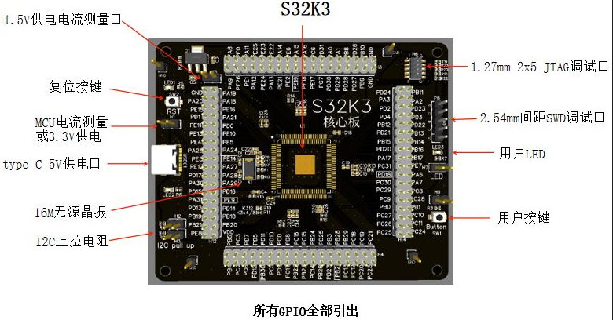

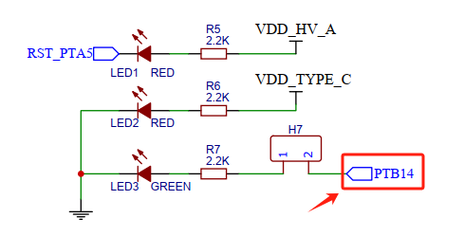

实验目的：通过PTB14点亮LED灯

**2 新建工程**

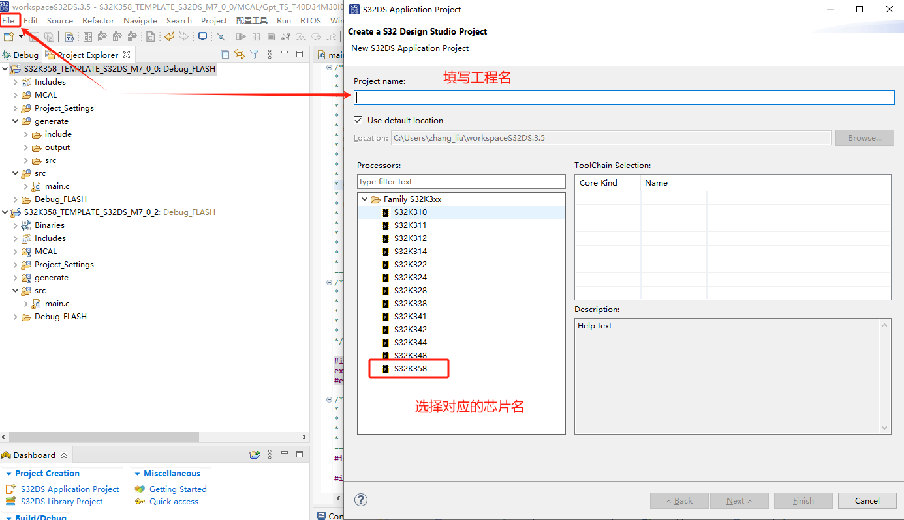

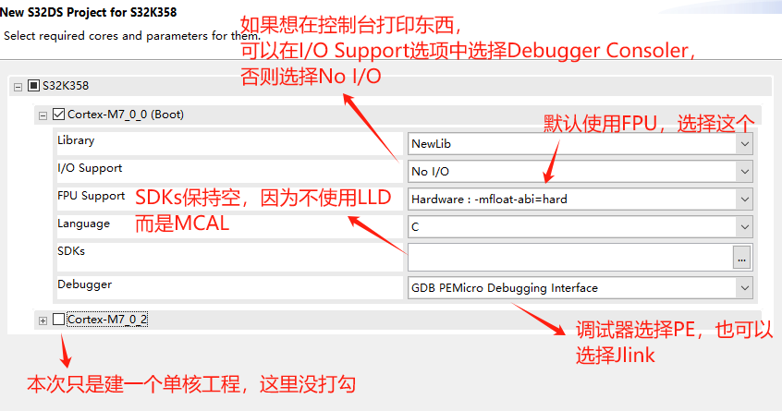

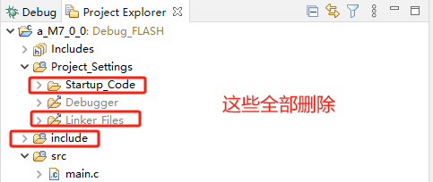

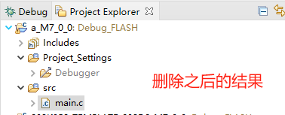

Main.c文件的内容，删除，从例程里替换

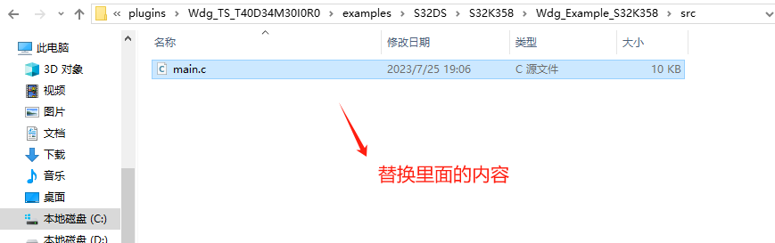

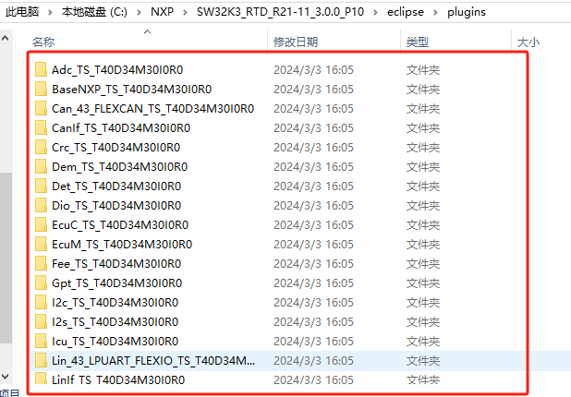

工程所在的文件夹下新建MCAL文件夹，复制这些所有

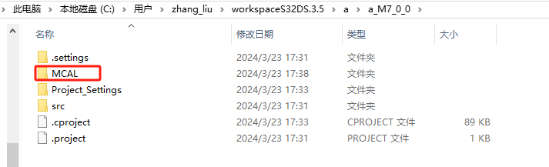

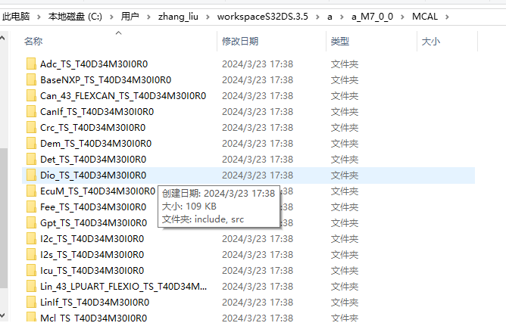

Platform和BaseNXP特殊，除此之外，仅保留src、include文件夹

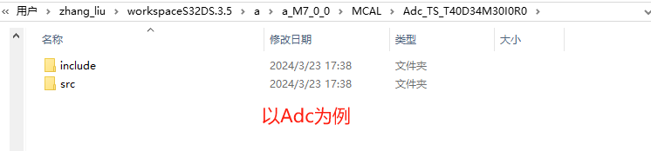

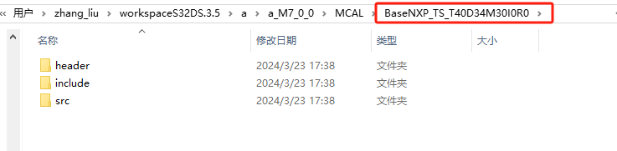

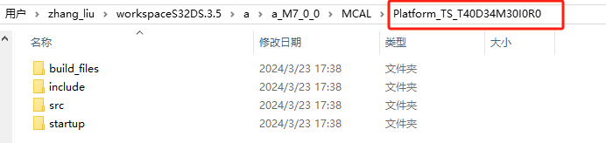

添加头文件路径

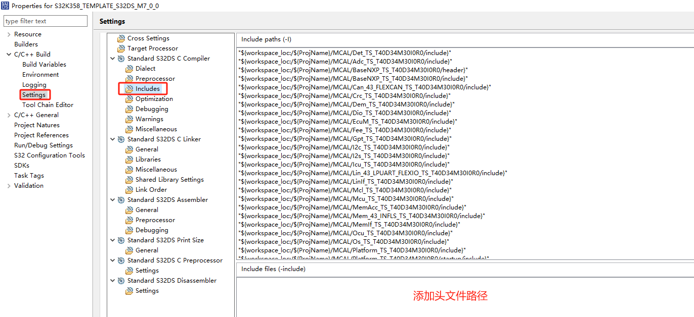

下面的内容可以直接复制粘贴：

"${workspace_loc:/${ProjName}/generate/include}"

"${workspace_loc:/${ProjName}/MCAL/Det_TS_T40D34M30I0R0/include}"

"${workspace_loc:/${ProjName}/MCAL/Adc_TS_T40D34M30I0R0/include}"

"${workspace_loc:/${ProjName}/MCAL/BaseNXP_TS_T40D34M30I0R0/header}"

"${workspace_loc:/${ProjName}/MCAL/BaseNXP_TS_T40D34M30I0R0/include}"

"${workspace_loc:/${ProjName}/MCAL/Can_43_FLEXCAN_TS_T40D34M30I0R0/include}"

"${workspace_loc:/${ProjName}/MCAL/Crc_TS_T40D34M30I0R0/include}"

"${workspace_loc:/${ProjName}/MCAL/Dem_TS_T40D34M30I0R0/include}"

"${workspace_loc:/${ProjName}/MCAL/Dio_TS_T40D34M30I0R0/include}"

"${workspace_loc:/${ProjName}/MCAL/EcuM_TS_T40D34M30I0R0/include}"

"${workspace_loc:/${ProjName}/MCAL/Fee_TS_T40D34M30I0R0/include}"

"${workspace_loc:/${ProjName}/MCAL/Gpt_TS_T40D34M30I0R0/include}"

"${workspace_loc:/${ProjName}/MCAL/I2c_TS_T40D34M30I0R0/include}"

"${workspace_loc:/${ProjName}/MCAL/I2s_TS_T40D34M30I0R0/include}"

"${workspace_loc:/${ProjName}/MCAL/Icu_TS_T40D34M30I0R0/include}"

"${workspace_loc:/${ProjName}/MCAL/Lin_43_LPUART_FLEXIO_TS_T40D34M30I0R0/include}"

"${workspace_loc:/${ProjName}/MCAL/LinIf_TS_T40D34M30I0R0/include}"

"${workspace_loc:/${ProjName}/MCAL/Mcl_TS_T40D34M30I0R0/include}"

"${workspace_loc:/${ProjName}/MCAL/Mcu_TS_T40D34M30I0R0/include}"

"${workspace_loc:/${ProjName}/MCAL/MemAcc_TS_T40D34M30I0R0/include}"

"${workspace_loc:/${ProjName}/MCAL/Mem_43_INFLS_TS_T40D34M30I0R0/include}"

"${workspace_loc:/${ProjName}/MCAL/MemIf_TS_T40D34M30I0R0/include}"

"${workspace_loc:/${ProjName}/MCAL/Ocu_TS_T40D34M30I0R0/include}"

"${workspace_loc:/${ProjName}/MCAL/Os_TS_T40D34M30I0R0/include}"

"${workspace_loc:/${ProjName}/MCAL/Platform_TS_T40D34M30I0R0/include}"

"${workspace_loc:/${ProjName}/MCAL/Platform_TS_T40D34M30I0R0/startup/include}"

"${workspace_loc:/${ProjName}/MCAL/Port_TS_T40D34M30I0R0/include}"

"${workspace_loc:/${ProjName}/MCAL/Pwm_TS_T40D34M30I0R0/include}"

"${workspace_loc:/${ProjName}/MCAL/Rm_TS_T40D34M30I0R0/include}"

"${workspace_loc:/${ProjName}/MCAL/Rte_TS_T40D34M30I0R0/include}"

"${workspace_loc:/${ProjName}/MCAL/Sent_TS_T40D34M30I0R0/include}"

"${workspace_loc:/${ProjName}/MCAL/Spi_TS_T40D34M30I0R0/include}"

"${workspace_loc:/${ProjName}/MCAL/Uart_TS_T40D34M30I0R0/include}"

"${workspace_loc:/${ProjName}/MCAL/Wdg_TS_T40D34M30I0R0/include}"

"${workspace_loc:/${ProjName}/MCAL/WdgIf_TS_T40D34M30I0R0/include}"

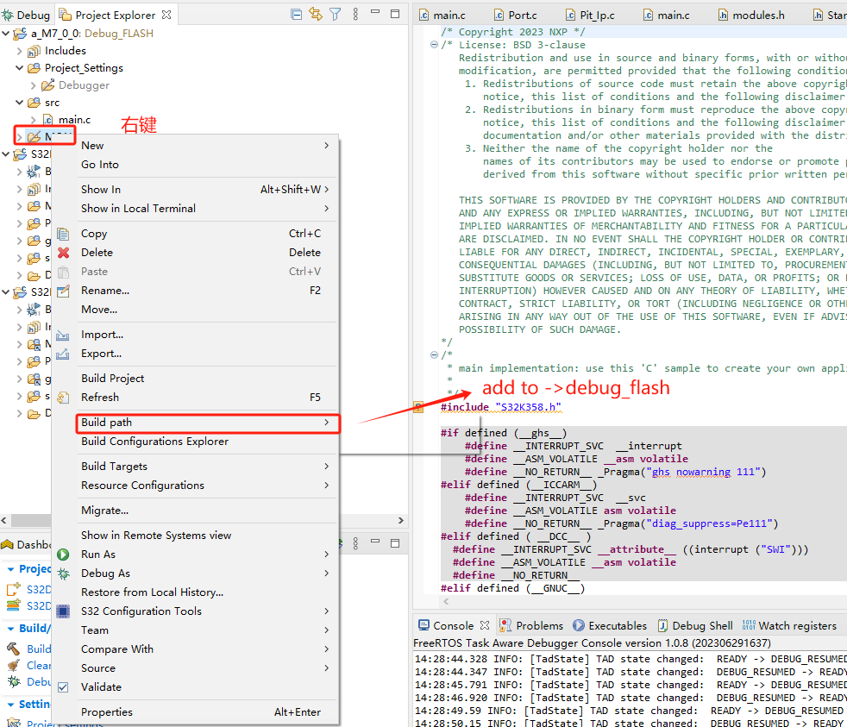

先在工程名上，右键，refresh，刷新一下，MCAL文件夹会出现

之后添加到编译状态，之后要根据使用了那些模块，没使用哪些模块，将没使用的模块，移出Debug_Flash

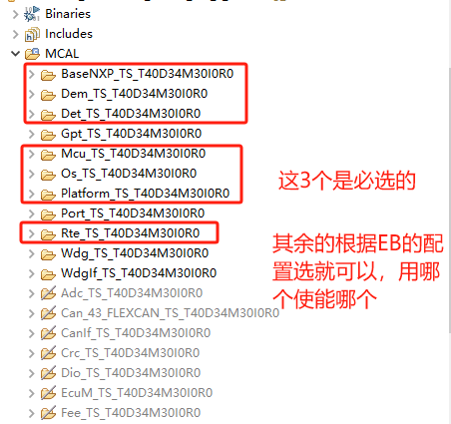

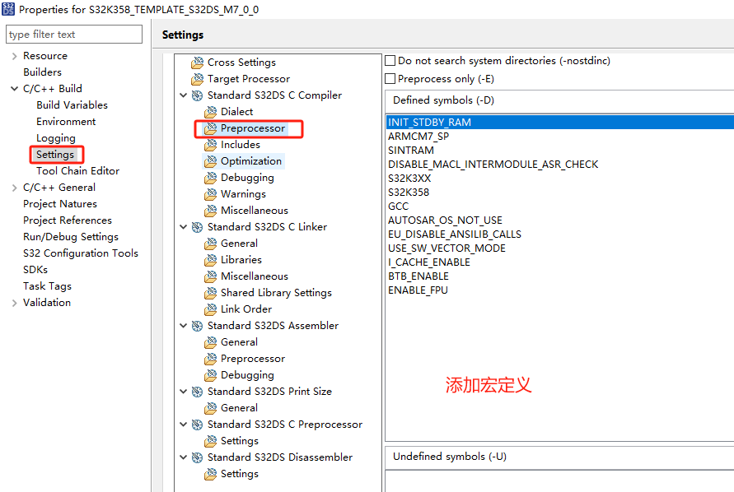

下面的内容可以复制粘贴：

注意：如果使用的调试器是PE，并且没有在创建工程的时候使用FPU，就不要在这里定义I_CACHE_ENABLE 和D_CACHE_ENABLE，否则会影响调试。

这意味着激活FPU，需要两个条件：

1. 创建工程的时候启用FPU
2. 这里的宏定义ENABLE_FPU

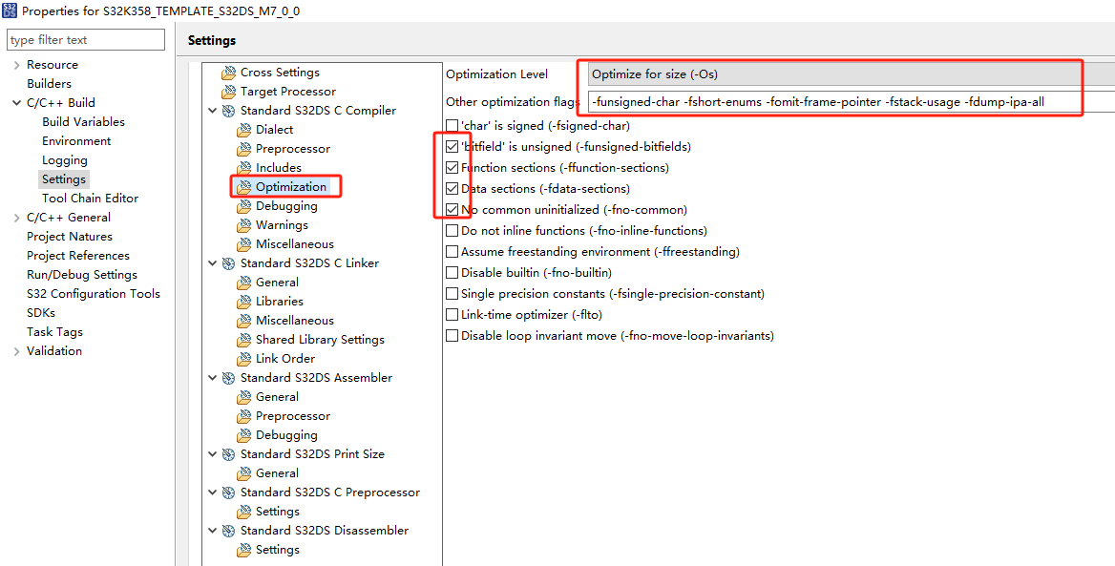

可以复制粘贴：

-funsigned-char -fshort-enums -fomit-frame-pointer -fstack-usage -fdump-ipa-all

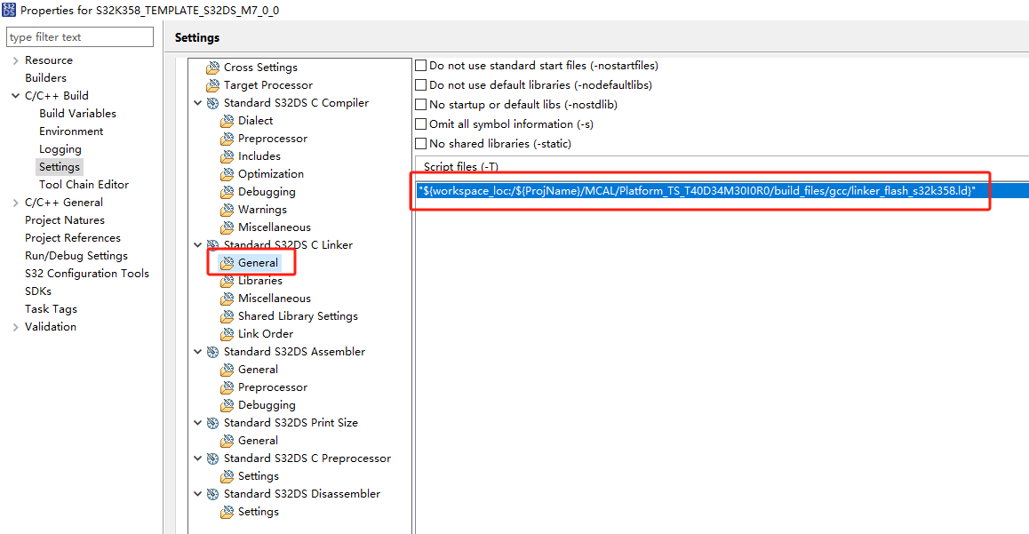

可以复制粘贴：

"${workspace_loc:/${ProjName}/MCAL/Platform_TS_T40D34M30I0R0/build_files/gcc/linker_flash_s32k358.ld}"

如果需要生成.bin .s19 .mot等文件，可以勾选 Create flash image

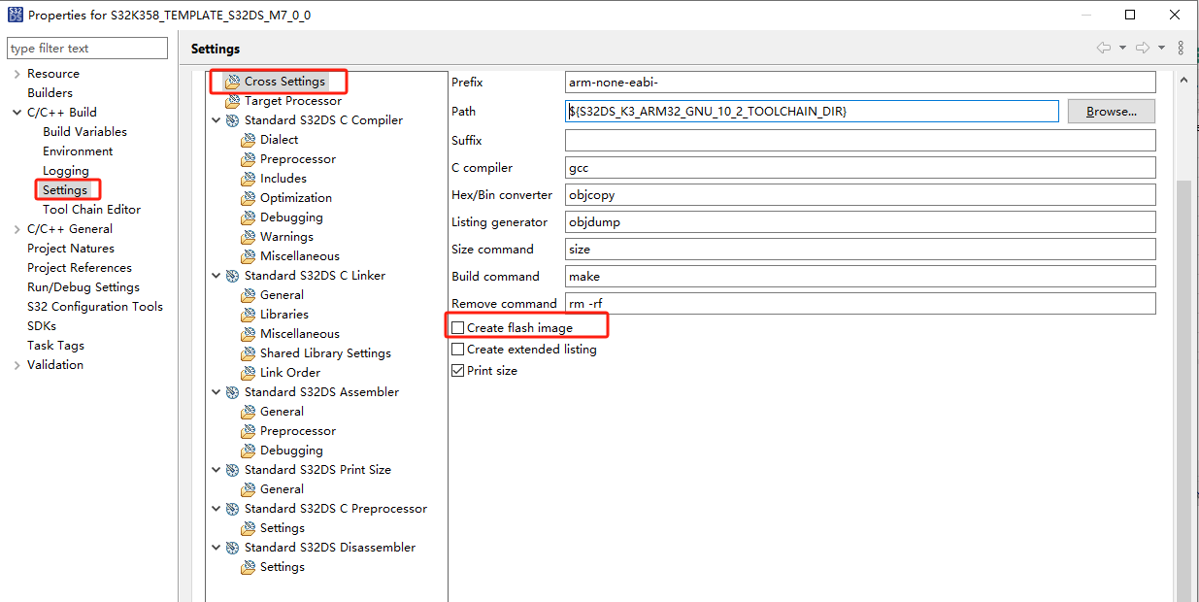

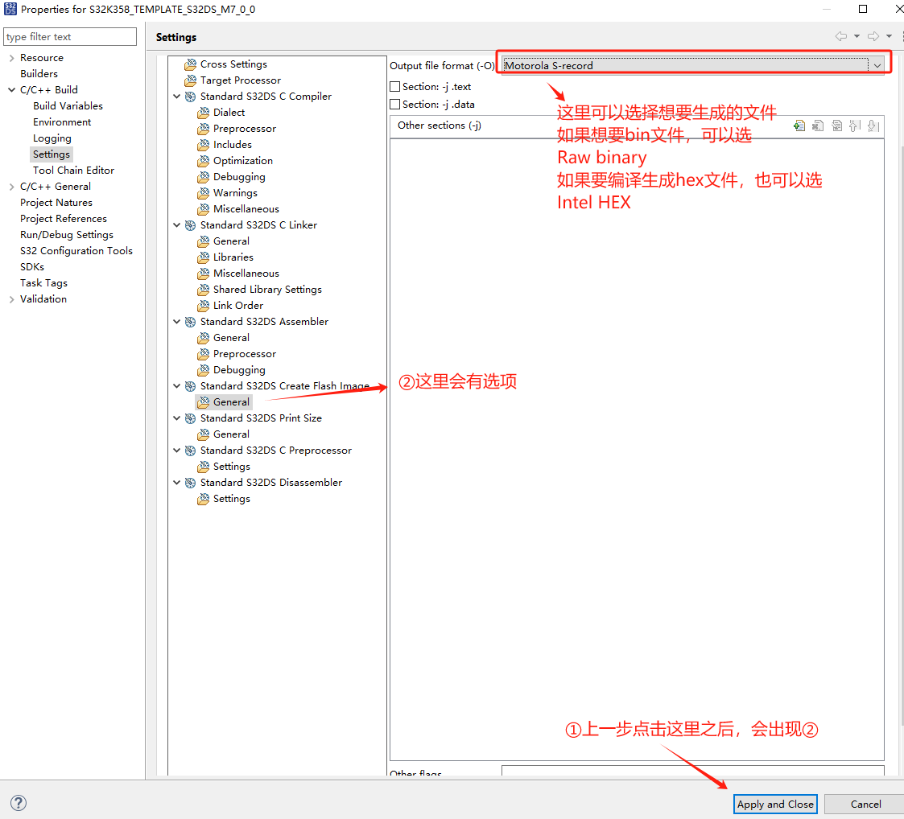

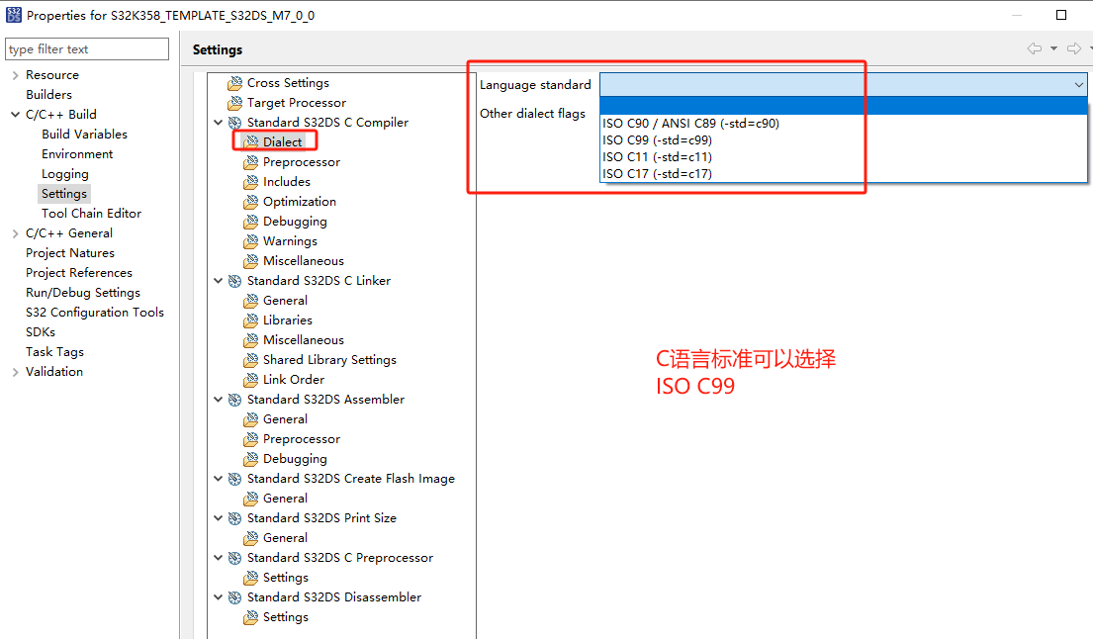

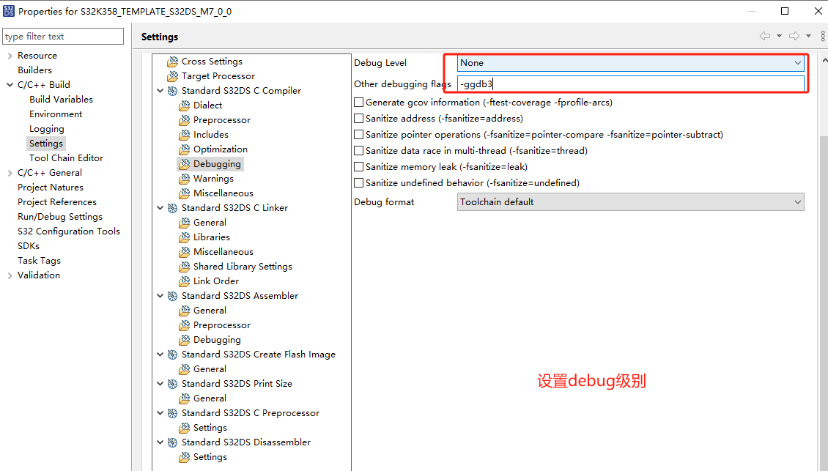

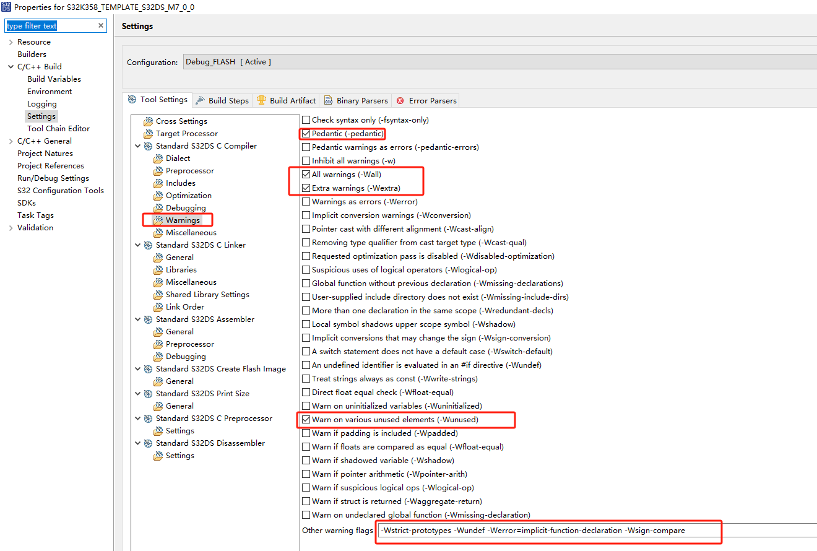

下面的可以复制粘贴

-Wstrict-prototypes -Wundef -Werror=implicit-function-declaration -Wsign-compare

