Jonah Brooks – Savannah Van Beek
CS 331 – Intro to AI
Programming Assignment 1
Uninformed and Informed Search
Methodology:
For all of our searches we used a modified C++ priority queue. By passing in different arguments to the constructor of this queue we could change the behavior to perform as a stack, queue or priority queue. Aside from IDDFS, all our implementations varied primarily by how this priority queue behaved.
BFS: We set up the fringe to function as a queue in this implementation. From there we simply implemented the GraphSearch algorithm and expand algorithm from the pseudocode.
DFS: For this we set up the fringe to function as a stack. From here the implementation was the same as BFS.
IDDFS: For this one we also used a stack. However, we needed to add the ability to do iterative deepening for this search. To do this we added a bool flag to GraphSearch that would enable or disable iterative deepening. If the flag was enabled, the GraphSearch function would purge the close list and fringe once the max depth was reached, then increment max depth, add initial node back on the fringe, and repeat.
A*: For this, we set the fringe to behave as a priority queue where the priority was determined by the path cost and heuristic function of each node. We chose totalRemainingMissionaries + totalRemainingCannibals - 1 for our heuristic function, since this was guaranteed to optimistically predict the quality of the path from that node.
Results:
We ran the code for each of the four search types and created the graph below. The blue bars indicates the number of nodes include in the solution path. The red bars indicate how many nodes were epanded in all to find the end solution path.
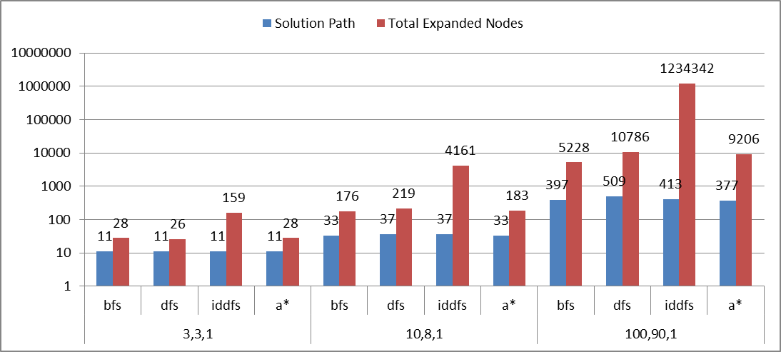
Discussion:
We were expecting to see BFS, IDDFS, and A* to be complete and optimal. However, the results that we obtained were slightly off from what we expected, and while they were complete they were not optimal. We know that at least BFS and IDDFS cannot be optimal due to the fact that A* found a more optimal solution in the final test case. We did expect to have a large number of nodes expanded for IDDFS since it is required to traverse (part of) the search tree multiple times before finding a solution.
Conclusion:
We were expecting A* to perform more efficiently than the other search algorithms, which turned out to be the case. However, BFS should have also been optimal and was for the first two test cases, but not the third case. IDDFS also should have been optimal, but was only so for the first case. These results show that our algorithms were not completely correct, but were complete.

